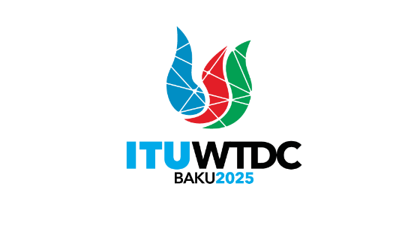 | Regional Preparatory Meeting  for the Americas Region for WTDC-25 (RPM-AMS)  Asuncion, Paraguay, 1-2 April 2025 |  | 
 |  | Document RPM-AMS25/INF/4-E
 |  | 27 March 2025
 |  | English only
Director, Telecommunication Development Bureau
Rules of procedure of ITU-D (WTDC Resolution 1)
Agenda item:
Item 7.4
Context:
The objective of this document is to provide the text of the WTDC Resolution 1 (Rev. Kigali, 2022).
Expected results:
RPM is informed of the Rules of procedure of the ITU Telecommunication Development Sector.

Background:
This document refers to Resolution 1 (Rev. Kigali 2022), which establishes the procedural rules for the ITU Telecommunication Development Sector (ITU-D) as adopted during the World Telecommunication Development Conference held in Kigali in 2022.
The resolution specifies the functions, responsibilities, and organizational structure of ITU-D, citing various resolutions and articles from the ITU Constitution and Convention that regulate its operations. Additionally, it addresses the appointment procedures for chairpersons of various groups within ITU-D. The text of the resolution is available through the provided link.
Review of Rules of Procedures:
The WTDC is tasked with adopting and modifying working methods for ITU-D's activities, considering reports from study groups, and approving new or revised ITU-D Recommendations. The conference also provides guidance for ITU-D's work program and establishes priorities for study questions. It is crucial for the WTDC to maintain a focus on the needs of developing countries, ensuring that the outputs from its studies and initiatives are relevant and beneficial.
As part of the preparations for the WTDC-25, members states may consider the existing rules and propose amendments to enhance the efficiency and responsiveness of ITU-D. This includes refining the procedures to better address emerging trends in telecommunications, fostering greater inclusivity in decision-making processes, and ensuring that the sector's activities align with the evolving needs of member states. It is imperative that these considerations are meticulously reviewed and integrated into the agenda of the forthcoming WTDC-25, as they will shape the strategic direction and operational effectiveness of ITU-D in the coming years.
The resolution serves as a foundational document that underpins the sector's commitment to advancing global telecommunication development, with an emphasis on facilitating progress and connectivity in developing nations.
________________

