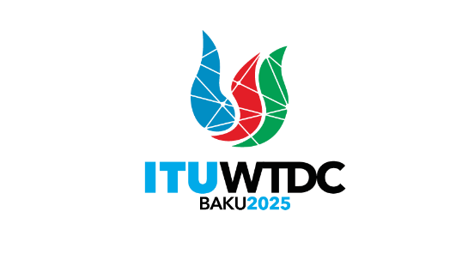 | Regional Preparatory Meeting  for the Americas Region for WTDC-25 (RPM-AMS)  Asuncion, Paraguay, 1-2 April 2025 |  | 
 |  | Document RPM-AMS25/INF/3-E
 |  | 27 March 2025
 |  | English only
Director, Telecommunication Development Bureau
Update on the Global Youth Summit, 2025 (GYS-25)
Agenda item:
Item 9
Context:
The objective of this document is to provide an update on the Global Youth Summit, held in Varadero, Cuba, from 11-13 March 2025.
Expected results:
RPM is invited to note this document.
References:
TDAG Documents: TDAG-24/DT/7, TDAG-24/13, and TDAG-24/13(Ann.1), TDAG-24/31(Ann.1),
TDAG-24/30, TDAG-24/32.

Background
The 2025 edition of the Global Youth Summit was held in Varadero, Cuba from 11 to 13 March 2025 under the theme “Amplifying youth voices in ICT for an inclusive and connected future”. GYS-25 was the 17th youth event organized by the International Telecommunication Union (ITU), continuing a journey that began with the first-ever youth summit, held in Johannesburg, South Africa in 2001.
Around 400 participants from 31 countries attended the event from all ITU regions, with young people from across the globe attending, with gender balance, and representation from Least Developed Countries (LDCs), Landlocked Developing Countries (LLDCs) and Small Island Developing States (SIDS). Governments, regional organizations, companies, and academia also took part, along with representatives of other UN agencies and Youth Envoys for ITU's Generation Connect programme.
The three-day event, organized by ITU and hosted by the Ministry of Communications of the Government of Cuba, set out to amplify youth voices on the tech-driven future. Participants from around the world between 18 and 25 years of age identified their priorities to ensure that information and communication technologies are safe, affordable and accessible.
Key tech issues for young people discussed at the summit included connectivity, digital inclusion, online safety, ethical development and use of artificial intelligence and emerging technologies, preparing for the future of work, and enabling digital participation by all to foster economic and social empowerment of youth globally.
The event included interactive thematic discussions, breakout exercises, intergenerational dialogues, and pitching and networking opportunities during which youth explored innovative youth-led projects. A song competition completed the series of interactive activities for youth to engage. Highlights of the Summit can be seen in the Highlights Video, available here.
The summit's networking opportunities and intergenerational dialogues allowed young people to learn from technology professionals, experts and policy makers. Discussions highlighted the need for youth to be digitally included and skilled to create opportunities for entrepreneurship and innovation as key drivers of global social and economic development.
This update on the ITU Global Youth Summit captures ideas shared at the event and challenges identified by youth as well as recommendations for action and will serve as a resource for stakeholders seeking to align approaches on digital issues and the digital development agenda, including by using the ideas as input to the Regional Preparatory Meetings (RPMs) and the World Telecommunication Development Conference 2025 (WTDC-25). The ideas captured in this update will also be presented during the Youth Celebration that will take place on 16 November 2025 in Baku, Azerbaijan, just before WTDC-2025.
Key challenges
Youth from around the world identified the following challenges that need addressing with urgency to ensure inclusive and sustainable progress in the digital era:
- Lack of critical and resilient infrastructure, particularly in LDCs, LLDCs, and SIDS.
- Digital skills gaps including in the access to, use and knowledge of ICTs that present major barriers to digital inclusion.
- Urban-rural digital divides that hinder equitable access to digital opportunities and resources.
- Inadequate e-waste management to mitigate impact and ensure environmental responsibility and sustainability.
- Lack of youth engagement in discussions on shaping the future of the digital world, the global technology landscape and future digital public policy.
Youth Voices for an inclusive and connected future
Youth recommended the following measures for action to foster an inclusive, sustainable, and digitally empowered society:
- Developing robust regulatory frameworks to enhance connectivity and build confidence and trust in digital technologies.
- Fostering collaboration through public-private partnerships and multistakeholder approaches to expand affordable connectivity solutions and infrastructure projects, particularly in unserved and underserved areas and for marginalized groups.
- Promoting digital accessibility for ICT products and services jointly with a holistic and intersectional approach in formulation and implementation of policies strategies aimed to enhance digital inclusion, to ensure equitable access to education, skills development, and employment opportunities, thus ensuring that no one is left behind in the digital society, and economy.
- Encouraging and empowering youth-led entrepreneurship and innovation in the digital world as drivers of youth employment and economic growth.
- Using technology, including green digital technologies, to protect the environment and ensure a sustainable and eco-friendly digital future.
- Prioritizing the development of digital skills among all youth to equip them with the tools needed to navigate and thrive in the rapidly evolving technological landscape.

Resources and background information:
For more information, please visit: https://www.itu.int/itu-d/meetings/global-youth-summit-25/
Press release: ITU Global Youth Summit places young people at the heart of digital transformation
Videos:
- Highlights video
- A journey through the ITU-D youth events throughout the years (Youtube)
________________

