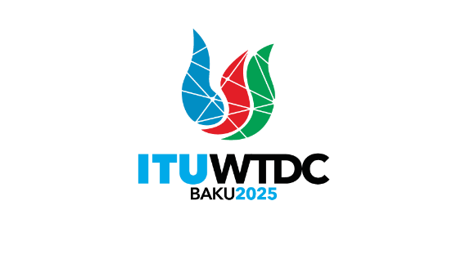 | Regional Preparatory Meeting  for the Americas Region for WTDC-25 (RPM-AMS)  Asuncion, Paraguay, 1-2 April 2025 |  | 
 |  | Document RPM-AMS25/INF/2-E
 |  | 27 March 2025
 |  | English only
Director, Telecommunication Development Bureau
Update on WSIS+20, 2030 Agenda for Sustainable Development and
UN Pact of the Future, including Global Digital Compact
Agenda item:
6
Context:
The objective of this report is to provide an executive update on the relevant UN processes, in particular the World Summit on the Information Society, the 2030 Agenda for Sustainable Development, and the United Nations Pact of the Future, including Global Digital Compact. As per WTDC Resolution 30 (Rev. Kigali 2022) and Kigali Action Plan, all activities of BDT contribute to the implementation of WSIS Action Lines and the 2030 Agenda for Sustainable Development.
Expected results:
RPM is invited to note this document.
References:
UNGA Resolutions A/RES/70/125, A/RES/70/1, A/RES/77/150, A/71/212, A/70/299, A/70/684, A/RES/73/218; UN ECOSOC Resolution E/RES/2023/3; Resolutions 140 (Rev. Bucharest, 2022), Council Resolutions 1332 (Modified 2024), 1334 (Modified 2023); WTDC Resolutions 30 (Rev. Kigali, 2022)

Background
ITU as the UN Agency for Digital is proactively engaged in the UN processes and continues to advocate for enabling role of digital technologies for sustainable development. The objective of this report is to provide an executive update on relevant UN processes, in particular the World Summit on the Information Society, the 2030 Agenda for Sustainable Development, and the United Nations Pact of the Future, including Global Digital Compact. As per WTDC Resolution 30 (Rev. Kigali 2022) and Kigali Action Plan, all activities of BDT contribute to the implementation of WSIS Action Lines and the 2030 Agenda for Sustainable Development.
WSIS and 2030 Agenda for Sustainable Development
The WSIS Process: The UN General Assembly Resolution 56/183 (21 December 2001) endorsed the holding of the World Summit on the Information Society (WSIS) in two phases. The first phase took place in Geneva from 10 to 12 December 2003 and the second phase took place in Tunis, from 16 to 18 November 2005.The objective of the first phase was to develop and foster a clear statement of political will and take concrete steps to establish the foundations for an Information Society for all, reflecting all the different interests at stake. Geneva Declaration of Principles and Geneva Plan of Action were adopted on 12 December 2003. The objective of the second phase was to put Geneva's Plan of Action into motion as well as to find solutions and reach agreements in the fields of Internet governance, financing mechanisms, and follow-up and implementation of the Geneva and Tunis documents. Tunis Commitment and Tunis Agenda for the Information Society were adopted on 18 November 2005.
Member States and all stakeholders have recognized the dynamic evolution of the WSIS as a proven and continually evolving process that addresses the impact of new technologies and expand digital cooperation across various platforms, including the WSIS Forum and Internet Governance Forum (IGF).
The WSIS Process and its elements like the WSIS Action Lines, United Nations Group on Information Society (UNGIS), WSIS Forum, WSIS Stocktacking, WSIS Special Initiatives, etc. provide an existing framework for leveraging Information and Communication Technologies (ICTs) for the benefit of people and the planet, focusing on enhancing capacities in developing countries, especially for underserved communities.
A comprehensive overview of ITU’s activities related to WSIS is regularly presented to the ITU Council Working Group on WSIS&SDG. The latest report is available here. As per WTDC Resolution 30 and Kigali Action Plan, all activities of BDT are contributing to the implementation of WSIS Action Lines and the 2030 Agenda for Sustainable Development, and the recent update on actions can be consulted here.
Year 2025 marks an important milestone for WSIS Process, i.e. 20 years since the outcomes of the WSIS were adopted by the UN General Assembly and 10 years since the Overall Review of the Implementation of WSIS (WSIS+10) review took place in 2015.
Resolution 70/125 requests the General Assembly to hold a high-level meeting on the overall review of the implementation of the outcomes of the World Summit on the Information Society in 2025 (referred to as “WSIS+20”), involving the input and participation of all stakeholders, including in the preparatory process, to take stock of progress on the outcomes of the World Summit and identify both areas of continued focus and challenges. It also recommends that the outcome of the high-level meeting be considered as an input into the review process for the 2030 Agenda for Sustainable Development, including outcomes of the SDG Summit in 2023 and inputs to the next SDG Summit in 2027. The WSIS+20 will provide an opportunity to reflect and discuss the evolution of the WSIS implementation process.
WSIS+20 roadmaps
- World Summit on the Information Society (WSIS)+20: WSIS Beyond 2025: WSIS+20 Roadmap; elaborates the ITU Secretary-General’s roadmap on the role of ITU in the WSIS+20 Review process and its preparations. It outlines ITU’s leadership in engaging stakeholders, assessing progress, and aligning WSIS Action Lines with the 2030 Agenda for Sustainable Development. The roadmap emphasizes comprehensive preparations, including detailing activities, events, and reporting mechanisms, all aimed at informing the UN General Assembly Overall Review in 2025. Through collaborative efforts, it identifies priorities for advancing digital development beyond 2025 while fostering global partnerships and dialogue.
- Report by the Director General on implementation of the World Summit on the Information Society (WSIS) outcomes, elaborates UNESCO’s roadmap towards the WSIS+20 Review.
- CSTD Roadmap for the WSIS+20 Review United Nations Conference on Trade and Development.
At the WSIS+20 Forum High-Level Event 2024, several multistakeholder dialogues and discussions were held to discuss on the preliminary steps towards the WSIS+20 Review process. The sessions were included as part of the Digital Governance Processes: WSIS, GDC/ Summit of the Future Special Track. These sessions concluded with key takeaways emphasizing the need to avoid duplication of efforts while acknowledging existing mechanisms and recognizing the substantial work that lies ahead. Stakeholders reaffirmed the value of the multistakeholder framework and highlighted the key elements of the WSIS process, such as the WSIS Forum, the Internet Governance Forum (IGF), the United Nations Group on the Information Society (UNGIS), the WSIS Stocktaking platform, etc.
The WSIS Forum 2025 will be branded as the WSIS+20 High-Level Event 2025 celebrating the achievements of the WSIS Process and identifying the opportunities and challenges in implementing the WSIS Action Lines. The event is scheduled to be held from 7 to 11 July 2025 in Geneva, Switzerland.
WSIS+20 Joint preparatory process
Towards the WSIS+20 Review, efforts have been made to establish a unified WSIS+20 Review process involving all UN agencies, including ITU, UNESCO, UNDP, UNCTAD, UN DESA, and UN CSTD. Regular meetings are organised to facilitate collaborative discussions and planning, reflecting our joint and dedicated approach towards the WSIS+20 Review. Kindly refer to the timeline of the joint preparatory process below.
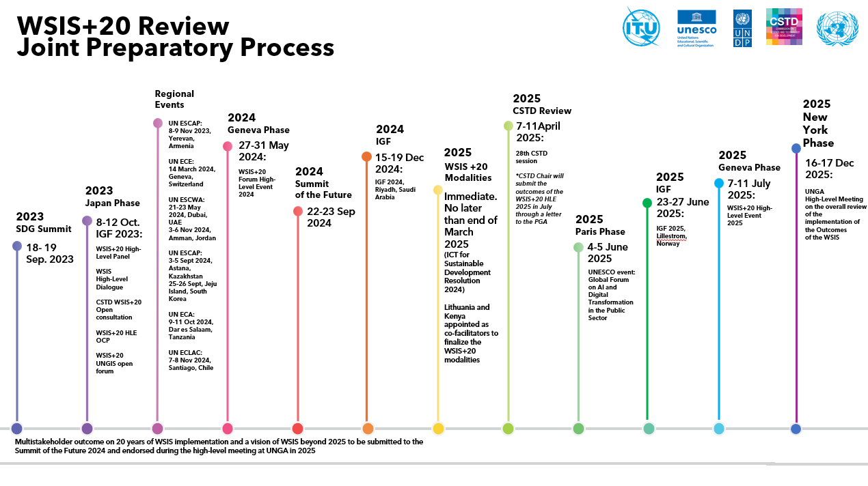
WSIS+20 modalities
In January 2025, the President of United Nations General Assembly (UNGA) appointed H.E. Mr. Erastus ‘Lokaale, Permanent Representative of the Republic of Kenya and H.E. Mr. Rytis Paulauskas, Permanent Representative of the Republic of Lithuania, as co-facilitators for intergovernmental consultations to finalize the modalities for the overall review by the General Assembly of the implementation of WSIS outcomes (letter dated 20 January 2025).
The resolution on ICT for sustainable development (A/RES/79/194) outlines that the modalities are to be finalised by the end of March 2025.
On 4 February 2025, the co-facilitators presented a timeline of the intergovernmental consultations of the modalities for the overall review by the General Assembly of the implementation of WSIS outcomes and circulated the zero draft of the modalities to be presented on 14 February 2025 in ECOSOC Chamber (see information here).
The following roadmap will guide the modalities process in the coming months:
Date | Location | Event
14 February 2025, 10 a.m. to 1 p.m | ECO | Presentation of the zero draft
26 February 2025, 10 a.m. to 1 p.m | CR-4 | First reading
6 March 2025, 10 a.m. to 1 p.m | CR-1 | Second reading
13 March 2025, 10 a.m. to 1 p.m | CR-1 | Third and ﬁnal reading
Weeks of 17 and  24 March |  | Submission to PGA, issuance of the draft  resolution and consideration in the plenary
WSIS+20 Action Lines milestones, challenges and emerging trends beyond 2025
The WSIS Action Lines serve as a key framework for advancing progress towards the achievement of SDGs. The WSIS Action Lines cover eleven areas of focus with technology serving as a key enabler for sustainable development. The WSIS-SDG Matrix, developed by the UN Action Line Facilitators, clearly shows the linkage between each Action Line and the 17 SDGs and provides rationale for each.
The ITU, together with other WSIS Action Line facilitators from UN agencies, have prepared presentations highlighting key milestones, challenges, and emerging trends beyond 2025. The presentations are available here.
ITU’s call for inputs on the WSIS+20 Review
In accordance with ITU Council Resolution 1332, ITU has launched a call for inputs on WSIS+20 Review. Members and other stakeholders are invited by the Chair of the CWG-WSIS&SDG to contribute their views on the work of the ITU in the WSIS+20 Review, including ideas related to the review of the WSIS Action Lines.
To date, we have received more than 80 responses, and the deadline for submissions has been extended to 14 March 2025, following several requests received from stakeholders. South Africa, as the current Chair of the CWG-WSIS&SDG, together with ITU, organized a special session during the Internet Governance Forum 2024 in Riyadh, Saudi Arabia, on the 20 years of WSIS implementation and the vision beyond 2025, while also highlighting this ongoing call for further submissions from stakeholders.
Alignment with other UN digital governance processes
On 22 September 2024, Member States adopted the Pact for the Future, which includes the Global Digital Compact (GDC). In paragraph 71, the GDC requests the Secretary-General to provide a Compact implementation map for consideration by Governments and other stakeholders. This map would reflect the contributions of the United Nations system and other relevant stakeholders, and will be included in the Secretary-General's report on the progress made in implementing and following up on the outcomes of the World Summit on the Information Society, at both regional and international levels, ahead of the WSIS+20 Review. The GDC and the WSIS+20 Review are closely aligned in their shared objective of advancing global digital cooperation and addressing the evolving challenges of the digital age.
In particular, the GDC encourages the WSIS+20 Review to explore how the WSIS process can support stakeholders' contributions to the Compact's implementation. Leveraging existing UN coordination mechanisms, particularly those addressing digital issues, the UN Group on the Information Society (UNGIS), supported by ITU, is well-positioned to enhance system-wide digital cooperation within the UN system.
Building on the mapping of the WSIS Process, the 2030 Agenda, and the GDC developed by UNGIS, the WSIS+20 Review will showcase best practices, identify gaps, and outline new priorities to ensure that the WSIS process remains relevant and effective, including in advancing the GDC’s objectives.
WSIS+20 High Level Event
The ITU 2024 session of the Council, through its Resolution 1332 on ITU role in the implementation of the WSIS outcomes and the 2030 Agenda for Sustainable Development, resolved that the WSIS Forum 2025 should be branded as the WSIS+20 High-Level Event 2025.
The event will be co-hosted by ITU and the Swiss Confederation and co-organized with ITU, UNESCO, UNDP, and UNCTAD, in collaboration with WSIS Action Line co-facilitators and other UN organizations. The WSIS+20 High-Level Event 2025 will take place from 7 to 11 July 2025 at Palexpo in Geneva, Switzerland. The event will serve as a key milestone for the 20 years of the implementation of the WSIS Process and its Action Lines, the WSIS+20 Review, taking stock the achievements, key trends, challenges and opportunities since the Geneva Plan of Action.
It will be held in conjunction with the AI for Good Global Summit, leveraging the synergies between these two events to provide complementary perspectives on topics related to emerging technologies and digital for development.
WSIS+20 High-Level Event 2025 Open Consultation Process (OCP) has been launched and is designed to shape the event’s agenda and program while gathering input from all stakeholders. It also facilitates the collection of views and contributions for the broader WSIS+20 Review.
The OCP is structured to ensure inclusivity and active participation, inviting stakeholders to share their perspectives and ideas through an online form and consultative meetings. All relevant information, including invitation letter for contributions, is available at: https://www.itu.int/go/OCP2025.
All stakeholders have been invited to respond to the call for action and engagement in the following Open Consultation Process, WSIS Stocktaking 2025, WSIS Prizes 2025, WSIS Fund in Trust 2025, WSIS Photo Contest 2025.
High-level participation at the Event will include Heads of State, Ministers, Regulators, CEOs, Head of UN Agencies, Civil-Society, Academia and other prominent leaders from different stakeholder types.
The WSIS Process at the regional level is implemented through the collaborative efforts of various stakeholders, including UN Regional Commissions, ITU regional offices, regional technical organizations, often in partnership with governments, private sector entities, civil society, and academia. These efforts align with the objectives of the WSIS Action Lines and the broader vision of achieving sustainable development goals (SDGs).
The regional dimension of WSIS remains instrumental for its successful implementation and for integrating region-specific priorities into global strategies. This approach ensures inclusivity, coherence, and responsiveness to diverse digital development challenges, directly contributing to the WSIS+20 Review process and the alignment with the Global Digital Compact (GDC).
The ITU will present regional insights from the WSIS Stocktaking database and WSIS Prizes, contributing to the assessment and enhancement of regional progress. These insights will directly inform the WSIS+20 Review process, culminating in the publication of the 20-year WSIS Stocktaking Regional Reports during the WSIS+20 High-Level Event in July 2025.
Regional WSIS+20 Review Events
In alignment with General Assembly Resolution A/70/125, the UN Regional Commissions continue to advance WSIS implementation and contribute to the WSIS+20 Review through regional reviews organized in collaboration with ITU and other UN agencies. These reviews provide a platform for assessing WSIS Action Lines and SDGs implementation at national and regional levels, offering valuable input for the WSIS review and beyond-2025 vision.
ITU has contributed to the following meetings, as part of the WSIS+20 Review joint preparatory process:
- Ministerial Conference on Digital Inclusion and Transformation, Astana, Kazakhstan (September 2024), organized by ESCAP, ITU, and CSTD. The summary record is available here
- Eighth Asia-Pacific Information Superhighway Steering Committee Meeting, Jeju, Republic of Korea (September 2024), organized by ESCAP
- Africa WSIS Annual Review: Success, Challenges & Prospects, Dar es Salaam, Tanzania (October 2024), organized by ECA
- 9th Ministerial Conference on the Information Society, Santiago, Chile (November 2024), organized by ECLAC
- Digital Cooperation and Development Forum (DCDF) 2025, 23-26 February 2025, in Amman, Jordan, organized by ESCWA
These WSIS+20 regional meetings reaffirmed the crucial role of the WSIS process as a UN multistakeholder coordination mechanism on digital and emerging technologies topics at the regional level. Regional stakeholders have acknowledged ITU's vital role in supporting WSIS implementation and follow-up. In collaboration with UN Regional Commissions and other regional organizations, ITU actively enhances regional engagement in the WSIS process. Each regional meeting addresses unique challenges and opportunities with a focus on the WSIS+20 Review and alignment with the GDC objectives, ensuring meaningful regional contributions to global digital frameworks.
Furthermore, UN Regional Commissions play a key role in the work of UNGIS, with UNECLAC serving as vice-chair for 2024-2025. ITU’s participation in these regional reviews integrates global digital perspectives into regional agendas, strengthening the synergy between regional priorities and the global WSIS process.
ITU regional contributions
The ITU regional offices are enhancing multistakeholder collaboration to drive the implementation of WSIS at the regional level. The ITU 2022 World Telecommunication Development Conference (WTDC) in Kigali approved new Regional Initiatives for 2023-2025, as outlined in the Kigali Action Plan. These initiatives target the specific needs of each region to accelerate digital transformation, with a focus on sustainable development and creating a resilient, circular information society. Additionally, ITU regional offices are actively contributing to the agenda and program development for the annual WSIS Forum, reinforcing their commitment to global digital progress, including the WSIS+20 High-Level Events.
The ITU Regional Development Forums (RDFs) continue to serve as a vital platform for annual dialogue between ITU regional offices and key decision-makers from Member States and Sector Members. These forums are instrumental in engaging regional stakeholders, fostering partnerships, and collaborating with regional and international organizations as well as UN agencies. Additionally, ITU regional offices actively participate in the UN Regional Forums for Sustainable Development, held annually across six regions. They advocate for the critical role of ICTs in achieving the SDGs and advise on integrating ICTs into UN development frameworks and initiatives led by other UN agencies.
CSTD Regional Consultations
The CSTD regional consultations on WSIS, organized in collaboration with UN Regional Commissions, serve as a platform for stakeholders to assess progress, address challenges, and chart the future of the WSIS vision. These consultations facilitate multi-stakeholder dialogues on the evolving impact of the WSIS framework in light of rapid technological advancements. Participants discuss strategies to enhance international cooperation, governance, and the alignment of digital transformation efforts with the Sustainable Development Goals (SDGs) to build an inclusive digital future. ITU has actively contributed to the series of regional regional consultation meetings carried out by CSTD for Latin America and the Caribbean (5 December 2024, Santiago, Chile), Africa (11 October 2024, Dar es Salaam, United Republic of Tanzania), Asia-Pacific Region (4 September 2024, Astana, Kazakhstan), European Region (17 June 2024, Vilnius, Lithuania), West Asia (22 May 2024, Dubai, United Arab Emirates).
The 2030 Agenda for Sustainable Development
At the core of the 2030 Agenda for Sustainable Development are the 17 SDGs, a global call to action for all nations. ITU actively promotes these goals by leveraging ICTs to foster a sustainable, equitable, and prosperous future.
In alignment with the outcomes of the ITU Plenipotentiary Conference (PP-22) and the revised resolutions, ITU's initiatives focus on implementing the UN's 2030 Agenda. Key resolutions guiding these efforts include Resolutions 200, 204, 205, 198, 184, 139, 140, 131, 130, 123, 102, and 101. Furthermore, the ITU Plenipotentiary Conference 2022 (PP-22), Member States reaffirmed the pivotal role of ICTs as drivers of socio-economic development and enablers of the 17 SDGs. Resolution 71 (Rev. Bucharest, 2022) emphasizes the need to align ITU’s efforts with the SDGs through the WSIS framework. For more details, see the ITU Plenipotentiary Conference 2022 outcomes.
Following the adoption of the 2030 Agenda, the WSIS-SDGs Matrix, developed in collaboration with UN agencies, highlights the connections between WSIS Action Lines and the SDGs, further supported by ITU’s SDG Mapping Tool. Since 2016, ITU has used the WSIS framework as the foundation for advancing the 2030 Agenda, as mandated by Resolution 1332 (Modified 2024).
In accordance with Resolution 1332 (Modified 2024), the ITU’s Roadmap for SDG-related actions remains a dynamic document, guiding ITU’s contributions to the implementation of the 2030 Agenda and the Sustainable Development Goals (SDGs).
Pact of the Future and Global Digital Compact
At the Summit of the Future on 22 September 2024, world leaders adopted the Pact for the Future and its annexes: the Global Digital Compact and Declaration on Future Generations (A/RES/79/1). The Pact for the Future highlights that the advances in knowledge, science, technology and innovation could deliver a breakthrough to a better and more sustainable future for all. (para 3). It also reaffirms commitment to the 2030 Agenda for Sustainable development and its SDGs (para 10). The Pact covers a broad range of themes covering:
- Sustainable development and financing for development;
- International peace and security;
- Science, technology and innovation and digital cooperation;
- Youth and future generations; and
- Transforming global governance.
The WSIS Process and the Pact of the Future share several key similarities:
- Focus on Inclusivity: Both emphasize the importance of creating an inclusive society where all individuals, regardless of their background, have access to technology and its benefits.
- Addressing the Digital Divide: Both initiatives aim to bridge the gap between developed and developing countries regarding access to information and communication technologies (ICTs).
- Promotion of International Cooperation: Both documents highlight the need for collaboration among governments, private sectors, and civil society to harness technology for sustainable development.
- Sustainable Development Goals (SDGs): They both align with the overarching goals of the 2030 Agenda for Sustainable Development, recognizing the role of technology in achieving these goals.
- Capacity Building: Both initiatives stress the importance of strengthening the capacities of countries, particularly developing ones, to effectively utilize technology and innovation.
- Human Rights Consideration: Both documents advocate for the protection and promotion of human rights in the context of technology, ensuring that advancements do not exacerbate existing inequalities.
- Innovation and Knowledge Sharing: They emphasize the need for fostering innovation and the sharing of knowledge and best practices among countries to enhance technological development.
- Ethical and Sustainable Use of Technology: Both underscore the importance of ensuring that science, technology, and innovation are used ethically, sustainably and responsibly to benefit all.
These similarities reflect a unified vision for leveraging technology to foster sustainable development and create a more equitable world.
_______________

