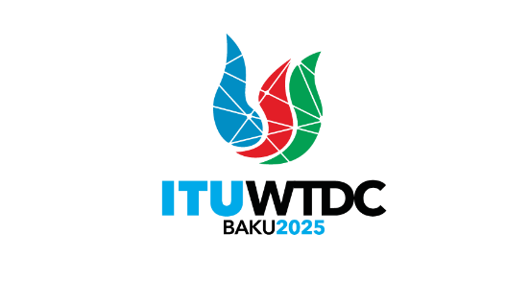 | Regional Preparatory Meeting  for the Americas for WTDC-25 (RPM-AMS)  Asuncion, Paraguay, 1-2 April 2025 |  | 
 |  | Document RPM-AMS25/7(Rev.1)-E
 |  | 19 March 2025
 |  | Original: English
Chair, TDAG-WG-DEC
Report on progress of the TDAG Working Group on the Declaration
Agenda item:
Item 7.3
Summary:
The document contains a summary of discussions and an update on progress of the Group.
Action required:
For information.
References:
- Terms of Reference of TDAG-WG-DEC (TDAG-24/DT/4)
- Report of the first meeting of the TDAG Working Group on the Declaration (TDAG-WG-DEC/2)
- Report of the second meeting of the TDAG Working Group on the Declaration (TDAG-WG-DEC/6)
- Revised annotated outline of the Baku Declaration 2025 (TDAG-WG-DEC/7)
- Mapping of topics in the Kigali Declaration and new and emerging topics (Document TDAG-WG-DEC/INF/1)
- Zero version - ITU-D TDAG WG DEC ALL (2025-03-05)
- Website of TDAG-WG-DEC

- Introduction
TDAG-WG-DEC was entrusted the task ‘to propose elements and make recommendations to ITU membership for the future draft Declaration’ of the World Telecommunication Development Conference 2025 (WTDC-25) (Terms of Reference of the Group TDAG-24/DT/4). The output of TDAG-WG-DEC will serve as input for members to consider as they work on the WTDC-25 Declaration in the lead up to and at the conference.
Dr Abdulkarim Oloyede from Nigeria was appointed as Chair, with Mr Ahmed Abd El-Aziz from Egypt and Ms Ke Wang from China serving as Vice-Chairs.
TDAG-WG-DEC held its first meeting on 6 September 2024, a second meeting on 2 December 2024, and a third meeting on 5 March 2025. Reports of the first two meetings are available on the Website of TDAG-WG-DEC. The report of the third meeting will be published shortly.
- Approach and Focus of the Draft WTDC-25 Declaration
In terms of the key topics to be addressed in the Declaration, the Group emphasised the need to coordinate with the other TDAG working groups, in particular the one on ITU-D Priorities (TDAG-WG-ITUDP).
During its first meeting, the Group agreed to retain a structure similar to the Kigali Declaration and be concise, simple and with clear and actionable language, speaking to both the challenges of global digital development and potential solutions.
Based on discussions during the first meeting of TDAG-WG-DEC and informal consultations, the Chair made a proposal to the second meeting for the title of the Declaration, ‘Universal and meaningful connectivity for an equitable digital future’, as outlined in Document TDAG-WG-DEC/4(Rev.1). Following discussion during the second meeting, the Group agreed on the title of the Declaration to be revised to ‘Universal, meaningful and affordable connectivity for an inclusive and sustainable digital future’. Some Member State representatives expressed their preference for a shorter title, while others were in favor of a more comprehensive one.
During the second meeting of the Group, the Chair of TDAG-WG-DEC also presented a draft annotated outline of the Baku Declaration (Document TDAG-WG-DEC/4(Rev.1)) comprising four main sections: Introduction, ‘We declare,’ ‘We commit,’ and Call to Action, to stir the discussion on the structure and possible topics of the Declaration. He also highlighted the rationale and thinking process behind the document, explaining that the draft outline was informed by the original mapping of topics in the Kigali Declaration and new and emerging topics as contained in Document TDAG-WG-DEC/INF/1.
Building on the feedback received during the second meeting of TDAG-WG-DEC, the Chair prepared an initial proposal of a narrative for the Declaration for the third meeting of the Group.
- Progress Reports by Regional Telecommunication Organizations
Regional Telecommunication Organizations have been invited to provide progress reports on their preparations for WTDC-25.
- Key Dates and Next Steps
The third meeting of TDAG-WG-DEC was held on 5 March 2025 where the group discussed the zero draft (ITU-D TDAG WG DEC ALL (2025-03-05) , incorporating feedback from member states and regional organizations.
Comments will be incorporated and contributions are welcome so that the final proposal may be presented at the May 2025 TDAG meeting.
Issues raised during discussions at the RPMs can be considered for the revision of the March draft.
A physical meeting is planned during TDAG-25 to wrap up the discussions of the Group.
In addition, the TDAG-WG-DEC Chair will provide reports on progress of the work of the Group to the upcoming Regional Preparatory Meetings (RPMs) in the lead up to WTDC-25.
The final version of the narrative agreed by the Working Group will be submitted for further consideration to TDAG-25/2 and possible submission as input to WTDC-25 where it will be finalized and the final Baku Declaration adopted.
_______________

