|  |  |
| --- | --- |
| **Regional Preparatory Meeting  for the Americas for WTDC-25 (RPM-AMS)**  **Asunción, Paraguay, 1-2 April 2025** |  |
|  |  |
|  | **Document** **RPM-AMS25/3-E** |
|  | **24 February 2025** |
|  | **Original: English** |
| Director, Telecommunication Development Bureau | |
| State of digital development and trends in the Americas:  Challenges and opportunities | |
|  | |
| **Agenda item:**  5  **Summary:**  This document, prepared for the RPM for the Americas, aims to inform participants and stakeholders in setting the region’s digital agenda. It is structured into two parts: the first provides an overview of the state of digital connectivity in the Americas through key indicators, and the second highlights impactful case studies from the region.  **Expected results:**  RPM-AMS is invited to note this document  **References:**  N/A | |

State of digital development and trends in the Americas: Challenges and opportunities

February 2025

Contents

Introduction 3

Part 1. The state of digital connectivity in the Americas and recent trends 5

ICT regulation and digital policy frameworks 5

Internet use 12

Broadband subscriptions 17

Mobile network coverage 19

Availability of fixed-broadband infrastructure 22

Internet traffic and international bandwidth 24

Affordability of ICT services 28

Mobile phone ownership and subscriptions 30

ICT skills 33

Revenue and investment 40

Cybersecurity 42

E-waste management 44

Disparities within the region 47

Overview of data availability in the Americas 49

Part 2. BDT4Impact: Selected case studies from the Americas 51

Bridging the digital divide in indigenous and rural communities in the Americas 51

Countries work to regulate e-waste to protect health, environment and resources 51

The Smart Seas Project builds disaster resilience among small-scale Caribbean fishers 52

Crisis response: Hurricane Beryl 52

Special event in Argentina builds girls’ technology skills and knowledge about careers 53

Developing national telecommunications mapping system in Uruguay 53

Annex: Data resources 54

Introduction

The Regional Preparatory Meetings (RPMs) engage member states in preparations for the World Telecommunication Development Conference 2025. Prepared for the RPM Americas on 1-2 April 2025, this document provides key insights to support participants and stakeholders in discussions on the region’s digital agenda. It consists of two parts: the first offers an overview of digital connectivity in the Americas through key indicators, while the second highlights impactful case studies from the region.

**Universal and meaningful connectivity is a policy imperative.** The concept of universal and meaningful connectivity (UMC) has emerged as a critical policy objective. UMC is defined as the possibility for everyone to enjoy a safe, enriching, and productive online experience at an affordable cost. UMC does not mean everyone must be connected all the time but describes a situation where everyone can access the Internet optimally and affordably whenever and wherever needed.

**The Americas region has made significant progress toward UMC.** As of 2024, 96 per cent of the region’s population had access to a mobile broadband network (3G or higher), including 63 per cent covered by a 5G network. Universal access is within reach, enabling almost everyone who wishes to connect to do so. Internet adoption is also high, with nearly nine in ten people (87 per cent) using the Internet—well above the global average of 68 per cent. Notably, the Americas is the only region to experience a ‘reverse gender gap,’ where women have higher Internet usage than men.

**The Americas is a region of digital contrasts.** Despite the achievements, the region is very diverse, notably in regulatory maturity, Internet affordability, quality of service, and cybersecurity readiness. North America generally leads, while Latin America and the Caribbean present a mixed landscape. The region’s small island developing states (SDIDs) and landlocked developing countries (LLDCs) lag in most dimensions of connectivity, as they face additional obstacles, including high infrastructure costs and geographic challenges.

**The urban-rural divide remains a challenge.** Although less pronounced than in most regions, the Americas’ urban-rural digital gap is significant. For instance, 90 per cent of urban residents were online in 2024, compared with 74 per cent of rural areas. And while 5G covered 70 per cent of the population in urban areas, it only covered 31 per cent of rural dwellers. The technology remained absent in 26 out of 35 countries.

**Affordability remains a key barrier to universal connectivity.** In 2024, the median price of an entry-level mobile broadband plan in the Americas was 1.8 per cent of gross national income (GNI) per capita, just below the UN Broadband Commission’s 2 per cent affordability target, but well above the global average (1.1 per cent). In 16 out of 35 countries, costs still exceed this target. Fixed broadband is even less affordable, with a median price of 3.2 per cent of GNI per capita, with only five countries meeting the target.

**Digital skills are essential for ensuring that connectivity translates into opportunities.** While Internet adoption in the Americas is high, data covering six countries suggests that digital literacy and ICT skills remain vary widely, limiting many people's ability to fully participate in the region’s digital transformation. Communication and collaboration skill levels are very high among Internet users. Information and data literacy skill levels also tend to be high. But many users lack the skills to engage safely and productively online, with notable gaps in problem-solving and content creation.

**Bridging these divides requires strong policy and regulatory frameworks.** Effective regulation is a key driver of connectivity, enabling competition, investment, and innovation. While two-thirds of the region’s countries have reached Generation 3 (G3) or Generation 4 (G4) of ICT regulation, the highest level of regulatory maturity, progress has slowed. North America has well-established digital policy frameworks, while Latin America and the Caribbean show considerable variation. Some nations have advanced regulatory environments that promote investment and competition, while others still operate under less developed frameworks that hinder digital growth. SIDS and LLDCs often struggle with limited regulatory capacity, further complicating their digital transformation efforts.

**Cybersecurity also varies widely across the region**. Cybersecurity readiness differs significantly across countries. The Global Cybersecurity Index (GCI) 2024 reveals an 82-point gap between the best performer (99.9 out of 100) and the lowest-ranked country (18.2), with the regional average standing at 53, well below the global average of 66. While 21 countries in the Americas have established national Computer Incident Response Teams, the need for stronger cybersecurity measures and coordinated regional efforts remains.

**Environmental sustainability remains a growing concern.** The Americas generated approximately 14.3 billion kilograms of electronic waste (e-waste) in 2022, accounting for 23 per cent of global e-waste generation. Recycling rates are still low: 30 per cent of e-waste in the region was properly collected and recycled, with only 20 countries reporting formal collection and recycling initiatives. This lack of regulatory frameworks poses significant environmental and economic challenges, underscoring the need for improved recycling initiatives and extended producer responsibility mechanisms.

**Impact stories from the region demonstrate the transformative power of digital connectivity.** The second part of this document showcases a selection of ITU-supported initiatives that highlight the impact of digital inclusion across the region. The ICT Network Bootcamp in Guatemala trained indigenous and rural leaders to build and manage community networks. The Dominican Republic and Paraguay advanced e-waste regulations to promote sustainable digital development. In the Caribbean, the Smart Seas Project equips small-scale fishers with digital tools for maritime safety. The Americas Girls Can Code initiative in Argentina fosters coding and STEM skills among young women. Uruguay’s broadband mapping project enhances digital infrastructure planning, and ITU’s disaster response efforts, such as after Hurricane Beryl, highlight the role of resilient telecommunications in crises.

**Achieving universal and meaningful connectivity will require a collective effort.** Governments, the private sector, and international organizations must work together to expand infrastructure, improve affordability, and strengthen digital skills. Enhancing regulatory cooperation, addressing cybersecurity risks, and implementing sustainable e-waste policies will be essential. Strategies must be tailored to recognize the vast geographical, demographic, and socio-economic disparities across the region, as well as the differing levels of digital development and varying national capacities.

Part 1. The state of digital connectivity in the Americas and recent trends

ICT regulation and digital policy frameworks

The evolving landscape of ICT regulation and digital policy frameworks play a critical role in driving an inclusive and sustainable digital transformation as well as fostering thriving digital economies. To ensure national frameworks remain effective and adaptive, it is crucial to assess progress, identify best practices and address existing gaps.

***ICT regulation in the Americas: steady progress, but momentum slowing down***

Over the past 15 years, ICT regulation has reshaped markets across the Americas. Today, two-thirds of countries in the region have adopted advanced regulatory frameworks, classified as Generation 3 (G3) or Generation 4 (G4). Leading the way were Brazil and the United States who became the first in the region to join the group of G4 countries in 2010. At that time, there were only 24 countries in the G4 category worldwide compared with 74 today.

However, since 2015, regulatory evolution in the region has slowed, with few countries graduating to a higher generation. Two countries remain in Generation 1 (G1) today, trailing regional leaders by more than 60 percentage points.

Evolution of the generations of ICT regulation in the Americas

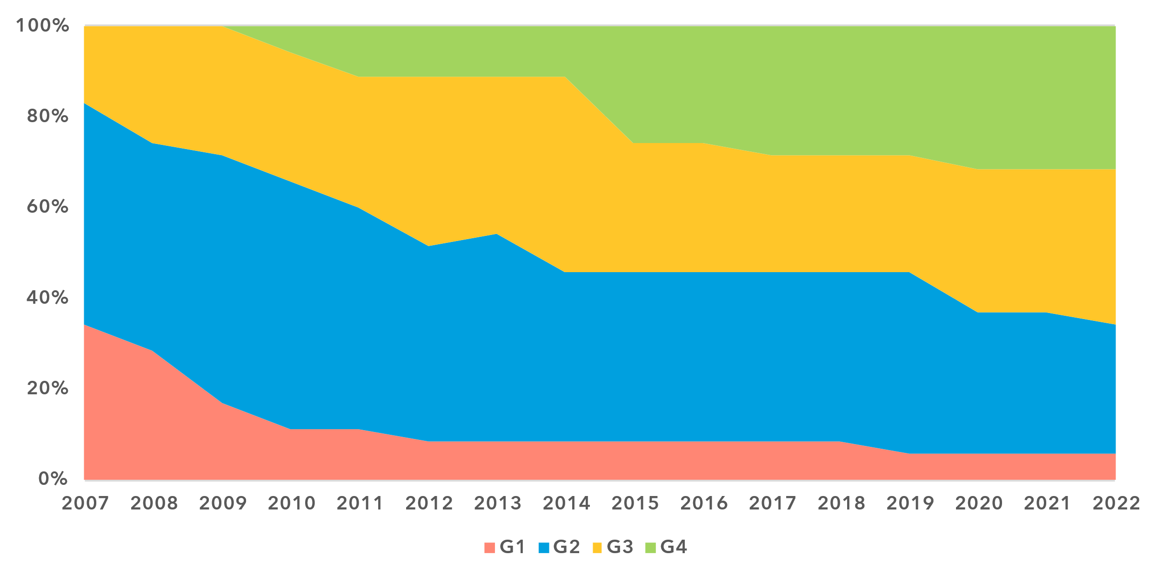

Note: The ‘Generations of ICT regulation’ provides a high-level conceptual framework for assessing the overall development of national legal instruments, policies and governance for the ICT and digital sectors. Generations 1 through 4 are based on [ICT Regulatory Tracker](https://app.gen5.digital/tracker/metrics) scores:

G1 – Command and control approach: score between 0 and 40   
G2 – Early open markets: score between 40 and 70   
G3 – Enabling investment and access: score between 70 and 85   
G4 – Integrated telecommunication regulation: score between 85 and 100

Data for 2021 is unavailable; 2020 data is used as a proxy for 2021.

Source: ITU

Countries with different geographical profiles have evolved at a different pace. While a slight majority of Small Island Developing States (SIDS) remain in G1 and G2, others have transitioned to more advanced regulatory frameworks. Three SIDS – Bahamas, Dominican Republic and Trinidad and Tobago – have reached G4, in 2022. Meanwhile, the region’s two landlocked developing countries (LLDCs), Bolivia and Paraguay, have progressed to G2.

Despite these advancements, most countries in the region still need to further evolve their regulatory frameworks to align with global trends and ensure a solid foundation for digital transformation.

***Fragmented development of digital governance***

With regards to digital governance, both Latin America and North America have their champions in G5 – the gold standards for collaborative digital regulation. In 2023. Canada and Colombia are in the top 10 countries in the world, joining the select group of 19 nations in the Leading tier of the G5 Benchmark.[1] North America, along with Europe, remain the only regions with an average G5 Benchmark at the Advanced threshold or higher, reflecting the prevalence of national formal collaboration mechanisms and institutions, the implementation of well-developed policy design principles, the implementation of digital economy enabling frameworks and a strong national digital agenda.

In contrast, two-thirds of countries in the region still linger in either the Limited or Transitioning level in G5 – reflecting significant fragmentation between the most and least advanced. Apart from the Dominican Republic, all SIDS and the two LLDCs in the region fall in this category, signalling systemic challenges and persistent barriers to progress in digital governance.

***Readiness of national frameworks in the Americas aligns with world trends, but SIDS fall behind***

Achieving universal and meaningful connectivity and inclusive digital economies require advanced digital readiness of national policy, legal and governance frameworks, supported by strong ICT regulation and adaptable digital governance. Countries must create balanced and coherent national frameworks and successfully implement them to facilitate digital transformation across all sectors. Modern national frameworks aligned with good regulatory practice are also essential for regional harmonization and economic integration, making ICT and digital policies top priorities for both national and regional development agendas.

Legal, policy and governance frameworks for digital transformation, 2023

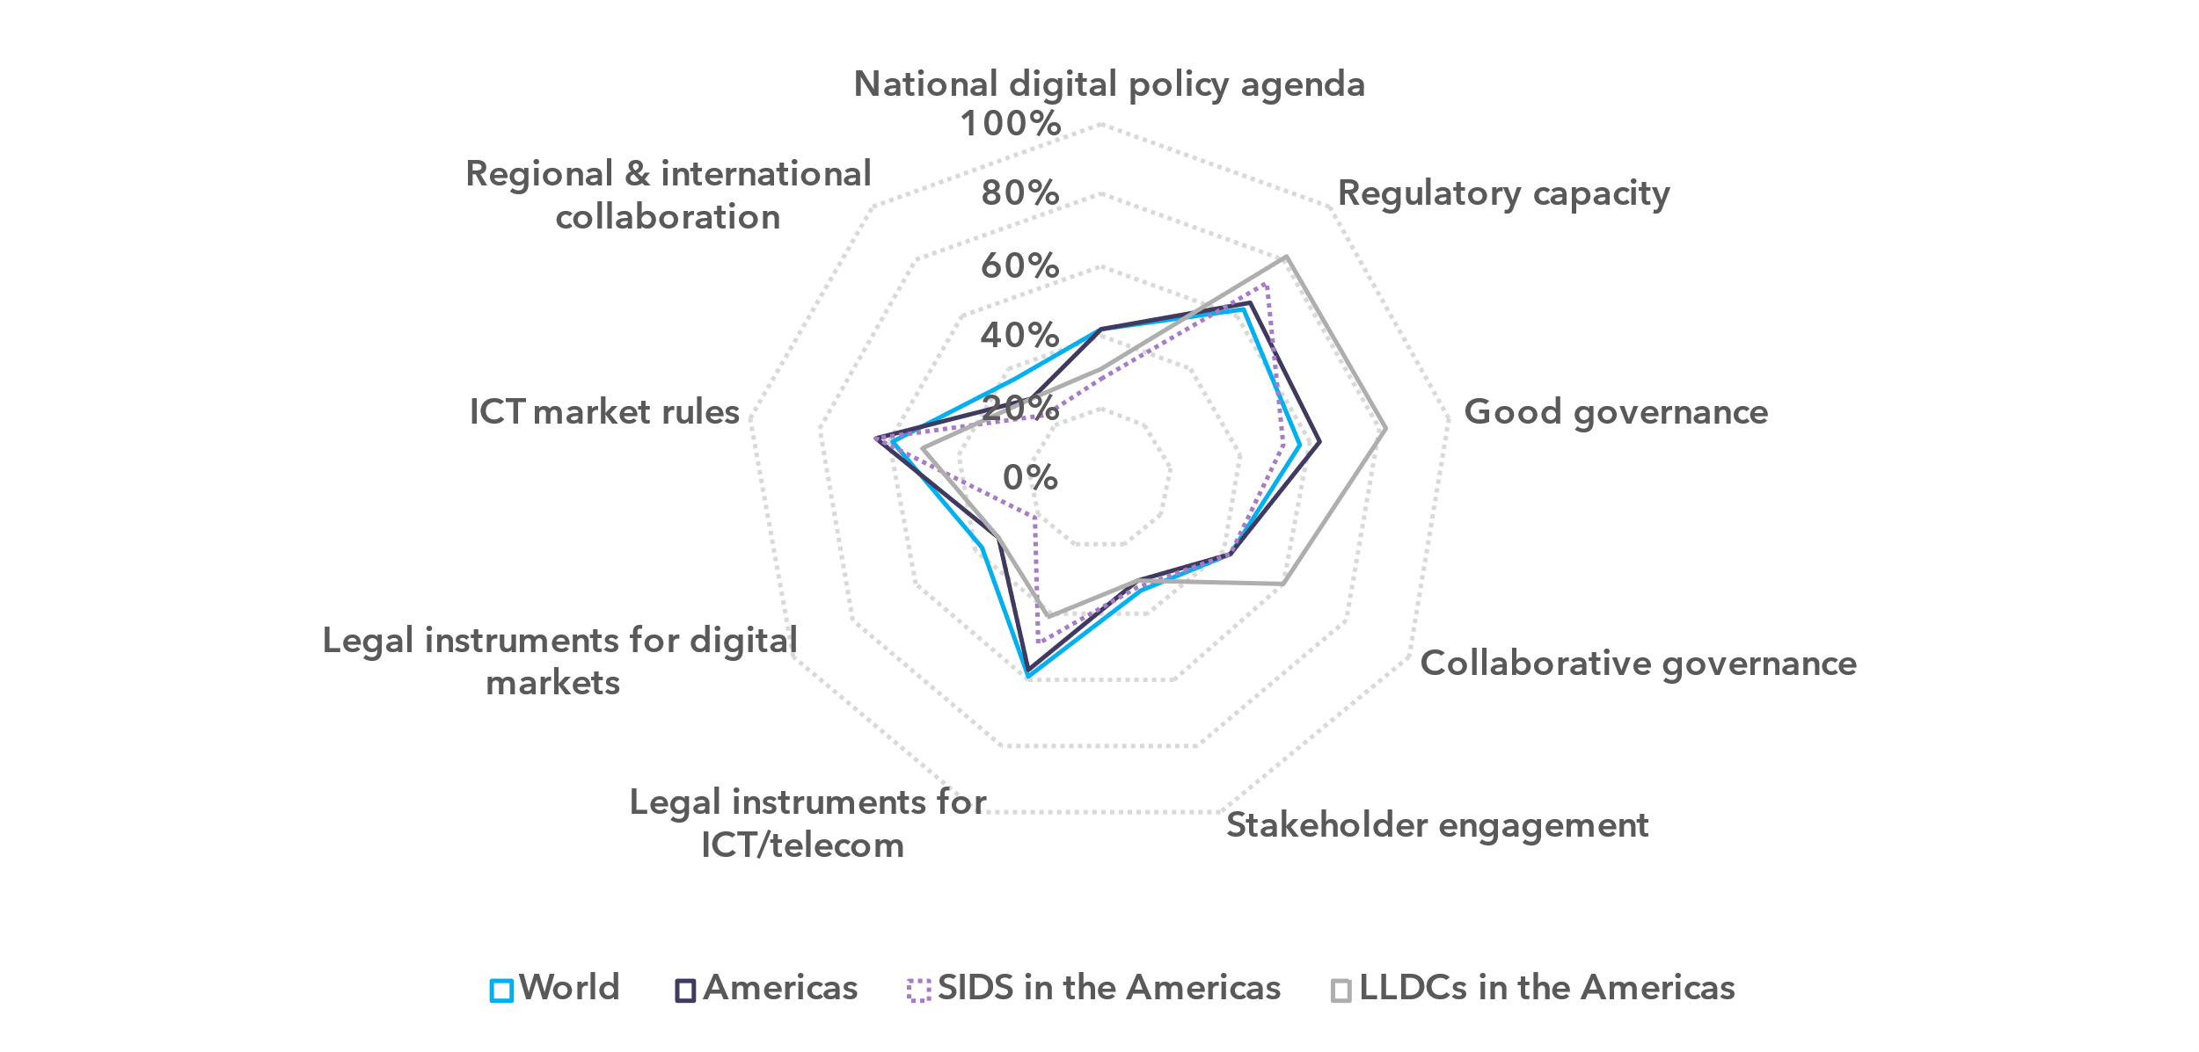

Note: The nine thematic benchmarks (as in the chart above) each comprise a subset of indicators, as part of the [ITU Unified Framework for the readiness of national policy, legal and governance frameworks for digital transformation](https://www.itu.int/pub/D-PREF-BB.REG_OUT01-2023/en).

The chart shows progress on the nine benchmarks for the Americas region (average for the group) compared to the world average and the average for SIDS (16 countries, including one LDCs) and LLDCs (2 countries) in the region. The percentage of achievement on each benchmark indicates the proportion of met versus unmet targets on indicators in each benchmark.

Note: The nine thematic benchmarks (as in the chart above) each comprise a subset of indicators, as part of the

Source: ITU

The overall readiness of national frameworks for digital transformation in the Americas of 50 per cent is closely aligned with the world average of 51 per cent, in 2023. Across the nine thematic benchmarks, five are on par with global trends. Notably, the region also performs above the world average in Good Governance (63 per cent) and Market Rules (64 per cent), exceeding global levels by five percentage points. Regional and International Cooperation is however less advanced – registering just 29 per cent, compared to the world average of 36 per cent.

SIDS overall readiness of 46 per cent lags the regional average, also behind North and Latin America which stand at 77 and 49 per cent, respectively. While performing in line with the regional average, LLDCs show stronger performance in Good Governance and Collaborative Governance but score significantly lower in Instruments for ICT Markets. Both SIDS and LLDCs outperform the regional average in Regulatory Capacity, likely because of long-term international development aid and capacity building. This relative advantage can be leveraged to accelerate ICT regulatory reform and digital governance in these countries, as strong institutional arrangements are a necessary foundation for both.

The Americas region performs relatively high in the Collaborative Governance benchmark indicating the development of a whole-of-government culture across the region; in contrast Stakeholder Engagement is achieved at only 30 per cent. Although consistent with the world average of 34 per cent, this area indicates a considerable scope for improvement – particularly given its critical role in the success of digital transformation initiatives. Interestingly, SIDS and LLDCs surpass the Latin America average of 26 per cent in this area, the lowest in the region.

National Digital Agendas including universal access policies and strategies for meaningfully connecting targeted groups such as women, youth and persons with disabilities are relatively well developed across the Americas, with the regional benchmark standing at 42 per cent. SIDS and LLDC trail at 29 and 31 per cent, respectively – in stark contrast with North America achieving 77 per cent. Further efforts are necessary to ensure adequate policy environment for an inclusive digital development in these countries.

All benchmarks have significant potential for improvement through stronger Regional and International Cooperation. The limited regional economic integration and lack of harmonization in ICT market frameworks constrain opportunities for regionalized innovation, the development of digital ecosystems and economies of scale. SIDS and Latin America are particularly affected, with only 24 per cent and 28 per cent of countries, respectively, participating in regional ICT integration initiatives. Greater collaboration and policy alignment will be key to overcoming the current gaps and ensuring inclusive progress in digital transformation.

***Disparities between ICT regulation and digital governance persist***

Across all regions, ICT regulatory maturity is more advanced than digital governance. While ICT regulation has evolved through successive waves of reforms since the 1990s, digital policies have emerged more recently and remain more fragmented. In many areas, the blueprint for good practice is still being defined. Policymakers and regulators must keep pace with the rapid development of new digital technologies and services, assess their impact on consumers, governments and the economy, and develop adaptive and forward-looking policy and regulatory frameworks, allowing to multiply the benefits of new digital services while mitigating risks.

According to ITU benchmarks, the level of development of ICT regulation globally stands at 59 per cent, whereas digital governance lags at 39 per cent – leaving a persistent 20-percentage-point gap. The disparity is even greater in the Americas region, where the difference reaches 25 percentage points, despite overall benchmarks aligning with global trends. SIDS and LLDCs perform significantly lower on both measures, with SIDS facing a 28-percentage-point gap. Addressing these gaps is crucial to accelerating access, adoption and value creation driven by digital technologies in these countries.

ICT and digital policy instruments in the Americas, 2023

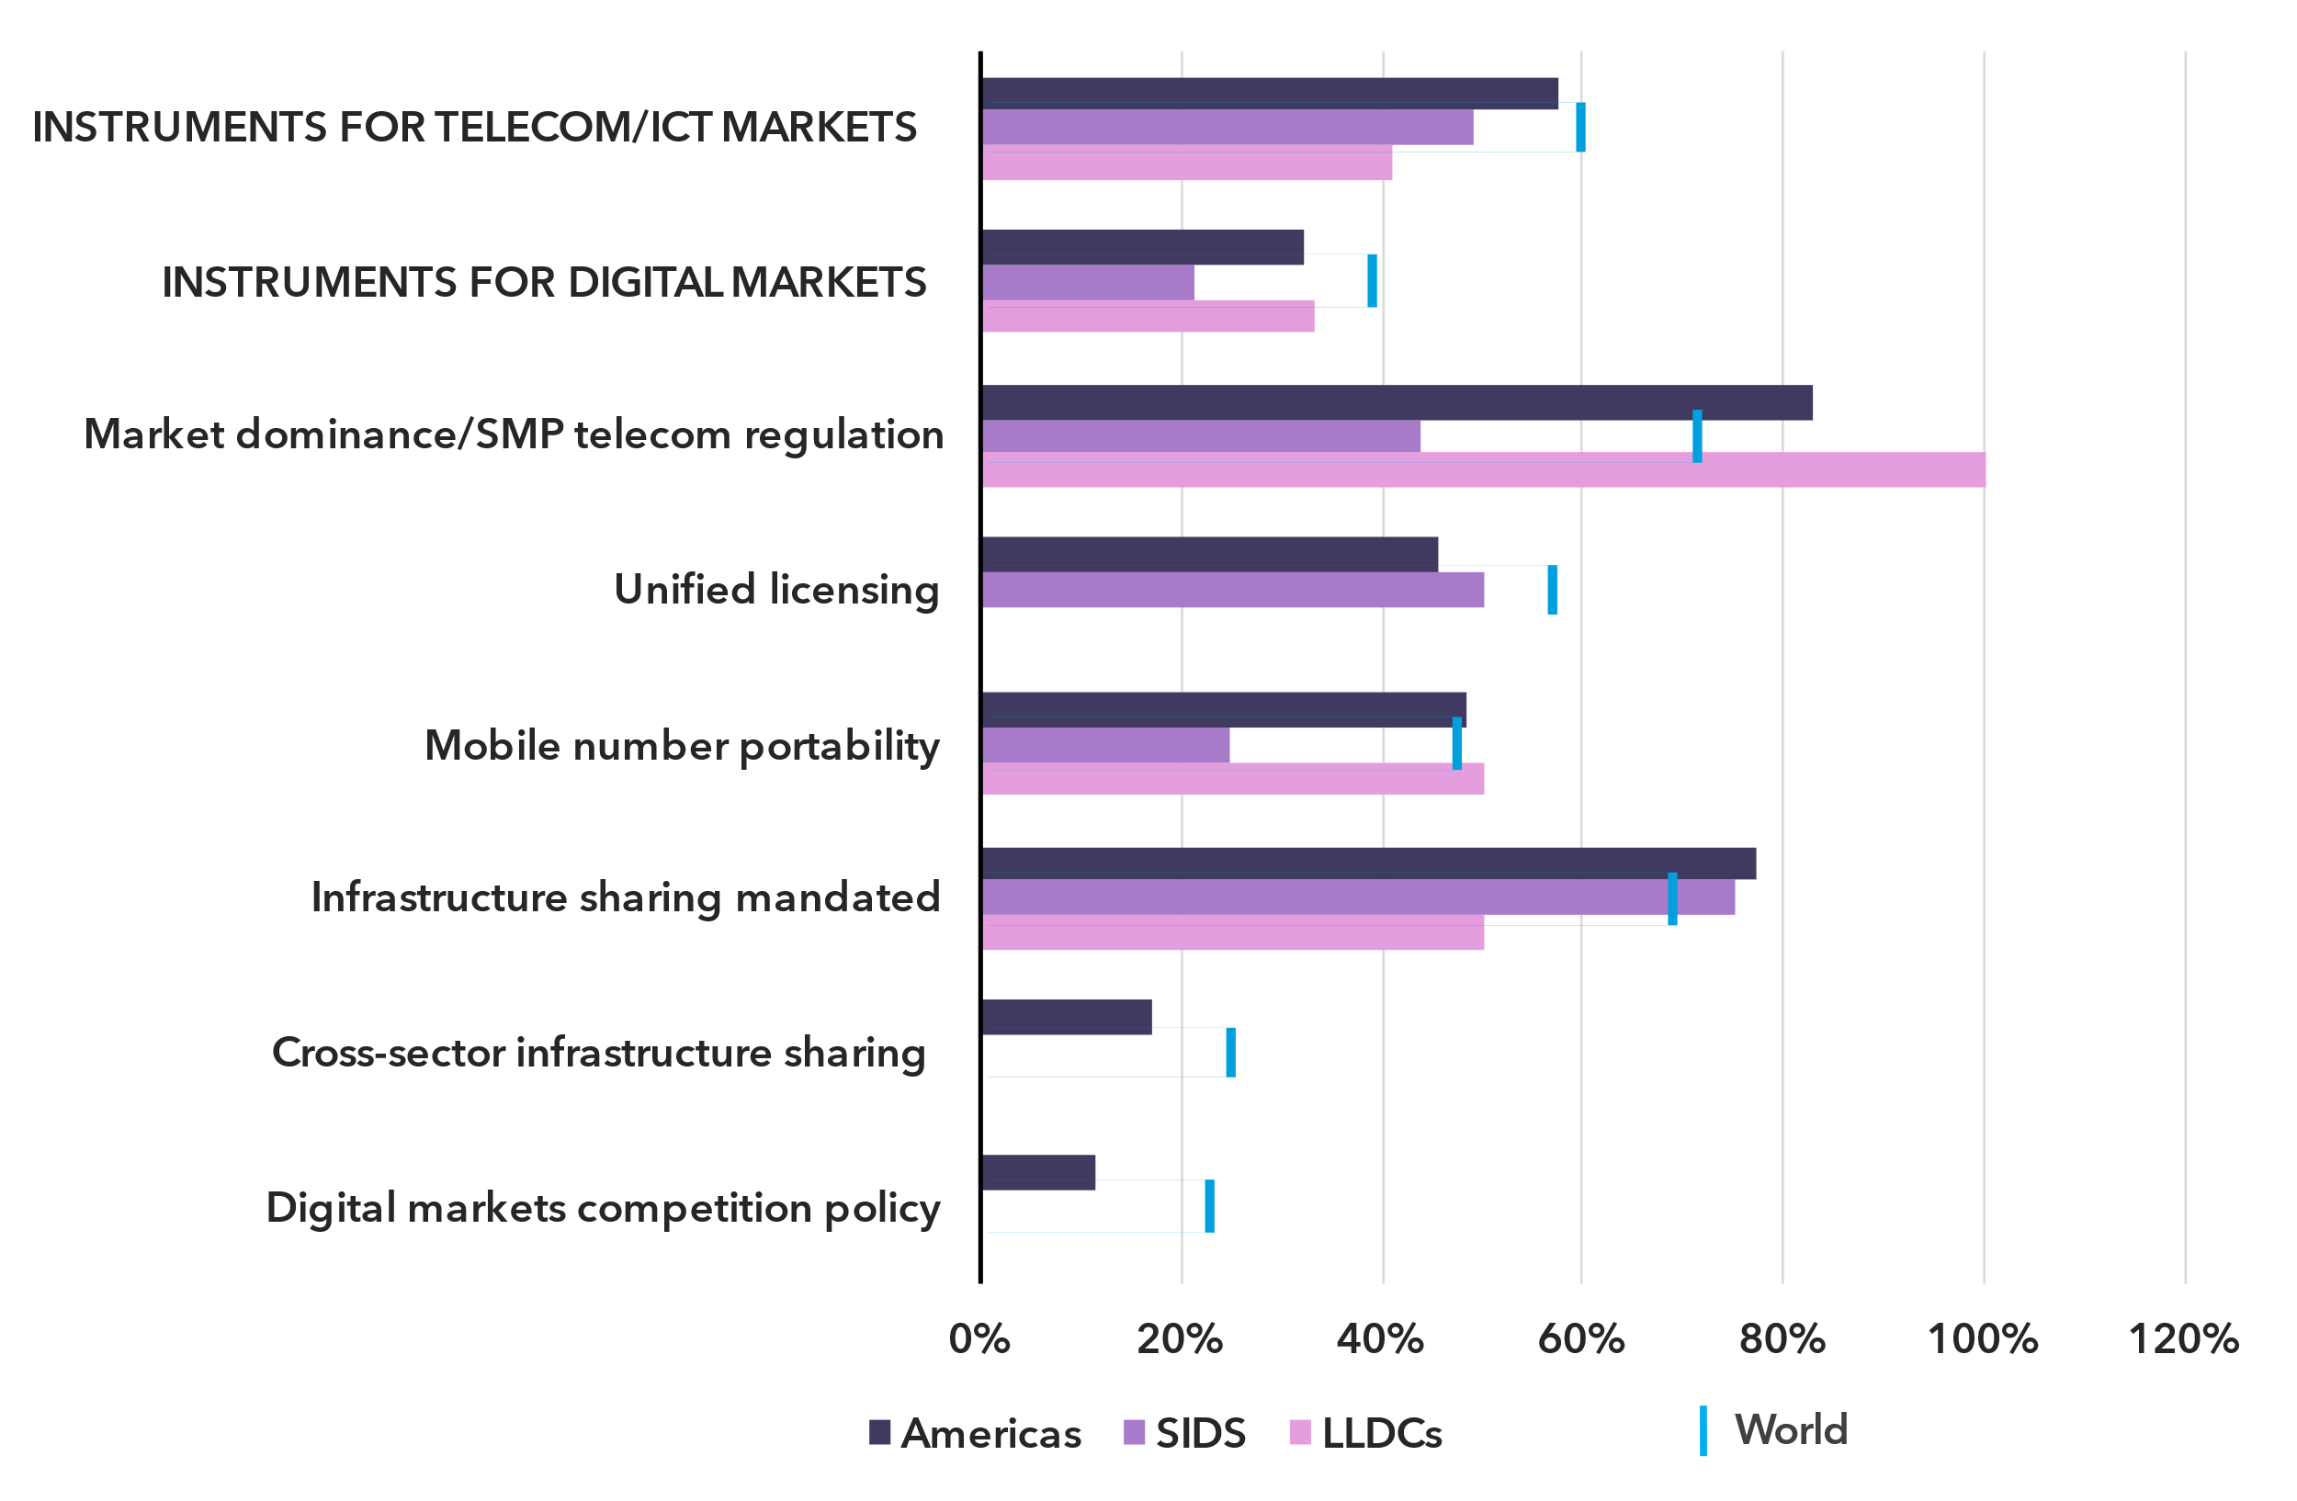Note: The region’s average scores for key indicators in the Legal Instruments for Telecom/ICT Markets, Legal Instruments for Digital Markets and Market Rules benchmarks under the ITU Unified Framework are compared to the averages for SIDS and LLDCs in the region, and the world average.

Source: ITU

The Americas region maintains strong regulatory provisions in key ICT market areas, with 83 per cent of countries enforcing market dominance regulations and 77 per cent mandating infrastructure sharing of essential facilities – both surpassing global averages of 71 per cent and 68 per cent. In another cross-cutting regulatory area, unified licensing, the regional average of 46 per cent falls 10 percentage points below the global average. Regulatory disparities also persist across different country groups. While approximately half of SIDS have provisions for market dominance and unified licensing, only a quarter have implemented mobile number portability. No LLDC in the region has introduced unified licensing frameworks.

Infrastructure-sharing is a critical area illustrating the same trend. The business practice plays a key role in expanding digital connectivity, particularly in underserved areas. Three-quarters of SIDS have a regulatory obligation for sharing network facilities. However, there are no frameworks in place for cross-sector infrastructure sharing leveraging assets across sectors such as energy, transport and telecommunications in SIDS and LLDCs in the region.

Overall, digital policy and regulatory instruments remain limited across the Americas. Merely 10 per cent of countries in the region have competition policies tailored to digital markets, ensuring a level playing field for traditional and over-the-top market players.

Stronger digital regulation and continued development of ICT regulatory frameworks are essential for achieving universal and meaningful connectivity across the region. These will also enable SIDS and LLDCs to develop their national digital markets while integrating into broader regional digital ecosystems.

***SIDS and LLDCs must create a conducive policy environment for emerging technologies***

SIDS and LLDCs across all regions face significant challenges and multi-dimensional vulnerabilities in their overall development and in digital transformation.

At the Fourth International Conference on Small Island Developing States (SIDS4) held in Antigua and Barbuda in May 2024, UN Member States adopted the ‘Antigua and Barbuda Agenda for Small Island Developing States: A Renewed Declaration for Resilient Prosperity’[2] to mobilize international catalytic actions and funding to support SIDS in critical development areas. A key area of action identified was Science, Technology, Innovation (STI) and Digitalization, calling for building the necessary ecosystems, institutions and capacity for promoting and leveraging STI and digital technologies to drive economic growth and sustainable development.

The Caribbean is one of the three main regions where SIDS are located. The institutional and policy landscape for digital and emerging technologies in these states remains uneven and, overall, underdeveloped, limiting opportunities for economic diversification and new market development. Fewer than 20 per cent of Caribbean countries have adopted national digital strategies, which are fundamental to accelerating digital transformation, as of 2023. Innovation policies indispensable for scaling STI are in place in only 13 per cent of these countries. However, a positive development is that nearly all Caribbean SIDS have implemented e-commerce strategies, which can support e-trade and foster digital entrepreneurship.

Selected digital economy policy instruments, the Americas, 2023

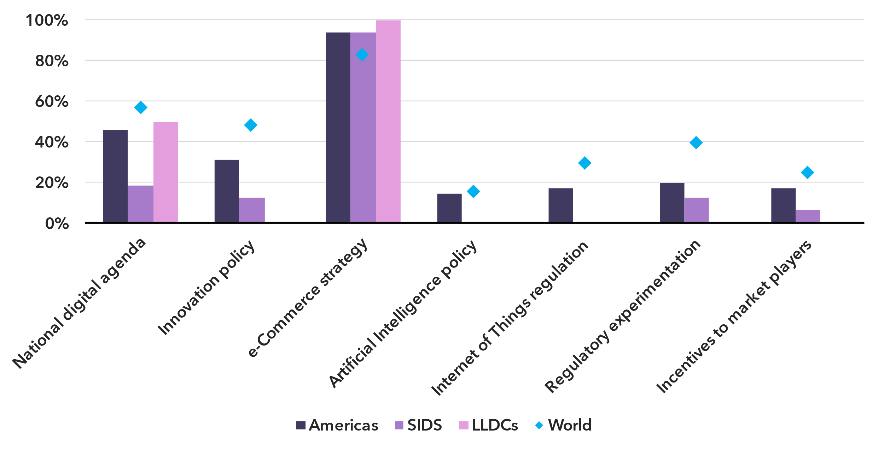Note: The regions’ average scores for key indicators in the National Digital Agenda, Legal Instruments for Digital Markets, Stakeholder Engagement and Market Rules benchmarks under the ITU Unified Framework are compared to the averages for SIDS and LLDCs in the region, and the world average.

Source: ITU

A key priority requiring urgent attention is the adoption of policies for emerging technologies. No Caribbean SIDS has yet introduced an artificial intelligence or cloud policy, Internet of Things regulations or a forward-looking spectrum strategy, in 2023. The absence of these frameworks creates significant barriers to digital innovation and entrepreneurship, potentially hindering broader economic and development objectives. Additionally, mechanisms for regulatory experimentation and targeted incentives for ICT and digital market players – currently present in only 13 per cent and 6 per cent of SIDS in the region, respectively, can be instrumental in stimulating national and Caribbean digital markets, harnessing STI and advancing digital transformation.

To support SIDS on this path, ITU has developed the ‘10-Step Plan for SIDS: Accelerating Sustainable and Inclusive Digital Transformation in SIDS’[3]*,* which outlines the key action areas where the Telecommunication Development Sector can assist SIDS, particularly in strengthening ICT regulation and digital governance in the region.

The ‘Programme of Action for LLDCs for the Decade 2024-2034’[4] was adopted by the UN General Assembly in December 2024. The Programme calls for strengthening policy measures in LLDCs to support sustainable digital infrastructure, enhance financial inclusion, foster digital innovation and enable the private sector to fully leverage opportunities created by e-commerce and the digital economy.

Like SIDS, the two LLDCs in the region need to intensify effort to establish enabling policy, legal and governance frameworks for digital transformation. Only one of the countries has a national digital strategy and neither has adopted an innovation policy or a framework for emerging technologies. While the countries’ e-commerce strategies can facilitate the regionalization of trade and business development, targeted policy instruments for emerging technologies can foster virtual digital ecosystem dynamics in LLDCs.

Equipping SIDS and LLDCs with the right policy instruments is a key priority for advancing universal and meaningful connectivity in the Americas and supporting the development of robust national and regional digital ecosystems.

Internet use

***Internet use in the Americas is nearing universality, but disparities persist***

Percentage of individuals using the Internet

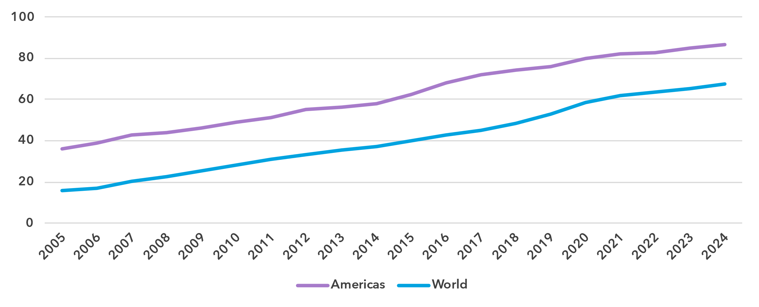Source: ITU

The proportion of people online in the Americas stood at 87 per cent in 2024, significantly above the global average of 68 per cent, and well advanced on a path to universal use.[5] Since 2005, the average annual growth rate of Internet penetration has been 4.7 per cent in the region, against 8 per cent globally. Over the last ten years, these percentages were more modest, at 4 and 6.1 per cent respectively.

The Americas are a heterogeneous region, from relatively poor central American countries to highly developed North American countries but also including small Caribbean islands and large South American countries. This heterogeneity is reflected in the country level data on Internet use, with penetration levels from 56 to 95 per cent.

Percentage of individuals using the Internet in the Americas, 2023 or latest year available[6]

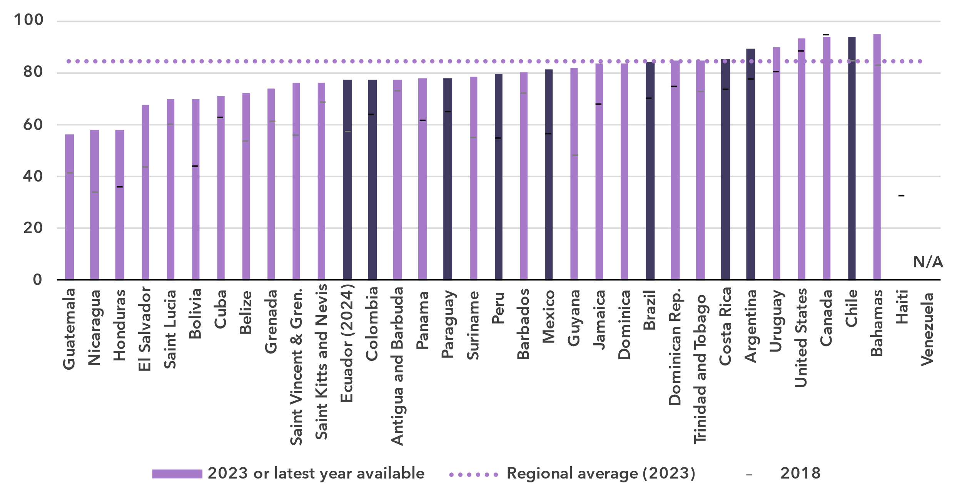

Note: Country submitted are in a darker shade, non-official data in a lighter shade.

Source: ITU

***Gender parity in Internet use has been reached, with higher adoption rate among women***

Percentage of individuals using the Internet, by gender, 2024

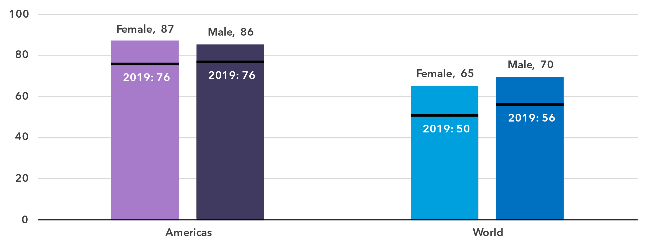

Source: ITU

In 2024, 87 per cent of women in the Americas were online, compared with 86 per cent of men. This translates into a gender parity score (GPS) of 1.02, up from 0.99 in 2019, indicating that parity has been achieved.[7] The Americas is the only region where more women than men are using the Internet.

In seven of the countries of the region for which data is available, gender parity has been reached with a GPS between 0.98 and 1.02. In four countries, there is still a bias towards men using the Internet, while in six countries the bias is towards women.

Percentage of individuals using the Internet, by gender, 2023 or latest year available

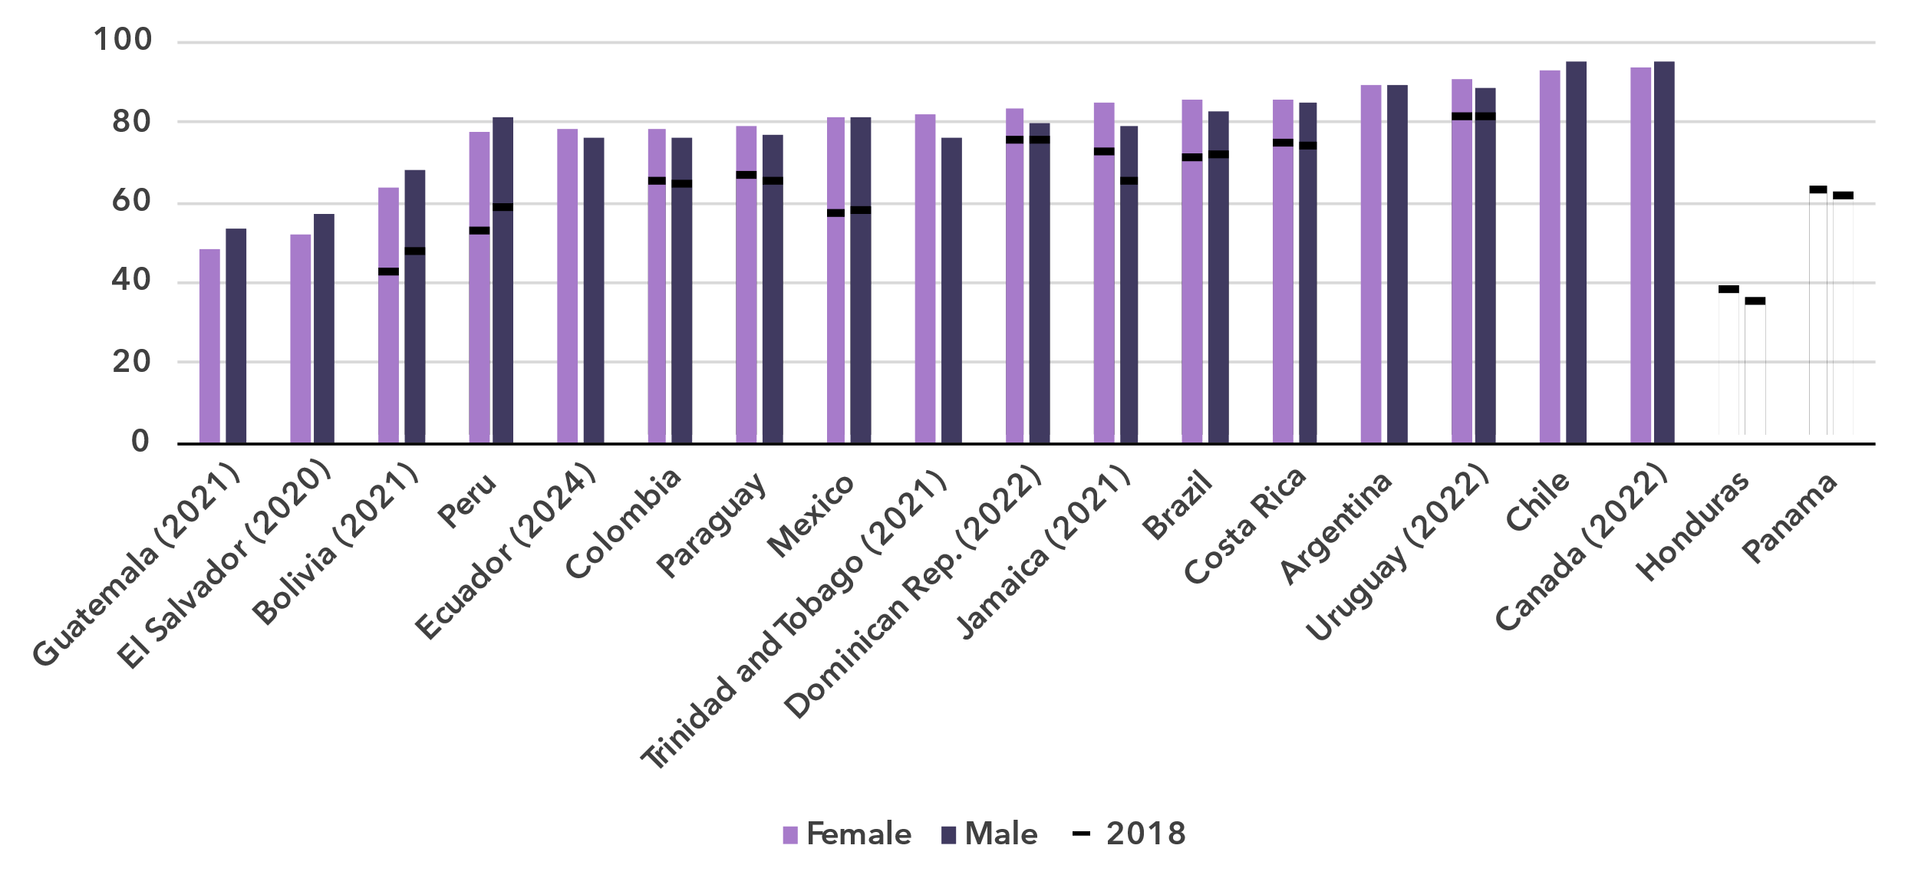

Source: ITU

***Universal use among young people reached***

Percentage of individuals aged between 15 and 24 years using the Internet, 2024

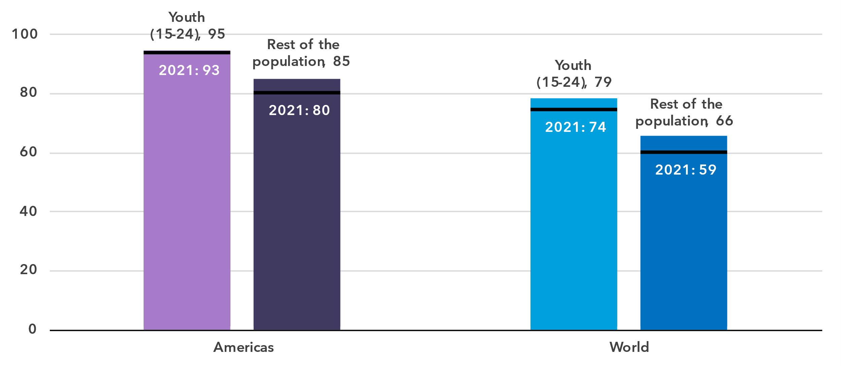

Source: ITU

In the Americas, 95 per cent of young people aged 15 to 24 used the Internet in 2024, compared to 85 per cent of the rest of the population. The generational gap in this region—measured as the ratio of Internet users between these two groups—is lower than the global average. Both in the region and globally, the ratio has been shrinking over the last four years. This means other age groups are catching up, and for the Americas this implies that universal use among the whole population is well under way.

In most countries for which there are data, the percentage of young people online is very high. This stands in sharp contrast with the proportion of the elderly (those 75 years and older) using the Internet, which is low or very low in all countries bar one.

Percentage of individuals using the Internet by age group, 2023 or latest year available

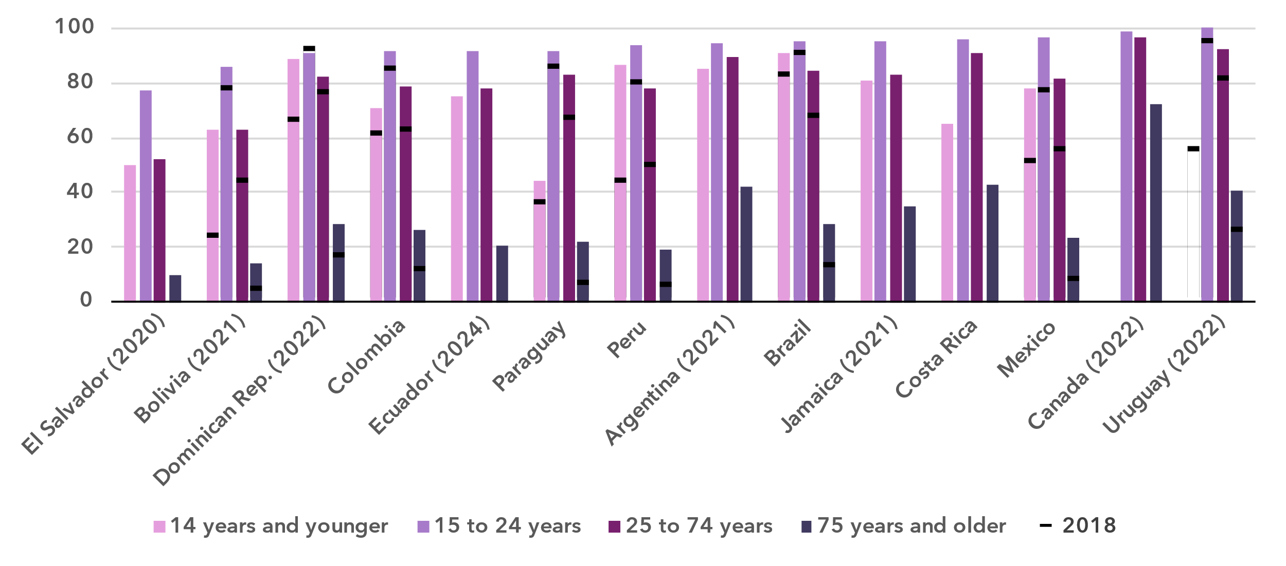

Source: ITU

***Internet use in rural areas trails behind urban areas, but less than globally***

Percentage of individuals using the Internet, by location, 2024

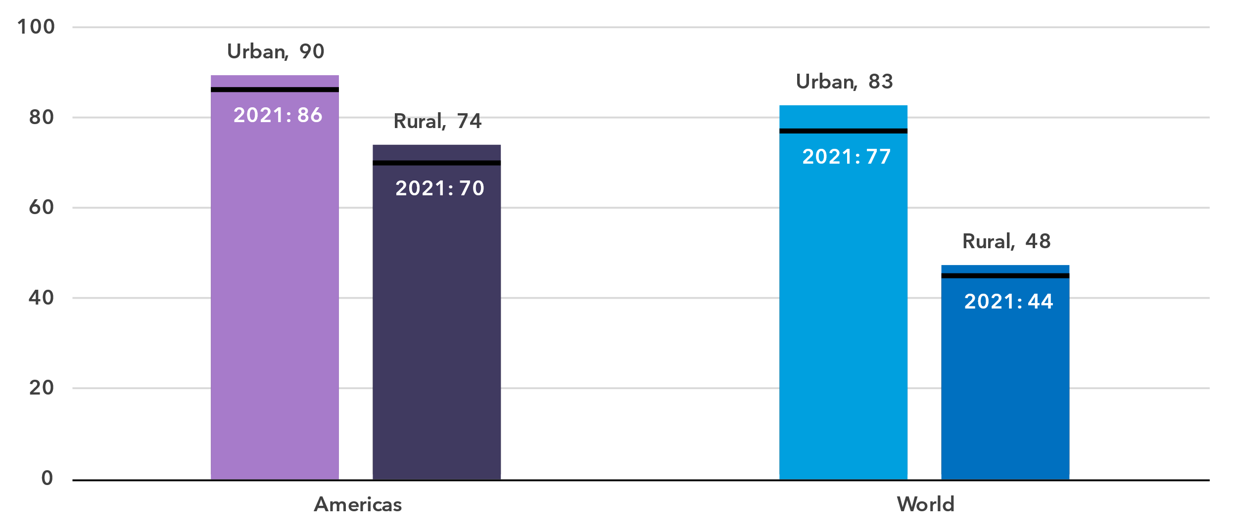

Source: ITU

In urban areas in the Americas, 90 per cent of the population was online in 2024, compared with 74 per cent in rural areas. This gap is much smaller than it is globally, with 83 per cent online in urban areas, against only 48 per cent in rural areas.

Generally, in countries with high overall Internet penetration, the urban-rural gap was much smaller than in countries with a lower Internet use percentage.

Percentage of individuals using the Internet by location, 2023 or latest year available

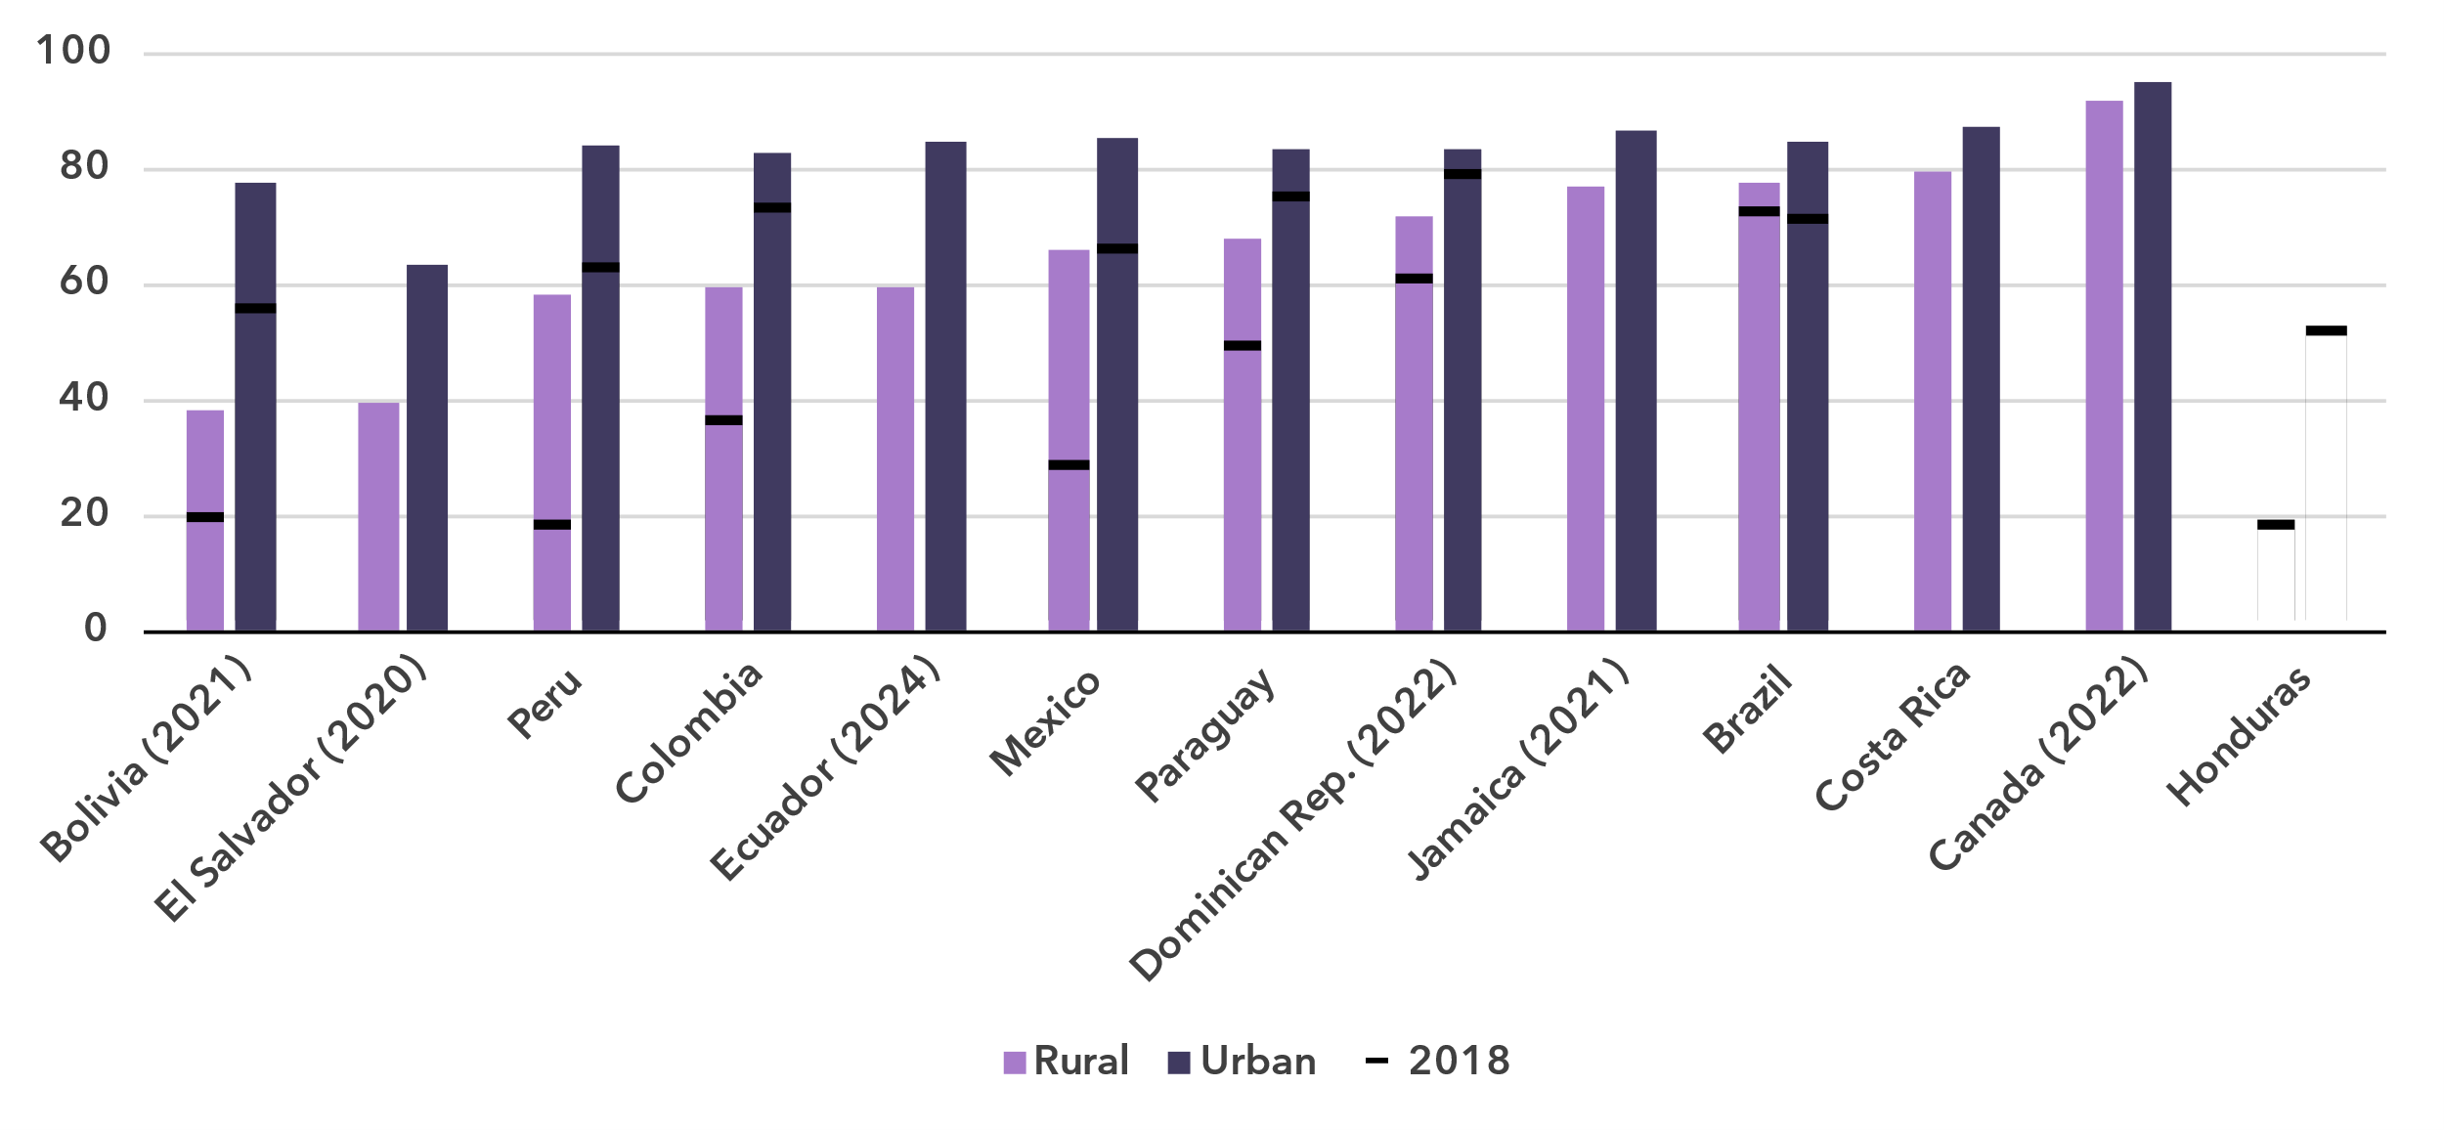

Source: ITU

Broadband subscriptions

***The Americas lead the world in mobile broadband adoption, while fixed broadband penetration varies widely***

Broadband subscriptions per 100 inhabitants

|  |  |
| --- | --- |
| **Mobile** | **Fixed** |

Source: ITU

In 2024, there were 125 mobile broadband subscriptions per 100 inhabitants in the Americas, the highest of all regions. For fixed-broadband subscriptions though, the region scores high – at 27 per 100 inhabitants – but is a distant second behind the Europe region.

Active mobile-broadband subscriptions per 100 inhabitants, 2023 or latest year available

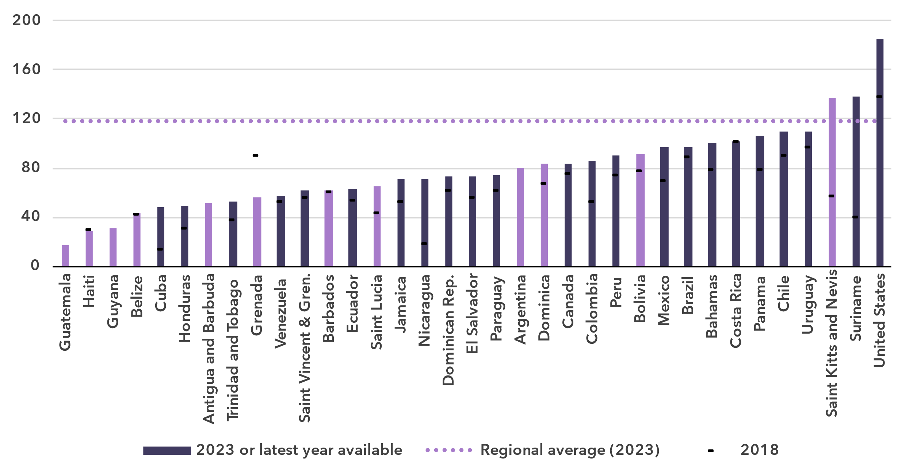Notes: Country submitted are in a darker shade, non-official data in a lighter shade.

Source: ITU

In most economies of the region, mobile broadband subscription penetration is high and still growing. However, there is a significant disparity between the lowest (17 subscriptions per 100 inhabitants) and the highest (185 subscriptions per 100 inhabitants).

The heterogeneity of the region is reflected in the country-level numbers of fixed broadband subscriptions, which ranges from 0.3 to 47 subscriptions per 100 inhabitants. In 16 out of the 28 countries with data, 90 per cent or more of subscriptions were with speeds of more than 10 Mbit per second.

Fixed-broadband subscriptions per 100 inhabitants, 2023 or latest year available

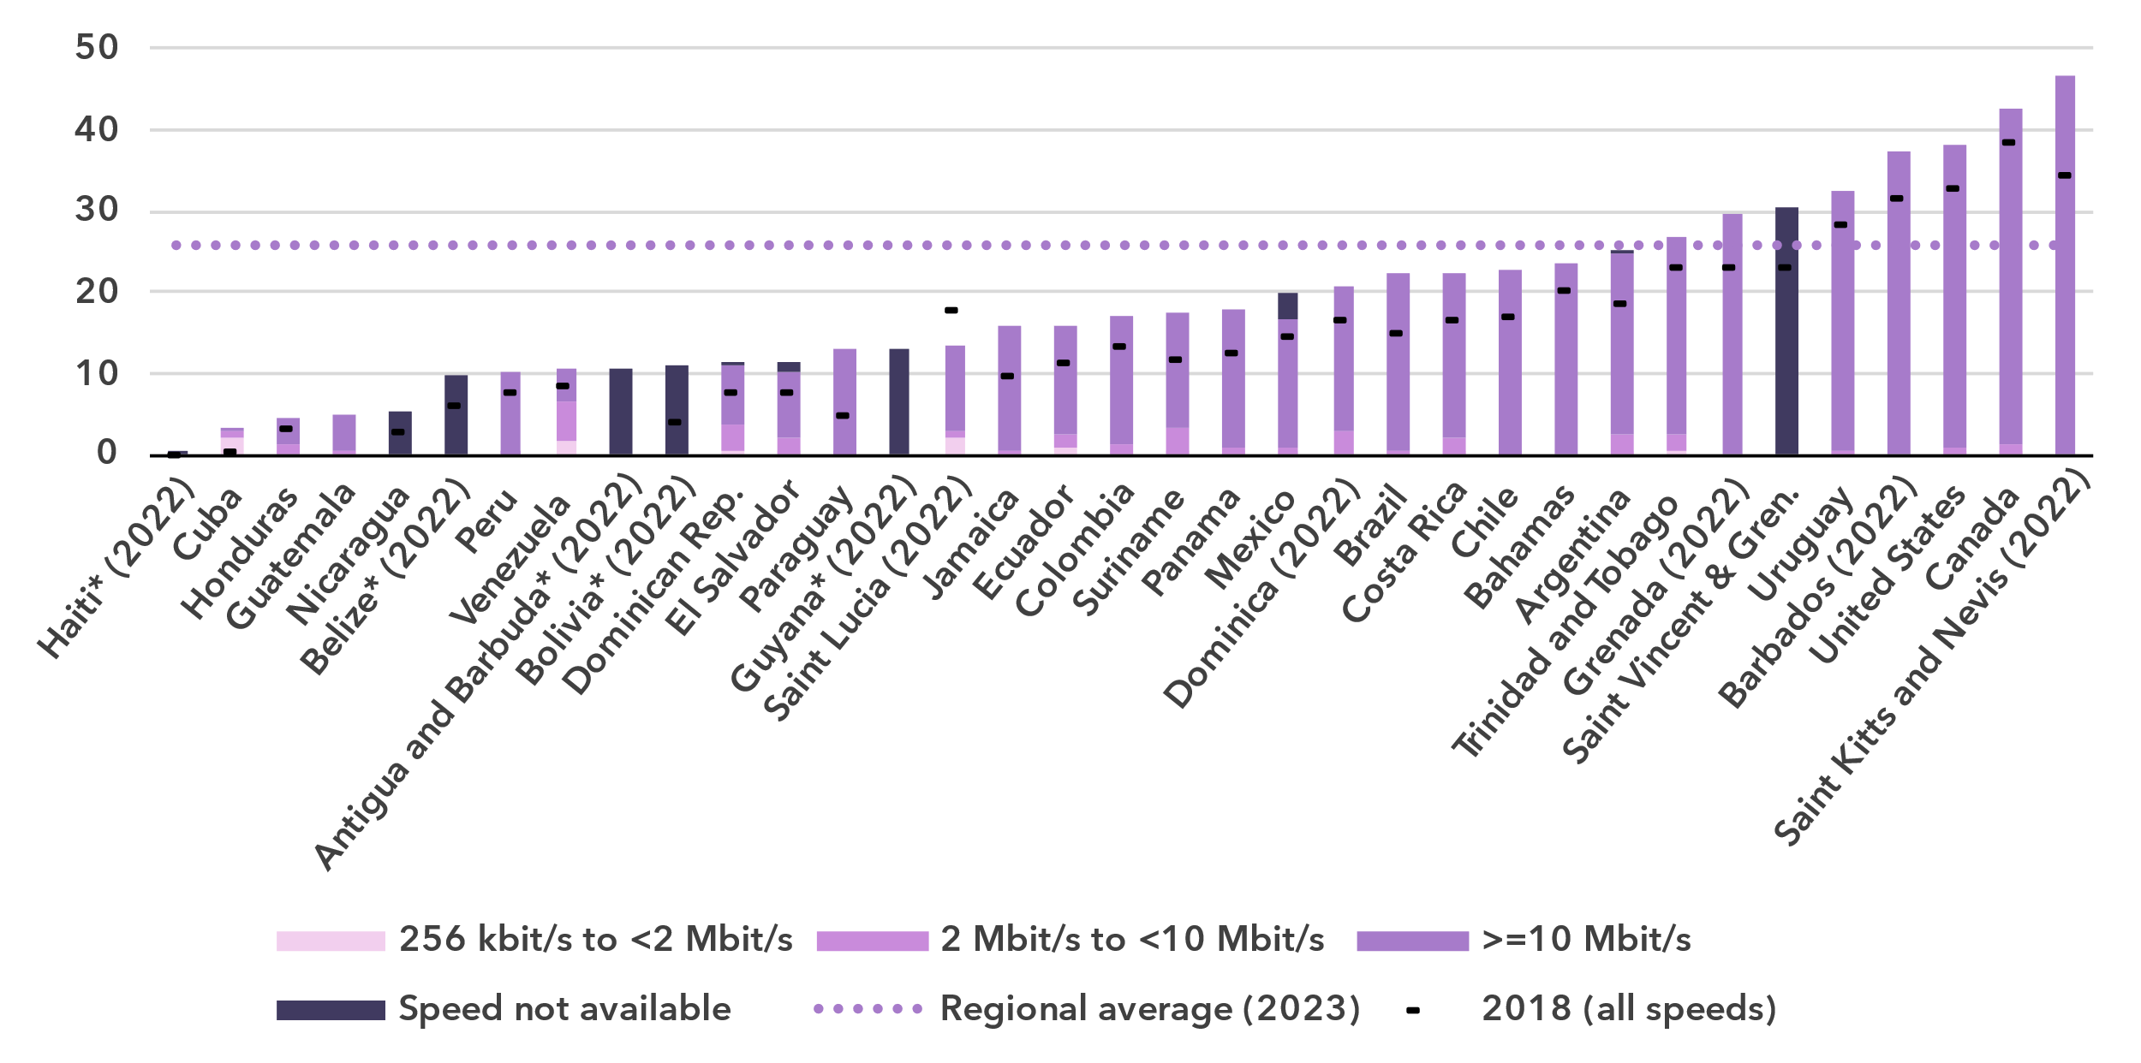* Data are ITU estimates

Source: ITU

Mobile network coverage

***Two-thirds of the population have access to 5G, but rural areas and some countries lag behind***

Percentage of population covered by type of mobile network

|  |  |
| --- | --- |
| **The Americas** | **World** |

Note: The values for 2G, 3G and 4G networks show the incremental percentage of the population that is not covered by a more advanced technology network (e.g. in 2024, 96 per cent of the world population is covered by at least a 3G or above network, that is 4 per cent + 41 per cent + 51 per cent). There are insufficient data to produce estimates for 5G coverage prior to 2020.

Source: ITU

Between 2020 and 2024, 5G mobile network coverage in the Americas increased from 35 to 63 per cent of the population. Over the same period, global coverage increased from 9 to 51 per cent. In the region, 4G mobile networks covered 94 per cent of the population in 2024, also above the global average of 92 per cent. Furthermore, 96 per cent of the population in the Americas had access to at least a 3G mobile broadband network, leaving 4 per cent without access to a mobile broadband network and therefore without any possibility of accessing the Internet. This coverage gap was the same as the global average.

Percentage of population covered by type of mobile network, 2023

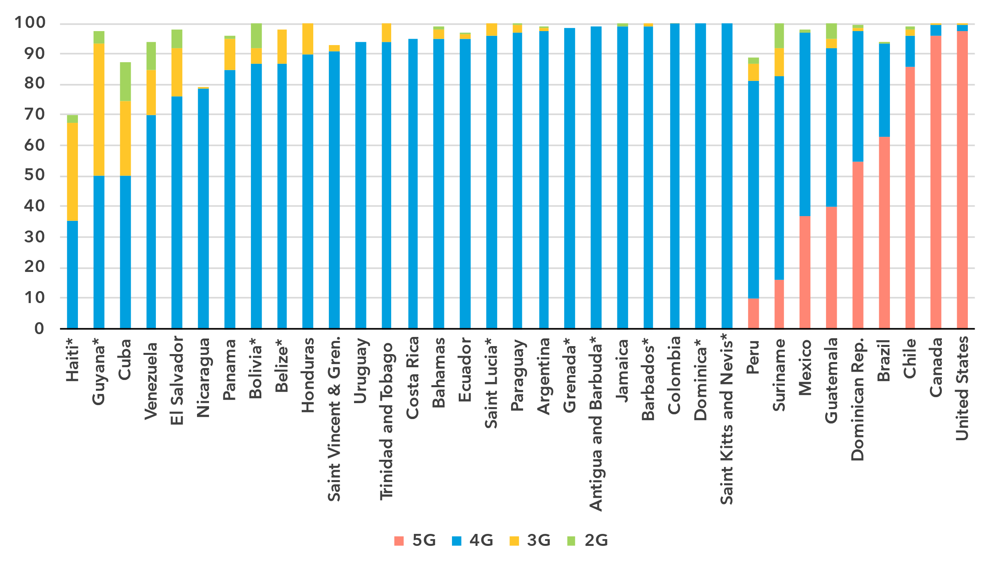* Data are ITU estimates

Note: The values for 2G, 3G and 4G networks show the incremental percentage of the population that is not covered by a more advanced technology network (e.g. in 2023, 93 per cent of the population in Brazil is covered by at least a 4G or above network, that is 63 per cent + 30 per cent).

Source: ITU

However, looking at country level data provides a different perspective. In 26 out of the 35 countries in the region, 5G was not available at all, while in only five countries 5G covered more than 50 per cent of the population.

Population coverage by type of mobile network and location, 2024

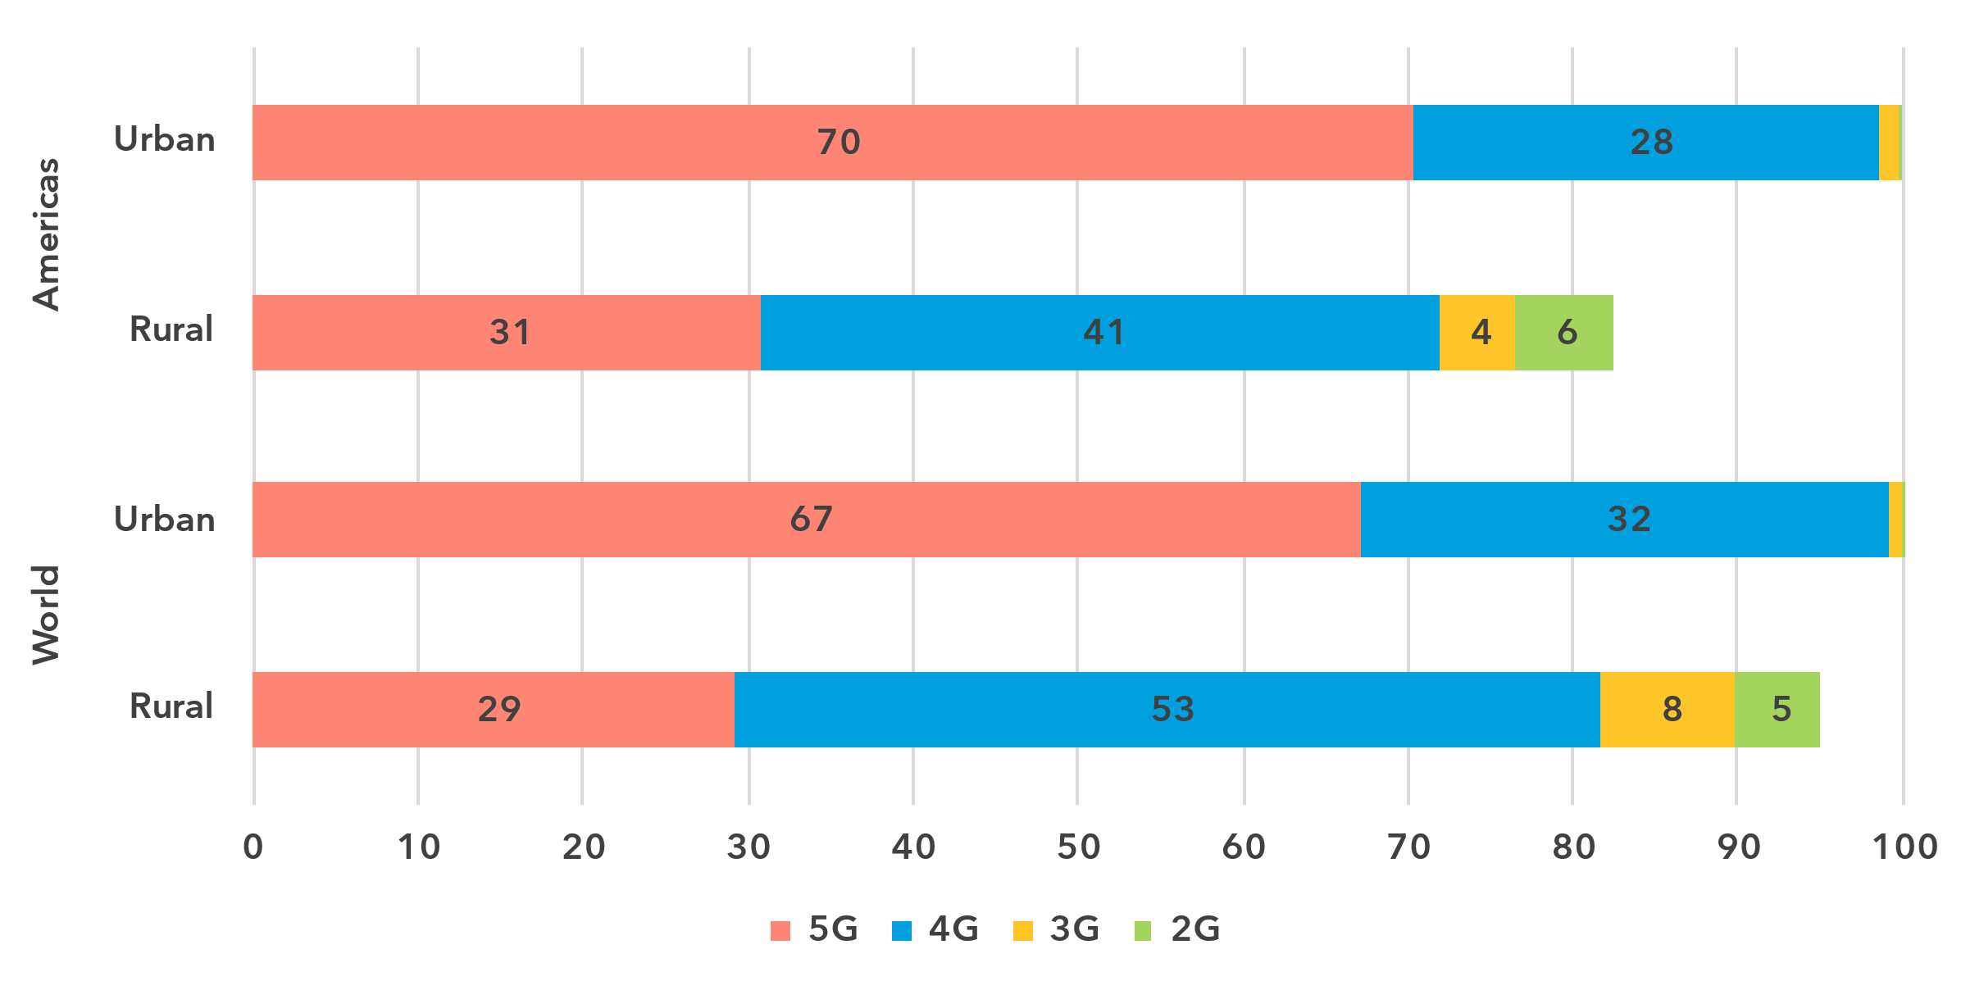

Note: The values for 2G, 3G and 4G networks show the incremental percentage of the population that is not covered by a more advanced technology network (e.g. 90 per cent of the world's rural population is covered by at least a 3G or above network, that is 29 per cent + 53 per cent + 8 per cent).

Source: ITU

As with Internet use, there is a significant gap in network availability between rural and urban areas. In 2024, 5G covered 70 per cent of the urban population the Americas, but only 31 per cent in rural areas. The disparity also existed for 4G networks, with 98 per cent of the urban population covered compared with 72 per cent in rural areas. When including 3G networks, coverage reached 100 per cent in urban areas but only 76 per cent in rural regions. This means that while every urban resident had access to a mobile broadband network, 24 per cent of the rural population in the Americas remained off the grid, much more than the global average (10 per cent).

Availability of fixed-broadband infrastructure

***Less than half of the population lives within 10 km of an optical fiber node, limiting high-speed access***

Fixed-broadband infrastructure forms the backbone of the Internet and is a cornerstone of digital transformation efforts. As part of ongoing research at ITU, the broadband map initiative provides an overview of fixed-broadband infrastructure placement. Overlaying this data with demographic data makes it possible to infer the availability and proximity of fixed broadband to populations. This is essential for planning – costly – infrastructure projects and helps to ensure that networks have the necessary capacity and reach.

Map of transmission networks and submarine cables for the Americas region

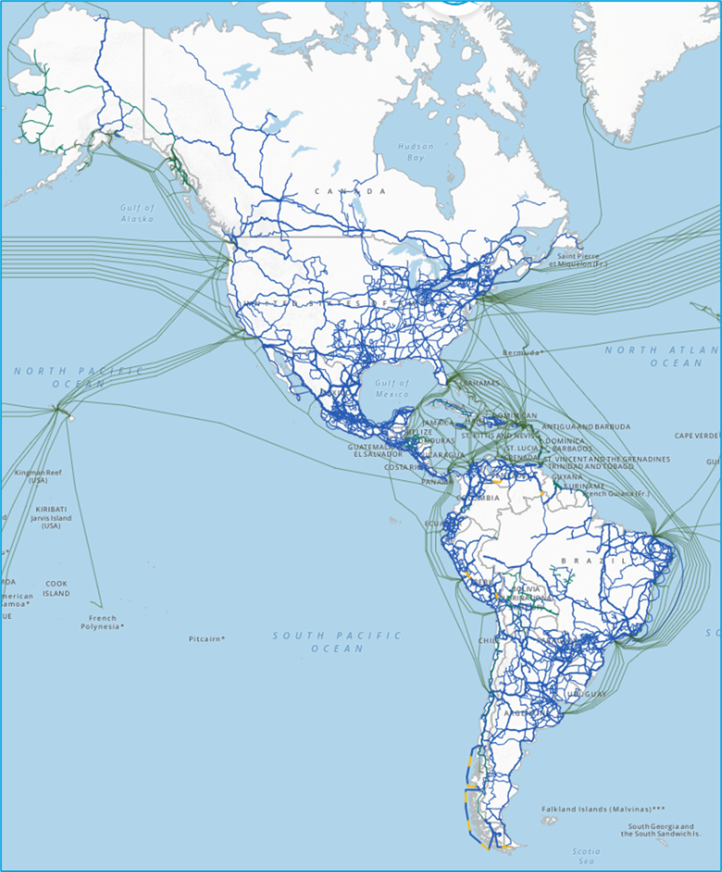

Note: The image shows active and planned submarine cables, and operational, planned and under-construction transmission networks (fibre-optic cable and microwave).

The designations employed and the presentation of material on the map do not imply the expression of any opinion whatsoever on the part of ITU or its secretariat concerning the legal status of the country, territory, city or area or its authorities, or concerning the delimitation of its frontiers or boundaries.

Source: ITU, <https://bbmaps.itu.int/app>

Proximity to an optical fibre node is a crucial metric for transformative connectivity as it directly impacts network performance, reliability and scalability. It reduces latency, improves connection stability and lowers deployment costs, making broadband access more affordable and efficient. Additionally, it enables easier upgrades to support growing bandwidth demands, ensuring networks remain future proof.

As of 2023, 45 per cent of the population of the Americas region lived within 10 km of an optical fibre node. Four out of every five people (81 per cent) lived within 25 km, 94 per cent within 50 km and almost everyone (98 per cent) within 100 km of a node.

Percentage of population within reach of a fibre node, 2023

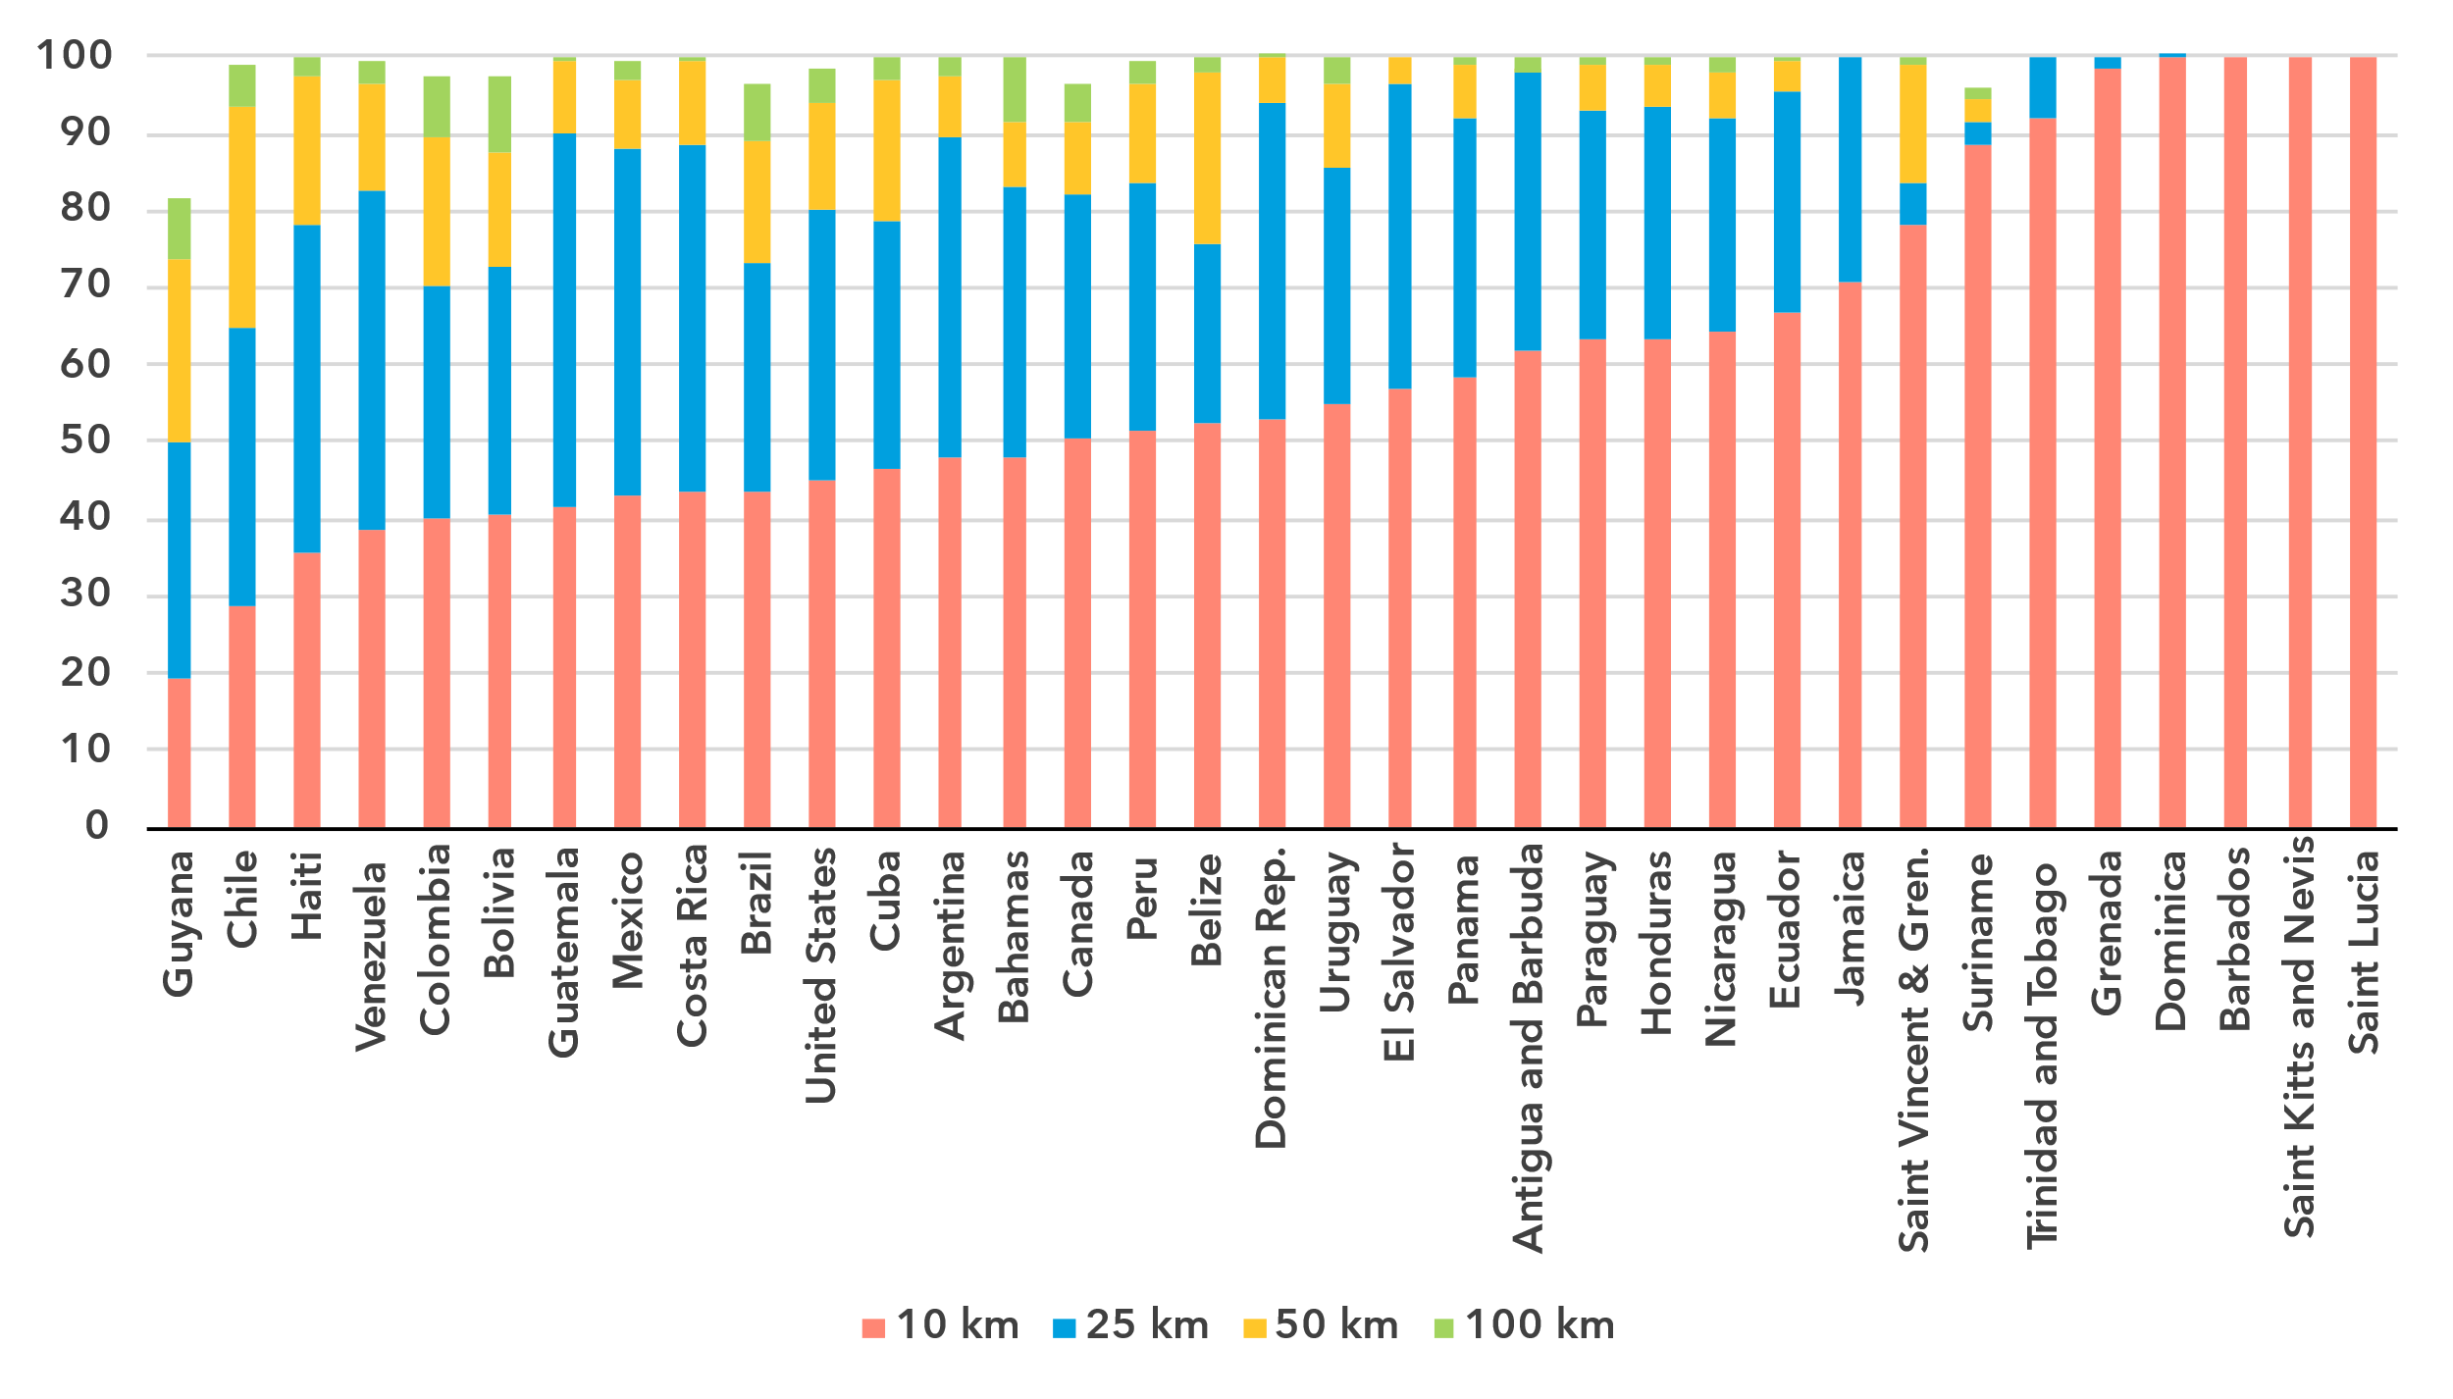Note: The percentage of population within reach of transmission networks refers to the percentage of people that are within physical reach of nodes on core terrestrial transmission networks for a given distance (see <https://bbmaps.itu.int/indicators-bbmaps>).

Source: ITU

Internet traffic and international bandwidth

***Mobile data usage is below the global average, while fixed broadband traffic exceeds it***

Broadband Internet traffic per subscription per month (GB)

|  |  |
| --- | --- |
| **Mobile** | **Fixed** |

Source: ITU

Internet traffic measures the total volume of data downloaded and upload by the end users in a country over a given period. For ease of interpretation, figures presented refer to the average monthly traffic per both fixed- and mobile-broadband subscription. Traffic levels are typically higher for fixed than mobile broadband, not only because subscriptions are shared by multiple users (e.g. in households), but also because they include mobile traffic routed over Wi-Fi when available.

Between 2019 and 2024 monthly mobile-broadband traffic in the Americas increased from 5 to 11 GB per mobile-broadband subscription, below the global average, which increased from 6 to 14 GB per month during the same period. The situation was reversed for fixed broadband traffic, which in the Americas increased from a monthly 188 GB to 402 GB per subscription, above the global average, which increased from 141 to 311 GB.

Mobile-broadband Internet traffic (GB) per subscription per month, 2023 or latest year available

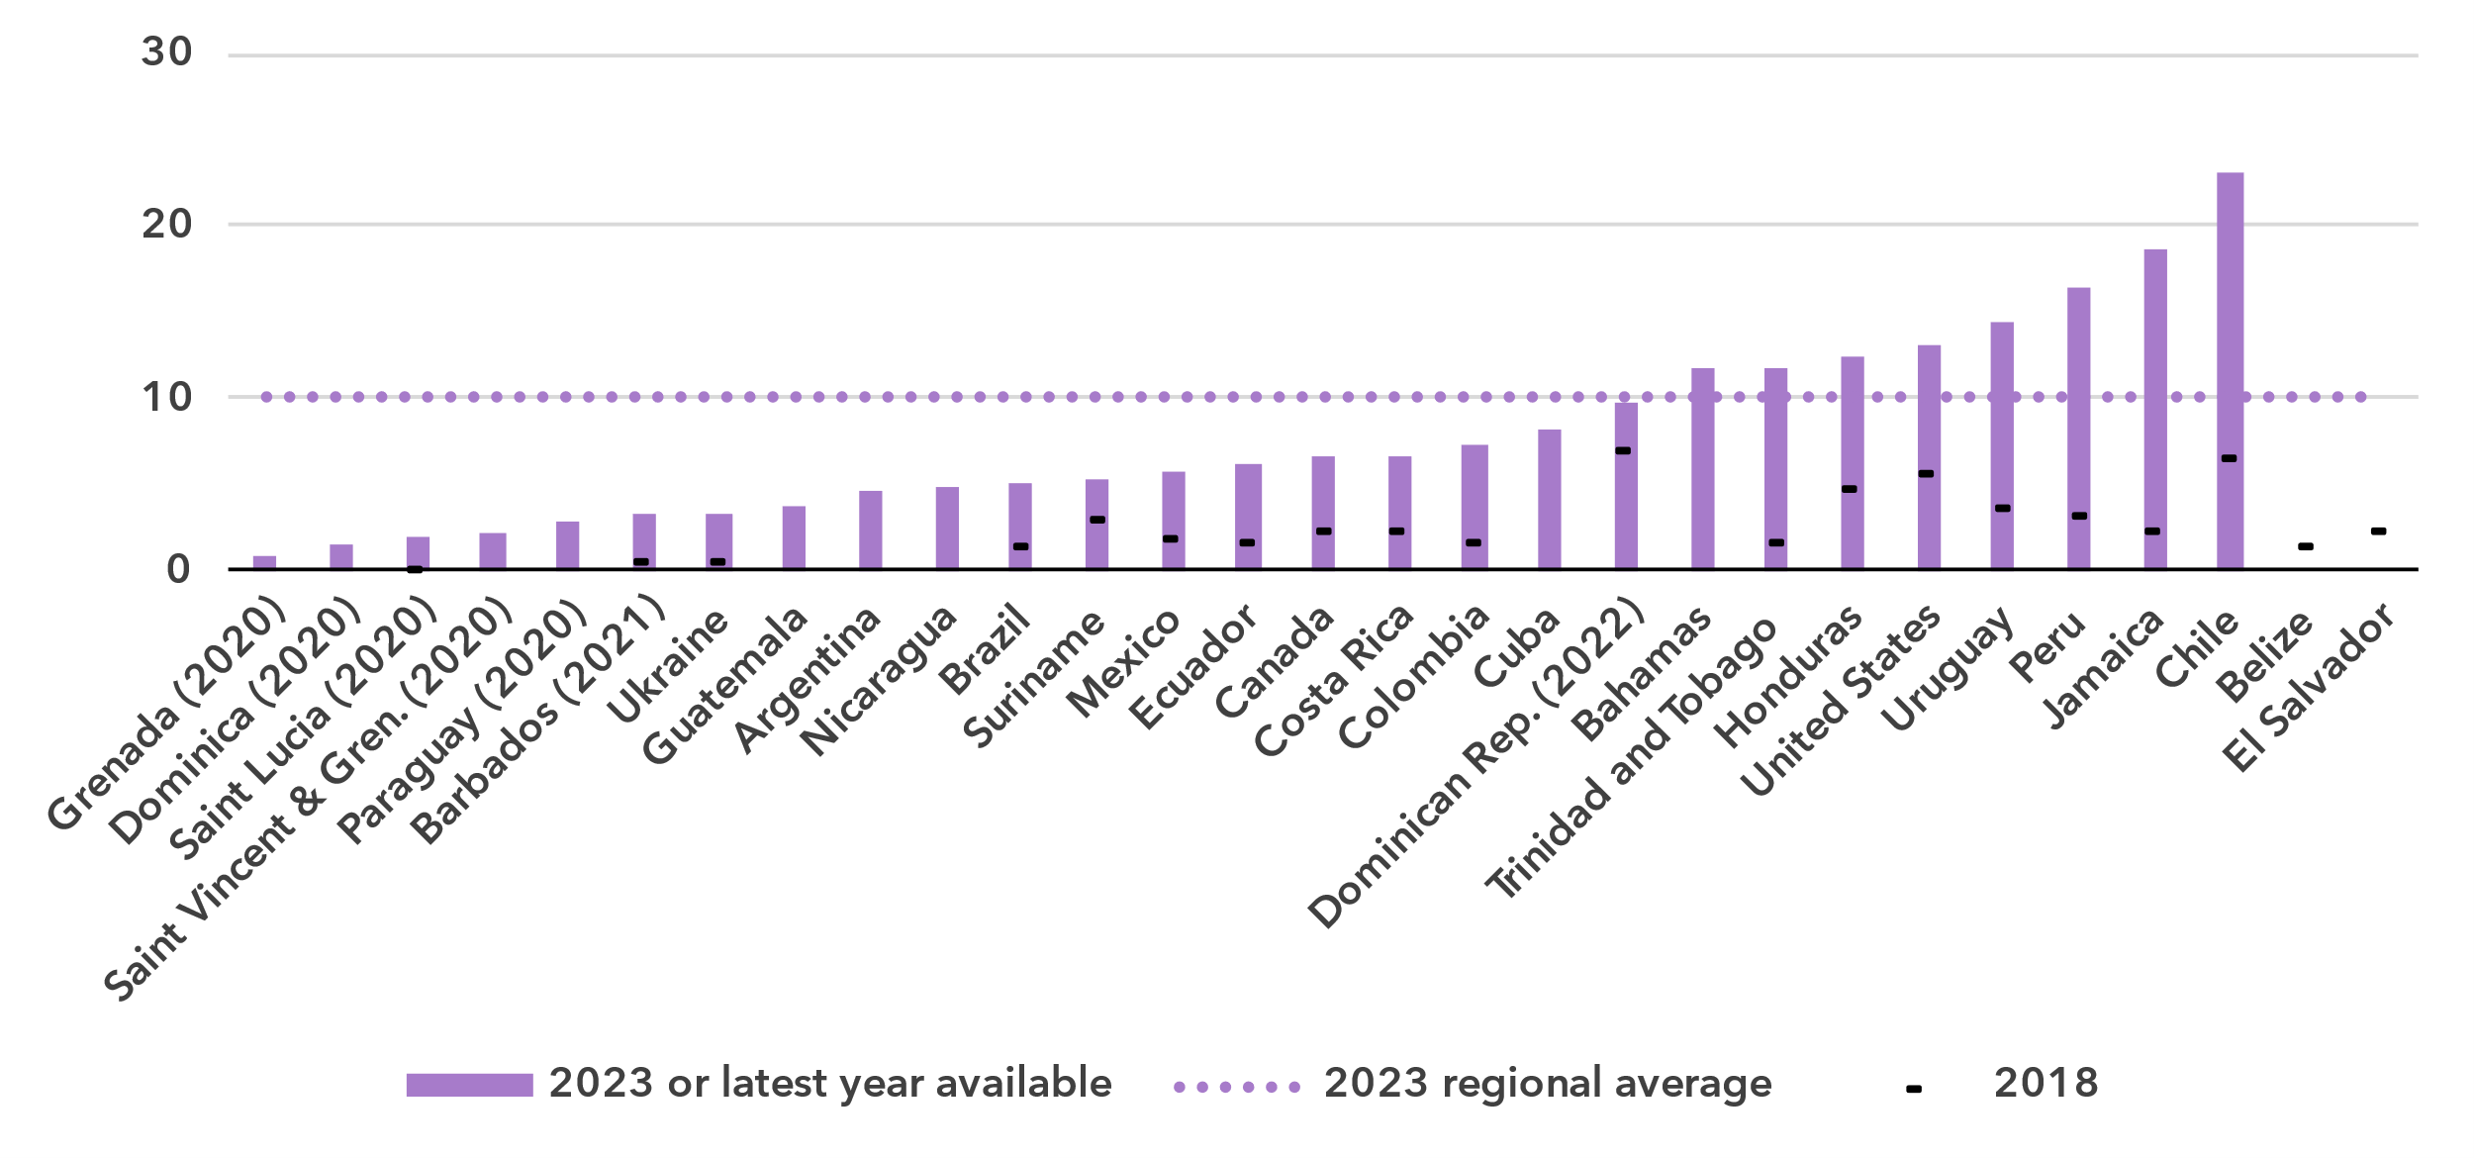 Note: Internet traffic originating within country.

Source: ITU

The region also exhibits a large variety when it comes to traffic indicators. Mobile broadband traffic ranged from less than 1 GB per subscription per month to 23. For fixed broadband traffic, the spread was from almost zero in Suriname to 553 GB per subscription per month in Chile. Of note is that some countries with high mobile broadband traffic have only average fixed broadband traffic and vice-versa.

Fixed-broadband Internet traffic per subscription per month (GB), 2023 or latest year available

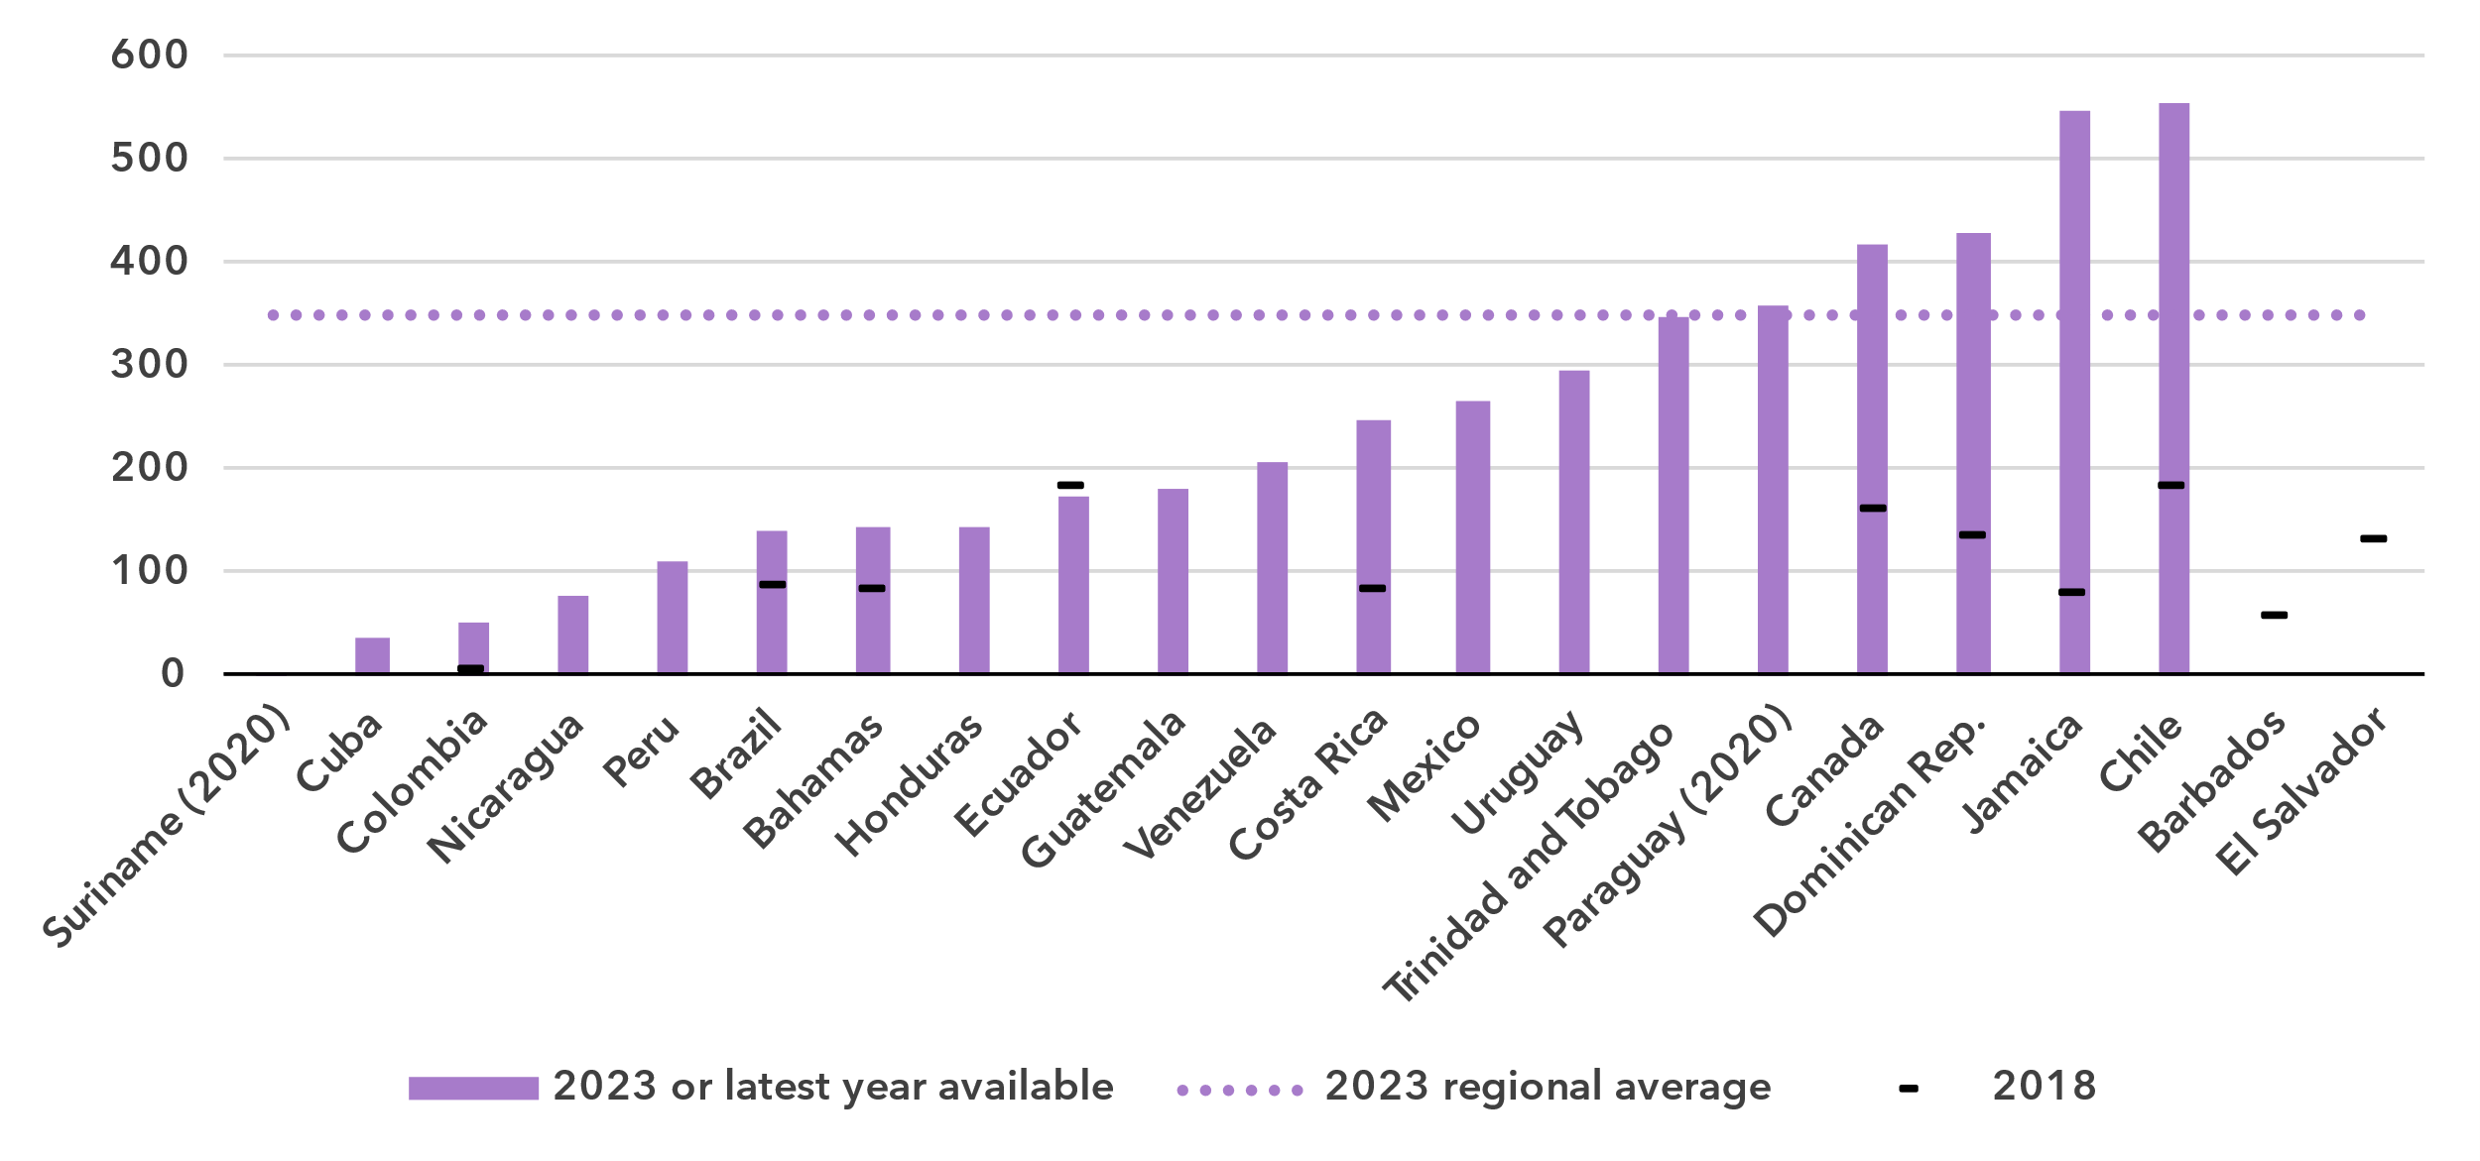 Source: ITU

International bandwidth per Internet user (kbit/s)

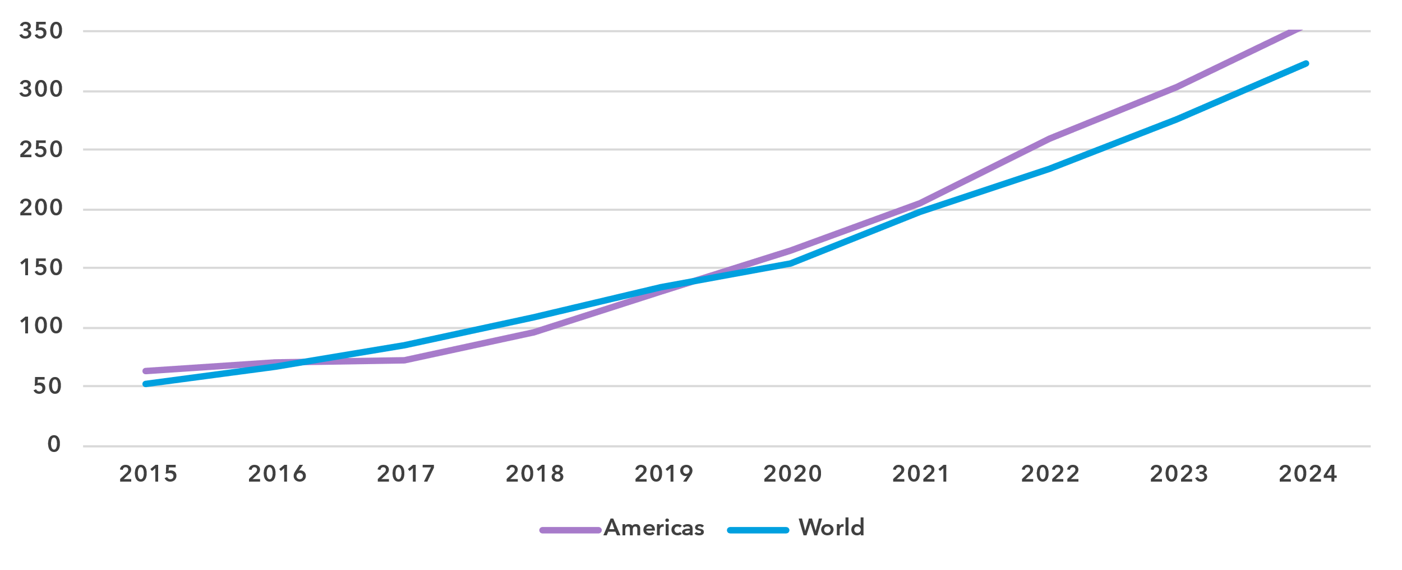

Source: ITU

Unlike the end-user Internet traffic measured above, international bandwidth usage is a throughput measure that refers to the annual average used capacity of international connections, typically carried over submarine or terrestrial fibre-optic cables or microwave links. It does not sum up all traffic, incoming and outgoing, but captures the larger of the two. For comparability, the figure for bandwidth is divided by the number of Internet users in the country. International bandwidth usage in the Americas stood at 357 kbit/s in 2024, just above the global average of 323 kbit/s.

International bandwidth per Internet user (kbit/s), latest year available

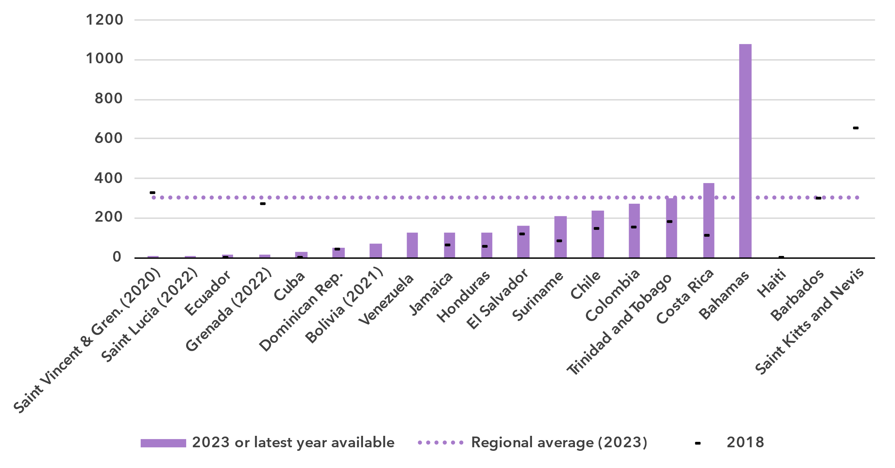Source: ITU

International bandwidth usage reflects the state of international connectivity infrastructure (presence of submarine and overland cables, including redundancies) and the degree to which a country is connected to international data flows. Demand for international bandwidth depends on many country-specific factors, such as geographical location or the size and development of domestic middle-mile connectivity infrastructure (e.g., small islands are dependent on international linkages, while a high density of data centres and Internet exchange points can somewhat reduce the demand for international data exchange for larger countries). While data are only available for less than half of the countries in the region, there are variations. In the Bahamas, bandwidth usage exceeded 1 Mbit/s, far above the world average, while seven countries reported bandwidth usage levels below 100 kbit/s, suggesting that international linkages may hamper universal and meaningful connectivity.

Affordability of ICT services

***Mobile broadband is becoming more affordable, but fixed broadband remains costly***

Broadband basket prices as % of gross national income per capita, 2018-2024

|  |  |
| --- | --- |
| **Mobile (2GB)** | **Fixed (5GB)** |
|  |  |

Note: Median values shown in the chart are calculated as a percentage of GNI per capita for the set of economies for which data was available for all years from 2018 to 2024 for a given basket to adjust the effect of changing data availability.

Source: ITU

Internet cost is a barrier to Internet use and to meaningful connectivity. The United Nations [Broadband Commission for Sustainable Development](https://www.broadbandcommission.org/) set itself the goal of making broadband in developing countries affordable by 2025, affordability being defined as the availability of broadband access at a price that is less than 2 per cent of monthly GNI per capita.

Entry-level data-only mobile broadband prices have gone done significantly in the region, from 2.6 per cent of GNI per capita in 2018 to 1.8 in 2024, for the first time below the 2 per cent target of the Broadband Commission.[8] The cost is still higher though than the global median.

For an entry-level fixed broadband service, the median price in 2024 was 3.2 per cent of GNI per capita, down from 4.2 in 2018. This was still significantly above the Broadband Commission target and above the global median.

Broadband basket prices as % of gross national income per capita, 2024

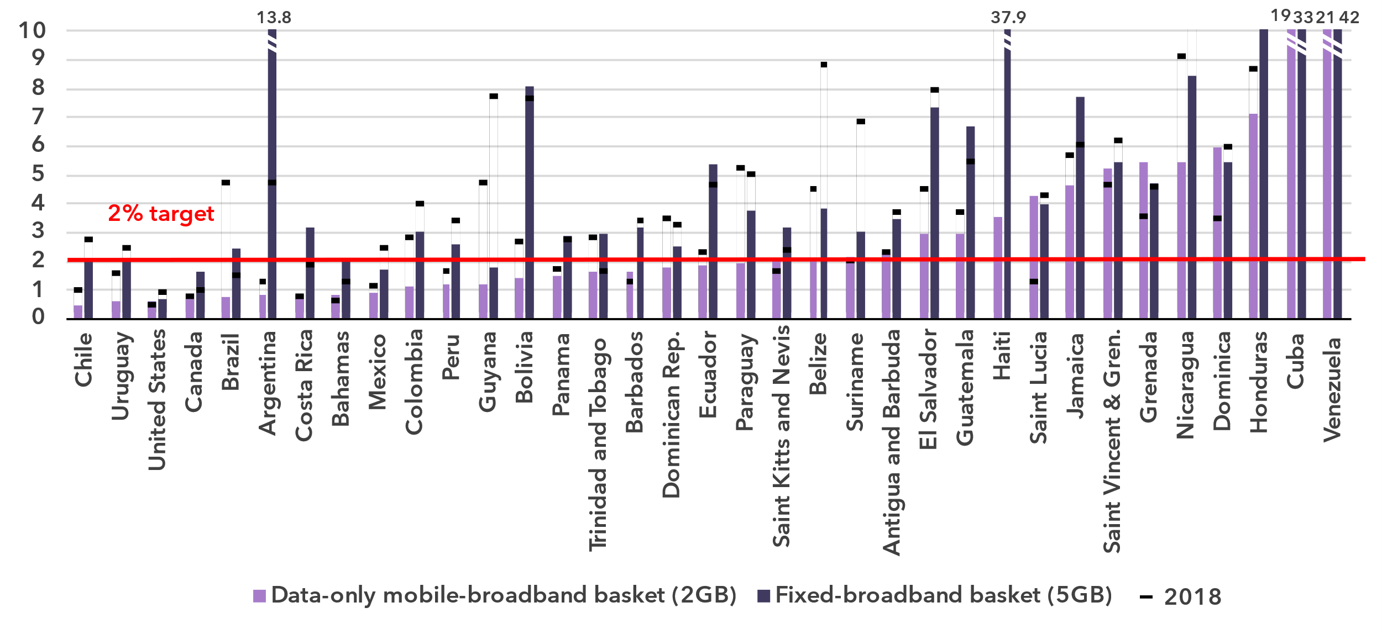Source: ITU

In 16 of 35 countries, the mobile broadband price was above the 2 per cent Broadband Commission target. Ten of these countries are small Pacific islands. For fixed broadband, only in five out of 35 countries prices were below the 2 per cent target.

Mobile phone ownership and subscriptions

***Mobile phone ownership is approaching universality***

|  |  |
| --- | --- |
| Percentage of individuals owning a mobile phone | Percentage of individuals owning a mobile phone by gender, 2024 |

Note: Individuals aged 10 and older.

Source: ITU

In 2024, 89 per cent of individuals in the Americas aged 10 and older owned a mobile phone, nine percentage points more than the global average. Growth over the last five years has been modest, which is not surprising considering the level is already high.

As for Internet use, there were more women than men owning a phone in the region, leading to a gender parity score of 1.01, up from 0.99 in 2021. During the same period, the global GPS also improved slightly, from 0.91 to 0.93.

Percentage of individuals owning a mobile phone, 2023 or latest year available

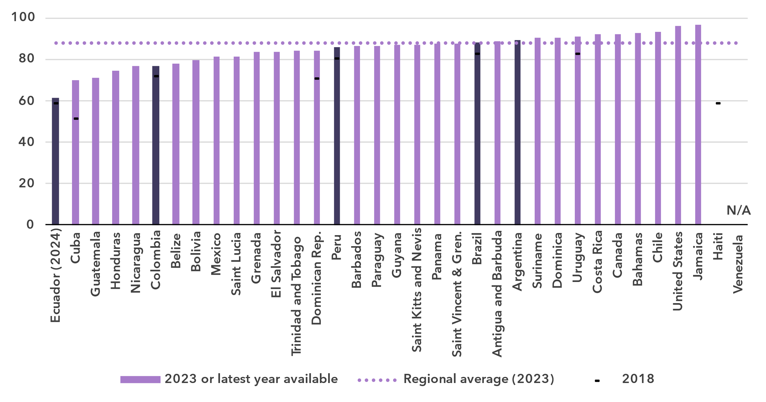 Notes: Individuals aged 10 and older. Country submitted are in a darker shade, non-official data in a lighter shade.

Source: ITU

In 25 out of 33 countries, mobile phone ownership was above 80 per cent of the population

Mobile-cellular subscriptions per 100 inhabitants

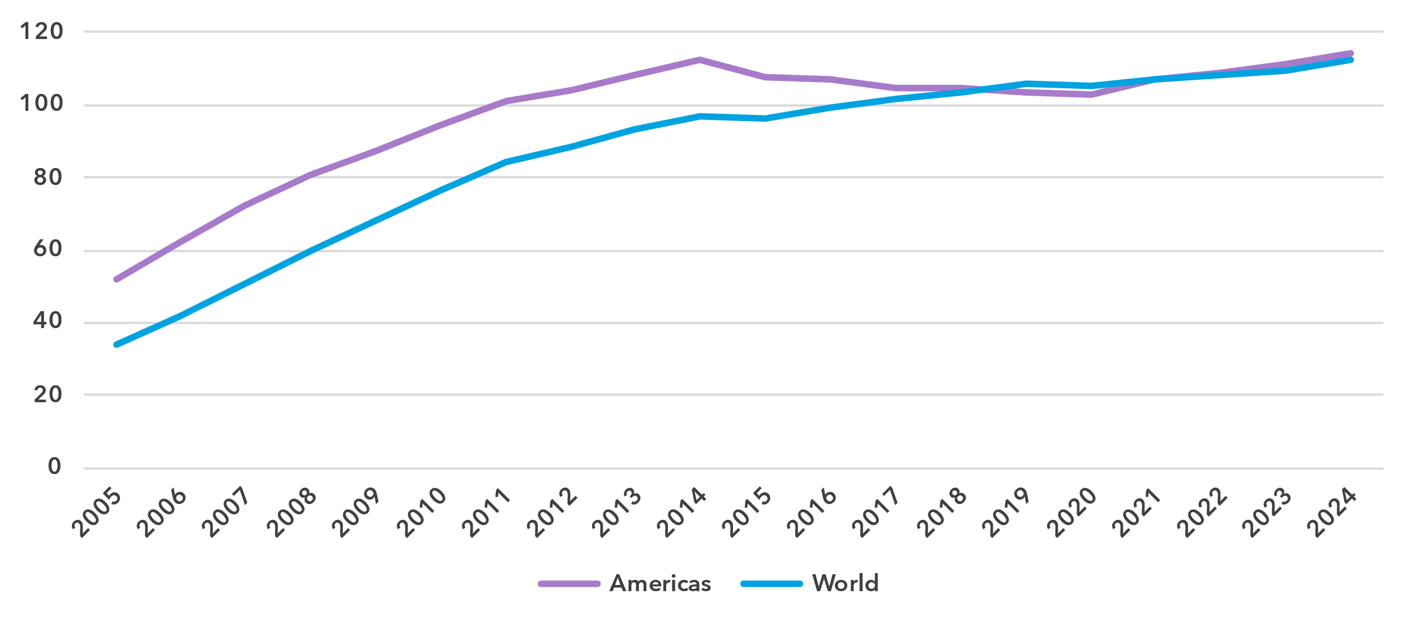

Source: ITU

To use a mobile phone, a mobile-cellular or mobile broadband subscription is needed. In the Americas, there were 114 subscriptions per 100 inhabitants in 2024, two more than the global average. This indicator is starting to plateau, as it has hardly moved in the last ten years.

At the country level though, there was still a significant gap between the economies with least and most subscriptions per 100 inhabitants, at 65 and 201 respectively.

Mobile-cellular subscriptions per 100 inhabitants, 2023 or latest year available

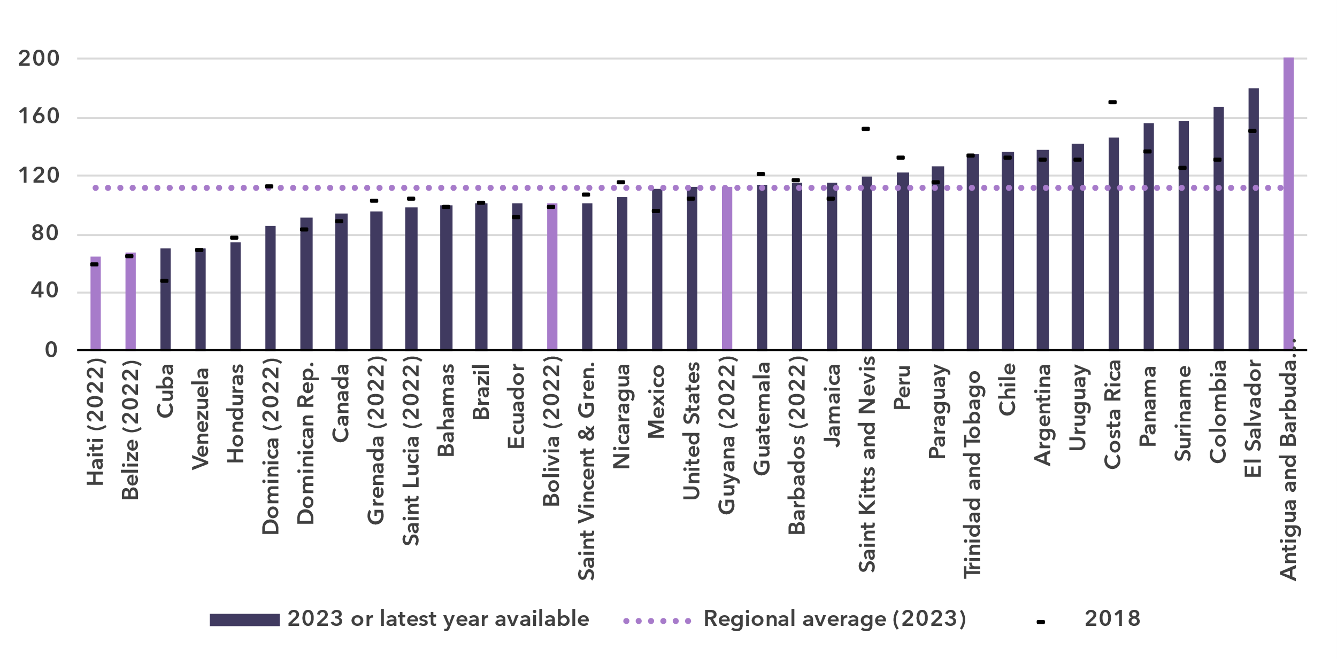 Notes: Country submitted are in a darker shade, non-official data in a lighter shade.

Source: ITU

ICT skills

***A wide gap in ICT skills leaves many users unable to fully benefit from digital opportunities***

Because self-reporting of individuals’ ICT skills is subjective, ICT skills are measured based on household surveys asking whether an individual has recently performed certain activities. Performing these activities presupposes a degree of proficiency in relevant digital skills. The activities are grouped into five areas: information and data literacy; communication and collaboration; digital content creation; safety; and problem solving.

While the importance of digital skills in leveraging ICTs for economic prosperity and social well-being is well-documented, data remain very scant, with only 13 countries in the Americas having submitted data since 2020. Even fewer – just 6 countries – provided (at least some) comparable data on ICT skill levels (see box for details on the methodology for calculating ICT skill levels).

|  |  |  |  |  |  |  |
| --- | --- | --- | --- | --- | --- | --- |
| **Methodology for calculating ICT skill levels**  At its 11th meeting in September 2023, ITU’s Expert Group on ICT Household Indicators (EGH) [recommended changes](https://www.itu.int/itu-d/meetings/statistics/wp-content/uploads/sites/8/2023/09/Report-of-the-EGH-subgroup-on-ICT-Skills.pdf) in how data on ICT skill levels are reported – most importantly, that skill levels of individuals should be assessed for different areas.  *Individuals should be assessed on the number of activities within a skill area they report having done in the last three months using the following progression:*   |  |  |  | | --- | --- | --- | | None | Basic | Above basic | | 0 activities | 1 activity | More than 1 activity |  * *Skill levels should not be assessed in skill areas where fewer than two indicators are collected.* * *Indicators should be weighted equally within each skill area.* * *Skill areas with different numbers of components should be treated equally.*   While this recommendation does not require any additional data collection, it does require that countries perform additional analysis on existing survey microdata. ITU requested data on ICT skills for the first time in its April 2024 data collection, and received data from 40 countries, including 6 countries in the Americas. However, other countries were unable to provide data, even though in many cases data on the underlying activities had been collected. It is expected that data availability will improve as familiarity with these new recommendations increases. |

ICT skills data goes beyond simple access and use of ICTs to provide a view of the capabilities of ICT users. Data on individuals in the Americas with different levels of ICT skills are shown below as a share of Internet users. These data demonstrate the substantial variation between countries in the level of ICT skills of those already using the Internet. They also show the areas where attention is needed to increase ICT skills.

Percentage of Internet users with ICT skills in the Americas, by skill level, 2023 or latest year available

|  |  |
| --- | --- |
| **Brazil** | **Canada (2022)** |
| **Chile** | **Dominican Republic (2022)** |
| **Mexico** | **Uruguay (2022)** |

Note: Data for Mexico refer to individuals aged 6 and older. Data for Brazil and Dominican Republic refer to individuals aged 10 and older. Data for Uruguay refer to individuals aged 14 and older. Data for Canada and Chile refer to individuals aged 15 and older.

Source: ITU

In general, communication and collaboration skill levels are very high among Internet users in the six countries with available data – all report that nearly 90 per cent or more Internet users have at least basic skills in this area.

In five of the six countries, information and data literacy skill levels are also high among Internet users (over 70 per cent with at least basic skills), although not as high as communication and collaboration skill levels. In the Dominican Republic, information and data literacy skill levels are substantially lower with less than 50 per cent of Internet users having at least basic skills.

Less than 50 per cent of Internet users have at least basic digital content creation skills in the Dominican Republic and Mexico. In the other countries, more than half of Internet users had such skills.

Safety skill levels are very low in the Dominican Republic – less than 20 per cent of Internet users had at least basic skills in this area. In Brazil, over 50 per cent of Internet users had at least basic safety skills while Internet users in Canada and Uruguay had higher levels of skills in this area.

Finally, in all countries except the Dominican Republic, more than half of Internet users had at least basic problem-solving skills. In general countries reported similar skill levels for problem solving and digital content creation.

A different way to analyse these data is by comparing the distribution of country values for the activities that comprise each of the five skill areas. This provides a view of the prevalence of each activity among Internet users relative to others in the same area. It also shows the wide range of variation in ICT skills in countries in the region even when focusing only on those using the Internet.

Percentage of Internet users with information and data literacy skills, latest year available

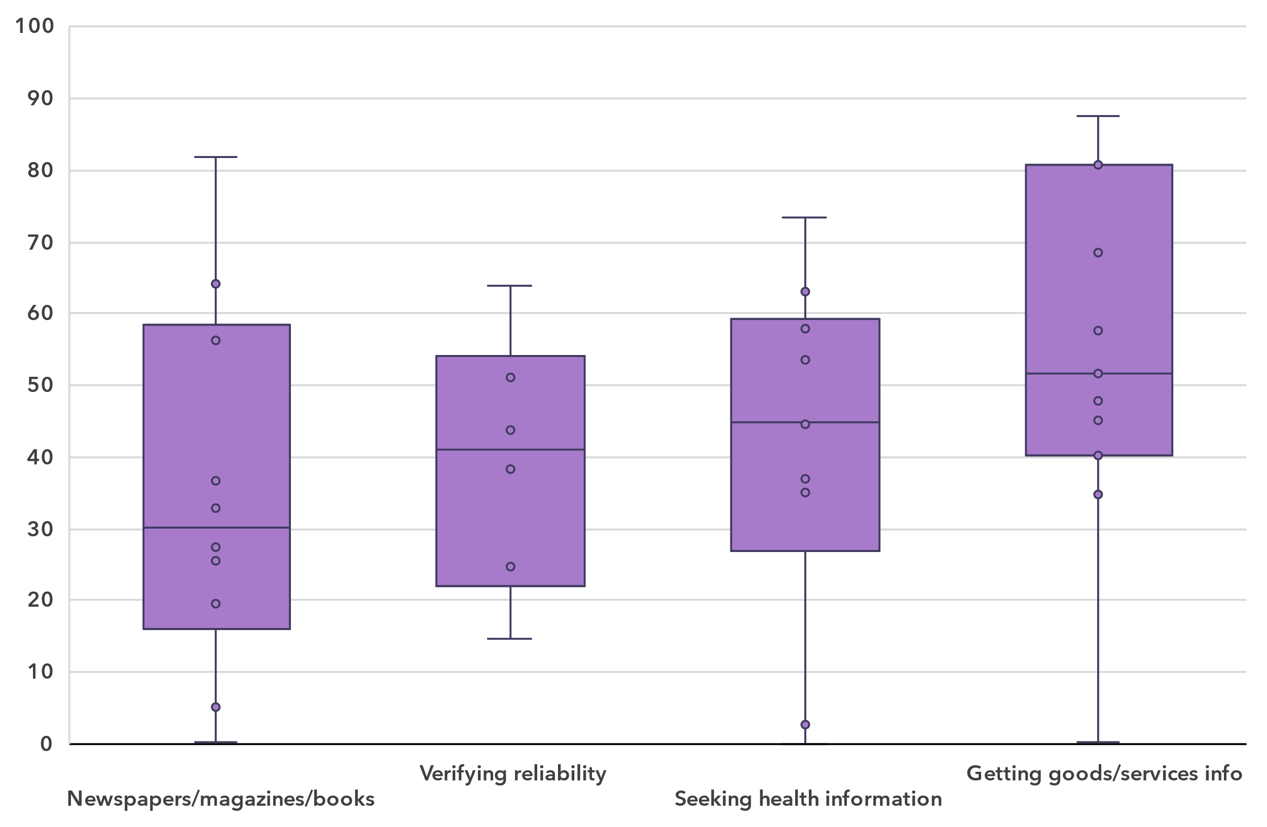Note: Bars indicate the 25th, median and 75th percentile of all country values. The whiskers (bottom and top lines) indicate individual minimum and maximum values. In-scope age varies between countries. Country data are for 2023 where available but no earlier than 2020. Data availability varies between indicators, ranging from six countries for *Verifying the reliability of information found online to* eleven countries for *Getting information about goods or services.* Detailed information – including complete indicator names – is available [here](https://www.itu.int/en/ITU-D/Statistics/Documents/facts/rpm_ams_pub_2025_data.xlsx).

Source: ITU

For information and data literacy, getting information about goods or services had the highest median (52 per cent) of the four activities that make up this skill category. Seeking health information (median of 45 per cent) and verifying the reliability of information found online (median of 41 per cent) had similar distributions of country shares. Conversely, using the Internet to read or download newspapers, magazines or books was less frequently reported (median of 30 per cent) by individuals across the region.

Percentage of Internet users with communication and collaboration skills, latest year available

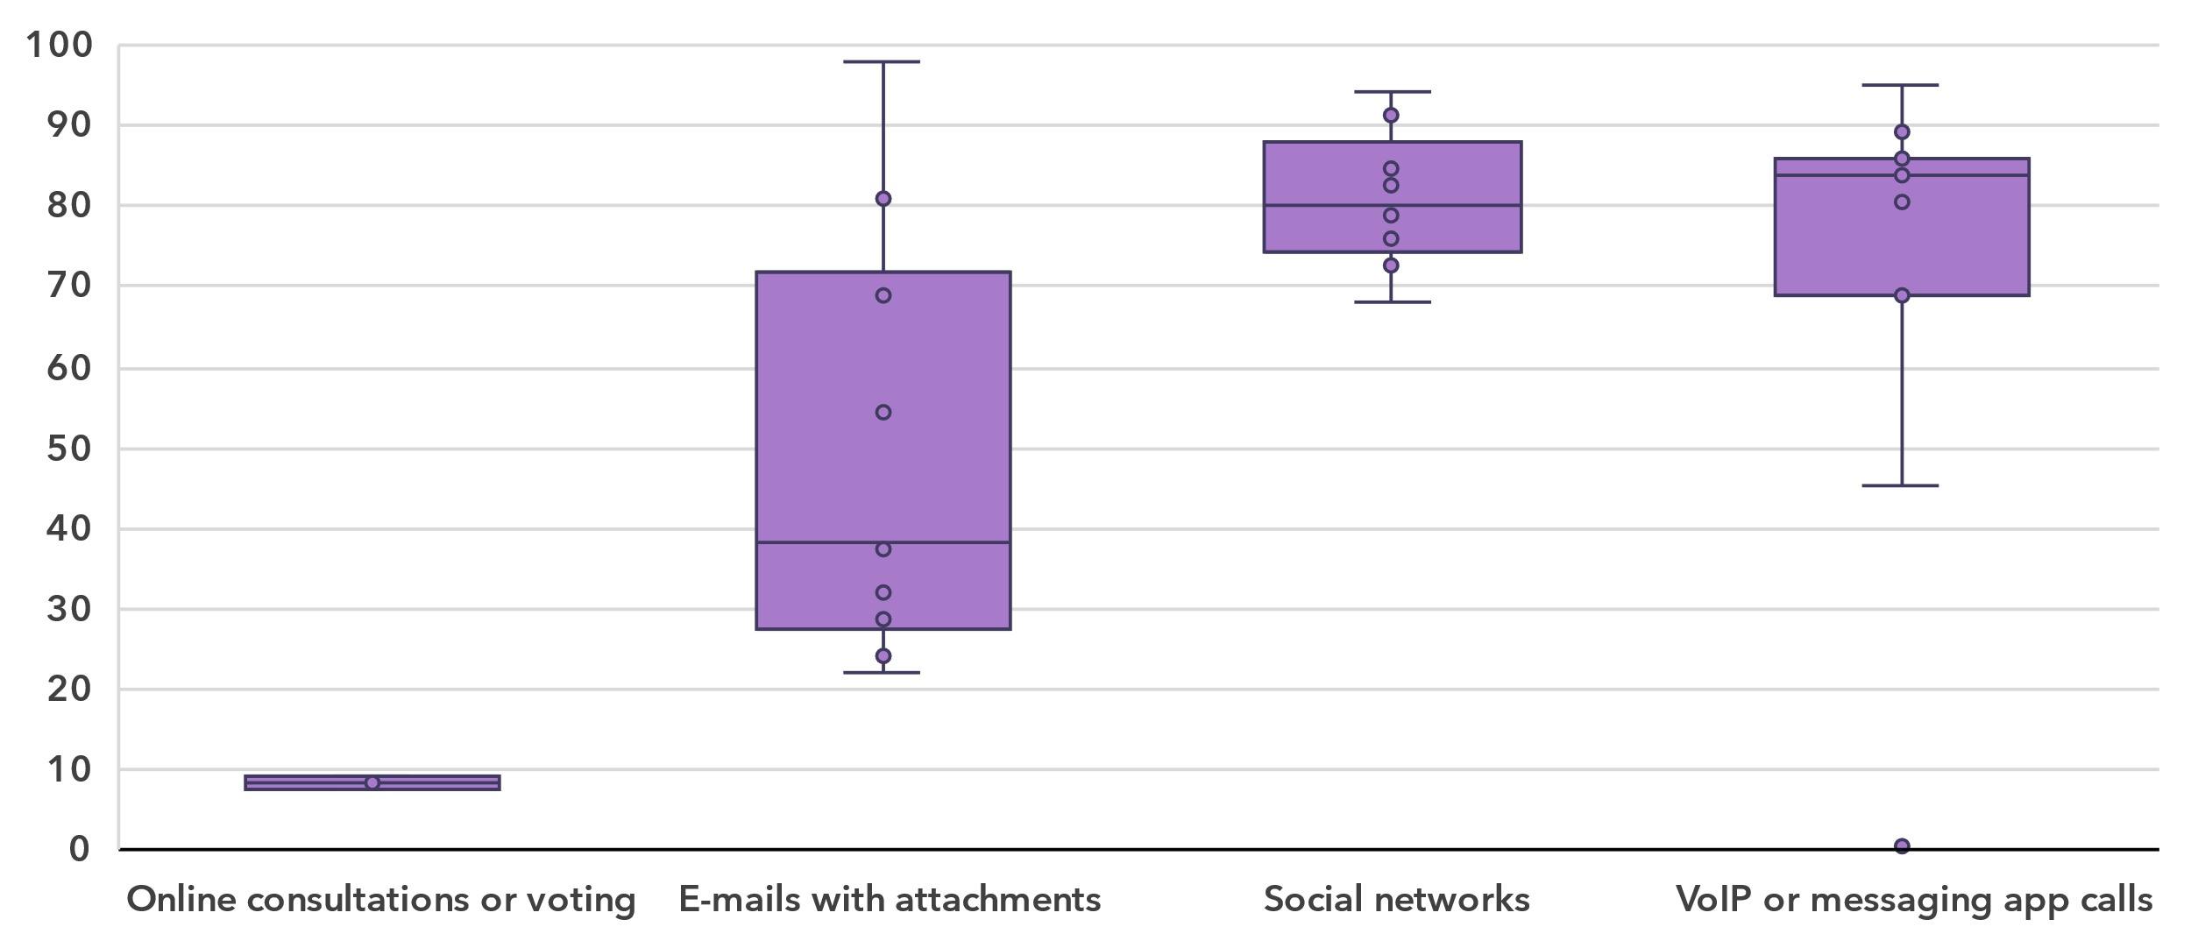Note: Bars indicate the 25th, median and 75th percentile of all country values. The whiskers (bottom and top lines) indicate individual minimum and maximum values. In-scope age varies between countries. Country data are for 2023 where available but no earlier than 2020. Data availability varies between indicators, ranging from three countries for *Taking part in online consultation or voting to define civic or political issues* to eleven countries for *Making calls using VoIP or messaging app.* Detailed information – including complete indicator names – is available [here](https://www.itu.int/en/ITU-D/Statistics/Documents/facts/rpm_ams_pub_2025_data.xlsx).

Source: ITU

The medians for communication and collaboration were much higher than for information and data literacy, especially for making calls using VoIP or messaging app (median of 84 per cent) and participating in social networks (median of 80 per cent). The one exception was taking part in online consultations or voting to define civic or political issues, which had a median of only 9 per cent and where data were collected in only three countries.

Percentage of Internet users with digital content creation skills, latest year available

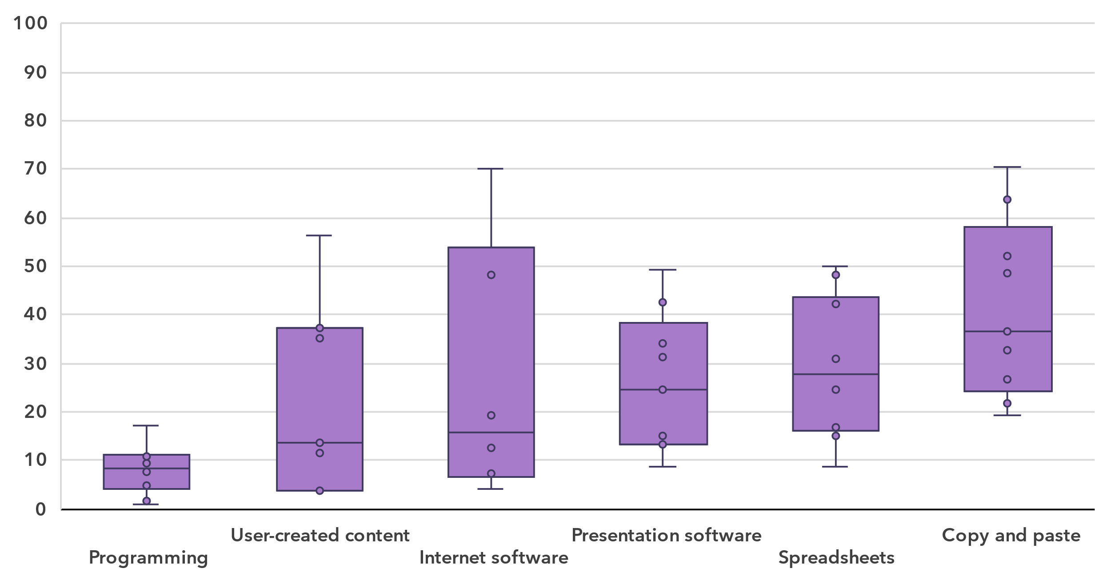Note: Bars indicate the 25th, median and 75th percentile of all country values. The whiskers (bottom and top lines) indicate individual minimum and maximum values. In-scope age varies between countries. Country data are for 2023 where available but no earlier than 2020. Data availability varies among indicators, ranging from six countries for *Using software run over the Internet for editing text documents, spreadsheets or presentations* to ten countries for *Writing a computer program using a programming language* and for *Using basic arithmetic formula in a spreadsheet.* Detailed information – including complete indicator names – is available [here](https://www.itu.int/en/ITU-D/Statistics/Documents/facts/rpm_ams_pub_2025_data.xlsx).

Source: ITU

The digital content creation skill area generally shows relatively low medians for the six activities, ranging from 9 to 37 per cent.

Percentage of Internet users with safety skills, latest year available

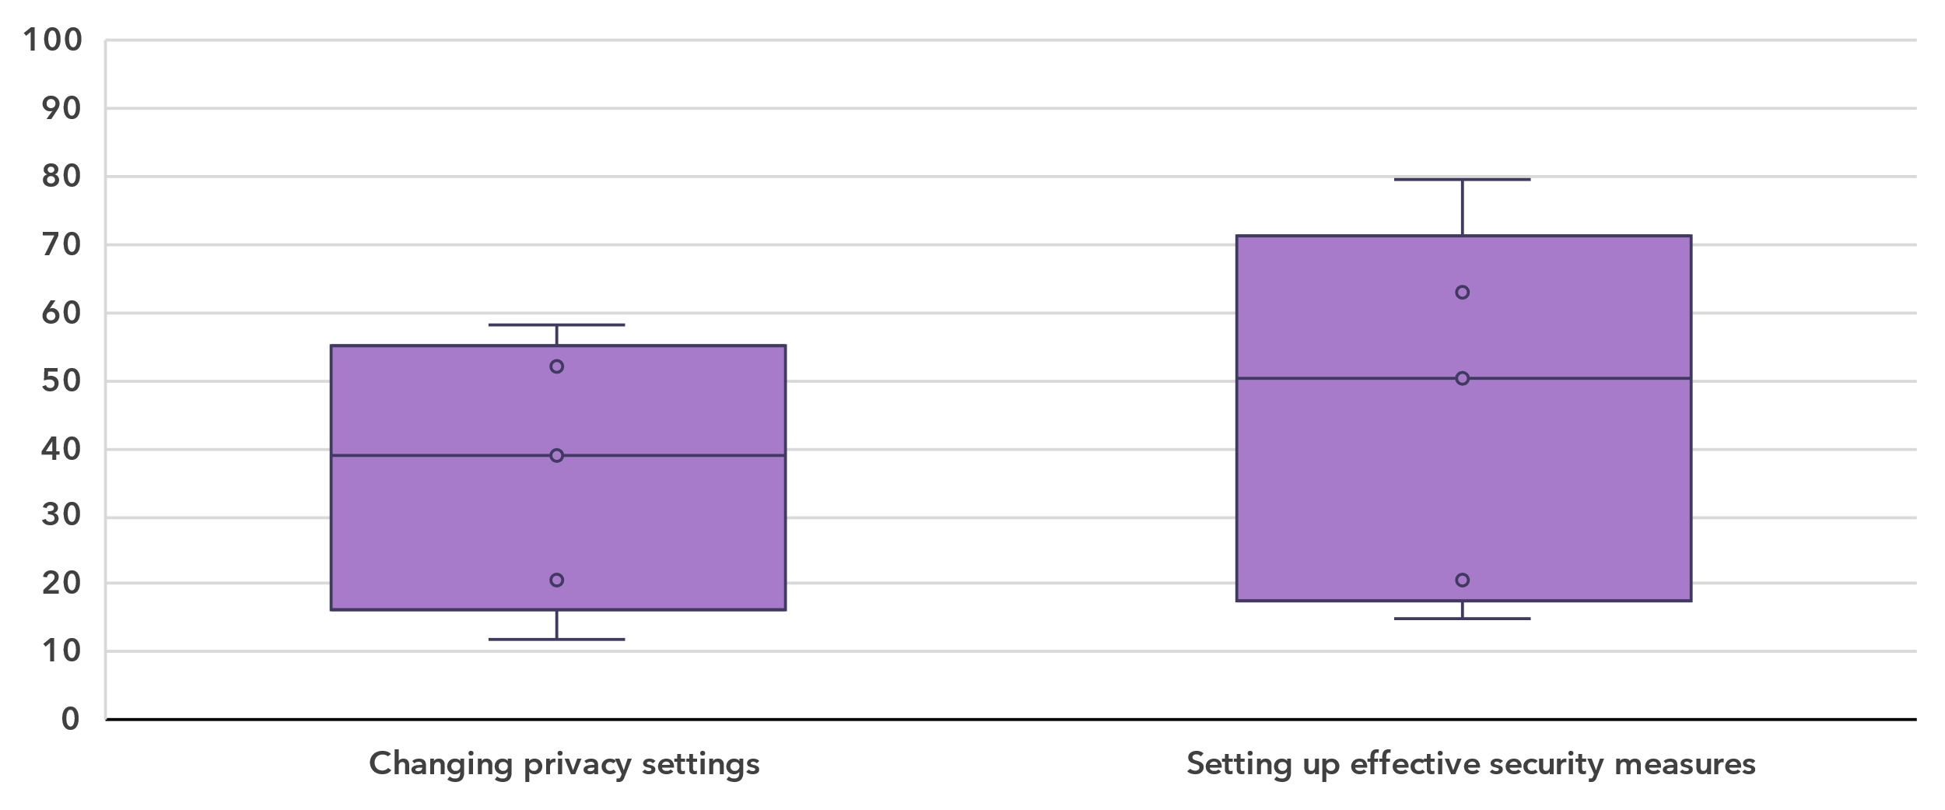Note: Bars indicate the 25th, median and 75th percentile of all country values. The whiskers (bottom and top lines) indicate individual minimum and maximum values. In-scope age varies between countries. Country data are for 2023 where available but no earlier than 2020. Five countries provided data for each indicator*.* Detailed information – including complete indicator names – is available [here](https://www.itu.int/en/ITU-D/Statistics/Documents/facts/rpm_ams_pub_2025_data.xlsx).

Source: ITU

The two activities in the safety category showed slightly different prevalences for countries in the region. The median shares were 39 and 50 per cent for changing privacy settings on one’s device, account or app and setting up effective security measures to protect devices and accounts, respectively. However, the share of individuals doing these activities varied widely between countries in the region.

Percentage of Internet users with problem solving skills, latest year available

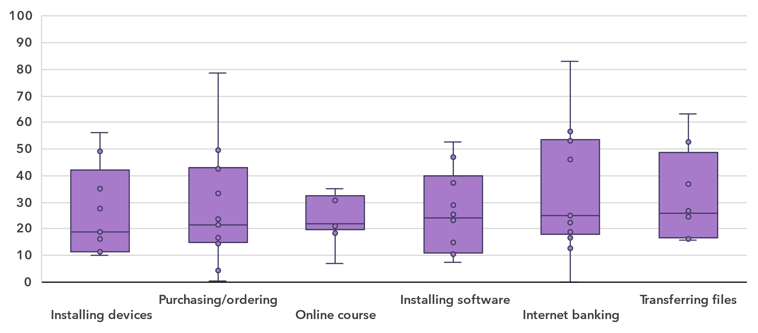Note: Bars indicate the 25th, median and 75th percentile of all country values. The whiskers (bottom and top lines) indicate individual minimum and maximum values. In-scope age varies between countries. Country data are for 2023 where available but no earlier than 2020. Data availability varies between nine and thirteen countries for each indicator*.* Detailed information – including complete indicator names – is available [here](https://www.itu.int/en/ITU-D/Statistics/Documents/facts/rpm_ams_pub_2025_data.xlsx).

Source: ITU

Finally, the medians for activities in the problem-solving skill area were quite close, from 19 per cent for connecting and installing new devices to 26 per cent for transferring files between a computer and other devices. Here as well, the share of individuals doing these activities varied widely between countries in the region.

Revenue and investment

***Telecommunications remains a key economic driver, but investment levels vary widely***

The telecommunication sector is an important enabler of economic development, with both direct and indirect impacts. While it is harder to capture the indirect impact, recent data on revenue and investment reveals the significance of the sector’s direct impact on development but also the considerable gaps between countries.

Revenue from all telecommunication services, in USD billion and as a % of GDP, 2023 or latest available year

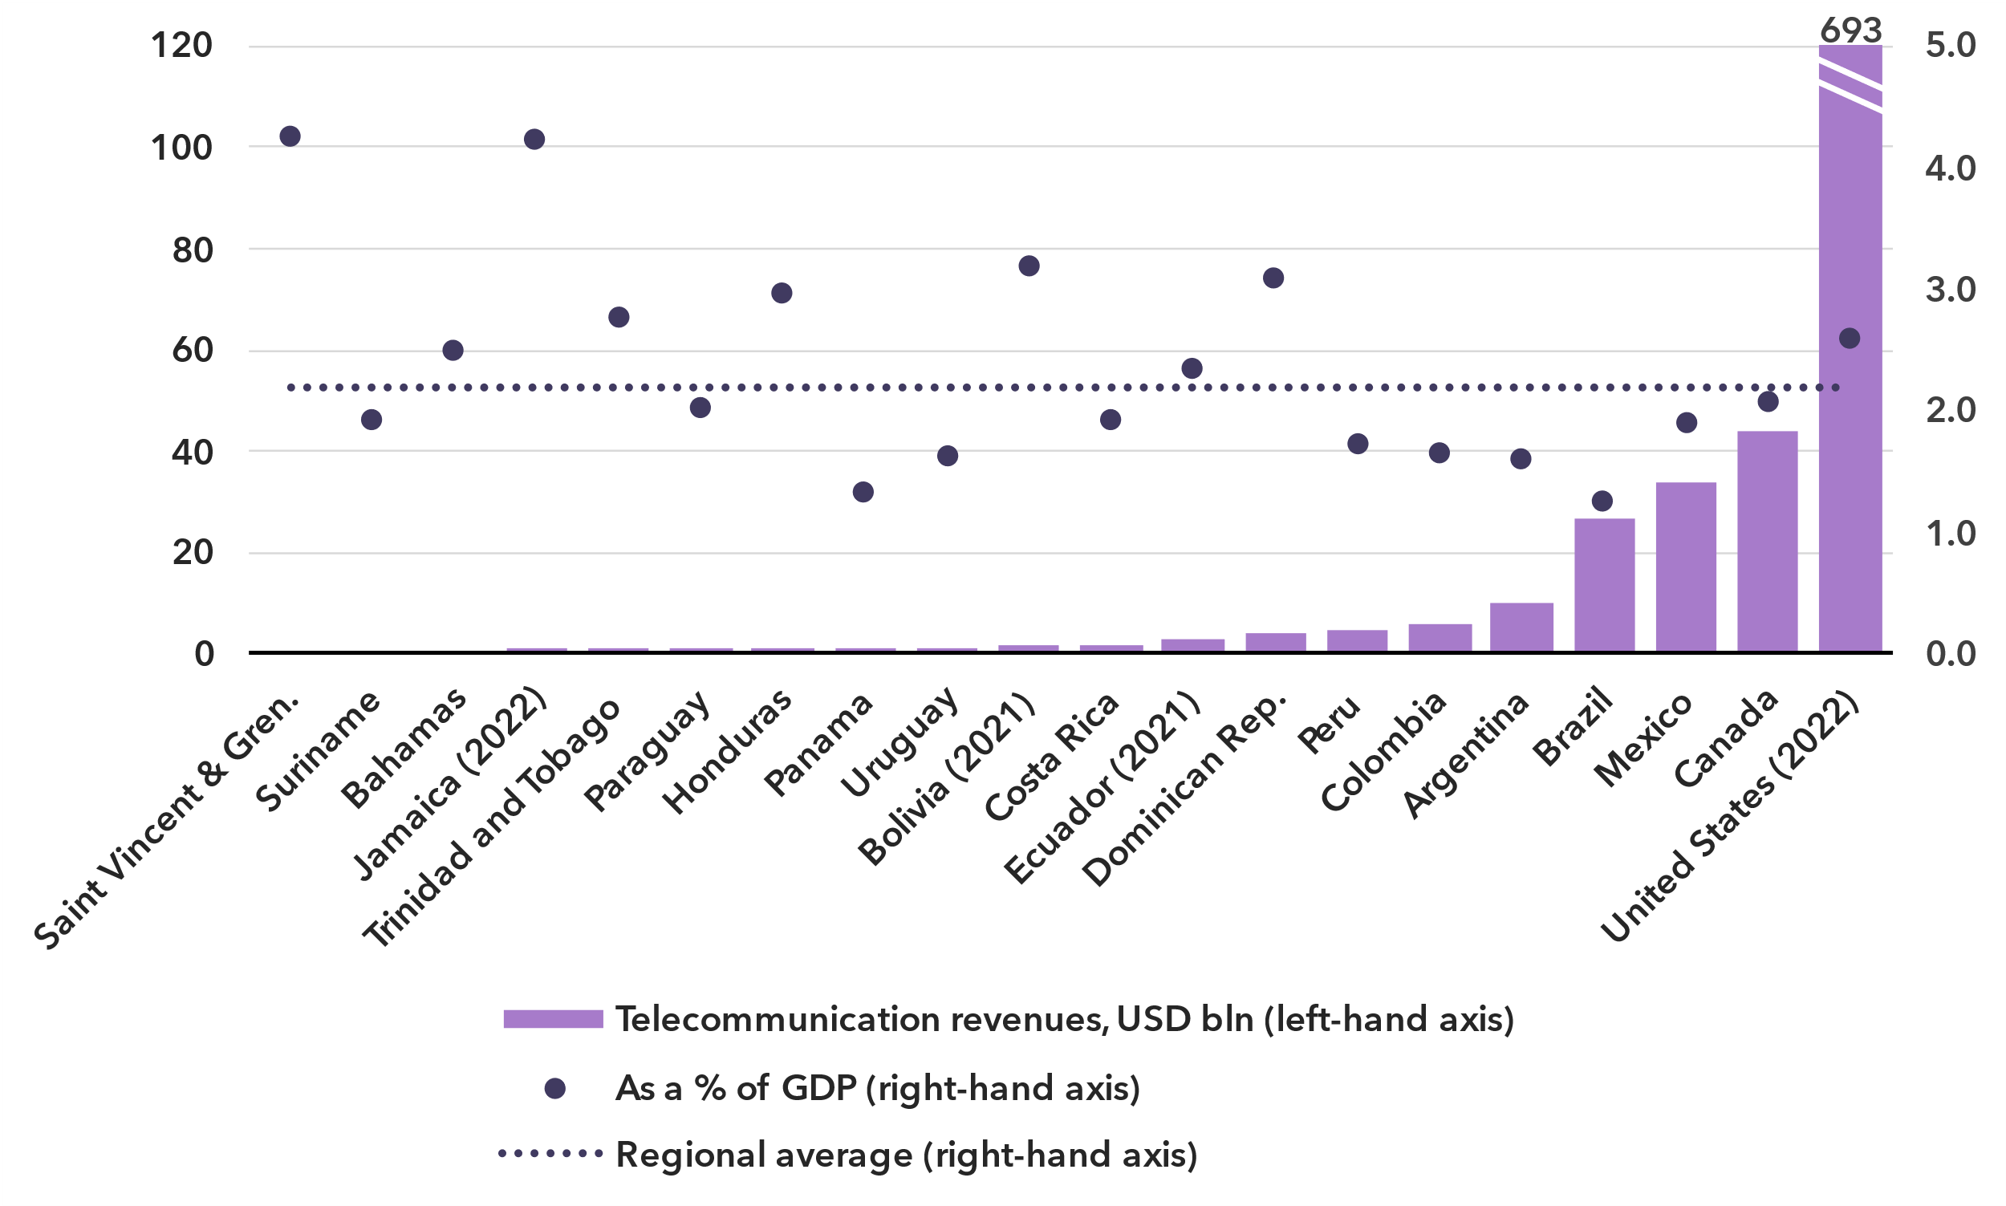Note: Annual average exchange rates applied, last available year values at constant 2023 prices.

Source: ITU, World Bank World Development Indicators

The ICT services sector includes activities providing telecommunications and related service activities, i.e. transmitting voice, data, text, sound and video, over wired, wireless, satellite or other networks.[9] The total annual retail revenue for the sector in the Americas region, for the 20 countries that provided data in the last available year since 2021, is estimated at around USD 834 billion. However, the size of the telecommunication market varies significantly across countries, with six countries reporting revenue below USD 1 billion, while the United States, the largest market, totalled USD 693 billion in revenue. Canada was a distant second with USD 44 billion.

This sector contributed an average of 2.2 per cent to the region's GDP. This proportion fluctuates, ranging from around 1 per cent to over 4 per cent in two countries.

Annual investment in telecommunication services, in USD billion and as % of GDP

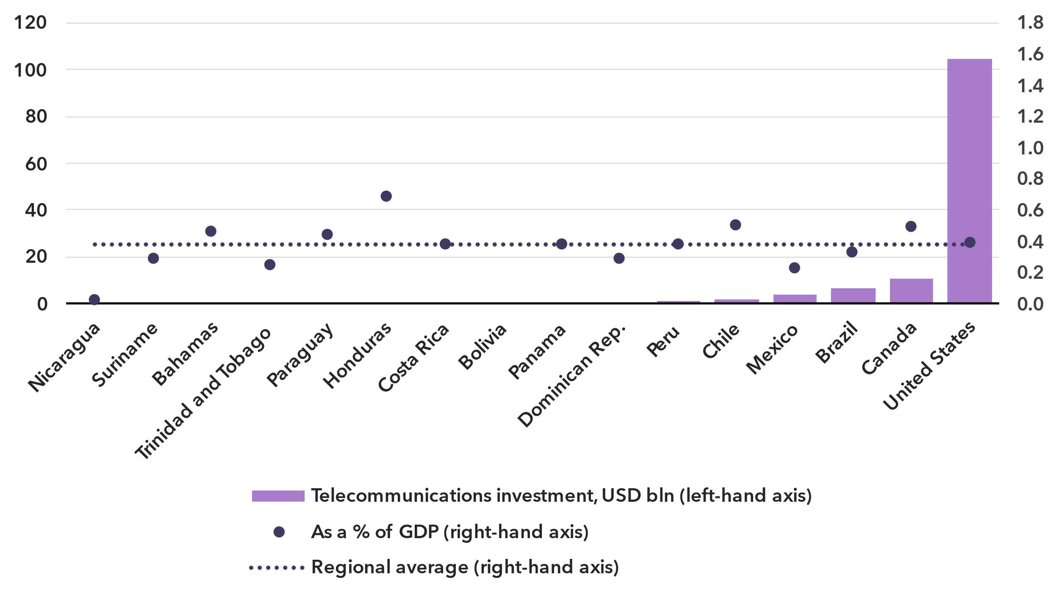Note: Data are a three-year (2021-2023) average of available data points to correct for annual fluctuations and gaps. Investment figures are in constant 2023 US dollars.

Source: ITU, World Bank World Development Indicators

The deployment of new network technologies and the upgrading of existing ones are highly capital-intensive activities. Investment projects often span multiple years and values fluctuate, which is why statistics are presented as the period average for 2021-2023. Those countries in Americas region for which data was available made annual investments ranging from less than USD 1 billion in eleven countries, to USD 11 billion in Canada and USD 104 billion in the United States. This corresponded to a median value of 0.4 per cent of GDP over the 2021-2023 period.[10]

Ensuring the infrastructural requirements for universal and meaningful connectivity requires significant, continuous investment efforts. On average, the ICT sector in the region invests around 18 per cent of the revenue, but this ratio changes from country to country. Investment levels in three countries of the region amount to around a quarter of the sectoral revenues, but in two of the countries this ratio does not reach 10 per cent.

Cybersecurity

***The Americas show stark contrasts in cybersecurity readiness and resilience***

Meaningful connectivity requires trustworthy and secure communications. With nine in ten people using the Internet, cybersecurity cannot be an afterthought. Addressing cybersecurity requires a holistic approach encompassing legal, technical, organizational, capacity development, and cooperation issues.

Global Cybersecurity Index scores, 2017-2024

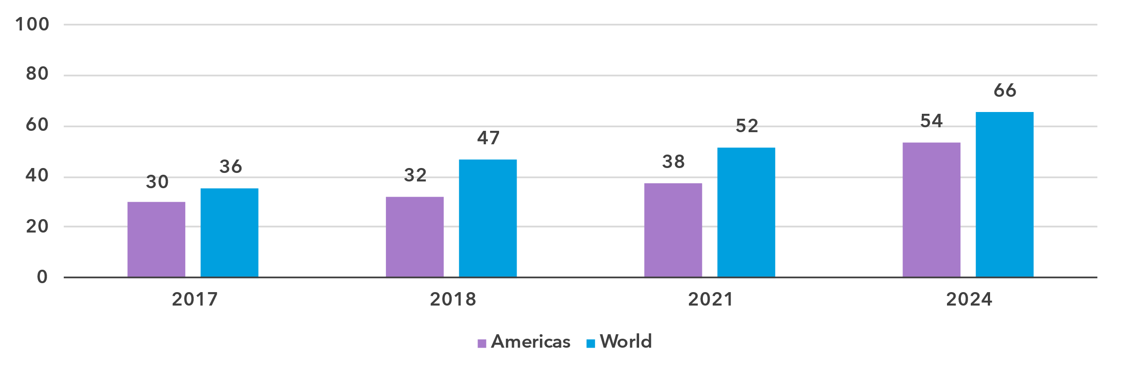

Note: Questions and weightings have been updated between editions, in collaboration with the GCI Expert Group, to better measure cybersecurity commitments by countries.

Source: ITU

Since 2015, the Global Cybersecurity Index (GCI) has tracked countries' performance on these issues, each represented by a pillar of the index, with an aggregate GCI score on a 0-100 scale. The 2024 edition revealed a notable improvement in countries’ commitment to cybersecurity: the average GCI score reached 66, up 14 points from the 2021 edition. Countries in the Americas have continued to expand their commitments with an average score of 54, a gain of 16 points from the previous edition.

Global Cybersecurity Index scores, by pillar and overall, 2024

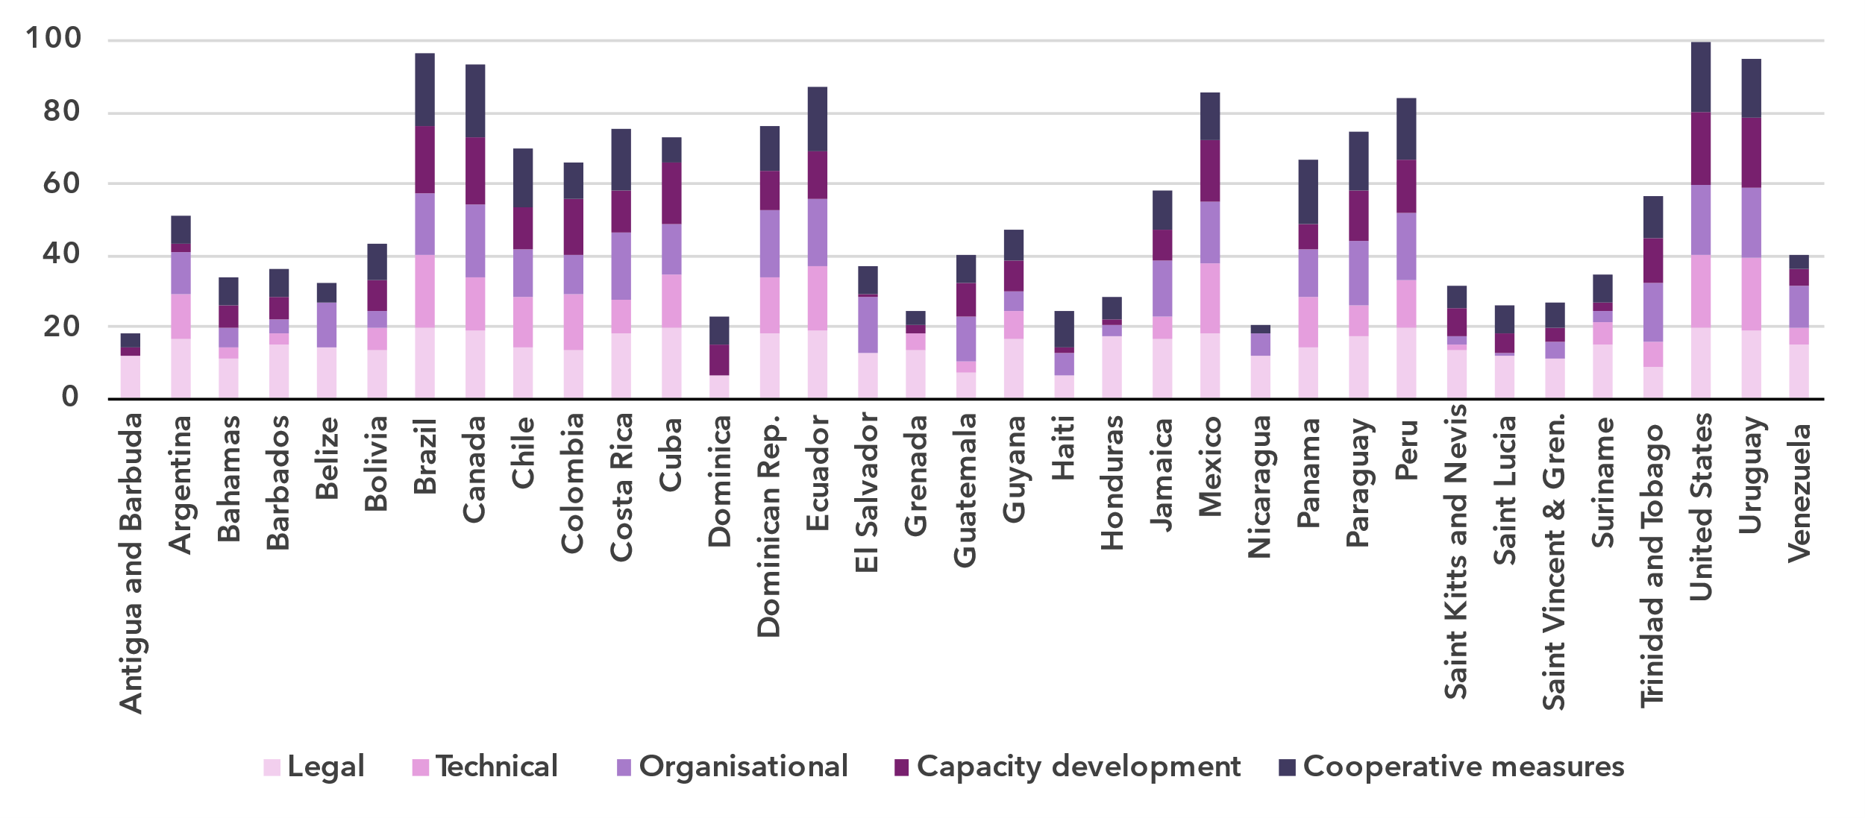Note: The overall GCI score shown is the sum of the score of the five pillars

Source: ITU

The performance in the GCI of the countries in the Americas region various greatly, with an 82-point gap between the region’s best performer, the United States scoring 99.9, and the region’s worst performer, Antigua and Barbuda, with a score of 18.2. The next lowest scoring country is Nicaragua, scoring 20.6, followed by other Small Island Developing States.

While Small Island Developing States are the among the lowest performers in the Americas, many SIDSs have shown significant improvement in the past years. Across the rest of the Americas Ecuador, Panama, Trinidad and Tobago have also made significant improvements.

The Technical Pillar of the GCI assesses the effectiveness of national mechanisms and institutional structures in detecting, preventing, responding to, and mitigating cyber threats and incidents. Computer Incident Response Teams (CIRTs) are responsible for the protection against, detection of, and response to cybersecurity incidents, and can enhance a country’s ability to manage cybersecurity incidents. 60 per cent (21) countries in Americas have established their national CIRTs, and many are participating in regional cyber exercises. Still, there is need for further development of these CIRTS, particularly among SIDS, and expanding efforts around the protection of critical information infrastructure.

Child Online Protection (COP) encompasses strategies and initiatives designed to protect children from harm or exploitation online. This includes ensuring children are using age-appropriate software and filtering tools and educating parents and children about staying safe online. Child Online Protection is tracked through questions under the Legal, Organizational, and Capacity Development pillars. A total of 164 countries reported having legal measures on Child Online Protection in the GCI 2024, compared to 130 countries in the previous edition. These measures were sometimes part of other rules, regulations, and substantive law, such as on online crime or sexual exploitation. 34 per cent (12) of countries in the Americas have some form of a Child Online Protection strategy with associated actions. Linking these efforts to educational efforts for educators, parents, and policy makers is key for long term impact.

Finally, to meet the demand for cybersecurity professionals, countries are increasingly developing cybersecurity skills within their populations. While 60 per cent (21) countries in the Americas have cybersecurity-focused university courses, countries still need to work to ensure that there are multiple pathways towards building cybersecurity competency to meet ongoing cyber needs.

E-waste management

***The Americas generate nearly a quarter of global e-waste, but only 30 per cent of it is recycled***

As countries strive to harness the benefits of technology to drive economic growth and achieve their national development priorities, the challenge of managing electronic waste has become increasingly urgent. Strengthened e-waste policy and regulatory e-waste management are pivotal for ensuring environmental sustainability, supporting circular economy practices, and advancing progress towards the sustainable development goals (SDGs).

E-waste generated, in millions of kilograms, 2022

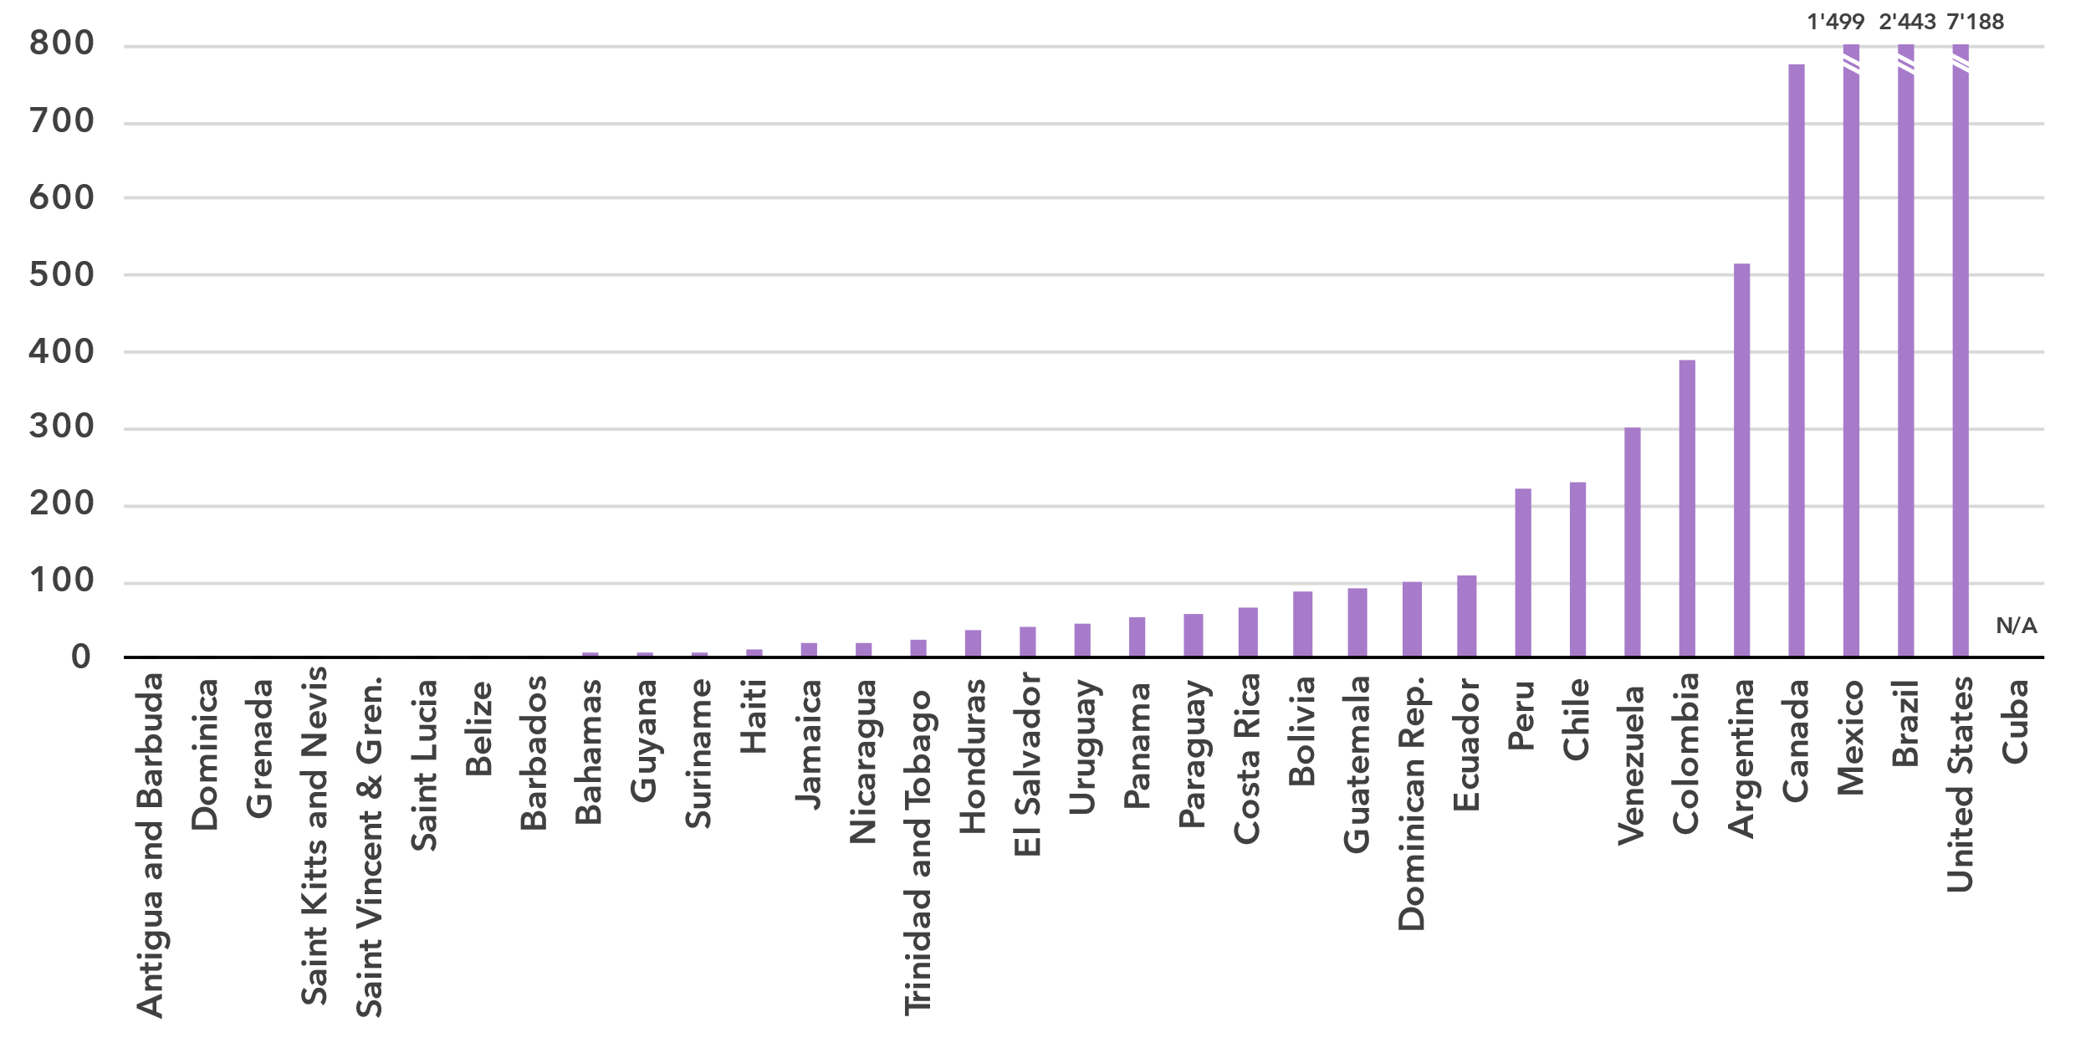 Source: ITU and UNITAR, [Global E-waste Monitor, 2024](https://www.itu.int/hub/publication/d-gen-e_waste-01-2024/)

The [Global E-waste Monitor 2024](https://www.itu.int/en/ITU-D/Environment/Pages/Publications/The-Global-E-waste-Monitor-2024.aspx) finds that in 2022, the Americas generated approximately 14.3 billion kg of e-waste, representing nearly 23 per cent of the global e-waste generation (62 billion kg). However, significant disparities exist across the region. The United States is the largest contributor, producing 7.2 billion kg, and accounting for over 50 per cent of the region’s total e-waste. Brazil and Mexico follow as significant contributors, generating 2.4 billion kg and 1.4 billion kg, respectively. In contrast, smaller countries like Dominica, Grenada, and Saint Kitts and Nevis generated 3 million kg of e-waste combined, representing less than 0.1 per cent of the total. This significant variation reflects differences in population size, economic development, and technological adoption across the region.

E-waste per capita generated in kg, 2022

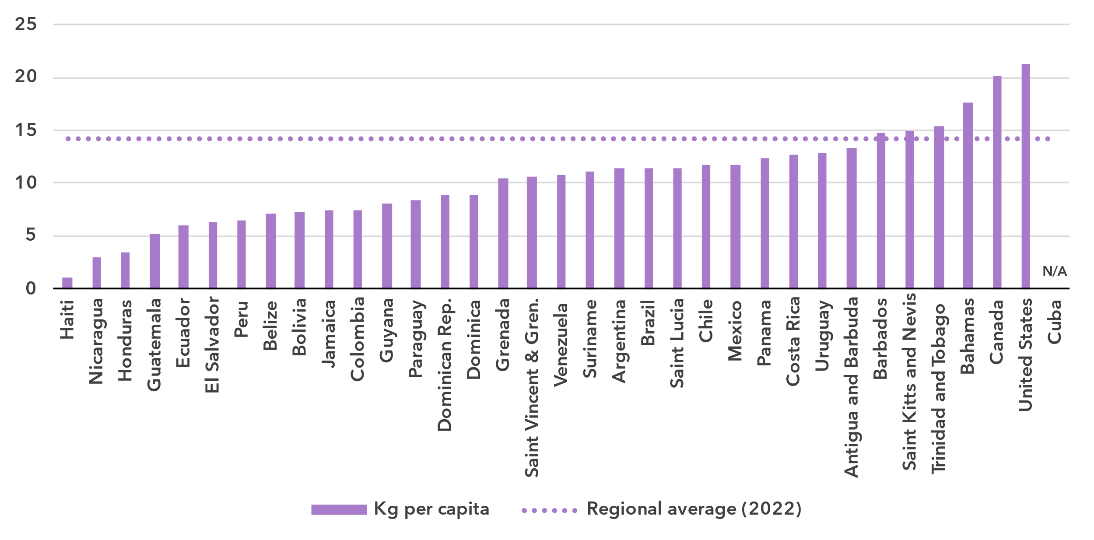 Source: ITU and UNITAR, [Global E-waste Monitor, 2024](https://www.itu.int/hub/publication/d-gen-e_waste-01-2024/)

The analysis of e-waste trends in the Americas can be further deepened by examining e-waste generation per capita. While the regional average of 14.1 kg per capita is higher than the global average of 7.8 kg, it reflects a diverse landscape. High-income countries like Canada and the United States lead with 20.2 kg and. 21.3 kg per capita, respectively, more than 2.5 times the global average. Countries such as Brazil and Mexico generate 11.4 kg and 11.8 kg per capita, surpassing the global average. In contrast, lower-income countries such as Haiti and Nicaragua, with per capita e-waste generation of just 1.1 kg and 3 kg, respectively, generate significantly less.

Despite the region’s significant e-waste generation, only 30 per cent (4.3 billion kg) of e-waste was documented as properly collected and recycled. Just 20 countries in the Americas report formal collection and recycling initiatives, while 15 countries lack such formal recycling activity. The United States leads the region with 4 billion kg, accounting for most of the recycled e-waste, followed by Canada with 98 million kg and Brazil with 79 million kg.

The absence of robust e-waste management policies presents a major challenge in the Americas, as only a limited number of countries have enacted comprehensive frameworks. While 42 per cent of countries globally (81 out of 193) have established national e-waste policies, legislation, or regulations, just 12 countries in the Americas have such measures in place, accounting for 35 per cent of the region.

E-waste policies and regulations in place, 2022

|  |  |  |  |  |
| --- | --- | --- | --- | --- |
|  | **National e-waste legislation/policy or regulation** | **Extended producer responsibility (EPR) framework for e-waste** | **Collection targets** | **Recycling targets** |
| Antigua and Barbuda | No | No | No | No |
| Argentina | Yes | Yes | No | No |
| Bahamas | No | No | No | No |
| Barbados | No | No | No | No |
| Belize | No | No | No | No |
| Bolivia | Yes | Yes | No | No |
| Brazil | Yes | Yes | Yes | No |
| Canada | Yes | No | No | No |
| Chile | Yes | Yes | No | No |
| Colombia | Yes | Yes | Yes | No |
| Costa Rica | Yes | Yes | No | No |
| Cuba | N/A | N/A | N/A | N/A |
| Dominica | No | No | No | No |
| Dominican Rep. | Yes | Yes | No | No |
| Ecuador | Yes | Yes | Yes | No |
| El Salvador | No | No | No | No |
| Grenada | No | No | No | No |
| Guatemala | No | No | No | No |
| Guyana | No | No | No | No |
| Haiti | No | No | No | No |
| Honduras | No | No | No | No |
| Jamaica | No | No | No | No |
| Mexico | Yes | No | No | No |
| Nicaragua | No | No | No | No |
| Panama | No | No | No | No |
| Paraguay | No | No | No | No |
| Peru | Yes | Yes | Yes | No |
| Saint Kitts and Nevis | No | No | No | No |
| Saint Lucia | No | No | No | No |
| Saint Vincent & Gren. | No | No | No | No |
| Suriname | No | No | No | No |
| Trinidad and Tobago | No | No | No | No |
| United States | Yes | No | No | No |
| Uruguay | No | No | No | No |
| Venezuela | No | No | No | No |

Source: ITU and UNITAR, [Global E-waste Monitor, 2024](https://www.itu.int/hub/publication/d-gen-e_waste-01-2024/)

The adoption of extended producer responsibility (EPR) frameworks, which are essential for holding producers accountable for the entire lifecycle of their products, is also limited. Only 9 countries have enacted EPR frameworks for e-waste. The absence of these frameworks across most of the Americas exacerbates the region’s e-waste challenges, contributing to the continued reliance on unregulated waste management practices that are harmful to both the environment and public health.

Additionally, formal collection and recycling targets remain scarce. While globally, countries with a policy or legal instrument that includes collection targets have a collection rate of 25 per cent on average, higher than the global average of 22 per cent, only 4 countries in the Americas have established collection targets. None has established recycling targets. Without such policies, the region risks missing key opportunities to advance towards a circular economy and reduce its environmental footprint.

Disparities within the region

***Regional averages mask deep inequalities in connectivity and digital access***

The Americas region is diverse in many respects: income level, with the wealthiest country’s GNI per capita more than 60 times larger than the poorest; urbanization rate, which ranges from less than 20 per cent to over 90 per cent; and population, which ranges from Small Island Developing States (SIDS) with less than 50,000 residents to large countries with more than 100 million residents.

Given these differences, it can be useful to group countries in the Americas into clusters, according to their scores on indicators of Internet use, mobile phone ownership, mobile broadband and fixed broadband subscription rates, affordability of entry-level mobile and fixed broadband, and gender equality. This ‘cluster analysis’ yields three distinct groups[11], whose respective members share similar ICT profiles.

The first group, consisting of Argentina, Bahamas, Brazil, Canada, Costa Rica, Jamaica, United States, and Uruguay, is characterized by rates of ICT usage and ownership that are well above the world average. Data-only mobile broadband is affordable relative to the world average, with median entry-level prices as a share of monthly GNI per capita below the Broadband Commission target of 2 per cent of monthly GNI per capita or lower for mobile broadband. However, the median affordability of fixed broadband is slightly above this target. There is also a high level of gender parity in terms of Internet use in this group.

The second group, consisting of more than half of countries in the Americas is closer to world averages for most indicators. Their average level of Internet use and mobile phone ownership are above the world average while subscription rates are slightly below the average. Gender parity for Internet use is in line with the world average and prices for both fixed and mobile broadband services are above the 2 per cent of monthly GNI per capita target.

The final group, consisting of Cuba, Ecuador, Guatemala, Haiti, Honduras, and Nicaragua, has the lowest rates of connectivity. While Internet use and mobile phone ownership are only slight below the world average, the group has much lower subscription rates and much worse affordability scores compared to the world. In contrast, Internet use gender parity is better than that for the world. Nevertheless, the overall low results for these indicators reflect the development challenges faced by these countries, particularly Haiti which is classified as an LDC.

Finally, Venezuela does not fall into any of the three groups, due in large part to its severe lack of affordability of broadband services.

The diversity of these groups of countries underlines the need to design tailored approaches to achieve universal and meaningful connectivity.

Average of key ICT indicators by groups of similar countries in the Americas, 2023

|  |  |  |  |  |  |
| --- | --- | --- | --- | --- | --- |
|  | Group | | |  | |
| **Indicator (units)** | 1  (8 American countries) | 2  (20 American countries) | 3  (6 American countries) | **World average** |
| Share of individuals using the Internet (%) | 89.2 | 78.3 | 61.2 | **65.4** |
| Gender equality - Internet use  (relative gender parity) | 1.13 | 0.94 | 1.00 | **0.90** |
| Share of individuals owning mobile phones (%) | 92.4 | 85.2 | 69.2 | **78.6** |
| Mobile-broadband subscriptions  (per 100 inhabitants) | 103.4 | 79.3 | 46.3 | **89.9** |
| Fixed-broadband subscriptions  (per 100 inhabitants) | 27.9 | 13.8 | 6.1 | **18.6** |
| Data-only mobile broadband prices  (as a % of GNI per capita) | 0.8 | 2.3 | 4.5 | **2.8** |
| Fixed broadband prices (as a % of GNI per capita) | 2.1 | 3.7 | 15.4 | **1.3** |

Note: Group medians shown for data-only mobile broadband and fixed broadband prices as a % of GNI per capita.

Source: ITU

Overview of data availability in the Americas

***More survey-based ICT indicators, better quality, and greater granularity are needed***

Data plays a key role in achieving universal and meaningful connectivity. Reliable and timely data equips policymakers to identify needs, set priorities, design effective interventions, track progress, and measure impact. Investing in data yields substantial returns by enabling better decision-making and more efficient interventions.

The importance of data for the delivery of the Kigali Action Plan was acknowledged by the BDT’s Telecommunication Development Advisory Group, which adopted five key performance indicators (KPIs) tracking the extent to which Member States submit timely ICT data to ITU, including KPIs related to the submission of ICT skills data and data on Internet use disaggregated by location and gender.

Availability for a core set of 14 core administrative ICT indicators, typically collected by national regulatory authorities or ministries, is on average 69 per cent in the region (see indicator list in the note of the figure below). Two countries report full availability, while ten countries are missing only one indicator. Five countries in the region do not have any recent data available for the selected indicators.

Some of the indicators are more readily available. Subscription and mobile network coverage indicators, for instance, are available in all but five countries of the region. However, additional efforts are needed to improve statistics on international bandwidth usage, fixed broadband Internet traffic as well as revenue and investments. These indicators are only available in at most 18 of the 35 countries studied in the Americas, and their quality also tends to vary over time.

Percentage availability of selected administrative ICT indicators, 2022-2023

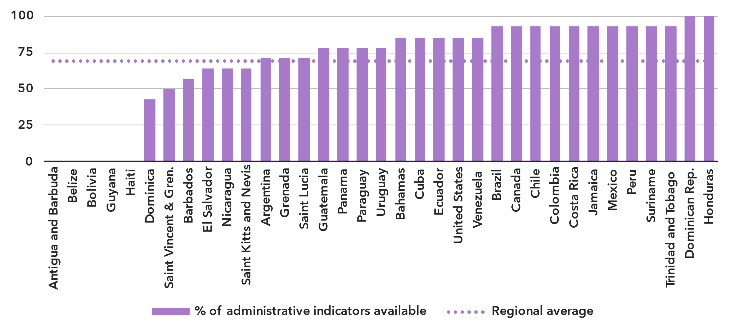Note: An indicator is considered available if at least one value is available for the period in question. Assessment based on the following set: active mobile broadband subscriptions, fixed broadband subscriptions (total, as well as by speed-tiers: 256 Kbit/s to 2 Mbit/s, 2 Mbit/s to 10 Mbit/s, and above 10 Mbit/s), mobile network coverage indicators by technology (at least 2G, 3G, LTE/WiMAX, 5G), total fixed broadband Internet traffic, mobile broadband Internet traffic within the country, international bandwidth usage, total telecommunication revenues and investment in telecommunication services.

Source: ITU

In contrast, data on ICT access and usage by households and individuals, usually derived from household surveys, varies widely between countries in the region. Only 16 countries in the Americas have provided at least partial data on ICT household indicators for the period 2022-2024. Nine countries haven’t provided any data in the last ten years.

The issue is even more acute for data disaggregated by socio-economic attributes, which is often not available. Seven countries have submitted recent data (2022 or more recent) for all six attributes of interest. Seven other countries have submitted recent data for at least one attribute.

Even when data is available, it may suffer from poor sample design, inadequate collection methods, or low response rates. Such shortcomings are likely to yield misleading results and may result in misguided policies. (For example, overestimation of ICT skills could lead policymakers to shift focus away from supporting populations that need training in this area.) Addressing these challenges requires a dual approach targeting both the producers and users of data. Through continuous efforts in capacity building, technical assistance, and advocacy, ITU aims to enhance the availability and quality of ICT data globally.

Latest year of submission of ICT household survey data, by socio-economic attribute



Source: ITU

Part 2. BDT4Impact: Selected case studies from the Americas

The second part of this document presents a selection of projects and initiatives supported by the ITU Telecommunication Development Bureau (BDT) in the Americas region. For more BDT impact stories, visit <https://www.itu.int/itu-d/sites/digital-impact-unlocked/all-stories/list/>.

Bridging the digital divide in indigenous and rural communities in the Americas

The [2024 ICT Network Bootcamp in Guatemala](https://www.itu.int/itu-d/sites/digital-impact-unlocked/bridging-the-digital-divide-in-indigenous-and-rural-communities-in-the-americas/) equipped leaders from indigenous and rural communities in Latin America with skills to build, sustain, and manage ICT networks.

The event also explored how technology can connect people, preserve cultural identities, and serve as a tool for education, healthcare, and economic opportunity.

**“**This training was not just about learning new skills; it was about understanding our communities’ identities and how technology can be a tool to enhance and preserve them,” said Jean Pierre Orozco Ruiz, an audiovisual creator who participated in the event.

The bootcamp was organized in collaboration with the Association for Progressive Communication, Rhizomatica, and Redes Por la Diversidad, Equidad y Sustentabilidad A.C.

Countries work to regulate e-waste to protect health, environment and resources

The Dominican Republic and Paraguay are building regulatory frameworks for the responsible management of e-waste, an important step towards creating a circular economy for electric and electronic devices.

So far, 12 countries in the Americas have established policy, legislation, or regulation governing the management of this complex and growing waste stream.

The Dominican Republic, which generates 100,000 tons of e-waste per year, recently approved new e-waste regulations, serving as a role model for nations facing similar challenges.

The new regulations were developed over two years with ITU support, in collaboration with the Dominican Republic’s Ministry of Environment and Natural Resources; INDOTEL, the country’s telecommunications regulatory entity; the United Nations Environment Programme; and private actors.

The Government of Paraguay aims to draft national regulations on e-waste in 2025 as part of a project sponsored by Saudi Arabia’s Communications, Space and Technology Commission. The project is supporting the country as it develops an e-waste regulatory framework.

The project is being implemented in cooperation with Paraguay’s Ministry of Environment and Sustainable Development and its National Telecommunications Commission (CONATEL). It began in December 2023 and will run through at least the end of 2025.

The Smart Seas Project builds disaster resilience among small-scale Caribbean fishers

The [Smart Seas Project](https://www.itu.int/itu-d/sites/digital-impact-unlocked/smart-seas-project-for-caribbean-small-scale-fishers/), a collaboration between the ITU Telecommunication Development Bureau, the Caribbean Telecommunication Union and the Telecommunications Authority of Trinidad and Tobago, provides digital tools and connectivity to improve maritime communications and help small-scale fishers stay safe at sea in Barbados, Grenada, St. Vincent and the Grenadines, and Trinidad and Tobago.

The project is also helping communities use ICTs for social and economic development.

Small-scale fishers, who comprise over 90 per cent of the world’s capture fisheries fleet, are highly vulnerable to disasters at sea, ranging from robbery and piracy to climate change-related disasters. These fishers provide about 40 per cent of the fish consumed daily, making them essential to economic and food security.

The Smart Seas Project demonstrates ITU’s commitment to using technology for social impact. As part of the project, workshops have been supporting the enabling environment and providing free tools for key agencies involved in maritime communications, such as regulators and rescue coordinators.

The free workshops include VHF-DSC radio training for fisherfolk, rescue coordinators, disaster management agencies, and regulators.

The work done is essential in saving lives, connecting vulnerable communities, and securing food and economic development in the Caribbean.

Crisis response: Hurricane Beryl

When Hurricane Beryl struck in June and July of 2024, spreading damage across the Caribbean and beyond, the [ITU Telecommunication Development Bureau responded in the immediate aftermath](https://www.itu.int/itu-d/sites/digital-impact-unlocked/crisis-response-itus-response-to-hurricane-beryl/) by providing satellite phones and accessories, and broadband global-area network devices.

In Grenada, Jamaica, and St. Vincent and the Grenadines, three of the worst-affected countries and home to more than 900,000 people, telephone and radio communication had been severely damaged or knocked out in the storm.

The ITU-led Disaster Connectivity Map was activated as well, to support responders with near real-time information on telecommunications connectivity.

Since it was launched in 2020, the Map has been activated in more than 30 countries/disasters to detect communications infrastructure outages. First responders, governments and UN agencies have used it extensively.

ITU is helping countries be better prepared for hazards. The work entails developing national emergency telecommunications plans, providing technical support, crafting policies and regulations that support sustainable, resilient ICT infrastructure, and more.

To ensure that communication networks can be quickly restored and maintained during emergencies, satellite equipment has been strategically placed in ITU regions, including in Bridgetown, Dubai, Geneva, and Harare.

Additionally, Intelsat, a multinational satellite services provider, is partnering with ITU to supply satellite equipment and services in disasters. Intelsat is part of the ITU's Partner2Connect Digital Coalition, which aims to improve digital inclusion and connectivity.

Special event in Argentina builds girls’ technology skills and knowledge about careers

An [Americas Girls Can Code event in Quilmes, Argentina](https://www.itu.int/itu-d/sites/digital-impact-unlocked/empowering-girls-in-technology-through-programming-and-innovation/) provided a forum for girls to learn computer programming and other tech-related skills and find out about careers in information and communication technology.

Yasmín, a professor of history from the National University of Quilmes, celebrated the event as a great opportunity for girls to meet, exchange ideas, and to build capacity to become the “women of the future.”

The event was part of the Americas Girls Can Code initiative, which is improving girls’ digital skills by promoting coding, robotics, and other science, technology, engineering and mathematics activities, while raising awareness about careers in information and communication technology.

The event was organised by the ITU Regional Office for the Americas with the support of the Subsecretary of Technologies and Information of Argentina, and the City of Quilmes.

Developing national telecommunications mapping system in Uruguay

A four-day mission in Montevideo, Uruguay, was undertaken to assist DINATEL, Uruguay’s National Directorate of Telecommunications and Audiovisual Communications Services, in organizing the first practical workshop on ICT infrastructure mapping, analysis, and planning.

The ITU Telecommunication Development Bureau is working with Uruguay to develop and implement a broadband mapping system to enhance the country's digital infrastructure and connectivity.

A telecommunications mapping system is a digital tool that collects and shows data about the coverage and quality of telecom networks in a specific area. Its main purpose is to help improve broadband networks by identifying gaps in coverage, quality, and affordability. This information supports decision-making for government officials, regulators, service providers, businesses, and citizens.

DINATEL has faced challenges due to a lack of centralized, up-to-date data on network deployment and service quality. The new system aims to provide comprehensive data, facilitating better coordination between public and private sectors.

The workshop took place during October 2024 and included sectoral meetings and site visits to key connectivity initiatives. The activities provided valuable insights into the state of telecommunications infrastructure.

Annex: Data resources

To ensure up-to-date information, and enhance readability, all data presented in this document are available for download as Excel files:

* [Country-level data](https://www.itu.int/en/ITU-D/Statistics/Documents/facts/rpm_arb_pub_2025_data.xlsx) organized by tabs corresponding to the sections of this document (URL: <https://www.itu.int/en/ITU-D/Statistics/Documents/facts/rpm_ams_pub_2025_data.xlsx>). Country level data were extracted from the [ITU DataHub](https://datahub.itu.int/), reflecting the February 2025 data release.
* [Regional and global estimates](https://www.itu.int/en/ITU-D/Statistics/Documents/facts/ITU_regional_global_Key_ICT_indicator_aggregates_Nov_2024.xlsx), as compiled for [Facts and Figures 2024](https://www.itu.int/itu-d/reports/statistics/facts-figures-2024/) (URL: <https://www.itu.int/en/ITUD/Statistics/Documents/facts/ITU_regional_global_Key_ICT_indicator_aggregates_Nov_2024.xlsx>).

1. The tiers of the G5 Benchmark reflect a country's level of digital governance. The four levels, from least to most advanced, are: Limited, Transitioning, Advanced and Leading. See [gen5.digital/benchmark](http://www.gen5.digital/benchmark)
2. <https://digitallibrary.un.org/record/4054465?ln=en>
3. ITU, [Accelerating Sustainable and Inclusive Digital Transformation in SIDS: A 10-Step Plan for SIDS](https://www.itu.int/net/epub/BDT/2024-ITUs-contribution-to-the-implementation-of-the-Antigua-and-Barbuda-Agenda-for-SIDS/index.html#p=1)
4. [https://docs.un.org/A/RES/79/233](https://eur03.safelinks.protection.outlook.com/?url=https%3A%2F%2Fdocs.un.org%2FA%2FRES%2F79%2F233&data=05%7C02%7Cyoulia.lozanova%40itu.int%7C0062349b3e6e4b3b9c3d08dd34f459e5%7C23e464d704e64b87913c24bd89219fd3%7C0%7C0%7C638724946270432167%7CUnknown%7CTWFpbGZsb3d8eyJFbXB0eU1hcGkiOnRydWUsIlYiOiIwLjAuMDAwMCIsIlAiOiJXaW4zMiIsIkFOIjoiTWFpbCIsIldUIjoyfQ%3D%3D%7C0%7C%7C%7C&sdata=KU3ejXHGwiBsr3GAie7k%2FxDEgJPQjzmmdFn3JCAXNsg%3D&reserved=0)
5. Considering that some people may never want to connect, as a matter of convention universality is taken to mean an Internet penetration rate of at least 95 per cent.
6. In this document, for figures reporting economy-level data, all economies are shown. Countries are sorted by value of the indicator. A data point is only shown if it is for the year 2020 or later, otherwise it is marked as not available (N/A), or excluded altogether (when data are not available for many countries). In addition, a marker shows the data point for the year 2018, if available. Data are extracted from the [ITU DataHub](https://datahub.itu.int/), based on the data release of February 2025. Since country-level data are available for the year 2023 at best, for comparison purposes, the regional average for the year 2023 is reported as well, as published in [Facts and Figures 2024](https://www.itu.int/itu-d/reports/statistics/facts-figures-2024/). To save space in these figures, “Saint Vincent & Gren.” is used instead of “Saint Vincent and the Grenadines”, and “Bolivia” is used instead of “Bolivia (Plurinational State of)”.
7. The gender parity score is calculated as the proportion of women who use the Internet divided by the proportion of men who use the Internet. A value less than one indicates that men are more likely to use the Internet than women, while a value greater than one indicates the opposite. Gender parity is considered achieved if the value lies between 0.98 and 1.02.
8. Considering only those countries for which data was available for all years from 2018 to 2024.
9. For a complete definition, see ISIC Rev. 4 class 61.
10. Investment statistics collected by ITU refer to acquiring or upgrading property (including tangible assets such as plants and non-tangible assets such as computer software) and networks. Expenditure on research and development, annual fees for operating licences and the use of radio spectrum, and investment in telecommunication software or equipment for internal use are excluded.
11. Venezuela is not included in the three groups due to substantial differences in connectivity with others in the region.