|  |  |  |  |
| --- | --- | --- | --- |
|  | **Regional Preparatory Meeting  for Africa for WTDC-25 (RPM-AFR)**  **Nairobi, Kenya, 8-9 April 2025** | |  |
|  | |  | |
|  | | **Document** **RPM-AFR25/3-E** | |
|  | | **4 March 2025** | |
|  | | **Original: English** | |
| Director, Telecommunication Development Bureau | | | |
| State of digital development and trends in the Africa region:  Challenges and opportunities | | | |
|  | | | |
| **Agenda item:**  5  **Summary:**  This document, prepared for the RPM for Africa, aims to inform participants and stakeholders in setting the region’s digital agenda. It is structured into two parts: the first provides an overview of the state of digital connectivity in Africa through key indicators, and the second highlights impactful case studies from the region.  **Expected results:**  RPM-AFR is invited to note this document  **References:**  N/A | | | |

State of digital development and trends in the Africa region: Challenges and opportunities

March 2025

Contents

Introduction 3

Part 1. The state of digital connectivity in Africa and recent trends 4

ICT regulation and digital policy frameworks 4

Internet use 10

Broadband subscriptions 15

Mobile network coverage 17

Availability of fixed-broadband infrastructure 20

Internet traffic and international bandwidth 22

Affordability of ICT services 25

Mobile phone ownership and subscriptions 27

ICT skills 29

Revenues and investment 31

Cybersecurity 33

E-waste management 35

Disparities within the region 39

Overview of data availability in Africa 41

Part 2. BDT4Impact: Selected case studies from Africa 44

Visually impaired people in Ghana learn computer basics 44

Working toward a digitally enabled Uganda 44

Digital terrestrial television training in Brazzaville, Republic of Congo 45

A new national e-waste policy in Malawi 45

Businesswomen in Africa thrive after developing their digital skills 45

Building regulatory capacity and regional collaboration through ICT benchmarking in Equatorial Guinea 46

Annex: Data resources 47

Introduction

The Regional Preparatory Meetings (RPMs) engage member states in preparations for the World Telecommunication Development Conference 2025. Prepared for the RPM for Africa on 8-9 April 2025, in Nairobi, Kenya, this document provides key insights to support participants and stakeholders in discussions on the region’s digital agenda.[1] It consists of two parts: the first offers an overview of digital connectivity in Africa through key indicators, while the second showcases case studies from the region.

**Universal and meaningful connectivity must be a central objective for Africa’s development.** The concept of universal and meaningful connectivity (UMC) has emerged as a critical policy objective. UMC is defined as the possibility for everyone to enjoy a safe, enriching, and productive online experience at an affordable cost. UMC does not mean everyone must be connected all the time but describes a situation where everyone can access the Internet optimally and affordably whenever and wherever needed.

**Africa’s digital transformation is at an early stage.** The gap between Africa’s digital reality and the ambition of UMC remains wide. Despite steady progress, digital connectivity in Africa remains limited, hindering the region’s digital transformation. Only a small fraction of the population is truly benefiting from and contributing to this process. Africa is home to a few countries whose digital development surpasses global averages, while others rank among the least connected in the world. Additionally, significant disparities exist within countries, with digital divides particularly pronounced between urban and rural populations, wealthier and lower-income users, and across gender lines.

**Mobile networks are the backbone of Internet access in Africa.** With fixed-broadband infrastructure still limited and costly, mobile networks play a dominant role in providing Internet access. By 2024, mobile broadband covered 86 per cent of Africa’s population, leaving 14 per cent without the possibility of connecting (25 per cent in rural areas). While 70 per cent of the population was covered by 4G, 16 per cent still relied on 3G, which offers slower speeds and a limited online experience. 5G rollout has started in a few countries but only reached 11 per cent of the population.

**Internet adoption is growing, but usage remains far behind other regions.** In 2024, only 38 per cent of Africa’s population used the Internet, the lowest rate among ITU regions and significantly below the global average of 68 per cent. Although adoption has increased, millions remain offline due to high service costs, digital illiteracy, and a lack of reliable connectivity, particularly in rural areas. Youth and urban populations are driving digital uptake, while older adults and rural communities continue to lag.

**The urban-rural digital divide remains stark.** In 2024, Internet usage among the urban population reached 57 per cent, compared to just 23 per cent in rural areas, by far the largest gaps among all regions. 4G and 5G networks primarily serve urban populations, leaving rural communities with slower and less reliable connectivity. Expanding rural broadband infrastructure and introducing targeted policies to address rural connectivity challenges will be crucial for bridging this divide.

**Affordability is a major barrier to digital inclusion.** In 2024, the median price of an entry-level mobile broadband plan (2GB) was 4.2 per cent of gross national income (GNI) per capita, down from 4.6 per cent the previous year, yet still the highest of any region and well above the UN Broadband Commission’s 2 per cent affordability target. Fixed broadband is even less accessible, with a median price of 15 per cent of GNI per capita. These high costs disproportionately impact lower-income groups, exacerbating digital inequalities.

**ICT regulation in Africa has advanced, but challenges persist.** Over the past decade, many African countries have strengthened their ICT regulatory frameworks, with a shift toward more competitive and investment-friendly policies. However, regulatory maturity in the region still lags global trends. Only 18 per cent of African countries have reached the most advanced stage of ICT regulation (G4), compared to a global average of 38 per cent. Strengthening digital governance and regulatory frameworks is crucial for accelerating digital transformation. The region must remain focused on adopting robust digital policies that drive infrastructure investment, targeted initiatives in digital identity and skills and cross-sector collaboration to bridge digital divides.

**Cybersecurity and data protection require greater attention.** As connectivity grows, so do risks related to cybersecurity, online fraud, and data privacy. Between 2021 and 2024, Africa’s average score on the Global Cybersecurity Index (GCI) increased by 22 points to reach 57 (out of 100). The difference with the global average score (66) has been cut in half. Many African countries still lack comprehensive cybersecurity strategies, national computer incident response teams (CIRTs), or strong data protection laws. This regulatory gap makes businesses and individuals vulnerable to cyber threats, impeding trust in digital services.

**E-waste is a growing environmental concern in Africa.** In 2022, the continent generated an estimated 2 billion kilograms (kg) of electronic waste (e-waste), accounting for a small fraction of the 62 billion kg produced globally. Only 0.7 per cent of Africa's e-waste was formally collected and recycled, significantly below the global average recycling rate of 22.3 per cent. This disparity highlights the urgent need for robust e-waste management policies and recycling infrastructure to mitigate environmental hazards and recover valuable materials. As it stands, however, only 12 countries in the region are covered by a national e-waste policy, legislation or regulation.

**The lack of reliable ICT data is a major obstacle to progress.** Africa faces a severe lack of ICT statistics, particularly from household surveys. For the period 2022-2024, only nine countries provided even partial ICT household data. Data on ICT skills is almost non-existent, with only eight countries submitting data on the topic since 2019 and only one providing data on skill levels. Embedding data collection into national digital strategies is crucial, as granular and timely information is essential for designing effective policies, allocating resources efficiently, and tracking progress.

**Impact stories from the region highlight the role of digital transformation.** The second part of the document showcases a selection of ITU-supported initiatives. In Ghana, visually impaired individuals are learning essential digital skills through specialized training programs. In Uganda, digital transformation initiatives are expanding access to e-government services and enhancing digital literacy. The Republic of Congo has strengthened its broadcasting sector with a digital terrestrial television training program. In Malawi, a new national policy promotes sustainable management of e-waste. Women entrepreneurs in Burundi and Ethiopia are thriving after developing digital skills that enhance their businesses. In Equatorial Guinea, ICT benchmarking initiatives are building regulatory capacity and fostering regional collaboration.

**A holistic, multistakeholder effort is needed.** Achieving UMC in Africa requires a comprehensive approach that prioritizes both access and enablers of digital inclusion. Expanding infrastructure for universal access is critical, but beyond that, the region must address key factors such as affordability, digital skills, and reliable connectivity. Updating policy frameworks will also be crucial in overcoming these challenges. Success will depend on collaboration among governments, the private sector, civil society, and international organizations.

Part 1. The state of digital connectivity in Africa and recent trends

ICT regulation and digital policy frameworks

The evolving landscape of ICT regulation and digital policy frameworks plays a critical role in driving an inclusive and sustainable digital transformation as well as fostering thriving digital economies. To ensure national frameworks remain effective and adaptive, it is crucial to assess progress, identify best practices and address existing gaps.

***ICT regulation in Africa is advancing but outpaced by global trends***

Africa has made significant strides in ICT regulation over the past 15 years, driven by reforms in key areas such as interconnection, quality of service, infrastructure sharing and competition. In 2007, African countries were almost evenly split between Generation 1 (G1) and Generation 2 (G2), the least advanced levels of ICT regulation. The COVID-19 pandemic brought long-standing regulatory issues to the forefront, driving reforms in spectrum licensing and ICT service-specific taxes. However, this momentum has since slowed.

Today, only two African least developed countries (LDCs) remain in G1 and three quarters of countries in the region have transitioned to either G2 or G3. Yet only 18 per cent of countries have reached Generation 4 (G4), the highest level – falling behind all other regions except one. By comparison, 38 per cent of countries worldwide had achieved G4 status by 2022, creating more enabling environments for ICT markets.

Evolution of the generations of ICT regulation in the Africa region

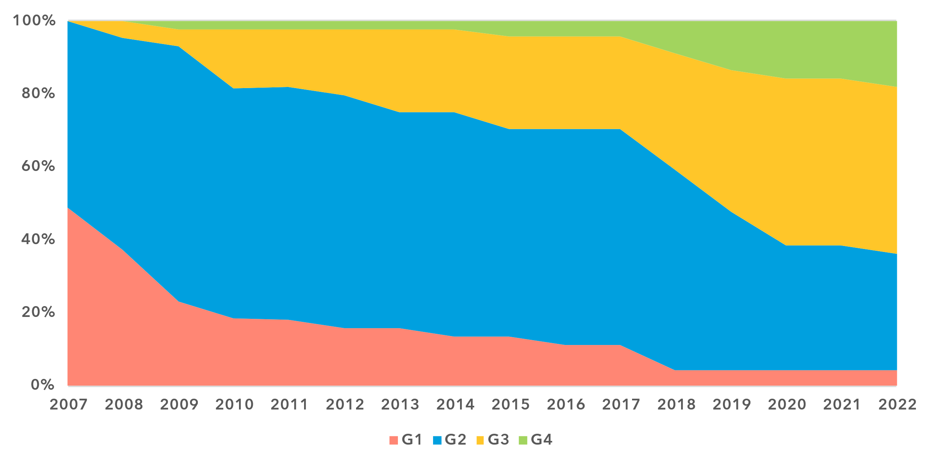

Note: The ‘Generations of ICT regulation’ provides a high-level conceptual framework for assessing the overall development of national legal instruments, policies and governance for the ICT and digital sectors. Generations 1 through 4 are based on [ICT Regulatory Tracker](https://app.gen5.digital/tracker/metrics) scores:

G1 – Command and control approach: score between 0 and 40   
G2 – Early open markets: score between 40 and 70   
G3 – Enabling investment and access: score between 70 and 85   
G4 – Integrated telecommunication regulation: score between 85 and 100

Data for 2021 is unavailable; 2020 data is used as a proxy for 2021.

Source: ITU

Progress has been uneven across different country groups. Africa is home to 28 least developed countries (LDCs), 16 landlocked developing countries (LLDCs) – 13 of which are also LDCs – and 5 small island developing states (SIDS), including two LDCs[2], making it the region with the highest concentration of vulnerable and least developed countries globally. LDCs and LLDCs are spread across all regulatory generations, but five LDCs – Burkina Faso, Malawi, Rwanda, Senegal, and Uganda – have reached G4, alongside Kenya, Nigeria and South Africa. No SIDS has yet achieved G4, though the majority (60 per cent) are in G3, making steady progress in strengthening their ICT regulatory frameworks.

Building on this progress, African countries must continue upgrading their national and regional regulatory frameworks. Strengthening ICT regulation will be essential to advancing digital governance and accelerating digital transformation across the continent.

***Digital governance in Africa: behind the curve***

Africa and CIS are the only regions without a country in the G5 Benchmark Leading category[3], the world’s top tier for digital governance frameworks. Only 16 per cent of African countries have reached the Advanced level, including Benin, Ghana, Kenya, Mauritius, Nigeria, Rwanda and South Africa. Notably, Benin and Rwanda stand out as the only LDCs globally in this category, underscoring that strong policy focus and institutional commitment can drive digital governance progress in any development context.

However, most African countries – 84 per cent – remain in the Limited or Transitioning tiers, the least advanced levels of digital governance. Despite notable progress since 2021, Africa remains the lowest-ranked region in digital governance benchmarks. In 2023, the region's overall digital governance score stood at 43 per cent, or nine percentage points below the world average.

Africa trails global trends in all four key areas of digital governance. The strongest relative performance is in National Collaborative Governance, where the gap with the world average is just six percentage points. However, the region lags significantly in Policy Design Principles, Digital Development Instruments and Digital Economy Policy Agenda benchmarks, with deficits ranging from 23 to 34 percentage points. The region’s performance suggests that legal and institutional gaps remain a challenge for effective digital governance, signalling a pressing need for further reforms.

***Readiness of national frameworks in Africa: progress uneven, gaps persist***

The readiness of national policy, legal and governance frameworks for digital transformation depends on robust ICT regulation and adaptive digital governance – two mutually reinforcing pillars. Together, they provide the foundation for inclusive and sustainable digital transformation across economic sectors, government and society. National frameworks also play a crucial role in regional integration, enabling digital markets to scale across borders.

In 2023, Africa’s overall readiness for digital transformation stood at 46 per cent – five percentage points below the world average. While the region outperforms the global average in two benchmarks, it lags in the remaining seven, with gaps ranging from four to 11 percentage points.

Strong and coherent national digital transformation agendas are a stepping stone towards achieving universal and meaningful connectivity. These agendas need to be supported by essential instruments such as holistic and sectoral digital policies alongside targeted strategies aimed at meaningfully connecting all citizens. Africa's National Digital Agenda benchmark stands at 39 per cent, just below the global average, while LDCs and SIDS lag further behind at 35 per cent and 30 per cent, respectively. This gap in governance frameworks weakens their capacity for digital transformation and risks hindering broader development goals across the continent.

Legal, policy and governance frameworks for digital transformation, 2023

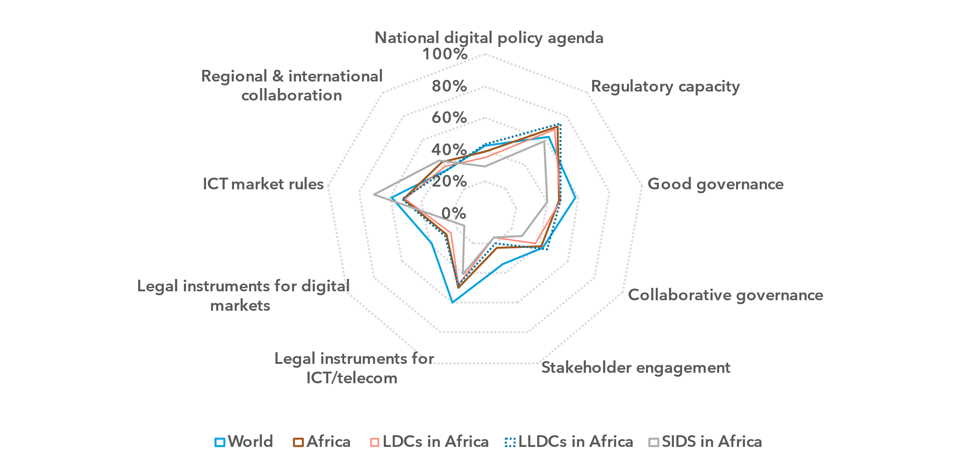Note: The nine thematic benchmarks (as in the chart above) each comprise a subset of indicators, as part of the [ITU Unified Framework for the readiness of national policy, legal and governance frameworks for digital transformation](https://www.itu.int/pub/D-PREF-BB.REG_OUT01-2023/en).

The chart shows progress on the nine benchmarks for the Africa region (average for the group) compared to the world average and the averages for LDCs (28 countries), LLDCs (16 countries) and SIDS (5 countries) in the region. The percentage of achievement on each benchmark indicates the proportion of met versus unmet targets on indicators in each benchmark.

Source: ITU

In contrast, Africa’s Regulatory Capacity benchmark of 71 per cent is on par with Europe (72 per cent) and significantly above the world average (63 per cent). This finding indicates that regulatory mandates are firmly embedded in legal frameworks, with decision-making, enforcement and accountability mechanisms well established across most countries in the region, including LDCs, LLDCs and SIDS.

However, gaps in good governance and market regulation frameworks persist. Stakeholder Engagement (23 per cent) and Instruments for Digital Markets (27 per cent) are the weakest regional benchmarks, with the largest gaps in LDCs and SIDS. These deficits slow down the development of inclusive digital economies.

The disparity between ICT market regulation (50 per cent) and digital market regulation (27 per cent) is particularly concerning. Africa is the second lowest ranked region in Legal Instruments for ICT markets – nine percentage points below the world average. In Legal Instruments for digital markets, the gap is even wider at 12 percentage points, making Africa the lowest-ranked region.

Regional and international cooperation in Africa can be a powerful driver for progress across all main areas of ICT regulation and digital governance. Africa’s benchmark in this area – 46 per cent – is above the world average and second only to Europe. This relative strength presents a strategic opportunity. By leveraging regional collaboration, Africa can accelerate digital governance reforms, foster regulatory convergence, and build dynamic, transformative digital ecosystems that drive economic and social progress.

***Growing policy focus on digital inclusion, but LDCs and SIDS face barriers***

Over the past decade, digital inclusion policies in Africa have gained traction, with LLDCs leading the way in most areas and often surpassing global benchmarks.

National digital strategies and universal access and service policies set the priorities, targets and mechanisms to ensure access to digital technologies and services, enabling meaningful participation in the economy and society. The adoption of national digital strategies (86 per cent) and universal access policies (57 per cent) in Africa aligns with world averages. Similarly, the region’s focus on gender-inclusive connectivity policies (in 20 per cent of countries) follows global trends, though adoption worldwide remains as low as 14 per cent. ICT accessibility policies show an even wider gap, with only 23 per cent of African countries implementing one, well below the global average of 58 per cent.

Digital inclusion policy instruments in the Africa region, 2023

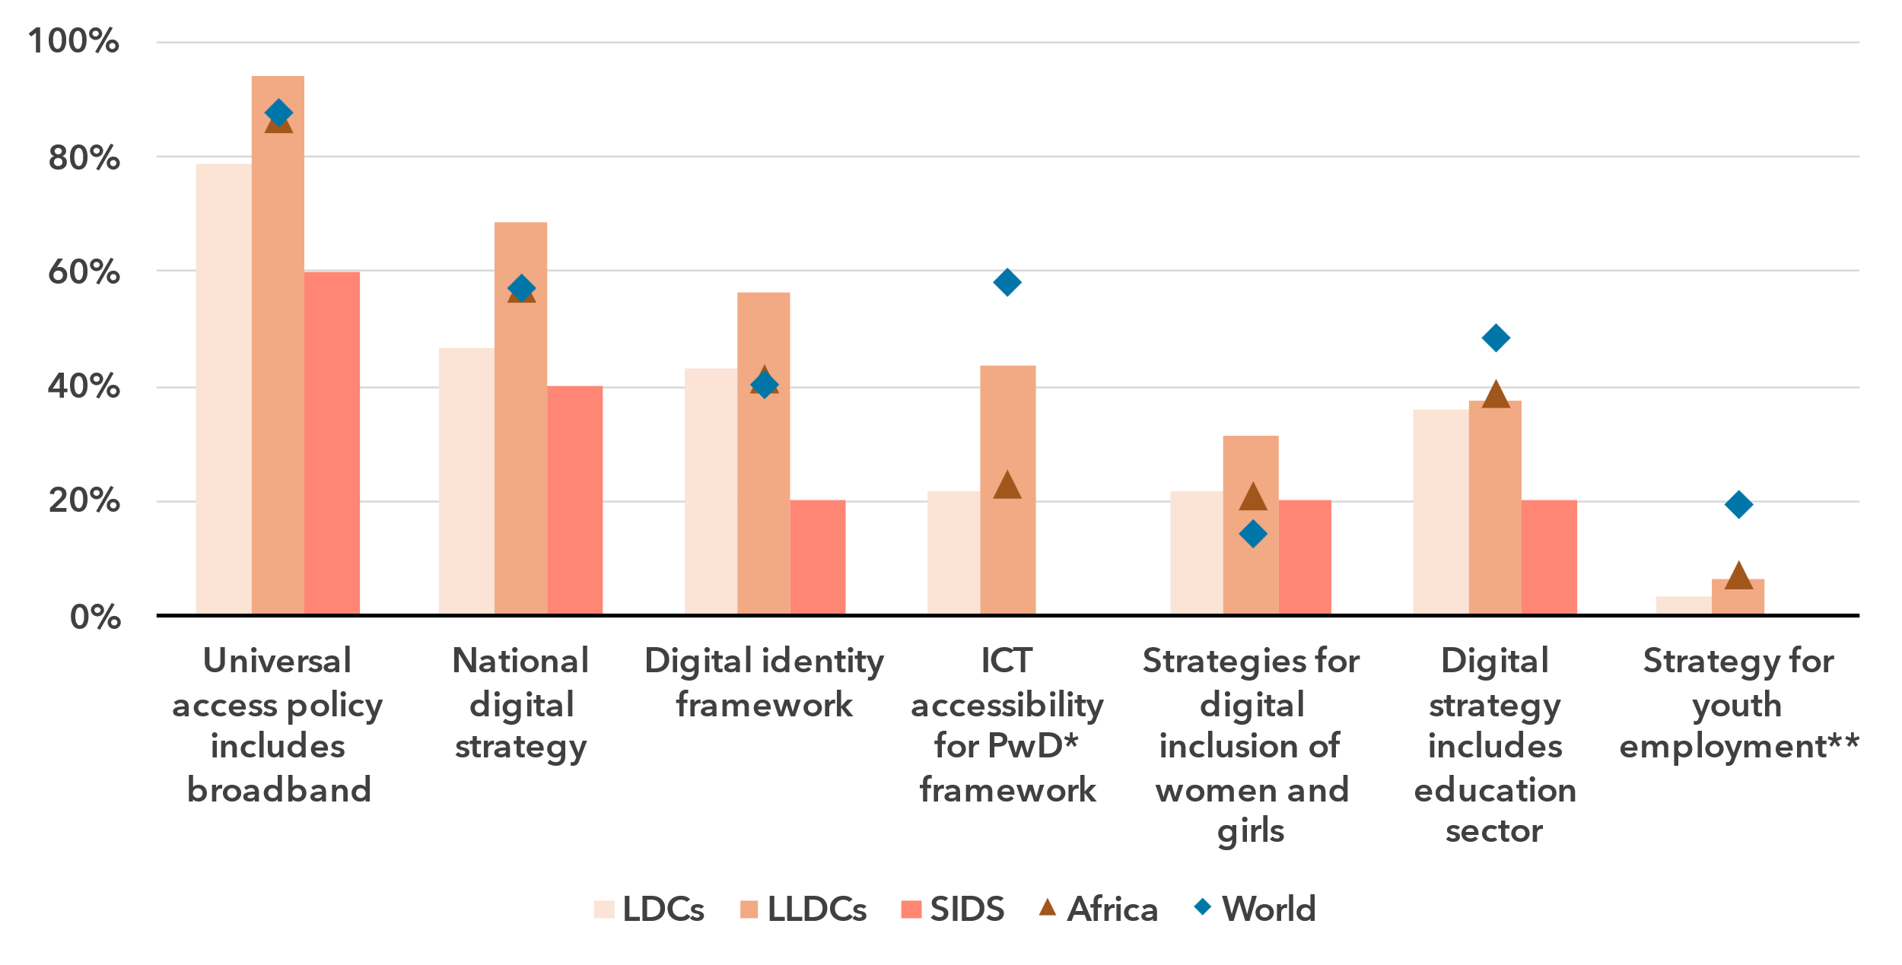* Persons with disabilities

** Based on SDG Target 8.b Develop and operationalize global strategy for youth employment and to implement the Global Jobs Pact of the International Labour Organization (ILO)

Note: The region’s average scores for key indicators in the National Digital Agenda, Legal Instruments for Digital Markets and Market Rules under the ITU Unified Framework are compared to the averages for LDCs, LLDCs and SIDS in the region, and the world average.

Source: ITU, based on data from ITU and SDG Indicators

LLDCs have emerged as policy frontrunners in cross-cutting digital inclusion policies, outperforming regional averages in most areas. With 40 per cent of LLDCs implementing digital identity frameworks, they exceed both regional and global averages by 16 and 15 percentage points, respectively. However, they still lag in ICT accessibility and ICTs in education strategies – critical areas for long-term inclusion and economic resilience.

Yet gaps widen further for LDCs and SIDS. While LDCs’ adoption of universal service policies for broadband (79 per cent) is a relative strength, their national digital strategy adoption (46 per cent) remains significantly lower, limiting their ability to drive broad-based digital transformation. Key policy instruments are lacking, with no LDC having frameworks for ICT accessibility or youth employment, and only one-fifth implementing strategies for women's digital inclusion or ICTs in education.

SIDS face the greatest policy constraints in digital inclusion frameworks, trailing regional averages by 7 to 23 percentage points across all key areas, except for gender-inclusive connectivity policies – which is, however, one of the weakest regional benchmarks overall (20 per cent). Digital identity frameworks in SIDS are largely absent, with only Mauritius having implemented one. Without these frameworks, citizens face barriers to accessing public services, financial inclusion and business opportunities.

Youth-focused digital inclusion is essential for unlocking learning and economic opportunities and fostering long-term prosperity. Yet only 39 per cent of African countries have adopted national policies for ICTs in education and digital skills, with vulnerable countries lagging even further behind. Likewise, policy efforts to prepare young people for employment in the digital economy remain limited. Only three countries – Ghana, Rwanda and South Africa, have national youth employment strategies, with Rwanda being the sole LDC and LLDC in the group.

To achieve meaningful digital inclusion, Africa needs stronger policy focus, increased infrastructure investment and targeted ecosystem initiatives, particularly in digital identity and digital skills. Collaboration between governments, the private sector and communities will be critical to closing policy gaps and digital divides to advance universal and meaningful connectivity across the continent, in the most vulnerable and least developed countries.

***Urgent need to strengthen Africa’s policy landscape for emerging technologies***

Digital economies require well-aligned, agile digital policy and governance frameworks to leverage the potential of digital technologies for development while mitigating the risks. The consistent, coordinated implementation of such policies can drive investment, create new markets and enhance national economic competitiveness while maximizing social benefits. Emerging technology policies play a crucial role in this context, especially in LDCs, LLDCs and SIDS, many of which are facing significant challenges and multi-dimensional vulnerabilities in their overall development and in digital transformation.

In the Africa region, emerging technology policies are less advanced than in most other regions and the global average, in 2023. Only 27 per cent of countries in the region have innovation policies, an essential lever for scaling digital economies through science, technology and innovation. LDCs, LLDCs and SIDS are more than twice less likely than the global average to adopt such policies, with only 20 per cent of countries in these groups implementing them. However, industry-specific digital policies – particularly in sectors such as agriculture and financial services, where digital and emerging technologies can spur economic growth – are more common, adopted by 48 per cent of African countries. Yet, digital market policies, critical for shaping emerging technology ecosystems, remain virtually absent, introduced by only five per cent of countries in the region.

Policy frameworks addressing advanced digital technologies are also underdeveloped across the region. Cloud computing strategies are the most widely adopted, yet only 16 per cent of African countries have one in place. While LDCs and LLDCs lead in cloud policy adoption, they lag in Internet of Things (IoT) regulation and artificial intelligence (AI) policies. Advanced spectrum technology policies are also lacking in the region, limiting opportunities for expanding high-speed connectivity and next-generation services.

Regulatory experimentation instruments remain underutilized in shaping emerging technologies markets in Africa. Regulatory sandboxes are established in only 23 per cent of countries, far below the global average of 40 per cent. Similarly, regulatory incentives for digital market players stand at 23 per cent, close to the world average of 25 per cent, but still insufficient to foster rapid market growth. ICT sector-specific tax exemptions are particularly low in comparison to other regions (39 per cent), with LLDCs being the exception and aligning with the world average of 56 per cent.

Enabling environment for emerging technologies in the Africa region, 2023

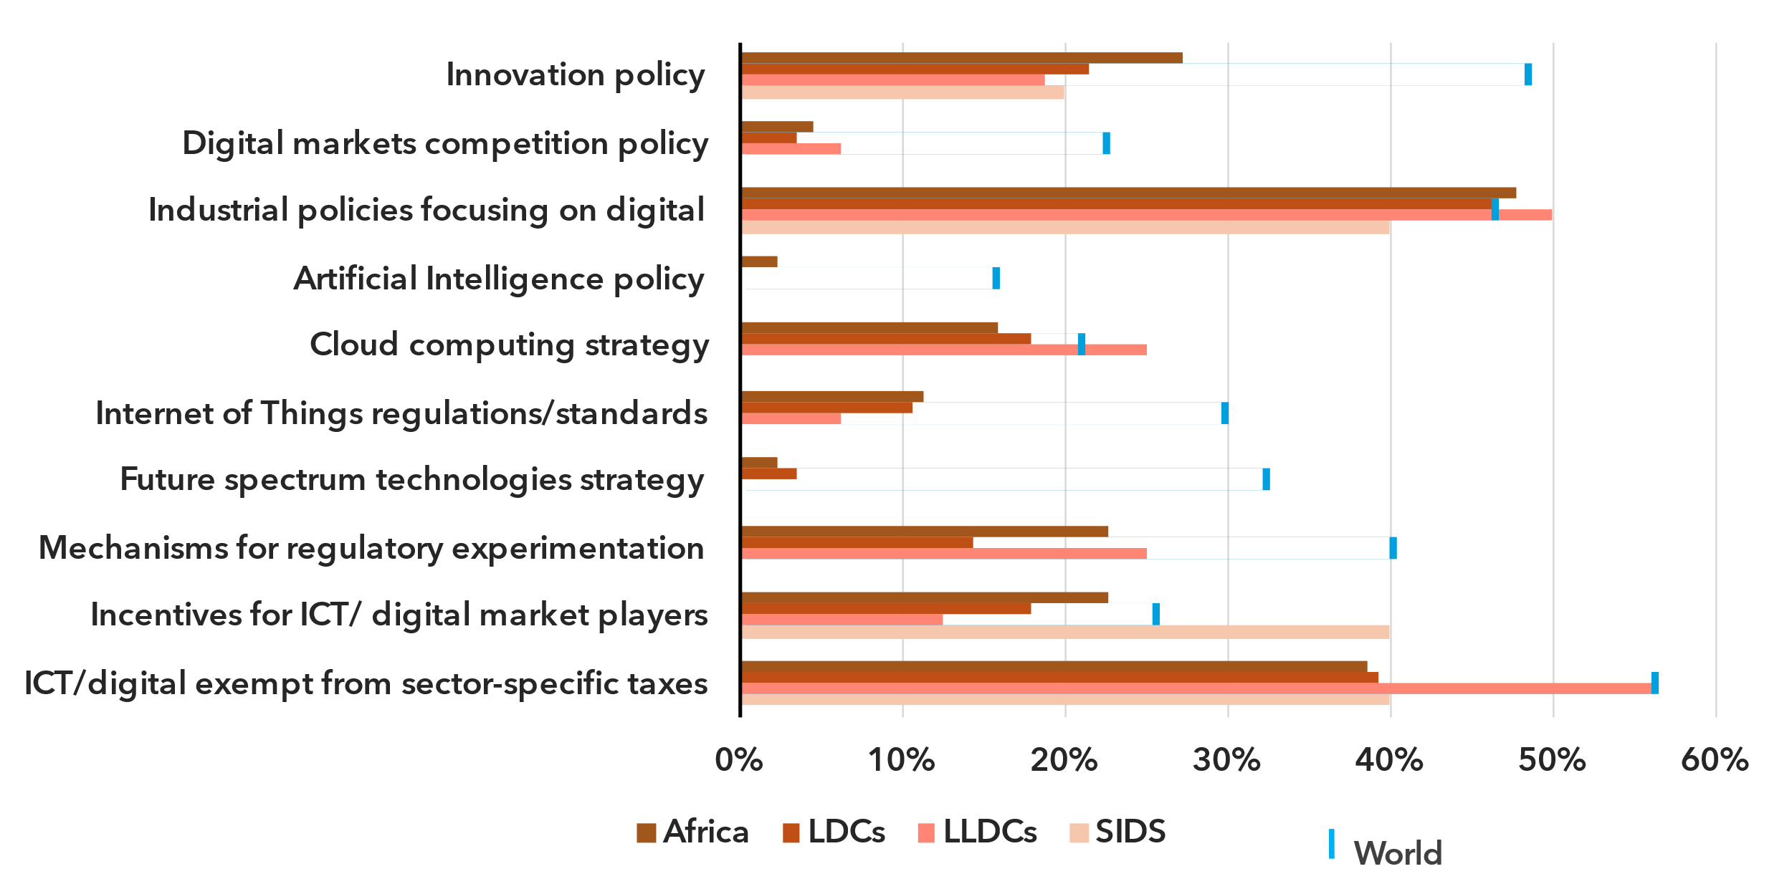Note: The region’s average scores for key indicators in the National Digital Agenda, Legal Instruments for Digital Markets and Stakeholder Engagement under the ITU Unified Framework are compared to the averages for LDCs, LLDCs and SIDS in the region, and the world average.

Source: ITU

As emerging technologies evolve rapidly, African countries must accelerate efforts to create robust policy and regulatory environments that foster digital innovation, entrepreneurship and value creation. Strengthening legal, institutional frameworks and good governance, closing policy gaps and enhancing regional and international cooperation will be critical to building inclusive and sustainable digital ecosystems at the national and regional levels. By advancing targeted reforms and aligning national strategies with global trends, Africa can harness emerging technologies to drive economic transformation, improve public services and promote digital inclusion.

The comprehensive Programmes of Action for LDCs, LLDCs and SIDS adopted by the United Nations[4] highlight the urgency of strengthening connectivity, digital transformation and digital governance in these countries. Equipping African LDCs, LLDCs and SIDS with robust policy instruments must be a priority to support the rapid, responsible development and adoption of emerging technologies. Without decisive policy action, these countries risk deepening digital divides and missing critical opportunities in the global digital economy.

Internet use

***Africa has the lowest internet usage rate of all regions***

Percentage of individuals using the Internet

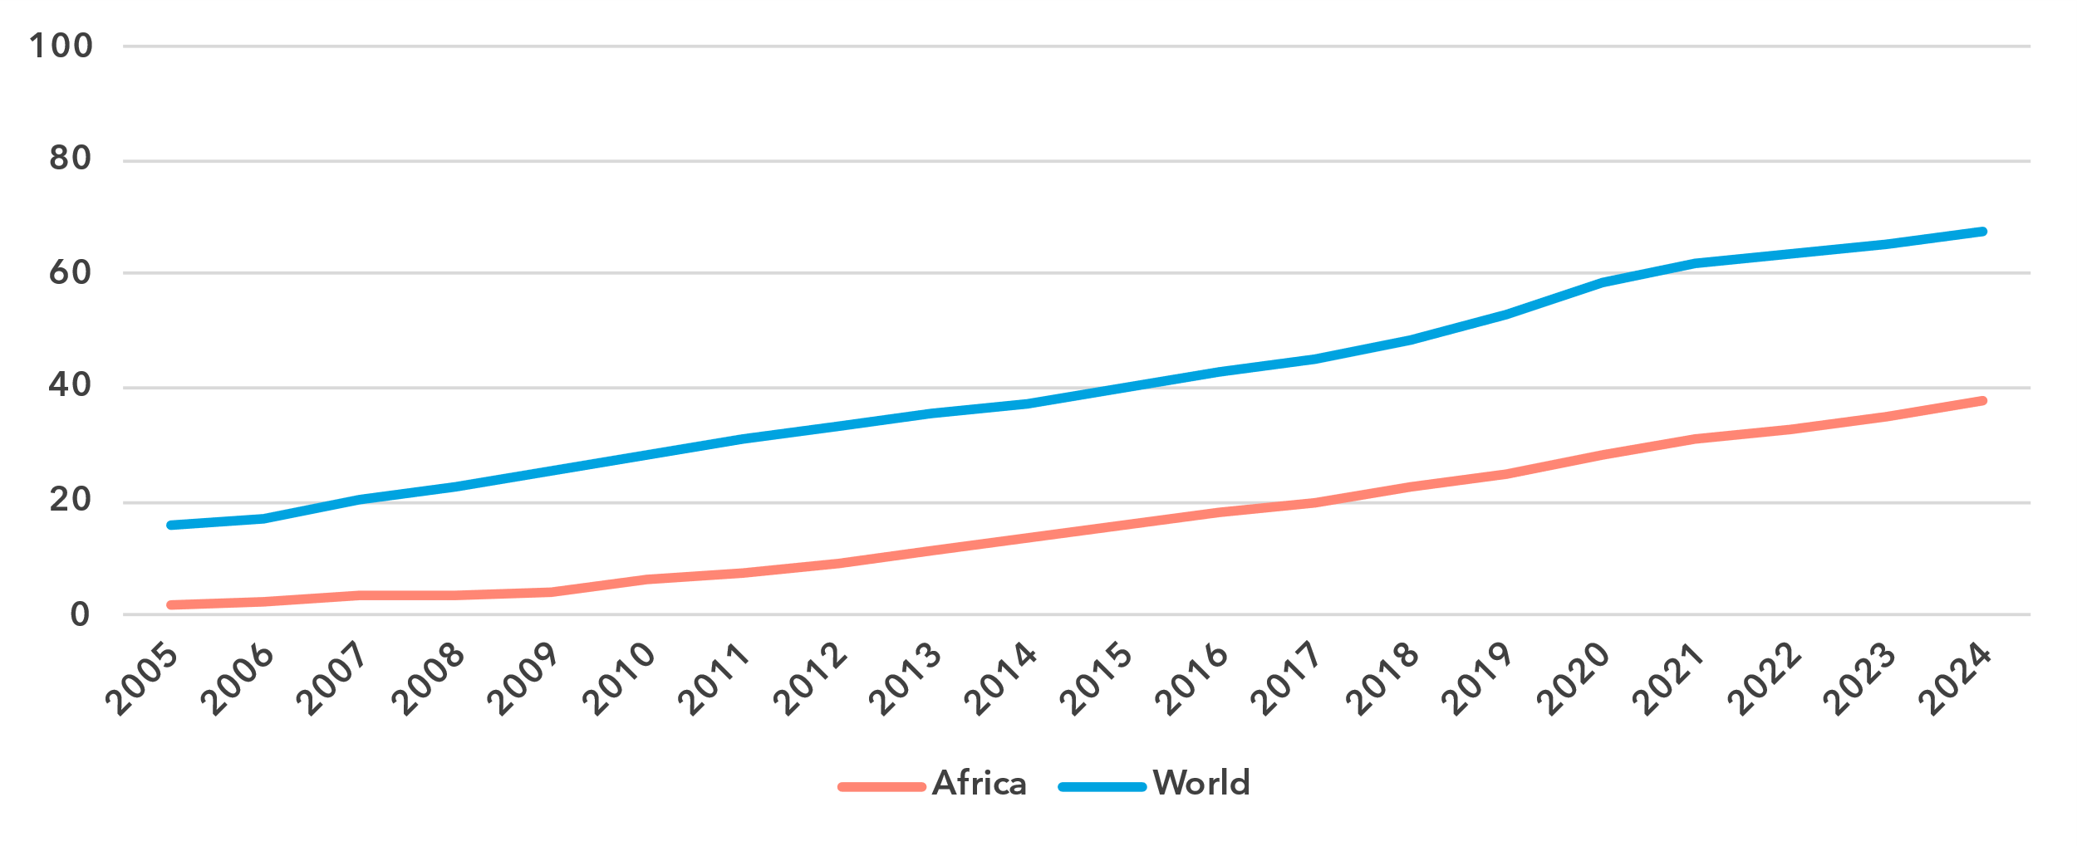Source: ITU

The proportion of people online in Africa stood at 38 per cent in 2024, far below the global average of 68 per cent. This makes Africa the region with the lowest Internet use penetration, 29 percentage points behind the next lowest region.

Africa is slowly catching up though, as can be inferred from growth in the percentage of Internet users. Since 2005, the average annual growth rate of Internet penetration has been 16.7 per cent in the region, against 8 per cent globally. Over the last ten years, these percentages were more modest, at 10.7 and 6.1 per cent respectively.

Africa is a very heterogeneous region, from small Islands to large landlocked countries. The region also contains 32 of the 44 least developed countries (LDCs). This heterogeneity is reflected in the country level data on Internet use, with penetration levels from 11 to 87 per cent. In most countries, universal Internet use is still a far way off.[5]

Percentage of individuals using the Internet in Africa, 2023 or latest year available[6]

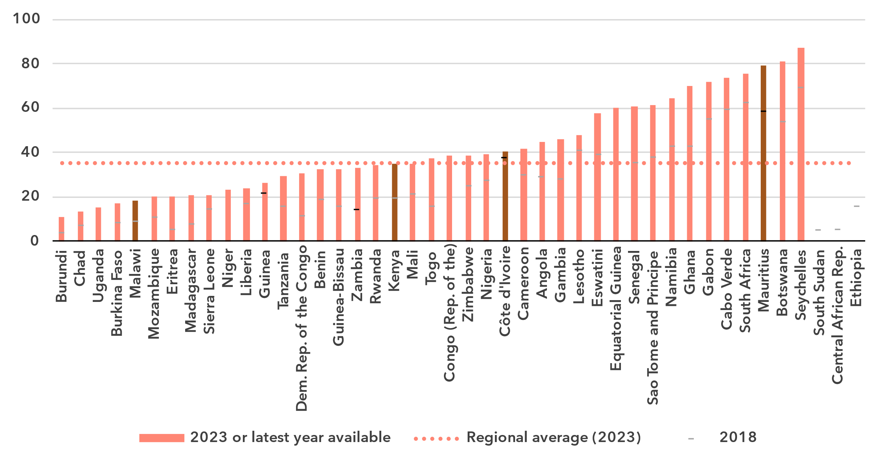

Note: Non-official data are in a lighter shade, country submitted data in a darker shade.

Source: ITU

***The gender gap in internet use is the widest globally***

In 2024, 43 per cent of men were online in Africa, against 31 per cent of women. This converts into a gender parity score (GPS)[7] of 0.72, far below the global GPS of 0.94 and even further removed from gender parity. On a more positive note, in the last five years, the GPS has improved from 0.69 to 0.72.

Percentage of individuals using the Internet, by gender, 2024

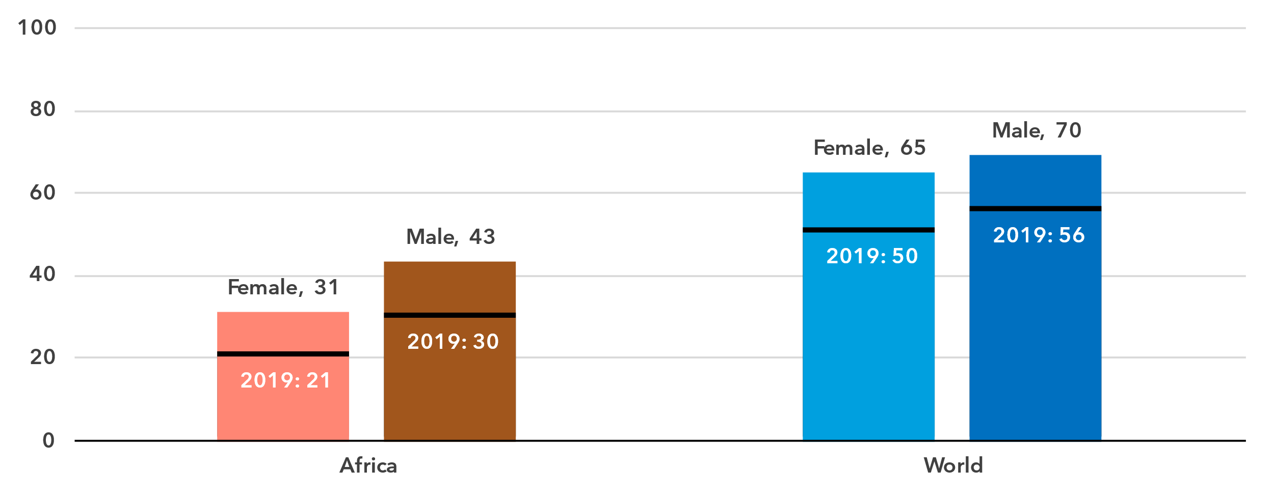Source: ITU

Gender parity is closely linked to overall development level and Internet penetration of a country. For the few countries for which data is available, those with the lowest Internet penetration levels usually also have the lowest GPS. The main exception is Zimbabwe, where despite a very low overall Internet use penetration rate, gender parity has been reached, with even more women than men using the Internet.

Percentage of individuals using the Internet, by gender, 2023 or latest year available

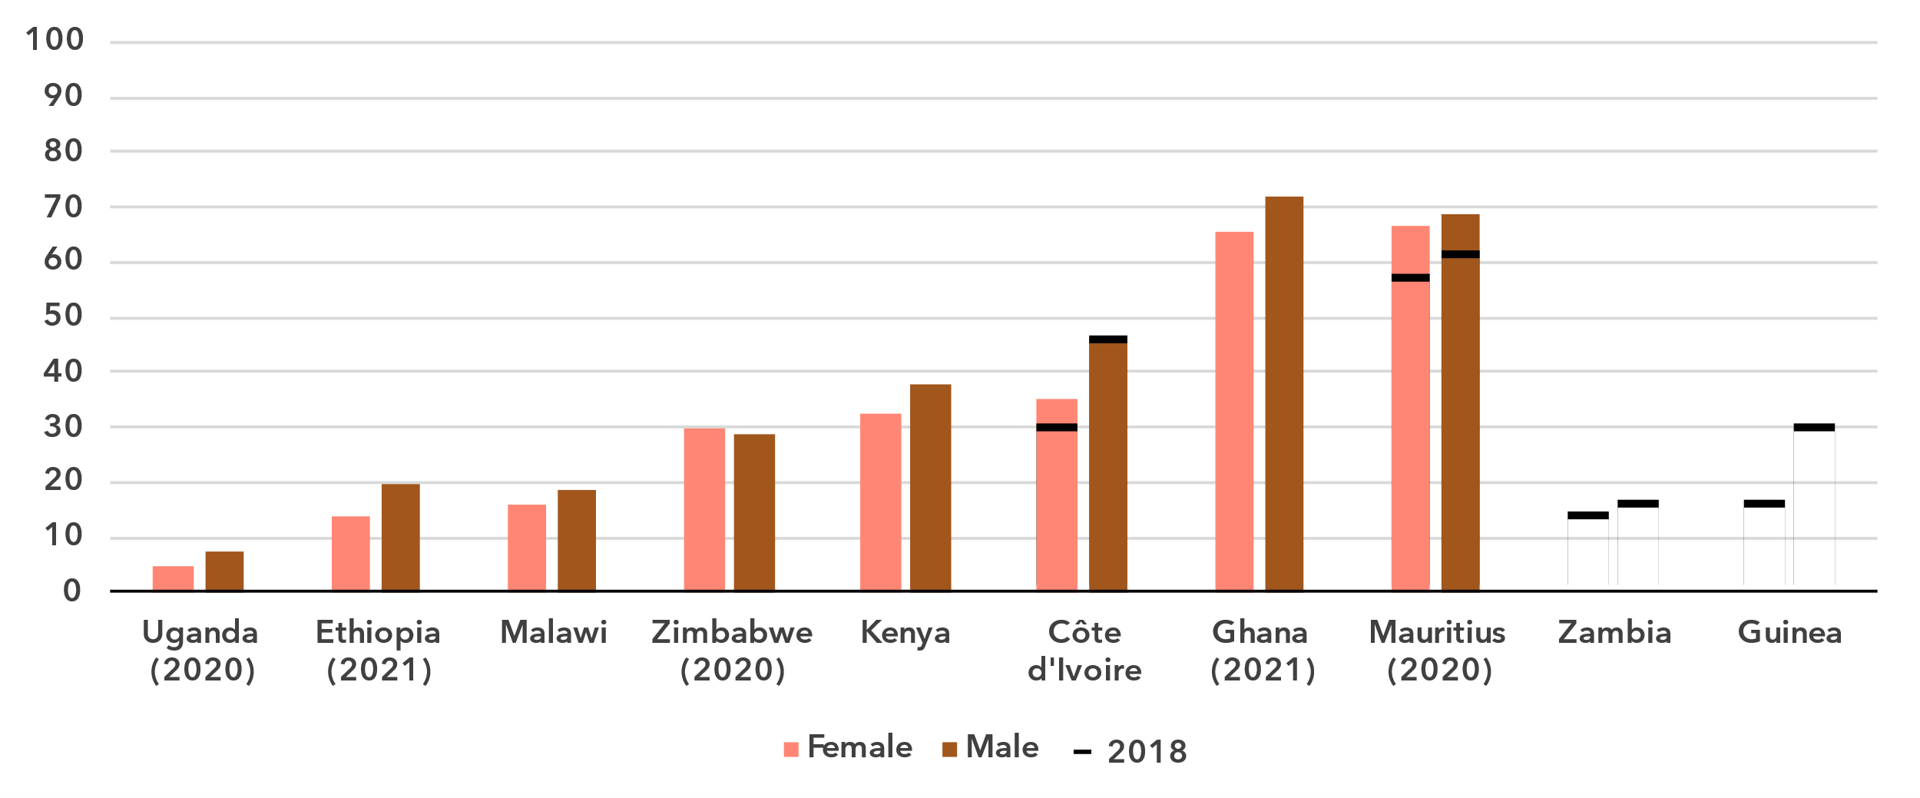

Source: ITU

***Young people drive internet adoption***

Percentage of individuals aged between 15 and 24 years using the Internet, 2024

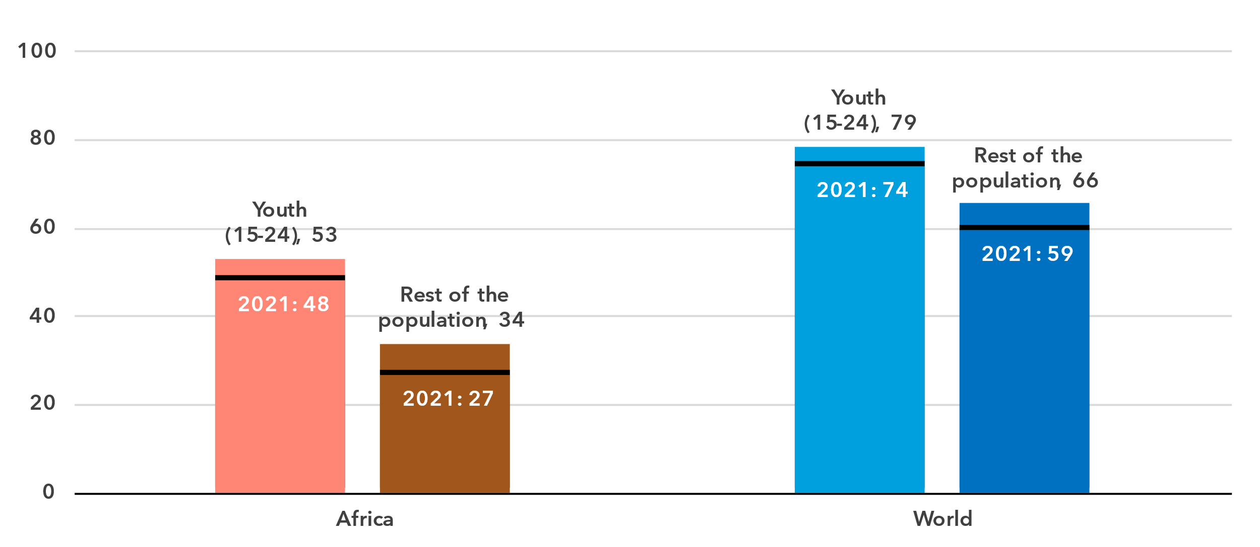Source: ITU

In the Africa region, 53 per cent of young people aged 15 to 24 used the Internet in 2024, compared to 34 per cent of the rest of the population. The generational gap in this region – measured as the ratio of Internet users between these two groups – is higher than the global average. Both in the region and globally, the ratio has been shrinking over the last four years.

There are only a few countries with recent Internet use data broken down by age. In three of these countries, the percentage of young people online is relatively high. This stands in sharp contrast with the proportion of the elderly (those 75 years and older) using the Internet, which is low or very low in all countries.

Percentage of individuals using the Internet by age group, 2023 or latest year available

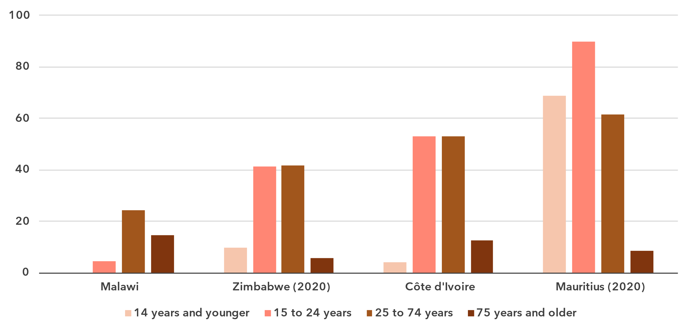

Source: ITU

***Africa’s rural-urban gap in Internet use is the highest of all regions***

Percentage of individuals using the Internet, by location, 2024

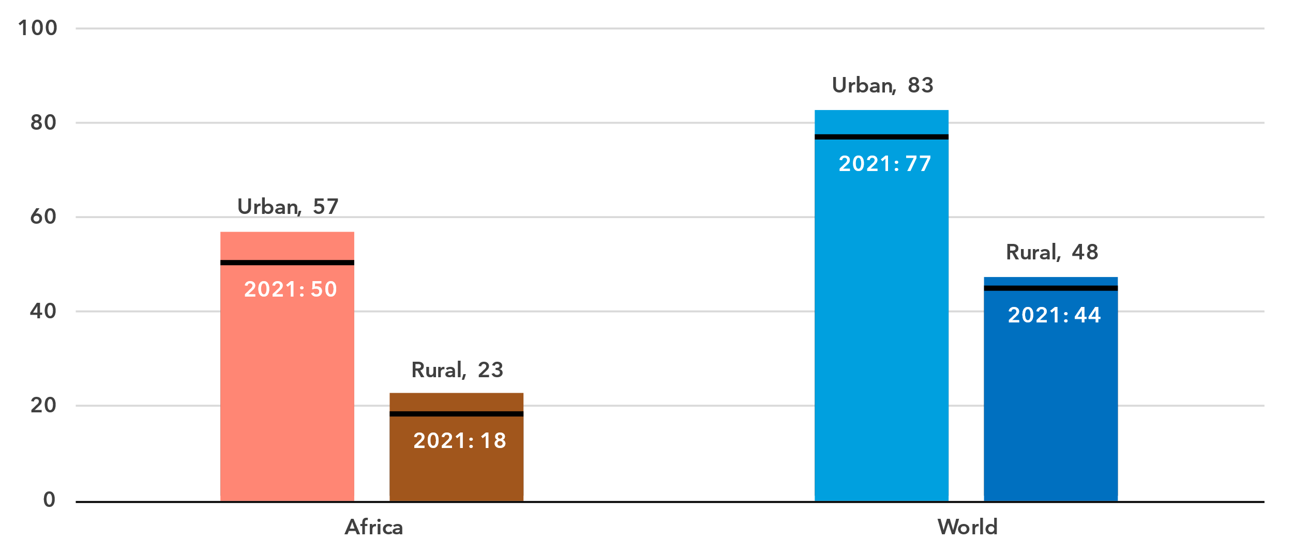

Source: ITU

In urban areas in the Africa region, 57 per cent of the population was online in 2024, compared with only 23per cent in rural areas. This gap is much bigger than it is globally, with 83 per cent online in urban areas, against 48 per cent in rural areas.

Once again, there are very few countries with recent Internet use data broken down by urban/rural area. In these four countries, the higher the overall Internet penetration, the smaller the urban-rural gap.

Percentage of individuals using the Internet by location, 2023 or latest year available

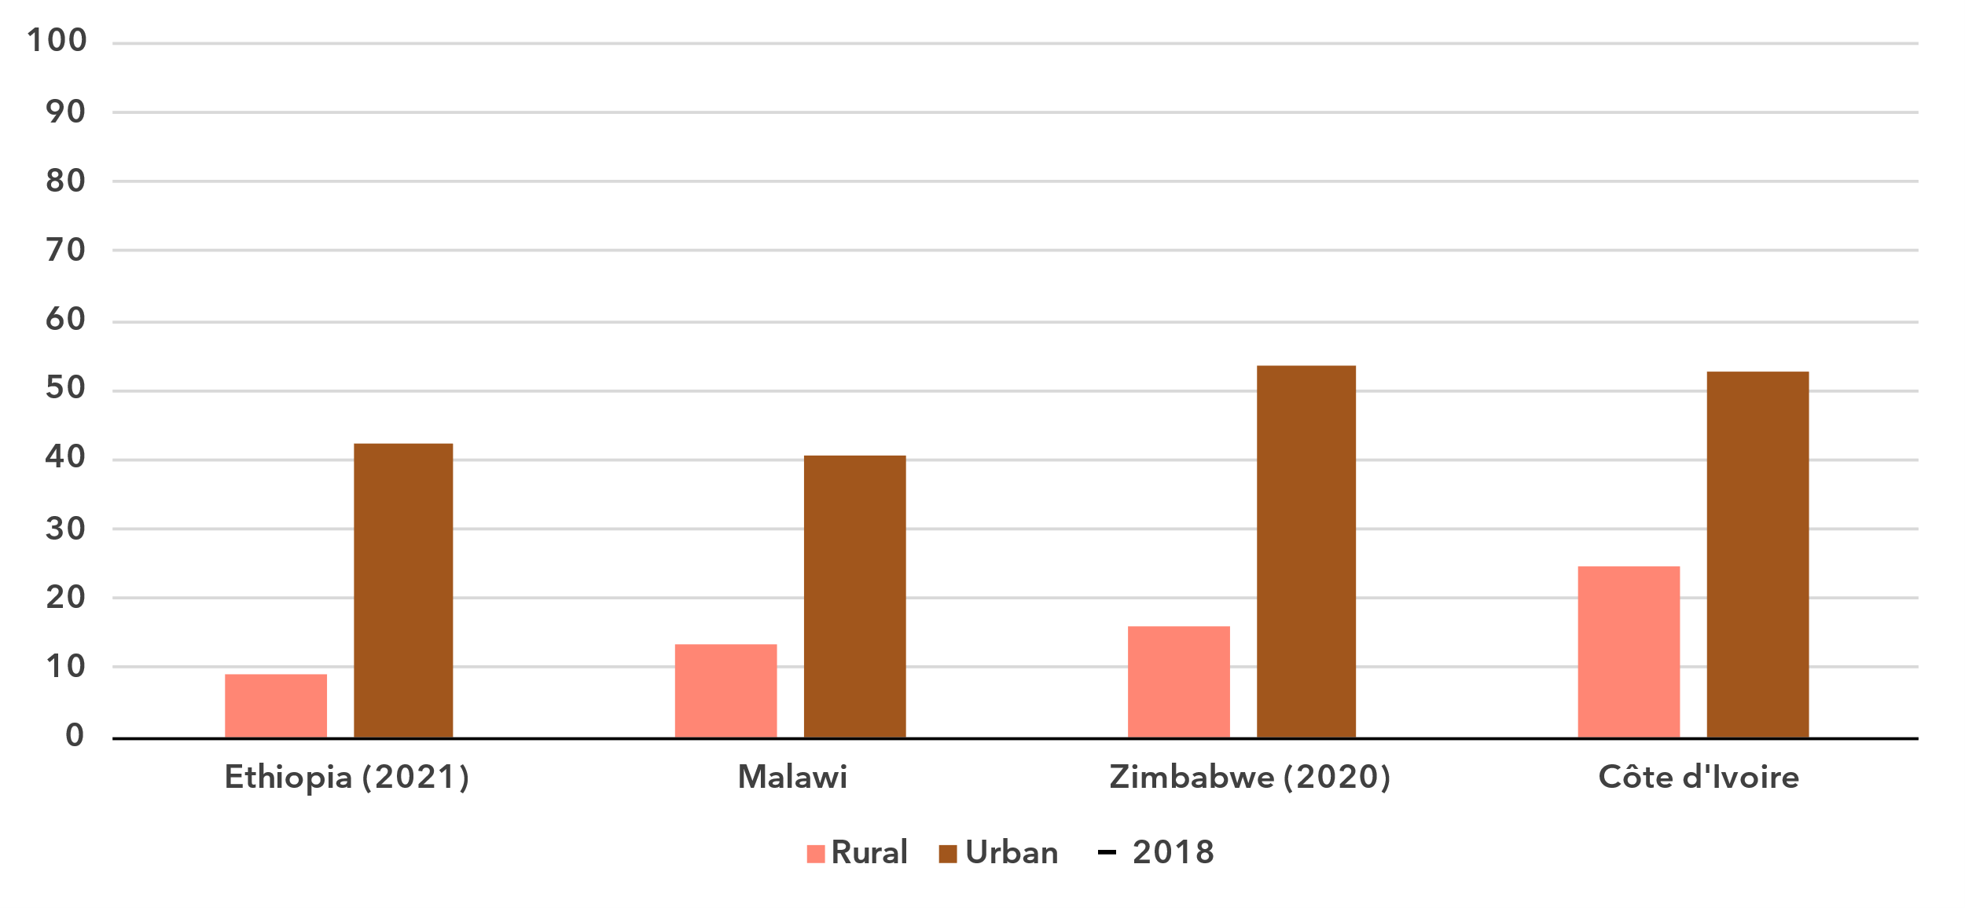Source: ITU

Broadband subscriptions

***Low mobile-broadband, and almost non-existent fixed-broadband subscription levels***

Broadband subscriptions per 100 inhabitants

|  |  |
| --- | --- |
| **Mobile** | **Fixed** |

Source: ITU

In 2024, there were 52 mobile broadband subscriptions per 100 inhabitants in the Africa region, substantially below the global average of 95 and the lowest of all regions. For fixed broadband, the situation was even worse. With less than 1 subscription per 100 inhabitants, fixed broadband plays a negligible role in Africa.

Active mobile-broadband subscriptions per 100 inhabitants, 2023 or latest year available

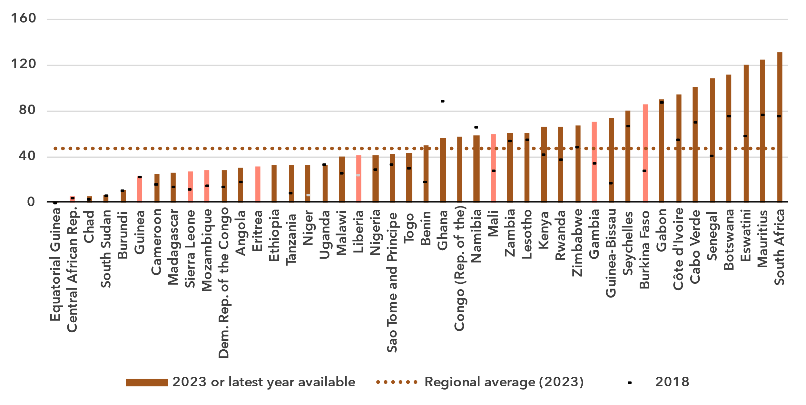Notes: Country submitted are in a darker shade, non-official data in a lighter shade.

Source: ITU

The lack of fixed-broadband subscriptions underscores the importance of mobile broadband as a gateway to the Internet. In most countries of the region, the number of mobile broadband subscriptions is growing. Nevertheless, there is a significant disparity between the lowest (1 subscription per 100 inhabitants) and the highest (138 subscriptions per 100 inhabitants).

An important level of fixed broadband subscriptions has only been reached in two countries of the region, Mauritius and the Seychelles, at 27 and 31subscriptions per 100 inhabitants respectively. In all other countries, except one, the level was below 4 subscriptions per 100 inhabitants.

Fixed-broadband subscriptions per 100 inhabitants, 2023 or latest year available

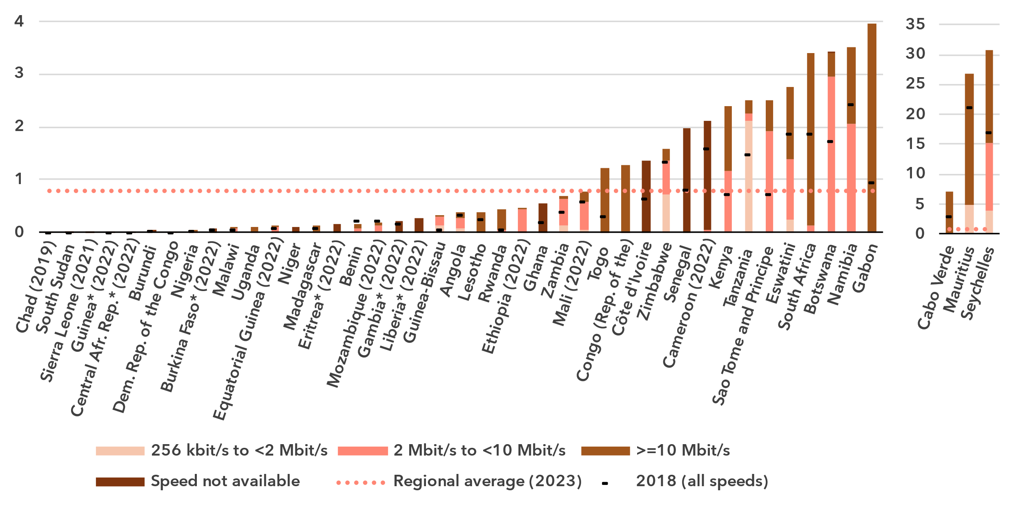* Data are ITU estimates

Source: ITU

Mobile network coverage

***The coverage gap is still substantial***

Percentage of population covered by type of mobile network

|  |  |
| --- | --- |
| **Africa** | **World** |

Note: The values for 2G, 3G and 4G networks show the incremental percentage of the population that is not covered by a more advanced technology network (e.g. in 2024, 96 per cent of the world population is covered by at least a 3G or above network, that is 4 per cent + 41 per cent + 51 per cent). There are insufficient data to produce estimates for 5G coverage prior to 2020.

Source: ITU

Between 2020 and 2024, 5G mobile network coverage in the region increased from 0 to 11 per cent of the population, far below the global coverage, which increased from 9 to 51 per cent over the same period. In the Africa region, 4G mobile networks covered only 71 per cent of the population in 2024, also substantially below the global average of 92 per cent. Furthermore, only 86 per cent of the population in Africa had access to at least a 3G mobile broadband network, leaving 14 per cent without access to a mobile broadband network and therefore without any possibility of accessing the Internet. This coverage gap was ten percentage points more than the global average, also the biggest of all regions.

Percentage of population covered by type of mobile network, 2023 or latest year available

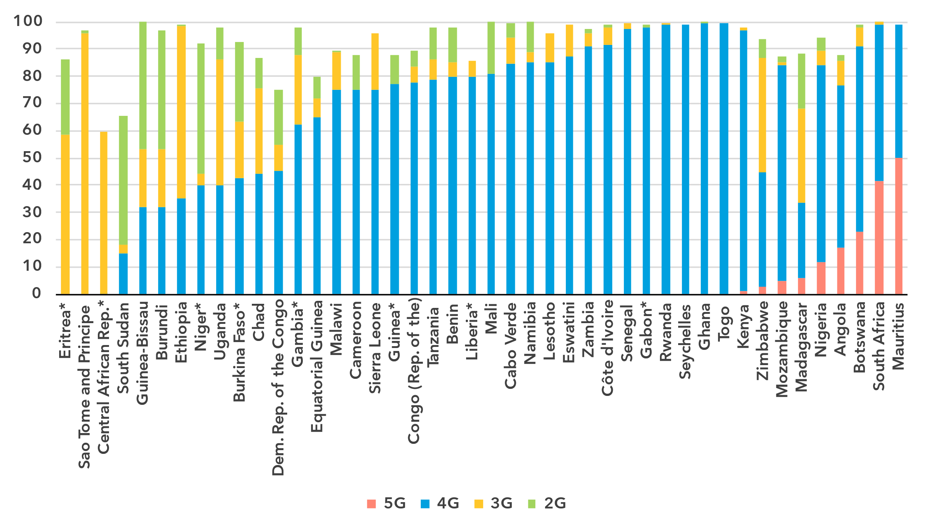

* Data are ITU estimates

Note: The values for 2G, 3G and 4G networks show the incremental percentage of the population that is not covered by a more advanced technology network (e.g. in 2023, 96 per cent of the population in Lesotho is covered by at least a 3G or above network, that is 85 per cent + 11 per cent).

Source: ITU

In nine countries 5G roll-out had started in 2023, even if not very extensive yet in some of those countries. At the same time, in fourteen countries, less than half of the population had access to a 4G network

Population coverage by type of mobile network and location, 2024

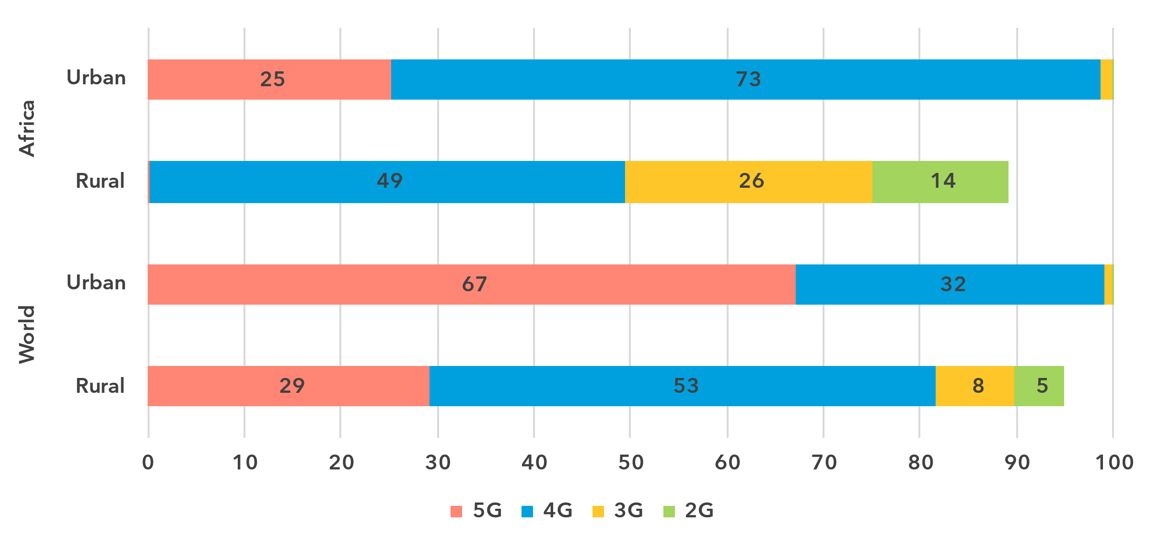

Note: The values for 2G, 3G and 4G networks show the incremental percentage of the population that is not covered by a more advanced technology network (e.g. 90 per cent of the world's rural population is covered by at least a 3G or above network, that is 29 per cent + 53 per cent + 8 per cent).

Source: ITU

As with Internet use, there is a significant gap in network availability between rural and urban areas. In 2024, 5G covered 25 per cent of the urban population in the Africa region, but almost no one in rural areas. A large disparity also existed for 4G networks, with 98 per cent of the urban population covered compared with only 49 per cent in rural areas. When including 3G networks, coverage reached 100 per cent in urban areas but only 75 per cent in rural regions. This means that while every urban resident had access to a mobile broadband network, a full quarter of the rural population in Africa remained off the grid.

Availability of fixed-broadband infrastructure

***Only three out of ten people live within 10 km of a fibre node***

Fixed-broadband infrastructure forms the backbone of the Internet and is a cornerstone of digital transformation efforts. As part of ongoing research at ITU, the broadband map initiative provides an overview of fixed-broadband infrastructure placement. Overlaying this data with demographic data makes it possible to infer the availability and proximity of fixed broadband to populations. This is essential for planning – costly – infrastructure projects and helps to ensure that networks have the necessary capacity and reach.

Map of transmission networks and submarine cables for the Africa region

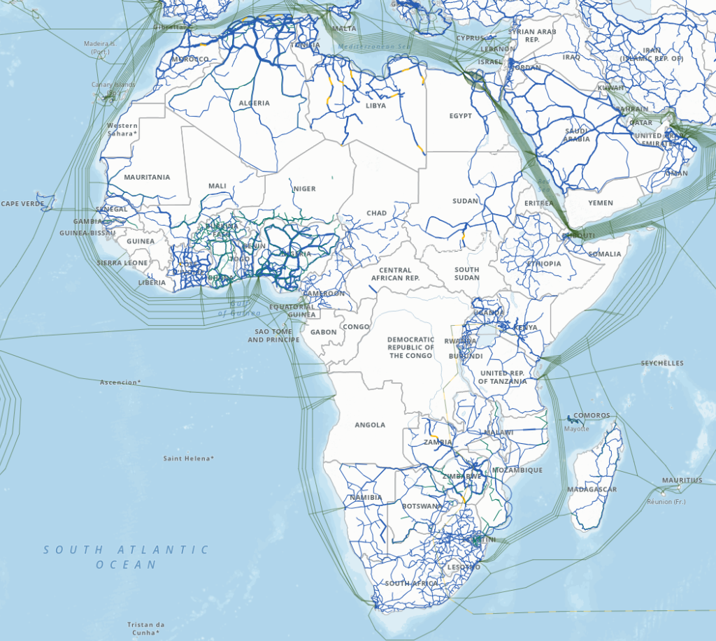Note: The image reports active and planned submarine cables, and operational, planned and under-construction transmission networks (fibre-optic cable and microwave).

The designations employed and the presentation of material on the map do not imply the expression of any opinion whatsoever on the part of ITU or its secretariat concerning the legal status of the country, territory, city or area or its authorities, or concerning the delimitation of its frontiers or boundaries.

Source: ITU, <https://bbmaps.itu.int/app>

Proximity to an optical fibre node is a crucial metric for transformative connectivity as it directly impacts network performance, reliability and scalability. It reduces latency, improves connection stability and lowers deployment costs, making broadband access more affordable and efficient. Additionally, it enables easier upgrades to support growing bandwidth demands, ensuring networks remain future proof.

As of 2023, 30 per cent of the population of the Africa region lived within 10 km of an optical fibre node. Half of the population (49 per cent) lived within 25 km, two-thirds (67 per cent) within 50 km and four in five people (79 per cent) within 100 km of a node.

Percentage of population within reach of a fibre node, 2023

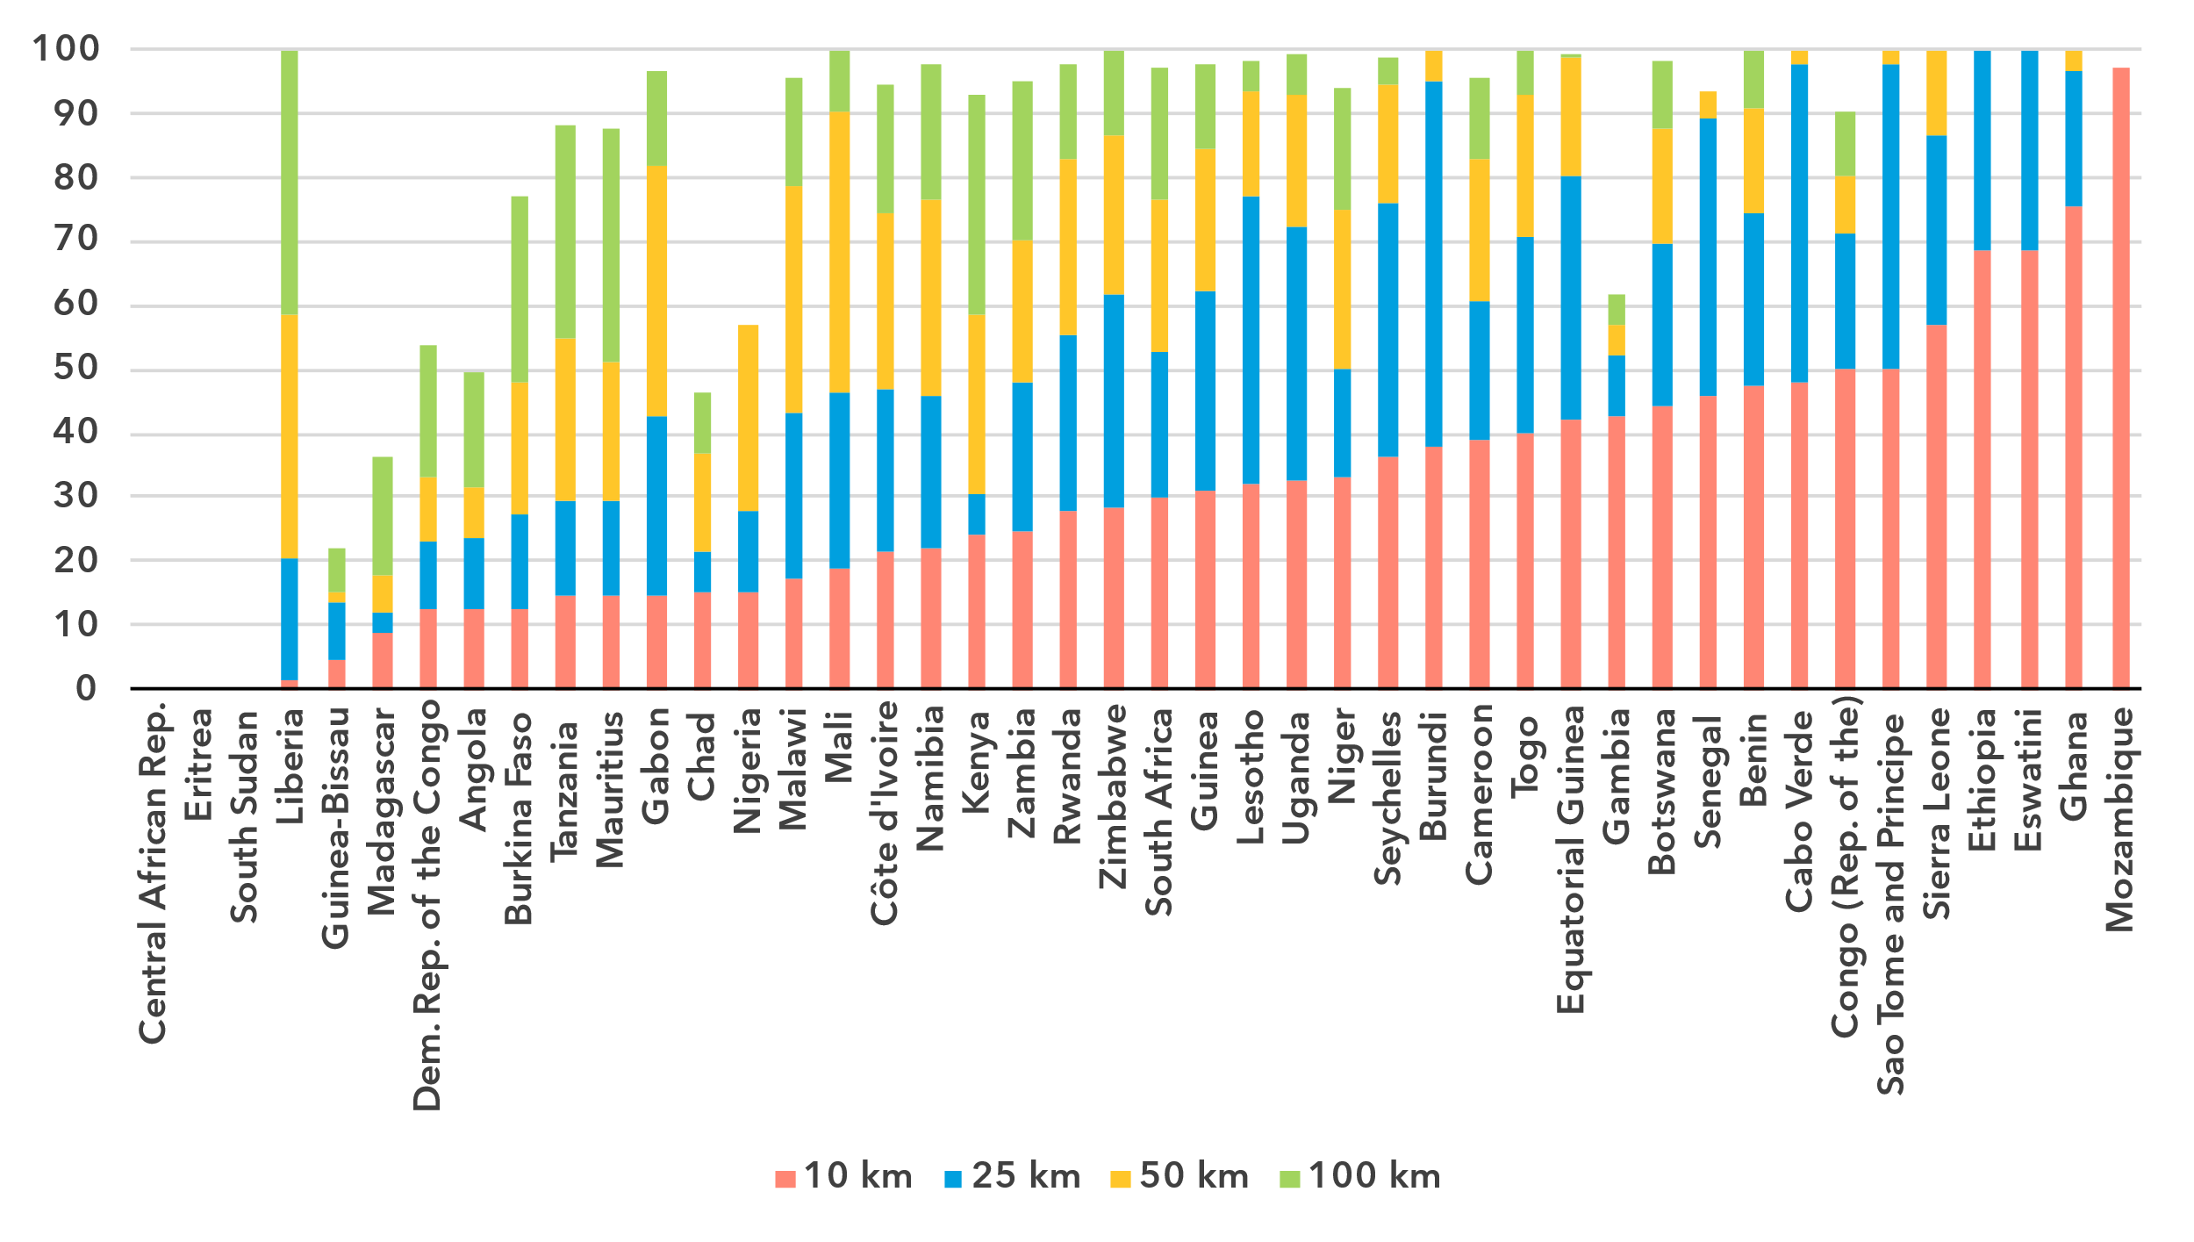Note: The percentage of population within reach of transmission networks refers to the percentage of people that are within physical reach of nodes on core terrestrial transmission networks for a given distance (see <https://bbmaps.itu.int/indicators-bbmaps>).

Source: ITU

Internet traffic and international bandwidth

***Internet traffic at low levels in Africa***

Broadband Internet traffic per subscription per month (GB)

|  |  |
| --- | --- |
| **Mobile** | **Fixed** |

Source: ITU

Internet traffic measures the total volume of data downloaded or uploaded by end users over a given period. For ease of interpretation, figures presented refer to the average monthly traffic per fixed as well as mobile broadband subscription. Traffic levels are typically higher for fixed than mobile broadband, not only because subscriptions are shared by multiple users (e.g. in households), but also because it also includes mobile device traffic routed over Wi-Fi when available.

Not only is Africa the region with the lowest Internet use penetration rates, but it is also the region where the lowest amount of data is consumed. Between 2019 and 2024 monthly mobile broadband traffic in the region increased from 0.9 to 3 gigabytes (GB) per mobile broadband subscription, during which time global traffic increased from 6 to 14 GB per mobile broadband subscription. Similar for fixed broadband traffic, which in Africa increased from a monthly 77 GB to 159 GB per subscription, while globally it increased from 141 to 311 GB.

Mobile-broadband Internet traffic (GB) per subscription per month, 2023 or latest year available

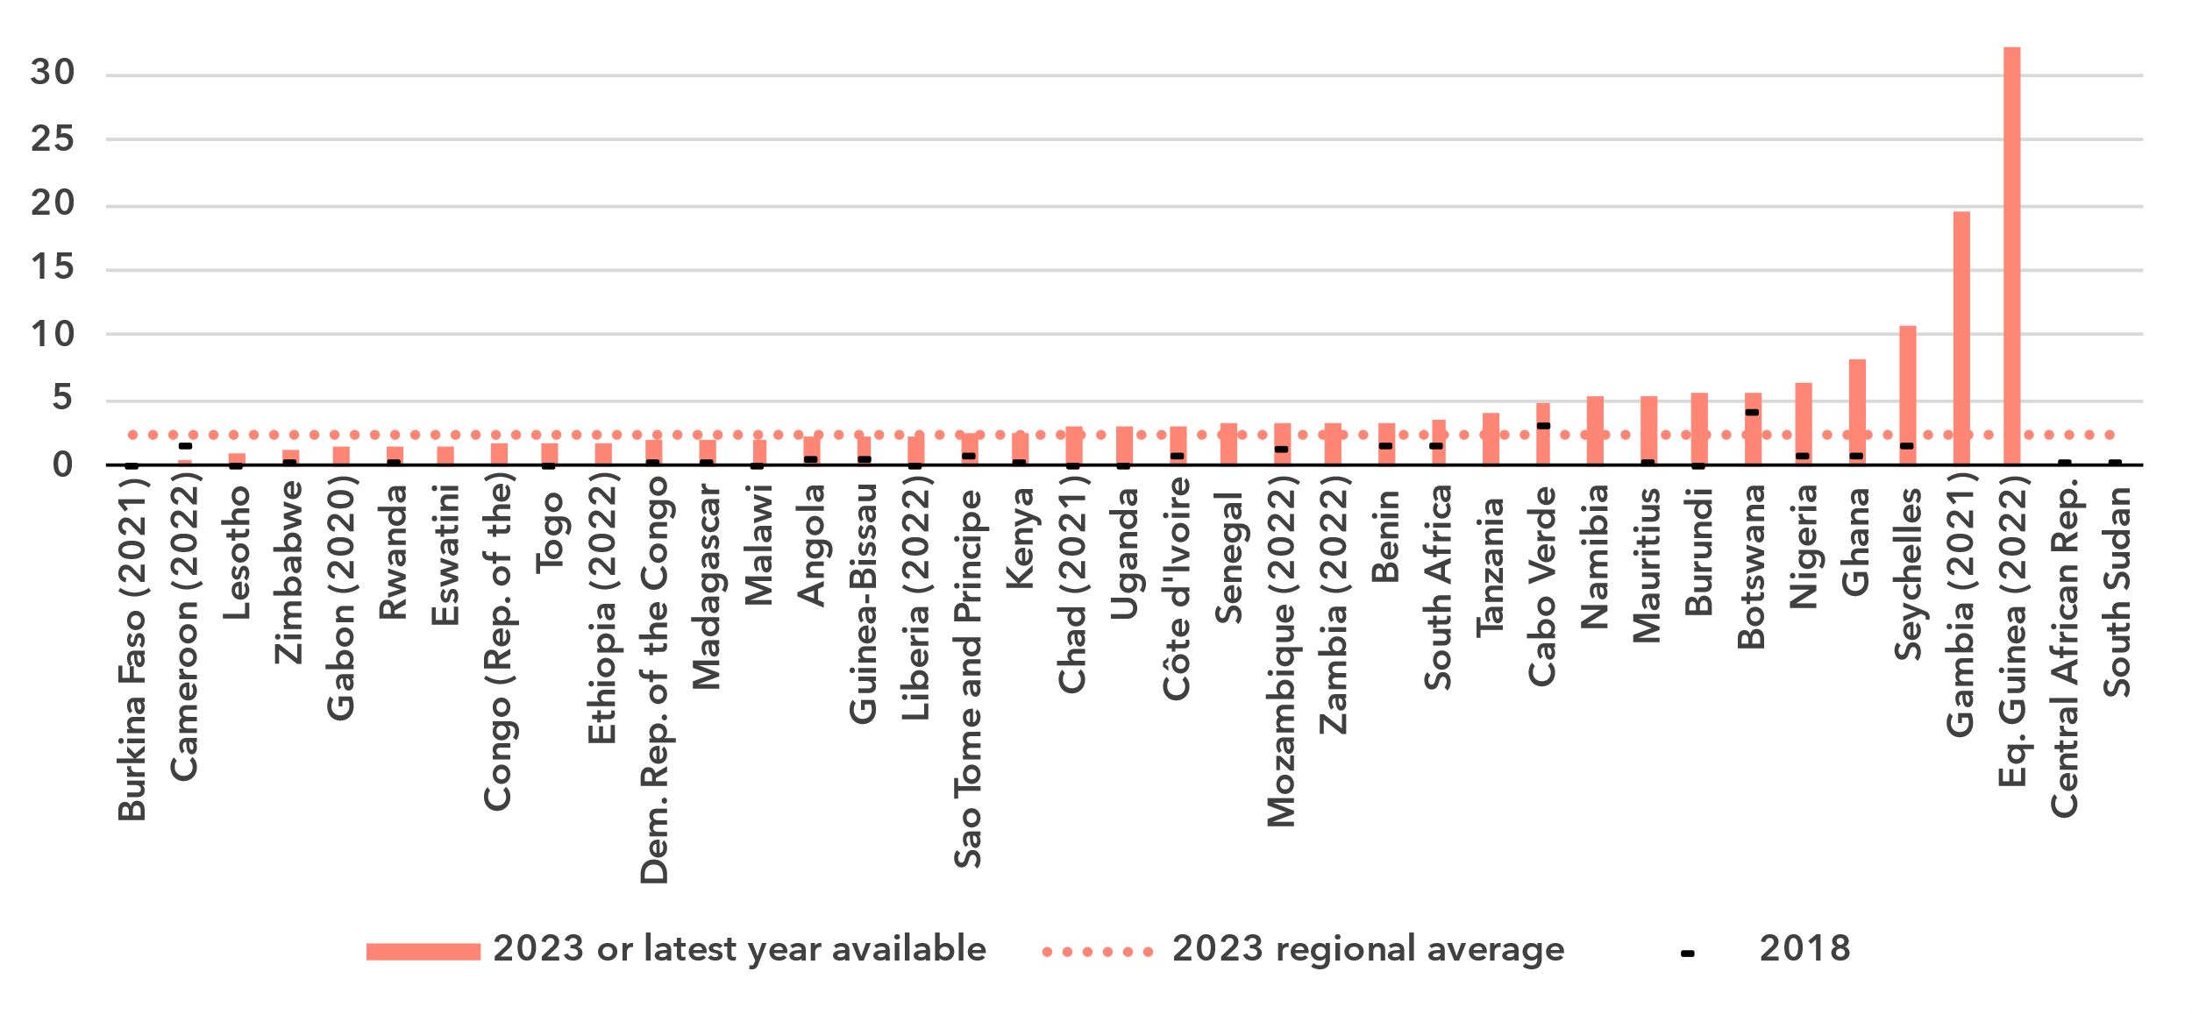Note: Internet traffic originating within country.

Source: ITU

The region exhibits some variety when it comes to traffic indicators. Mobile broadband traffic ranged from 0.1 GB to 32 GB per subscription per month. For fixed broadband traffic, the spread was from almost 0 to 474 GB per subscription per month.

Fixed-broadband Internet traffic per subscription per month (GB), 2023 or latest year available

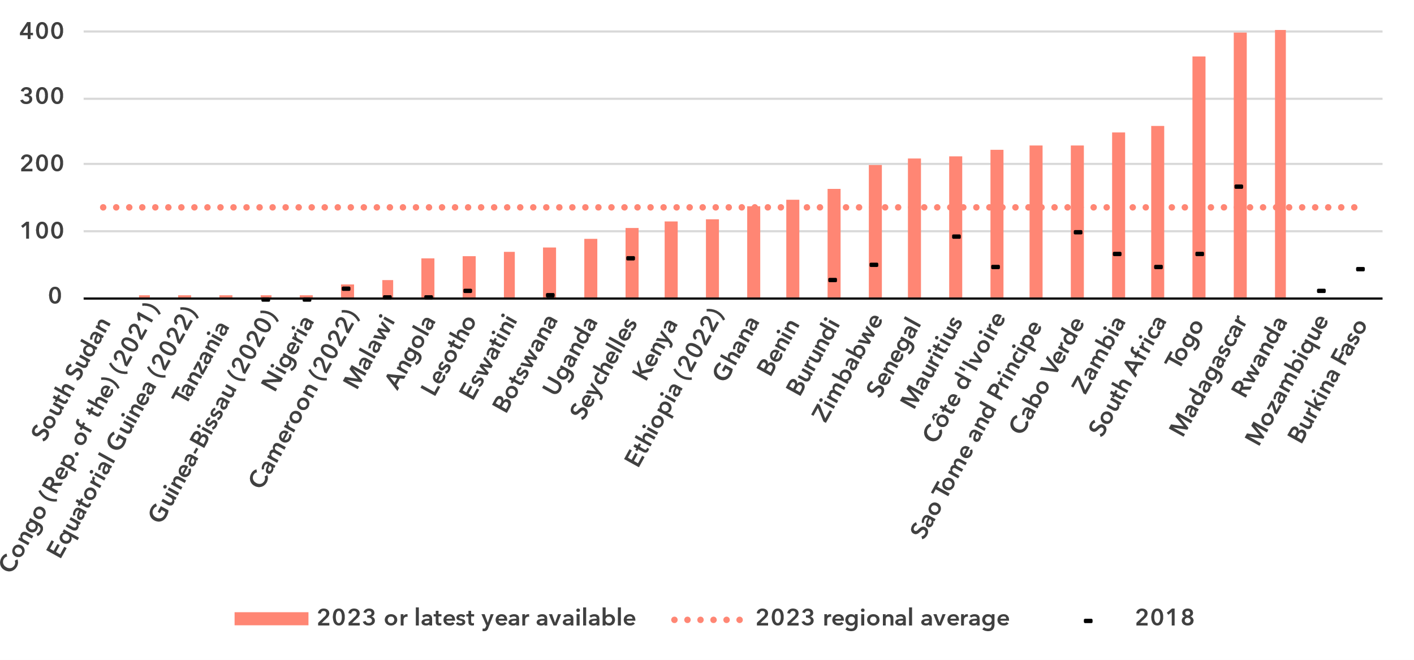Source: ITU

Unlike the end-user Internet traffic measured above, international bandwidth usage is a throughput measure that refers to the annual average used capacity of international connections, typically carried over submarine or terrestrial fibre-optic cables or microwave links. It does not sum up all traffic, incoming and outgoing, but captures the larger of the two. For comparability, the figure for bandwidth is divided by the number of Internet users in the country. International bandwidth usage in Africa stood at 80 kbit/s in 2024, far below the global average of 323 kbit/s.

International bandwidth per Internet user (kbit/s)

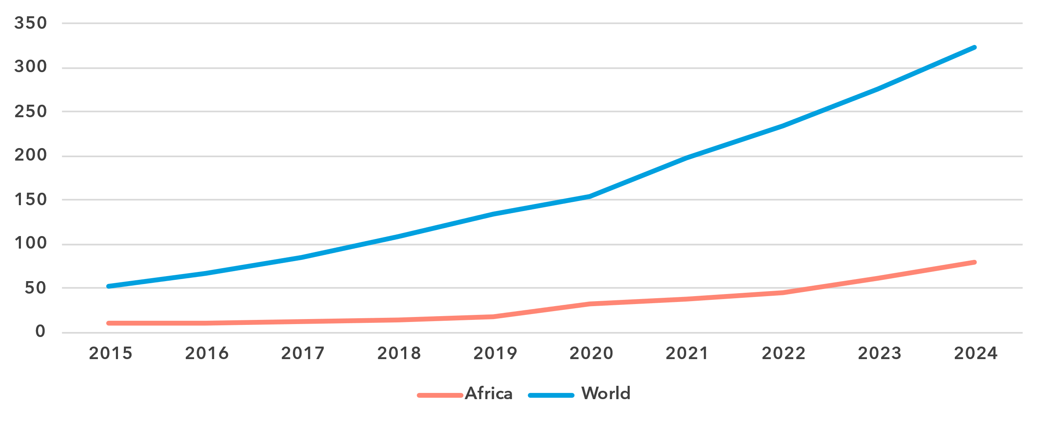

Source: ITU

International bandwidth usage reflects the state of international connectivity infrastructure (presence of submarine and overland cables, including redundancies) and the degree to which a country is connected to international data flows. Demand for international bandwidth depends on many country-specific factors, such as geographical location or the size and development of domestic middle-mile connectivity infrastructure (e.g., small islands are dependent on international linkages, while a high density of data centres and Internet exchange points can somewhat reduce the demand for international data exchange for larger countries).

The region portrays some variations. While the highest bandwidth usage was more than 500 kbit/s, in no less than 30 countries, reported bandwidth usage levels were below 100 kbit/s, suggesting that international linkages may hamper universal and meaningful connectivity.

International bandwidth per Internet user (kbit/s), latest year available

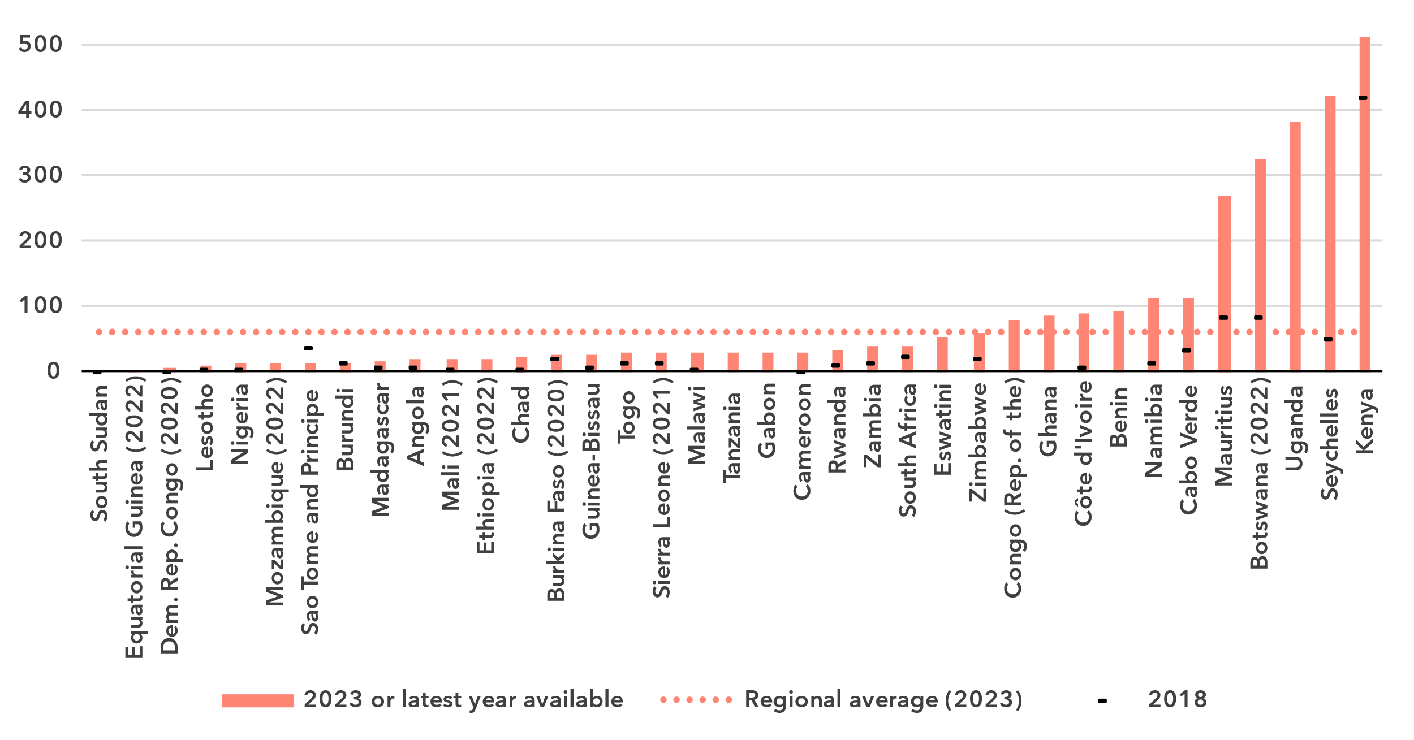

Source: ITU

Affordability of ICT services

***Broadband services generally not affordable in Africa***

Broadband basket prices as % of gross national income per capita, 2018-2024

|  |  |
| --- | --- |
| **Mobile (2GB)** | **Fixed (5GB)** |

Note: Median values shown in the chart are calculated as a percentage of GNI per capita for the set of economies for which data was available for all years from 2018 to 2024 for a given basket to adjust the effect of changing data availability.

Source: ITU

Internet cost is a barrier to Internet use and to meaningful connectivity. The United Nations [Broadband Commission for Sustainable Development](https://www.broadbandcommission.org/) set itself the goal of making broadband in developing countries affordable by 2025, affordability being defined as the availability of broadband access at a price that is less than 2 per cent of monthly GNI per capita.

Entry-level data-only mobile broadband prices have gone done significantly in the region, from 7.3 per cent of GNI per capita in 2018 to 3.9 in 2024. However, this is still significantly above the 2 per cent target of the Broadband Commission.[8] For an entry-level fixed broadband service, the median price in 2024 was no less than 13.4 per cent of GNI per capita, far above the Broadband Commission target. These very high prices explain the low level of fixed broadband subscriptions in the region.

Mobile broadband basket prices as % of gross national income per capita, 2024

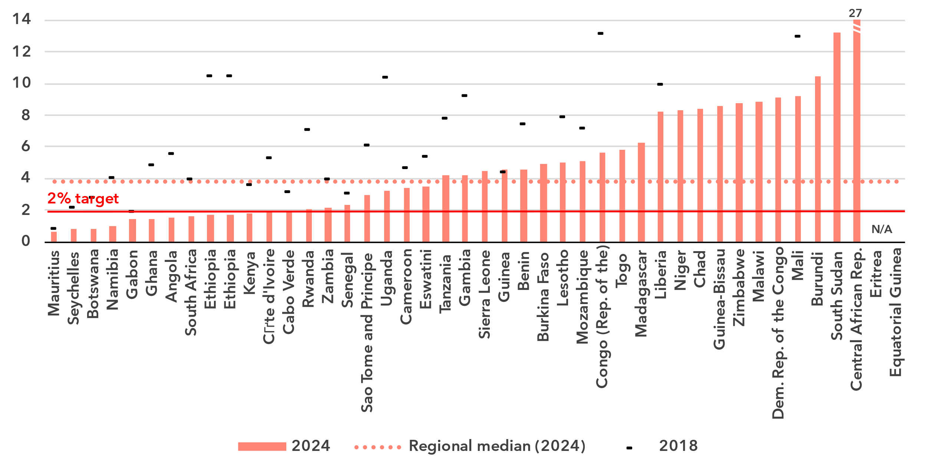Source: ITU

In 29 of 42 countries, the mobile broadband price was above the 2 per cent Broadband Commission target. For seventeen of those countries, the price was more than 5 per cent of GNI per capita. For fixed broadband, prices in all but three of 32 countries were above the 2 per cent target. In 27 countries, the price was above 5 per cent of GNI per capita.

Fixed broadband basket prices as % of gross national income per capita, 2024 or latest year available

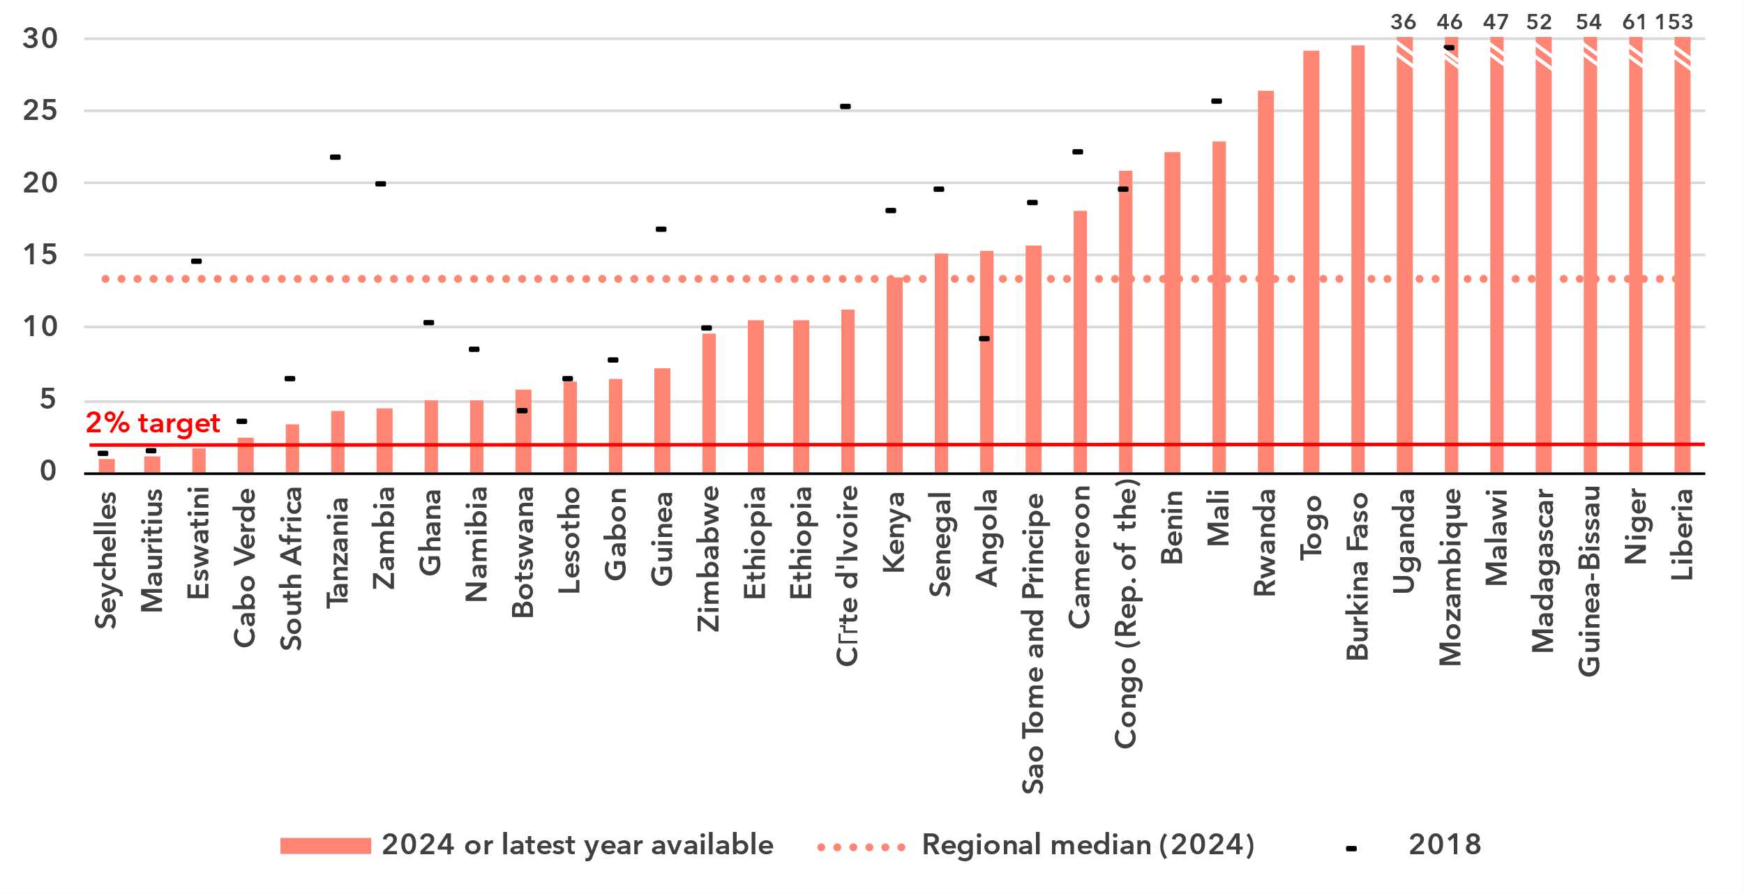Source: ITU

Mobile phone ownership and subscriptions

***Two-thirds of the population owns a mobile phone***

|  |  |
| --- | --- |
| Percentage of individuals owning a mobile phone | Percentage of individuals owning a mobile phone by gender, 2024 |

Note: Individuals aged 10 and older.

Source: ITU

In 2024, 66 per cent of individuals in the Africa region aged 10 and older owned a mobile phone, fourteen percentage points less than the global average. Over the last five years ownership increased from 54 to 66 per cent, an average annual increase of 4.2 per cent. The gender parity score for ownership stood at 0.81, improving from 0.78 in 2021. During the same period, the global GPS also improved slightly, from 0.91 to 0.93. In twelve (out of 39) countries, mobile phone ownership was below 60 per cent of the population.

Percentage of individuals owning a mobile phone, 2023 or latest year available

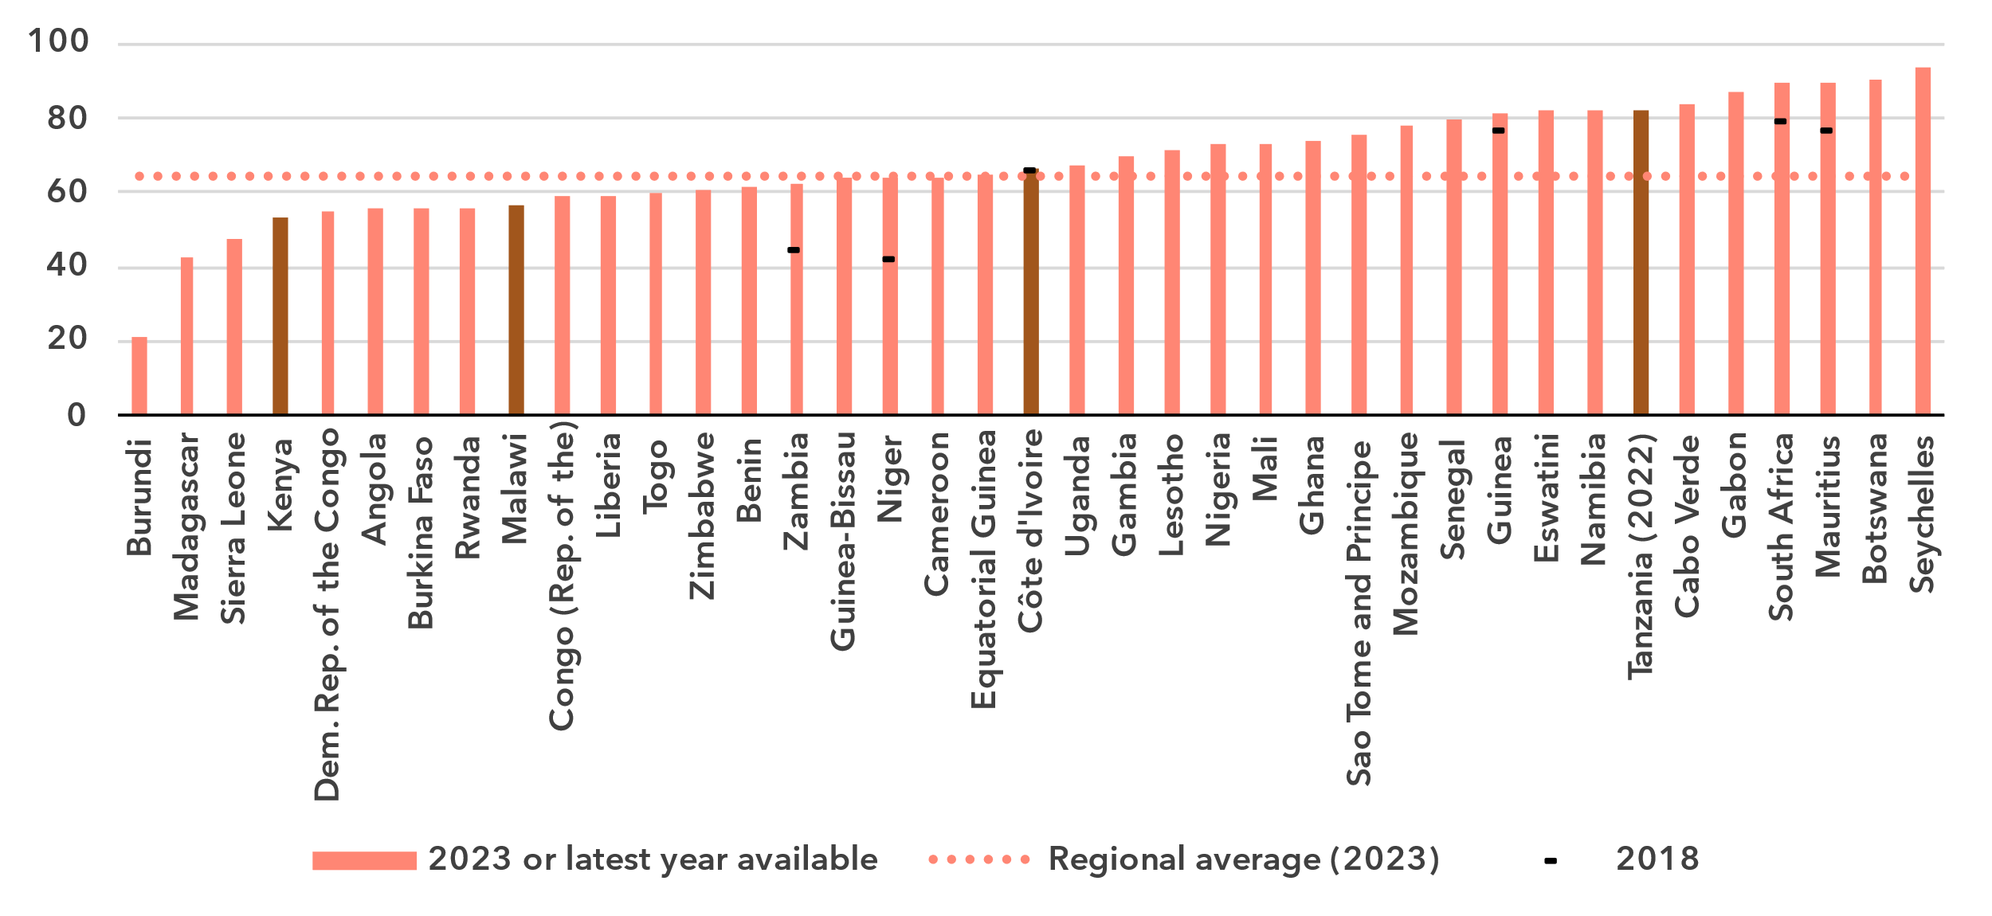Notes: Individuals aged 10 and older. Non-official data are in a lighter shade, country submitted data in a darker shade.

Source: ITU

Mobile-cellular subscriptions per 100 inhabitants

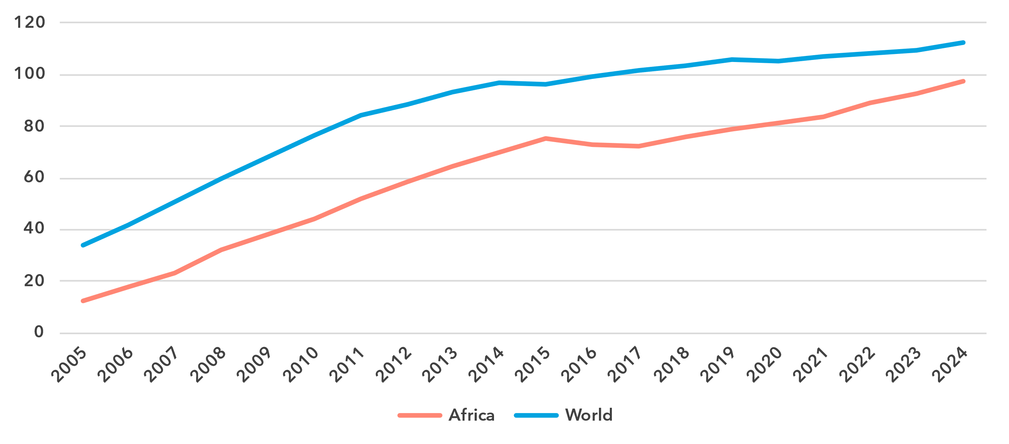 Notes: Non-official data are in a lighter shade, country submitted data in a darker shade.

Source: ITU

To use a mobile phone, a mobile-cellular or mobile broadband subscription is needed. In the Africa region, there were 98 subscriptions per 100 inhabitants in 2024, fourteen less than the global average. In the last few years, Africa has been slowly catching up with the world, with an annual average growth of 3.4 per cent over the last ten years, against 1.5 per cent globally.

At the country level, there is still a significant gap between the economies with least and most subscriptions per 100 inhabitants, at 32 and 185 respectively.

Mobile-cellular subscriptions per 100 inhabitants, 2023 or latest year available

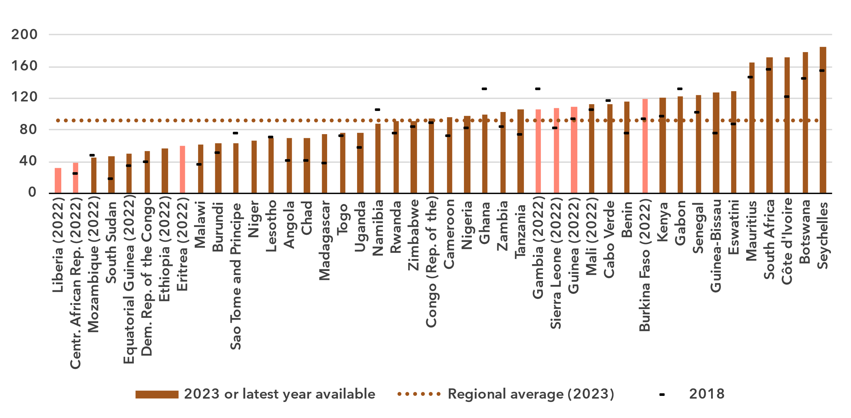

Source: ITU

ICT skills

***Lack of data prevents solid ICT skills assessment among Internet users***

Because self-reporting of individuals’ ICT skills is subjective, ICT skills are measured based on household surveys asking whether an individual has recently performed certain activities. Performing these activities presupposes a degree of proficiency in relevant digital skills. The activities are grouped into five areas: information and data literacy; communication and collaboration; digital content creation; safety; and problem solving.

While the importance of digital skills in leveraging ICTs for economic prosperity and social well-being is well-documented, data remain very scant, especially in Africa, with only eight countries having submitted ICT skills data since 2019. Furthermore, just one country provided comparable data on ICT skill levels (see box for details on the methodology for calculating ICT skill levels).

|  |  |  |  |  |  |  |
| --- | --- | --- | --- | --- | --- | --- |
| **Methodology for calculating ICT skill levels**  At its 11th meeting in September 2023, ITU’s Expert Group on ICT Household Indicators (EGH) [recommended changes](https://www.itu.int/itu-d/meetings/statistics/wp-content/uploads/sites/8/2023/09/Report-of-the-EGH-subgroup-on-ICT-Skills.pdf) in how data on ICT skill levels are reported – most importantly, that skill levels of individuals should be assessed for different areas.  *Individuals should be assessed on the number of activities within a skill area they report having done in the last three months using the following progression:*   |  |  |  | | --- | --- | --- | | None | Basic | Above basic | | 0 activities | 1 activity | More than 1 activity |  * *Skill levels should not be assessed in skill areas where fewer than two indicators are collected.* * *Indicators should be weighted equally within each skill area.* * *Skill areas with different numbers of components should be treated equally.*   While this recommendation does not require any additional data collection, it does require that countries perform additional analysis on existing survey microdata. ITU requested data on ICT skills for the first time in its April 2024 data collection, and received data from 40 countries, including one African country. However, other countries were unable to provide data, even though in many cases data on the underlying activities had been collected. It is expected that data availability will improve as familiarity with these new recommendations increases. |

ICT skills data goes beyond simple access and use of ICTs to provide a view of the capabilities of ICT users. Data on individuals in Africa with different levels of ICT skills are available only for Malawi and are shown below as a share of Internet users. These data show the areas where attention is needed to increase ICT skills.

Percentage of Internet users with ICT skills in Malawi, by skill level, 2023

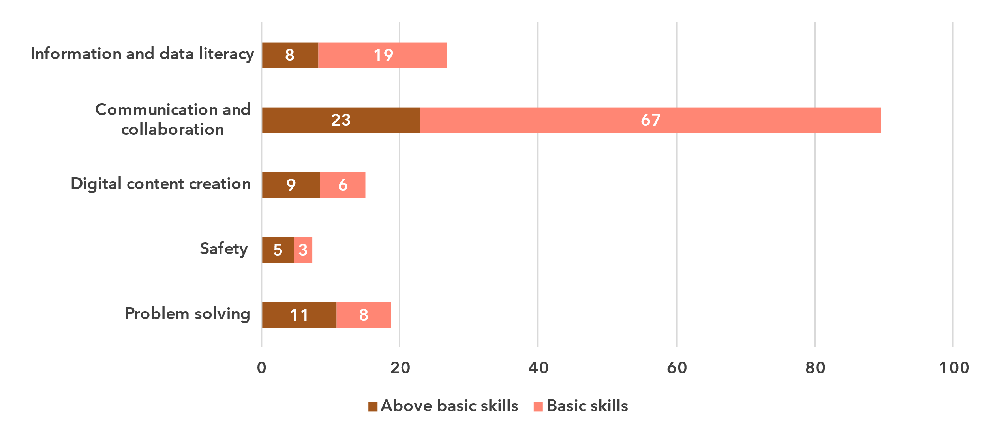Note: Data refer to individuals aged 15 and older.

Source: ITU

There is a marked difference between the five skill areas. Communication and collaboration skill levels are very high in Malawi, with 90 per cent of Internet users reporting to have at least basic skills in this area.

The second highest skill area is information and data literacy, but trailing communication and collaboration significantly, with only 27 per cent of Internet users reporting at least basic skills.

The results for the other three skill areas are even lower, especially for safety, with only eight per cent of Internet users reporting at least basic skills in this area.

Data provided by the other seven countries does not allow for a meaningful comparison between these countries. To be able to make a proper assessment of the level of ICT skills in the Africa region, there is a great need for investment in data collection.

Revenues and investment

***The telecom sector is a key economic driver in Africa***

The telecommunication sector is an important enabler of economic development, with both direct and indirect impacts. While it is harder to capture the indirect impact, recent data on revenue and investment reveals the significance of the sector’s direct impact on development but also the considerable gaps between countries.

Revenue from all telecommunication services, in USD billion and as a % of GDP, 2023 or latest available year

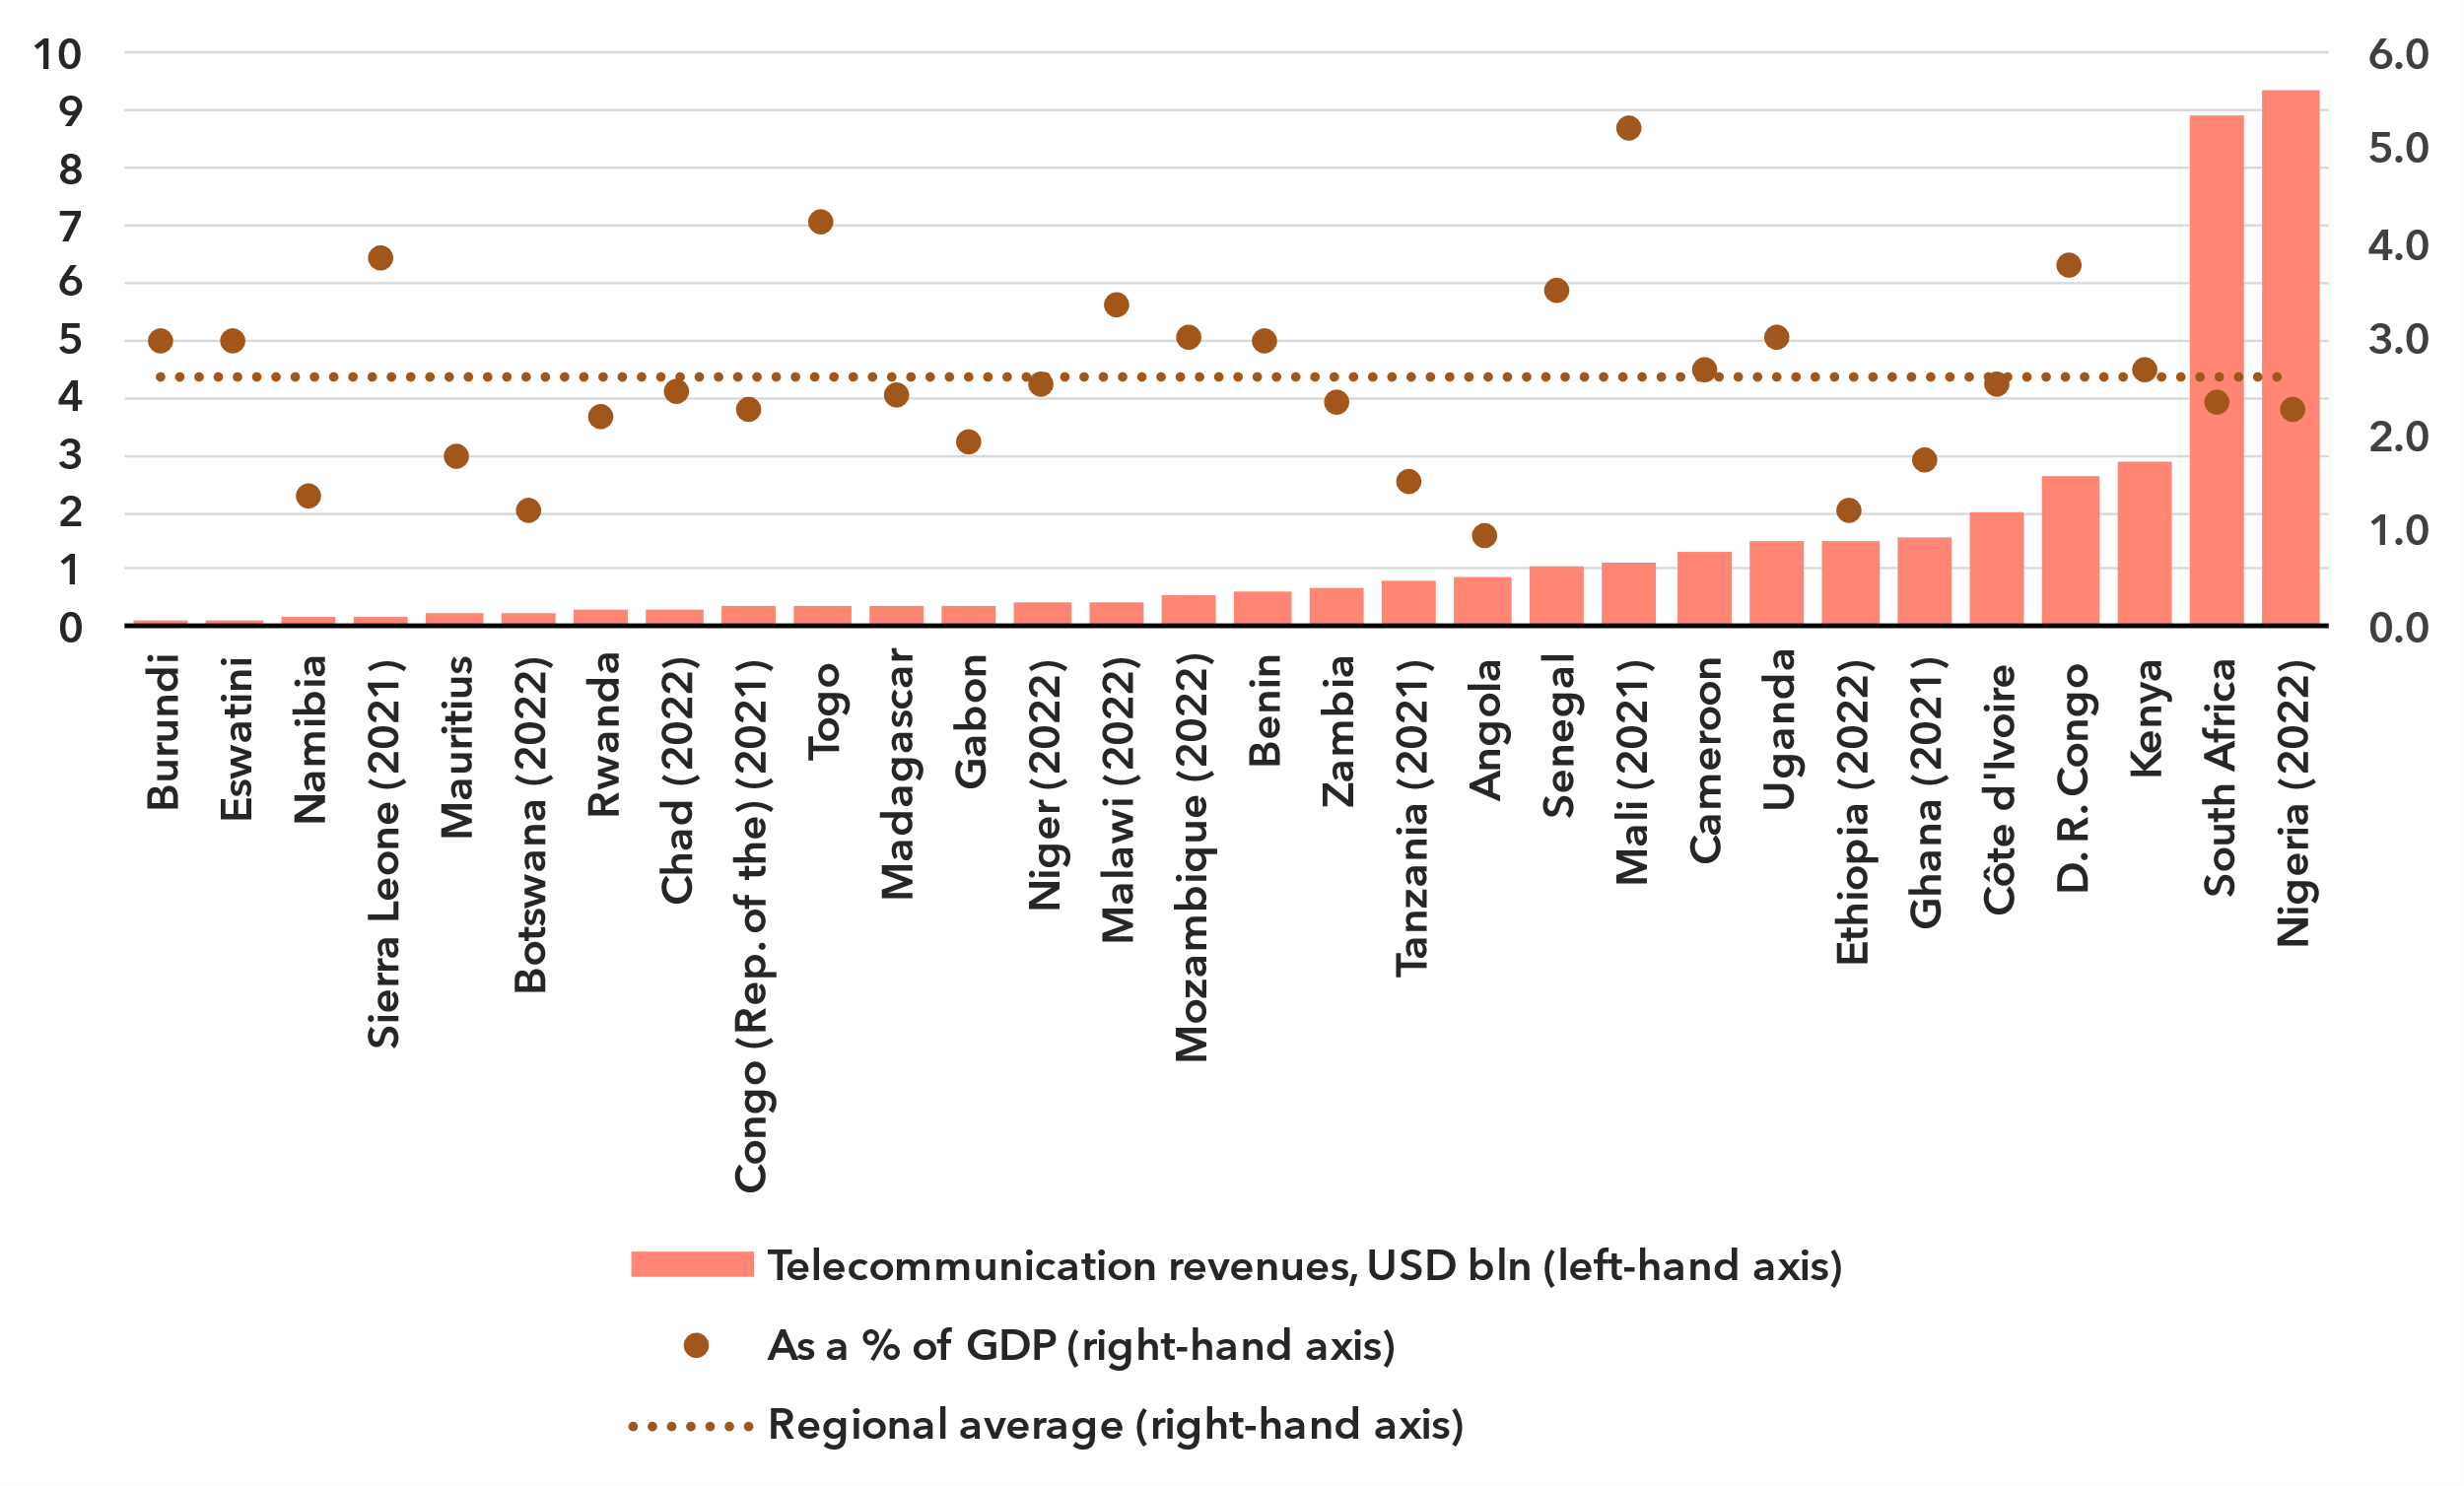Note: Annual average exchange rates applied, last available year values at constant 2023 prices.

Source: ITU, World Bank World Development Indicators

The ICT services sector includes activities providing telecommunications and related service activities, i.e. transmitting voice, data, text, sound and video, over wired, wireless, satellite or other networks.[9] The total retail revenues for the sector in the Africa region, for the 30 countries that provided data in the last available year since 2021, is estimated at around USD 42 billion. However, the size of the telecommunication market varies significantly across countries, with fourteen countries reporting revenue below USD 500 million, while the two largest markets reached USD 9 billion.

This sector contributed an average of 2.6 per cent to the region's GDP. This proportion fluctuates, ranging from less than 0.9 to 5.2 per cent.

Annual investment in telecommunication services, in USD billion and as % of GDP

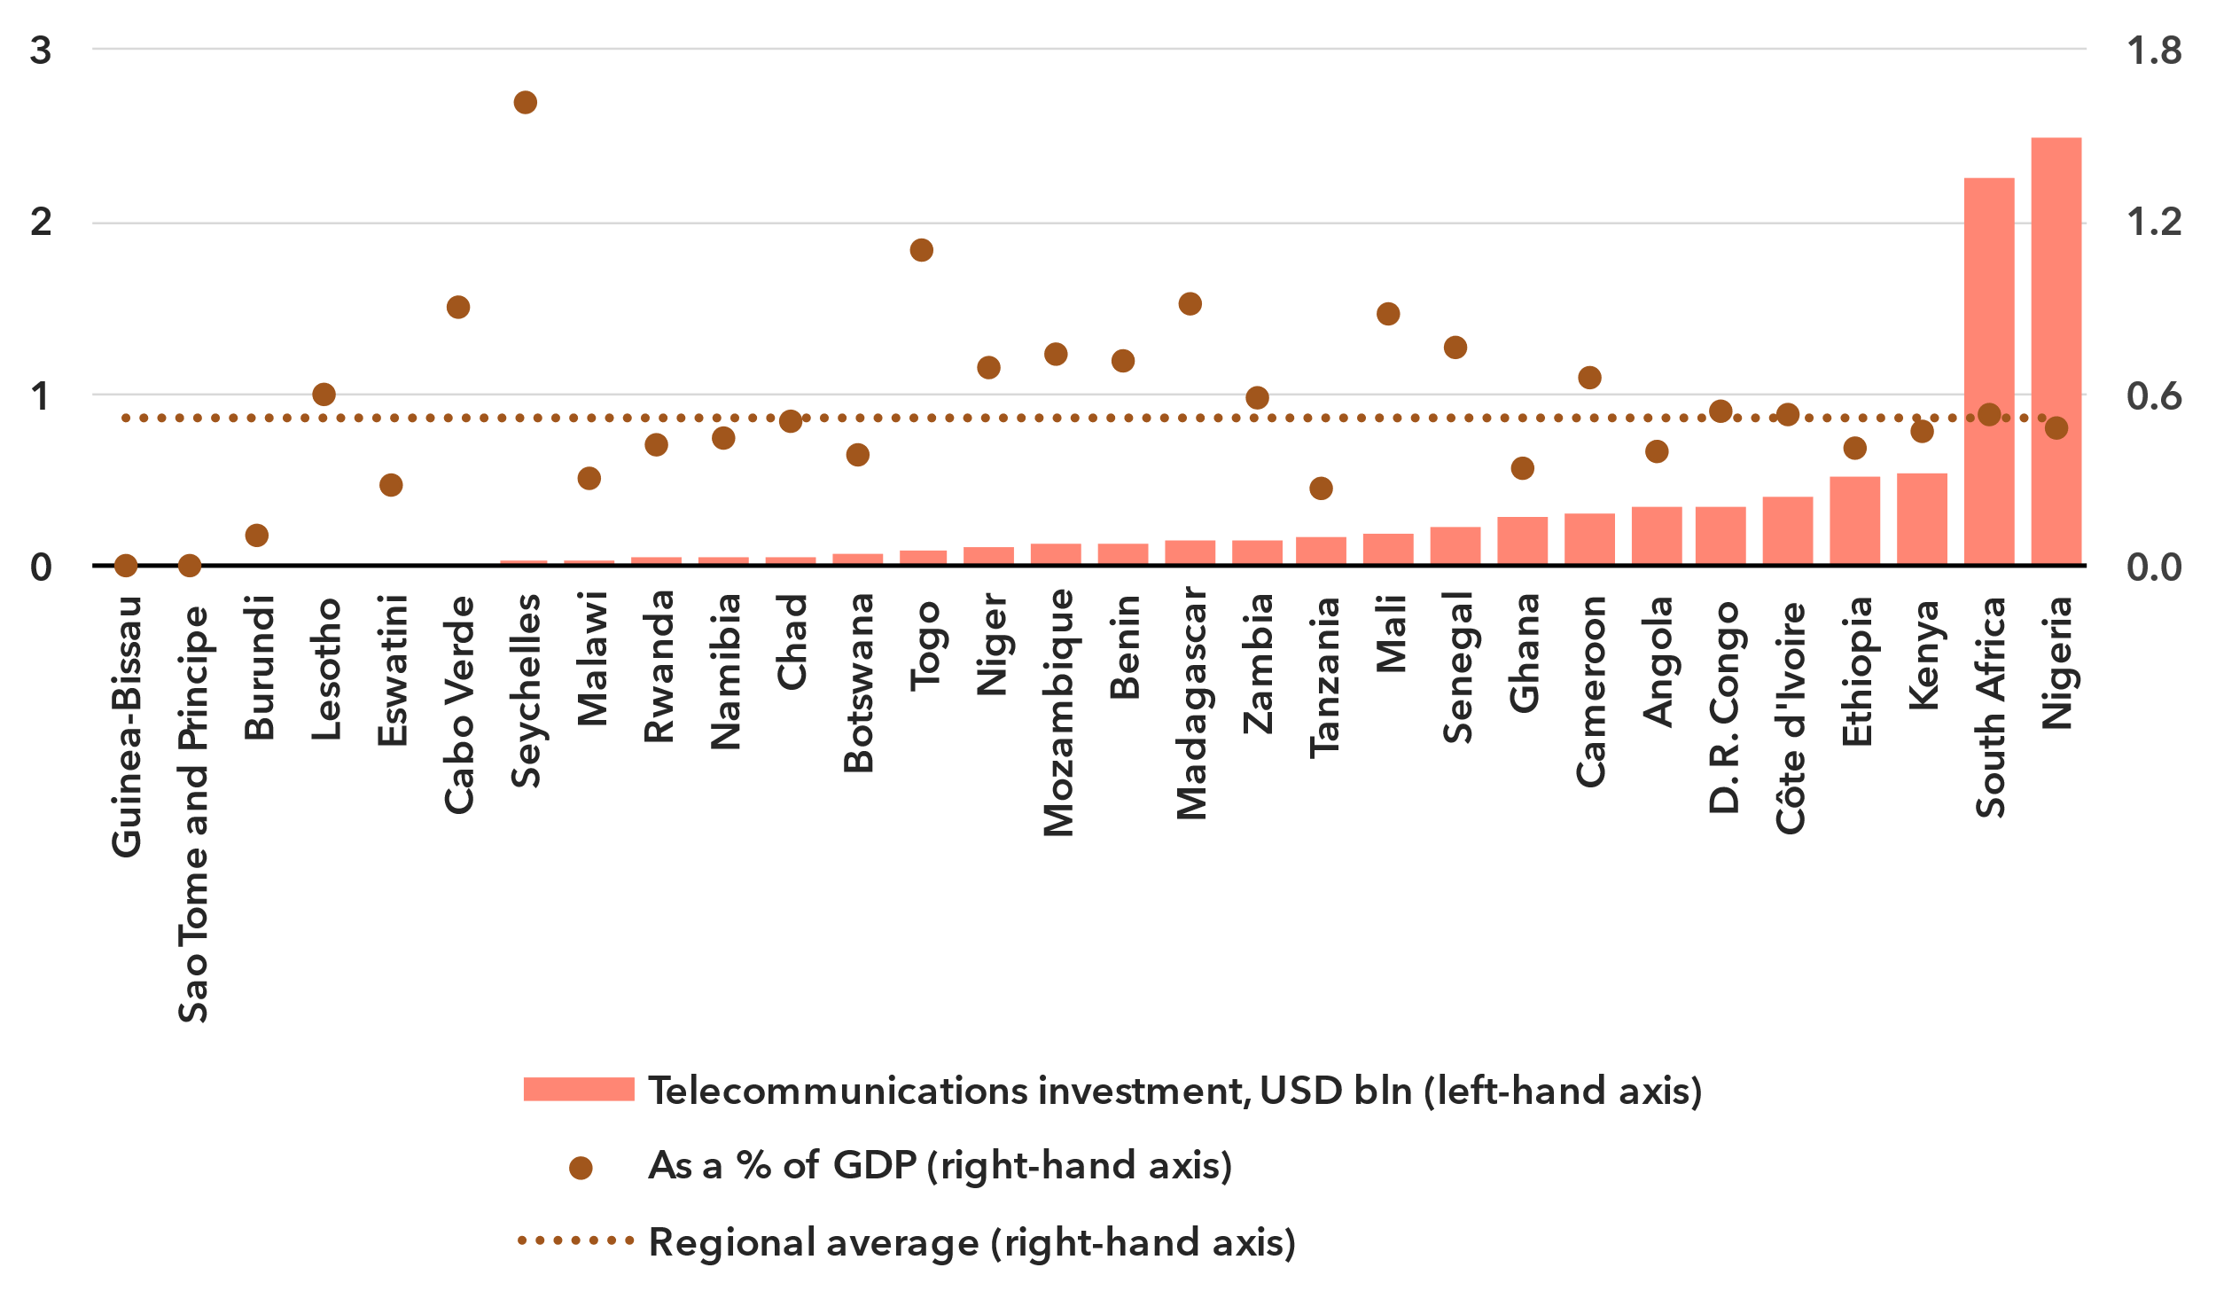Note: Data are a three-year (2021-2023) average of available data points to correct for annual fluctuations and gaps. Investment figures are in constant 2023 US dollars.

Source: ITU, World Bank World Development Indicators

The deployment of new network technologies and the upgrading of existing ones are highly capital-intensive activities. Investment projects often span multiple years and values fluctuate, which is why statistics are presented as the period average for 2021-2023. Those countries in the Africa region for which data was available made annual investments ranging from less than USD 5 million in three countries, to more than USD 2 billion in the two largest markets. This corresponded to a median value of 0.5 per cent of GDP over the 2021-2023 period.[10]

Investment is unevenly distributed across countries in the region, and both the levels and the per GDP rates of capital expenditure vary significantly. Low levels of investment in countries with mobile network coverage gaps and low penetration of mobile and fixed broadband are particularly concerning, as they perpetuate the digital divide and hinder development in Africa.

Cybersecurity

***African countries are showing that cybersecurity can be part of digital development***

Meaningful connectivity requires trustworthy and secure communications. With over 450 million Internet users in Africa, cybersecurity cannot be an afterthought. It requires a holistic approach encompassing legal, technical, organizational, capacity development, and cooperation issues. Since 2015, the Global Cybersecurity Index (GCI) has tracked countries' performance on these issues, each represented by a pillar of the index, with an aggregate GCI score on a 0-100 scale. The 2024 edition revealed a notable improvement in countries’ commitment to cybersecurity: the average GCI score reached 66, up 14 points from the 2021 edition. The countries in Africa have expanded their commitments with an average score of 57, a gain of 22 points from the previous edition.

Global Cybersecurity Index scores, 2017-2024

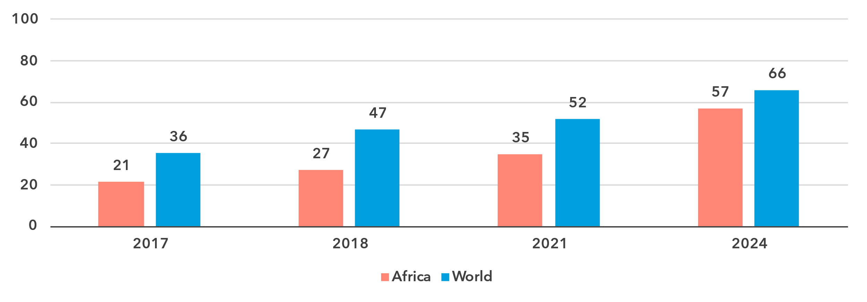

Note: Questions and weightings have been updated between editions, in collaboration with the GCI Expert Group, to better measure cybersecurity commitments by countries.

Source: ITU

The performance in the GCI of the countries in the African region various greatly, with a 98-point gap between the region’s best performer, Mauritius scoring 100, and the region’s lowest scorer, Eritrea, with a score of 2. The next lowest scoring country is the Central African Republic, scoring 5.

While the region faces challenges, much progress can be ascribed to efforts in Africa to implement National Cybersecurity Strategies, implement and harmonize laws, advance incidence response, and expand on capacity development. For example, DR Congo, Eswatini, and Togo have made significant improvements.

The Technical Pillar of the GCI assesses the effectiveness of national mechanisms and institutional structures in detecting, preventing, responding to, and mitigating cyber threats and incidents. Computer Incident Response Teams (CIRTs) are responsible for the protection against, detection of, and response to cybersecurity incidents, and can enhance a country’s ability to manage cybersecurity incidents. 55 per cent (24) countries in Africa have established their national CIRTs, and many are participating in regional cyber exercises. Still, there is need for further development of these CIRTS, expanding efforts around the protection of critical information infrastructure.

Global Cybersecurity Index scores, by pillar and overall, 2024

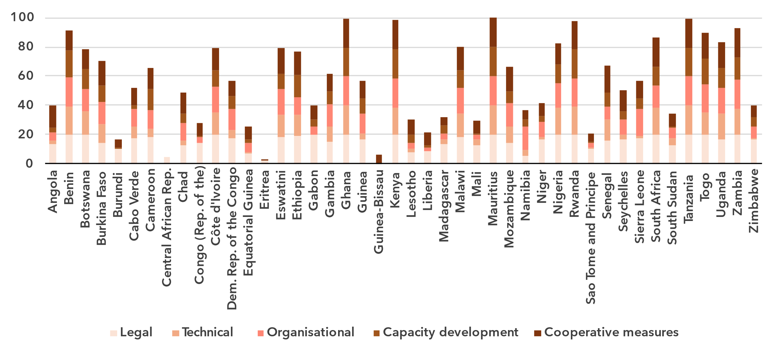Note: The overall CGI score shown is the sum of the score of the five pillars

Source: ITU

Child Online Protection (COP) encompasses strategies and initiatives designed to protect children from harm or exploitation online. This includes ensuring children are using age-appropriate software and filtering tools and educating parents and children about staying safe online. Child Online Protection is tracked through questions under the Legal, Organizational, and Capacity Development pillars. A total of 164 countries reported having legal measures on Child Online Protection in the GCI 2024, compared to 130 countries in the previous edition. These measures were sometimes part of other rules, regulations, and substantive law, such as on online crime or sexual exploitation. Almost 39 per cent (17) of countries in Africa have some form of a Child Online Protection strategy with associated actions. Linking these efforts to educational efforts for educators, parents, and policy makers is key for long term impact.

Finally, to meet the demand for cybersecurity professionals, countries are increasingly developing cybersecurity skills within their populations. While 61 per cent (27) countries in Africa have cybersecurity-focused university courses, countries still need to work to ensure that there are multiple pathways towards building cybersecurity competency to meet ongoing cyber needs.

E-waste management

***Lack of comprehensive policies for e-waste management remains a significant challenge***

As countries strive to harness the benefits of technology to drive economic growth and achieve their national development priorities, the challenge of managing electronic waste has become increasingly urgent. Strengthened e-waste policy and regulatory e-waste management are pivotal for ensuring environmental sustainability, supporting circular economy practices, and advancing progress towards the sustainable development goals (SDGs).

E-waste generated, in millions of kilograms, 2022

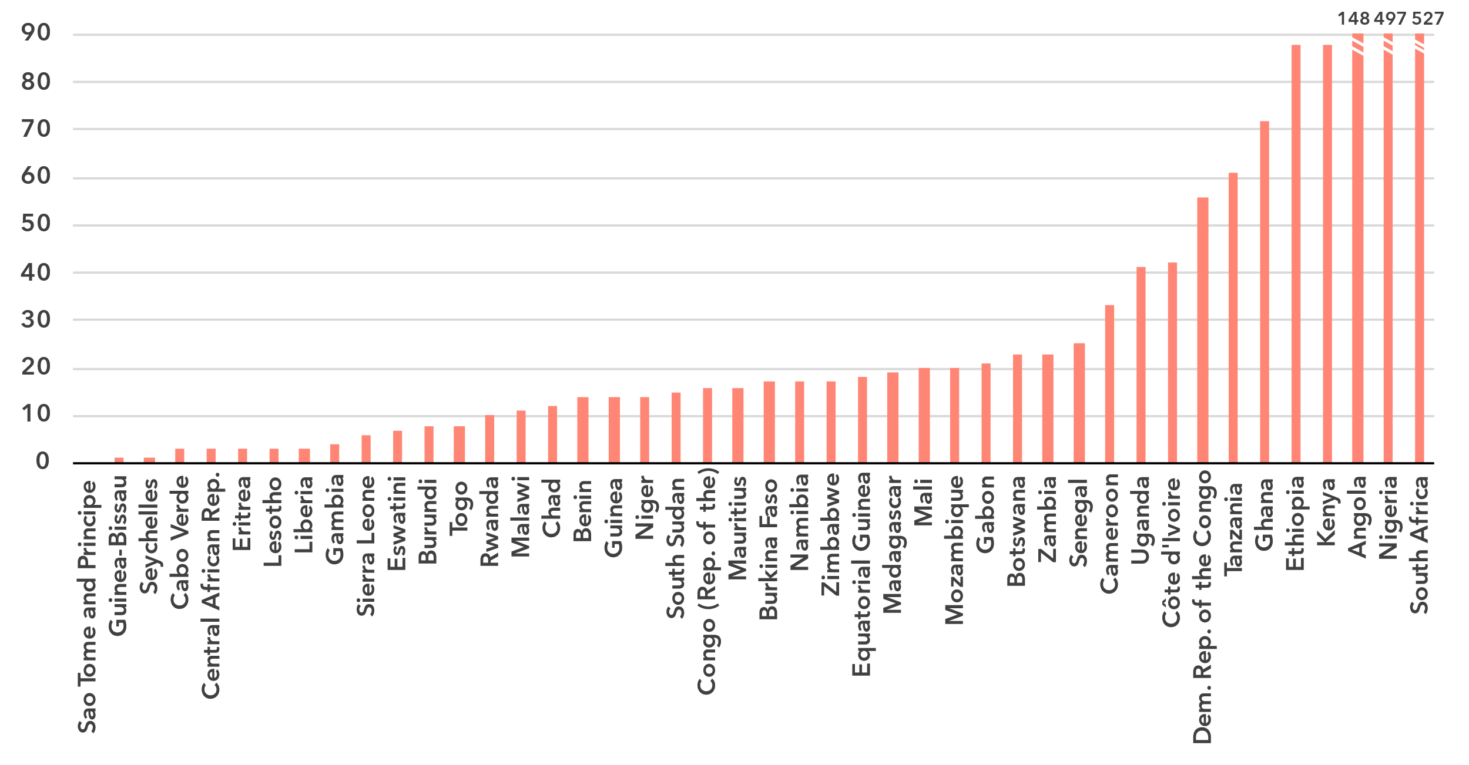Source: ITU and UNITAR, [Global E-waste Monitor, 2024](https://www.itu.int/hub/publication/d-gen-e_waste-01-2024/)

The [Global E-waste Monitor 2024](https://www.itu.int/en/ITU-D/Environment/Pages/Publications/The-Global-E-waste-Monitor-2024.aspx) finds that in 2022, African countries generated approximately 2 billion kg of e-waste, representing almost 3.3 per cent of global e-waste generation (62 billion kg). However, significant disparities exist across the region. South Africa and Nigeria were the largest contributors, producing 527 million kg and 497 million kg, respectively, together contributing more than 50 per cent of the region’s total e-waste. In contrast, smaller countries like Sao Tome and Principe, as well as Guinea-Bissau, generated minimal amounts, with contributions as low as 1 million kg, representing less than 0.1 per cent of the total. This significant variation reflects differences in population size, economic development, and technological adoption across the region.

E-waste per capita generated in kg, 2022

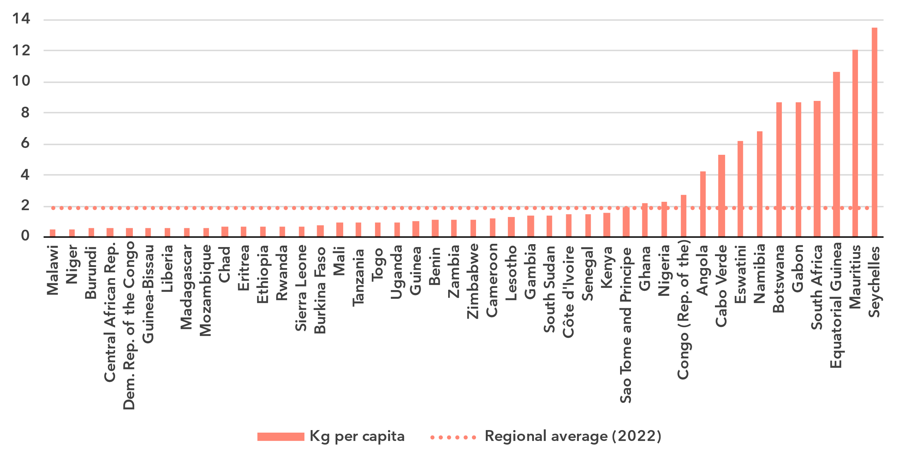Source: ITU and UNITAR, [Global E-waste Monitor, 2024](https://www.itu.int/hub/publication/d-gen-e_waste-01-2024/)

The analysis of e-waste trends in the region can be further deepened by examining per capita e-waste generation. While African countries collectively fall below the global per capita e-waste average of 7.8 kg per capita, disparities between countries are stark. The regional average of 1.9 kg per capita reflects a diverse landscape where high-income economies significantly drive up the overall figure. For instance, Seychelles stands out with the highest per capita generation at 13.5 kg, which is more than 1.7 times the global average. Similarly, Equatorial Guinea and South Africa, with 10.6 kg and 8.8 kg per capita, respectively, also exhibit high figures, aligning with their economic status and widespread access to advanced digital technologies. In contrast, lower-income countries such as Burundi and Chad, with per capita e-waste generation of just 0.6 kg and 0.7 kg, respectively, generate significantly less.

Despite these regional generation rates, only 1.2 per cent (25.3 million kg) of the e-waste generated was documented as properly collected and recycled – well below the global average of 22.3 per cent. Only a handful of countries, such as Cameroon, Rwanda, and Uganda, report formal collection and recycling initiatives. Notably, South Africa documented having recycled 22.9 million kg of e-waste. In contrast, many countries in the region, including high e-waste generators like Nigeria and Angola (which together produced over 645 million kg), lack significant formal recycling activity.

E-waste policies and regulations in place, 2022

|  |  |  |  |  |
| --- | --- | --- | --- | --- |
|  | **National e-waste legislation/policy or regulation** | **Extended producer responsibility (EPR) framework for e-waste** | **Collection targets** | **Recycling targets** |
| Angola | No | No | No | No |
| Benin | No | No | No | No |
| Botswana | No | No | No | No |
| Burkina Faso | No | No | No | No |
| Burundi | No | No | No | No |
| Cameroon | Yes | Yes | No | No |
| Cabo Verde | No | No | No | No |
| Central African Rep. | No | No | No | No |
| Chad | No | No | No | No |
| Congo (Rep. of the) | No | No | No | No |
| Côte d'Ivoire | Yes | Yes | No | No |
| Dem. Rep. of the Congo | No | No | No | No |
| Equatorial Guinea | No | No | No | No |
| Eritrea | No | No | No | No |
| Eswatini | No | No | No | No |
| Ethiopia | No | No | No | No |
| Gabon | No | No | No | No |
| Gambia | No | No | No | No |
| Ghana | Yes | Yes | No | No |
| Guinea | No | No | No | No |
| Guinea-Bissau | No | No | No | No |
| Kenya | No | No | No | No |
| Lesotho | No | No | No | No |
| Liberia | No | No | No | No |
| Madagascar | Yes | No | No | No |
| Malawi | No* | No | No | No |
| Mali | No | No | No | No |
| Mauritius | No | No | No | No |
| Mozambique | No | No | No | No |
| Namibia | No | No | No | No |
| Niger | No | No | No | No |
| Nigeria | Yes | Yes | Yes | No |
| Rwanda | Yes | Yes | No | No |
| Sao Tome and Principe | No | No | No | No |
| Senegal | No | No | No | No |
| Seychelles | No | No | No | No |
| Sierra Leone | No | No | No | No |
| South Africa | Yes | Yes | Yes | Yes |
| South Sudan | No | No | No | No |
| Tanzania | Yes | Yes | No | No |
| Togo | No | No | No | No |
| Uganda | Yes | No | No | No |
| Zambia | Yes | Yes | No | No |
| Zimbabwe | No | No | No | No |

*Malawi adopted a Malawi adopted an e-waste policy after publication of the Global E-waste Monitor.

Source: ITU and UNITAR, [Global E-waste Monitor, 2024](https://www.itu.int/hub/publication/d-gen-e_waste-01-2024/)

The lack of comprehensive policies for e-waste management remains a significant challenge in Africa, where only a few countries have implemented national e-waste legislation and extended producer responsibility (EPR) frameworks. Globally, 42 per cent of countries (81 out of 193) have enacted national e-waste policies, legislation, or regulations. In contrast, only 10 countries in the Africa region have a national e-waste policy, legislation or regulation in place, which accounts for only 25 per cent of the region.[11]

Moreover, only 8 out of 44 countries in ITU's Africa region have introduced EPR frameworks for e-waste. The absence of these frameworks across most of the countries exacerbates the region’s e-waste challenges, contributing to the continued reliance on unregulated practices that are harmful to both the environment and public health.

The lack of formalized collection and recycling targets in law can significantly impede progress. Globally, countries with a policy or legal instrument that includes collection targets have a collection rate of 25 per cent on average, higher than the global average of 22 per cent. In contrast, only Nigeria and South Africa have established formal collection targets for e-waste and South Africa is the only country in the region with e-waste recycling targets. With limited policy, legislation or regulation in place, the region will face difficulties meeting collection and recycling targets, thereby missing key opportunities to advance towards a circular economy and reduce its environmental footprint.

Disparities within the region

***Regional averages conceal disparities in connectivity among countries in Africa***

The Africa region is diverse in many respects: income level, with the wealthiest country’s GNI per capita more than 50 times larger than the poorest; urbanization rate, which ranges from less than 20 per cent to over 90 per cent; and population, which ranges from Small Island Developing States (SIDS) with less than 150,000 residents to large countries with more than 100 million residents.

Given these differences, it can be useful to group countries in Africa into clusters, according to their scores on indicators of Internet use, mobile phone ownership, mobile broadband and fixed broadband subscription rates, affordability of entry-level mobile and fixed broadband, and gender equality. This ‘cluster analysis’ yields five distinct groups, whose respective members share similar ICT profiles.

The first group, consisting only of Mauritius and Seychelles, is characterized by rates of ICT usage and ownership that are well above the world average. Data-only mobile broadband is affordable relative to the world average, with median entry-level prices as a share of monthly GNI per capita below the Broadband Commission target of 2 per cent of monthly GNI per capita or lower for both mobile and fixed broadband. The level of gender parity in terms of Internet use is also in line with world averages for these countries.

The second group, consisting of 14 countries, is closer to world averages for most indicators. Their average level of Internet use and mobile phone ownership are slightly below the world average while fixed-broadband subscription rates are far below the average. Gender parity for Internet use is in line with the world average. However, prices for both fixed and mobile broadband services are above the 2 per cent of monthly GNI per capita target. Of these countries, four are LDCs (Angola, Gambia, Lesotho, and Senegal)

The next is the largest group in Africa, consisting of 20 countries. This group has far lower rates of connectivity. Their average level of Internet use and subscription rates are far below the world averages. The gender gap for Internet use is also much wider than the world average. In addition, prices for both broadband services are far above the 2 per cent of monthly GNI per capita target with the median fixed broadband prices nearly 20 per cent of GNI per capita. Of these countries, 15 are LDCs (Benin, Burkina Faso, Democratic Republic of Congo, Eritrea, Ethiopia, Guinea, Liberia, Mali, Mozambique, Niger, Rwanda, Sierra Leone, Tanzania, Togo, and Zambia).

The fourth group consists of Guinea-Bissau, Madagascar, Malawi, and Uganda – all LDCs. This group has slightly lower rates of connectivity than the previous group and has particularly poor affordability measures. While the gender gap in Internet use remains wide for these countries, it is closer to the world average than for some of the other country groups in Africa.

The final group, consisting of Burundi, Central African Republic, Chad, and South Sudan, has the lowest rates of connectivity. Internet use and mobile phone ownership rates are extremely low, and affordability is extremely poor. Nevertheless, the overall low results for these indicators reflect the development challenges faced by these countries, all of which are classified as an LDC.

The diversity of these groups of countries underlines the need to design tailored approaches to achieve universal and meaningful connectivity.

Average of key ICT indicators by groups of similar countries in Africa, 2023

|  |  |  |  |  |  |  |
| --- | --- | --- | --- | --- | --- | --- |
|  | Group | | | | |  |
| **Indicator (units)** | 1  (2 African countries) | 2  (14 African countries) | 3  (20 African countries) | 4  (4 African countries) | 5  (4 African countries) | **World average** |
| Share of individuals using the Internet (%) | 83.5 | 61.2 | 29.7 | 21.5 | 12.8 | **65.4** |
| Gender equality - Internet use  (relative gender parity) | 0.93 | 0.90 | 0.73 | 0.87 | 0.75 | **0.90** |
| Share of individuals owning mobile phones (%) | 91.6 | 76.4 | 61.1 | 57.6 | 34.8 | **78.6** |
| Mobile-broadband subscriptions  (per 100 inhabitants) | 102.6 | 71.8 | 48.3 | 43.1 | 7.0 | **89.9** |
| Fixed-broadband subscriptions  (per 100 inhabitants) | 28.8 | 2.2 | 0.6 | 0.2 | 0.0 | **18.6** |
| Data-only mobile broadband prices  (as a % of GNI per capita) | 1.2 | 6.9 | 19.2 | 54.3 | 39.6 | **2.8** |
| Fixed broadband prices (as a % of GNI per capita) | 1.2 | 2.3 | 5.6 | 8.9 | 29.9 | **1.3** |

Note: Group medians shown for data-only mobile broadband and fixed broadband prices as a % of GNI per capita.

Source: ITU

Overview of data availability in Africa

***More survey-based ICT indicators, better quality, and greater granularity are needed***

Data plays a key role in achieving universal and meaningful connectivity. Reliable and timely data equips policymakers to identify needs, set priorities, design effective interventions, track progress, and measure impact. Investing in data yields substantial returns by enabling better decision-making and more efficient interventions.

The importance of data for the delivery of the Kigali Action Plan was acknowledged by the BDT’s Telecommunication Development Advisory Group, which adopted five key performance indicators (KPIs) tracking the extent to which Member States submit timely ICT data to ITU, including KPIs related to the submission of ICT skills data and data on Internet use disaggregated by location and gender.

Availability for a core set of 14 core administrative ICT indicators, typically collected by national regulatory authorities or ministries, is on average 75 per cent in the region (see indicator list in the note of the figure below). Sixteen countries report full availability, while seven countries are missing only one indicator. On the other hand, there are six countries that haven’t provided any data in 2022 or 2023.

Percentage availability of selected administrative ICT indicators, 2022-2023

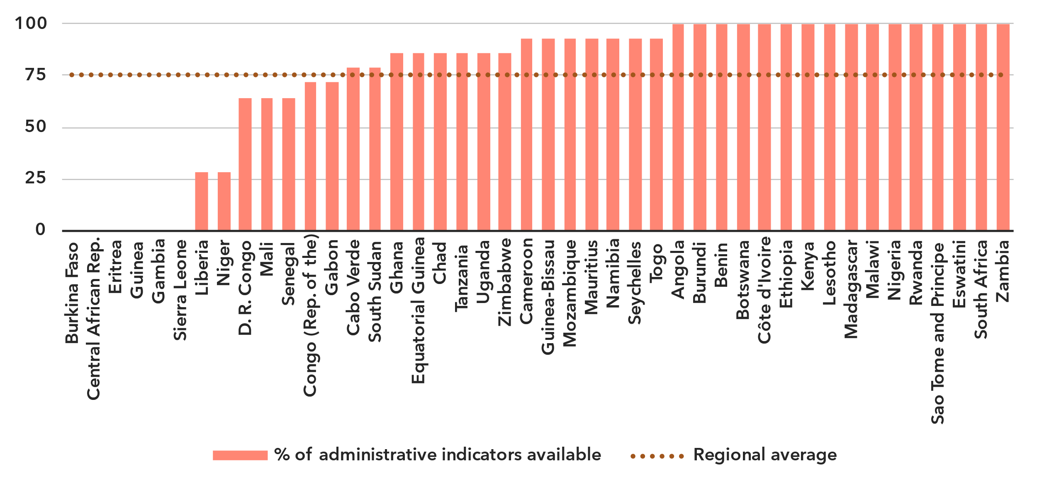Note: An indicator is considered available if at least one value is available for the period in question. Assessment based on the following set: active mobile broadband subscriptions, fixed broadband subscriptions (total, as well as by speed-tiers: 256 Kbit/s to 2 Mbit/s, 2 Mbit/s to 10 Mbit/s, and above 10 Mbit/s), mobile network coverage indicators by technology (at least 2G, 3G, LTE/WiMAX, 5G), total fixed broadband Internet traffic, mobile broadband Internet traffic within the country, international bandwidth usage, total telecommunication revenues and investment in telecommunication services.

Source: ITU

In contrast, data on ICT access and usage by households and individuals, usually derived from household surveys, is generally lacking for countries in the region. Only nine countries in Africa have provided even partial data on ICT household indicators for the period 2022-2024. Eighteen countries have not provided any data in the last ten years.

Latest year of submission of ICT household survey data, by socio-economic attribute



Source: ITU

The issue is even more acute for data disaggregated by socio-economic attributes, which is often not available. Only two countries have submitted recent data (2022 or more recent) for all six attributes of interest. Seven other countries have submitted recent data for at least one attribute.

Even when data is available, it may suffer from poor sample design, inadequate collection methods, or low response rates. Such shortcomings are likely to yield misleading results and may result in misguided policies. (For example, overestimation of ICT skills could lead policymakers to shift focus away from supporting populations that need training in this area.) Addressing these challenges requires a dual approach targeting both the producers and users of data. Through continuous efforts in capacity building, technical assistance, and advocacy, ITU aims to enhance the availability and quality of ICT data globally.

Part 2. BDT4Impact: Selected case studies from Africa

Visually impaired people in Ghana learn computer basics

The ITU [Digital Transformation Centres Initiative (DTCI)](https://academy.itu.int/itu-d/projects-activities/digital-transformation-centres-initiative) is supporting countries as they strengthen the digital capacity of citizens, particularly in underserved communities.

Under the Initiative, the ITU Telecommunication Development Bureau and the STMicroelectronics Foundation (ST Foundation) have collaborated to deliver training in basic and intermediate digital skills for citizens in countries where the Centers and the ST Foundation have a presence.

The collaboration will also explore expanding DTCI course offerings by incorporating ST Foundation’s training resources on digital skills for people with disabilities.

One example of this partnership in action was a course on computer basics for visually impaired people in Ghana in November 2023. The course used a variety of training styles (virtual, face-to-face, and offline) and took advantage of new, low-cost assistive technologies for education.

The training, held at the University of Ghana Computing Systems Assistive Technology Laboratory, brought together 20 trainers – 10 visually impaired and 10 sighted.

The trainings were carried out in a way that enabled sighted trainers to experience the sessions in the same way that their visually impaired counterparts did, a method that fosters a deeper understanding of the challenges of visually impaired learners.

Working toward a digitally enabled Uganda

The ITU Telecommunication Development Bureau is working with the Government of Uganda on many fronts to support the [country’s transition into a digitally enabled society and knowledge economy](https://www.itu.int/itu-d/sites/digital-impact-unlocked/towards-a-digitally-enabled-uganda/).

Among the efforts is a multi-pronged project entitled "Technical Assistance and Training to Uganda on National ICT Development Strategy" that is supporting the country as it crafts policies on matters such as 5G uptake, e-waste management, and extended producer responsibility. The project is also providing a wide variety of capacity-building activities in child online protection, data privacy, spectrum management, digital skills assessment, and more.

Implemented by ITU and the Government of Uganda, with financial support from the South-South Cooperation Assistance Fund and the Global Development and South-South Cooperation Fund, the project aligns with Uganda's Digital Transformation Roadmap (2023-2027).

Many of the project’s cross-cutting capacity-development activities are delivered in partnership with the Uganda Institute of Communications and Technology (UICT). These include advanced technical training for government officials and basic digital skills courses for entrepreneurs, teachers, and rural healthcare providers.

UICT also serves as one of ITU’s 14 Digital Transformation Centers, which are providing digital skills training across the globe.

Digital terrestrial television training in Brazzaville, Republic of Congo

The ITU Regional Office for Africa hosted a [training on digital terrestrial television in Brazzaville, Republic of Congo](https://www.itu.int/itu-d/sites/digital-impact-unlocked/digital-terrestrial-television-training-in-brazzaville-republic-of-congo/) in April 2024.

Participants from 34 countries gathered for the training, which supported the countries’ transition from analogue to digital television and strengthened collaboration among African telecommunication regulators.

Digital television offers better quality, more content, and more features than the old analogue system.

The training equipped professionals with knowledge and practical skills on transitioning from analogue to digital processes, and on the implementation of migration roadmaps. Practical exercises helped participants understand the challenges their countries might face when deploying digital terrestrial television.

The training was provided as part of the PRIDA project, which aims to facilitate universally accessible, affordable, and efficient wireless broadband services across Africa, unleashing the cross-cutting benefits of ICT services. PRIDA is a joint initiative of the African Union, the European Union, and ITU.

A new national e-waste policy in Malawi

The National E-waste Management Policy – [Malawi’s first guiding document for e-waste management](https://www.itu.int/itu-d/sites/digital-impact-unlocked/a-new-national-e-waste-policy-in-malawi/) – was launched in October 2024.

Officials in Malawi said the new policy limits the importation of e-waste, mandates that all equipment is properly vetted, that illegal movement of materials is stopped, and that other countries are protected.

The policy was developed over seven years by the Ministry of Natural Resources and Climate Change through the Environmental Affairs Department, in collaboration with the Malawi Communication Regulatory Authority, and with support from ITU’s Telecommunication Development Bureau.

Businesswomen in Africa thrive after developing their digital skills

New horizons are opening for young fashion entrepreneurs in [Burundi](https://www.itu.int/itu-d/sites/digital-impact-unlocked/unleashing-digital-empowerment-through-the-itu-eif-joint-programme-in-burundi/) and [Ethiopia](https://www.itu.int/itu-d/sites/digital-impact-unlocked/transforming-futures-with-digital-skills-through-the-itu-eif-joint-programme-in-ethiopia/) who have learned to create websites, conduct online market research, and harness the power of social media.

The learning was made possible by a joint mentorship initiative of the ITU Telecommunication Development Bureau, the Enhanced Integrated Framework and EQUALS Global Partnership.

“We were able to really connect with the markets, connect with new buyers, connect with a new audience, study whether or not our brands and our products would be a good fit for the market,” said Margaux Rusita, founder and chief designer at Margaux Wong in Burundi. “Using technology, we were able to show them our websites and our Instagram.”

“The difficult thing for me was how to reach out to buyers, how to reach out to customers, how to do it through e-commerce, how to use social media,” said Mastewal, a fashion designer in Ethiopia whose business benefitted from the training. She employs three other women. “It gives me a wonderful feeling to empower myself and to empower others.”

Building regulatory capacity and regional collaboration through ICT benchmarking in Equatorial Guinea

ITU’s Telecommunication Development Bureau organized a two-day hands-on workshop in Malabo that provided Central Africa’s regulators with tools to bridge gaps in ICT policy and regulatory frameworks across 11 member countries of the Economic Community of Central African States.

The ‘Stakeholder Workshop for Benchmarking of ICT in Central Africa’ aimed to strengthen the foundation for regional cooperation through interactive sessions on regulatory frameworks, data-driven policy approaches and collaborative governance.

Among the workshop’s standout moments was a session on co-creation of national roadmaps, where participants worked together to craft actionable strategies to address shared challenges such as data governance and regulatory coherence across sectors.

During the workshop, participants also worked together to strengthen capacity-building initiatives; align national ICT strategies with the African Union’s Digital Transformation Strategy; and enhance regional collaboration by bringing together regulators, policymakers, and stakeholders under a shared vision for digital transformation and regional integration.

The workshop was organized in collaboration with the European Union delegation in the Democratic Republic of Congo and Cellule d'appui à l'Ordonnateur national du Fonds européen de développement (COFED).

Annex: Data resources

To save space, ensure up-to-date information, and enhance readability, all data presented in this document are available for download as Excel files:

* [Country-level data](https://www.itu.int/en/ITU-D/Statistics/Documents/facts/rpm_arb_pub_2025_data.xlsx) organized by tabs corresponding to the sections of this document (URL: <https://www.itu.int/en/ITU-D/Statistics/Documents/facts/rpm_afr_pub_2025_data.xlsx>). Country level data were extracted from the [ITU DataHub](https://datahub.itu.int/), reflecting the February 2025 data release.
* [Regional and global estimates](https://www.itu.int/en/ITU-D/Statistics/Documents/facts/ITU_regional_global_Key_ICT_indicator_aggregates_Nov_2024.xlsx), as compiled for [Facts and Figures 2024](https://www.itu.int/itu-d/reports/statistics/facts-figures-2024/) (URL: <https://www.itu.int/en/ITUD/Statistics/Documents/facts/ITU_regional_global_Key_ICT_indicator_aggregates_Nov_2024.xlsx>).

________________

1. As of March 2025, the Africa region, as defined by ITU, consists of the following 44 economies: Angola, Benin, Botswana, Burkina Faso, Burundi, Cameroon, Cabo Verde, Central African Republic, Chad, Congo (Republic of the), Côte d'Ivoire, Democratic Republic of the Congo, Equatorial Guinea, Eritrea, Eswatini, Ethiopia, Gabon, Gambia, Ghana, Guinea, Guinea-Bissau, Kenya, Lesotho, Liberia, Madagascar, Malawi, Mali, Mauritius, Mozambique, Namibia, Niger, Nigeria, Rwanda, Sao Tome and Principe, Senegal, Seychelles, Sierra Leone, South Africa, South Sudan, Tanzania, Togo, Uganda, Zambia, and Zimbabwe. For the sake of readability, the Africa region is also referred to as Africa throughout this document.
2. Sao Tome and Principe graduated from the LDC category at the end of 2024.
3. The tiers of the G5 Benchmark reflect a country's level of digital governance. The four levels, from least to most advanced, are: Limited, Transitioning, Advanced and Leading. The four pillars of the G5 Benchmark encompass 119 targets across National Collaborative Governance, Policy Design Principles, Digital Development Toolbox, and National Digital Policy Agenda. See [gen5.digital/benchmark](http://www.gen5.digital/benchmark)
4. The [Doha Programme of Action for LDCs for the Decade 2022-2031](https://digitallibrary.un.org/record/3959499?ln=en&v=pdf), the [Antigua and Barbuda Agenda for Small Island Developing States: A Renewed Declaration for Resilient Prosperity](https://digitallibrary.un.org/record/4054465?ln=en) (2024-2034) and the [Programme of Action for LLDCs for the Decade 2024–2034](https://docs.un.org/A/RES/79/233). See also ITU, [Accelerating Sustainable and Inclusive Digital Transformation in SIDS: A 10-Step Plan for SIDS](https://www.itu.int/net/epub/BDT/2024-ITUs-contribution-to-the-implementation-of-the-Antigua-and-Barbuda-Agenda-for-SIDS/index.html#p=1).
5. Considering that some people may never want to connect, as a matter of convention universality is taken to mean an Internet penetration rate of at least 95 per cent.
6. In this document, for figures reporting economy-level data, all economies are shown. Countries are sorted by value of the indicator. A data point is only shown if it is for the year 2020 or later, otherwise it is marked as not available (N/A), or excluded altogether (when data are not available for many countries). In addition, a marker shows the data point for the year 2018, if available. Data are extracted from the [ITU DataHub](https://datahub.itu.int/), based on the data release of February 2025. Since country-level data are available for the year 2023 at best, for comparison purposes, the regional average for the year 2023 is reported as well, as published in [Facts and Figures 2024](https://www.itu.int/itu-d/reports/statistics/facts-figures-2024/).
7. The gender parity score is calculated as the proportion of women who use the Internet divided by the proportion of men who use the Internet. A value less than one indicates that men are more likely to use the Internet than women, while a value greater than one indicates the opposite. Gender parity is considered achieved if the value lies between 0.98 and 1.02.
8. Considering only those countries for which data was available for all years from 2018 to 2024.
9. For a complete definition, see ISIC Rev. 4 class 61.
10. Investment statistics collected by ITU refer to acquiring or upgrading property (including tangible assets such as plants and non-tangible assets such as computer software) and networks. Expenditure on research and development, annual fees for operating licences and the use of radio spectrum, and investment in telecommunication software or equipment for internal use are excluded.
11. Including Malawi, which adopted an e-waste policy after publication of the Global E-waste Monitor.