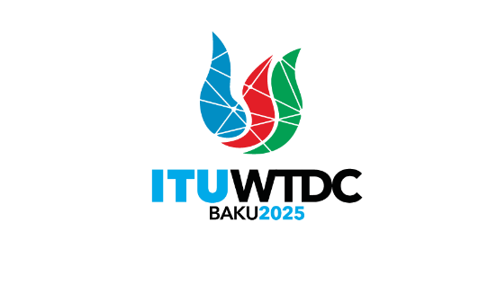 | Regional Preparatory Meeting  for Africa for WTDC-25 (RPM-AFR)  Nairobi, Kenya, 8-9 April 2025 |  | 
 |  | Document RPM-AFR25/1(Rev.2)-E
 |  | 4 March 2025
 |  | Original: English
Director, Telecommunication Development Bureau
Draft agenda

- Opening ceremony
- Election of the Chair and Vice-Chairs
- Approval of the agenda
- Consideration of the time management plan
- Report on the implementation of the WTDC-22 Kigali Action Plan (including the Regional Initiatives) and Presentation on State of digital development and trends in the Africa Region: Challenges and opportunities
- Report on the decisions of other ITU Conferences, Assemblies and meetings related to ITU-D work
- Preparations for WTDC-25
  - Preliminary draft ITU-D contribution to the ITU Strategic Plan, and draft Action Plan
  - Future Study Group questions
  - Preliminary draft WTDC-25 Declaration
  - Rules of procedure of ITU-D (WTDC Resolution 1)
  - Streamlining WTDC Resolutions
- Priority setting for Regional Initiatives, related projects and financing mechanisms
- Any other business (AOB)
_______________

