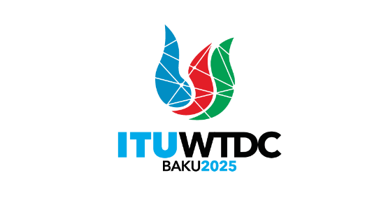 | First Inter-Regional Meeting (IRM-1) to prepare for the WTDC-25  Virtual, 14-15 July 2025 |  | 
 |  | Document IRM25-1/1-E
 |  | 29 May 2025
 |  | Original: English
Director, Telecommunication Development Bureau
Draft agenda

- Opening of the meeting
- Approval of the agenda
- WTDC update
- Update on RTO preparations
- Contributions from membership
- Proposed actions to WTDC resolutions by regions
- WTDC Committee chairpersonships
- Assignment of work of the Conference to Committees
- Any other business
- Closing
_______________

