 | Second Inter-Regional Meeting (IRM-2) to prepare for the WTDC-25  Virtual, 29 September 2025 |  | 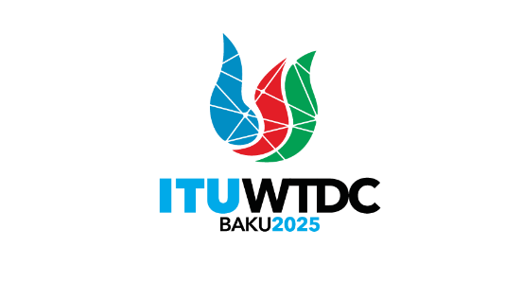
 |  | Document IRM25-2/1-E
 |  | 8 August 2025
 |  | Original: English
Director, Telecommunication Development Bureau
Draft agenda

- Opening of the meeting
- Approval of the agenda
- Update by RTOs on the status of preparations for WTDC-25
- Contributions from membership
  - WTDC-25 Declaration
  - ITU-D Priorities
  - Regional Initiatives
  - Future Study Group Questions
  - Proposals on WTDC resolutions
- WTDC-25 Committee Vice Chair Persons
- Any other business
- Closing

______________

