|  |  |  |
| --- | --- | --- |
|  | **World Telecommunication Development Conference (WTDC-22)**  **Kigali, Rwanda, 6-16 June 2022** | |
|  | |  |
| PLENARY MEETING | | **Document** **WTDC-22/7-E** |
|  | | **20 May 2022** |
|  | | **Original: English** |
| Chairman, ITU-D Study Group 2 | | |
| ITU-D Study Group 2 Activities for the Seventh study period between WTDC-17 and WTDC-22 | | |
|  | | |
|  | | |
| **Summary:**  This report summarizes the activities carried out by ITU-D Study Group 2 for the seventh study period between WTDC-17 and WTDC-22.  **Expected results:**  WTDC-22 is invited to note this document.  **References:**  [TDAG-18/13](https://www.itu.int/md/D18-TDAG23-C-0013), [TDAG-19/13](https://www.itu.int/md/D18-TDAG24-C-0013), [TDAG-20/13](https://www.itu.int/md/D18-TDAG25.2-C-0013), [TDAG-21/9](https://www.itu.int/md/D18-TDAG28-C-0009), [TDAG-21/2/6](https://www.itu.int/md/D18-TDAG29-C-0006), [TDAG-21/2/DT/5](https://www.itu.int/md/D18-TDAG29-211108-TD-0005), [2/REP/8](https://www.itu.int/md/D18-SG02-R-0008/en) (2018), [2/REP/16](https://www.itu.int/md/D18-SG02-R-0016/en) (2019), [2/REP/24](https://www.itu.int/md/D18-SG02-R-0024/en) & [SG2RGQ/REP/22](https://www.itu.int/md/D18-SG02.RGQ-R-0022) (2020), [2/REP/32](https://www.itu.int/md/D18-SG02-R-0032) & [2/REP/33](https://www.itu.int/md/D18-SG02-R-0033) & [SG2RGQ/REP/23](https://www.itu.int/md/D18-SG02.RGQ-R-0023) (2021) | | |

# Introduction

The report covers the seventh study period for ITU-D Study Group 2 (SG2). This study group concluded its work at its fourth and final meeting held in Geneva from 15 to 19 March 2021, approving output reports for all seven Questions. Following decision by TDAG during its meeting held from 24 to 28 May 2021, an additional meeting was held from 18 to 22 October 2021, focused on review and updates to the terms of reference of the SG2 Questions to define its future work until the next WTDC.

The 2018-2022 study period for SG2 concluded to-date with:

* 7 output reports and video clips to promote them[1];
* 5 annual deliverables[2];
* 4 annual SG2 meetings from 2018 to 2021;
* 4 annual SG2 rapporteur group meetings from 2018 to 2021, as well as 1 block of informal rapporteur group meetings in February 2021;
* Video interviews by 7 (co-)authors of annual deliverables[3];
* 3 webinars in the 2020 “Reflections on COVID-19” series[4];
* 3 WSIS 2020 sessions (one thematic workshop and two high-level policy sessions) and 4 WSIS 2021 sessions (one high-level policy session, two thematic workshops and one country workshop)[5];
* 21 workshops and other events[6];
* 6 ITU News blogs[7] and 1 ITU communique[8];
* 166 incoming liaison statements (SG2 and rapporteur group level);
* 86 outgoing liaison statements (SG2 and rapporteur group level);
* 587 contributions (membership, SG2 management team and ITU);
* The highest number of participants for a SG2 plenary level meeting was 130 (second meeting in 2019);
* The highest percentage of female participation for a SG2 plenary level meeting was 37% (fourth meeting in 2021);
* The highest number of participants for a SG2 rapporteur group level meeting was 156 (first meeting in 2018);
* The highest percentage of female participation for a SG2 rapporteur group level meeting was 42% (last meeting in October 2021);
* SG2 management team contributed to ITU work including representations in regional workshops, RDFs, RPMs and IRMs;
* Draft revised terms of reference of the SG2 Questions were developed and reached agreement during the last SG2 meetings of this study period (18-22 October 2021).

## Mandate and outcomes

SG2 was established in accordance with WTDC Resolution 2 (Rev. Buenos Aires, 2017) to study Questions and issues relating to ICT services and applications for the promotion of sustainable development. The study group is responsible for seven substantive topics to study the use and impact of ICTs in the areas of: 1) smart cities and society, 2) e-health, 3) cybersecurity, 4) conformance and interoperability testing, counterfeit ICT equipment and theft of mobile devices, 5) disaster risk reduction and management, 6) e-waste and climate change, and 7) human exposure to electromagnetic fields. SG2 takes also into account the work of other ITU Sectors and relevant organizations, and the priorities of developing countries in fulfilling its mandate.

The formal titles of the SG2 Questions are as follows:

* **Question 1/2**: Creating smart cities and society: Employing information and communication; technologies for sustainable social and economic development;
* **Question 2/2**: Telecommunications/ICTs for e-health;
* **Question 3/2**: Securing information and communication networks: Best practices for developing a culture of cybersecurity;
* **Question 4/2**: Assistance to developing countries for implementing conformance and interoperability (C&I) programmes and combating counterfeit ICT equipment and theft of mobile devices;
* **Question 5/2**: Utilizing telecommunications/ICTs for disaster risk reduction and management;
* **Question 6/2**: ICTs and the environment;
* **Question 7/2**: Strategies and policies concerning human exposure to electromagnetic fields.

The definitions of the Questions, which include, *inter alia*, the statement of the problem, the description of the expected output and the initial work plan with the required timing for the output, is available on the SG2 website[9].

SG2 concluded its work at its fourth annual meeting held virtually from 15 to 19 March 2021, approving output reports for all seven study group Questions. Following postponement of WTDC to June 2022 and decision by TDAG, extra SG2 plenary and rapporteur group meetings were held from 18 to 22 October 2021 and were principally focused on developing draft revisions of the terms of reference of the SG2 Questions in preparation for future studies. All revisions were agreed by SG2 and submitted to TDAG for consideration[10].

## ITU-D Study Group 2 management

WTDC-17 designated the SG2 leadership for the study period 2018-2022: Dr Ahmad Reza Sharafat (Iran (Islamic Republic of)) (ASP) served as Chairman of ITU-D SG2; he was ably assisted by the following vice-chairmen:

* Mr Abdelaziz Alzarooni (United Arab Emirates) (ARB)
* Ms Nora Abdalla Hassan Basher (Sudan) (ARB)
* Ms Maria Bolshakova (Russian Federation) (CIS)
* Ms Celina Delgado (Nicaragua) (AMS)
* Mr Ananda Raj Khanal (Nepal (Republic of)) (ASP)
* Mr Roland Yaw Kudozia (Ghana) (AFR)
* Mr Tolibjon Oltinovich Mirzakulov (Uzbekistan) (CIS)
* Ms Alina Modan (Romania) (EUR)
* Mr Henry Chukwudumeme Nkemadu (Nigeria) (AFR)
* Ms Ke Wang (China) (ASP)
* Mr Dominique Würges (France) (EUR).

The following vice-chairmen resigned during this study period:

* Mr Nasser Al Marzouqi (United Arab Emirates) (ARB)
* Mr Filipe Miguel Antunes Batista (Portugal) (EUR)
* Mr Yakov Gass (Russian Federation) (CIS).

The SG2 vice-chairmen actively followed the work assigned by WTDC-17, providing sound and valuable advice to the chairman on all issues related to the study group. Some vice-chairmen were also co-rapporteurs and vice-rapporteurs of study group Questions. In 2020, as part of preparation for WTDC-22 and to explore synergies with certain key ITU projects relevant to study group Questions, some vice-chairmen were appointed as coordinators together with other rapporteurs and vice-rapporteurs (see **Annex 2**). Vice-chairmen were also encouraged to work with ITU regional offices and with administrations in their regions to take forward the ICT development agenda:

* to effectively support WTDC-22 regional preparatory processes especially for WTDC Resolution 1 (Rev. Buenos Aires, 2017) and WTDC Resolution 2 (Rev. Buenos Aires, 2017); and
* to enhance regional engagement in ITU-D study groups and to provide relevant ITU-D study group products to the Member States (and relevant entities) in each region.

SG2 management team members were active as speakers in ITU and external events including the Global Symposium for Regulators (GSR)[11], the World Summit on the Information Society (WSIS) Forums[12], the Global Forum on Emergency Telecommunications (GET)[13], the Emerging Technology for Connectivity[14], the Global Manufacturing and Industrialisation Summit (GMIS)[15], the Global Forum on Human Settlements (GFHS), as well as various regional events including RDFs, RPMs and workshops. They also contributed as experts to several ITU publications.

All engagements with the SG2 management team during the 2018-2022 study period were conducted in a cooperative manner with team spirit and professionalism reflecting each management team member’s sincere dedication to the mission and objectives of the study group.

The list of appointed chairman, vice-chairmen, rapporteurs and vice-rapporteurs of SG2 Questions can be found in **Annex 1**.

## Participation and written contributions (2018-2022 study period)

An aggregate number of 1210 participants attended SG2 and rapporteur group meetings (including the joint ITU-D Study Group 1 (SG1) and SG2 plenary held in March 2021) during this study period. **Table 1** details the number of participants during each SG2 event of the study period. Each event gathered about 121 participants on average per meeting.

**Table 1: Participation statistics to SG2 and rapporteur group meetings**



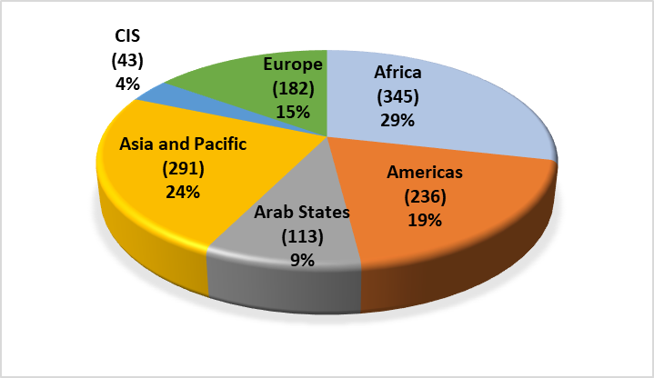

**Figure 1: Aggregate number of participants (per region) for SG2**

**Figure 1** provides the regional distribution of all participants. The majority of participants were from the African and Asia and Pacific regions, followed by Americas, Europe, Arab States and CIS.

Many delegates regularly attended study group and rapporteur group activities, either in person or remotely, from year to year. A total of 483 individual delegates[16] participated in at least one SG2 meeting. **Figure 2** shows the regional distribution of these individual delegates. While the Asia and Pacific region is ahead with the most individual delegates followed by Africa, the distribution is similar to the regional distribution of the aggregate number of participants in Figure 1.

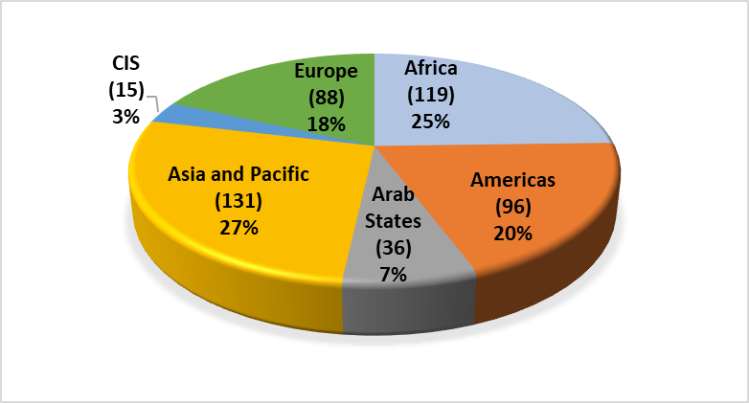

**Figure 2: Number of individual participants (per region) for SG2**

SG2 considered a total of 926 documents during this study period, 587 of which were contributions. A deeper analysis shows that 369 of these contributions were submitted by the membership[17], while the remaining 218 contributions come from the SG2 management team members (chairman, vice-chairmen, rapporteurs, vice-rapporteurs and coordinators) while performing their duties, and from ITU (BDT including BDT focal points, other BDT staff and the study group secretariat, as well as the other ITU Sectors and the General Secretariat). **Table 2** lists the different documents during this study period.

**Table 2: Documents considered by SG2**

|  |  |  |  |  |  |
| --- | --- | --- | --- | --- | --- |
| Documents for SG2 and rapporteur group meetings | 2018 | 2019 | 2020 | 2021 | Study period |
| Contributions   * From members * From SG2 management team + ITU | 138 | 162 | 177 | 110 | **587** 369218 |
| Incoming liaison statements | 63 | 41 | 29 | 34 | 167 |
| Outgoing liaison statements | 38 | 21 | 13 | 14 | 86 |
| Meeting and progress reports | 14 | 21 | 21 | 30 | 86 |
| Total documents | 253 | 245 | 240 | 188 | **926** |

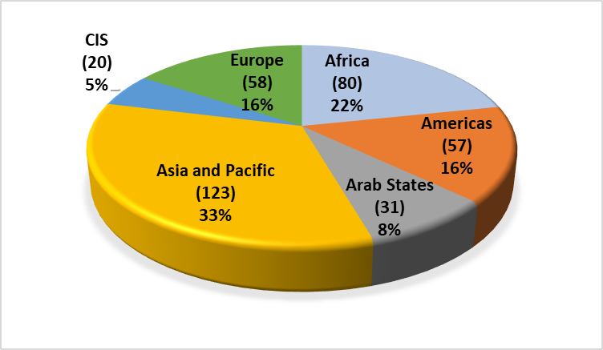

**Figure 3: Regional distribution of contributions submitted by the membership to SG2**

As can be seen in **Figure 3**, the majority of the contributions came from the Asia and Pacific and Africa regions, followed by Europe, Americas, Arab States and CIS.

As illustrated in **Table 3**, each Question received a satisfactory number of written contributions to complete its deliverables for the study period. The three Questions (excluding contributions to all Questions – “QAll/2”) which received the most contributions are Question 1/2 (area: smart cities and communities) with 123, followed by Question 3/2 (area: cybersecurity) with 106, and then Question 2/2 (area: e-health) with 104. Despite the pandemic, SG2 enjoyed business continuity with 2020 being the year with the highest number of contributions received. This is comparable to the previous study period (the busiest year was also on the third year in 2016), as members were actively involved in the final phase of development of output reports. All rapporteur groups also organized workshops and webinars (see **section 3**) during this study period, the results of which were also used as inputs to support and complement their output reports.

**Table 3: Number of contributions received per SG2 Question**

|  |  |  |  |  |  |
| --- | --- | --- | --- | --- | --- |
| Contributions received for annual SG2 and rapporteur group meetings[18] | 2018 | 2019 | 2020 | 2021 | Total |
| Q1/2 | 35 | 39 | 38 | 11 | **123** |
| Q2/2 | 23 | 22 | 41 | 18 | **104** |
| Q3/2 | 26 | 30 | 39 | 11 | **106** |
| Q4/2 | 21 | 16 | 31 | 6 | **74** |
| Q5/2 | 19 | 21 | 35 | 16 | **91** |
| Q6/2 | 18 | 14 | 25 | 8 | **65** |
| Q7/2 | 20 | 23 | 36 | 9 | **88** |
| QAll/2 | 15 | 16 | 31 | 55 | **117** |
| Total | **177** | **181** | **276** | **134** | **768** |

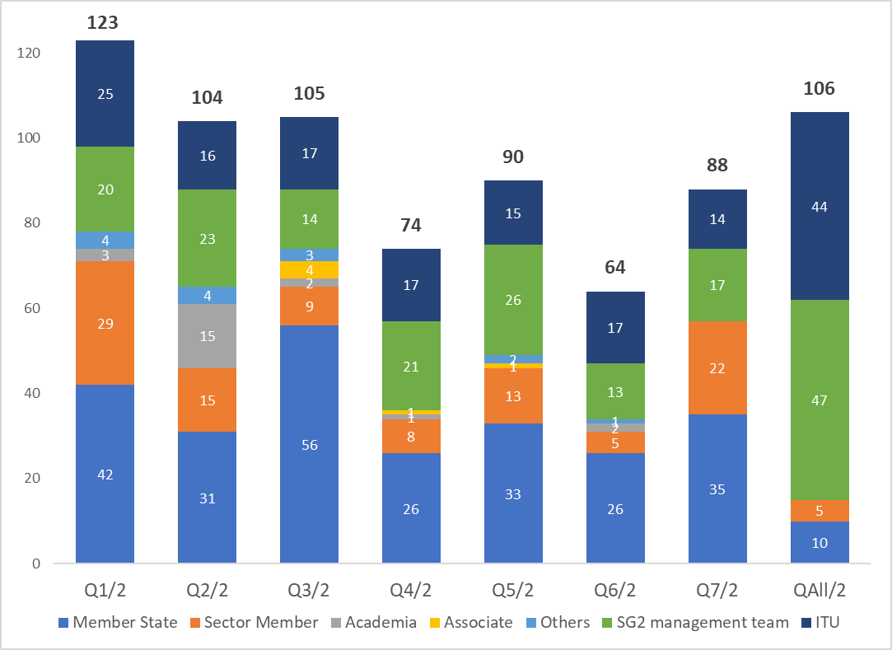

**Figure 4: Number of contributions received for SG2 per Question and source[19]**

**Figure 4** illustrates the distribution of contributions per source type. Similar to the previous study period, Member States remain the highest contributor across all Questions, with more contributions submitted to Question 3/2 (area: cybersecurity). Sector Members (which include regional/international organizations) followed suit with more contributions in Questions 1/2 (area: smart cities and communities) and 7/2 (area: human exposure to eletromagnetic fields). While more active participation from Academia and Associates remains desirable, their activity slightly increased compared to the previous study period, especially in Question 2/2 (area: e-health) for Academia and Question 3/2 (area: cybersecurity) for Associates. Some SMEs which participated in the SME pilot project[20] also contributed during this study period during the years 2018 and 2019.

# Tools for results

## Study Group 2 work plan

The following contributions were made by the Chairman of ITU-D SG2 and the SG2 management team to help guide SG2 activities: a work plan through 2021 ([TDAG-18/13](https://www.itu.int/md/D18-TDAG23-C-0013/)) as required by WTDC Resolution 1 (Rev. Buenos Aires, 2017), along with a detailed workplan for each Question (see Annex 1 of rapporteur group meeting reports, [link](https://www.itu.int/md/D18-SG02.RGQ-181001-R/en)). The SG2 work plan (see **Annex 3**) includes a timeline with dates, important milestones and other actions towards completion of the WTDC expected outputs. During this study period, all rapporteur groups also developed their final report outlines in order to develop the content and identify potential synergies between the rapporteur groups. Both work plans and outlines of final outputs were updated throughout the study period.

## BDT collaborative tools

The study group secretariat maintained and introduced several collaborative tools to facilitate electronic participation in the study group work.A sharepoint site was available to provide a virtual meeting place for participants. The site incorporates a calendar of study group activities, announcements, and a document exchange feature to facilitate work in between meetings. Sub-sites with similar facilities were created exclusively for the study group management teams. Mailing lists were created to allow study group participants interested in specific topics under study to exchange e‑mails. The tools are available on a dedicated web page[21].

Towards the end of the study period, some rapporteur group management teams relied on collaborative tools to draft together their final reports through a common shared document, which enabled them to see texts and comments in real-time. This helped them to efficiently develop their reports, and could be further explored in the next study period.

ITU-D study group web pages were enhanced for easier access and better visuals, including a new ITU-D study group landing page[22] for harmonized user experience across web pages under BDT.

For each annual SG2 meeting, the study group secretariat made available statistics summarizing participation by region, contributions by Question, and standard webcast service with interactive, multilingual and remote participation. The full archives of the meetings are also available.

## Adapting to COVID-19 situation

With COVID-19 that arose in March 2020, additional SG2 management team meetings were held online to advance the work and prepare for the first fully virtual SG2 rapporteur group meeting held from 5 to 16 October 2021.

Due to the pandemic, instead of workshops, three webinars were held in July 2020 to collect much needed inputs to complete the final output reports of SG2 Questions. The virtual setting was successfully used with captioning, and became a standard for all study group events.

The raw caption text and the text from online chat during the meeting were captured for each event, and were used for reference/cross-checks and for preparing reports. Registered participants were invited to test sessions prior to the virtual meetings and were provided guidelines for effective online participation and judicious use of the available limited time.

Learning from the first virtual rapporteur group meetings, additional meetings as listed in **Annex 4** were held in fully virtual mode in 2021. Despite the reduced meeting times (members connecting from different time zones), all management teams and participants were actively engaged in this difficult period to ensure that all objectives are achieved.

# Meetings

## Management team meetings

During this study period, four annual SG2 management team meetings with the chairman, vice-chairmen, (co-)rapporteurs, vice-rapporteurs and BDT focal points were held on the day before each annual SG2 meeting, in order to prepare for the meeting, approve the time management plan, review the progress of each Question under study, discuss planned and ongoing activities and consider proposals to further improve the functioning of the study groups.

Besides, nine additional management team meetings (four of which jointly with SG1) were held from the third annual meeting of SG2 in 2020 to facilitate the progress of annual and final deliverables and to coordinate on other areas, including preparations for the next WTDC (e.g., working methods in WTDC Res. 1, future study groups and Questions in WTDC Res. 2). Coordinators were appointed to facilitate the work on key topics, a list of which and the names of the coordinators can be found in **Annex 2** to this report.

Finally, the seven rapporteur groups held management team meetings to ensure coordination.

## ITU-D Study Group 2 meetings

During the study period, SG2 met six times. Four annual meetings were held in May 2018, March 2019, February 2020 and March 2021. In addition and for better preparations during the COVID-19 pandemic, two extra SG2 plenaries were held in October 2020 and October 2021 to review relevant inputs, including proposals on study topics and revisions to draft terms of references of study group Questions for the next WTDC, as well as on synergies with BDT projects and approval of new annual deliverables. Finally, a joint plenary meeting of SG1 and SG2 was held on 31 March – 1 April in order to develop joint proposals on two topics (working methods – WTDC Res. 1, future study group Questions – WTDC Res. 2) in preparation for the next WTDC.

The rapporteur groups met in total nine times during this study period, during each annual study group meeting and separately in October 2018, 2019, 2020 and 2021, which included one block of informal meetings in February 2021 to compensate for the shortened meeting times due to COVID-19, to progress the work and to identify any issues before finalizing their output reports.

**Annex 4** presents the dates of the study group and rapporteur group meetings during this study period. Work was also done electronically and by correspondence in between physical meetings.

#### First annual meeting of ITU-D Study Group 2

The meeting was held in Geneva from 7 to 11 May 2018, and took the following main actions and decisions:

* Reviewed the main outcomes from the 2014-2017 study period, SG2 work plan and expectations for the 2018-2022 study period;
* Appointed new (co-)rapporteurs and vice-rapporteurs to lead the Questions under study;
* Approved draft work plans and tables of contents for each Question to start the work;
* Developed a draft mapping table between ITU-D and ITU-T study group Questions, in the context of inter-sectoral coordination between the ITU Sectors.

The report of this meeting is available in Document [2/REP/8](https://www.itu.int/md/D18-SG02-R-0008).

#### Second annual meeting of ITU-D Study Group 2

The meeting was held in Geneva from 25 to 29 March 2019, and took the following main actions:

* Appointed additional co-rapporteurs and vice-rapporteurs to strengthen activities of the management teams;
* Approved an annual deliverable from Question 1/2, on a holistic approach to creating smart societies, released as an ongoing work under the auspices of the Chairman of ITU‑D SG2.[23] A panel discussion was also held to present the annual deliverable and discuss its main themes;
* Developed and stabilized mappings between ITU-D study group Questions and activities of other ITU Sectors;
* Initiated studies on possible linkages between ITU-D study group Questions with ITU projects, ITU capacity building activities and WSIS prizes in 2018 and 2019;
* Progressed on the implementation of ITU Plenipotentiary Conference Resolution 131 (Rev. Dubai, 2018) by defining future actions to be taken by SG2 on topics related to statistics, with a vice-chairman to coordinate the work;
* Progressed on the implementation of WTDC Resolution 9 (Rev. Buenos Aires, 2017) by identifying the relevant Questions and appointing corresponding contact points and a vice-chairman to coordinate the work.

The report of this meeting is available in Document [2/REP/16](https://www.itu.int/md/D18-SG02-R-0016).

#### Third annual meeting of ITU-D Study Group 2

The meeting was held in Geneva from 24 to 28 February 2020, and took the following main actions and decisions:

* Appointed 2 vice-chairmen (CIS and Europe regions), 1 co-rapporteur and 2 vice-rapporteurs to reinforce the management teams following resignations;
* Agreed to initiate a coordination process between relevant experts to receive further inputs on a new annual deliverable from Question 1/2, on security and trust for the creation of smart cities, and to release it as an ongoing work under the auspices of the Chairman of ITU-D SG2;
* Held a session on IoT for development: opportunities and risks for developing countries, in order to provide a better understanding of IoT, explore its potential for development and inform the participants of the underlying opportunities and challenges, especially in developing countries;
* Advanced on mapping of activities between ITU-D study group Questions and activities of other ITU Sectors. Some conflicts with respect to a proposal received from TSAG was resolved through coordination in the Inter-Sector Coordination Group (ISCG) following this meeting;
* In relation with ITU Plenipotentiary Conference Resolution 131 (Rev. Dubai, 2018), initiated studies of linkages between ITU-D study group Questions with activities of the Expert Group on ICT Household Indicators (EGH) and the Expert Group on Telecommunication/ICT Indicators (EGTI). A liaison statement was also sent for further collaboration with these expert groups;
* In relation with WTDC Resolution 9 (Rev. Buenos Aires, 2017), identified topics for collaboration from the relevant Questions (Q1/2, Q4/2 and Q7/2);
* Initiated discussions on new topics for future study group Questions;
* Shared preparations for a dedicated session on ITU-D study groups during WSIS Forum 2020;

The report of this meeting is available in Document [2/REP/24](https://www.itu.int/md/D18-SG02-R-0024).

#### Extra plenary meeting of ITU-D Study Group 2 (October 2020)

The meeting was held virtually on 5 October 2020, and took the following main actions:

* Consolidated preliminary views on topics in preparation for the next WTDC (working methods – WTDC Res. 1, future study group Questions – WTDC Res. 2, streamlining of resolutions, draft WTDC declaration), which were then shared with the TDAG Working Group on WTDC Resolutions, Declaration and Thematic Priorities (TDAG-WG-RDTP);
* Explored status of two BDT projects (Financial Inclusion Global Initiative – FIGI, Policy and Regulation Initiative for Digital Africa – PRIDA) for potential synergies with study group Questions;
* Approved two annual deliverables from Question 1/2, on vertical applications in smart cities, and Question 5/2, on draft guidelines for conducting national level emergency communications drills and exercises, released as an ongoing work under the auspices of the Chairman of ITU-D SG2;
* Appointed 1 co-rapporteur for Question 5/2 to ensure continued co-leadership and resource in its management team following a co-rapporteur’s resignation;
* Reviewed a draft joint survey on the work of the ITU-D study groups for the 2018-2022 study period, prior to its launch soon after the meeting;
* Reviewed other inputs of relevance to ITU-D study groups (WSIS, Digital regulation handbook and online platform, GSR-20 best practice and guidelines).

The report of this meeting is available in Document [SG2RGQ/REP/22](http://www.itu.int/md/D18-SG02.RGQ-R-0022/).

#### Fourth annual meeting of ITU-D Study Group 2

The meeting was held virtually from 15 to 19 March 2021, and took the following main actions:

* Approved the output reports on the seven SG2 Questions for the study period;
* Consolidated the views on future study topics for each Question;
* Re-approved two annual deliverables from Questions 1/2 and 5/2, which were revised by professional editors, for release;
* Reviewed potential mechanisms for collaboration with an external organization (Eastern Partnership Electronic Communications Regulators Network);[24]
* Reviewed other areas of relevance to ITU-D activities, including: implementation of WTDC Resolution 9 (Rev. Buenos Aires, 2017); results of last meetings of EGTI, EGH and the World Telecommunication/ICT Indicators Symposium (WTIS); results of the meetings of the ITU Coordination Committee for Terminology (ITU CCT); update of the BDT PRIDA project; and BDT report on AI and big data.

The report of this meeting is available in Document [2/REP/32](https://www.itu.int/md/D18-SG02-R-0032).

#### Joint plenary meeting of ITU-D Study Groups 1 and 2

The meeting[25]was held virtually on 31 March and 1 April 2021, and took the following main actions:

* Noted the status of current progress in TDAG-WG-RDTP;
* Noted the results of the joint end-of-cycle survey and introduction to the Results Based Management (RBM) initiative from BDT started for study groups;
* Agreed a joint proposal with SG1 that updates parts of WTDC Resolution 1 (Rev. Buenos Aires, 2017), on rules of procedure of the ITU Telecommunication Development Sector, related to study groups. The proposal was conveyed to TDAG-WG-RTDP through a liaison statement (Annex 1 of Document [2/438](https://www.itu.int/md/D18-SG02-C-0438));
* Agreed a joint proposal with SG1 that updates Annex 1 to WTDC Resolution 2, on scope of ITU‑D study groups, based on discussions on future study topics held during the fourth meetings of ITU-D study groups in March 2021 and this joint plenary meeting. The proposal was conveyed to TDAG-WG-RTDP through a liaison statement (Annex 2 of Document [2/438](https://www.itu.int/md/D18-SG02-C-0438));
* Noted the current status on streamlining of WTDC resolutions;
* Noted the draft Declaration under discussion in the TDAG-WG-RDTP.

#### Extra plenary and rapporteur group meetings of ITU-D Study Group 2 (October 2021)

The meeting was held virtually from 18 to 22 October 2021, and took the following main actions:

* Reached consensus on revised terms of reference (ToRs) for the seven SG2 Questions, as a follow-up to related decisions made during the 28th meeting of TDAG (24-28 May 2021). The list of revised ToRs can be found in **Annex 7** to this report and in Document [TDAG-21/2/DT/5](https://www.itu.int/md/D18-TDAG29-211108-TD-0005/);
* Noted with appreciation the publication of all output reports of SG2, along with related video clips;
* Approved one annual deliverable from Question 2/2, on telecommunication/ICTs for pandemics and suicide prevention, released as an ongoing work under the auspices of the Chairman of ITU-D SG2;
* Reviewed new proposals submitted by members in relation with the next iteration of the Global Cybersecurity Index (GCIv5). It was agreed to create a new correspondence group to harmonize the proposals and submit their outcomes to GCIv5 after approval;
* Reviewed other areas of relevance to ITU-D activities, including: exploring synergies with the Generation Connect initiative, update of ITU’s work in the Question topics and ICT measurement, continued collaboration with the WSIS platform.

The report of this meeting is available in Document [SG2RGQ/REP/23](http://www.itu.int/md/D18-SG02.RGQ-R-0023).

# Summary of the key results achieved

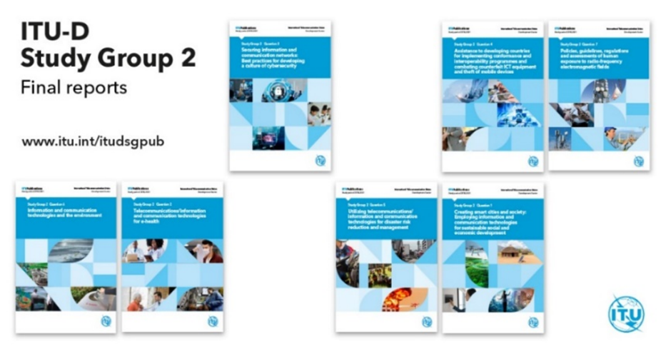

**Figure 4: Output reports of ITU-D Study Group 2 for the 2018-2022 study period**

## Question 1/2 – Creating smart cities and society: Employing information and communication technologies for sustainable social and economic development

The output report on Question 1/2 in Document [2/375](https://www.itu.int/md/D18-SG02-C-0375) (Rev.2) was approved and published ([link](https://www.itu.int/hub/publication/D-STG-SG02.01.2-2021/)). A video clip about the report is also available ([link](https://youtu.be/MOv1nJqNoto)).

The following annual deliverables on Question 1/2 were approved for release in the ongoing work page[26] under the auspices of the Chairman of ITU-D SG2:

* A holistic approach to creating smart societies(annual deliverable 2019, [link](https://www.itu.int/oth/D0717000002)). A dedicated panel session presented the key findings of this deliverable ([presentations](https://www.itu.int/md/D18-SG02-190325-TD-0020)).
* Promoting trust and safety for the creation of smart cities and communities(annual deliverable 2020, [link](https://www.itu.int/oth/D072A000002/en)). A dedicated panel session presented its key findings ([presentations](https://www.itu.int/md/D18-SG02-200224-TD-0035)).
* Vertical applications in smart cities(annual deliverable 2020, [link](https://www.itu.int/oth/D0723000004)). A dedicated interview ([link](https://youtu.be/051ieMmdMeA)) presented the key findings of this deliverable. A related article is also available ([link](https://www.itu.int/en/myitu/News/2021/04/30/11/32/Digital-agriculture-hydroponic-melon-farming-Japan)).

Rapporteur Group on Question 1/2 also organized and/or participated in the following workshops:

* GMIS-UNIDO-ITU special session ontechnology and innovation powering connectivity for inclusive and sustainable industrial development, held on 1 October 2018 ([programme](https://www.itu.int/en/ITU-D/Study-Groups/2018-2021/Pages/meetings/GMIS-UNIDO-ITU-special-session.aspx), Annex 5 of [report](http://www.itu.int/md/D18-SG02.RGQ-R-0001));
* Workshop/tutorial on AI and emerging technologies, held on 11 October 2019 ([programme](https://www.itu.int/en/ITU-D/Study-Groups/2018-2021/Pages/meetings/tutorial_AI_oct19.aspx), Annex 4 of [report](http://www.itu.int/md/D18-SG02.RGQ-R-0008)).

An updated draft ToR for Question 1/2 was agreed and is available in Document [SG2RGQ/319](https://www.itu.int/md/D18-SG02.RGQ-C-0319) (Rev.1).

## Question 2/2 – Telecommunications/ICTs for e-health

The output report on Question 2/2 in Document [2/376](https://www.itu.int/md/D18-SG02-C-0376) (Rev.2) was approved and published ([link](https://www.itu.int/hub/publication/D-STG-SG02.02.3-2021/)). A video clip about the report is also available ([link](https://youtu.be/9JFJ2Pl8sKE)).

The following annual deliverable on Question 2/2 was approved for release in the ongoing work page[27] under the auspices of the Chairman of ITU-D SG2:

* Telecommunication/ICTs for pandemics and suicide prevention(annual deliverable 2021, [link](https://www.itu.int/oth/D072A000001/en))*.*

Rapporteur Group on Question 2/2 also organized the following workshops and webinar:

* Workshop onadoption of new digital health technologies, held on 5 October 2018 ([programme](https://www.itu.int/en/ITU-D/Study-Groups/2018-2021/Pages/meetings/session-Q2-2-oct18.aspx), Annex 5 of [report](http://www.itu.int/md/D18-SG02.RGQ-R-0002));
* Workshop onnew communication technologies for e-health and socio-economic issues, held on14 October 2019 ([programme](https://www.itu.int/en/ITU-D/Study-Groups/2018-2021/Pages/meetings/session-Q2-2-oct19.aspx), Annex 3 of [report](http://www.itu.int/md/D18-SG02.RGQ-R-0009));
* Webinar on new e-health solutions to combat pandemics with ICT, held on 6 July 2020 ([programme](https://www.itu.int/en/ITU-D/Study-Groups/2018-2021/Pages/meetings/Webinars/2020/Q2-2-july06.aspx), [report](https://www.itu.int/en/myitu/News/2020/07/17/13/08/New--COVID19-ehealth-tools) (ITU News article)).

An updated draft ToR for Question 2/2 was agreed and is available in Document [SG2RGQ/320](https://www.itu.int/md/D18-SG02.RGQ-C-0320) (Rev.2).

## Question 3/2 – Securing information and communication networks: Best practices for developing a culture of cybersecurity

The output report on Question 3/2 in Document [2/377](https://www.itu.int/md/D18-SG02-C-0377) (Rev.2) was approved and published ([link](https://www.itu.int/hub/publication/D-STG-SG02.03.2-2021/)). A video clip about the report is also available ([link](https://youtu.be/qXu-ZwAq21o)).

Rapporteur Group on Question 3/2 also organized a workshop oncybersecurity emerging issues, held on 9 October 2018 ([programme](https://www.itu.int/en/ITU-D/Study-Groups/2018-2021/Pages/meetings/session-Q3-2-oct18.aspx), Annex 5 of [report](http://www.itu.int/md/D18-SG02.RGQ-R-0003)).

An updated draft ToR for Question 3/2 was agreed and is available in Document [SG2RGQ/321](https://www.itu.int/md/D18-SG02.RGQ-C-0321) (Rev.2).

## Question 4/2 – Assistance to developing countries for implementing conformance and interoperability (C&I) programmes and combating counterfeit ICT equipment and theft of mobile devices

The output report on Question 4/2 in Document [2/378](https://www.itu.int/md/D18-SG02-C-0378) (Rev.3) was approved and published ([link](https://www.itu.int/hub/publication/D-STG-SG02.04.2-2021/)). A video clip about the report is also available ([link](https://youtu.be/IIt-CG0JHYQ)).

Rapporteur Group on Question 4/2 also organized the following workshops:

* Workshop oncombating counterfeit ICT devices, held on 4 October 2018 ([programme](https://www.itu.int/en/ITU-D/Study-Groups/2018-2021/Pages/meetings/session-Q4-2-oct18.aspx), Annex 6 of [report](http://www.itu.int/md/D18-SG02.RGQ-R-0004));
* Workshop onICT conformance and interoperability: challenges for developing countries, held on16 October 2019 ([programme](https://www.itu.int/en/ITU-D/Study-Groups/2018-2021/Pages/meetings/session-Q4-2-oct19.aspx), Annex 4 of [report](http://www.itu.int/md/D18-SG02.RGQ-R-0011)).

An updated draft ToR for Question 4/2 was agreed and is available in Document [SG2RGQ/322](https://www.itu.int/md/D18-SG02.RGQ-C-0322) (Rev.2).

## Question 5/2 – Utilizing telecommunications/ICTs for disaster risk reduction and management

The output report on Question 5/2 in Document [2/379](https://www.itu.int/md/D18-SG02-C-0379) (Rev.3) was approved and published ([link](https://www.itu.int/hub/publication/d-stg-sg02-05-2-2021/)). A video clip about the report is also available ([link](https://youtu.be/WrDaDaXL8O4)).

An annual deliverable on Question 5/2 was approved for release in the ongoing work page[28] under the auspices of the Chairman of ITU-D SG2, on guidelines for conducting national-level emergency telecommunication drills and exercises(annual deliverable 2020, [link](https://www.itu.int/oth/D0723000005)). A dedicated interview ([link](https://youtu.be/ZEsV0RIHpSA)) presented the key findings of this deliverable. A related article is also available ([link](https://www.itu.int/en/myitu/News/2021/08/02/06/54/Telcos-strengthen-India-disaster-preparedness)).

Rapporteur Group on Question 5/2 also organized the following workshops and webinar:

* Workshop onearly warning systems (EWS), held on 8 May 2018 ([programme](https://www.itu.int/en/ITU-D/Study-Groups/2018-2021/Pages/meetings/panel-EWS.aspx), Annex 4 of [report](https://www.itu.int/md/D18-SG02-R-0005));
* Workshop ondisaster drills and emerging technologies on disaster management, held on 3 October 2018 ([programme](https://www.itu.int/en/ITU-D/Study-Groups/2018-2021/Pages/meetings/session-Q5-2-oct18.aspx), Annex 4 of [report](https://www.itu.int/md/D18-SG02.RGQ-R-0005));
* Workshop onconducting national level emergency communications drills and exercises: guidelines for Small Island Developing States (SIDs) and Least Developed Countries (LDCs), held on 7 October 2019 ([programme](https://www.itu.int/en/ITU-D/Study-Groups/2018-2021/Pages/meetings/session-Q5-2-oct19.aspx), Annex 4 of [report](http://www.itu.int/md/D18-SG02.RGQ-R-0012));
* Webinar onthe enabling policy environment for effective disaster management including for COVID-19 response, held on 14 July 2020 ([programme](https://www.itu.int/en/ITU-D/Study-Groups/2018-2021/Pages/meetings/Webinars/2020/Q5-2-july14.aspx), [report](https://news.itu.int/disaster-management-ict-policy-covid-19/) (ITU News article)).

An updated draft ToR for Question 5/2 was agreed and is available in Document [SG2RGQ/323](https://www.itu.int/md/D18-SG02.RGQ-C-0323) (Rev.2).

## Question 6/2 – ICTs and the environment

The output report on Question 6/2 in Document [2/380](https://www.itu.int/md/D18-SG02-C-0380) (Rev.2) was approved and published ([link](https://www.itu.int/hub/publication/D-STG-SG02.06.2-2021/)). A video clip about the report is also available ([link](https://youtu.be/LyQ16QhhdOs)).

Rapporteur Group on Question 6/2 also organized the following workshops and webinar:

* Workshop one-waste policies, strategies and frameworks, held on 9 October 2018 ([programme](https://www.itu.int/en/ITU-D/Study-Groups/2018-2021/Pages/meetings/session-Q6-2-oct18.aspx), Annex 5 of [report](https://www.itu.int/md/D18-SG02.RGQ-R-0006));
* Workshop onfrontier ICTs for climate action, held on 15 October 2019 ([programme](https://www.itu.int/en/ITU-D/Study-Groups/2018-2021/Pages/meetings/session-Q6-2-oct19.aspx), Annex 4 of [report](http://www.itu.int/md/D18-SG02.RGQ-R-0013));
* Webinar onICTs for climate action and rebuilding greener economies after COVID-19, held on 15 July 2020 ([programme](https://www.itu.int/en/ITU-D/Study-Groups/2018-2021/Pages/meetings/Webinars/2020/Q6-2-july15.aspx), [report](https://news.itu.int/leveraging-icts-to-build-back-greener-after-covid-19/) (ITU News article)).

An updated draft ToR for Question 6/2 was agreed and is available in Document [SG2RGQ/324](https://www.itu.int/md/D18-SG02.RGQ-C-0324) (Rev.2).

## Question 7/2 – Strategies and policies concerning human exposure to electromagnetic fields

The output report on Question 7/2 in Document [2/381](https://www.itu.int/md/D18-SG02-C-0381) (Rev.4) was approved and published ([link](https://www.itu.int/hub/publication/D-STG-SG02.07.2-2021/)). A video clip about the report is also available ([link](https://youtu.be/qLJdBKv9HGY)).

Rapporteur Group on Question 7/2 also organized a workshop on modern policies, guidelines, regulations and assessments of human exposure to radio-frequency electromagnetic fields, held on 10 October 2018 ([programme](https://www.itu.int/en/ITU-D/Study-Groups/2018-2021/Pages/meetings/session-Q7-2-oct18.aspx), Annex 7 of [report](https://www.itu.int/md/D18-SG02.RGQ-R-0007)).

An updated draft terms of reference for Question 7/2 was agreed and is available in Document [SG2RGQ/325](https://www.itu.int/md/D18-SG02.RGQ-C-0325) (Rev.2).

# Collaboration with other groups

## Mapping of activities between ITU-D study group Questions and with other ITU Sectors

During this study period, mapping of activities between ITU-D study group Questions themselves (intra-sector mapping) and with activities of other ITU Sectors (inter-sector mapping) were developed in order to identify potential areas of common interest, facilitate coordination and further strengthen collaboration. The study groups appointed two coordinators to facilitate development and exchange of these mapping tables: Mr Arseny Plossky (Russian Federation), Co-Rapporteur for Question 4/1, and Mr Haim Mazar (ATDI, France), Co-Rapporteur for Question 7/2.

Both the intra-sector and inter-sector mapping tables were developed and regularly updated during this study period. It was agreed that all documents related to inter-sector mappings would be stored as living documents in a common repository, currently maintained by the Inter-Sector Coordination Group (ISCG) on issues of mutual interest. Consequently, further updates will be maintained through coordination between the ISCG and representatives of the three ITU Bureaux.

Documents for more information:

* Intra-sector mapping table: **Annex 5** to this report;
* Inter-sector mapping tables with other ITU Sectors: [mapping tables](https://www.itu.int/en/general-secretariat/Pages/ISCG/ISCT_Documents-Mapping_Tables.aspx) maintained by the ISCG.

## WTDC Resolution 9 (Rev. Buenos Aires, 2017)

In order to fulfil the needs of developing countries as stated in WTDC Resolution 9 (Rev. Buenos Aires, 2017), ITU-D study groups shared with TDAG in 2019 a proposal for how ITU-D study groups could contribute to the implementation of this resolution within their scope of work. The study groups appointed two coordinators to ensure continuous update: Mr Roberto Hirayama (Brazil), Vice-Chairman of ITU-D SG1, and Mr Fadel Digham (Egypt), Co-Rapporteur for Question 1/2.

SG2 identified Questions 1/2, 4/2 and 7/2 as the most relevant with WTDC Resolution 9. During this study period, these Questions analyzed their needs in this resolution and potential topics for collaboration with ITU-R, as described in **Annex 6** to this report.

In line with WTDC Resolution 9 objectives, expressed in Annex 1 to this resolution, the last SG2 meeting expressed a desire to explore new and innovative approaches to fulfil the resolution’s objectives, in full collaboration with the BR and BDT Directors, taking into consideration relevant ITU-R study group activities and events, such as, ITU-R workshops and seminars, but also, other relevant events, such as PRIDA, WSIS Action Line C2 sessions during the WSIS Forum, etc.

Documents for more information:

* Liaison statement from the Chairmen of ITU-D SG1 and SG2 to TDAG (2019): [TDAG-19/40](https://www.itu.int/md/D18-TDAG24-C-0040);
* Report from the Chairman of ITU-D SG2 to TDAG (2020): section 4.2 of [TDAG-20/13](https://www.itu.int/md/D18-TDAG25.2-C-0013) (Rev.1);
* Report from the study group coordinators on WTDC Resolution 9: [2/402](https://www.itu.int/md/D18-SG02-C-0402).

## ITU Coordination Committee for Terminology

ITU Coordination Committee for Terminology (ITU CCT) was created through Council Resolution 1386 in 2017 as a joint working body within ITU for the adoption of terms and definitions in the field of telecommunications/ICTs in all six official languages of the Union. In accordance with WTDC Resolution 86 (Buenos Aires, 2017), on the use in the ITU Telecommunication Development Sector of the languages of the Union on an equal footing, TDAG in 2018 appointed Mr Peter Mbengie (Cameroon), Vice-Chairman of ITU-D SG1, and Ms Ke Wang (People’s Republic of China), Vice-Chairman of ITU-D SG2, to be the ITU-D’s representatives on the ITU CCT.

During the 2018-2022 study period, ITU CCT met nine times. The meeting considered liaison statements and contributions with matters concerning terminology and agreed on the updates to the ITU terminology database, especially what is called Part 3 with the terms, acronyms and definitions. Matters of interest to ITU-D work included the following:

* General definition of broadband: given the rapid evolution and the diverging views, it was decided that a general definition of broadband access suitable to all parties could not be given.
* Several terms and definitions proposed by ITU-R and ITU-T study groups were linked with ITU-D study group Questions, e.g. smart cities and communities, broadcasting, cloud computing, etc.
* Some ITU-D Questions discussed potential new terms and definitions, e.g., in the area of e-health. Following discussions, the meetings decided to not define any new terms, and encouraged considering the existing terms and definitions in ITU, in particular those in the online ITU terms and definitions database.
* The use of inclusive language in ITU standards and other publications gained importance. Since this is a cultural issue to be addressed at a higher level, ITU CCT will seek advice from the Council Working Group on the use of the six official languages of the Union (CWG-LANG). ITU-D study groups will continue to monitor the situation and follow-up accordingly.

Overall, ITU-D study group members acknowledged the need to be more and more involved in the work of ITU CCT, and continue to carry out fruitful cooperation in the future.

Documents for more information:

* Summary records of ITU CCT meetings: [R15-CCV/47](https://www.itu.int/md/R15-CCV-C-0047) (1 June 2018), [R15-CCV/49](https://www.itu.int/md/R15-CCV-C-0049) (22 Nov. 2018), [R15-CCV/59](https://www.itu.int/md/R15-CCV-C-0059) (17 June 2019), [R19-CCV/3](https://www.itu.int/md/R19-CCV-C-0003) (3 June 2020), [R19-CCV/11](https://www.itu.int/md/R19-CCV-C-0011) (7 Dec. 2020), [R19-CCV/14](https://www.itu.int/md/R19-CCV-C-0014) (7 April 2021), [R19-CCV/20](https://www.itu.int/md/R19-CCV-C-0020) (23 June 2021), [R19-CCV/21](https://www.itu.int/md/R19-CCV-C-0021) (8 September 2021) and [R19-CCV/33](https://www.itu.int/md/R19-CCV-C-0033) (8 February 2022).
* Report from the study group coordinators: [2/406](https://www.itu.int/md/D18-SG02-C-0406) (March 2021).[29]

## Expert Group on Telecommunication/ICT Indicators and Expert Group on ICT Household Indicators

In order to implement Resolution 131 (Rev. Dubai, 2018) of the Plenipotentiary Conference (PP), on measuring information and communication technologies to build an integrating and inclusive information society, and WTDC Resolution 8 (Rev. Buenos Aires, 2017), on collection and dissemination of information and statistics, two liaison statements from the Expert Group on Telecommunication/ICT Indicators (EGTI) and the Expert Group on ICT Household Indicators (EGH) respectively were received with the aim to create a working mechanism to ensure collaboration between these expert groups and the ITU-D study groups, and to share information of mutual interest. Following this proposal, the study groups appointed Ms Anastasia Konukhova (Russian Federation), Vice-Chairman of ITU-D SG1, and Mr Roland Kudozia (Ghana), Vice-Chairman of ITU‑D SG2, as coordinators to explore deeper synergies and identify linkages between ITU-D study group Questions and activities of EGTI and EGH (e.g. through a mapping table), as well as to identify topics and indicators of interest for their current and future studies.

* During the 2020 meetings of EGTI (15-16 September 2020) and EGH (17-18 September 2020), topics for future work were agreed, several of which were of direct relevance to study group Questions, such as on the measurement of over-the-top services effects on mobile traffic, impact of the COVID-19 pandemic on telecoms and the way ICT was used to mitigate it, e‑waste indicators in household surveys, and child online protection. A new discussion topic was also agreed to share experience and evidence on the proposals from SG1 and SG2. Both expert groups highlighted the importance of further collaboration with ITU‑D study groups and encouraged ITU-D members to participate actively in meetings and online forum discussions on the topics outlined for future work.
* Outcomes of the last meeting of EGTI (13-15 September 2021) and EGH (15-16 September 2021) were presented during the last plenary and rapporteur group meetings of ITU-D Study Group 2 (18-22 October 2021). Members noted with appreciation the ongoing work and updates from their subgroups, such as on 5G/IMT-2020, child online protection and e-waste, which are relevant to the SG2 Questions.

Documents for more information:

* Liaison statements (LS) from EGTI and EGH: [2/247](https://www.itu.int/md/D18-SG02-C-0247/) (LS from EGTI), [2/248](https://www.itu.int/md/D18-SG02-C-0248/) (LS from EGH)
* Reply liaison statements from study groups: [2/353](https://www.itu.int/md/D18-SG02-C-0353/) (reply LS from SG2)
* Reports/presentations from study group coordinators and BDT: [2/404](https://www.itu.int/md/D18-SG02-C-0404) (EGTI, EGH and WTIS activities in 2020), [SG2RGQ/339 + annex](https://www.itu.int/md/D18-SG02.RGQ-C-0339/en) (EGTI and EGH activities in 2021)

## Synergies with BDT projects and initiatives

To strengthen synergies between the study groups and BDT activities, linkages between the ITU-D study group Questions and BDT projects were considered. In particular, possible collaborations with the following projects were explored:

* FIGI (Financial Inclusion Global Initiative)[30], which aims at leveraging ICTs for financial services to achieve digital financial inclusion. Coordinators: Mr Ahmad Gad (Egypt), Vice-Chairman of ITU‑D SG1, and Mr Fadel Digham (Egypt), Co-Rapporteur for Question 1/2.
* PRIDA (Policy and Regulation Initiative for Digital Africa)[31], which is a programme in collaboration between the African Union, the European Union and the ITU to foster universally accessible and affordable broadband across the African continent to unlock future benefits of Internet-based services. Coordinator: Mr Haim Mazar (ATDI, France), Co-Rapporteur for Question 7/2.

A background and status of implementation of both projects were presented. Also, events/activities such as capacity-building workshops and development of technical guidelines that are relevant to the study group Questions were identified. Management teams and members were encouraged to explore possible synergies with these activities/events.

Other initiatives towards more meaningful outputs include:

* A call for engaging the youth in the future study periods, which was made by the Generation Connect team;
* Outcomes from the Global Symposium for Regulators (GSR), which are regularly received as contributions for consideration by relevant study group Questions, in preparation of their outputs;
* A presentation on emerging technology trends to help developing countries embrace the opportunities offered by AI and big data deployment.

Documents for more information:

* Linkages between ITU-D study group Questions and BDT projects: [2/185](https://www.itu.int/md/D18-SG02-C-0185/)
* Report from the study group coordinators on FIGI: [SG2RGQ/252 + annex](https://www.itu.int/md/D18-SG02.RGQ-C-0252)
* Reports from the study group coordinator on PRIDA: [SG2RGQ/245 + annex](https://www.itu.int/md/D18-SG02.RGQ-C-0245), [2/396](https://www.itu.int/md/D18-SG02-C-0396)
* Document on Generation Connect: [SG2RGQ/336](https://www.itu.int/md/D18-SG02.RGQ-C-0336)
* Documents on GSR: [SG2RGQ/249](https://www.itu.int/md/D18-SG02.RGQ-C-0249), [SG2RGQ/46](https://www.itu.int/md/D18-SG02.RGQ-C-0046)
* Document on emerging technology trends: [2/366](https://www.itu.int/md/D18-SG02-C-0366)

## Collaboration with the World Summit on the Information Society

In order to seek a close alignment between the World Summit on the Information Society (WSIS) process and the 2030 Agenda for Sustainable Development, as called by the high-level meeting of the United Nations General Assembly on the overall review of the implementation of the WSIS outcomes[32], and as encouraged by the Council Working Group on WSIS & SDGs to closely work between ITU study groups and the WSIS secretariat for contribution to the WSIS and SDG process, several areas of collaboration were explored with follow-up actions during this study period:

* Developed jointly with the WSIS secretariat linkages between winning and champion projects from WSIS prizes and ITU-D study group Questions (Document [2/190](https://www.itu.int/md/D18-SG02-C-0190/));
* Reviewed contributions on commitments to WSIS (Documents [2/251](https://www.itu.int/md/D18-SG02-C-0251/), [2/TD/34](https://www.itu.int/md/D18-SG02-200224-TD-0034/));
* Organized a thematic workshop on facing realities in digital transformation: emerging trends and challenges, which presented activities of the two study groups during the WSIS Forum 2020 ([programme](https://www.itu.int/net4/wsis/forum/2020/Agenda/Session/274), [report](https://www.itu.int/net4/wsis/forum/2020/Files/outcomes/draft/WSISForum2020_OutcomeDocument_DRAFT-20210201.pdf#page=184))[33]
* Several members of SG2 management team participated in several high-level policy sessions, and in thematic and country workshops during WSIS Forums 2020 and 2021:
  + Building confidence and security in the use of ICTs ([programme](https://www.itu.int/net4/wsis/forum/2020/Agenda/Session/211), [report](https://www.itu.int/net4/wsis/forum/2020/Files/outcomes/draft/WSISForum2020_HighLevelTrackOutcomesAndExecutiveBrief_DRAFT.pdf#page=88));
  + Knowledge societies, capacity building and e-learning ([programme](https://www.itu.int/net4/wsis/forum/2020/Agenda/Session/204), [report](https://www.itu.int/net4/wsis/forum/2020/Files/outcomes/draft/WSISForum2020_HighLevelTrackOutcomesAndExecutiveBrief_DRAFT.pdf#page=172));
  + ICT applications and services/e-environment/climate change ([programme](https://www.itu.int/net4/wsis/forum/2021/Agenda/Session/160), [report](https://www.itu.int/net4/wsis/forum/2021/Files/outcomes/draft/WSISForum2021_HighLevelTrackOutcomesAndExecutiveBrief.pdf#page=112));
  + Towards a digital government ([programme](https://www.itu.int/net4/wsis/forum/2021/Agenda/Session/448))[34];
  + Combating counterfeit telecommunication/ICT devices and software ([programme](https://www.itu.int/net4/wsis/forum/2021/Agenda/Session/406), [report](https://www.itu.int/net4/wsis/forum/2021/Files/outcomes/draft/WSISForum2021_OutcomeDocument.pdf#page=247));
  + ICTs for inclusive, resilient and sustainable societies and economies in the Arab States ([programme](https://www.itu.int/net4/wsis/forum/2021/Agenda/Session/338))[35];
* Reviewed regular contributions to inform about upcoming WSIS activities and explore possibilities for more collaboration with the study groups (Documents [2/76](https://www.itu.int/md/D18-SG02-C-0076/en), [SG2RGQ/81](https://www.itu.int/md/D18-SG02.RGQ-C-0081/en), [SG2RGQ/167](https://www.itu.int/md/D18-SG02.RGQ-C-0167/en), [2/312](https://www.itu.int/md/D18-SG02-C-0312/en), [2/317](https://www.itu.int/md/D18-SG02-C-0317), [SG2RGQ/240](https://www.itu.int/md/D18-SG02.RGQ-C-0240/en), [SG2RGQ/258](https://www.itu.int/md/D18-SG02.RGQ-C-0258), [2/434](https://www.itu.int/md/D18-SG02-C-0434/en), [2/435](https://www.itu.int/md/D18-SG02-C-0435), [2/436](https://www.itu.int/md/D18-SG02-C-0436), [2/437](https://www.itu.int/md/D18-SG02-C-0437), [SG2RGQ/340](https://www.itu.int/md/D18-SG02.RGQ-C-0340), [SG2RGQ/341](https://www.itu.int/md/D18-SG02.RGQ-C-0341), [SG2RGQ/342](https://www.itu.int/md/D18-SG02.RGQ-C-0342), [SG2RGQ/343](https://www.itu.int/md/D18-SG02.RGQ-C-0343), [SG2RGQ/344](https://www.itu.int/md/D18-SG02.RGQ-C-0344), [SG2RGQ/345](https://www.itu.int/md/D18-SG02.RGQ-C-0345)).

# Results of the survey on the work of ITU-D study groups (7th study period, 2018-2022)

In keeping with section 12.4.3 of WTDC Resolution 1 (Rev. Buenos Aires, 2017), the ITU-D study groups issued a joint survey to help ascertain the extent to which the ITU-D membership, and in particular developing countries, benefit from the outputs of studies.

A draft questionnaire was submitted for comments at the rapporteur group meetings of ITU-D SG1 and SG2 held in September-October 2020. The final version of the questionnaire was issued as an online survey to the ITU-D membership (see Document [BDT/DKH/CSTG-11](https://www.itu.int/md/D18-CA-CIR-0011)) on 18th December 2020 with the closing date of 15th January 2021, which was extended to 29th January 2021. The results of the joint survey were analysed and submitted to the meetings of the study groups. Through this report, SG2 wishes to apprise TDAG of Document [2/429](https://www.itu.int/md/D18-SG02-C-0429) (BDT) which has as annex the survey report and a shorter presentation of the key findings.

Some findings to consider:

* 68 responses were received (37 responses in previous survey).
* Developing countries had the highest percentage of respondents, while respondents represented a fairly consistent geographical spread.
* Attendance to virtual meetings were high as they are less resource intensive and less costly. Connectivity is a challenge for virtual meetings. Lack of budget was the main reason for not attending physical meetings in the past.
* Governments are perceived as encouraging SMEs, academia and industry participation in study groups’ work (specific examples were shared by respondents).
* Collaboration with ITU-T and ITU-R were appreciated and stand to be further enhanced.
* While most respondents understand the structure of Questions, almost half of them consider that certain important topics are not being addressed.
* Questions having the highest importance are Q1/1, Q5/1, Q3/1 and Q3/2 (**Figure 6**).
* 85% of respondents use study group work output in drafting policies and regulations with specific examples provided in the report.
* More workshops, more annual deliverables throughout the study period rank high in the opinion of respondents when asked how to enhance usage of outputs.

The findings of the surveys can be useful for preparations for WTDC-22, particularly the sections relevant to discussions on future of Questions and on working methods of study groups.

**Figure 6: Perceived average importance of Questions from the survey**

# Conclusion

SG2 has successfully carried out its mandate because of the hard work, dedication, perseverance, flexibility, and expertise of all the parties concerned: the SG2 management team, vice-chairmen, (co-)rapporteurs, vice-rapporteurs, BDT focal points, secretariat, active contributors, meeting participants, interpreters and translators and all other persons working behind the scene. With strong support from the BDT Director and her staff, the group has fulfilled its mission.

**Annexes**

**Annex 1: Appointed chairman, vice-chairmen, (co-)rapporteurs and vice-rapporteurs of ITU-D Study Group 2 Questions for the 2018-2022 study period**

**Table 1A: List of chairman and vice-chairmen** (also available at: <https://www.itu.int/net4/ITU-D/CDS/sg/chairmen.asp?lg=1&sp=2018>)

|  |  |
| --- | --- |
|  | ITU-D STUDY GROUP 2 |
| Chairman | Mr Ahmad Reza SHARAFAT (Islamic Republic of Iran) |
| Vice-chairmen | Mr Nasser AL MARZOUQI (United Arab Emirates)  *(Stepped down in 2019)* |
| Mr Abdelaziz ALZAROONI (United Arab Emirates) |
| Mr Filipe Miguel ANTUNES BATISTA (Portugal) *(Stepped down in 2019)* |
| Ms Nora Abdalla Hassan BASHER (Sudan) |
| Ms Maria BOLSHAKOVA (Russian Federation) |
| Ms Celina Delgado CASTELLÓN (Nicaragua) |
| Mr Yakov GASS (Russian Federation)  *(Stepped down in 2020)* |
| Mr Ananda Raj KHANAL (Republic of Nepal) |
| Mr Roland Yaw KUDOZIA (Ghana) |
| Mr Tolibjon Oltinovich MIRZAKULOV (Uzbekistan) |
| Ms Alina MODAN (Romania) |
| Mr Henry Chukwudumeme NKEMADU (Nigeria) |
| Ms Ke WANG (China) |
| Mr Dominique WÜRGES (France) |

**Table 2A: List of (co-)rapporteurs and vice-rapporteurs**   
(also available at: <https://www.itu.int/net4/ITU-D/CDS/sg/rapporteurs.asp?lg=1&sp=2018>)

| **ITU-D Question** | **Role** |  | **First name** | **Last name** | **Entity / Country** | **Region** | **Organization** |
| --- | --- | --- | --- | --- | --- | --- | --- |
| **Question 1/2** | **Co-rapporteur** | Mr | James | Njeru | Kenya | Africa | Administration |
| **Question 1/2** | **Co-rapporteur** | Mr | Fadel F | Digham | Egypt | Arab States | Administration |
|  | Vice-rapporteur | Mr | Seydou | Diarra | Mali | Africa | Administration |
|  | Vice-rapporteur | Ms | Carrelle | Toho Acclassato | Benin | Africa | Administration |
|  | Vice-rapporteur | Ms | Aminata Niang | Diagne | Senegal | Africa | Administration |
|  | Vice-rapporteur | Mr | Turhan | Muluk | United States | Americas | Intel Corporation |
|  | Vice-rapporteur | Mr | Abdelmadjid | Loumi | Algeria | Arab States | Administration |
|  | Vice-rapporteur | Mr | Fadi | Morjanh | State of Palestine | Arab States | Administration |
|  | Vice-rapporteur | Mr | Sanjeev | Banzal | India | Asia & Pacific | Administration |
|  | Vice-rapporteur | Mr | Cai | Chen | China | Asia & Pacific | Administration |
|  | Vice-rapporteur | Mr | Jong-Sung | Hwang | Korea (Rep. of) | Asia & Pacific | Administration |
|  | Vice-rapporteur | Mr | Ataru | Kobayashi | Japan | Asia & Pacific | Administration |
|  | Vice-rapporteur | Mr | Yoshihiro | Nakayama | Japan | Asia & Pacific | Administration |
|  | Vice-rapporteur | Mr | Evgeny | Bondarenko | Russian Federation | CIS | Administration |
|  | Vice-rapporteur | Ms | Neslihan | Cenk | Turkey | Europe | Türk Telekom |
| **Question 2/2** | **Co-rapporteur** | Mr | Isao | Nakajima | Japan | Asia & Pacific | Administration |
| **Question 2/2** | **Co-rapporteur** | Mr | Done-Sik | Yoo | Korea (Rep. of) | Asia & Pacific | Administration |
|  | Vice-rapporteur | Mr | Paul | Kiage | Kenya | Africa | Administration |
|  | Vice-rapporteur | Ms | Lydia | Ouedraogo/Seneme | Burkina Faso | Africa | Administration |
|  | Vice-rapporteur | Ms | Fatoumata | Samake | Mali | Africa | Administration |
|  | Vice-rapporteur | Mr | Babou | Sarr | Senegal | Africa | Administration |
|  | Vice-rapporteur | Ms | Carrelle | Toho Acclassato | Benin | Africa | Administration |
|  | Vice-rapporteur | Mr | Gregory | Domond | Haiti | Americas | Administration |
|  | Vice-rapporteur | Mr | Mayank | Mrinal | India | Asia & Pacific | Administration |
|  | Vice-rapporteur | Ms | Malina | Jordanova | Bulgaria | Europe | Administration |
|  | Vice-rapporteur | Mr | John | Owuor | Sweden | Europe | Administration |
|  | Vice-rapporteur | Mr | Leonid | Androuchko |  | World or Multi-Regional | Dominic Foundation |
| **Question 3/2** | **Co-rapporteur** | Ms | Aimee | Meacham | United States | Americas | Administration |
| **Question 3/2** | **Co-rapporteur** | Mr | Dominique | Wurges | France | Europe | Administration |
|  | Vice-rapporteur | Mr | Amine Adoum | Bakhit | Chad | Africa | Administration |
|  | Vice-rapporteur | Mr | Mahamadou | Zarou | Mali | Africa | Administration |
|  | Vice-rapporteur | Mr | Damnam Kanlanfei | Bagolibe | Togo | Africa | Administration |
|  | Vice-rapporteur | Mr | Cissé | Kane |  | Africa | African Civil Society on the Information Society |
|  | Vice-rapporteur | Mr | Jean David | Rodney | Haiti | Americas | Administration |
|  | Vice-rapporteur | Ms | Jabin | Vahora | United States | Americas | Administration |
|  | Vice-rapporteur | Mr | Karim | Hasnaou | Algeria | Arab States | Administration |
|  | Vice-rapporteur | Ms | Sonam | Choki | Bhutan | Asia & Pacific | Administration |
|  | Vice-rapporteur | Ms | Miho | Naganuma | Japan | Asia & Pacific | Administration |
|  | Vice-rapporteur | Ms | Xinxin | Wan | China | Asia & Pacific | Administration |
|  | Vice-rapporteur | Mr | Jaesuk | Yun | Korea (Rep. of) | Asia & Pacific | Administration |
|  | Vice-rapporteur | Ms | Maria | Bolshakova | Russian Federation | CIS | Administration |
| **Question 4/2** | **Rapporteur** | Mr | Cheikh Tidjani | Oudaa | Mauritania | Arab States | Administration |
|  | Vice-rapporteur | Mr | Ahmadou Dit | Adi Cisse | Mali | Africa | Administration |
|  | Vice-rapporteur | Mr | Joseph | Onaya | Kenya | Africa | Administration |
|  | Vice-rapporteur | Mr | Serigne Abdou | Lahatt Sylla | Senegal | Africa | Administration |
|  | Vice-rapporteur | Mr | Brillant Harivony | Rakotoratsimanjefy | Madagascar | Africa | Administration |
|  | Vice-rapporteur | Ms | Amel | Khiar | Algeria | Arab States | Administration |
| **Question 5/2** | **Co-rapporteur** | Ms | Kelly | O’Keefe | United States | Americas | Administration |
| **Question 5/2** | **Co-rapporteur** | Mr | Sanjeev | Banzal | India | Asia & Pacific | Administration |
|  | Vice-rapporteur | Mr | Abdulkarim Ayopo | Oloyede | Nigeria | Africa | Administration |
|  | Vice-rapporteur | Mr | Parag | Agrawal | India | Asia & Pacific | Administration |
|  | Vice-rapporteur | Mr | Hideo | Imanaka | Japan | Asia & Pacific | Administration |
|  | Vice-rapporteur | Mr | Joses | Jean Baptiste | Haiti | Americas | Administration |
| **Question 6/2** | **Co-rapporteur** | Mr | Cissé | Kane |  | Africa | African Civil Society on the Information Society |
| **Question 6/2** | **Co-rapporteur** | Ms | Aprajita | Sharrma | India | Asia & Pacific | Administration |
|  | Vice-rapporteur | Mr | Richard | Anago | Burkina Faso | Africa | Administration |
|  | Vice-rapporteur | Ms | Amandine Kalima | Katanti | Dem. Rep. of the Congo | Africa | Administration |
|  | Vice-rapporteur | Mr | Joses | Jean Baptiste | Haiti | Americas | Administration |
|  | Vice-rapporteur | Mr | Issa | Camara | Mali | Africa | Administration |
| **Question 7/2** | **Co-rapporteur** | Mr | Tongning | Wu | China | Asia & Pacific | Administration |
| **Question 7/2** | **Co-rapporteur** | Mr | Haim | Mazar | France | Europe | ATDI |
|  | Vice-rapporteur | Mr | Enock | Gothias | Central African Rep. | Africa | Administration |
|  | Vice-rapporteur | Ms | Aminata Niang | Diagne | Senegal | Africa | Administration |
|  | Vice-rapporteur | Mr | R.M. | Chaturvedi | India | Asia & Pacific | Administration |
|  | Vice-rapporteur | Mr | Gregory | Domond | Haiti | Americas | Administration |

**Annex 2: List of ITU-D study group coordinators on key topics of interest**

**Table 3A: List of appointed coordinators**

|  | ITU-D Study Group 1 | ITU-D Study Group 2 |
| --- | --- | --- |
| Preparation of topics for WTDC-22 | | |
| Working methods (WTDC-22 Res. 1) | Mr Arseny Plossky, Rapporteur for Q4/1, Russian Federation | Ms Alina Modan, Vice-Chairman, ITU-D SG2, Romania |
| Future study group Questions (WTDC-22 Res. 2) | Mr Roberto Hirayama, Vice-Chairman, ITU-D SG1 & Rapporteur for Q2/1, Brazil | Mr Abdelaziz Alzarooni, Vice-Chairman, ITU-D SG2, United Arab Emirates |
| Synergies of future study group Questions with regional preparatory processes | Mr Roberto Hirayama, Vice-Chairman, ITU-D SG1 & Rapporteur for Q2/1, Brazil | Ms Maria Bolshakova, Vice-Chairman, ITU-D SG2, Russian Federation |
| Streamlining of WTDC-22 Resolutions | Mr Arseny Plossky, Rapporteur for Q4/1, Russian Federation | |
| WTDC-22 draft declaration | Ms Sameera Belal Momen Mohammad, Vice-Chairman, ITU-D SG1, Kuwait | Ms Amel Khiar, Vice-Rapporteur for Q4/2, Algérie Télécom (Algeria) |
| Other key activities and topics for ITU-D study groups | | |
| Dashboard for monitoring Question progress | Mr Vadym Kaptur Vice-Chairman, Vice-Chairman , ITU-D SG1 & Rapporteur for Q1/1, Ukraine | Mr Abdulkarim Oloyede, Vice-Rapporteur for Q5/2, Nigeria (Federal Republic of) |
| Inter-sectoral mappings | Mr Arseny Plossky, Rapporteur for Q4/1, Russian Federation | Mr Haim Mazar, Co-Rapporteur for Q7/2, ATDI (France) |
| ITU CCT (Vocabulary) | Mr Peter Mbengie, Vice-Chairman, ITU-D SG1, Cameroon | Ms Ke Wang, Vice-Chairman, ITU-D SG2, China (People’s Republic of) |
| Statistics (EGTI, EGH) | Ms Anastasia Konukhova, Vice-Chairman , ITU-D SG1 & Vice-Rapporteur for Q7/1, Russian Federation | Mr Roland Kudozia, Vice-Chairman, ITU-D SG2, Ghana |
| Synergies of study group Questions with BDT projects | FIGI: Mr Ahmed Abdel Aziz Gad, Vice-Chairman, ITU-D SG1, Egypt (Arab Republic of) | FIGI: Mr Fadel Digham, Co-Rapporteur for Q1/2, Egypt (Arab Republic of) |
| PRIDA: Mr Haim Mazar, Co-Rapporteur for Q7/2, ATDI (France) | |
| WTDC Resolution 9 | Mr Roberto Hirayama, Vice-Chairman, ITU-D SG1 & Rapporteur for Q2/1, Brazil | Mr Fadel Digham, Co-Rapporteur for Q1/2, Egypt (Arab Republic of) |

**Annex 3: Work plan of ITU-D Study Group 2 (with update done in October 2021)**

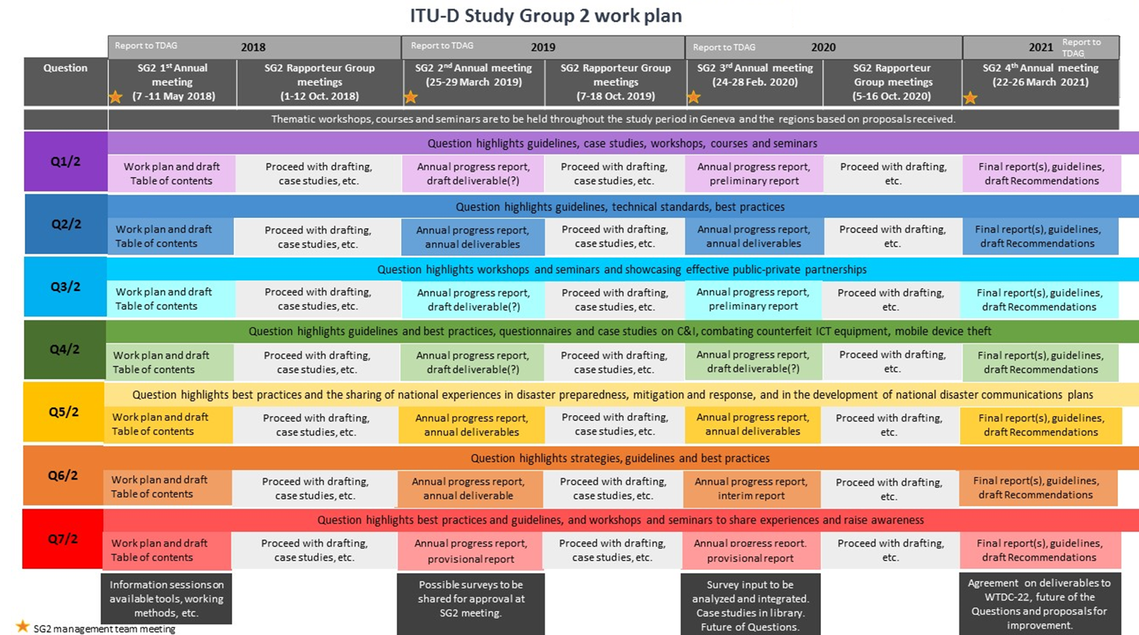(continued on the next page)

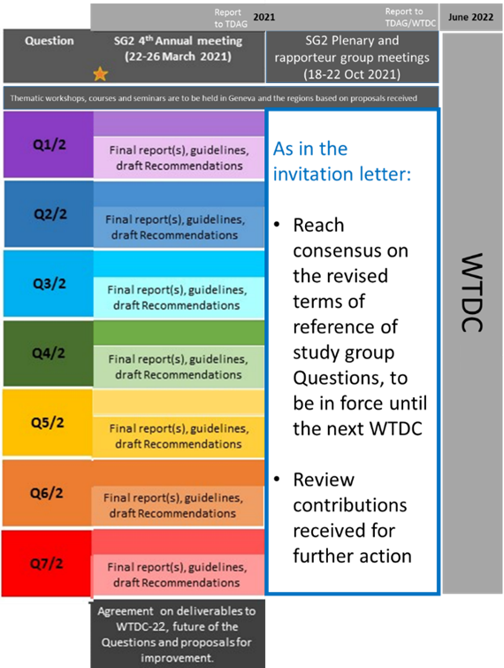

**Annex 4: ITU-D Study Group 2 and rapporteur group meetings**

**Table 4A: List of ITU-D Study Group 2 and rapporteur group meetings**

| **ITU-D study group / rapporteur group meeting** | **Date and location** |
| --- | --- |
| **ITU-D Study Group 2 meetings** |  |
| [Fourth meeting of ITU-D Study Group 2](https://www.itu.int/net4/ITU-D/CDS/sg/blkmeetings.asp?lg=1&sp=2018&blk=26284) | 15 - 19 March 2021, fully virtual e-meeting |
| [Third meeting of ITU-D Study Group 2](https://www.itu.int/net4/ITU-D/CDS/sg/blkmeetings.asp?lg=1&sp=2018&blk=24908) | 24 - 28 February 2020, Switzerland [Geneva] |
| [Second meeting of ITU-D Study Group 2](https://www.itu.int/net4/ITU-D/CDS/sg/blkmeetings.asp?lg=1&sp=2018&blk=21833) | 25 - 29 March 2019, Switzerland [Geneva] |
| [First meeting of ITU-D Study Group 2](https://www.itu.int/net4/ITU-D/CDS/sg/blkmeetings.asp?lg=1&sp=2018&blk=20349) | 7 - 11 May 2018, Switzerland [Geneva] |
| **ITU-D Study Group 2 rapporteur group meetings** |  |
| [Plenary and rapporteur group meetings](https://www.itu.int/net4/ITU-D/CDS/sg/blkmeetings.asp?lg=1&stg=2&sp=2018&blk=27666) | 18 - 22 October 2021, fully virtual e-meeting |
| [Plenary and rapporteur group meetings](https://www.itu.int/net4/ITU-D/CDS/sg/blkmeetings.asp?lg=1&sp=2018&blk=24969) | 5 - 16 October 2020, fully virtual e-meeting |
| [Rapporteur group meetings](https://www.itu.int/net4/ITU-D/CDS/sg/blkmeetings.asp?lg=1&sp=2018&blk=21835) | 7 - 18 October 2019, Switzerland [Geneva] |
| [Rapporteur group meetings](https://www.itu.int/net4/ITU-D/CDS/sg/blkmeetings.asp?lg=1&sp=2018&blk=20351) | 1 - 12 October 2018, Switzerland [Geneva] |
| **Informal meetings** |  |
| [Informal rapporteur group meetings](https://www.itu.int/net4/ITU-D/CDS/sg/blkmeetings.asp?lg=1&sp=2018&blk=26282) | 22 - 26 February 2021, fully virtual e-meeting |
| **Joint meetings** |  |
| [Joint plenary meeting of ITU-D Study Groups 1 and 2](https://www.itu.int/net4/ITU-D/CDS/sg/blkmeetings.asp?lg=1&sp=2018&blk=26278) | 31 March - 1 April 2021, fully virtual e-meeting |

All associated workshops and webinars are detailed in the ITU-D study groups website on the page dedicated to workshops and other events (see [link](https://www.itu.int/en/ITU-D/Study-Groups/2018-2021/Pages/meetings/events_workshops.aspx)).

**Annex 5: Intra-sector mapping between ITU-D Study Group 1 and Study Group 2 Questions**

This aim of this matrix of relationships and interactions between study group Questions in ITU-D SG1 and ITU-D SG2 was to identify areas of possible areas of overlap and opportunities where collaboration could be further strengthened.

**Table 5A: Matrix of relationships between study group Questions in ITU-D SG1 and ITU-D SG2**

|  |  |  |  |  |  |  |  |  |  |  |  |  |  |  |
| --- | --- | --- | --- | --- | --- | --- | --- | --- | --- | --- | --- | --- | --- | --- |
|  | [**Q1/1**](https://www.itu.int/net4/ITU-D/CDS/sg/rgqlist.asp?lg=1&sp=2018&rgq=D18-SG01-RGQ01.1&stg=1) | [**Q2/1**](https://www.itu.int/net4/ITU-D/CDS/sg/rgqlist.asp?lg=1&sp=2018&rgq=D18-SG01-RGQ02.1&stg=1) | [**Q3/1**](https://www.itu.int/net4/ITU-D/CDS/sg/rgqlist.asp?lg=1&sp=2018&rgq=D18-SG01-RGQ03.1&stg=1) | [**Q4/1**](https://www.itu.int/net4/ITU-D/CDS/sg/rgqlist.asp?lg=1&sp=2018&rgq=D18-SG01-RGQ04.1&stg=1) | [**Q5/1**](https://www.itu.int/net4/ITU-D/CDS/sg/rgqlist.asp?lg=1&sp=2018&rgq=D18-SG01-RGQ05.1&stg=1) | [**Q6/1**](https://www.itu.int/net4/ITU-D/CDS/sg/rgqlist.asp?lg=1&sp=2018&rgq=D18-SG01-RGQ06.1&stg=1) | [**Q7/1**](https://www.itu.int/net4/ITU-D/CDS/sg/rgqlist.asp?lg=1&sp=2018&rgq=D18-SG01-RGQ07.1&stg=1) | [**Q1/2**](https://www.itu.int/net4/ITU-D/CDS/sg/rgqlist.asp?lg=1&sp=2018&rgq=D18-SG02-RGQ01.2&stg=2) | [**Q2/2**](https://www.itu.int/net4/ITU-D/CDS/sg/rgqlist.asp?lg=1&sp=2018&rgq=D18-SG02-RGQ02.2&stg=2) | [**Q3/2**](https://www.itu.int/net4/ITU-D/CDS/sg/rgqlist.asp?lg=1&sp=2018&rgq=D18-SG02-RGQ03.2&stg=2) | [**Q4/2**](https://www.itu.int/net4/ITU-D/CDS/sg/rgqlist.asp?lg=1&sp=2018&rgq=D18-SG02-RGQ04.2&stg=2) | [**Q5/2**](https://www.itu.int/net4/ITU-D/CDS/sg/rgqlist.asp?lg=1&sp=2018&rgq=D18-SG02-RGQ05.2&stg=2) | [**Q6/2**](https://www.itu.int/net4/ITU-D/CDS/sg/rgqlist.asp?lg=1&sp=2018&rgq=D18-SG02-RGQ06.2&stg=2) | [**Q7/2**](https://www.itu.int/net4/ITU-D/CDS/sg/rgqlist.asp?lg=1&sp=2018&rgq=D18-SG02-RGQ07.2&stg=2) |
| [**Q1/1**](https://www.itu.int/net4/ITU-D/CDS/sg/rgqlist.asp?lg=1&sp=2018&rgq=D18-SG01-RGQ01.1&stg=1) |  | **X** | **X** | **X** | **X** |  | **X** | **X** | **X** |  | **X** | **X** | **X** |  |
| [**Q2/1**](https://www.itu.int/net4/ITU-D/CDS/sg/rgqlist.asp?lg=1&sp=2018&rgq=D18-SG01-RGQ02.1&stg=1) | **X** |  |  |  | **X** |  | **X** |  |  |  | **X** | **X** | **X** |  |
| [**Q3/1**](https://www.itu.int/net4/ITU-D/CDS/sg/rgqlist.asp?lg=1&sp=2018&rgq=D18-SG01-RGQ03.1&stg=1) | **X** |  |  | **X** |  | **X** | **X** |  |  | **X** |  | **X** | **X** |  |
| [**Q4/1**](https://www.itu.int/net4/ITU-D/CDS/sg/rgqlist.asp?lg=1&sp=2018&rgq=D18-SG01-RGQ04.1&stg=1) | **X** |  | **X** |  | **X** | **X** | **X** |  |  |  |  | **X** |  |  |
| [**Q5/1**](https://www.itu.int/net4/ITU-D/CDS/sg/rgqlist.asp?lg=1&sp=2018&rgq=D18-SG01-RGQ05.1&stg=1) | **X** | **X** |  | **X** |  | **X** |  | **X** | **X** |  |  | **X** | **X** |  |
| [**Q6/1**](https://www.itu.int/net4/ITU-D/CDS/sg/rgqlist.asp?lg=1&sp=2018&rgq=D18-SG01-RGQ06.1&stg=1) |  |  | **X** | **X** | **X** |  | **X** |  |  | **X** | **X** |  |  | **X** |
| [**Q7/1**](https://www.itu.int/net4/ITU-D/CDS/sg/rgqlist.asp?lg=1&sp=2018&rgq=D18-SG01-RGQ07.1&stg=1) | **X** | **X** | **X** | **X** |  | **X** |  |  | **X** | **X** |  | **X** |  |  |
| [**Q1/2**](https://www.itu.int/net4/ITU-D/CDS/sg/rgqlist.asp?lg=1&sp=2018&rgq=D18-SG02-RGQ01.2&stg=2) | **X** |  |  |  | **X** |  |  |  | **X** | **X** | **X** | **X** | **X** | **X** |
| [**Q2/2**](https://www.itu.int/net4/ITU-D/CDS/sg/rgqlist.asp?lg=1&sp=2018&rgq=D18-SG02-RGQ02.2&stg=2) | **X** |  |  |  | **X** |  | **X** | **X** |  | **X** |  | **X** |  |  |
| [**Q3/2**](https://www.itu.int/net4/ITU-D/CDS/sg/rgqlist.asp?lg=1&sp=2018&rgq=D18-SG02-RGQ03.2&stg=2) |  |  | **X** |  |  | **X** | **X** | **X** | **X** |  |  | **X** |  |  |
| [**Q4/2**](https://www.itu.int/net4/ITU-D/CDS/sg/rgqlist.asp?lg=1&sp=2018&rgq=D18-SG02-RGQ04.2&stg=2) | **X** | **X** |  |  |  | **X** |  | **X** |  |  |  |  |  | **X** |
| [**Q5/2**](https://www.itu.int/net4/ITU-D/CDS/sg/rgqlist.asp?lg=1&sp=2018&rgq=D18-SG02-RGQ05.2&stg=2) | **X** | **X** | **X** |  | **X** |  | **X** | **X** | **X** | **X** |  |  | **X** |  |
| [**Q6/2**](https://www.itu.int/net4/ITU-D/CDS/sg/rgqlist.asp?lg=1&sp=2018&rgq=D18-SG02-RGQ06.2&stg=2) | **X** | **X** | **X** |  | **X** |  |  | **X** |  |  |  | **X** |  | **X** |
| [**Q7/2**](https://www.itu.int/net4/ITU-D/CDS/sg/rgqlist.asp?lg=1&sp=2018&rgq=D18-SG02-RGQ07.2&stg=2) |  |  |  |  |  | **X** |  | **X** |  |  | **X** |  | **X** |  |

**Annex 6: Needs and collaboration topics on WTDC Resolution 9 (Rev. Buenos Aires, 2017) linked with ITU-D Study Group 2 Questions**

**Table 6A: Identified needs and potential collaboration topics on WTDC Resolution 9   
(Rev. Buenos Aires, 2017)**

|  |  |  |
| --- | --- | --- |
| **Question** | **Corresponding Needs in Res. 9** | **Potential topics for collaboration with ITU-R** |
| Q1/2: Creating the smart cities and society: Employing ICTs for sustainable social and economic development | **Need 9**: Assistance in identifying the most efficient ways to utilize the digital dividend  **Need 10**: Emerging technologies and approaches in using spectrum | * Passive and active mobile sites sharing: sharing is a key principal for efficiency in smart cities. In particular, there is a need to examine different models and case studies for active sharing; * Existing and future frequency allocations for Wi-Fi: public Wi-Fi and hotspots are being highly adopted in many cities. It is essential to be aware of the current and future potential spectrum allocations for Wi-Fi and their relevant use cases; * Identification of potential technologies and relevant spectrum allocation for utilities management (e.g. meters connectivity); * IoT and short range devices: what are the current and potential plans for IoT and short range devices? * Any specific studies in relation to emerging systems (along with relevant spectrum issues) that could be adopted in smart cities such as connected cars, intelligent transportation, flying stations or drones, etc. |
| Q4/2: Assistance to developing countries for implementing conformance and interoperability (C&I) programs and combating counterfeit ICT equipment and theft of mobile devices | **Need 12**: Assistance with interference caused by devices in derogation of national spectrum allocations | * Legal framework for spectrum management; * How spectrum is used; * What spectrum is available for particular purposes (national table of frequency allocation) ; * Equipment specifications and standards (for each band/purpose); * Spectrum quality control, interference management & enforcement; * Proposed changes to regulations and spectrum use; * Spectrum & apparatus assignment/licensing processes/mechanisms. |
| Q7/2: Strategies and policies concerning human exposure to electromagnetic fields (EMF) | **Need 1**: Assistance in raising the awareness of national policy-makers as to the importance of effective spectrum management for a country's economic and social development | * Challenges of spectrum monitoring, taking into account ITU-R Recommendations, reports, handbooks and other outputs from ITU-R; * What are the impacts of active site-sharing on EMF exposures around transmitting stations? * Given no change in other parameters (technology, power, altitude; coverage, capacity and QoS), does provision of additional RF spectrum to cellular operators reduce EMF exposure around base stations, and also reduce the number of base stations? * How to quantify EMF exposure around low and high-power non-beam wireless power transfer devices? |

**Annex 7: Revised terms of reference for ITU-D Study Group 2 Questions**

The following table provides a list of revised terms of reference (ToRs) for SG2 Questions. All ToRs reached consensus during the SG2 plenary meeting held on 22 October 2021.

**Table 7A: Revised draft terms of reference for SG2 Questions**

|  |  |
| --- | --- |
| **Question** | **Revised ToR** |
| Q1/2 | [SG2RGQ/319](https://www.itu.int/md/D18-SG02.RGQ-C-0319) (Rev.1) |
| Q2/2 | [SG2RGQ/320](https://www.itu.int/md/D18-SG02.RGQ-C-0320) (Rev.2) |
| Q3/2 | [SG2RGQ/321](https://www.itu.int/md/D18-SG02.RGQ-C-0321) (Rev.2) |
| Q4/2 | [SG2RGQ/322](https://www.itu.int/md/D18-SG02.RGQ-C-0322) (Rev.2) |
| Q5/2 | [SG2RGQ/323](https://www.itu.int/md/D18-SG02.RGQ-C-0323) (Rev.2) |
| Q6/2 | [SG2RGQ/324](https://www.itu.int/md/D18-SG02.RGQ-C-0324) (Rev.2) |
| Q7/2 | [SG2RGQ/325](https://www.itu.int/md/D18-SG02.RGQ-C-0325) (Rev.2) |

________________

1. All output reports and video clips are accessible through the following web page: <http://www.itu.int/itudsgpub>.
2. See <https://www.itu.int/en/ITU-D/Study-Groups/2018-2021/Pages/OngoingWork.aspx>.
3. *Ibid.*
4. For Questions 2/2, 5/2 and 6/2. See <https://www.itu.int/en/ITU-D/Study-Groups/2018-2021/Pages/covid19/webinars/1stSeries.aspx>.
5. See section 5.6 for more information.
6. See the full list in <https://www.itu.int/en/ITU-D/Study-Groups/2018-2021/Pages/meetings/events_workshops.aspx>.
7. See [link1](https://www.itu.int/en/myitu/News/2021/04/30/11/32/Digital-agriculture-hydroponic-melon-farming-Japan) (Q1/2, 2021), [link2](https://www.itu.int/en/myitu/News/2021/08/02/06/54/Telcos-strengthen-India-disaster-preparedness) (Q5/2, 2021), [link3](https://www.itu.int/en/myitu/News/2020/07/17/13/08/New--COVID19-ehealth-tools) (Q2/2, 2020), [link4](https://www.itu.int/en/myitu/News/2020/07/23/14/34/Effective-disaster-management-policy-environment-COVID-19) (Q5/2, 2020), [link5](https://www.itu.int/en/myitu/News/2020/07/27/09/39/Leveraging-ICTs-build-back-greener-COVID-19) (Q6/2, 2020), [link6](https://www.itu.int/en/myitu/News/2020/03/27/14/06/IMT-2020-5G-and-the-electromagnetic-field--ITU-shares-the-latest-global-information) (Q7/2, 2018).
8. See <https://www.itu.int/en/mediacentre/Pages/MC_OCT_2021_.aspx>.
9. See Document [2/2](https://www.itu.int/md/D18-sg02-c-0002).
10. See Document [TDAG-21/2/DT/5](https://www.itu.int/md/D18-TDAG29-211108-TD-0005).
11. See <https://www.itu.int/en/ITU-D/Conferences/GSR/Pages/GSR.aspx>.
12. See section 5.6 of this report for more information.
13. See <https://www.itu.int/en/ITU-D/Emergency-Telecommunications/Pages/Events/2019/GET-2019/default.aspx>.
14. See <https://www.itu.int/en/ITU-D/Conferences/ET/2021/Pages/default.aspx>.
15. See <https://gmisummit.com/summits/2019>.
16. This total does not include participants who attended only the workshops held in conjunction with the SG2 and rapporteur group meetings.
17. Some contributions are from SMEs who had participated in the SME pilot until end of 2019, see [here](https://www.itu.int/en/join/smes/Documents/SMEs%20background%20info_final_8july%20(1).pdf) for more information.
18. Some contributions may be counted more than once if allocated to more than one Question.
19. The “Others” category in the figure includes Palestine (in accordance with Resolution 99 (Rev. Dubai, 2018) of the Plenipotentiary Conference), SMEs which participated in the SME pilot project (see [link](https://www.itu.int/md/S18-PP-C-0052) for more information), and the United Nations system (other than ITU).
20. See Document [52](https://www.itu.int/md/S18-PP-C-0052) of the Plenipotentiary Conference (Dubai, 2018).
21. See <http://www.itu.int/en/ITU-D/Study-Groups/2014-2018/Pages/collaborative-tools.aspx>.
22. See <https://www.itu.int/itu-d/sites/studygroups/>.
23. The “ongoing work” web page is available in <https://www.itu.int/en/ITU-D/Study-Groups/2018-2021/Pages/OngoingWork.aspx>.
24. Following this meeting, a joint reply liaison statement with SG1 was approved to continue exploring such possibilities in the next WTDC, when the next set of Questions will be approved.
25. See meeting webpage <https://www.itu.int/net4/ITU-D/CDS/sg/blkmeetings.asp?lg=1&sp=2018&blk=26278>.
26. See <https://www.itu.int/en/ITU-D/Study-Groups/2018-2021/Pages/OngoingWork.aspx>.
27. See <https://www.itu.int/en/ITU-D/Study-Groups/2018-2021/Pages/OngoingWork.aspx>.
28. See <https://www.itu.int/en/ITU-D/Study-Groups/2018-2021/Pages/OngoingWork.aspx>.
29. Oral reports were provided in previous years.
30. More information about FIGI is available in <https://www.itu.int/net4/ITU-D/CDS/projects/display.asp?ProjectNo=9GLO17088>.
31. More information about PRIDA is available in <https://www.itu.int/en/ITU-D/Projects/ITU-EC-ACP/PRIDA/Pages/default.aspx>.
32. See “*Outcome document of the high-level meeting of the General Assembly on the overall review of the implementation of the outcomes of the World Summit on the Information Society*”, [Res. A/70/125](https://unctad.org/en/PublicationsLibrary/ares70d125_en.pdf).
33. Another thematic workshop was also organized specific to Question 3/1: “A Roadmap for a trusted Cloud for Good” ([programme](https://www.itu.int/net4/wsis/forum/2020/Agenda/Session/279), [report](https://www.itu.int/net4/wsis/forum/2020/Files/outcomes/draft/WSISForum2020_OutcomeDocument_DRAFT-20210201.pdf) (Page 178)).
34. The workshop report was not yet available at the time of writing this report.
35. The workshop report was not yet available at the time of writing this report.