|  |  |  |  |
| --- | --- | --- | --- |
|  | **World Telecommunication Development Conference (WTDC-22)**  **Kigali, Rwanda, 6-16 June 2022** | | |
|  | |  |
| PLENARY MEETING | | **Document WTDC-22/5-E** |
|  | | **25 May 2022** |
|  | | **Original: English** |
| Chairman, Telecommunication Development Advisory Group (TDAG) | | |
| Report to WTDC-22 on the Telecommunication Development Advisory Group (TDAG) Activities 2018-2021 | | |
|  | | |
|  | | |
| **Summary:**  This report summarizes the work carried out by the Telecommunication Development Advisory Group (TDAG) during the period 2018 -2021 as required by WTDC Resolution 24.  **Expected results:**  WTDC-22 is invited to note this report.  **References:**  [TDAG-18/38](https://www.itu.int/md/D18-TDAG23-C-0038/), [TDAG-19/44](https://www.itu.int/md/D18-TDAG24-C-0044/en), [TDAG-20/59](https://www.itu.int/md/D18-TDAG25.2-C-0059/), [TDAG-20/2/5](https://www.itu.int/md/meetingdoc.asp?lang=en&parent=D18-TDAG26-C-0005), [TDAG-20/3/7](https://www.itu.int/md/D18-TDAG27-C-0007/en), [TDAG-21/39](https://www.itu.int/md/D18-TDAG28-C-0039/en), [TDAG-21/2/34](https://www.itu.int/md/meetingdoc.asp?lang=en&parent=D18-TDAG29-C-0034) | | | |

***Note:*** *From 1 May 2022 the decision was taken to refer to the present Conference as WTDC-22 thus reflecting the postponement from November 2021 to June 2022, due to the COVID-19 pandemic. In this document, instances of WTDC-21 coexist with WTDC-22 when quoting older documents.*

Table of Contents

1. Introduction 3

1.1 Terms of reference of TDAG 3

1.2 Telecommunication Development Advisory Group bureau 3

2. TDAG meetings 3

2.1 23rd TDAG meeting 4

2.2 24th TDAG meeting 11

2.3 25th TDAG meeting 18

2.4 26th TDAG meeting 25

2.5 27th TDAG meeting 28

2.6 28th TDAG meeting 31

2.7 29th TDAG meeting 39

3. TDAG Working Group meetings 47

4. Matters assigned to TDAG by WTDC Resolution 24 (Rev. Dubai, 2014) 47

4.1 Background 47

4.2 Upkeep of up-to-date, efficient and flexible working guidelines 49

4.3 ITU-D objectives and budgetary appropriations available for activities, programmes and regional initiatives; ITU-D operational plan; Buenos Aires Action Plan 49

4.4 Study groups 51

4.5 Advise the Director of BDT on relevant financial and other matters 53

5. Cooperation and collaboration 53

# Introduction

The 2018-2021 session of the Telecommunication Development Advisory Group (TDAG) was indelibly marked by the world’s first global pandemic, fully virtual meetings, long-desired evolutions in the Development Sector’s highest forum - the World Telecommunications Development Conference (WTDC) - and myriad adjustments required by its eventual postponement. While this seventh cycle of TDAG will forever be associated with the first worldwide pandemic in history, it will also be remembered, equally if not chiefly, for the tenacity and perseverance, the flexibility and adaptability, and the innovation and creativity that was employed over these four plus years to accomplish the work in the TDAG remit.

Beyond its review of all BDT strategic priorities, projects and activities, the regional presence, study groups, and dedicated groups on inter sector coordination, capacity building initiatives, and industry advice on Development -- as developed by the TDAG Working Groups, and with the TDAG Vice Chairs, TDAG rendered substantial advice on enhancements to the WTDC, delivered the base draft for the WTDC-22 Declaration, made contributions to the draft WTDC-22 Action Plan and ITU-D strategic considerations, approved base documents for the ITU-D study questions available for the WTDC and held substantial deliberations on and advice regarding the BDT Programmes, Thematic Priorities, Resolutions 1 and 2 and the ITU Strategic Plan. This was achieved in spite of the many obstacles the pandemic presented, and all participants in the TDAG – from membership and the Telecommunication Development Bureau (BDT) alike – can contemplate and celebrate the hard-won milestones reflected in this report.

The seventh cycle of TDAG demonstrated a determination to work together as a global community to do our part, as far as the ITU mandate allows, to ensure that no one is left behind in the advancing digital age, that all membership voices are heard, particularly those with the greatest challenges, and that a fit-for-purpose BDT stands ready to combine the collective will, intellect and resources of ITU membership with those of its own to achieve these aims.

## Terms of reference of TDAG

Acting through the Director, TDAG is charged with reviewing the relationship between the objectives in the ITU Strategic Plan and **budgetary appropriations available for ITU-D activities,** especially the **programs/thematic priorities and** **regional initiatives,** as well as the **current ITU-D operational plan and the draft operational plan**that is presented to the ITU Council for approval. The rules also contemplate that TDAG will help **facilitate links** to the ITU Strategic Plan and the ITU-D 4-year rolling operational plan, and offer advice on **work allocation**, **ITU-D working methods**, strategies and relations with **other related bodies** inside and outside of the ITU, the effectiveness of **study group questions** and activities and **implementation of regional actions, initiatives and projects**.  Further information on the terms of reference of TDAG can be found on the [TDAG webpage](http://www.itu.int/ITU-D/tdag/).

## Telecommunication Development Advisory Group Bureau

The TDAG Bureau is appointed by the WTDC[1] and is comprised of two Vice Chairs from each of the five regions, the Chairs of the ITU-D Study Groups, and the TDAG Chair. Each Bureau member maintains an area of interest, indicated here: <https://www.itu.int/en/ITU-D/Conferences/TDAG/Pages/Role-of-TDAG-Chairman-and-Vice-Chairmen.aspx>. TDAG Vice Chairs can engage both with membership and the regional and area offices within their respective regions to follow progress of the regional initiatives. Resolution 208 (Rev. Dubai 2018) of the Plenipotentiary Conference further encourages Vice Chairs to “assume a leadership role in activities in order to ensure equitable distribution of the tasks and achieve greater involvement of Vice Chairs in the management and work of advisory [and] study groups.”

In accord with ITU-D Resolution 61 (Rev. Dubai, 2014), WTDC-17 adopted the composition of the TDAG Bureau and appointed its TDAG chairman and vice-chairmen, as follows:

|  |  |  |  |
| --- | --- | --- | --- |
| **Chairman/**  **Vice-Chairmen** | **Name** | **Country** | **BDT Region** |
| Chairman | **Ms Roxanne McElvane Webber** | United States | AMS |
| Vice-Chairman | Ms Regina Fleur Assoumou Bessou | Côte d'Ivoire | Chairman, SG1 |
| Vice-Chairman | Mr Ahmad Reza Sharafat | Iran (Islamic Rep. of) | Chairman, SG2 |
| Vice-Chairman | Mr Christopher Kipkoech Kemei | Kenya | AFR |
| Vice-Chairman | Mr Abdulkarim Ayopo Oloyede | Nigeria | AFR |
| Vice-Chairman | Mr Nicolás Ernesto Karavaski | Argentina | AMS* |
| Vice-Chairman | **Mr Neil Checo Valera** | Dominican Republic | AMS** |
| Vice-Chairman | Mr Al-Ansari Almashakbeh | Jordan | ARB |
| Vice-Chairman | **Mr Tariq H Alamri** | Saudi Arabia | ARB |
| Vice-Chairman | Mr Kishore BabuMr Kishore Babu GSC Yerraballa | India | ASP |
| Vice-Chairman | Mr Nguyen Quyen | Vietnam | ASP*** |
| Vice-Chairman | Ms Aichurok Maralbek Kyzy | Kyrgyz Republic | CIS**** |
| Vice-Chairman | **Mr Arseny Plossky** | Russian Federation | CIS |
| Vice-Chairman | Mr Wim Rullens | Netherlands | EUR |
| Vice-Chairman | **Ms Blanca González** | Spain | EUR |

# *In 2020, Mr Karavaski replaced Mr Hugo Dario Miguel from Argentina.

** In December 2020, Mr Valera replaced Ms Amparo Arango Echeverri (INDOTEL) who had replaced Ms  Naut.

*** Mr Nguyen Quyen served admirably through the 7th period, from 2018 to 2021.

****In 2019, Ms Kyzy replaced Ms Nurzat Boljobekova from Kyrgyz Republic.

# TDAG meetings

TDAG held three meetings during the period covered by this report under the chairmanship of Roxanne McElvane Webber (United States). The complete summary of conclusions of these meetings can be found at: [www.itu.int/ITU-D/tdag/](http://www.itu.int/ITU-D/tdag/).

Extraordinarily, TDAG held seven meetings during the period covered by this report under the chairmanship of Roxanne McElvane Webber (United States). The complete summary of conclusions of these meetings can be found at: [www.itu.int/ITU-D/tdag/](http://www.itu.int/ITU-D/tdag/). Associated meetings of working groups created by TDAG, web dialogues associated with the WTDC and extraordinary meetings necessitated by pandemic-driven remote status brought the total meetings held by TDAG and its working groups to no fewer than 27 during the period. Notable positive trends included a steady increase in participation, especially by women, which grew over the seventh period from 27 percent to almost 50 percent.

Given the substantial effects experienced within individual countries around the globe from the COVID-19 pandemic, beginning in 2020 all TDAG meetings were required to be conducted virtually. The BDT’s swift pivot to a robust and effective entirely remote format was unquestionably critical and highly commendable. Like all such meetings that are international in nature, the virtual format nevertheless challenged member participation in at least three ways. First, a broadband connection was needed for optimal participation which regrettably impacted many developing countries, particularly during the first year of the pandemic. Second, it quickly became clear that additional meetings would be required to accomplish approximately the same amount of work completed in a physical meeting. And third, because a virtual meeting originates in one time zone only, entities outside that zone were challenged to varying degrees, and for all members, the press of multiple meetings, many outside of normal working hours, was not insubstantial. The BDT provided ample technical support, rapidly developed and published guidelines for remote participation and limited meeting times to help offset these challenges, and participation steadily increased across the years to more than double its initial numbers.

## 23rd TDAG meeting

1. The 23rd meeting of the Telecommunication Development Advisory Group (TDAG) took place from 9 to 11 April 2018 at ITU headquarters in Geneva, under the chairmanship of Ms Roxanne McElvane Webber.

The meeting marked the first TDAG meeting after the[World Telecommunication Development Conference 2017 (WTDC-17)](https://www.itu.int/en/ITU-D/Conferences/WTDC/WTDC17/Pages/default.aspx), convened in Buenos Aires, Argentina, from 9 to 20 October 2017.

1. *Participants*

The following chart provides the breakdown of participants by category:

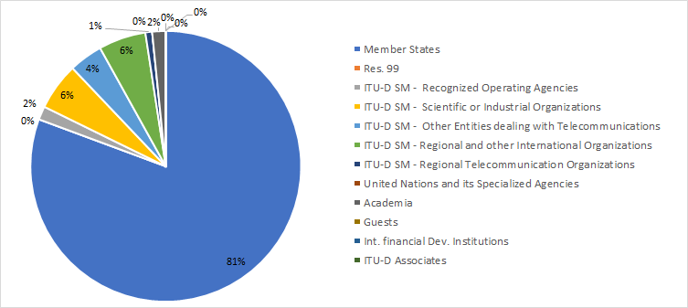The following chart provides the breakdown of participants by region:

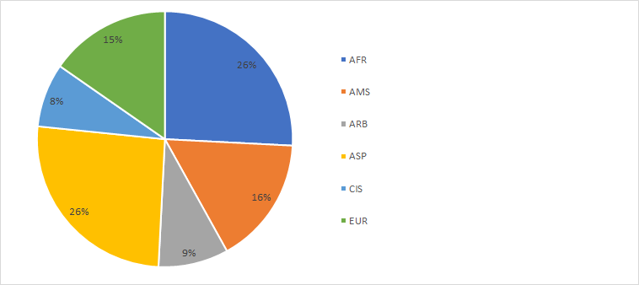

The following chart provides the breakdown of participants by gender:

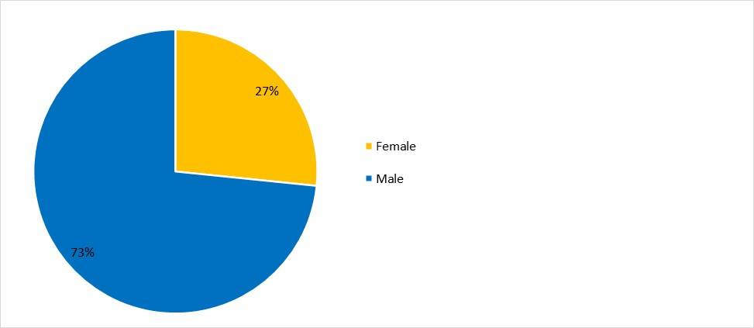

1. *Documents*

The following chart provides the number of documents broken down by category of documents:

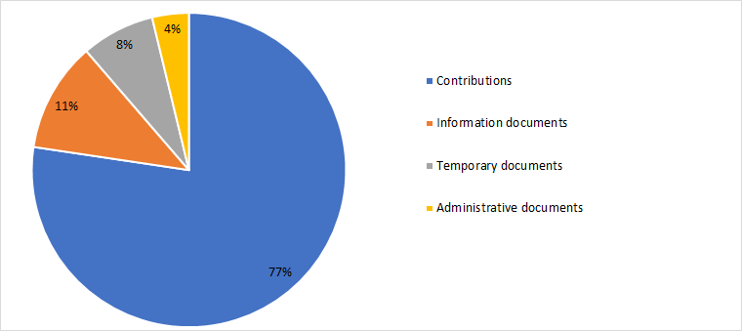

1. *23rd TDAG meeting outcomes*

The following table provides the summary of the outcomes according to subject:

| *Agenda item* | *TDAG Conclusions / Outcomes* |
| --- | --- |
| **Outcomes of WTDC-17:** Report on WTDC-17 | [Document 4](https://www.itu.int/md/D18-TDAG23-C-0004/en), *Report on World Telecommunication Development Conference (WTDC 17)*: The summary report on the World Telecommunication Development Conference (WTDC-17) was reviewed, discussed, welcomed and noted.  [Document 8](https://www.itu.int/md/D18-TDAG23-C-0008/en), *Financial implications of the regional initiatives approved by WTDC-17*: TDAG noted the financial implications for ITU of the decisions made by WTDC-17 and the importance of prioritizing and mobilizing resources to implement the newly adopted regional initiatives.  TDAG reviewed and welcomed and noted the document.  [Document 9](https://www.itu.int/md/D18-TDAG23-C-0009/en), *BDT Management Retreat 2018 debrief*: TDAG welcomed and noted the debrief on the main discussions and conclusions that took place during the Retreat, from 5 to 9 February 2018, in Geneva, Switzerland |
| **Outcomes of WTDC-17** TDAG scope of work and working methods - WTDC Resolutions 24 and 61 (Rev. Dubai, 2014), WTDC Resolution 1 (Rev. Buenos Aires, 2017) and the Buenos Aires Action Plan. | [Document 7(Rev.1)](https://www.itu.int/md/D18-TDAG23-C-0007/en), *TDAG scope of work and working methods* and [document 10](https://www.itu.int/md/D18-TDAG23-C-0010/en), *Electronic working methods for ITU-D events*: TDAG took note of the document and emphasized that its content would provide useful guidance for its work going forward. TDAG also recognised existing BDT efforts that make electronic working methods available for ITU-D events. |
| **Outcomes of WTDC-17** TDAG scope of work and working methods - Effective use in the ITU Telecommunication Development Sector of the six official languages of the Union on an equal footing | [Document 24](https://www.itu.int/md/D18-TDAG23-C-0024/en), *Effective use in the ITU Telecommunication Development Sector of the six official languages of the Union on an equal footing*: While recognizing the importance of linguistics, in particular for developing countries, and of treating all six languages of the Union on an equal footing, discussions recognized existing efforts of BDT in this area and highlighted that when analyzing possible future technical solutions, financial implications must also be considered.  TDAG welcomed the document and suggested that in future meetings, BDT may consider making a presentation on these issues to provide further information on available resources |
| **Outcomes of WTDC-17** TDAG scope of work and working methods - Internet of Things (IoT) Online Resources Portal | [Document 28](https://www.itu.int/md/D18-TDAG23-C-0028/en), *Internet of Things (IoT) Online Resources Portal*: TDAG welcomed the proposal, and while participants supported the need to consolidate information about ITU activities, resources, and relevant research and development on key topics such as IoT, and also recognized its potential to strengthen ITU-wide information sharing and best practices, TDAG suggested that further discussion may be required, in particular on the practical implementation and scope of the proposal and its financial implications. |
| **Outcomes of WTDC-17** TDAG scope of work and working methods - Work and procedures of the World Telecommunication Development Conferences | [Document 35](https://www.itu.int/md/D18-TDAG23-C-0035/en), *Work and procedures of the World Telecommunication Development Conferences*: There was general support for the proposal to have a discussion among membership on ways to improve the structure and functioning of future WTDCs. TDAG noted the document with appreciation and agreed that this advice to the Director would be taken into account, including mechanisms for implementation, in the preparations for the next WTDC and could be discussed at future TDAG meetings. |
| Collaboration with the other Sectors: Report on Inter-Sector Coordination Team on Issues of Mutual Interest | [Document 5(Rev.2)](https://www.itu.int/md/D18-TDAG23-C-0005/en), *Inter-Sector Coordination Team on Issues of Mutual Interest*: TDAG welcomed and noted the report with interest. |
| Collaboration with the other Sectors: Reply Liaison Statement to ITU-D Study Group 1 (Copy to TDAG and for information to RAG and ITU-R Study Group 5) | [Document 23(Rev.1)](https://www.itu.int/md/D18-TDAG23-C-0023/en), *Incoming liaison statement - Reply liaison statement to ITU-D Study Group 1 (copy to TDAG and for information to RAG and ITU-R Study Group 5)*: TDAG thanked ITU-R Study Group 1 for the liaison statement and noted its contents. |
| Collaboration with the other Sectors: Studies in response to Resolution 9 | [Document 36](https://www.itu.int/md/D18-TDAG23-C-0036/en), *Studies in response to Resolution 9 (Rev. Buenos Aires, 2017) - Participation of countries, particularly developing countries, in spectrum management*: TDAG noted the document and invited the study group chairmen to integrate the resources, to the extent possible and as required, in the work of the Questions under study. TDAG noted that the list would be updated by BR as appropriate. |
| **Collaboration with the other Sectors:** Incoming liaison statement on ITU inter-sector coordination (reply to TSAG - LS 1 - E) & Incoming liaison statement on ITU inter-Sector coordination [to ISCT, TDAG, ITU-D SGs, RAG, ITU-R SGs, ITU-T SGs] | [Document 25](https://www.itu.int/md/D18-TDAG23-C-0025/en), *Incoming liaison statement on ITU inter-Sector coordination (reply to TSAG - LS 1 -E)* and [document 27](https://www.itu.int/md/D18-TDAG23-C-0027/en), *Incoming liaison statement on ITU inter-Sector coordination [to ISCT, TDAG, ITU-D SGs, RAG, ITU-R SGs, ITU-T SGs]*: TDAG thanked ITU-T for the liaison statements and noted the contents. |
| **Collaboration with the other Sectors:** Streamlining PP and WTDC resolutions | [Document 29](https://www.itu.int/md/D18-TDAG23-C-0029/en), *Streamlining PP and WTDC resolutions*: TDAG supported in principle the importance of streamlining resolutions and noted that it could revisit the matter following the Plenipotentiary Conference (Dubai, 2018).  TDAG noted Document TDAG-18/29 and thanked the Russian Federation for the proposal. |
| **Collaboration with the other Sectors:** ITU-D representatives to the ITU Coordination Committee for Terminology (ITU CCT) | [Document DT/2](https://www.itu.int/md/D18-TDAG23-180409-TD-0002/en), *ITU-D representatives to the ITU Coordination Committee for Terminology (ITU CCT)*: TDAG appointed Mr Peter Mbengie (Cameroon) from ITU-D Study Group 1, and Ms Ke Wang (China) from ITU-D Study Group 2 to ITU CCT |
| **Collaboration with the other Sectors:** Progress report of Chairman of ISCT | [Document 37](https://www.itu.int/md/D18-TDAG23-C-0037/en), *Report of the meeting of ISCT held on 9 April 2018*: TDAG welcomed and considered the report, and thanked Mr Bigi for agreeing to lead the ISCT over the new four-year period.  Ms Nurzat Boljobekova and Mr Arseny Plossky were appointed TDAG representatives to ISCT.  TDAG discussed the draft revision of the ISCT Terms of Reference provided in Annex 1 to document 37. No objection was expressed to adding the activities of the General Secretariat in the analysis of ISCT, however, TDAG agreed that further clarification was needed on a number of issues. For example, questions were raised regarding the composition and title of ISCT. Additional questions were raised regarding the relationship of the Inter-Sectoral Coordination Task Force (ISC-TF) and the ISCT, the first being an internal-ITU coordination mechanism, while the latter is a body composed of representatives of the three advisory groups. TDAG noted that the issue would be discussed further and decided upon during Council, and recommended that the BDT Director inform Council about the discussions that took place during TDAG. |
| Report on the implementation of the ITU-D strategic plan and operational plan 2017 | [Document 2(Rev.1)](https://www.itu.int/md/D18-TDAG23-C-0002/en), *Performance report 2017*: TDAG noted and expressed its appreciation for the comprehensive document and for the hard work of BDT during 2017. TDAG called upon BDT to continue efforts to strengthen collaboration and coordination with regional organizations, and requested additional information on some of the cooperation agreements and related projects and activities mentioned in the report. |
| ITU-D contribution to the implementation of the WSIS Plan of Action and the 2030 Agenda for Sustainable Development | [Document 3](https://www.itu.int/md/D18-TDAG23-C-0003/en), *ITU-D contribution to the implementation of the WSIS Outcomes and the 2030 Agenda for Sustainable Development*: TDAG called upon BDT to continue highlighting member’s existing needs and circumstances, including infrastructure requirements, and how such needs could be addressed to strengthen ICTs as a cross-cutting tool to achieve the SDGs. TDAG noted the document with the various clarifications and additions provided. |
| **ITU-D four-year rolling operational plan 2019-2022** Draft ITU-D four-year rolling operational plan 2019-2022 | [Document 6(Rev.2)](https://www.itu.int/md/D18-TDAG23-C-0006/en), *Draft ITU-D four-year rolling operational plan 2019-2022*: TDAG supported the document with appreciation, including a slight revision already reflected in the final report of WTDC-17. |
| **ITU-D four-year rolling operational plan 2019-2022** Draft four-year rolling operational plan for the General Secretariat for the period 2019-2022 | [Document 32](https://www.itu.int/md/D18-TDAG23-C-0032/en), *Draft four-year rolling operational plan for the General Secretariat for 2019-2022*: TDAG noted the document with appreciation. |
| ITU-D study group-related matters | [Document 12](https://www.itu.int/md/D18-TDAG23-C-0012/en), *Scope of work of ITU-D Study Group 1 for the 2018-2021 study period* and [document 13](https://www.itu.int/md/D18-TDAG23-C-0013/en), *Scope of work of ITU-D Study Group 2 for the 2018-2021 study period*: The chairman welcomed both study group chairmen, highlighting new developments in the study group working methods for this period, including a pilot project to promote SME participation. TDAG welcomed both documents TDAG-18/12 and 13 from the study groups. |
| Proposal for holding a panel session on Early Warning System (EWS) in the first ITU-D SG2 Meeting | [Document 34](https://www.itu.int/md/D18-TDAG23-C-0034/en), *Proposal to hold a panel session on early warning system during the first ITU-D SG2 Meeting*: TDAG noted the information, which was submitted to inform participants about important upcoming study group activities. TDAG noted its appreciation for the work on Early Warning Systems and for efforts to organize the workshop to enrich the work of the study Question. TDAG also suggested that the next study group meetings could identify further topics that could be the subject of workshops or seminars at future such meetings. |
| Regional Development Forums (RDFs) | [Document 14(Rev.2)](https://www.itu.int/md/D18-TDAG23-C-0014/en), *Regional Development Forums*:TDAG welcomed and noted the report, which provided an update on the six Regional Development Forums (RDFs), scheduled to be held in 2018, taking into account the outcomes of WTDC-17 that resolved to strengthen the platforms for regional coordination. In particular, the report emphasized the RDF role as both a framework for implementation and as a contributor to the implementation of the WSIS Action Lines and SDGs and included the schedule of RDFs for 2018. |
| **Report on ITU-D major events/initiatives** Global Symposium for Regulators (GSR) | [Document 16](https://www.itu.int/md/D18-TDAG23-C-0016/en), *17th Global Symposium for Regulators 2017 (GSR-17) and preparations for GSR-18*: TDAG noted the report, which summarized the 17th edition of the Global Symposium for Regulators (GSR-17) and provided information on GSR-18, with appreciation. |
| **Report on ITU-D major events/initiatives** Capacity building activities | [Document 17(Rev.1)](https://www.itu.int/md/D18-TDAG23-C-0017/en), *Report of the Chairman of the Group on Capacity Building Initiatives (GCBI)*: Global Capacity Building Initiative (GCBI): TDAG congratulated the GCBI Chairman for the report and the GCBI for the important work accomplished, and encouraged GCBI members to continue their good work. A key recommendation from GCBI was to expand the target group of ITU capacity building activities to reflect the changing ecosystem, e.g. SMEs, microenterprises, students, youth, women, civil society and academia.  TDAG thanked the Chairman of GCBI and took note of the report.  [Document 18](https://www.itu.int/md/D18-TDAG23-C-0018/en), *Report on* *Capacity building activities*: TDAG welcomed the report and congratulated BDT on its activities in this area. |
| **Report on ITU-D major events/initiatives**  World Telecommunication/ICT Indicators Symposium (WTIS) | [Document 19](https://www.itu.int/md/D18-TDAG23-C-0019/en), *15th World Telecommunication/ICT Indicators Symposium (WTIS) 2017 and 2018*: TDAG noted the report with appreciation.  [Document 31](https://www.itu.int/md/D18-TDAG23-C-0031/en), *Proposal on optimizing the the working mechanism of ICT indicators*: TDAG welcomed the proposals, noting that suggestions made could be considered and further discussed in future expert groups and in study group meetings, so as to stabilize the recently made changes to the IDI framework and methodology. |
| **Report on ITU-D major events/initiatives**  ITU-D Innovation | [Document 22(Rev.1)](https://www.itu.int/md/D18-TDAG23-C-0022/en), *ITU-D innovation*: TDAG noted the report, which provided an overview of this topic as one of the outputs and goals adopted at WTDC-17 and PP-14, respectively. |
| Membership, partnership, private sector-related matters | [Document 20](https://www.itu.int/md/D18-TDAG23-C-0020/en), *ITU-D Sector Membership and enhancing private sector engagement in the ITU-D*: TDAG welcomed the information and noted the report with appreciation.  [Document 21(Rev.1)](https://www.itu.int/md/D18-TDAG23-C-0021/en), *ITU-D partnership and resource mobilization*: TDAG welcomed the report and its annex and noted both with appreciation.  [Document 26](https://www.itu.int/md/D18-TDAG23-C-0026/en), *Linkages between achieving the objectives of the Buenos Aires Action Plan, partnerships and mobilization of resources by least developed countries (LDCs) and small island developing States (SIDS)*: TDAG noted the contribution with appreciation.  [Document 33](https://www.itu.int/md/D18-TDAG23-C-0033/en), *The Industry Advisory Group for Development (IAGD): Issues to strengthen the role of private industry in the ITU-D*: TDAG supported this document and agreed on the important role that the private sector has to play in the Development Sector, as indicated in Resolution 71. TDAG acknowledged the fast pace of the technology sector and the importance for regulators, especially in developing countries, to encourage a proper regulatory environment to promote healthy competition and industry growth.  TDAG also noted that the first IAGDI activity was tentatively planned for GSR 2018, and that work was underway with BDT to establish the IAGDI structure. |
| Calendar of ITU-D events | [Document 15](https://www.itu.int/md/D18-TDAG23-C-0015/en), *Calendar of ITU-D events*: TDAG noted the events planned for the period 2018-2021. |

## 24th TDAG meeting

1. The 24th meeting of the Telecommunication Development Advisory Group (TDAG) was held at ITU headquarters in Geneva, from 3 to 5 April 2019, under the chairmanship of Ms Roxanne McElvane Webber.

The meeting was the first meeting held after the 2018 Plenipotentiary Conference (Dubai, 2018) and featured eight breakout sessions organized by the Director and BDT staff − four on process and governance topics and four on BDT substantive areas of work, along with six informal sessions during which all ITU regional directors, accompanied by staff from the regional offices, described activities undertaken to serve ITU membership in the field, particularly to implement the regional initiatives adopted at WTDC-17. The full meeting report, in the six official languages of ITU, is available at [this link](https://www.itu.int/md/D18-TDAG24-C-0044/en).

1. *Participants*

The following chart provides the breakdown of participants by category:

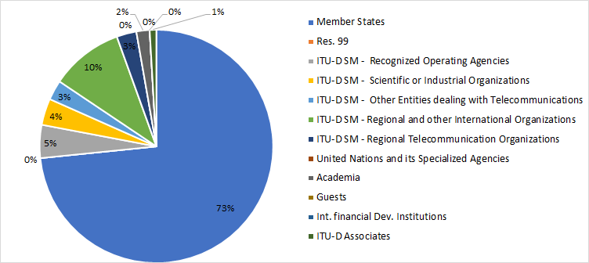

The following chart provides the breakdown of participants by region:

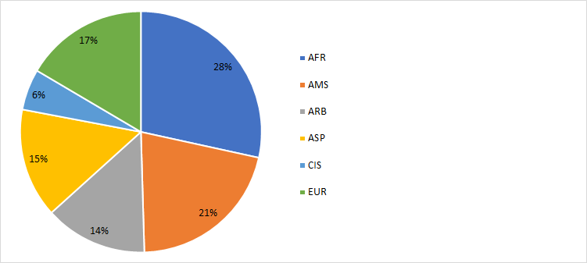

The following chart provides the breakdown of participants by gender:

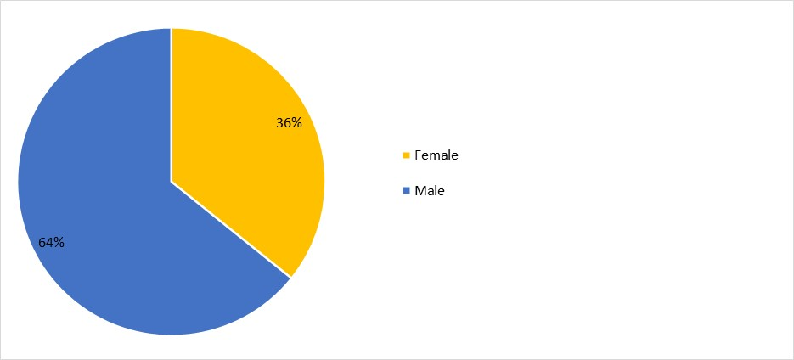

1. *Documents*

The following chart provides the number of documents broken down by category of documents:

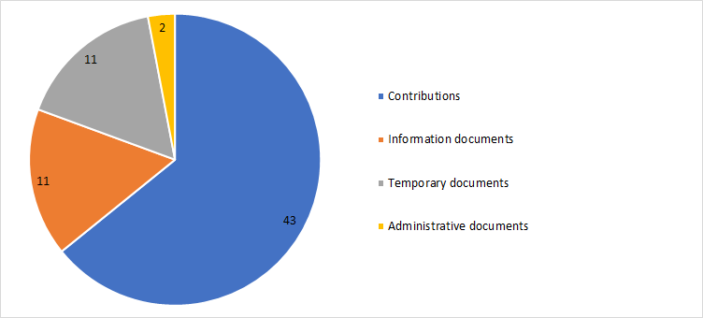

1. *24th TDAG meeting outcomes*

Outcomes according to subject:

| ***Agenda item*** | ***TDAG Conclusions / Outcomes*** |
| --- | --- |
| New TDAG vice-chairmen appointed to vacant positions | [Document 7](https://www.itu.int/md/D18-TDAG24-C-0007/en), *Appointment of two vice-chairmen of TDAG*: TDAG appointed by acclamation Ms Amparo Arango Echeverri, Manager of International Relations at the Dominican Institute of Telecommunications (INDOTEL), as a TDAG Vice‑Chairman, replacing Ms Katrina Naut.  TDAG also appointed by acclamation Ms Aichurok Maralbek Kyzy, Chief Expert of the Radio Spectrum Management Department of the State Communications Agency in the State Committee of Information Technologies and Communications of the Kyrgyz Republic, as a TDAG Vice‑Chairman, replacing Ms Nurzat Boljobekova. |
| **2018 ITU Plenipotentiary Conference (Dubai, 2018) and WSIS matters relevant to ITU-D:** Outcomes of Plenipotentiary Conference (Dubai, 2018) related to ITU-D | [Document 4(Rev.1)](https://www.itu.int/md/D18-TDAG24-C-0004/en), *Outcomes of the 20th ITU Plenipotentiary Conference (Dubai, 2018) with implications for the work of ITU-D*: TDAG took note of the main outcomes of the plenipotentiary conference that relate to ITU-D. TDAG participants underlined the need to balance the budget for 2020-2023,acknowledged the importance of these resolutions and decisions, and stressed the need to include other equally important resolutions that have implications for the work to be carried out by ITU-D. TDAG requested, and the secretariat agreed, to update the document to include*:*   * **Resolution 70** on mainstreaming a gender perspective in ITU and promoting gender equality and the empowerment of women through telecommunications and ICTs. * **Resolution 136** on using telecommunications and ICTs for humanitarian assistance and to monitor and manage emergency and disaster situations for early warning, prevention, mitigation and relief. * **Resolution 169** on participation of academia in the work of the Union. * **Resolution 175** on telecommunication/ICT accessibility for persons with disabilities and with specific needs. * **Resolution 179** on the ITU role in child online protection. * **Resolution 196** on protecting telecommunication service users and consumers. * **Resolution 198** on empowering youth through telecommunications/ICTs; and   **Resolution 176** on measurement and assessment concerns related to human exposure to electromagnetic fields. |
| **2018 ITU Plenipotentiary Conference (Dubai, 2018) and WSIS matters relevant to ITU-D:** ITU-D actions relevant to the World Summit on the Information Society (WSIS) Plan of Action and the 2030 Agenda for Sustainable Development | [Document 3](https://www.itu.int/md/D18-TDAG24-C-0003/en), *ITU-D Contribution to the Implementation of WSIS Outcomes and the 2030 Agenda for Sustainable Development*: TDAG agreed that a segment on WSIS and SDGs should be included as a regular agenda item in the regional development forums. |
| **Operational plans considered:**  ITU-D four-year rolling operational plan 2020-2023 | [Document 6(Rev.1)](https://www.itu.int/md/D18-TDAG24-C-0006/en), *ITU-D four-year rolling operational plan 2020-2023*: TDAG endorsed the document and supported the BDT Director’s strategy to continue to improve service delivery through clustering topics based on the outcomes of WTDC-17 and the Plenipotentiary Conference (Dubai, 2018). |
| **Operational plans considered:** General Secretariat four-year rolling operational plan 2020-2023 | [Document 25](https://www.itu.int/md/D18-TDAG24-C-0025/en), *Draft operational plan for the* *General Secretariat for 2020-2023*: TDAG noted the plan with appreciation. |
| **Operational plans considered:** Activities implementing the ITU-D operational plan 2018 | [Document 2](https://www.itu.int/md/D18-TDAG24-C-0002/en), *Performance report 2018*: TDAG noted the contents of the report with appreciation. |
| **BDT major work areas, events and initiatives:**  Infrastructure and spectrum management activities | [Document 29](https://www.itu.int/md/D18-TDAG24-C-0029/en), *ITU-D infrastructure development*: TDAG noted the document, recognizing that infrastructure development is one of the main goals articulated by ITU membership at WTDC-17 and at the Plenipotentiary Conference (Dubai, 2018), and that this goal falls under SDG 9 - to build resilient infrastructure and foster innovation. |
| **BDT major work areas, events and initiatives:**  Spectrum management activities under Resolution 9 | [Document 32](https://www.itu.int/md/D18-TDAG24-C-0032/en), *Implementation of WTDC Resolution 9 (Rev. Buenos Aires, 2017)*: TDAG noted the document with interest and appreciation and approved the approach proposed by the chairmen of Study Group 1 and Study Group 2 recounted above and the coordinators selected. |
| **BDT major work areas, events and initiatives:**  Cybersecurity and ICT applications | [Document 30](https://www.itu.int/md/D18-TDAG24-C-0030/en), *Cybersecurity and ICT applications activities*: TDAG noted the document with appreciation, and encouraged BDT to continue measuring cybersecurity progress with the GCI while improving the methodology and scoring mechanism through continuous dialogue and collaboration with Member States, industry, academia, and experts in the area of cybersecurity and data analysis. TDAG suggested that a mechanism could be developed to ensure that products and services are developed taking into consideration such input from the membership. |
| **BDT major work areas, events and initiatives:**  Regulatory and market environment, including the Global Symposium for Regulators (GSR) | [Document 16](https://www.itu.int/md/D18-TDAG24-C-0016/en), *ITU-D policy and regulatory programme*: TDAG noted the document with interest and appreciation and participants requested further clarification on events, portals, studies and research, and asked that information on reports and studies be made available to membership and shared with regional offices so that best practices on policy and regulation could be widely disseminated. |
| **BDT major work areas, events and initiatives:**  Digital inclusion | [Document 31](https://www.itu.int/md/D18-TDAG24-C-0031/en), *ITU-D digital inclusion programme*: TDAG noted the document with interest and appreciation, acknowledging the need to highlight the importance of implementing policies on digital inclusion and accessibility, and underlining the need to foster an enabling environment to achieve trust in ICTs. |
| **BDT major work areas, events and initiatives:**  Capacity-building activities | [Document 18](https://www.itu.int/md/D18-TDAG24-C-0018/en), *Capacity-building activities* and [document 17(Rev.1)](https://www.itu.int/md/D18-TDAG24-C-0017/en), *Report on the work of the Group on Capacity Building Initiatives (GCBI) to TDAG*: TDAG noted the important activities related to the centres of excellence, ITU Academy, and working in partnership with other stakeholders with appreciation, recognizing the importance of building capacity for digital inclusion, including digital literacy. TDAG suggested that BDT could explore mechanisms to leverage the expertise created through the training activities and emphasized the importance of including the gender dimension in capacity building and skills development work. |
| **BDT major work areas, events and initiatives:**  ICT data and statistics, including World Telecommunication/ICT Indicators Symposium (WTIS) | [Document 19](https://www.itu.int/md/D18-TDAG24-C-0019/en), *Report on ICT data and statistics 2018*: TDAG noted the document with interest and appreciation, recognizing that ICT statistics are a critical output of ITU and an essential input for ICT policy. TDAG also stressed that statistics published by ITU must be reliable and trustworthy. TDAG encouraged experts from Member States to contribute actively in the ongoing work. |
| **BDT major work areas, events and initiatives:**  Breakout session: ICT data and statistic | [Document 35(Rev.1)](https://www.itu.int/md/D18-TDAG24-C-0035/en), *Proposals on the work of study groups on statistics in the field of telecommunications/ICT in accordance with the revision of Resolution 131 (Rev. Dubai, 2018) Measuring information and communication technologies to build an integrating and inclusive information society*: Breakout session ICT data and statistics: TDAG agreed that relevant ITU ICT statistics and information on the latest publications should be made available to study groups, that revision or update to such data should be made by experts in the statistics field in the expert group and that members of study groups could be invited to attend these meetings, as appropriate. |
| **BDT major work areas, events and initiatives:**  Emergency telecommunications, climate change, e-waste, LDCs, LLDCs, and SIDS | [Document 26](https://www.itu.int/md/D18-TDAG24-C-0026/en), *Emergency telecommunications, climate change, e-waste, LDCs, LLDCs, and SIDS*: TDAG noted the report with interest and appreciation, recognizing the importance of initiatives on emergency telecommunications, climate change, e-waste, LDCs, LLDCs, and SIDS to all members. |
| **BDT major work areas, events and initiatives:**  ITU-D projects | [Document 27(Rev.1)](https://www.itu.int/md/D18-TDAG24-C-0027/en), *ITU-D projects*: TDAG noted these important activities to connect the unconnected with interest and appreciated the comprehensive reporting and efforts undertaken. |
| **BDT major work areas, events and initiatives:**  Innovation | [Document 22](https://www.itu.int/md/D18-TDAG24-C-0022/en), *ITU-D Innovation*: TDAG noted the document with interest and appreciation, recognizing innovation as an imperative for future growth in all sectors. |
| **BDT major work areas, events and initiatives:**  Membership, partnership and private sector-related matters | [Document 20](https://www.itu.int/md/D18-TDAG24-C-0020/en), *ITU-D Sector Membership*: TDAG noted these efforts with interest and appreciation, and BDT agreed to make best efforts to maintain existing members and recruit new ones, and would list all Sector Members in the regions on the pegional presence website.  [Document 21](https://www.itu.int/md/D18-TDAG24-C-0021/en), *ITU-D partnership and resource mobilization*: TDAG recognised the importance of partnerships to assist the ITU through BDT to address the gaps in ICT connectivity, access and use. |
| Reports from the regions: Activities and trends | [Document 2](https://www.itu.int/md/D18-TDAG24-C-0002/en), *Performance report 2018*: Activities in 2018: TDAG noted all activities with interest and appreciation, and welcomed this open dialogue and interaction with the regional directors as a source of first-hand information allowing TDAG to become apprised of the tremendous amount of work conducted on behalf of members, and to provide guidance and advice where needed. With so many activities implemented, TDAG asked how the impact of the activities could be best measured, suggesting that all success stories be widely shared, and any challenges faced in implementing planned activities be documented as lessons learned. |
| 2019 Regional Development Forums | [Document 14(Rev.1)](https://www.itu.int/md/D18-TDAG24-C-0014/en), *Regional Development Forums*: TDAG agreed that going forward a segment on WSIS and SDGs should be included as a regular agenda item at the regional development forums. |
| Financing regional initiatives | [Document 37(Rev.1)](https://www.itu.int/md/D18-TDAG24-C-0037/en), *Proposals for regional initiatives financing*: In discussing the seed money that has been allocated by the Council for the regional initiatives, TDAG agreed that in-kind contributions that can be quantified can be included in project documents as one of the funding sources, and must be submitted with the initial project document. |
| ITU-D study group annual reports | [Document 12(Rev.1)](https://www.itu.int/md/D18-TDAG24-C-0012/en), *ITU-D Study Group 1 - Activities and Progress* and [document 13(Rev.1)](https://www.itu.int/md/D18-TDAG24-C-0013/en), *ITU-D Study Group 2 - Activities and Progress*: TDAG noted the reports on study group activities with interest and appreciation, and observed that both study groups and all 14 Questions were making good progress towards the WTDC expected outputs under the leadership of the study group chairmen. TDAG commended the Chairman of ITU-D Study Group 1, Ms Regina Fleur Assoumou Bessou and the Chairman of ITU-D Study Group 2, Dr Ahmad Reza Sharafat for the impressive achievements both study groups have made in just one year in the 2018-2021 period.  Recognizing that expert knowledge exchanges on specific study topics had been conducted in several countries in 2018, TDAG appreciated that both study groups had been building synergies between the work undertaken in the study Questions and the activities in the regions. TDAG also noted that good progress was being made to identify possible links between ITU-D study Questions and ITU projects, ITU capacity building and WSIS activities, as well as with work in the other ITU Sectors. TDAG acknowledged the value of topical panel sessions held during the study group and rapporteur group meetings, including the additional sessions planned for the upcoming rapporteur group meetings in October 2019.  TDAG noted that the ITU-D study group website will feature a new section that will showcase ongoing work and will include the annual reports described above. TDAG participants also considered the possibility of involving external publishing companies to showcase quality work, and noted that it would be discussed further. |
| Collaboration with other Sectors | TDAG welcomed the progress report on the activities undertaken and commended Mr Bigi for the achievements of the group. TDAG approved the way forward. |
| Mapping links between ITU-D, ITU-T, and ITU-R study group activities | [Document 9](https://www.itu.int/md/D18-TDAG24-C-0009/en), *Outgoing liaison statement - Coordination with the other Sectors* and [document 41](https://www.itu.int/md/D18-TDAG24-C-0041/en), *Incoming liaison statement - Liaison statement from the Chairmen of ITU-D SG1 and SG2 to TDAG on mapping work related to ITU-D Question-to-Question, ITU-D to ITU-T, and ITU-D to ITU-R mapping to support collaboration*: TDAG thanked the chairmen of the ITU-D study groups along with Arseny Plossky (Russian Federation) and Dr Haim Mazar (ATDI Group) for their hard work to update the tables so comprehensively to support coordination between the Sectors. TDAG welcomed the liaison statement (document 41). TDAG noted that the liaison statement is a result of extensive discussions in the ITU-D study groups, and that the statement clarifies their understanding that the purpose of the mapping tables is to identify topics of mutual interest and the entities responsible across the three ITU Sectors in accord with their mandates and Constitution and Convention of the Union; to improve information exchange within the Union on the topics of mutual interest; and to ensure that responsible entities in each Sector will know whom to contact for incoming and outgoing communications on such topics. |
| Preparations for WTDC | [Document 39](https://www.itu.int/md/D18-TDAG24-C-0039/en), *Preparations for the World Telecommunication Development Conference 2021*: TDAG thanked Ethiopia for the kind and generous invitation, expressed significant support for the proposal and noted the importance of beginning to make concrete plans, including decisions about regional preparatory meetings. |
| Calendar of ITU-D events | [Document 15](https://www.itu.int/md/D18-TDAG24-C-0015/en), *Calendar of ITU-D events in 2019-2022*: TDAG noted the document and emphasized the need to avoid conflicts with religious holidays, consecutive meetings of study groups, TDAG and WSIS, and major conferences in the Sector. |

## 25th TDAG meeting

1. The 25th meeting of the Telecommunication Development Advisory Group (TDAG) was convened from 2 to 5 June 2020, under the chairmanship of Ms Roxanne McElvane Webber. This meeting was held as a fully virtual meeting due to the need to protect delegates and staff during the COVID-19 pandemic which had by this point seriously impacted the global health situation. The meeting was preceded by five virtual “web dialogues” on the following topics pertaining to the work of TDAG and of ITU-D. The topics were:

* Regional presence
* A new ITU Index
* WTDC
* Results-based management
* **Partnerships for digital transformation**

The full meeting report, in the six official languages of ITU, is available [here](https://www.itu.int/md/D18-TDAG25.2-C-0059/).

1. *Participants*

The following chart provides the breakdown of participants by category:

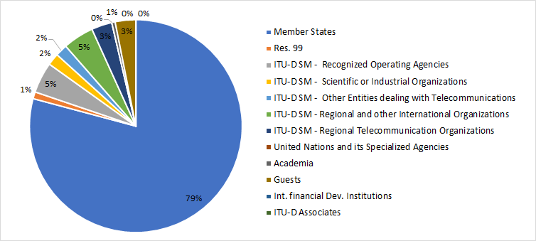

The following chart provides the breakdown of participants by region:

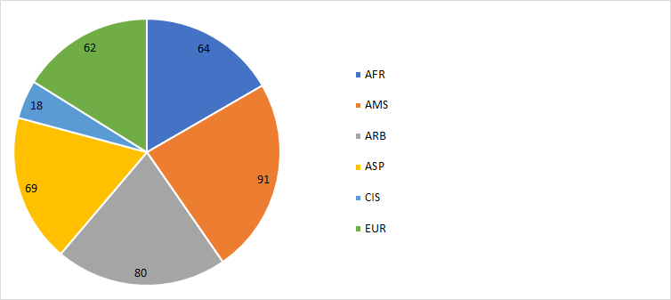

The following chart provides the breakdown of participants by gender:

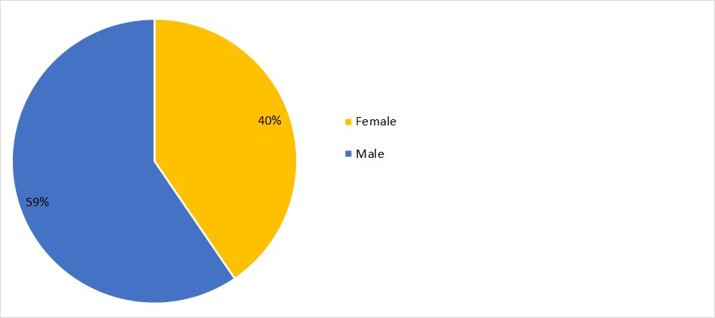

1. *Documents*

The following chart provides the number of documents broken down by category of documents:

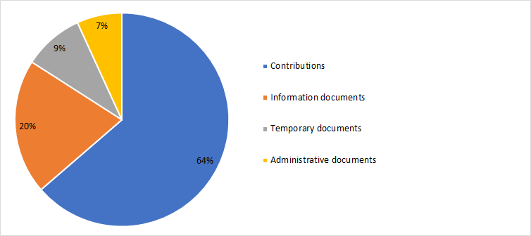

1. *25th TDAG meeting outcomes*

Outcomes according to subject:

| ***Agenda item*** | ***TDAG Conclusions / Outcomes*** |
| --- | --- |
| Appointment of a new TDAG Vice-Chairman to a vacant position | [Document 38](https://www.itu.int/md/D18-TDAG25.2-C-0038/en), *Appointment of a Vice-Chairman of TDAG*:TDAG appointed by acclamation Mr Nicolás Karavaski as a TDAG Vice-Chairman, replacing Mr Hugo Dario Miguel. |
| Outcomes of WRC-19 related to the work of ITU-D | [Document 4(Rev.1)](https://www.itu.int/md/D18-TDAG25.2-C-0004/en), *Outcomes of WRC-19, RA-19 and CPM23-1 related to ITU-D*: TDAG expressed appreciation for the document and noted the close cooperation between BDT and BR, especially for the continued capacity building efforts and support for developing countries on the implementation of WRC-19 and RA-19 decisions and preparation for WRC-23. TDAG noted that the work on spectrum-related issues continued to be of great interest for developing countries with many regions underlining its importance. |
| ITU draft operational plan for 2021-2024 | [Document 6](https://www.itu.int/md/D18-TDAG25.2-C-0006/en), *ITU draft operational plan 2021-2024*: TDAG noted the draft operational plan for 2021-2024 in its new format and endorsed its contents. BDT agreed to submit information on risk evaluation to be included in the 2021 plan.  BDT took good note of the comments and agreed to include further references and more details in the 2021 plan.  [Document 17](https://www.itu.int/md/D18-TDAG25.2-C-0017/en), *Assistance to developing countries* and [document 30](https://www.itu.int/md/D18-TDAG25.2-C-0030/en), *Increasing the value of ITU statistical products through better visibility of the challenges faced by LLDCs and SIDS*: This proposal received support from TDAG participants. TDAG also recognized the need for easily accessible and accurate information from ITU and welcomed innovations by BDT to improve the use and access to that information and preserve its longstanding reputation in the field of telecommunication-related statistics.  [Document 31](https://www.itu.int/md/D18-TDAG25.2-C-0031/), *Improving access to ITU resources related to the digital divide*: TDAG noted the document with interest and appreciation, acknowledging the need to highlight the importance of making information and best practice about bridging the digital divide more accessible, contextual and useful, and underlining the need to foster an enabling environment to bridge the digital divide, bringing together all relevant materials, including material from regional organizations and material on policy and regulation as well as on capacity building.  [Document 32](https://www.itu.int/md/D18-TDAG25.2-C-0032/), *Best practices and accessibility of ICTs*: TDAG thanked Cuba for bringing this longstanding work improving digital literacy to the attention of membership, an effort without which the promise of connectivity cannot be reached.  [Document 39](https://www.itu.int/md/D18-TDAG25.2-C-0039/en), *Wide dissemination of ITU-D publications through regional and area offices*: TDAG underlined the importance of information sharing and welcomed the proposal to disseminate ITU-D publications through ITU regional and area offices, while also noting the importance of distributing material in the ITU languages used in the regions. |
| Report on the implementation of the ITU-D strategic plan and operational plan 2019, including programmes, regional initiatives and major events | [Document 2](https://www.itu.int/md/D18-TDAG25.2-C-0002/en), *Wide dissemination of ITU-D publications through regional and area offices*:TDAG noted with appreciation the wealth of information presented on thematic priorities and regional initiatives, as well as the high-quality products and publications available to members and called for more promotion and translation into the six ITU official languages. TDAG welcomed I-CoDI as an important project that will help ITU membership integrate innovation into their national development agendas and activities. |
| ITU-D contribution to the implementation of the WSIS Plan of Action and the 2030 Agenda for Sustainable Development | [Document 3](https://www.itu.int/md/D18-TDAG25.2-C-0003/en), *ITU-D contribution to the implementation of the WSIS Outcomes and the 2030 Agenda for Sustainable Developmen*: TDAG expressed appreciation for the report and encouraged membership to engage actively in BDT activities that contribute to the implementation of the WSIS Outcomes and the 2030 Agenda for Sustainable Development in line with WTDC-17. |
| ITU-D projects | [Document 10](https://www.itu.int/md/D18-TDAG25.2-C-0010/en), *ITU-D Projects*: TDAG acknowledged the importance of projects undertaken in concert with and for the advancement of ITU-D membership, and noted the document with interest and appreciation. |
| ITU-D Study Group-related matters | [Document 12(Rev.2)](https://www.itu.int/md/D18-TDAG25.2-C-0012/en), *ITU-D Study Group 1 - Activities and progress* and [document 13(Rev.1)](https://www.itu.int/md/D18-TDAG25.2-C-0013/en), *ITU-D Study Group 2 - Activities and progress*: TDAG noted with interest and appreciation the detailed reports on study group activities, and observed that both study groups and all 14 Questions were making good progress towards the WTDC expected outputs under the leadership of the study group chairmen.  [Document 55](https://www.itu.int/md/D18-TDAG25.2-C-0055/en), *Appointment of a new co-rapporteur to ITU-D Study Group 2*:TDAG appointed Ms Aimee K. Meacham (United States) as Co-Rapporteur for ITU-D Study Group 2 Question 3/2.  TDAG agreed on the proposed dates for the ITU-D study group meetings in 2021. |
| **Collaboration with the other Sectors:** Inter-Sector Coordination Group (ISCG) on issues of mutual interes | [Document 5(Rev.1)](https://www.itu.int/md/D18-TDAG25.2-C-0005/en), *Progress Report of the Inter-Sector Coordination Group (ISCG) on issues of mutual interest*: TDAG noted with appreciation the progress report from the Chairman of the Inter-Sector Coordination Group on issues of mutual interest and welcomed the group’s decision to pursue “climate change” as a pilot theme, where all Sectors could be involved and could collaborate; and “accessibility” as the next suggested pilot theme. TDAG noted the liaison statements on inter-Sector coordination. TDAG further noted that the most up-to-date [mapping tables on inter-Sector coordination are](https://www.itu.int/en/general-secretariat/Pages/ISCG/default.aspx) maintained by the ISCG on its website. |
| **Preparations for WTDC:** Proposals on improving WTDC | [Document 8](https://www.itu.int/md/D18-TDAG25.2-C-0008/en), *Preparations for WTDC-21,* [Document 40](https://www.itu.int/md/D18-TDAG25.2-C-0040/en), *ITU-D study group and Question deliverables,* [Document 41](https://www.itu.int/md/D18-TDAG25.2-C-0041/en), *BDT new cluster-based approach,* [Document 42](https://www.itu.int/md/D18-TDAG25.2-C-0042/en), *WTDC-21 workshops,* [Document 37(Rev.2)](https://www.itu.int/md/D18-TDAG25.2-C-0037/en), *Achieving organizational and operational efficiencies at WTDC-21,* [Document 43](https://www.itu.int/md/D18-TDAG25.2-C-0043/en), *Preparation for the World Telecommunication Development Conference 2021,* [Document 44](https://www.itu.int/md/D18-TDAG25.2-C-0044/en), *Revision of ITU-D study group Questions,* [Document 51](https://www.itu.int/md/D18-TDAG25.2-C-0051/en), *Web dialogues on WTDC reform,* [Document 52](https://www.itu.int/md/D18-TDAG25.2-C-0052/en), *WTDC reform and innovation,* [Document 53](https://www.itu.int/md/D18-TDAG25.2-C-0053/en), *ITU-D study group innovation*: TDAG thanked all contributors for their constructive proposals, recognizing that all aim to make WTDC more efficient and impactful. TDAG agreed to set up a working group that would review the ITU-D contribution to the ITU strategic plan, to be led by Ms Blanca Gonzalez (Spain), assisted by Mr Christopher Kemei (Kenya) and Mr Wim Rullens (Netherlands). The terms of reference for this group, found in DT/7, were approved.  TDAG also agreed to create two working groups to prepare for WTDC: a group to work on WTDC preparations and a group to work on administrative outputs such as resolutions and the Declaration. TDAG agreed that an extraordinary session of TDAG would be held to establish high-level terms of reference for both groups. TDAG agreed that the group on WTDC preparations would be led by Santiago Reyes-Borda of Canada. The date for the meeting was subsequently fixed as 16 June 2020. |
| **Preparations for WTDC:** Streamlining resolutions | [Document 22](https://www.itu.int/md/D18-TDAG25.2-C-0022/en), *Incoming liaison statement received on streamlining resolutions,*  [Document 34](https://www.itu.int/md/D18-TDAG25.2-C-0034/en), *Incoming liaison statement received on streamlining resolutions*, [Document 45](https://www.itu.int/md/D18-TDAG25.2-C-0045/en), *Draft revision of Resolution 8 (Rev. Buenos Aires, 2017) “Collection and dissemination of information and statistical data”* and [Document 46](https://www.itu.int/md/D18-TDAG25.2-C-0046/en), *Streamlining PP Resolution 58 and WTDC Resolution 31*: TDAG noted the documents and recognized the importance of early work on resolutions, which would help free up conference time to discuss ICT development issues. |
| Membership, partnership and private sector-related matters | [Document 7(Rev.1)](https://www.itu.int/md/D18-TDAG25.2-C-0007/en), *ITU-D Partnership and resource mobilization*: TDAG noted the document with interest and appreciation, recognizing the importance of partnership and resource mobilization to implement WTDC-17 programmes and regional initiatives. TDAG supported the BDT Director’s plan to hire a consultancy firm and a senior advisor for this purpose, and to provide training and capacity building for BDT staff on resource mobilization).  [Document 11](https://www.itu.int/md/D18-TDAG25.2-C-0011/en), *ITU-D Sector Members, Associates and Academia* and [Document INF/13](https://www.itu.int/md/D18-TDAG25.2-INF-0013/en), *Draft Terms of Reference of the Industry Advisory Group on Development Issues and Private Sector Chief Regulatory Officers Meeting (IAGDI-CRO)*: TDAG noted both reports with appreciation and interest. In particular, TDAG noted the strategies that have been taken to increase membership outreach and engagement, such as cross-selling among ITU Sectors, diversification with new industries, digital marketing to reinforce acquisition, and retention of current members by engaging them in ITU-D activities and events. Additional information was provided by the BDT secretariat and the BDT Director on factors influencing the decrease of sector membership such as industry consolidation, economic situation, the inability of some members to pay the annual membership fees, delays in approval from Member States, and decisions by some Sector Members to switch to Associate and Academia membership categories. |
| Report by the Chairman of the Group on Capacity Building Initiatives (GCBI) | [Document 27](https://www.itu.int/md/D18-TDAG25.2-C-0027/en), *Report on the Group on Capacoty Building Initiatives*: TDAG noted the report with appreciation and congratulated GCBI for the excellent work done. TDAG highlighted the importance of capacity development in the work of BDT as it is a priority for four of the five regions as reflected in their regional initiatives. |
| ITU-D Youth Strategy | [Document 16](https://www.itu.int/md/D18-TDAG25.2-C-0016/en), *Draft Youth Strategy*: TDAG noted the document with appreciation and significant support by its members. TDAG encouraged BDT to work closely with regional offices to ensure coordination and proper implementation. |
| Contribution to the work of the Expert Group on the International Telecommunication Regulations (EG-ITR) | [Document 9(Rev.1)](https://www.itu.int/md/D18-TDAG25.2-C-0009/en), *Expert Group on the International Telecommunication Regulations (EG-ITRS): Progress Report to TDAG*: TDAG noted the report and will follow the progress of the Expert Group on ITRs. |
| Status of the feasibility study to establish an ITU training institute | [Document 26](https://www.itu.int/md/D18-TDAG25.2-C-0026/en), *Status on a feasibility study to establish a capacity-building institute in ITU*: TDAG noted with appreciation the actions taken by the Director to implement the Council instructions regarding a capacity-building institute in ITU. |
| Report on results-based management (RBM) | [Document 28(Rev.1)](https://www.itu.int/md/D18-TDAG25.2-C-0028/en), *2019 Progress Report on the implementation of results-based management in BDT*: TDAG noted the document with interest and appreciation, and expressed support forthe progress made by BDT on the implementation of RBM, and indicated it would look forward to the next update. |
| Activities linked to COVID-19 | [Document 14](https://www.itu.int/md/D18-TDAG25.2-C-0014/en), *COVID-19 related initiatives undertaken by BDT*: TDAG commended BDT for the fast reaction to the crisis and for providing relevant and useful information that supported efficient and safe use of network resources. TDAG also noted the continued efforts of ITU-D study groups to support the ongoing BDT work on COVID-19 issues and welcomed announcements of future projects funded by Member States to help developing countries. Many members offered help and wished to support BDT efforts by using the ITU platform to disseminate their own initiatives. Despite the volume of input to the platform, membership requested the translation of some of the material into other languages of the Union, and underscored the need to collate the initiatives of all ITU Sectors for Council. |
| Calendar of ITU-D events | [Document 15](https://www.itu.int/md/D18-TDAG25.2-C-0015/en), *Calendar of ITU-D events* and [Documaent 33](https://www.itu.int/md/D18-TDAG25.2-C-0033/en), *Rationalisation of high level meetings and capacity enhancement*: TDAG noted the contents of the documents with interest. With regard to the ITU-D calendar of events, TDAG noted the importance of trying to avoid holding two major ITU events in the same calendar year. |
| Any other business | [Document 47](https://www.itu.int/md/D18-TDAG25.2-C-0047/en), *Girls in ICT Day 2020*: TDAG noted the contents of the report with interest and appreciation. TDAG expressed its support for this global initiative and thanked BDT for the assistance provided to all stakeholders in their efforts to celebrate Girls in ICT Day virtually, to inspire girls and young women to take up studies and careers in STEM, and to leverage the power of digital technology, despite the limitations imposed by the current global health crisis (COVID-19). TDAG recognized the importance of establishing broader partnerships and collaboration with governments, civil society, Academia and industry and stressed the importance of active participation and engagement of girls in the Youth Summit at WTDC.  [Document 48](https://www.itu.int/md/D18-TDAG25.2-C-0048/en), *Child online protection (COP) guidelines*: TDAG noted the document with appreciation and welcomed the involvement of Member States in the review process of the 2020 child online protection guidelines.  TDAG encouraged all Member States to take note of the content of the guidelines.  [Document 49](https://www.itu.int/md/D18-TDAG25.2-C-0049/en), *GIGA UNICEF-ITU global initiative*: TDAG noted the document with interest and appreciation, and voiced support for the progress made in GIGA. Rwanda, Kazakhstan, and United States each made interventions in support of GIGA and their involvement as Lead Country for Africa, Lead Country for Central Asia, and as a provider of GIGA technical assistance, respectively. Some Member States have expressed interest in learning more about GIGA and BDT will follow up accordingly. |

## 26th TDAG meeting

TDAG held an extraordinary meeting on 16 June 2020, with one key item on its agenda: to discuss and approve high-level terms of reference for its two working groups established on 5 June 2020 to prepare for WTDC, which at that time had been scheduled to take place in Addis Ababa, Ethiopia, on 8-19 November 2021.

The “TDAG Working Group on WTDC Preparations” and the “TDAG Working Group on WTDC Resolutions, Declaration and Thematic Priorities” formed by TDAG were open to all ITU Member States and ITU-D Sector Members.

The working groups began work in July 2020, and their terms of reference are contained in DT/3(Rev.1).

The full meeting report, in the six official languages of ITU, is available at [this link](https://www.itu.int/md/D18-TDAG26-C-0005/en).

1. *Participants*

The following chart provides the breakdown of participants by category:

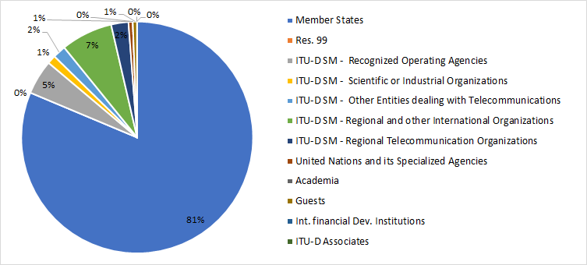

The following chart provides the breakdown of participants by region:

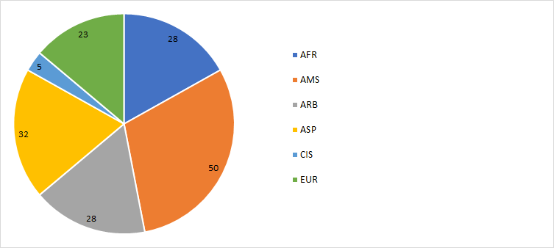

The following chart provides the breakdown of participants by gender:

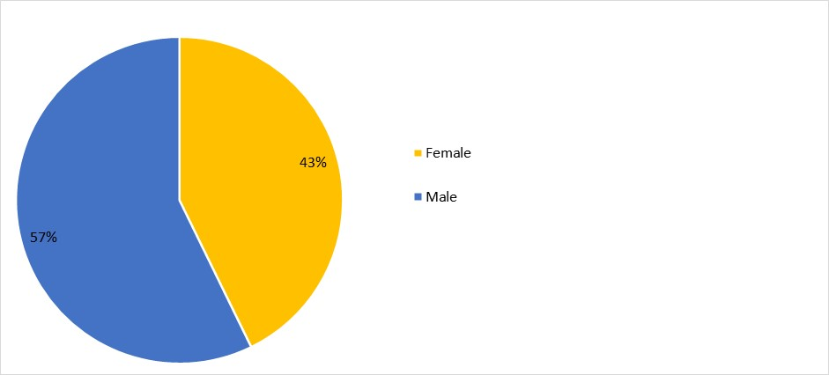

1. *Documents*

The following chart provides the number of documents broken down by category of documents:

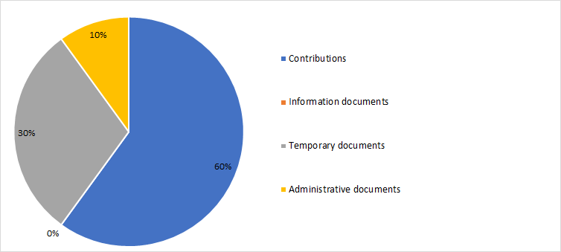

1. *26th TDAG meeting outcomes*

| ***Agenda item*** | ***TDAG conclusions / outcomes*** |
| --- | --- |
| Formation of TDAG working groups | **TDAG Working Group on the Strategic and Operational Plans**  The group is chaired by Ms Blanca González (Spain) assisted by two TDAG vice-chairmen: Mr Christopher Kemei (Kenya) and Mr Wim Rullens (Netherlands).  **TDAG Working Group on WTDC Preparations**  The meeting confirmed the appointment of Mr Santiago Reyes-Borda (Canada) as Chairman.  **TDAG Working Group on WTDC Resolutions, Declaration and Thematic Priorities**  The meeting appointed Dr Ahmad Reza Sharafat (Islamic Republic of Iran) as Chairman. |
| Discussion and approval of the terms of reference of the TDAG working groups | [Document 2](https://www.itu.int/md/D18-TDAG26-C-0002/en), *ITU-D study group innovation,* [Document 3](https://www.itu.int/md/D18-TDAG26-C-0003/en), *Proposal on the terms of reference for the two TDAG working groups to prepare WTDC-21,* [Document 4](https://www.itu.int/md/D18-TDAG26-C-0004/en), *Terms of reference for working groups to prepare WTDC-21,* [Document DT/2](https://www.itu.int/md/D18-TDAG26-200616-TD-0002/en), *Terms of reference for working groups to prepare WTDC-21* and [Document DT/3(Rev.1)](https://www.itu.int/md/D18-TDAG26-200616-TD-0003/en), *Agreed terms of reference for workging groups to prepare WTDC-21*: TDAG adopted terms of reference for the TDAG Working Group on WTDC Preparations, the TDAG Working Group on WTDC Resolutions, Declaration and Thematic Priorities, and the TDAG Working Group on Strategic and Operational Plans contained in DT/3 (Rev.1). |
| Composition of the groups and working methods | The working groups are open to all ITU Member States and ITU-D Sector Members. They may meet electronically, as required, and otherwise communicate electronically. They may meet during TDAG, normally not at the same time as another group. |

## 27th TDAG meeting

The 27th meeting of the Telecommunication Development Advisory Group (TDAG) took place on 23 November 2020, under the chairmanship of Ms Roxanne McElvane Webber.

The purpose of the meeting was to consider reports prepared by the three TDAG Working Groups created in June 2020 to evolve the impact of, and preparation for, the upcoming ITU World Telecommunication Development Conference (WTDC). The Working Group on WTDC Preparations (TDAG-WG-Prep); the Working Group on the Strategic and Operational Plans (TDAG-WG-SOP); and the Working Group on WTDC Resolutions, Declaration and Thematic Priorities (TDAG-WG-RDTP) each presented reports.

TDAG, inter alia, unanimously endorsed “Connecting the unconnected to achieve Sustainable Development” as the overall theme for the World Telecommunication Development Conference (WTDC).

1. *Participants*

The following chart provides the breakdown of participants by category:

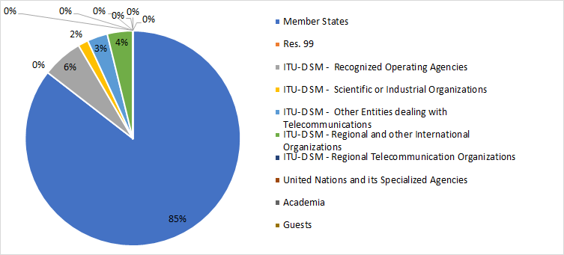

The following chart provides the breakdown of participants by region:

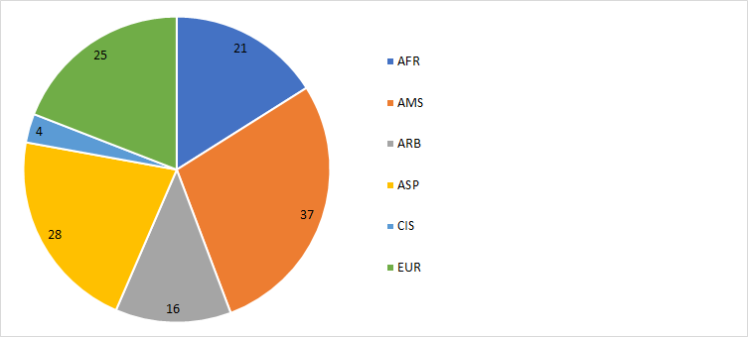

The following chart provides the breakdown of participants by gender:

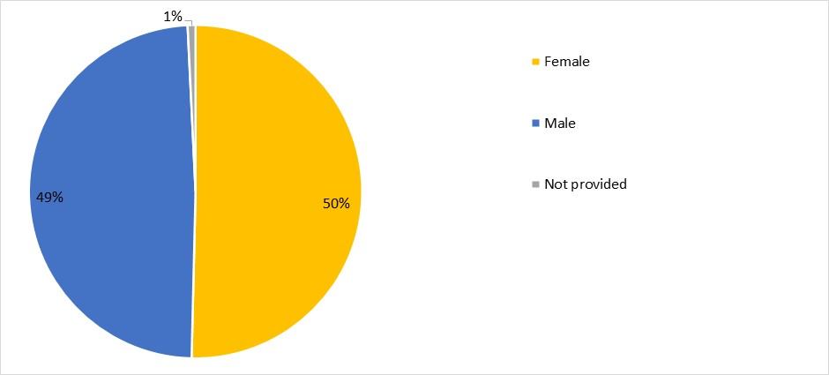

1. *Documents*

The following chart provides the number of documents broken down by category of documents:

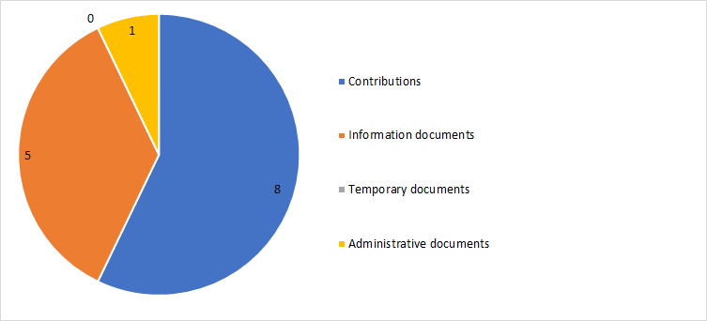

1. *27th TDAG meeting outcomes*

Outcomes according to subject:

| ***Agenda item*** | ***TDAG Conclusions / Outcomes*** |
| --- | --- |
| Reports from the TDAG working groups | [Document 5](https://www.itu.int/md/D18-TDAG27-C-0005/en), *Final Report of the TDAG Working Group on WTDC Preparations*: TDAG endorsed the report and recommendations from the Working Group on WTDC preparations.  TDAG reviewed and endorsed the matters in the Working Group report on which consensus had been reached, and discussed and reached consensus on specific questions as noted below:   * Theme for WTDC: Connecting the unconnected to achieve Sustainable Development * Development Track * Inter-Regional Preparatory Meetings (IRMs)   [Document 3](https://www.itu.int/md/D18-TDAG27-C-0003/en), *Report of the TDAG Working Group on Strategic and Operational Plans (TDAG-WG-SOP) to TDAG*: TDAG noted with appreciation the progress report from the TDAG-WG-SOP.  [Document 4](https://www.itu.int/md/D18-TDAG27-C-0004/en), *Report of the Meeting of the TDAG Working Group on Resolutions, Delcaration and Thematic Priorities (21 October 2020)*: TDAG noted with appreciation the progress report from the TDAG-WG-RDTP. |

## 28th TDAG meeting

The 28th meeting of the Telecommunication Development Advisory Group (TDAG) was conducted virtually from 24 to 28 May 2021, under the chairmanship of Ms Roxanne McElvane Webber.

Due to the continued prevalence of the COVID-19 pandemic, the meeting was held virtually for the second year in a row and was limited to three hours per day (2 hours on 24 May 2021) to help minimize the requirements for delegates from all time zones to both participate in TDAG and remain abreast, available and engaged in their duties within their individual Administrations/entities during the meeting days. TDAG-21 took stock of the regional preparations for WTDC, considered the outcomes of the TDAG working groups and discussed relevant issues highlighted during the Inter-Regional Meeting that had taken place before TDAG-21.

1. *Participants*

The following chart provides the breakdown of participants by category:

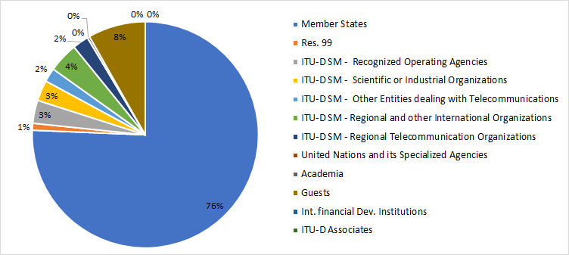

The following chart provides the breakdown of participants by region:

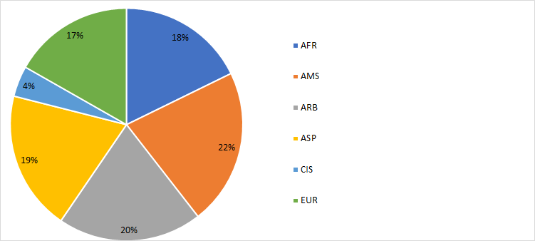

The following chart provides the breakdown of participants by gender:

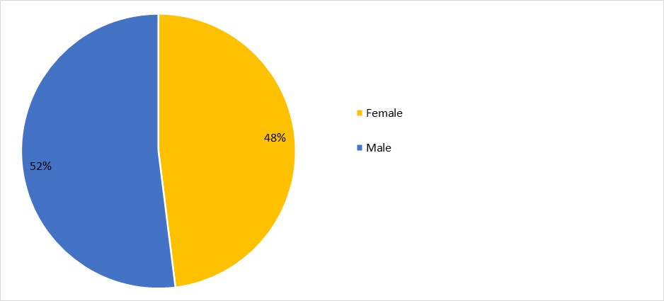

1. *Documents*

The following chart provides the number of documents broken down by category of documents:

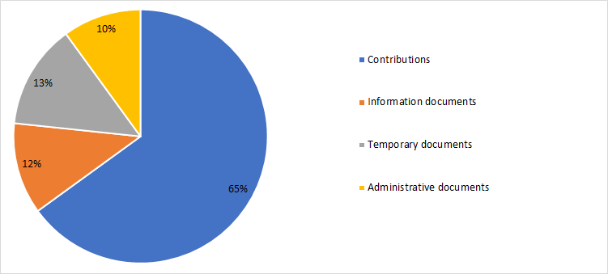

1. *28th TDAG meeting outcomes*

Outcomes according to subject:

| ***Agenda item*** | ***TDAG Conclusions / Outcomes*** |
| --- | --- |
| ITU-D four-year rolling operational plan 2022-2025 | [Document 4](https://www.itu.int/md/D18-TDAG28-C-0004/en), *ITU-D four-year rolling operational plan 2022-2025*: TDAG reviewed and endorsed the ITU-D four-year rolling operational plan for 2022-2025. |
| Reporting on the implementation of the WTDC-17 Buenos Aires Action Plan (including the regional initiatives), and  contribution to the implementation of the WSIS Plan of Action and the Sustainable Development Goals (SDGs) | [Document 2](https://www.itu.int/md/D18-TDAG28-C-0002/en), *Reporting on the implementation of the WTDC-17 Buenos Aires Action Plan (including regional initiatives), and contribution to the implementation of the WSIS Plan of Action and the Sustainable Development Goals (SDGs)*: TDAG noted and underlined the importance of the report in Document 2, which is structured around the current 10 thematic priorities, and noted the ongoing discussions reflected principally in the TDAG-WG-RDTP to reduce that number for the next four-year period. |
| **Reporting on the implementation of the WTDC-17 Buenos Aires Action Plan (including the regional initiatives), and contribution to the implementation of the WSIS Plan of Action and the Sustainable Development Goals (SDGs):**  Reporting on the Youth Strategy implementation | [Document 23](https://www.itu.int/md/D18-TDAG28-C-0023/en), *Update on the implementation of the ITU Youth Strategy*: TDAG noted the report and the related presentations by the youth representatives with enthusiasm and appreciation, welcomed the youth initiatives as refreshing, and underscored the importance of investing in youth, in including them in TDAG activities and taking their perspectives into account in the work of ITU. |
| ITU-D projects | [Document 11(Rev.1)](https://www.itu.int/md/D18-TDAG28-C-0011/en), *ITU-D projects*: TDAG noted the report with interest and appreciation and expressed support for the ongoing work and its impact on the ground, including steps taken to strengthen ITU project management practices. |
| **Preparations for WTDC:** General preparations for the World Telecommunication Development Conference | [Document 16(Rev.2)](https://www.itu.int/md/D18-TDAG28-C-0016/en), *Preparations for the World Telecommunication Development Conference 2021*: TDAG noted with appreciation the document providing an outline of the WTDC preparations. |
| **Preparations for WTDC:** Update on the preparations for the Youth Summit | [Document 18](https://www.itu.int/md/D18-TDAG28-C-0018/en), *Preparations for the WTDC-21 Generation Connect Global Youth Summit*: TDAG noted this document with appreciation and agreed that the Youth Summit would also have to be postponed to a suitable date prior to 6 June 2022, in collaboration with the host country. |
| **Preparations for WTDC:** Preparations for the WTDC Partner2Connect for Digital Development Segment | [Document 19](https://www.itu.int/md/D18-TDAG28-C-0019/en), *Update on the preparations for the Partner2Connect*: TDAG noted the document and confirmed that following its decision taken in November 2020, the Partner2Connect for Digital Development Segment will take place as an integral part of the main WTDC programme from Day 2 to Day 4 of the conference. |
| **Preparations for WTDC:** WTDC preparations and contingency plans for the work of ITU-D in the case of postponement of WTDC | [Document 30](https://www.itu.int/md/D18-TDAG28-C-0030/en), *Proposals for the continuation of the ITU-D study groups work in case of possible postponement of the WTDC-21*: TDAG noted with appreciation the proposed action plan put forward in this document, acknowledging its relationship to the broad continuity plans also proposed by BDT in Document 10(Rev.1).  [Document 33](https://www.itu.int/md/D18-TDAG28-C-0033/en), *Views on ITU-D study group activities given likely WTDC-21 postponement*: TDAG noted with appreciation the proposals put forward in this document, observing its relationship to the broad continuity plans proposed by BDT in Document 10(Rev.1) section 2, on ITU-D study group work. In particular, TDAG agreed that ITU-D should leverage and promote the study group output reports between now and WTDC, and would not re-open discussion or subject the reports to further revisions.  [Document 37](https://www.itu.int/md/D18-TDAG28-C-0037/), *Proposal for continuation of the work of study groups in view of the proposed postponement of WTDC before WTDC*:TDAG noted with appreciation the proposal put forward in this document, observing its relationship to the broad continuity plans proposed by BDT in Document 10(Rev.1) section 2.  [Document 10](https://www.itu.int/md/D18-TDAG28-C-0010/en)(Rev.1), *Continuity plans for the work of ITU-D in case of postponement of WTDC-21 to June 2022*: TDAG noted with appreciation the comprehensive document prepared by BDT proposing a course of action to ensure business continuity in ITU-D, given the impending postponement of WTDC-21.  Taking into account all contributions on the issue of continuity plans, TDAG agreed that study groups should continue their work, that the TDAG-WG-SOP and TDAG-WG-RDTP should continue their work and report to an extraordinary meeting of TDAG in November 2021, and that the schedule for interregional meetings should be adjusted.  [Document 31](https://www.itu.int/md/D18-TDAG28-C-0031/en), *Proposals on the revision of terms of reference of Question 4/1 “Economic policies and methods of determining the costs of services related to national telecommunication/ICT networks, including next-generation networks”* and [document 32](https://www.itu.int/md/D18-TDAG28-C-0031/en), *Proposals on the revision of terms of reference of Question 4/1 “Economic policies and methods of determining the costs of services related to national telecommunication/ICT networks, including next-generation networks”*: TDAG noted the proposals and commended the chairmen of SG1 and SG2, members of the Questions 4/1 and 7/1 management teams, and all contributors for their efforts and hard work in producing updated terms of reference.  TDAG agreed that new and revised terms of reference for study Questions would continue to be discussed at the study group meetings to be held in October 2021 with the aim of reaching consensus. The results of these meetings would then be submitted to the November 2021 TDAG meeting for decision in accordance with the relevant provisions of Resolution 1 (Rev. Buenos Aires, 2017) of WTDC. |
| **Preparations for WTDC:** Structure of WTDC | [Document 17](https://www.itu.int/md/D18-TDAG28-C-0017/en), *Draft structure of the World Telecommunication Development Conference 2021*: TDAG noted the document with appreciation, and in particular the addition of the Partner2Connect for Digital Development Segment as a new integral part of the WTDC programme. |
| **Report on preparatory process for WTDC-21:** Report on the work of the TDAG-WG-RDTP | [Document 21](https://www.itu.int/md/D18-TDAG28-C-0021/en), *Chairman's report on the work of the TDAG Working Group on WTDC Resolutions, Declaration and Thematic Priorities*: TDAG noted with appreciation the report of the Chairman of the TDAG-WG-RDTP and commended him for the tremendous work done by the group to facilitate the work of the conference. TDAG agreed to extend the timeline for TDAG-WG-RDTP to continue and complete its work under the existing terms of reference and leadership according to the schedule approved by this meeting in Document TDAG-21/DT/6(Rev.2).  TDAG noted the proposal by TDAG-WG-RDTP to reduce the number of thematic priorities and the proposal to have a fifth thematic priority on cybersecurity.  [Document 24](https://www.itu.int/md/D18-TDAG28-C-0024/en), *Draft Addis Ababa Declaration,* [Document 26](https://www.itu.int/md/D18-TDAG28-C-0026/en), *African common proposal on Addis Ababa Declaration,* [Document 27](https://www.itu.int/md/D18-TDAG28-C-0027/en), *African common proposal on ITU-D thematic priorities,* [Document 29](https://www.itu.int/md/D18-TDAG28-C-0029/en), *African common proposal on modifications to Resolution 1,* [Document 36](https://www.itu.int/md/D18-TDAG28-C-0036/en), *Proposal on WTDC-21 Draft Declaration* and [Document DT/3(Rev.1)](https://www.itu.int/md/D18-TDAG28-210524-TD-0003/en): *Inter-American Contribution (IAC) on Thematic Priorities:* TDAG agreed that all documents that had been submitted to the meeting for consideration under agenda item 10.1 (report of the work of the TDAG-WG-RDTP) would be presented, discussed, and fully considered by the TDAG-WG-RDTP at its next meeting. TDAG examined and approved proposed dates for the meetings as contained in Document TDAG-21/DT/6(Rev.2). |
| **Report on preparatory process for WTDC-21:** Matters related to the ITU-D component of the ITU strategic plan and report on the work of the TDAG-WG-SOP | [Document 28](https://www.itu.int/md/D18-TDAG28-C-0028/en), *African common proposal on the proposed revision of provision 1.8.2 of WTDC Resolution 1* and [Document 34](https://www.itu.int/md/D18-TDAG28-C-0034/en), *Discussion on the future of TDAG Working Group on Strategic and Operational Plans*: TDAG respectfully noted the position of the African Telecommunications Union (ATU) and the Africa region presented in Documents 28 and 34 on the ITU-D contribution to the ITU strategic plan and agreed to their request, made during this meeting, to place on record the following statement: “African Member States share the view that WTDC is the right venue to deliberate on, and approve, the draft ITU-D contribution to the strategic plan of the Union, for the various reasons expressed during this TDAG-21 meeting. In view of the current exceptional circumstances, African Member States recommend that the current process of TDAG-WG-SOP will continue to proceed forward. At the same time, provision 1.8.2 of Resolution 1 and Resolution 24 of WTDC will be kept unchanged. The processes as set in these resolutions will be honoured to ensure that in normal circumstances, WTDC still has the opportunity to receive proposals and entertain discussions on the strategic plan. The ITU-D advisory group (i.e. TDAG) will be able to discuss and send its final input to the Council Working Group on the strategic and financial plans which will be created at the next Council session for further development. Moreover, African Member States want to make sure that all their members’ views and positions are recorded in the minutes of this meeting. Any other options related to the discussed issue, can be envisioned and further elaborated in other appropriate ITU venues, such as the ITU Council. This statement is only confined to this current circumstance that we are witnessing and should not be taken in any way as a precedent.”  TDAG agreed that TDAG-WG-SOP would continue to meet, including by correspondence, would collect and reflect the aspirations and views of the ITU-D Sector membership on the strategic plan, and report to TDAG in November 2021.  [Document 22](https://www.itu.int/md/D18-TDAG28-C-0022/en)(Rev.1), *Report of the work of the TDAG-WG-SOP*: The Chairman of TDAG-WG-SOP, Ms Blanca Gonzalez (Spain), presented recommendations from the report of her group. TDAG agreed that the TDAG-WG-SOP would review the draft of the ITU strategic plan at its meeting in October 2021 which would follow the Council Working Group first public consultation in September 2021.  TDAG also agreed to entrust TDAG-WG-SOP with preparing the draft Addis Ababa Action Plan, and requested the BDT secretariat to provide a skeleton draft for consideration by the group, and subsequent expansion at WTDC. |
| **Report on preparatory process for WTDC-21:** Report of the Regional Preparatory Meetings Coordination Meeting (RPM-CM) | [Document 5(Rev.1)](https://www.itu.int/md/D18-TDAG28-C-0005/en), *Report of the Chairman of the RPM Coordination Meeting to TDAG*: TDAG noted the report and the presentation by His Excellency Ocko, Chairman of RPM-EUR, on the RPM-EUR with interest and appreciation. |
| Report of Inter-Regional Meeting (IRM-1) | [Document 3(Rev.1)](https://www.itu.int/md/D18-TDAG28-C-0003/en), *Report of the first Inter-Regional Meeting (IRM) to prepare for WTDC-21*: TDAG noted the report with interest and appreciation. |
| **Report on study group activitie:** ITU-D Study Group 1 activities for the seventh study period | [Document 8(Rev.1)](https://www.itu.int/md/D18-TDAG28-C-0008/en), *ITU-D Study Group 1 activities for the seventh study period between WTDC-17 and WTDC-21*: TDAG noted with appreciation the report of the Chairman of Study Group 1 and congratulated her for the excellent work and for the achievements of the study group during the study period. |
| **Report on study group activitie:** ITU-D Study Group 2 activities for the seventh study period | [Document 9(Rev.1)](https://www.itu.int/md/D18-TDAG28-C-0009/en), *ITU-D Study Group 2 activities for the seventh study period*: TDAG noted with appreciation the report of the Chairman of Study Group 2 and congratulated him for the excellent work and for the achievements of the study group during the study period. |
| Collaboration with the other Sectors | [Document 13](https://www.itu.int/md/D18-TDAG28-C-0013/en), *Progress report of the Inter-Sector Coordination Group (ISCG) on issues of mutual interest*: TDAG noted with appreciation the report of the Chairman of the Inter-Sector Coordination Group (ISCG) on issues of mutual interest and congratulated him for his excellent work as chairman of the group. |
| **Membership, partnership, private sector-related matters:** ITU-D partnership and resource mobilization | [Document 7](https://www.itu.int/md/D18-TDAG28-C-0007/en), *ITU-D partnership and resource mobilization*: TDAG noted the document with appreciation and underlined the importance of partnership and resource mobilization to implement WTDC outcomes. TDAG reiterated its support for the Director’s reform process aimed at achieving a “Fit4Purpose” BDT that is able to identify and leverage new opportunities, build new partnerships, and more effectively engage with its traditional and long-standing partners. |
| **Membership, partnership, private sector-related matters:** ITU-D Sector Members, Associates and Academia | [Document 12](https://www.itu.int/md/D18-TDAG28-C-0012/en): *ITU-D Sector Members, Associates and Academia*: TDAG noted the report and commended the secretariat for the fine efforts made and the initiatives being implemented to build more value for its membership. TDAG also highlighted the importance of linking study group work to membership participation. |
| Report by the Chairman of the Group on Capacity Building Initiatives (GCBI) | [Document 14](https://www.itu.int/md/D18-TDAG28-C-0014/en), *Report on the work of the Group on Capacity Building Initiatives (GCBI) to TDAG*: TDAG noted the report, expressed appreciation to GCBI and highlighted the importance of digital capacity and skills development in the work of BDT. TDAG recognized the impact of the COVID-19 pandemic on training and learning, including the growing shift towards online learning, and the need to address the digital skills requirements of youth and marginalized groups, through programmes such as the Digital Transformation Centre Initiative. |
| Contribution to the work of the Expert Group on the International Telecommunication Regulations (EG-ITR) | [Document 6](https://www.itu.int/md/D18-TDAG28-C-0006/en), *Expert Group on the International Telecommunication Regulations (EG-ITRS): Progress report to TDAG*: TDAG noted the progress report from the Expert Group on the International Telecommunication Regulations (EG-ITR) and requested that its appreciation be conveyed to the group, with the Chairman of TDAG informing participants that any inputs to the work of EG-ITR could be channelled through the BDT secretariat. |
| Update on ITU regional presence review | [Document 20](https://www.itu.int/md/D18-TDAG28-C-0020/en), *Review of ITU Regional Presence*: TDAG welcomed the report with appreciation. |
| Updates to measures and principles for interpretation and translation in ITU | [Document INF/4](https://www.itu.int/md/D18-TDAG28-INF-0004/en), *Updates to measures and principles for interpretation and translation in ITU:* TDAG noted the information document on measures and principles for interpretation and translation in ITU, underscored the importance of this topic, and stressed the need to harmonize these measures across the Union. |
| Harmonization of ITU websites | [Document 25](https://www.itu.int/md/D18-TDAG28-C-0025/en), *OneITU website*: TDAG welcomed the presentation on the One ITU website project and the related next steps. TDAG called for all issues being faced by delegates on the current website to be taken on board by the project team and to be resolved. |
| Calendar of ITU-D events | [Document 15](https://www.itu.int/md/D18-TDAG28-C-0015/en), *Calendar of ITU-D events* and [Document DT/6(Rev.2)](https://www.itu.int/md/D18-TDAG28-210524-TD-0006/en), *Proposed calendar of meetings for WTDC-21 preparatory process*: TDAG noted the calendar for 2021 and 2022 and approved the proposed calendar for the remainder of the preparatory process. |
| Any other business | The BDT secretariat presented a live demonstration of its two new information dashboards developed to support results-based management in BDT: (1) The BDT Reporting Dashboard, which monitors how operational planning resources are being used, facilitates collaboration between teams, and helps identify opportunities to repurpose resources throughout the year; and (2) the BDT Project Assessment Dashboard, which identifies the implementation status of projects using criteria such as the percentage of activities completed, key performance indicators (KPIs) and disbursement of funds. The tool allows for projects with a risk of delay to be a quickly identified and remedied.  The presentation was followed by interventions from several Member States, who expressed appreciation for the new tools and encouraged the secretariat to make them available to the rest of ITU, as well as to ITU delegates, for better transparency on the use of ITU resources. |

## 29th TDAG meeting

The 29th meeting of the Telecommunication Development Advisory Group (TDAG) was conducted from 8 to 12 November 2021, under the chairmanship of Ms Roxanne McElvane Webber.

In view of the continued prevalence of the COVID-19 pandemic, the meeting was once again held virtually and was limited to three hours per day to help minimize the disturbance to participants from all time zones enabling delegates to both participate in TDAG and remain abreast, available, and engaged in their duties within their individual Administrations/entities during the meeting days.During the opening, the Secretary-General of ITU informed the meeting that, in light of the introduction of a six-month State of Emergency by the Government of Ethiopia, the United Nations had issued a decision severely restricting travel for UN staff to Ethiopia and on holding UN activities in the country until further notice. He reported that ITU security services were closely monitoring the United Nations Department of Safety and Security deliberations on this issue. Mr Zhao recognized the excellent collaboration with the host country to arrange for the conference and the efforts to mitigate the current situation. He indicated that the secretariat was ready to begin developing possible alternate arrangements while continuing to engage with Ethiopia, in order to ensure viable options for WTDC. He further stated that the secretariat would aim to communicate a clear and confirmed position to membership no later than 6 December 2021.

TDAG-21/2 reviewed, discussed, and noted the continuing preparations for WTDC and considered the outcomes of the TDAG working groups.

The full meeting report, in the six official languages of ITU, is available at [this link](https://www.itu.int/md/meetingdoc.asp?lang=en&parent=D18-TDAG29-C-0034).

1. *Participants*

The following chart provides the breakdown of participants by category:

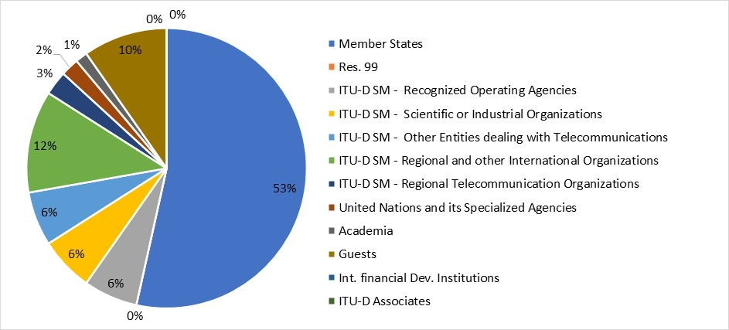

The following chart provides the breakdown of participants by region:

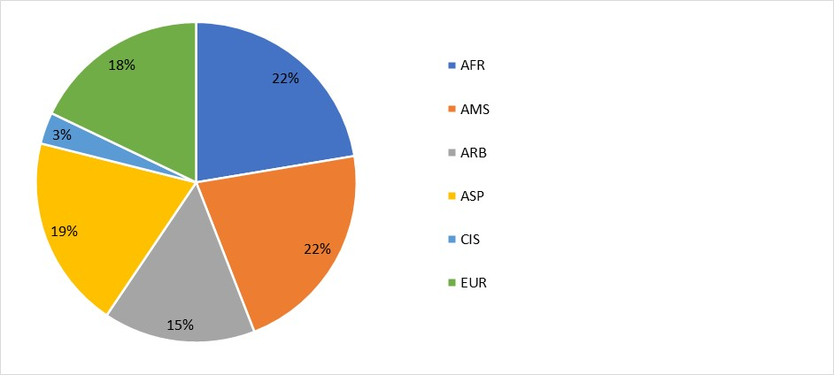

The following chart provides the breakdown of participants by gender:

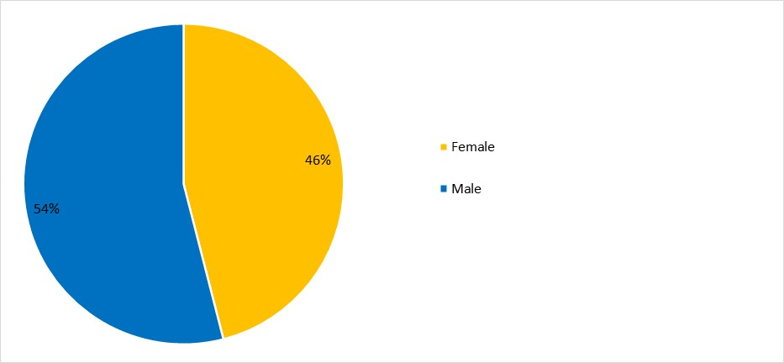

1. *Documents*

The following chart provides the number of documents broken down by category of documents:

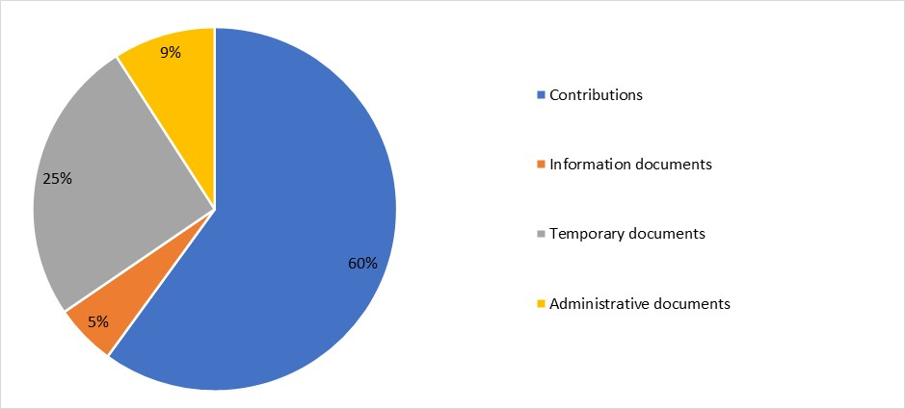

1. *29th TDAG meeting outcomes*

The following table provides the summary of the outcomes of the 29th TDAG meeting by subject:

| ***Agenda item*** | ***TDAG Conclusions / Outcomes*** |
| --- | --- |
| Reporting on the implementation of the WTDC-17 Buenos Aires Action Plan (including the regional initiatives), and contribution to the implementation of the WSIS Plan of Action and the Sustainable Development Goals (SDGs) | [Document 2](https://www.itu.int/md/meetingdoc.asp?lang=en&parent=D18-TDAG29-C-0002), *Reporting on the implementation of the WTDC-17 Buenos Aires Action Plan (including regional initiatives), and contribution to the implementation of the WSIS Plan of Action and the Sustainable Development Goals (SDGs)*: TDAG noted the document and thanked BDT for all the efforts to implement the Buenos Aires Action Plan. Further updates on the ongoing work and outcomes will be made available in the lead up to WTDC.  [Document 19](https://www.itu.int/md/meetingdoc.asp?lang=en&parent=D18-TDAG29-C-0019), *Second update on the implementation of the ITU Youth Strategy*: TDAG noted the report with interest and appreciation. BDT will continue the implementation of the ITU Youth Strategy and will provide further updates in due course. |
| **Preparations for WTDC:** Update on the preparations for WTDC, including COVID-19 mitigation and contingency measures | Due to the evolving situation in the host country, Documents 12 and DT/8 were tabled. As the Secretary-General noted in his opening remarks, the ITU secretariat would provide further information by 6 December 2021. |
| **Preparations for WTDC:** Draft agenda for WTDC | [Document 13(Rev.1)](https://www.itu.int/md/meetingdoc.asp?lang=en&parent=D18-TDAG29-C-0013), *Draft Agenda of the World Telecommunication Development Conference (WTDC)*: TDAG endorsed the proposed agenda. It will be submitted to the ITU Council for approval by correspondence, and then to all ITU Member States, also by correspondence. |
| **Preparations for WTDC:** Youth Summit | [Document 14](https://www.itu.int/md/meetingdoc.asp?lang=en&parent=D18-TDAG29-C-0014), *Preparations for the Generation Connect Global Youth Summit*: TDAG noted the report and commended BDT on the initiative and for promoting participation by youth and women in ITU events, and in WTDC, in particular. Updates on the organization of the Youth Summit will be provided in due course. |
| **Preparations for WTDC:** Partner2Connect | [Document 15](https://www.itu.int/md/meetingdoc.asp?lang=en&parent=D18-TDAG29-C-0015), *Preparations for the WTDCPartner2Connect Digital Development Roundtable*: TDAG noted the document with appreciation. More information on the Partner2Connect initiative will be provided as the initiative gains momentum. |
| **Preparatory process for WTDC:** Report on the work of the TDAG-WG-RDTP | [Document 17(Rev.1)](https://www.itu.int/md/meetingdoc.asp?lang=en&parent=D18-TDAG29-C-0017), *Chairman's Report on the work of the TDAG Working Group on Resolutions, Declaration and Thematic Priorities*: TDAG noted the report with appreciation and commended Dr Sharafat, Chairman of TDAG-WG-RDTP, for his exceptional commitment and for the significant amount of work achieved for ITU-D and its membership.  **Declaration:**  [Document 32](https://www.itu.int/md/meetingdoc.asp?lang=en&parent=D18-TDAG29-C-0032), *Draft Addis Ababa Declaration*: TDAG noted the output and thanked the Chairman of TDAG-WG-RDTP and all participants in the group for their substantial and fruitful efforts which had continued over 18 months and had produced a very good draft Declaration for ITU membership.  [Document 22](https://www.itu.int/md/meetingdoc.asp?lang=en&parent=D18-TDAG29-C-0022), *APT View on Draft Addis Ababa Declaration*: TDAG noted Document 22 and thanked the Asia-Pacific Telecommunity (APT) for sharing their views in the contribution, which supported the draft Declaration expressed in Document 32 with no changes.  [Document 28](https://www.itu.int/md/meetingdoc.asp?lang=en&parent=D18-TDAG29-C-0028), *Multi country contribution to TDAG on Draft Addis Ababa Declaration*: TDAG discussed revisions to the draft Declaration proposed by several CEPT countries in Document 28 along with additional text proposed by Algeria, Saudi Arabia and the United States from the floor. TDAG agreed to include the revisions proffered by CEPT countries (except those in item d), the United States, and Algeria. The revised proposal for the draft TDAG output on the WTDC Declaration is contained in Document DT/11.  TDAG agreed that [Document DT/11](https://www.itu.int/md/meetingdoc.asp?lang=en&parent=D18-TDAG29-211108-TD-0011) may serve as the basis for further proposals and refinement by ITU membership in preparation for the WTDC, where it will be finalized.  **WTDC Resolution 1:**  [Document 25](https://www.itu.int/md/meetingdoc.asp?lang=en&parent=D18-TDAG29-C-0025), *Proposals towards the revision of WTDC Resolution 1 (Rev. Buenos Aires, 2017) Rules of procedure of the ITU Telecommunication Development Sector*: TDAG thanked the Russian Federation for their efforts and noted the document, which may be considered by Member States in preparing their proposals to revise Resolution 1 in the lead up to WTDC.  **Streamlining resolutions:**  [Document 27](https://www.itu.int/md/meetingdoc.asp?lang=en&parent=D18-TDAG29-C-0027), *Streamlining WTDC and PP resolutions*: TDAG noted the document and observed that it provides useful food for thought as Member States proceed further with their individual country proposals and within regional preparations for the upcoming WTDC and beyond. TDAG thanked the Russian Federation for sharing its views in the contribution.  **Thematic priorities:**  [Document 31](https://www.itu.int/md/meetingdoc.asp?lang=en&parent=D18-TDAG29-C-0031), *Revised proposal for ITU-D thematic priorities (WTDC) - four thematic priorities*: TDAG noted Document 21 and thanked the Chairman of TDAG-WG-RDTP and all participants in the group for their substantial efforts and contributions to the outcomes of the group.  [Document 21](https://www.itu.int/md/meetingdoc.asp?lang=en&parent=D18-TDAG29-C-0021), *Revised proposal for ITU-D thematic priorities (WTDC) - four thematic priorities*: TDAG noted the views presented and thanked APT for sharing their views in the contribution.  [Document 26](https://www.itu.int/md/meetingdoc.asp?lang=en&parent=D18-TDAG29-C-0026), *Consideration of thematic priorities at the draft Addis-Ababa Action Plan*: TDAG noted the views presented and thanked the Russian Federation for sharing their views in the contribution.  [Document 29](https://www.itu.int/md/meetingdoc.asp?lang=en&parent=D18-TDAG29-C-0029), *Multi-country contribution to TDAG on ITU-D/WTDC thematic priorities:* TDAG noted the views presented and thanked the 11 CEPT countries for sharing their views in the contribution.  [Document DT/3](https://www.itu.int/md/meetingdoc.asp?lang=en&parent=D18-TDAG29-211108-TD-0003), *Addis Ababa Action Plan - draft structure*: TDAG noted the views presented and thanked CITEL for sharing their views in the contribution.  [Document DT/12(+Rev.2)](https://www.itu.int/md/meetingdoc.asp?lang=en&parent=D18-TDAG29-211108-TD-0012), *Compilation of proposals and views for revision of ITU-D thematic priorities (WTDC)*: TDAG agreed that the document as modified during the TDAG-21/2 Closing Plenary could serve as the basis for further proposals by membership and the work of regional telecommunication organizations in preparation for WTDC. |
| **Preparatory process for WTDC:** Report on the work of the TDAG-WG-SOP | [Document 18](https://www.itu.int/md/meetingdoc.asp?lang=en&parent=D18-TDAG29-C-0018)(Rev.1), *Compilation of proposals and views for revision of ITU-D thematic priorities (WTDC)*: Acknowledging that TDAG-WG-SOP was tasked with coordinating the TDAG input to the ITU strategic plan and with preparing a draft of the WTDC Action Plan, TDAG noted the report, expressing appreciation for the work conducted and outcomes achieved by the TDAG-WG-SOP Chairman, the Vice Chairmen, and all participants in the group.  TDAG agreed that the Outcomes and Outputs listed in the document, as revised during the TDAG-21/2 and contained in [Document DT/13](https://www.itu.int/md/meetingdoc.asp?lang=en&parent=D18-TDAG29-211108-TD-0013), may serve as the basis for further proposals for revision and refinement by ITU Member States and their delegations in preparation for WTDC. The areas highlighted in red signify areas that lack consensus and will remain in square brackets to identify them as such for all negotiations and discussions in the lead up to WTDC.  The revised Outcomes and Outputs will be available to the Council Working Group on Strategic and Financial Plans (CWG-SFP) which has committed to reflect the substance appropriately in the new ITU Strategic Plan. Following the first draft of the new ITU strategic plan which will be available in December 2021 for the January 2022 meetings of CWG-SFP, BDT indicated that it could provide an updated draft WTDC Action Plan with necessary adjustments to align with the new framework of the draft Strategic Plan.  [Document DT/6](https://www.itu.int/md/meetingdoc.asp?lang=en&parent=D18-TDAG29-211108-TD-0006), *Draft Addis Ababa Action Plan*: TDAG noted the document and supported the proposed simplified structure for the draft WTDC Action Plan, and the increased use of infographics.  [Document 23](https://www.itu.int/md/meetingdoc.asp?lang=en&parent=D18-TDAG29-C-0023), *APT View on Asia-Pacific Vision for the ITU Development Sector*: TDAG noted the views presented with appreciation and thanked APT for their contribution. |
| Report to WTDC on TDAG activities (as per Resolution 24 (Rev. Dubai, 2014)) | [Document 16](https://www.itu.int/md/meetingdoc.asp?lang=en&parent=D18-TDAG29-C-0016), ***Report on TDAG Activities***: TDAG noted the report which covered the six meetings that had been held to date (Seven were held in total). The TDAG Chairman recognized the outstanding support and commitment of the BDT Director, the TDAG Vice-Chairmen, the BDT Secretariat, and all participants.  TDAG agreed that the draft report will be updated as requested by the meeting participants to reflect the discussions and decisions of TDAG-21/2, the seventh and final meeting in the series. As per usual, Membership would have the opportunity to comment on that report by correspondence within two weeks after posting. At the end of this period, the report would be considered as endorsed, and its contents would be included in the report to WTDC. |
| Study Group activities | [Document 5(Rev.3)](https://www.itu.int/md/meetingdoc.asp?lang=en&parent=D18-TDAG29-C-0005), *ITU-D* ***Study Group 1 Activities for the Seventh Period****:* TDAG noted the report with appreciation and recognized the important and comprehensive work accomplished by ITU-D membership, supported by BDT staff and focal points and led by the ITU-D Study Group 1 Chairman Ms Regina Fleur Assoumou Bessou with professionalism, fairness and tenacity.  [Document 6(Rev.1)](https://www.itu.int/md/meetingdoc.asp?lang=en&parent=D18-TDAG29-C-0006), *ITU-D Study Group 2 activities for the seventh study period*: TDAG noted the report with appreciation and recognized the important and comprehensive work accomplished by ITU-D membership, supported by the BDT staff and focal points and led by the ITU-D Study Group 2 Chairman, Dr Ahmad Reza Sharafat with professionalism, fairness and tenacity.  [Document DT/4(Rev.1)](https://www.itu.int/md/meetingdoc.asp?lang=en&parent=D18-TDAG29-211108-TD-0004), *Revised terms of reference for Study Group 1 Questions*: TDAG noted that the revised terms of reference for the Study Group 1 Questions were agreed by Study Group 1 at their October 2021 plenary meetings.  [Document DT/5](https://www.itu.int/md/meetingdoc.asp?lang=en&parent=D18-TDAG29-211108-TD-0005), *Revised terms of reference for* ***Study Group 2 Questions***: TDAG noted that the revised Terms of Reference (ToR) of Study Group 2 Questions were agreed by Study Group 2 at their October 2021 Plenary meetings.  Recognizing that all study Questions will be finalized at WTDC, and in accordance with Article 19 of WTDC Resolution 1 (Rev. Buenos Aires, 2017), TDAG recommended that the revisions to the terms of reference could be used as base text for further membership proposals on study Questions in the lead up to and at WTDC.  TDAG also agreed that if the upcoming WTDC is significantly postponed such that it does not take place before the 2022 Plenipotentiary Conference, the revised terms of reference would be considered to be adopted by TDAG and would be circulated by BDT for membership approval in accordance with Article 20 of WTDC Resolution 1 (Rev. Buenos Aires, 2017).  The revised ToR for **SG1 Questions** were included in Annex 1 to the Chairman’s report on TDAG29. The revised ToR for **SG2 Questions** were included in Annex 2 to the Chairman’s report on TDAG29.  [Document 30](https://www.itu.int/md/meetingdoc.asp?lang=en&parent=D18-TDAG29-C-0030), *Revised terms of reference for Study Group 2 Questions*: TDAG noted the proposal in Document 30 and thanked the United States for sharing its views in the contribution. |
| Collaboration with the other Sectors | [Document 9](https://www.itu.int/md/meetingdoc.asp?lang=en&parent=D18-TDAG29-C-0009), *Revised terms of reference for Study Group 2 Questions*: TDAG noted the report with appreciation and thanked the ISCG Chair, Dr Fabio Bigi, for his excellent leadership. |
| Membership, partnership, private sector-related matters | [Document 4](https://www.itu.int/md/meetingdoc.asp?lang=en&parent=D18-TDAG29-C-0004)(Rev.1), *ITU-D partnerships and resource mobilization*: TDAG noted the report and expressed appreciation for the work BDT is accomplishing in gaining new partners and increased financial resources.  [Document 8(Rev.1)](https://www.itu.int/md/meetingdoc.asp?lang=en&parent=D18-TDAG29-C-0008), *ITU-D Sector Members, Associates and Academia*: TDAG noted the report with appreciation for the work of BDT in expanding ITU-D membership and for the recent and important initiatives involving private sector members and Academia, as well as for the IAGD-CRO, its contributions, and for its Chairman. |
| Report by the Chairman of the Group on Capacity Building Initiatives (GCBI) | [Document 10](https://www.itu.int/md/meetingdoc.asp?lang=en&parent=D18-TDAG29-C-0010), *Report on the work of the Group on Capacity Building Initiatives (GCBI) to TDAG*: TDAG noted the report with appreciation and looks forward to the outcome of the strategic review of the centres of excellence ahead of WTDC. TDAG also awaits the final recommendations on the feasibility study on establishing an ITU training institute. |
| ITU-D projects | [Document 7](https://www.itu.int/md/meetingdoc.asp?lang=en&parent=D18-TDAG29-C-0007), *ITU-D Projects*: TDAG noted the report and expressed appreciation for the work of BDT to implement new and existing projects, including increased financial resources for this purpose and innovations in training and monitoring. |
| Contribution to the work of the Expert Group on the International Telecommunication Regulations (EG-ITR) | [Document 3](https://www.itu.int/md/meetingdoc.asp?lang=en&parent=D18-TDAG29-C-0003), *Report on the work of the Expert Group on the International Telecommunication Regulations (EG-ITR)*: TDAG noted the document with appreciation. |
| Measures and Principles for interpretation and translation in ITU | [Document 20(Rev.1)](https://www.itu.int/md/meetingdoc.asp?lang=en&parent=D18-TDAG29-C-0020), *Updates to measures and principles for interpretation and translation in ITU*: TDAG adopted the document with the amendment agreed during the TDAG-21/2 Closing Plenary. |
| Calendar of ITU-D events | [Document 11](https://www.itu.int/md/D18-TDAG29-C-0011/en), ***Draft Calendar of ITU-D Events***: TDAG noted the information presented and acknowledged that further changes may be made to the draft ITU-D calendar of events, including possibly moving the Global Symposium for Regulators (GSR) to post plenipotentiary conference 2022 and the next study group meetings, now scheduled to take place immediately after the plenipotentiary conference. Delegates also asked the secretariat to consider scheduling ITU-D events on a rotational basis to better accommodate ITU membership in different regions and time zones.  Due to the dismantling of the Varembé building starting in 2023 and the New Building project, meeting rooms at ITU headquarters will be unavailable from 2023. TDAG noted that membership interested in hosting ITU-D events during this transition period should approach the secretariat. |
| Any other business | [Document 24](https://www.itu.int/md/meetingdoc.asp?lang=en&parent=D18-TDAG29-C-0024), *Incoming Liaison Statement - Liaison Statement from ITU-R Working Party 5D to TDAG, ITU-D Study Groups 1 and 2, ITU-R Working Party 4B and ITU-T Study Group 13 on preliminary draft new edition of the Handbook on Global Trends in International Mobile Telecommunications (IMT)*: TDAG noted the Liaison Statement, its value and relevance for the ITU-D Sector, and thanked ITU-R for the information.  [Document DT/7](https://www.itu.int/md/D18-TDAG29-211108-TD-0007/en), *Incoming Liaison Statement - Liaison Statement from ITU-R Working Party 5D to TDAG, ITU-D Study Groups 1 and 2, ITU-R Working Party 4B and ITU-T Study Group 13 on preliminary draft new edition of the Handbook on Global Trends in International Mobile Telecommunications (IMT)*: TDAG noted the Liaison Statement and its relevance for the ITU-D Sector, particularly in regard to the upcoming WTDC and thanked ITU-T for the information. |

# TDAG Working Groups

At its meetings held 2-5 June, 2020, TDAG established three Working Groups:

TDAG Working Group on WTDC Preparations TDAG-WG-Prep ([Working Group webpage](https://www.itu.int/en/ITU-D/Conferences/TDAG/Pages/TDAG_WG_WTDC_Prep.aspx)); TDAG Working Group on WTDC Resolutions, Declaration and Thematic Priorities (TDAG-WG-RDTP) ([Working Group webpage](https://www.itu.int/en/ITU-D/Conferences/TDAG/Pages/TDAG_WG_WTDC.aspx)); and the TDAG Working Group on the Strategic and Operational Plans (TDAG-WG-SOP) ([Working Group webpage](https://www.itu.int/en/ITU-D/Conferences/TDAG/Pages/TDAG_WG_SOP.aspx)).

TDAG-WG-Prep: Chaired by Mr. Santiago Reyes Borda (Canada), the TDAG-WG-Prep served as the harbinger for an evolved WTDC-22 and covered themes, preparatory process and conference arrangements, including content, thematic tracks, and stakeholders. TDAG unanimously endorsed “Connecting the unconnected to achieve Sustainable Development” as the overall theme for the WTDC, and to actualize this theme, as proposed by TDAG-WG-Prep, advised the Director to target a balanced cadre of new stakeholders, to include those seeking and those providing solutions, and incorporate them into the WTDC conference agenda, which would feature high-level panels, roundtables, and thematic discussions of development topics, rather than serial policy statements delivered at the outset of the conference. TDAG encouraged the Director and her team to actively and widely promote the conference to all stakeholders, and recommend that inter-regional meetings to further advance preparatory work.

TDAG-WG-RDTP: Chaired by TDAG Bureau member and Chair of ITU-D Study Group 2 Dr Ahmad Sharafat (Iran), the WG-RDTP produced the draft WTDC Declaration, draft alternative sets of ITU-D Thematic Priorities which also guided discussions on the WTDC Action and BDT strategic plans, and significant discussions on changes to the ITU-D rules of procedure (Resolution 1) and the Scope of the Study Groups and revisions to their existing Questions (Resolution 2) for consideration by the full TDAG. These exchanges, reflections, and review advanced membership views and proposals on these issues, formed the basis for TDAG’s endorsement of the draft Declaration and contributed to the terms of reference and other outcomes presented and to TDAG by ITU-D Study Groups 1 and 2 which were also endorsed.

TDAG-WG-SOP: Chaired by TDAG Vice Chair Ms Blanca González (Spain) and assisted by TDAG Vice-chairmen Messrs. Christopher Kemei (Kenya) and Wim Rullens (Netherlands). Consistent with its terms of reference, TDAG-WG-SOP developed a draft WTDC Action Plan as well as other recommendations relevant to the ITU-D contribution to the ITU strategic plan for TDAG consideration. The draft WTDC Action Plan was based on the outcomes of the discussions in TDAG-WG-RDTP which defined new ITU-D Thematic Priorities, taking a modular approach to accommodate two alternative views (the sets of four and of five Thematic Priorities). TDAG agreed that the Outcomes and Outputs listed by WG-SOP in its report to TDAG, as revised during the TDAG-21/2 and contained in **Document** [**DT/13**](https://www.itu.int/md/meetingdoc.asp?lang=en&parent=D18-TDAG29-211108-TD-0013), may serve as the basis for further proposals for revision and refinement by ITU Member States and their delegations in preparation for WTDC.The groups worked through electronic means and meetings, and their full reports were presented to TDAG, and are reflected within TDAG reports as summarised in section 2 above.

# Matters assigned to TDAG by WTDC Resolution 24 (Rev. Buenos Aires, 2017)

## Background and Overview

Article 17 of the ITU Convention, Provision 215JA requires the TDAG to submit to the WTDC a report on the specific matters assigned to it by WTDC, in accordance with Article 16, Provision 213A of the Convention. This section reports on the following specific matters assigned by WTDC-17 revised Resolution 24 (Rev. Buenos Aires, 2017).

TDAG endorsed the overall direction of the Sector 2018-2021, including early decisions to undertake extensive staff training in project management and resource mobilization, the overall progress in the regional initiatives as well as various management efficiencies such as streamlining the number of the BDT programs/thematic priorities from the existing 10 to facilitate more effective management, reporting, performance monitoring and impact, and to simplify the WTDC action plan and related documents outlining the strategic priorities[2] for the Sector. Significantly, TDAG endorsed decisions to focus on connecting the unconnected, including in developing countries, least developed countries, and small island developing states, highlighting gender and youth, the GIGA initiative (a joint ITU-UNICEF program that aims to connect every school to the Internet) and to aim for impactful projects that could be catalyzed by WTDC through its Partner to Connect initiative.

## Maintain and update efficient and flexible working guidelines

The period since WTDC-17 has been dominated by the sudden onset of and continuing impact of the COVID-19 pandemic, which starting in March 2020 caused global lockdowns of national borders and resulted in various levels of isolation and social distancing measures in all countries globally throughout 2021. Electronic working methods, including remote participation, have expanded and become embedded in the work of all global entities, and TDAG has been able to complete its work in the face of widespread disruptions without interruption.

With the advice and assistance of the BDT Secretariat at the urging of the BDT Director, TDAG was the first ITU advisory group to host meetings virtually with a series of webinars hosted in March and April 2020. TDAG’s 23rd meeting, in May 2020 was its first fully virtual meeting, held using the Interprefy platform. TDAG was able to adapt quickly to apply suitable working methods to accommodate global meetings in a remote setting. To date, with the support of the TDAG Bureau and membership, TDAG continued its work through virtual meetings, including the effective use of Working Groups which also operated through virtual meetings or electronic correspondence methods) to address the reduced meeting hours afforded to TDAG itself.

The move to electronic, remote working methods was under constant review, including implementing a shift to a Zoom based meeting platform to enhance the interaction between delegates attending and the stability of delegate connection to meetings.

The electronic methods enabled TDAG to host additional meetings, and significantly increased the average attendance from some regions at its meetings (up to fourfold). However the importance and desirability of physical meetings as a critical forum for efficient decision making and negotiation has continued to be stressed by TDAG for the reasons mentioned above.

## 4.3 Review ITU-D objectives in the strategic plan for the Union; budgetary appropriations available for activities, programmes and regional initiatives; ITU-D operational plan; Buenos Aires Action Plan

Throughout the period since WTDC-17 the BDT Director reported systematically to TDAG at each meeting on:

* The progress made by BDT to implement Results Based Management (RBM) in BDT and the objectives set out in the Buenos Aires Action plan;
* The BDT’s work to create and operationalize “Thematic Priorities” as part of RBM implementation and its efforts to use these priorities to organize the Buenos Aires Action Plan deliverables;
* BDT’s progress in implementing the four-year ITU-D operational plan;
* BDT efforts to enhance both its outreach to create new partnerships and its resource mobilization efforts towards larger scale, more impactful projects and activities;
* New initiatives created and implemented by BDT, including the inclusion of youth, women and other specific sectors of the society.

The reports provided by the BDT were detailed and comprehensive, and as RBM implementation progressed within BDT, were delivered in the context of RBM principles (i.e. impact driven). These reports also included information extracted from a series of interactive dashboards which were implemented by BDT management and which track, in real time, the status of BDT projects and activities, and the use of associated resources assigned to BDT. TDAG welcomed and analysed these reports throughout the period and on their basis monitored program delivery, considering such information to be a useful basis to provide oversight and advice to the BDT Director on ways to enhance the delivery of activities, including projects, programmes and regional initiatives.

TDAG supported the BDT’s intent to ensure ITU-D projects in the six regions are demand driven, people centered and focused on solutions to support the 2030 sustainable development goals. With a portfolio of 77 ongoing projects valued at CHF 93.9 million (September 2021) TDAG recognized that the BDT is engaged in impactful work designed to increase connectivity and digital skills. TDAG also welcomed enhancements to project management incuding the establishment of the BDT Projects Board in November 2020. Relatedly, BDT’s resource mobilization efforts during the period significantly increased; the decision to first conduct a comprehensive review of this area and to create a dedicated resource mobilization team within the BDT to develop and maintain appropriate expertise to build enhanced partnerships to increase support for ITU-D’s work was welcome by TDAG, and together with enhancements to project management delivered notable results.

The improvement of ITU’s regional presence, per Resolution 25 (Rev. Dubai, 2018) of the Plenipotentiary Conference was a key issue presented to TDAG during the period since WTDC-17 with significant changes in the management of regional offices implemented as part of the RBM methodology, to improve reporting and cohesion of ITU at a global level, through effective management of its regional offices. TDAG received reports on regional initiatives directly from Regional Directors as part of the reporting on the BaAP, and noted the enhancements implemented in the management of the regional and area offices.

Throughout its various meetings, TDAG stressed the important role of the private sector in the work of ITU-D and supported the progress achieved to collaborate with these stakeholders. TDAG took note of the various initiatives and efforts to attract new members, including the robust and effective use of online events to raise the profile of BDT globally as an important player in the delivery of connectivity, particularly within the COVID-19 context.

BDT’s REG4COVID platform, launched in the early days of the COVID-19 pandemic to provide a platform for sharing of information and best practices among regulators, policymakers, and other stakeholders was applauded by TDAG and was seen by many countries as an invaluable tool in their efforts to implement necessary relief mechanisms.

TDAG welcomed and supported reports from the BDT secretariat on the Generation Connect initiative which engages youth in the work of BDT and ITU, and which planned the Youth Summit to be held before WTDC. Presentations made to TDAG by youth during and on the margins of TDAG meetings during the period were impressive, opening up the work of BDT to key new stakeholders.

TDAG also welcomed the BDT Network of Women for WTDC (#NoW4WTDC), recognizing its potential to help further the objectives of Resolution 70 (Rev. Dubai, 2018) of the Plenipotentiary Conference to increase participation by women in the work of ITU. Notably, both the Generation Connect and Network of Women initiatives have been implemented within the regions as well as at a global level, greatly enhancing and increasing participation.

## Review Study groups

TDAG received comprehensive reports on the Study Groups at each of its meetings, noting with interest and appreciation the progress and variety of the work ongoing in both groups and the excellence of the Study Group Chairs. Beginning in March 2020, the groups conducted their work fully virtually with critical support from the Seretariat including focused technical support for persons with disabilities to enable participation in targeted activities including the availability of online international sign language facilities. In 2020, as part of the preparation for WTDC-22 and to explore synergies with certain key ITU projects and relevant study Questions, TDAG endorsed the role of coordinators in the Study Groups to review the working methods and consolidate Study Group positions on the future of the study Questions. Initial positions on the future of Questions were shared with TDAG in May 2020 (TDAG-20/12 annex 3 and TDAG-20/13 section 2.2**)** and in November 2021 TDAG approved text for the questions that could be used as base documents for the conference.

Fourteen final output reports and one Guideline produced by the Study Groups ([www.itu.int/itudsgpub](http://www.itu.int/itudsgpub)) are now available as free publications in all UN official languages and are complemented by 14 short video clips.

## Advise the Director of BDT on relevant financial and other matters

In considering the implementation of the Buenos Aires Action Plan and the reporting discussed in detail in section 4.2 above, TDAG expressed its support and appreciation for the resultsbased management (RBM) approach, focusing on outcomes and achieved impact, the increased monitoring and evaluation put in place, and the use of effective reporting tools such as dashboards, to evaluate performance across all areas of BDT work.

TDAG also took note and commended the effective and timely repurposing of BDT resources following the onset of the COVID-19 pandemic in reviews of the 2020 performance of BDT, and in particular the increased direction of BDT funds toward the completion of activities in country.

TDAG also received updates on the Review of the Regional Presence conducted by independent consultants PwC, and was informed of efforts to finalize a report that met the objectives set by Council. TDAG also received reports on the forensic investigation ongoing related to the matters which arose in ITU’s Regional Office for Asia and the Pacific.

# Cooperation and collaboration

**Inter-Sector Coordination Group on issues of mutual interest (ISCG)**

The [Inter-Sector Coordination Group (ISCG)](https://www.itu.int/en/general-secretariat/Pages/ISCG/default.aspx) on issues of mutual interest, which is composed of representatives of the Radiocommunication Advisory Group (RAG), the Telecommunication Standardization Advisory Group (TSAG) and the TDAG, identifies subjects common to the three Sectors and the General Secretariat, and mechanisms to enhance cooperation and collaboration in all Sectors to optimize the Union’s use of resources and avoid duplication. The ISCG also considers the reports by the three Directors and the Inter-Sectoral Coordination Task Force (ISC-TF) on ways to improve cooperation, and undertakes its activities in line with [Resolution 191 (Rev. Dubai, 2018)](https://www.itu.int/en/council/Documents/basic-texts/RES-191-E.pdf). ISCG met seven times since WTDC-17 with TDAG participation and reported its activities to each of TDAG’s meetings.

* 9 April 2018
* 4 April 2019
* 25 September 2019
* 1 June 2020
* 12 March 2021
* 1 September 2021
* 2 February 2022

TDAG welcomed the Group’s procedures to update the mechanism to identify common areas of interest between the study groups in each of the Sectors and supported topics selected to serve as pilots for inter-Sectoral cooperation, e.g., climate change and accessibility, acknowledging the successfull cooperation on these two topics thus far. TDAG expressed appreciation for the results achieved and noted ISCG’s importance to effective and fiscally sound operation of the Union’s Sectors.

_______________

1. Any subsequent substitutions required are nominated by an Administration and approved by TDAG membership.
2. *See also* activities of the TDAG Working Group on the Stratgic and Operational Plans, reported above.