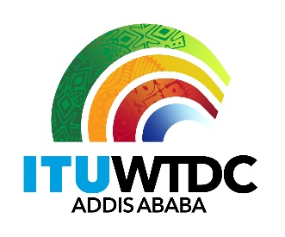 | Telecommunication Development  Advisory Group (TDAG)  29th Meeting, Virtual, 8-12 November 2021 |  | 
 |  | Document TDAG-21/2/24-E
 |  | 20 October 2021
 |  | English only
ITU-R Working Party 5D
Liaison Statement from ITU-R Working Party 5D to TDAG, ITU-D Study Groups 1 and 2, ITU-R Working Party 4B and ITU-T Study Group 13 on preliminary draft new edition of the Handbook on Global Trends in International Mobile Telecommunications (IMT)
Summary:
This document contains a liaison statement received from ITU-R Working Party 5D for comment on the preliminary draft new edition of the Handbook on Global Trends in International Mobile Telecommunications (IMT).
Action required:
TDAG is invited to note this document and provide guidance as deemed appropriate.
References:
n/a

Radiocommunication Study Groups | 
Source: Document 5D/TEMP/454(Rev.1)
 | 20 October 2021
 | English only
Working Party 5D
liaison statement to TDAG, ITU-D Study Groups 1 and 2,
ITU-R Working Party 4B and
ITU-T Study Group 13
Preliminary draft new edition of the Handbook on Global Trends in International Mobile Telecommunications (IMT)
Working Party 5D has initiated the development of a draft new edition of the Handbook on Global Trends in International Mobile Telecommunications (IMT). Fast development of mobile broadband worldwide urgently requires up-to-date general guidance on issues related to the deployment of IMT systems and the introduction/development of their IMT-2000, IMT-Advanced and IMT-2020 networks. One of the important ITU-R study publications on this issue, is the Handbook on Global Trends in International Mobile Telecommunications (IMT) that provides general information such as service requirements, application trends, system characteristics, as well as substantive information on spectrum, regulatory issues, guidelines for evolution and migration, and core network evolution. Since this Handbook was published in 2015, it requires urgent substantial updates to be a valid reference publication for the ITU membership.
Working Party 5D has invited contributions from the membership with the objective of completing the draft for consideration for approval by Working Party 5D at its 7-23 February 2022 meeting, with a deadline for contributions of 1600 hours UTC, 31 January 2022.
Working Party 5D looks forward to continuing its cooperation with ITU-D on IMT for ITU Members, in particular developing countries, as well as with ITU-R WP 4B and ITU-T SG 13 on overall matters as needed.
Attachment: Preliminary draft new edition of the Handbook on Global Trends in International Mobile Telecommunications (IMT)
Status: For information and action, if any.
Contact: Dr Haim Mazar | Email: h.mazar@atdi-group.com
________________

