|  |  |  |  |
| --- | --- | --- | --- |
|  | **Telecommunication Development** **Advisory Group (TDAG)**  **29th Meeting, Virtual, 8-12 November 2021** | |  |
|  | |  | |
|  | | **Document** **TDAG-21/2/****16-E** | |
| **8 November 2021** | |
| **Original:** **English** | |
| Chairman, Telecommunication Development Advisory Group (TDAG) | | | |
| Report on the Telecommunication Development Advisory Group (TDAG) Activities to WTDC, as mandated in WTDC Resolution 24 | | | |
| **Summary:**  This report contains a summary of the work carried out by the Telecommunication Development Advisory Group (TDAG) during the period 2018-2021.  **Action required:**  TDAG is invited to consider this report and to provide guidance as deemed appropriate.  **References:**  [TDAG-18/38](https://www.itu.int/md/D18-TDAG23-C-0038/), [TDAG-19/44](https://www.itu.int/md/D18-TDAG24-C-0044/en), [TDAG-20/59](https://www.itu.int/md/D18-TDAG25.2-C-0059/), [TDAG-20/2/5](https://www.itu.int/md/meetingdoc.asp?lang=en&parent=D18-TDAG26-C-0005), [TDAG-20/3/7](https://www.itu.int/md/D18-TDAG27-C-0007/en), [TDAG-21/39](https://www.itu.int/md/D18-TDAG28-C-0039/en) | | | |

Table of Contents

1. Introduction 2

1.1 Terms of Reference of TDAG 2

1.2 Telecommunication Development Advisory Group Bureau 2

2. TDAG Meetings 2

2.1 23rd TDAG Meeting 3

2.2 24th TDAG Meeting 9

2.3 25th TDAG Meeting 15

2.4 26th TDAG Meeting 23

2.5 27th TDAG Meeting 24

2.6 28th TDAG Meeting 28

3. TDAG Working Group Meetings 34

4. Matters assigned to TDAG by WTDC Resolution 24 (Rev. Dubai, 2014) 35

4.1 Background 35

4.2 Upkeep of up-to-date, efficient and flexible working guidelines 36

4.3 ITU-D objectives and budgetary appropriations available for activities, programmes and regional initiatives; ITU-D operational plan; Buenos Aires Action Plan 37

4.4 Study Groups 39

4.5 Advise the Director of BDT on relevant financial and other matters; 40

5. Cooperation and Collaboration 41

# Introduction

This report contains a summary of the work carried out by the Telecommunication Development Advisory Group (TDAG) during the period 2018-2021.

## Terms of Reference of TDAG

The terms of reference of TDAG can be found on the [TDAG webpage](http://www.itu.int/ITU-D/tdag/).

## Telecommunication Development Advisory Group Bureau

In application of Resolution 61 (Rev. Dubai, 2014), WTDC-17 adopted the composition of the TDAG Bureau and appointed the TDAG chairman and vice-chairmen, as follows:

|  |  |  |  |
| --- | --- | --- | --- |
| **Chairman/**  **Vice-Chairmen** | **Name** | **Country** | **BDT Region** |
| Chairman | **Ms Roxanne McElvane Webber** | USA | AMS |
| Vice-Chairman | Ms Regina Fleur Assoumou Bessou | Côte d'Ivoire | Chairman, SG1 |
| Vice-Chairman | Mr Ahmad Reza Sharafat | Iran (Islamic Rep. of) | Chairman, SG2 |
| Vice-Chairman | Mr Christopher Kipkoech Kemei | Kenya | AFR |
| Vice-Chairman | Mr Abdulkarim Ayopo Oloyede | Nigeria | AFR |
| Vice-Chairman | Mr Nicolás Ernesto Karavaski | Argentina | AMS |
| Vice-Chairman | **Mr Neil Checo Valera** | Dominican Republic | AMS |
| Vice-Chairman | Mr Al-Ansari Almashakbeh | Jordan | ARB |
| Vice-Chairman | **Mr Tariq H Alamri** | Saudi Arabia | ARB |
| Vice-Chairman | Mr Kishore BabuMr Kishore Babu GSC Yerraballa | India | ASP |
| Vice-Chairman | Ms Aichurok Maralbek Kyzy | Kyrgyz Republic | CIS |
| Vice-Chairman | **Mr Arseny Plossky** | Russian Federation | CIS |
| Vice-Chairman | Mr Wim Rullens | Netherlands | EUR |
| Vice-Chairman | **Ms Blanca González** | Spain | EUR |

# TDAG Meetings

TDAG held three meetings during the period covered by this report under the chairmanship of Roxanne McElvane Webber (United States). The complete summary of conclusions of these meetings can be found at: [www.itu.int/ITU-D/tdag/](http://www.itu.int/ITU-D/tdag/).

## 23rd TDAG Meeting

1. The 23rd meeting of the Telecommunication Development Advisory Group (TDAG) took place from 9 to 11 April 2018 at ITU headquarters in Geneva, under the Chairmanship of Ms Roxanne McElvane Webber.

TDAG’s mandate ranges from reviewing priorities, strategies, operations and financial matters of the Telecommunication Development Sector (ITU-D), to advising the Director of the Telecommunication Development Bureau (BDT) on the implementation of Action Plans from world telecommunication development conferences (WTDCs).

The 23rd meeting of TDAG had a broad agenda as it marked the first TDAG meeting after the [World Telecommunication Development Conference 2017 (WTDC-17)](https://www.itu.int/en/ITU-D/Conferences/WTDC/WTDC17/Pages/default.aspx), convened in Buenos Aires, Argentina, from 9 to 20 October 2017.

1. *Participants*

The following chart provides the breakdown of participants by category:

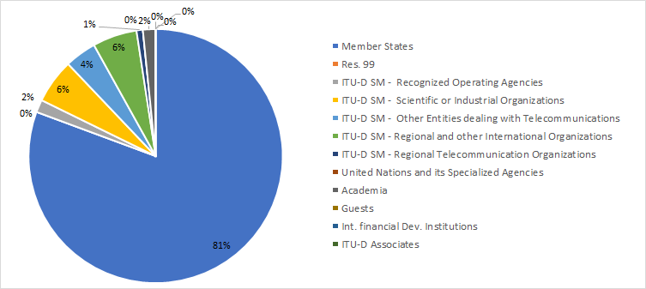The following chart provides the breakdown of participants by region:

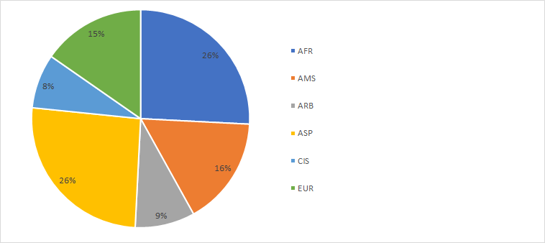

The following chart provides the breakdown of participants by gender:

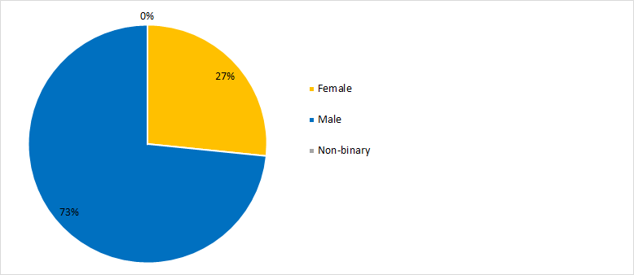

1. *Documents*

The following chart provides the number of documents broken down by category of documents:

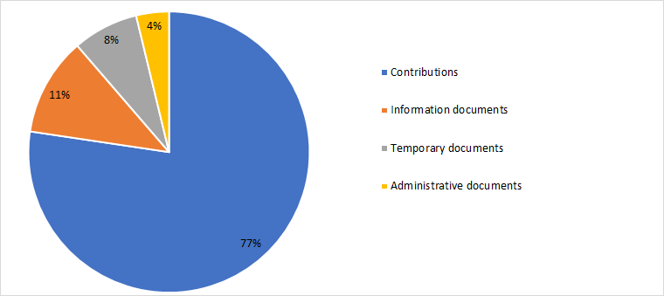

1. *23rd TDAG Meeting Outcomes*

The following table provides the summary of the outcomes of the 23rd TDAG meeting by subject:

| *Subject* | *TDAG Conclusions / Outcomes* |
| --- | --- |
| World Telecommunication Development Conference (WTDC 17) | The summary report on the World Telecommunication Development Conference (WTDC-17) was welcomed and noted. |
| Financial implications of the Regional Initiatives approved by WTDC-17 | TDAG noted the financial implications for ITU of the decisions made by WTDC-17 and the importance of prioritizing and mobilizing resources to implement the newly adopted Regional Initiatives.  TDAG welcomed and noted the document. |
| Summary of the BDT Management Retreat 2018 | TDAG welcomed and noted the debrief on the main discussions and conclusions that took place during the Retreat, from 5 to 9 February 2018, in Geneva, Switzerland |
| TDAG's scope of work and working methods - WTDC Resolutions 24 and 61 (Rev. Dubai, 2014), WTDC Resolution 1 (Rev. Buenos Aires, 2017) and the Buenos Aires Action Plan. | TDAG took note of the document and emphasized that its content would provide useful guidance for its work going forward. TDAG also recognised existing BDT efforts that make electronic working methods available for ITU-D events. |
| Effective use in the ITU Telecommunication Development Sector of the six official languages of the Union on an equal footing | While recognizing the importance of linguistics, in particular for developing countries, and of treating all six languages of the Union on an equal footing, discussions recognized existing efforts of BDT in this area and highlighted that when analyzing possible future technical solutions, financial implications must also be considered.  TDAG welcomed the document and suggested that in future meetings, BDT may consider making a presentation on these issues to provide information on available resources |
| Internet of Things (IoT) Online Resources Portal | TDAG welcomed the proposal, and while participants supported the need to consolidate information about ITU activities, resources, and relevant research and development on key topics such as IoT, and also recognized its potential to strengthen ITU-wide information sharing and best practices, TDAG suggested that further discussion may be required, in particular on the practical implementation and scope of the proposal and its financial implications. |
| Work and procedures of the World Telecommunication Development Conferences | There was general support for the proposal to have a discussion among membership on ways to improve the structure and functioning of future WTDCs. TDAG noted the document with appreciation and agreed that this advice to the Director would be taken into account, including mechanisms for implementation, in the preparations for the next WTDC and could be discussed at future TDAG meetings. |
| Report on Inter-Sector Coordination Team on Issues of Mutual Interest | TDAG welcomed and noted the report. |
| Reply Liaison Statement to ITU-D Study Group 1 (Copy to TDAG and for information to RAG and ITU-R Study Group 5) | TDAG thanked ITU-R Study Group 1 for the liaison statement and noted its contents. |
| Studies in response to Resolution 9 | TDAG noted the document and invited the SG Chairmen to integrate the resources, to the extent possible and as required, in the work of the Questions under study. TDAG noted that the list would be updated by BR as appropriate. |
| Incoming liaison statement - LS/R on ITU inter-sector coordination (reply to TSAG - LS 1 - E) & Incoming liaison statement - LS/o on ITU inter-Sector coordination [to ISCT, TDAG, ITU-D SGs, RAG, ITU-R SGs, ITU-T SGs] | TDAG thanked ITU-T for the liaison statements and noted the contents. |
| Streamlining PP and WTDC Resolutions | TDAG supported in principle the importance of streamlining resolutions and noted that it could revisit the matter following PP-18.  TDAG noted Document TDAG-18/29 and thanked the Russian Federation for the proposal. |
| ITU-D’s representatives to the ITU Coordination Committee for Terminology (ITU CCT) | TDAG appointed Mr Peter Mbengie (Cameroon) from ITU-D SG 1, and Ms Ke Wang (China) from ITU-D SG 2 to ITU CCT |
| Progress report of Chairman of ISCT | TDAG welcomed and considered the report, and thanked Mr Bigi for agreeing to lead the ISCT over the new four-year period.  Ms Nurzat Boljobekova and Mr Arseny Plossky were appointed TDAG representatives to ISCT.  TDAG discussed the draft revision of the ISCT Terms of Reference provided in Annex 1 to document 37. No objection was expressed to adding the activities of the General Secretariat in the analysis of ISCT, however, TDAG agreed that further clarification was needed on a number of issues. For example, questions were raised regarding the composition and title of ISCT. Additional questions were raised regarding the relationship of the Inter-Sectoral Coordination Task Force (ISC-TF) and the ISCT, the first being an internal-ITU coordination mechanism, while the latter is a body composed of representatives of the three advisory groups. TDAG noted that the issue would be discussed further and decided upon during Council, and recommended that the BDT Director inform Council about the discussions that took place during TDAG. |
| Report on the implementation of the ITU-D Strategic Plan and Operational Plan 2017 | TDAG noted and expressed its appreciation for the comprehensive document and for the BDT’s hard work during 2017. TDAG called upon BDT to continue efforts to strengthen collaboration and coordination with regional organizations, and requested additional information on some of the cooperation agreements and related projects and activities mentioned in the report. |
| ITU-D contribution to the implementation of the WSIS Plan of Action and the 2030 Agenda for Sustainable Development | TDAG called upon BDT to continue highlighting member’s existing needs and circumstances, including infrastructure requirements, and how such needs could be addressed to strengthen ICTs as a cross-cutting tool to achieve the SDGs. TDAG noted the document with the various clarifications and additions provided. |
| ITU-D four-year rolling Operational Plan 2019-2022 | TDAG supported the document with appreciation, including a slight revision already reflected in the final report of WTDC-17. |
| Draft four-year rolling Operational Plan for the General Secretariat for the period 2019-2022 | TDAG noted the document with appreciation. |
| ITU-D Study Group-related matters | The chairman welcomed both Study Group chairmen, highlighting new developments in the Study Group working methods for this period, including pilot project to promote SME participation. TDAG welcomed both documents TDAG-18/12 and 13 from the Study Groups. |
| Proposal for holding a panel session on Early Warning System (EWS) in the first ITU-D SG2 Meeting | TDAG noted the information, which was submitted to inform participants about important upcoming Study Group activities. TDAG noted its appreciation for the work on Early Warning Systems and for efforts to organize the workshop to enrich the work of the Study Question. TDAG also suggested that the next study group meetings could identify further topics that could be the subject of workshops or seminars at future such meetings. |
| Regional Development Forums (RDFs) | TDAG welcomed and noted the report, which provided an update on the six Regional Development Forums (RDFs), scheduled to be held in 2018, taking into account the outcomes of WTDC-17 that resolved to strengthen the platforms for regional coordination. In particular, the report emphasized RDF’s role as both a framework for implementation and as a contributor to the implementation of the WSIS Action Lines and SDGs and included the schedule of RDFs for 2018. |
| Global Symposium for Regulators (GSR) | TDAG noted the report, which summarized the 17th edition of the Global Symposium for Regulators (GSR-17) and provided information on GSR-18, with appreciation. |
| Capacity building activities | Global Capacity Building Initiative (GCBI): TDAG congratulated the GCBI Chairman for the report and the GCBI for the important work accomplished, and encouraged GCBI members to continue their good work. A key recommendation from GCBI was to expand the target group of ITU’s capacity building activities to reflect the changing ecosystem, e.g. SMEs, microenterprises, students, youth, women, civil society and academia.  TDAG thanked the Chairman of GCBI and took note of the report.  Report on Capacity building initiatives: TDAG welcomed the report and congratulated BDT on its activities in this area. |
| World Telecommunication/ICT Indicators Symposium (WTIS) | Document 19: TDAG noted the report with appreciation.  Document 31: TDAG welcomed the proposals, noting that suggestions made could be considered and further discussed in future expert groups and in study group meetings, so as to stabilize the recently made changes to the IDI framework and methodology. |
| ITU-D Innovation | TDAG noted the report, which provided an overview of this topic as one of the outputs and goals adopted at WTDC-17 and PP-14, respectively. |
| Membership, Partnership, Private Sector-related matters | Document 20: TDAG welcomed the information and noted the report with appreciation.  Document 21(Rev.1): TDAG welcomed the report and its annex and noted both with appreciation.  Document 26: TDAG noted the contribution with appreciation.  Document 33: TDAG supported this document and agreed on the important role that the private sector has to play in the Development Sector, as indicated in Resolution 71. TDAG acknowledged the fast pace of the technology sector and how regulators, especially in developing countries, should encourage a proper regulatory environment to promote healthy competition and industry growth.  TDAG also noted that the first IAGDI activity is tentatively planned for GSR 2018, and that work is being undertaken with the BDT to establish the IAGDI structure. |
| Calendar of ITU-D events | TDAG noted the events planned for the period 2018-2021. |

## 24th TDAG Meeting

1. The 24th meeting of the Telecommunication Development Advisory Group (TDAG) was held at ITU headquarters in Geneva, from 3 to 5 April 2019, under the chairmanship of Ms Roxanne McElvane Webber.

The 24th TDAG meeting was the first meeting held after the 2018 Plenipotentiary Conference (PP-18) and also featured eight breakout sessions organized by the Director and BDT staff − four on process and governance topics and four on BDT substantive areas of work, along with six informal sessions during which all ITU Regional Directors, accompanied by staff from the regional offices, described activities undertaken to serve ITU membership in the field, particularly to implement the regional initiatives adopted at WTDC-17. The full meeting report, in the six official languages of ITU, is available at [this link](https://www.itu.int/md/D18-TDAG24-C-0044/en).

1. *Participants*

The following chart provides the breakdown of participants by category:

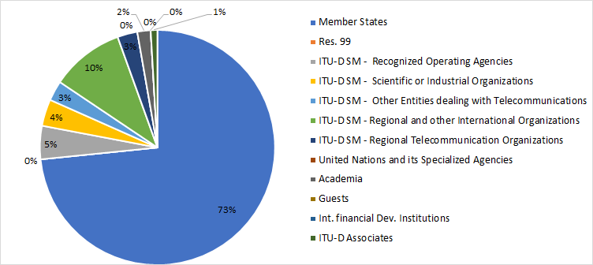

The following chart provides the breakdown of participants by region:

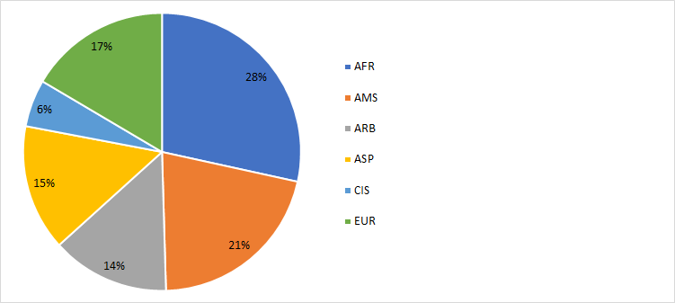

The following chart provides the breakdown of participants by gender:

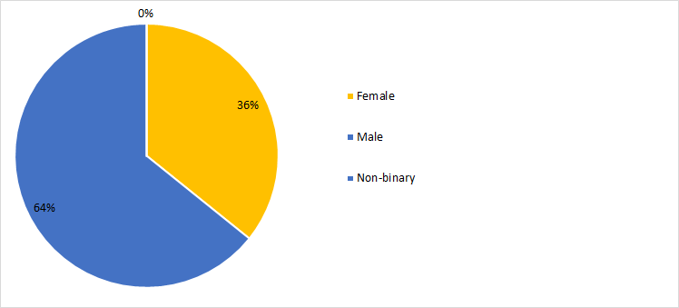

1. *Documents*

The following chart provides the number of documents broken down by category of documents:

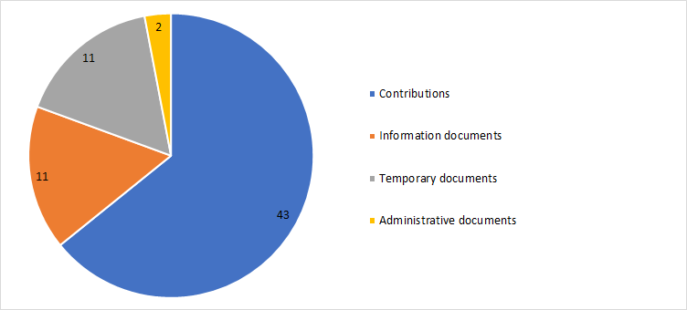

1. *24th TDAG Meeting Outcomes*

The following table provides the summary of the outcomes of the 24th TDAG meeting by subject:

| ***Subject*** | ***TDAG Conclusions / Outcomes*** |
| --- | --- |
| New TDAG Vice-Chairmen appointed to vacant positions | TDAG appointed by acclamation Ms Amparo Arango Echeverri, Manager of International Relations at the Dominican Institute of Telecommunications (INDOTEL), as a TDAG Vice‑Chairman, replacing Ms Katrina Naut.  TDAG also appointed by acclamation Ms Aichurok Maralbek Kyzy, Chief Expert of the Radio Spectrum Management Department of the State Communications Agency in the State Committee of Information Technologies and Communications of the Kyrgyz Republic, as a TDAG Vice‑Chairman, replacing Ms Nurzat Boljobekova. |
| Outcomes of PP-18 related to ITU-D | TDAG took note of the main outcomes of the 20th Plenipotentiary Conference that relate to ITU-D. TDAG participants underlined the need to balance the budget for 2020-2023,acknowledged the importance of these resolutions and decisions, and stressed the need to include other equally important resolutions that have implications for the work to be carried out by ITU-D. TDAG requested, and the secretariat agreed, to update the document to include*:*   * **Resolution 70** on mainstreaming a gender perspective in ITU and promoting gender equality and the empowerment of women through telecommunications and ICTs. * **Resolution 136** on using telecommunications and ICTs for humanitarian assistance and to monitor and manage emergency and disaster situations for early warning, prevention, mitigation and relief. * **Resolution 169** on academia’s participation in the work of the Union. * **Resolution 175** on telecommunications/ICTs for persons with disabilities and with specific needs. * **Resolution 179** on the ITU role in child online protection. * **Resolution 196** on protecting telecommunication service users and consumers. * **Resolution 198** on empowering youth through telecommunications ICTs; and   **Resolution 176** on measurement and assessment concerns related to human exposure to electromagnetic fields. |
| ITU-D actions relevant to the World Summit on the Information Society (WSIS) Plan of Action and the 2030 Agenda for Sustainable Development | TDAG agreed that a segment on WSIS and SDGs should be included as a regular agenda item in the regional development forums. |
| ITU-D four-year rolling Operational Plan 2020-2023 | TDAG endorsed the document and supported the BDT Director’s strategy to continue to improve service delivery through clustering topics based on the outcomes of WTDC-17 and PP-18. |
| General Secretariat four-year rolling operational plan 2020-2023 | TDAG noted the plan with appreciation. |
| Activities implementing the ITU-D Operational Plan 2018 | TDAG noted the contents of the report with appreciation. |
| Infrastructure and spectrum management activities | TDAG noted the document, recognizing that infrastructure development is one of the main goals articulated by ITU membership at WTDC-17 and at PP-18, and that this goal falls under SDG 9 - to build resilient infrastructure and foster innovation. |
| Spectrum Management Activities under Resolution 9 | TDAG noted the document with interest and appreciation and approved the approach proposed by the Chairmen of Study Group 1 and Study Group 2 recounted above and the coordinators selected. |
| Cybersecurity and ICT applications | TDAG noted the document with appreciation, and encouraged BDT to continue measuring cybersecurity progress with the GCI while improving the methodology and scoring mechanism through continuous dialogue and collaboration with Member States, industry, academia, and experts in the area of cybersecurity and data analysis. TDAG suggested that a mechanism could be developed to ensure that products and services are developed taking into consideration such input from the membership. |
| Regulatory and market environment, including the Global Symposium for Regulators (GSR) | TDAG noted the document with interest and appreciation and participants requested further clarification on events, portals, studies and research, and asked that information on reports and studies be made available to membership and shared with regional offices so that best practices on policy and regulation could be widely disseminated. |
| Digital inclusion | TDAG noted the document with interest and appreciation, acknowledging the need to highlight the importance of implementing policies on digital inclusion and accessibility, and underlining the need to foster an enabling environment to achieve trust in ICTs. |
| Capacity-building activities | TDAG noted the important activities related to the centres of excellence, ITU Academy, and working in partnership with other stakeholders with appreciation, recognizing the importance of doing work to build capacity for digital inclusion, including digital literacy. TDAG suggested that BDT could explore mechanisms to leverage the expertise created through the training activities and emphasized the importance of including the gender dimension in capacity building and skills development work. |
| ICT data and statistics, including World Telecommunication/ICT Indicators Symposium (WTIS) | TDAG noted the document with interest and appreciation, recognizing that ICT statistics are a critical output of ITU and an essential input for ICT policy. TDAG also stressed that statistics published by ITU must be reliable and trustworthy. TDAG encouraged experts from Member States to contribute actively in the ongoing work.  Breakout session ICT data and statistics: TDAG agreed that relevant ITU ICT statistics and information on the latest publications should be made available to study groups, that revision or update to such data should be made by experts in the statistics field in the expert group and that members of study groups could be invited to attend these meetings, as appropriate. |
| Emergency telecommunications, climate change, e-waste, LDCs, LLDCs, and SIDS | TDAG noted the report with interest and appreciation, recognizing the importance of initiatives on emergency telecommunications, climate change, e-waste, LDCs, LLDCs, and SIDS to all members. |
| ITU-D projects | TDAG noted these efforts with interest and appreciation. |
| Innovation | TDAG noted the document with interest and appreciation, recognizing innovation as an imperative for future growth in all sectors. |
| Membership, partnership and private sector-related matters | TDAG noted these efforts with interest and appreciation, and BDT agreed to make best efforts to maintain existing members and recruit new ones, and would list all Sector Members in the regions on the Regional Presence website. TDAG recognised the importance of partnerships to assist the ITU through the BDT address the gaps in ICT connectivity, access and use. |
| Reports from the regions: Activities and Trends | Activities in 2018**:** TDAG noted all activities with interest and appreciation, and welcomed this open dialogue and interaction with the Regional Directors as a source of first-hand information allowing TDAG to become apprised of the tremendous amount of work on behalf of members, and to provide guidance and advice where needed. With so many activities implemented, TDAG asked how the impact of the activities could be best measured, suggesting that all success stories be widely shared, and any challenges faced in implementing planned activities be documented as lessons learned. |
| 2019 Regional Development Forums | TDAG agreed that going forward a segment on WSIS and SDGs should be included as a regular agenda item at the regional development forums. |
| Financing Regional Initiatives | In discussing the seed money that has been allocated by the Council for the regional initiatives, TDAG agreed that in-kind contributions that can be quantified can be included in project documents as one of the funding sources, and must be submitted with the initial project document. |
| ITU-D Study Groups Annual Reports | TDAG noted the reports on study group activities with interest and appreciation, and observed that both study groups and all 14 Questions were making good progress towards the WTDC expected outputs under the leadership of the study group chairmen. TDAG commended the Chairman of ITU-D Study Group 1, Ms Regina Fleur Assoumou Bessou and the Chairman of ITU-D Study Group 2, Dr Ahmad Reza Sharafat for the impressive achievements both study groups have made in just one year in the 2018-2021 period.  Recognizing that expert knowledge exchanges on specific study topics had been conducted in several countries in 2018, TDAG appreciated that both study groups had been building synergies between the work undertaken in the study Questions and the activities in the regions. TDAG also noted that good progress was being made to identify possible links between ITU-D study Questions and ITU projects, ITU capacity building and WSIS activities, as well as with work in the other ITU Sectors. TDAG acknowledged the value of topical panel sessions held during the study group and rapporteur group meetings, including the additional sessions planned for the upcoming rapporteur group meetings in October 2019.  TDAG noted that the ITU-D study group website will feature a new section that will showcase ongoing work and will include the annual reports described above. TDAG participants also considered the possibility of involving external publishing companies to showcase quality work, and noted that it would be discussed further. |
| Collaboration with other sectors | TDAG welcomed the progress report and commended Mr Bigi for the group’s achievements. TDAG approved the way forward. |
| Mapping Links between ITU-D, ITU-T, and ITU-R Study Group Activities | TDAG thanked the chairmen of the ITU-D study groups along with Arseny Plossky (Russian Federation) and Dr Haim Mazar (ATDI Group) for their hard work to update the tables so comprehensively to support coordination between the Sectors. TDAG welcomed the liaison statement (document 41). TDAG noted that the liaison statement is a result of extensive discussions in the ITU-D study groups, and that the statement clarifies their understanding that the purpose of the mapping tables is to identify topics of mutual interest and the entities responsible across the three ITU Sectors in accord with their mandates and Constitution and Convention of the Union; to improve information exchange within the Union on the topics of mutual interest; and to ensure that responsible entities in each Sector will know whom to contact for incoming and outgoing communications on such topics. |
| Preparations for WTDC | TDAG thanked Ethiopia for the kind and generous invitation, expressed significant support for the proposal and noted the importance of beginning to make concrete plans, including decisions about regional preparatory meetings. |
| Calendar of ITU-D events | TDAG noted the document and emphasized the need to avoid conflicts with religious holidays, consecutive meetings of study groups, TDAG and WSIS, and major conferences in the sector. |

## 25th TDAG Meeting

1. The 25th meeting of the Telecommunication Development Advisory Group (TDAG) was convened from 2 to 5 June 2020, under the chairmanship of Ms Roxanne McElvane Webber. This meeting was held fully virtually due to the need to protect delegates and staff against the COVID-19 pandemic which had by this point seriously impacted global health situation. The meeting was preceded by a series of virtual “web dialogues” on topics pertaining to the work of TDAG and of ITU-D. The topics were:

* Web Dialogue on the Regional Presence
* Web Dialogue on a new ITU Index
* Web Dialogue on WTDC
* Web Dialogues on Results Based Management
* **Web dialogue on Partnerships for Digital Transformation: Engaging Stakeholders for Meaningful Impact, 21 May 2020**

The full meeting report, in the six official languages of ITU, is available [here](https://www.itu.int/md/D18-TDAG25.2-C-0059/).

1. *Participants*

The following chart provides the breakdown of participants by category:

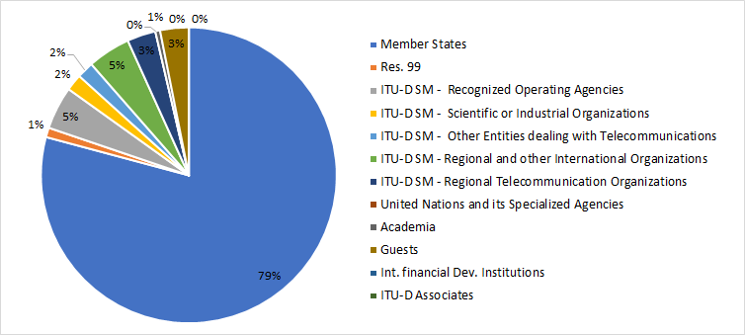

The following chart provides the breakdown of participants by region:

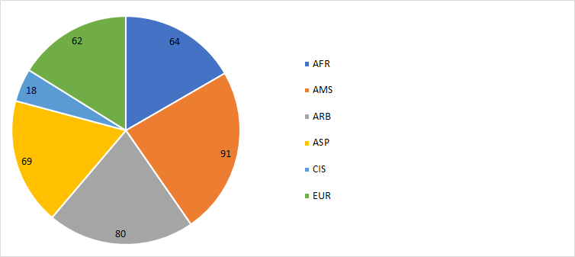

The following chart provides the breakdown of participants by gender:

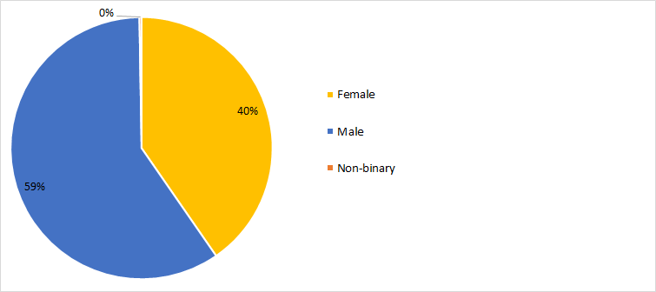

1. *Documents*

The following chart provides the number of documents broken down by category of documents:

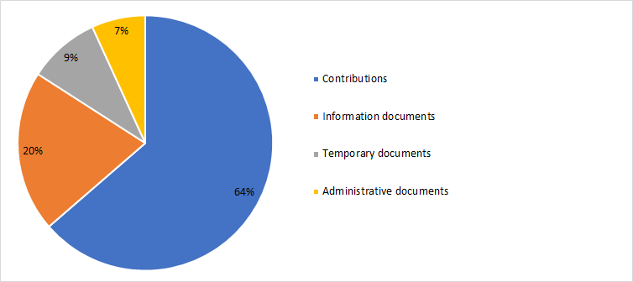

1. *25th TDAG Meeting Outcomes*

The following table provides the summary of the outcomes of the 25th TDAG meeting by subject:

| ***Subject*** | ***TDAG Conclusions / Outcomes*** |
| --- | --- |
| Appointment of a new TDAG Vice-chairman to a vacant position | TDAG appointed by acclamation Mr Nicolás Karavaski as a TDAG ViceChairman, replacing Mr Hugo Dario Miguel. |
| Outcomes of WRC-19 related to the work of ITU-D | TDAG expressed appreciation for the document and noted the close cooperation between BDT and BR, especially for the continued capacity building efforts and support for developing countries on the implementation of WRC-19 and RA-19 decisions and preparation for WRC-23. TDAG noted that the work on spectrum-related issues continued to be of great interest for developing countries with many regions underlining its importance. |
| ITU draft Operational Plan for 2021-2024 | TDAG noted the draft operational plan for 2021-2024 in its new format and endorsed its contents. BDT agreed to submit information on risk evaluation to be included in the 2021 plan.  BDT took good note of the comments and agreed to include further references and more details in the 2021 plan. Document 30: This proposal received support from TDAG participants. TDAG also recognized the need for easily accessible and accurate information from ITU and welcomed innovations by BDT to improve the use and access to that information and preserve its longstanding reputation in the field of telecommunication-related statistics. [Document 31](https://www.itu.int/md/D18-TDAG25.2-C-0031/): TDAG noted the document with interest and appreciation, acknowledging the need to highlight the importance of making information and best practice about bridging the digital divide more accessible, contextual and useful, and underlining the need to foster an enabling environment to bridge the digital divide, bringing together all relevant materials, including material from regional organizations and material on policy and regulation as well as on capacity building. [Document 32](https://www.itu.int/md/D18-TDAG25.2-C-0032/): TDAG thanked Cuba for bringing this longstanding work improving digital literacy to the attention of membership, an effort without which the promise of connectivity cannot be reached.  [Document 39](https://www.itu.int/md/D18-TDAG25.2-C-0039/): TDAG underlined the importance of information sharing and welcomed the proposal to disseminate ITU-D publications through ITU regional and area offices, while also noting the importance of distributing material in the ITU languages used the regions. |
| Report on the implementation of the ITU-D Strategic Plan and Operational Plan 2019, including programmes, regional initiatives and major events | TDAG noted with appreciation the wealth of information presented on thematic priorities and regional initiatives, as well as the high-quality products and publications available to members and called for more promotion and more translation into the six ITU official languages. TDAG welcomed I-CoDI as an important project that will help ITU membership integrate innovation into their national development agendas and activities. |
| ITU-D contribution to the implementation of the WSIS Plan of Action and the 2030 Agenda for Sustainable Development | TDAG expressed appreciation for the report and encouraged membership to engage actively in BDT activities that contribute to the implementation of the WSIS outcomes and the 2030 Agenda for Sustainable Development in line with WTDC-17. |
| ITU-D projects | TDAG noted the document with appreciation. |
| ITU-D Study Group-related matters | TDAG noted with interest and appreciation the detailed reports on study group activities, and observed that both study groups and all 14 Questions were making good progress towards the WTDC expected outputs under the leadership of the study group chairmen.  TDAG appointed Ms Aimee K. Meacham (United States) as a Co-Rapporteur for ITU-D Study Group 2 Question 3/2.  TDAG agreed on the proposed dates for the ITU-D study group meetings in 2021. |
| Collaboration with the other Sectors | TDAG noted with appreciation the progress report from the Chairman of the Inter-Sector Coordination Group on issues of mutual interest and welcomed the group’s decision to pursue “climate change” as a pilot theme, where all Sectors could be involved and could collaborate; and “accessibility” as the next suggested pilot theme. TDAG noted the liaison statements on inter-Sector coordination. TDAG further noted that the most up-to-date [mapping tables on inter-Sector coordination are](https://www.itu.int/en/general-secretariat/Pages/ISCG/default.aspx) maintained by the ISCG on its website. |
| Preparations for WTDC | TDAG thanked all contributors for their constructive proposals, recognizing that all aim to make WTDC more efficient and impactful. TDAG agreed to set up a working group that would review the ITU-D contribution to the ITU strategic plan, to be led by Ms Blanca Gonzalez (Spain), assisted by Mr Christopher Kemei (Kenya) and Mr Wim Rullens (Netherlands). The terms of reference for this group, found in DT/7, were approved.  TDAG also agreed to create two working groups to prepare for WTDC: a group to work on WTDC preparations and a group to work on administrative outputs such as resolutions and the Declaration. TDAG agreed that an extraordinary session of TDAG would be held to establish high-level terms of reference for both groups. TDAG agreed that the group on WTDC Preparations would be led by Santiago Reyes-Borda of Canada. The date for the meeting was subsequently fixed as 16 June 2020. |
| Streamlining resolutions | TDAG noted the documents and recognized the importance of early work on resolutions, which would help free up conference time to discuss ICT development issues. |
| Membership, Partnership and Private Sector-related matters | Document 7: TDAG noted the document with interest and appreciation, recognizing the importance of partnership and resource mobilization to implement WTDC-17 programmes and regional initiatives. TDAG supported the BDT Director’s plan to hire a consultancy firm and a senior advisor for this purpose, and to provide training and capacity building for BDT staff on resource mobilization).  Document 11 and Information Document 13: TDAG noted both reports with appreciation and interest. In particular, TDAG noted the strategies that have been taken to increase membership outreach and engagement, such as cross-selling among ITU Sectors, diversification with new industries, digital marketing to reinforce acquisition, and retention of current members by engaging them in ITU-D activities and events. Additional information was provided by the BDT secretariat and the BDT Director on factors influencing the decrease of sector membership such as industry consolidation, economic situation, the inability of some members to pay the annual membership fees, delays in approval from Member States, and decisions by some Sector Members to switch to Associate and Academia membership categories. |
| Report by the Chairman of the Group on Capacity Building Initiatives (GCBI) | TDAG noted the report with appreciation and congratulated GCBI for the excellent work done. TDAG highlighted the importance of capacity development in the work of BDT as it is a priority for four of the five regions as reflected in their regional initiatives. |
| ITU-D’s Youth Strategy | TDAG noted the document with appreciation and significant support by its members. TDAG encouraged BDT to work closely with regional offices to ensure coordination and proper implementation. |
| Contribution to the work of the Expert Group on the International Telecommunication Regulations (EG-ITR) | TDAG noted the report and will follow the progress of the Expert Group on ITRs. |
| Status of the feasibility study to establish an ITU training institute | TDAG noted with appreciation the actions taken by the Director to implement the Council instructions regarding a capacity-building institute in ITU. |
| Report on Results-Based Management (RBM) | TDAG noted the document with interest and appreciation, supports the progress made by BDT on the implementation of RBM, and looks forward to the next update. |
| Activities linked to COVID-19 | TDAG commended BDT for the fast reaction to the crisis and for the provision of relevant and useful information that supported efficient and safe use of network resources. TDAG also noted the continued efforts of ITU-D study groups to support the ongoing BDT work on COVID-19 issues and welcomed the announcements of future projects funded by Member States to help developing countries. Many members offered help and wished to support the BDT efforts by using the platform to disseminate their own initiatives. Despite the volume of input to the platform, membership requested the translation of some of the material into other languages of the Union, and underscored the need to collate the initiatives of all ITU Sectors for Council. |
| Calendar of ITU-D events | TDAG noted the contents of the documents with interest. With regard to the ITU-D calendar of events, TDAG noted the importance of trying to avoid holding two major ITU events in the same calendar year. |
| Any other business: Documents 47, 48 and 49 | Document 47: TDAG noted the contents of the report with interest and appreciation. TDAG expressed its support for this global initiative and thanked BDT for the assistance provided to all stakeholders in their efforts to celebrate Girls in ICT Day in a virtual manner, to inspire girls and young women to take up studies and careers in STEM, and to leverage the power of digital technology, despite the limitations imposed by the current global health crisis (COVID-19). TDAG recognized the importance of establishing broader partnerships and collaboration with governments, civil society, Academia and industry and stressed the importance of active participation and engagement of girls in the Youth Summit at WTDC.  Document 48: TDAG noted the document with appreciation and welcomed the involvement of Member States in the review process of the 2020 child online protection guidelines.  TDAG encouraged all Member States to take note of the content of the guidelines.  Document 49: TDAG noted the document with interest and appreciation, and supports the progress made in GIGA. Rwanda, Kazakhstan, and United States each made interventions in support of GIGA and their involvement as Lead Country for Africa, Lead Country for Central Asia, and as a provider of GIGA technical assistance, respectively. Some Member States have expressed interest in learning more about GIGA and BDT will follow up accordingly. |

## 26th TDAG Meeting

TDAG held an extraordinary meeting on 16 June 2020, with one key item on its agenda: to discuss and approve high-level terms of reference for its two working groups established on 5 June 2020 to prepare for WTDC-, scheduled to take place in Addis Ababa, Ethiopia, on 8-19 November 2021.

The groups, the “TDAG Working Group on WTDC Preparations” and the “TDAG Working Group on WTDC Resolutions, Declaration and Thematic Priorities” formed by TDAG are open to all ITU Member States and ITU-D Sector Members.

The working groups began work in July 2020, and their terms of reference are contained in DT/3(Rev.1).

The full meeting report, in the six official languages of ITU, is available at [this link](https://www.itu.int/md/D18-TDAG26-C-0005/en).

1. *Participants*

The following chart provides the breakdown of participants by category:

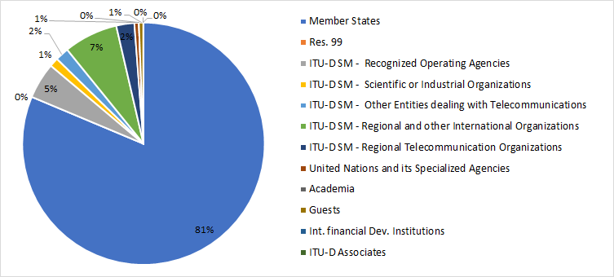

The following chart provides the breakdown of participants by region:

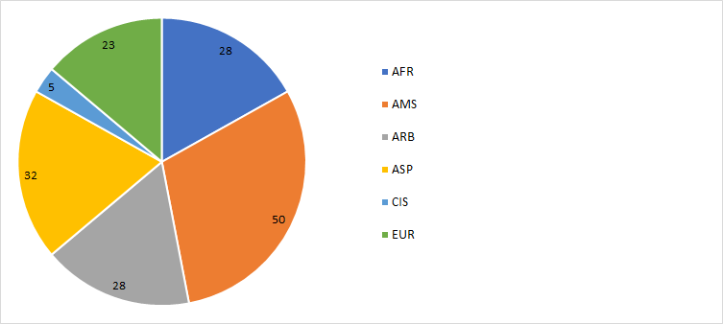

The following chart provides the breakdown of participants by gender:

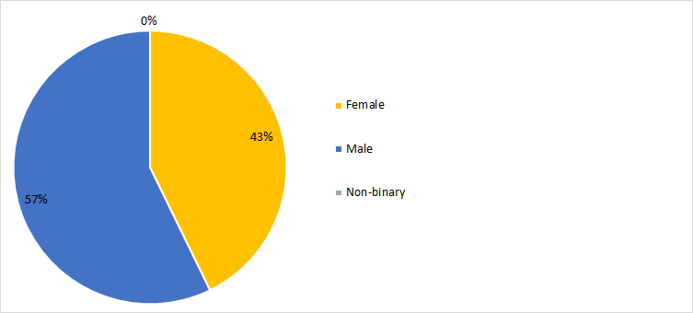

1. *Documents*

The following chart provides the number of documents broken down by category of documents:

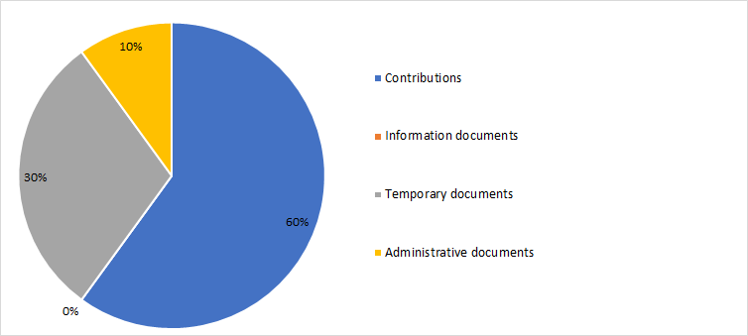

1. *26th TDAG Meeting Outcomes*

| ***Subject*** | ***TDAG conclusions / outcomes*** |
| --- | --- |
| Formation of TDAG Working Groups | **TDAG working group on the Strategic and Operational Plans.**  The group is chaired by Ms Blanca González (Spain) assisted by two TDAG Vice-chairmen: Mr Christopher Kemei (Kenya) and Mr Wim Rullens (Netherlands).  **TDAG Working Group on WTDC Preparations.**  The meeting confirmed the appointment of Mr Santiago Reyes-Borda (Canada) as Chairman.  **TDAG Working Group on WTDC Resolutions, Declaration and Thematic Priorities.**  The meeting appointed Dr Ahmad Reza Sharafat (Islamic Republic of Iran) as Chairman. |
| Discussion and approval of the terms of reference of the TDAG Working Groups | TDAG adopted terms of reference for the TDAG Working Group on WTDC Preparations, the TDAG Working Group on WTDC Resolutions, Declaration and Thematic Priorities, and the TDAG Working Group on Strategic and Operational Planscontained in [DT/3 (Rev.1)](https://www.itu.int/md/D18-TDAG26-200616-TD-0003/en). |
| Composition of the groups and working methods | The working groups are open to all ITU Member States and ITU-D Sector Members. They may meet electronically, as required, and otherwise communicate electronically. They may meet during TDAG, normally not at the same time as another group. |

## 27th TDAG Meeting

The 27th meeting of the Telecommunication Development Advisory Group (TDAG) took place on 23 November 2020, under the chairmanship of Ms Roxanne McElvane Webber.

The purpose of the meeting was to consider reports prepared by the three TDAG Working Groups created in June 2020 to evolve the impact of, and preparation for, the upcoming ITU World Telecommunication Development Conference (WTDC). The three groups, the Working Group on WTDC Preparations (TDAG-WG-Prep); the Working Group on the Strategic and Operational Plans (TDAG-WG-SOP); and the Working Group on WTDC Resolutions, Declaration and Thematic Priorities (TDAG-WG-RDTP) each presented reports at the meeting which were considered by UDAG.

At the meeting TDAG, inter alia, unanimously endorsed “Connecting the unconnected to achieve Sustainable Development” as the overall theme for the World Telecommunication Development Conference (WTDC-21), scheduled to take place in Addis Ababa, Ethiopia from 8 to 19 November 2021.

1. *Participants*

The following chart provides the breakdown of participants by category:

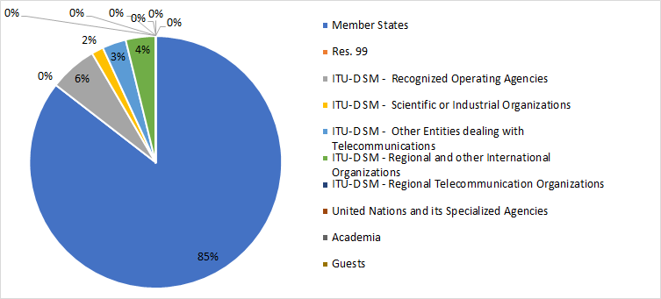

The following chart provides the breakdown of participants by region:

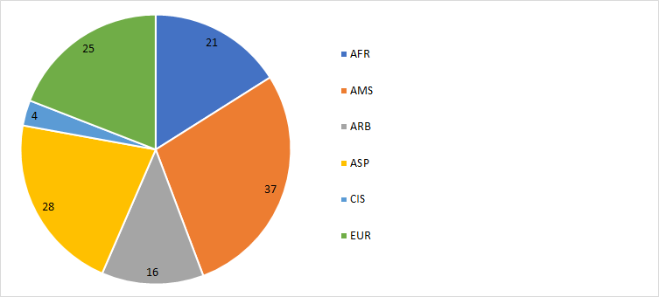

The following chart provides the breakdown of participants by gender:

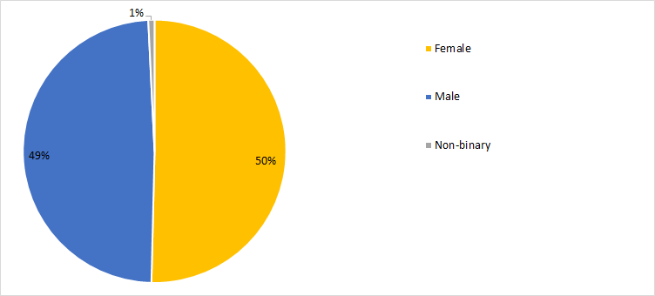

1. *Documents*

The following chart provides the number of documents broken down by category of documents:

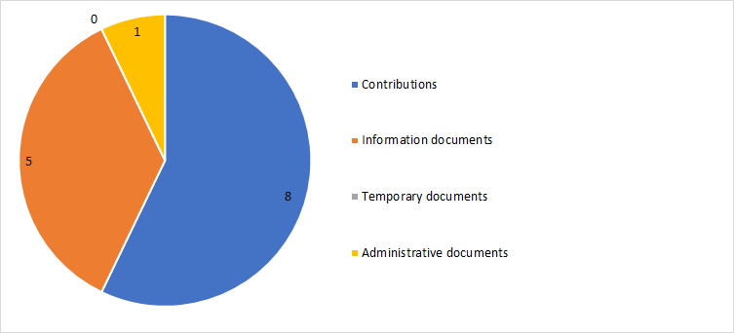

1. *27th TDAG Meeting Outcomes*

The following table provides the summary of the outcomes of the 27th TDAG meeting by subject:

| ***Subject*** | ***TDAG Conclusions / Outcomes*** |
| --- | --- |
| Reports from the TDAG working groups | TDAG endorsed the report and recommendations from the Working Group on WTDC preparations.  TDAG reviewed and endorsed the matters in the Working Group’s report on which consensus had been reached, and discussed and reached consensus on specific questions as noted below:   * Theme for WTDC: Connecting the unconnected to achieve Sustainable Development * Development Track * Inter-Regional Preparatory Meetings (IRMs)   TDAG noted with appreciation the progress report from the TDAG-WG-SOP.  TDAG noted with appreciation the progress report from the TDAG-WG-RDTP. |

## 28th TDAG Meeting

The 28th meeting of the Telecommunication Development Advisory Group (TDAG) was conducted virtually from 24 to 28 May 2021, under the chairmanship of Ms Roxanne McElvane Webber.

In view of the continued prevalence of the COVID-19 pandemic, the meeting of TDAG was held virtually for the second year in a row. The meeting was limited to three hours per day (2hours on 24 May 2021) to minimize the disturbance to participants from all time zones.

TDAG-21 took stock of the regional preparations for WTDC, considered the outcomes of the ​TDAG working groups and discussed relevant issues highlighted during the two Inter-Regional Meetings that had taken​ place before TDAG-21.

1. *Participants*

The following chart provides the breakdown of participants by category:

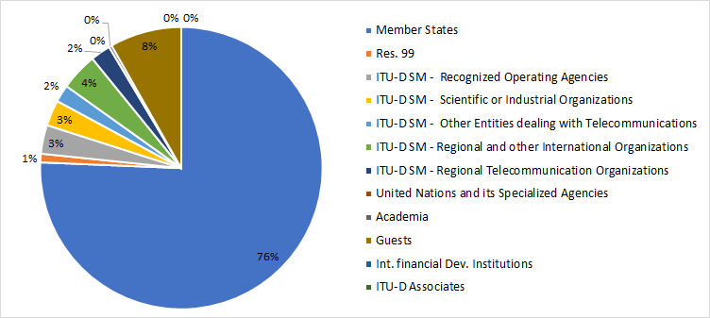

The following chart provides the breakdown of participants by region:

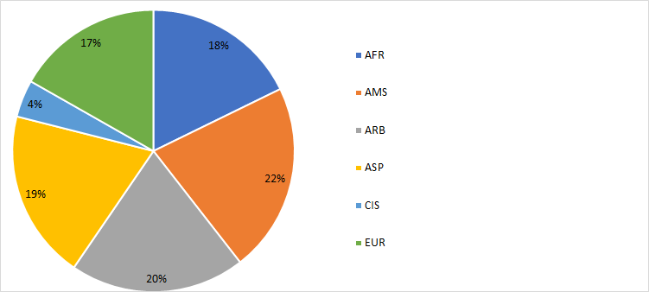

The following chart provides the breakdown of participants by gender:

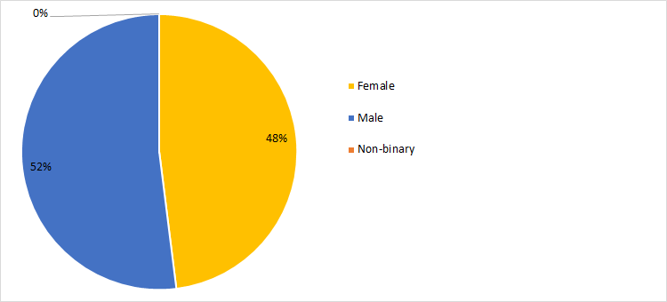

1. *Documents*

The following chart provides the number of documents broken down by category of documents:

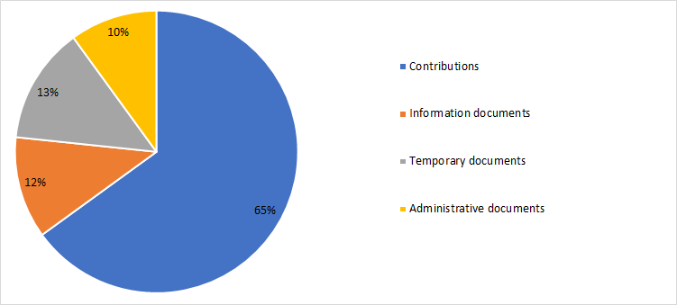

1. *28th TDAG Meeting Outcomes*

The following table provides the summary of the outcomes of the 28th TDAG meeting by subject:

| ***Subject*** | ***TDAG Conclusions / Outcomes*** |
| --- | --- |
| ITU-D four-year rolling Operational Plan 2022-2025 | TDAG reviewed and endorsed the ITU-D four-year rolling Operational Plan for 2022-2025. |
| Reporting on the implementation of the WTDC-17 Buenos Aires Action Plan (including the Regional Initiatives), and contribution to the implementation of the WSIS Plan of Action and the Sustainable Development Goals (SDGs) | TDAG noted and underlined the importance of the report in Document 2, which is structured around the current 10 thematic priorities, and noted the ongoing discussions reflected principally in the TDAG-WG-RDTP to reduce that number for the next four-year period. |
| Reporting on the Youth Strategy implementation and the Generation Connect Visionaries Board has been established to offer strategic high-level guidance to ITU youth-related work, and held its first meeting in April 2021 | TDAG noted the report and the related presentations by the youth representatives with enthusiasm and appreciation, welcomed the youth initiatives as refreshing, and underscored the importance of investing in youth, in including them in TDAG activities and taking their perspectives into account in the work of ITU. |
| ITU-D projects | TDAG noted the report with interest and appreciation and expressed support for the ongoing work and its impact on the ground, including steps taken to strengthen ITU project management practices. |
| Preparations for WTDC | TDAG noted with appreciation the document providing an outline of the WTDC preparations. |
| Update on the preparations for the Youth Summit | TDAG noted this document with appreciation and agreed that the Youth Summit would also have to be postponed to a suitable date prior to 6 June 2022, in collaboration with the host country. |
| Preparations for the WTDC Partner2Connect for Digital Development Segment | TDAG noted the document and confirmed that following its decision taken in November 2020, the Partner2Connect for Digital Development Segment will take place as an integral part of the main WTDC program from Day 2 to Day 4 of the conference. |
| WTDC preparations and contingency plans for the work of ITU-D in the case of postponement of WTDC | Document 30: TDAG noted with appreciation the proposed action plan put forward in this document, acknowledging its relationship to the broad continuity plans also proposed by BDT in Document 10(Rev.1).  [Document 33](https://www.itu.int/md/D18-TDAG28-C-0033/en): TDAG noted with appreciation the proposals put forward in this document, observing its relationship to the broad continuity plans proposed by BDT in Document 10(Rev.1) section 2, on ITU-D study group work. In particular, TDAG agreed that ITU-D should leverage and promote the study group’s output reports between now and WTDC, and would not re-open discussion or subject the reports to further revisions.  [Document 37](https://www.itu.int/md/D18-TDAG28-C-0037/): TDAG noted with appreciation the proposal put forward in this document, observing its relationship to the broad continuity plans proposed by BDT in Document 10(Rev.1) section 2.  [Document 10](https://www.itu.int/md/D18-TDAG28-C-0010/en)(Rev.1): TDAG noted with appreciation the comprehensive document prepared by BDT proposing a course of action to ensure business continuity in ITU-D, given the impending postponement of WTDC-21.  Taking into account all contributions on the issue of continuity plans, TDAG agreed that study groups should continue their work, that the TDAG-WG-SOP and TDAG-WG-RDTP should continue their work and report to an extraordinary meeting of TDAG in November 2021, and that the schedule for interregional meetings should be adjusted.  TDAG also agreed that all documents that had been submitted to the meeting for consideration under agenda item 10.1 (Report of the work of the TDAG-WG-RDTP) would be presented, discussed, and fully considered by the TDAG-WG-RDTP at its next meetings.  TDAG examined and approved proposed dates for the meetings of these groups, as contained in Document TDAG-21/DT/6(Rev.2).  [Documents 31 and 32](https://www.itu.int/md/D18-TDAG28-C-0032/en): TDAG noted the proposals and commended the Chairmen of SG1 and SG2, members of the Questions 4/1 and 7/1 management teams, and all contributors for their efforts and hard work in producing updated terms of reference.  TDAG agreed that new and revised terms of reference for study Questions would continue to be discussed at the study group meetings to be held in October 2021 with the aim of reaching consensus. The results of these meetings would then be submitted to the November 2021 TDAG meeting for decision in accordance with the relevant provisions of Resolution 1 (Rev. Buenos Aires, 2017) of WTDC. |
| Structure of WTDC | TDAG noted the document with appreciation, and in particular the addition of the Partner2Connect for Digital Development Segment as a new integral part of the WTDC programme. |
| Report on the work of the TDAG-WG-RDTP | TDAG noted with appreciation the report of the Chairman of the TDAG-WG-RDTP and commended him for the tremendous work done by the group to facilitate the work of the conference. TDAG agreed to extend the timeline for TDAG-WG-RDTP to continue and complete its work under the existing terms of reference and leadership according to the schedule approved by this meeting in Document TDAG-21/DT/6(Rev.2).  TDAG noted the proposal by TDAG-WG-RDTP to reduce the number of thematic priorities to those listed above and the proposal to have a fifth thematic priority on cybersecurity. |
| Matters Related to the ITU-D component of the ITU Strategic Plan and Report on the work of the TDAG-WG-SOP | TDAG respectfully noted the position of ATU and the Africa region presented in Documents 28 and 34 on the ITU-D contribution to the ITU strategic plan and agreed to their request, made during this meeting, to place on record the following statement:  “African Member States share the view that WTDC is the right venue to deliberate on, and approve, the draft ITU-D contribution to the strategic plan of the Union, for the various reasons expressed during this TDAG-21 meeting. In view of the current exceptional circumstances, African Member States recommend that the current process of TDAG-WG-SOP will continue to proceed forward. At the same time, provision 1.8.2 of Resolution 1 and Resolution 24 of WTDC will be kept unchanged. The processes as set in these resolutions will be honoured to ensure that in normal circumstances, WTDC still has the opportunity to receive proposals and entertain discussions on the strategic plan. The ITU-D advisory group (i.e. TDAG) will be able to discuss and send its final input to the Council Working Group on the strategic and financial plans which will be created at the next Council session for further development. Moreover, African Member States want to make sure that all their members’ views and positions are recorded in the minutes of this meeting. Any other options related to the discussed issue, can be envisioned and further elaborated in other appropriate ITU venues, such as the ITU Council. This statement is only confined to this current circumstance that we are witnessing and should not be taken in any way as a precedent.”  TDAG agreed that TDAG-WG-SOP would continue to meet, including by correspondence, would collect and reflect the aspirations and views of the D Sector membership on the strategic plan, and report to TDAG in November 2021.  [Document 22](https://www.itu.int/md/D18-TDAG28-C-0022/en): The Chairman of TDAG-WG-SOP, Ms Blanca Gonzalez (Spain), presented recommendations from the report of her group. TDAG agreed that the TDAG-WG-SOP would review the draft of the ITU strategic plan at its meeting in October 2021 which would follow the Council Working Group's first public consultation in September 2021.  TDAG also agreed to entrust TDAG-WG-SOP with preparing the draft Addis Ababa Action Plan, and requested the BDT secretariat to provide a skeleton draft for consideration by the group, and subsequent expansion at WTDC. |
| Report of the Regional Preparatory Meetings Coordination Meeting (RPM-CM) | TDAG noted the report and the presentation by His Excellency Ocko on the RPM-EUR with interest and appreciation. |
| Report of IRM-1 | TDAG noted the report with interest and appreciation. |
| ITU-D Study Group 1 activities for the seventh study period | TDAG noted with appreciation the report of the Chairman of Study Group 1 and congratulated her for the excellent work and for the achievements of the study group during the study period. |
| ITU-D Study Group 2 activities for the seventh study period | TDAG noted with appreciation the report of the Chairman of Study Group 2 and congratulated him for the excellent work and for the achievements of the study group during the study period. |
| Collaboration with the other Sectors | TDAG noted with appreciation the report of the Chairman of the Inter-Sector Coordination Group (ISCG) on issues of mutual interest and congratulated him for his excellent work as chairman of the group. |
| ITU-D Partnership and Resource Mobilization | TDAG noted the document with appreciation and underlined the importance of partnership and resource mobilization to implement WTDC outcomes. TDAG reiterated its support for the Director’s reform process aimed at achieving a “Fit4Purpose” BDT that is able to identify and leverage new opportunities, build new partnerships, and more effectively engage with its traditional and long-standing partners. |
| ITU-D Sector Members, Associates and Academia | TDAG noted the report and commended the secretariat for the fine efforts made and the initiatives being implemented to build more value for its membership. TDAG also highlighted the importance of linking study group work to membership participation. |
| Report by the Chairman of the Group on Capacity Building Initiatives (GCBI) | TDAG noted the report, expressed appreciation to GCBI and highlighted the importance of digital capacity and skills development in the work of BDT. TDAG recognized the impact of the COVID-19 pandemic on training and learning, including the growing shift towards online learning, and the need to address the digital skills requirements of youth and marginalized groups, through programmes such as the Digital Transformation Centre Initiative. |
| Contribution to the work of the Expert Group on the International Telecommunication Regulations (EG-ITR) | TDAG noted the progress report from the Expert Group on the International Telecommunication Regulations (EG-ITR) and requested that its appreciation be conveyed to the group, with the Chairman of TDAG informing participants that any inputs to the work of EG-ITR could be channelled through the BDT secretariat. |
| Update on ITU Regional Presence Review | TDAG welcomed the report with appreciation. |
| Updates to measures and principles for interpretation and translation in ITU | TDAG noted the information document on measures and principles for interpretation and translation in ITU, underscored the importance of this topic, and stressed the need to harmonize these measures across the Union. |
| Harmonization of ITU websites | TDAG welcomed the presentation on the One ITU website project and the next steps concerning the ITU-D website. TDAG called for all issues being faced by delegates on the current website to be taken on board by the project team and to be resolved. |
| Calendar of ITU-D events | TDAG noted the calendar for 2021 and 2022 with appreciation and approved the proposed calendar for the remainder of the preparatory process. |
| Any other business | The BDT secretariat presented a live demonstration of its two new information dashboards developed to support results-based management in BDT: (1) The BDT Reporting Dashboard, which monitors how operational planning resources are being used, facilitates collaboration between teams, and helps identify opportunities to repurpose resources throughout the year; and (2) the BDT Project Assessment Dashboard, which identifies the implementation status of projects using criteria such as the percentage of activities completed, key performance indicators (KPIs) and disbursement of funds. The tool allows for projects with a risk of delay to be a quickly identified and remedied.  The presentation was followed by interventions from several Member States, who expressed appreciation for the new tools and encouraged the secretariat to make them available to the rest of ITU, as well as to ITU delegates, for better transparency on the use of ITU resources. |

# TDAG Working Group Meetings

TDAG, at its meetings on 2-5 June and 16 June 2020, decided to establish three Working Groups:

* TDAG Working Group on WTDC Preparations ([Working Group webpage](https://www.itu.int/en/ITU-D/Conferences/TDAG/Pages/TDAG_WG_WTDC_Prep.aspx));
* TDAG Working Group on WTDC Resolutions, Declaration and Thematic Priorities ([Working Group webpage](https://www.itu.int/en/ITU-D/Conferences/TDAG/Pages/TDAG_WG_WTDC.aspx));
* TDAG Working Group on the Strategic and Operational Plans ([Working Group webpage](https://www.itu.int/en/ITU-D/Conferences/TDAG/Pages/TDAG_WG_SOP.aspx)).

The Groups worked through electronic means and meetings, and their full reports were presented to TDAG, and are reflected within TDAG’s reports as summarised in section 2 above.

# Matters assigned to TDAG by WTDC Resolution 24 (Rev. Dubai, 2014)

## Background

According to provision No. 215JA of Article 17 of the Convention of the International Telecommunication Union, the Telecommunication Development Advisory Group (TDAG) shall submit a report to the World Telecommunication Development Conference (WTDC-17) on the specific matters assigned to it by WTDC, in accordance with provision No. 213A of Article 16 of the Convention.

This section reports on the following specific matters assigned by WTDC-17 revised Resolution 24 (Rev. Dubai, 2017).

i) continue to maintain efficient and flexible working guidelines, and update them as necessary, including to provide opportunities for cross-regional sharing of experiences on the implementation of regional actions, initiatives and projects;

ii) review, on an ongoing basis, the relationship between the ITU‑D objectives outlined in the strategic plan for the Union and the budgetary appropriations available for activities, particularly programmes and regional initiatives, with a view to recommending any measures necessary to ensure the efficient and effective delivery of the principal products and services (outputs) of the Sector;

iii) review, on an ongoing basis and in accordance with No. 223A of the Convention, the implementation of the rolling four-year operational plan for ITU‑D and provide guidance to BDT on the elaboration of the draft ITU‑D operational plan to be approved by the following ITU Council session;

iv) evaluate, and update as necessary, working methods and guidelines to ensure the most efficient and flexible implementation of the key elements of the WTDC Action Plan;

v) evaluate periodically the working methods and functioning of the ITU‑D study groups, to identify options for maximizing programme delivery and to approve appropriate changes thereto following an assessment of their work programme, including strengthening of the synergy between Questions, programmes and regional initiatives;

vi) conduct the assessment pursuant to v) above, taking into account the following actions in relation to the current work programme of the study groups, if needed:

• redefinition of the terms of reference of Questions in order to provide focus and eliminate overlap;

• deletion or merging of Questions as appropriate; and

• evaluation of criteria to measure the effectiveness of Questions, both in qualitative and quantitative terms, including a periodical review based on the ITU‑D strategic plan with a view to further exploring performance measures in order to more effectively implement actions referred to in v) above;

vii) restructure ITUD study groups, if required, and, as a result of a restructuring or creation of ITUD study groups, appoint chairmen and vice-chairmen to act until the next WTDC in response to the needs and concerns of the Member States, within the agreed budgetary limits;

viii) issue advice on study group schedules that meet development priorities;

ix) advise the Director of BDT on relevant financial and other matters;

x) approve the programme of work arising from the review of existing and new Questions and determine the priority, urgency, estimated financial implications and time-scale for the completion of their study;

xi) in order to promote flexibility in responding rapidly to high-priority matters, if required, create, terminate or maintain other groups, appoint their chairmen and vice-chairmen, and establish their terms of reference with a defined duration, in accordance with Nos 209A and 209B of the Convention and taking into account the leading role of the study groups in carrying out the studies on such matters; such other groups shall not adopt Questions or Recommendations;

xii) consult the Director of BDT on the development and implementation of an action plan on electronic working methods and, going forward, procedures and rules for electronic meetings, including legal aspects, taking into account the needs and the means of developing countries and in particular the least developed countries.

## Upkeep of up-to-date, efficient and flexible working guidelines

*“i) continue to maintain efficient and flexible working guidelines, and update them as necessary, including to provide opportunities for cross-regional sharing of experiences on the implementation of regional actions, initiatives and projects; …*

*xii) consult the Director of BDT on the development and implementation of an action plan on electronic working methods and, going forward, procedures and rules for electronic meetings, including legal aspects, taking into account the needs and the means of developing countries and in particular the least developed countries.”*

The period since WTDC-17 has been dominated by the sudden onset of and continuing impact of the COVID-19 pandemic, which starting in March 2020 has caused global lockdowns of national borders and resulted in various levels of isolation and social distancing measures in all countries globally into 2021. Electronic working methods, including remote participation, have become embedded in and expanded in the work of all global entities during the period under consideration, and TDAG has been able to successfully continue its work in the face of widespread disruptions without interruption. In March 2020, the rapid spread globally of the COVID-19 virus prevented the hosting of physical meetings to advance the work of the Union.

With the advice and assistance of the secretariat at the urging of the BDT Director, TDAG was the first ITU advisory group to host meetings virtually when a series of webinars were hosted within the ambit of TDAG in March and April 2020. TDAG’s 23rd meeting, in May 2020 was its first fully virtual meeting, held using the Interprefy platform. TDAG was able to adapt quickly to apply suitable working methods to accommodate global meetings in a remote setting. To date, with the support of the TDAG Bureau and membership, TDAG has continued its work through virtual meetings, including the effective use of Working Groups (also operating through virtual meetings or electronic correspondence methods) to address the reduced meeting hours afforded to TDAG itself.

The move to electronic, remote working methods has been under constant review, including implementing a shift to a Zoom based meeting platform to enhance the interaction between delegates attending and the stability of delegate connection to meetings.

It is noted that the electronic methods have allowed TDAG additional flexibility regarding the hosting of additional meetings, and have significantly increased the average attendance at TDAG meetings (up to fourfold) however the importance and desirability of physical meetings as a forum for enhanced decision making and negotiation has continued to be stressed by TDAG.

## ITU-D objectives and budgetary appropriations available for activities, programmes and regional initiatives; ITU-D operational plan; Buenos Aires Action Plan

*“ii) review, on an ongoing basis, the relationship between the ITU‑D objectives outlined in the strategic plan for the Union and the budgetary appropriations available for activities, particularly programmes and regional initiatives, with a view to recommending any measures necessary to ensure the efficient and effective delivery of the principal products and services (outputs) of the Sector;*

*iii) review, on an ongoing basis and in accordance with No. 223A of the Convention, the implementation of the rolling four-year operational plan for ITU‑D and provide guidance to BDT on the elaboration of the draft ITU‑D operational plan to be approved by the following ITU Council session;*

*iv) evaluate, and update as necessary, working methods and guidelines to ensure the most efficient and flexible implementation of the key elements of the WTDC Action Plan;”*

Throughout the period since WTDC-17 the BDT Director has reported systematically to TDAG at each meeting on:

* The progress made by BDT in the implementation of Results Based Management (RBM) in BDT and the progress being made in the implementation of the objectives as set out in the Buenos Aires Action plan;
* The creation and operationalisation by the BDT of Thematic Priorities as part of the RBM implementation and their application to the organisation of the Buenos Aires Action Plan deliverables by the BDT;
* BDT’s progress on its implementation of the four-year ITU-D operational plan;
* BDT’s implementation of the Buenos Aires Action Plan;
* The enhancement by BDT of its outreach to create new partnerships and to enhance BDT’s resource mobilization efforts, toward implementation of larger scale, more impactful activities and projects;
* New initiatives created and implemented by BDT including related to inclusion of youth, women and other specific sectors of the society.

The reporting by the BDT to TDAG has been detailed and comprehensive, and increasingly as enhanced RBM implementation has progressed within BDT, delivered in the context of RBM principles (i.e. impact driven). This regular reporting has also included information extracted from a series of interactive dashboards which have been implemented by BDT management and which track, in real time, the status of activities and projects and the use of the resources assigned to BDT. TDAG has welcomed and analysed these reports throughout the period and has been able to monitor delivery, and to provide invaluable oversight and advice to the BDT Director on ways to improve and enhance the delivery of activities, including projects, programmes and regional initiatives.

Throughout its various meetings, TDAG stressed the important role of the private sector in the work of ITU-D and highlighted the progresses achieved to further foster collaboration with the private sector. TDAG took note of the various initiatives and efforts to attract new members, including the robust and effective use of online events to raise the profile of BDT globally and to ensure that ITU and BDT in particular are seen as a central player in the delivery of connectivity, particularly within the COVID-19 context.

BDT’s REG4COVID platform, launched in the early days of the COVID-19 pandemic to provide a platform for sharing of information and best practices among regulators, policymakers, and other stakeholders was applauded by TDAG and was seen by many countries as an invaluable tool in their efforts to implement mechanisms to relieve the impact of the COVID-19 pandemic on their societies.

The improvement of ITU’s regional presence, as per Resolution 25 (Rev. Dubai, 2018) of the Plenipotentiary Conference was a key issue reported on to TDAG during the period since WTDC-17 with significant changes in the management of regional offices being implemented as part of the implementation of RBM methods, to improve reporting and cohesion of ITU at a global level, through effective management of its regional offices. TDAG received reports on regional initiatives directly from Regional Directors as part of the reporting on the BaAP, and noted the enhancements implemented in the management of the regional and area offices.

TDAG noted with appreciations the actions carried out at global and regional levels to encourage partnerships, including public-private partnerships and TDAG’s Working Group on WTDC Preparations encouraged the BDT Director to implement a new development track for the WTDC under which the BDT Director formulated the Partner2Connect initiatives, which are applauded by TDAG as having the potential to become a powerful tool to enhance global connectivity and digital transformation.

BDT’s resource mobilization efforts during the period have already significantly increased during the period. The decision to firstly engage a comprehensive review of BDT’s resource mobilization and to create a dedicated resource mobilization team within the BDT to engage appropriate expertise focussed on building enhanced partnerships which result in increased support to ITU-D’s work was received enthusiastically by TDAG, and has already delivered results.

TDAG received and enthusiastically endorsed reports from the BDT secretariat on the Generation Connect initiative which engages youth within the work of BDT and ITU, and plans for the Youth Summit to be held before WTDC. Presentations made to TDAG by youth during and on the margins of TDAG meetings during the period have been impressive, opening up the work of BDT to new and critical youth stakeholders. Another significant initiative launched by BDT and reported to TDAG is the BDT Network of Women for WTDC (#NoW4WTDC), which has the potential to significantly enhance the inclusion in the work of ITU-D, and to further the objectives of Resolution 70 (Rev. Dubai, 2018) of the Plenipotentiary Conference to increase participation by women in the work of ITU. Notably, both the Generation Connect and Network of Women initiatives have been implemented both regionally and at a global level, greatly enhancing and increasing participation by creating the group at a local country level, and scaling up to a global platform.

## Study Groups

*“v)* *evaluate periodically the working methods and functioning of the ITUD study groups, to identify options for maximizing programme delivery and to approve appropriate changes thereto following an assessment of their work programme, including strengthening of the synergy between Questions, programmes and regional initiatives;*

*vi)* *conduct the assessment pursuant to v) above, taking into account the following actions in relation to the current work programme of the study groups, if needed:*

*•* *redefinition of the terms of reference of Questions in order to provide focus and eliminate overlap;*

*•* *deletion or merging of Questions as appropriate; and*

*•* *evaluation of criteria to measure the effectiveness of Questions, both in qualitative and quantitative terms, including a periodical review based on the ITUD strategic plan with a view to further exploring performance measures in order to more effectively implement actions referred to in v) above;*

*vii)* *restructure ITUD study groups, if required, and, as a result of a restructuring or creation of ITUD study groups, appoint chairmen and vice-chairmen to act until the next WTDC in response to the needs and concerns of the Member States, within the agreed budgetary limits;*

*viii)* *issue advice on study group schedules that meet development priorities;*

*ix)* *approve the programme of work arising from the review of existing and new Questions and determine the priority, urgency, estimated financial implications and time-scale for the completion of their study;”*

In 2020, as part of the preparation for WTDC-21 and to explore synergies with certain key ITU projects and relevant study Questions, the role of coordinators was endorsed (see TDAG-21/8 annex 2 and TDAG-21/9 annex 2) with a view for them to work together with active Rapporteurs. Vice-Chairmen were encouraged to work with ITU regional offices and with Administrations in their regions to take the ICT development agenda forward.

Coordinators were specifically appointed for coordinating reviews of working methods and for consolidating SG positions on the future of Questions. Initial positions on the future of Questions were shared with TDAG in May 2020 (TDAG-20/12 annex 3 and TDAG-20/13 section 2.2).A joint, fully virtual meeting of SG1 and SG2 was held on 31 March and 1 April 2021, to further discuss and consolidate outcomes of working methods (Resolution 1) and Future of Questions (Resolution2) prior to submission to the TDAG-WG-RDTP (TDAG-WG-RDTP/38).

SG plenaries received updates on key initiatives including FIGI, PRIDA and Generation Connect with a call for meaningful participation in these activities.

A “regional action guideline for ITU-D SG Vice Chairs” (see TDAG-21/8 annex 3) was shared towards a common understanding and harmonizing the work of Vice-Chairmen to:

* effectively support the WTDC-21 regional preparatory processes especially for the Future of Questions (WTDC Resolution 2) and working methods (WTDC Resolution 1); and
* activate regional engagement in ITU-D SGs and in return provide relevant ITU-D SG products to the countries (and relevant entities) in each region.

SG management team members were active as speakers in ITU events including REDs[[1]](https://euc-word-edit.officeapps.live.com/we/wordeditorframe.aspx?ui=en-us&rs=en-us&wopisrc=https%3A%2F%2Fituint.sharepoint.com%2Fsites%2FTDAG%2F_vti_bin%2Fwopi.ashx%2Ffiles%2F747227e405b049a688169499b3b93abd&wdenableroaming=1&mscc=1&hid=6d9c75ac-e713-cd9c-0ba3-d97ed82d5871-2702&uiembed=1&uih=teams&uihit=files&hhdr=1&dchat=1&sc=%7B%22pmo%22%3A%22https%3A%2F%2Fteams.microsoft.com%22%2C%22pmshare%22%3Atrue%2C%22surl%22%3A%22%22%2C%22curl%22%3A%22%22%2C%22vurl%22%3A%22%22%2C%22eurl%22%3A%22https%3A%2F%2Fteams.microsoft.com%2Ffiles%2Fapps%2Fcom.microsoft.teams.files%2Ffiles%2F3066640977%2Fopen%3Fagent%3Dpostmessage%26objectUrl%3Dhttps%253A%252F%252Fituint.sharepoint.com%252Fsites%252FTDAG%252FShared%2520Documents%252FTDAG-21-2%2520(8-12%2520November%25202021)%252FDocument%252016%252FDraft%2520TDAG%2520Report_20211020.docx%26fileId%3D747227E4-05B0-49A6-8816-9499B3B93ABD%26fileType%3Ddocx%26ctx%3Dmw%26scenarioId%3D2702%26locale%3Den-us%26theme%3Ddefault%26version%3D21072105700%26setting%3Dring.id%3Ageneral%26setting%3DcreatedTime%3A1634906629005%22%7D&wdorigin=TEAMS-ELECTRON.p2p_ns.mw&wdhostclicktime=1634906628873&jsapi=1&jsapiver=v1&newsession=1&corrid=8641d4cd-9612-481e-acb1-f5b9d04bd5f3&usid=8641d4cd-9612-481e-acb1-f5b9d04bd5f3&sftc=1&sams=1&accloop=1&sdr=6&scnd=1&hbcv=1&htv=1&hodflp=1&instantedit=1&wopicomplete=1&wdredirectionreason=Unified_SingleFlush&rct=Medium&ctp=LeastProtected#_ftn1), RDFs[[2]](https://euc-word-edit.officeapps.live.com/we/wordeditorframe.aspx?ui=en-us&rs=en-us&wopisrc=https%3A%2F%2Fituint.sharepoint.com%2Fsites%2FTDAG%2F_vti_bin%2Fwopi.ashx%2Ffiles%2F747227e405b049a688169499b3b93abd&wdenableroaming=1&mscc=1&hid=6d9c75ac-e713-cd9c-0ba3-d97ed82d5871-2702&uiembed=1&uih=teams&uihit=files&hhdr=1&dchat=1&sc=%7B%22pmo%22%3A%22https%3A%2F%2Fteams.microsoft.com%22%2C%22pmshare%22%3Atrue%2C%22surl%22%3A%22%22%2C%22curl%22%3A%22%22%2C%22vurl%22%3A%22%22%2C%22eurl%22%3A%22https%3A%2F%2Fteams.microsoft.com%2Ffiles%2Fapps%2Fcom.microsoft.teams.files%2Ffiles%2F3066640977%2Fopen%3Fagent%3Dpostmessage%26objectUrl%3Dhttps%253A%252F%252Fituint.sharepoint.com%252Fsites%252FTDAG%252FShared%2520Documents%252FTDAG-21-2%2520(8-12%2520November%25202021)%252FDocument%252016%252FDraft%2520TDAG%2520Report_20211020.docx%26fileId%3D747227E4-05B0-49A6-8816-9499B3B93ABD%26fileType%3Ddocx%26ctx%3Dmw%26scenarioId%3D2702%26locale%3Den-us%26theme%3Ddefault%26version%3D21072105700%26setting%3Dring.id%3Ageneral%26setting%3DcreatedTime%3A1634906629005%22%7D&wdorigin=TEAMS-ELECTRON.p2p_ns.mw&wdhostclicktime=1634906628873&jsapi=1&jsapiver=v1&newsession=1&corrid=8641d4cd-9612-481e-acb1-f5b9d04bd5f3&usid=8641d4cd-9612-481e-acb1-f5b9d04bd5f3&sftc=1&sams=1&accloop=1&sdr=6&scnd=1&hbcv=1&htv=1&hodflp=1&instantedit=1&wopicomplete=1&wdredirectionreason=Unified_SingleFlush&rct=Medium&ctp=LeastProtected#_ftn2), RPMs (including NoW)[[3]](https://euc-word-edit.officeapps.live.com/we/wordeditorframe.aspx?ui=en-us&rs=en-us&wopisrc=https%3A%2F%2Fituint.sharepoint.com%2Fsites%2FTDAG%2F_vti_bin%2Fwopi.ashx%2Ffiles%2F747227e405b049a688169499b3b93abd&wdenableroaming=1&mscc=1&hid=6d9c75ac-e713-cd9c-0ba3-d97ed82d5871-2702&uiembed=1&uih=teams&uihit=files&hhdr=1&dchat=1&sc=%7B%22pmo%22%3A%22https%3A%2F%2Fteams.microsoft.com%22%2C%22pmshare%22%3Atrue%2C%22surl%22%3A%22%22%2C%22curl%22%3A%22%22%2C%22vurl%22%3A%22%22%2C%22eurl%22%3A%22https%3A%2F%2Fteams.microsoft.com%2Ffiles%2Fapps%2Fcom.microsoft.teams.files%2Ffiles%2F3066640977%2Fopen%3Fagent%3Dpostmessage%26objectUrl%3Dhttps%253A%252F%252Fituint.sharepoint.com%252Fsites%252FTDAG%252FShared%2520Documents%252FTDAG-21-2%2520(8-12%2520November%25202021)%252FDocument%252016%252FDraft%2520TDAG%2520Report_20211020.docx%26fileId%3D747227E4-05B0-49A6-8816-9499B3B93ABD%26fileType%3Ddocx%26ctx%3Dmw%26scenarioId%3D2702%26locale%3Den-us%26theme%3Ddefault%26version%3D21072105700%26setting%3Dring.id%3Ageneral%26setting%3DcreatedTime%3A1634906629005%22%7D&wdorigin=TEAMS-ELECTRON.p2p_ns.mw&wdhostclicktime=1634906628873&jsapi=1&jsapiver=v1&newsession=1&corrid=8641d4cd-9612-481e-acb1-f5b9d04bd5f3&usid=8641d4cd-9612-481e-acb1-f5b9d04bd5f3&sftc=1&sams=1&accloop=1&sdr=6&scnd=1&hbcv=1&htv=1&hodflp=1&instantedit=1&wopicomplete=1&wdredirectionreason=Unified_SingleFlush&rct=Medium&ctp=LeastProtected#_ftn3), Road to Addis[[4]](https://euc-word-edit.officeapps.live.com/we/wordeditorframe.aspx?ui=en-us&rs=en-us&wopisrc=https%3A%2F%2Fituint.sharepoint.com%2Fsites%2FTDAG%2F_vti_bin%2Fwopi.ashx%2Ffiles%2F747227e405b049a688169499b3b93abd&wdenableroaming=1&mscc=1&hid=6d9c75ac-e713-cd9c-0ba3-d97ed82d5871-2702&uiembed=1&uih=teams&uihit=files&hhdr=1&dchat=1&sc=%7B%22pmo%22%3A%22https%3A%2F%2Fteams.microsoft.com%22%2C%22pmshare%22%3Atrue%2C%22surl%22%3A%22%22%2C%22curl%22%3A%22%22%2C%22vurl%22%3A%22%22%2C%22eurl%22%3A%22https%3A%2F%2Fteams.microsoft.com%2Ffiles%2Fapps%2Fcom.microsoft.teams.files%2Ffiles%2F3066640977%2Fopen%3Fagent%3Dpostmessage%26objectUrl%3Dhttps%253A%252F%252Fituint.sharepoint.com%252Fsites%252FTDAG%252FShared%2520Documents%252FTDAG-21-2%2520(8-12%2520November%25202021)%252FDocument%252016%252FDraft%2520TDAG%2520Report_20211020.docx%26fileId%3D747227E4-05B0-49A6-8816-9499B3B93ABD%26fileType%3Ddocx%26ctx%3Dmw%26scenarioId%3D2702%26locale%3Den-us%26theme%3Ddefault%26version%3D21072105700%26setting%3Dring.id%3Ageneral%26setting%3DcreatedTime%3A1634906629005%22%7D&wdorigin=TEAMS-ELECTRON.p2p_ns.mw&wdhostclicktime=1634906628873&jsapi=1&jsapiver=v1&newsession=1&corrid=8641d4cd-9612-481e-acb1-f5b9d04bd5f3&usid=8641d4cd-9612-481e-acb1-f5b9d04bd5f3&sftc=1&sams=1&accloop=1&sdr=6&scnd=1&hbcv=1&htv=1&hodflp=1&instantedit=1&wopicomplete=1&wdredirectionreason=Unified_SingleFlush&rct=Medium&ctp=LeastProtected#_ftn4) , WSIS[5], and recently in an ITU event on the Future of Cable TV. Certain SG management team members also contributed as experts to the elaboration of ITU products such as the Last Mile Connectivity Toolkit[[6]](https://euc-word-edit.officeapps.live.com/we/wordeditorframe.aspx?ui=en-us&rs=en-us&wopisrc=https%3A%2F%2Fituint.sharepoint.com%2Fsites%2FTDAG%2F_vti_bin%2Fwopi.ashx%2Ffiles%2F747227e405b049a688169499b3b93abd&wdenableroaming=1&mscc=1&hid=6d9c75ac-e713-cd9c-0ba3-d97ed82d5871-2702&uiembed=1&uih=teams&uihit=files&hhdr=1&dchat=1&sc=%7B%22pmo%22%3A%22https%3A%2F%2Fteams.microsoft.com%22%2C%22pmshare%22%3Atrue%2C%22surl%22%3A%22%22%2C%22curl%22%3A%22%22%2C%22vurl%22%3A%22%22%2C%22eurl%22%3A%22https%3A%2F%2Fteams.microsoft.com%2Ffiles%2Fapps%2Fcom.microsoft.teams.files%2Ffiles%2F3066640977%2Fopen%3Fagent%3Dpostmessage%26objectUrl%3Dhttps%253A%252F%252Fituint.sharepoint.com%252Fsites%252FTDAG%252FShared%2520Documents%252FTDAG-21-2%2520(8-12%2520November%25202021)%252FDocument%252016%252FDraft%2520TDAG%2520Report_20211020.docx%26fileId%3D747227E4-05B0-49A6-8816-9499B3B93ABD%26fileType%3Ddocx%26ctx%3Dmw%26scenarioId%3D2702%26locale%3Den-us%26theme%3Ddefault%26version%3D21072105700%26setting%3Dring.id%3Ageneral%26setting%3DcreatedTime%3A1634906629005%22%7D&wdorigin=TEAMS-ELECTRON.p2p_ns.mw&wdhostclicktime=1634906628873&jsapi=1&jsapiver=v1&newsession=1&corrid=8641d4cd-9612-481e-acb1-f5b9d04bd5f3&usid=8641d4cd-9612-481e-acb1-f5b9d04bd5f3&sftc=1&sams=1&accloop=1&sdr=6&scnd=1&hbcv=1&htv=1&hodflp=1&instantedit=1&wopicomplete=1&wdredirectionreason=Unified_SingleFlush&rct=Medium&ctp=LeastProtected#_ftn5), the Digital Regulatory handbook and online platform, and the QoS ITU online training, among others.

In view of the COVID-19 pandemic, ITU-D SGs adapted all meetings to fully virtual meetings from March 2020 with secretariat support through testing sessions and elaboration of e-meeting guidelines for meeting chairs, interveners/contributors as well as for participants. Recently, specific technical support was included for persons with disabilities for Question 7/1 including the availability of online international sign language facilities. In May 2020, ITU-D SGs initiated webinars/web dialogues were organized as an approach to collect more content to finalise output reports in the absence of workshops.

Fourteen final output reports and one Guideline ([www.itu.int/itudsgpub](http://www.itu.int/itudsgpub)) are now available as free publications in all UN official languages and are complemented by 14 short video clips.

Footnotes

[[1]](https://euc-word-edit.officeapps.live.com/we/wordeditorframe.aspx?ui=en-us&rs=en-us&wopisrc=https%3A%2F%2Fituint.sharepoint.com%2Fsites%2FTDAG%2F_vti_bin%2Fwopi.ashx%2Ffiles%2F747227e405b049a688169499b3b93abd&wdenableroaming=1&mscc=1&hid=6d9c75ac-e713-cd9c-0ba3-d97ed82d5871-2702&uiembed=1&uih=teams&uihit=files&hhdr=1&dchat=1&sc=%7B%22pmo%22%3A%22https%3A%2F%2Fteams.microsoft.com%22%2C%22pmshare%22%3Atrue%2C%22surl%22%3A%22%22%2C%22curl%22%3A%22%22%2C%22vurl%22%3A%22%22%2C%22eurl%22%3A%22https%3A%2F%2Fteams.microsoft.com%2Ffiles%2Fapps%2Fcom.microsoft.teams.files%2Ffiles%2F3066640977%2Fopen%3Fagent%3Dpostmessage%26objectUrl%3Dhttps%253A%252F%252Fituint.sharepoint.com%252Fsites%252FTDAG%252FShared%2520Documents%252FTDAG-21-2%2520(8-12%2520November%25202021)%252FDocument%252016%252FDraft%2520TDAG%2520Report_20211020.docx%26fileId%3D747227E4-05B0-49A6-8816-9499B3B93ABD%26fileType%3Ddocx%26ctx%3Dmw%26scenarioId%3D2702%26locale%3Den-us%26theme%3Ddefault%26version%3D21072105700%26setting%3Dring.id%3Ageneral%26setting%3DcreatedTime%3A1634906629005%22%7D&wdorigin=TEAMS-ELECTRON.p2p_ns.mw&wdhostclicktime=1634906628873&jsapi=1&jsapiver=v1&newsession=1&corrid=8641d4cd-9612-481e-acb1-f5b9d04bd5f3&usid=8641d4cd-9612-481e-acb1-f5b9d04bd5f3&sftc=1&sams=1&accloop=1&sdr=6&scnd=1&hbcv=1&htv=1&hodflp=1&instantedit=1&wopicomplete=1&wdredirectionreason=Unified_SingleFlush&rct=Medium&ctp=LeastProtected#_ftnref1) RED Africa 2020 <https://www.itu.int/en/ITU-D/Regulatory-Market/Pages/Events2020/RED-AFR-2020.aspx> and ITU Colloquium Americas <https://www.itu.int/en/ITU-D/Regulatory-Market/Pages/Events2020/RED-AFR-2020.aspx>

[[2]](https://euc-word-edit.officeapps.live.com/we/wordeditorframe.aspx?ui=en-us&rs=en-us&wopisrc=https%3A%2F%2Fituint.sharepoint.com%2Fsites%2FTDAG%2F_vti_bin%2Fwopi.ashx%2Ffiles%2F747227e405b049a688169499b3b93abd&wdenableroaming=1&mscc=1&hid=6d9c75ac-e713-cd9c-0ba3-d97ed82d5871-2702&uiembed=1&uih=teams&uihit=files&hhdr=1&dchat=1&sc=%7B%22pmo%22%3A%22https%3A%2F%2Fteams.microsoft.com%22%2C%22pmshare%22%3Atrue%2C%22surl%22%3A%22%22%2C%22curl%22%3A%22%22%2C%22vurl%22%3A%22%22%2C%22eurl%22%3A%22https%3A%2F%2Fteams.microsoft.com%2Ffiles%2Fapps%2Fcom.microsoft.teams.files%2Ffiles%2F3066640977%2Fopen%3Fagent%3Dpostmessage%26objectUrl%3Dhttps%253A%252F%252Fituint.sharepoint.com%252Fsites%252FTDAG%252FShared%2520Documents%252FTDAG-21-2%2520(8-12%2520November%25202021)%252FDocument%252016%252FDraft%2520TDAG%2520Report_20211020.docx%26fileId%3D747227E4-05B0-49A6-8816-9499B3B93ABD%26fileType%3Ddocx%26ctx%3Dmw%26scenarioId%3D2702%26locale%3Den-us%26theme%3Ddefault%26version%3D21072105700%26setting%3Dring.id%3Ageneral%26setting%3DcreatedTime%3A1634906629005%22%7D&wdorigin=TEAMS-ELECTRON.p2p_ns.mw&wdhostclicktime=1634906628873&jsapi=1&jsapiver=v1&newsession=1&corrid=8641d4cd-9612-481e-acb1-f5b9d04bd5f3&usid=8641d4cd-9612-481e-acb1-f5b9d04bd5f3&sftc=1&sams=1&accloop=1&sdr=6&scnd=1&hbcv=1&htv=1&hodflp=1&instantedit=1&wopicomplete=1&wdredirectionreason=Unified_SingleFlush&rct=Medium&ctp=LeastProtected#_ftnref2) See RDF Africa <https://www.itu.int/en/ITU-D/Regional-Presence/Africa/Pages/EVENTS/2020/RDF.aspx>

[[3]](https://euc-word-edit.officeapps.live.com/we/wordeditorframe.aspx?ui=en-us&rs=en-us&wopisrc=https%3A%2F%2Fituint.sharepoint.com%2Fsites%2FTDAG%2F_vti_bin%2Fwopi.ashx%2Ffiles%2F747227e405b049a688169499b3b93abd&wdenableroaming=1&mscc=1&hid=6d9c75ac-e713-cd9c-0ba3-d97ed82d5871-2702&uiembed=1&uih=teams&uihit=files&hhdr=1&dchat=1&sc=%7B%22pmo%22%3A%22https%3A%2F%2Fteams.microsoft.com%22%2C%22pmshare%22%3Atrue%2C%22surl%22%3A%22%22%2C%22curl%22%3A%22%22%2C%22vurl%22%3A%22%22%2C%22eurl%22%3A%22https%3A%2F%2Fteams.microsoft.com%2Ffiles%2Fapps%2Fcom.microsoft.teams.files%2Ffiles%2F3066640977%2Fopen%3Fagent%3Dpostmessage%26objectUrl%3Dhttps%253A%252F%252Fituint.sharepoint.com%252Fsites%252FTDAG%252FShared%2520Documents%252FTDAG-21-2%2520(8-12%2520November%25202021)%252FDocument%252016%252FDraft%2520TDAG%2520Report_20211020.docx%26fileId%3D747227E4-05B0-49A6-8816-9499B3B93ABD%26fileType%3Ddocx%26ctx%3Dmw%26scenarioId%3D2702%26locale%3Den-us%26theme%3Ddefault%26version%3D21072105700%26setting%3Dring.id%3Ageneral%26setting%3DcreatedTime%3A1634906629005%22%7D&wdorigin=TEAMS-ELECTRON.p2p_ns.mw&wdhostclicktime=1634906628873&jsapi=1&jsapiver=v1&newsession=1&corrid=8641d4cd-9612-481e-acb1-f5b9d04bd5f3&usid=8641d4cd-9612-481e-acb1-f5b9d04bd5f3&sftc=1&sams=1&accloop=1&sdr=6&scnd=1&hbcv=1&htv=1&hodflp=1&instantedit=1&wopicomplete=1&wdredirectionreason=Unified_SingleFlush&rct=Medium&ctp=LeastProtected#_ftnref3) See Africa RPM NOW event <https://www.itu.int/en/ITU-D/Conferences/WTDC/WTDC21/NoW/Pages/Events/Regional/Africa/2021_03.aspx> and RPM Europe <https://www.itu.int/en/ITU-D/Conferences/WTDC/WTDC21/Pages/RPM-EUR.aspx>

[[4]](https://euc-word-edit.officeapps.live.com/we/wordeditorframe.aspx?ui=en-us&rs=en-us&wopisrc=https%3A%2F%2Fituint.sharepoint.com%2Fsites%2FTDAG%2F_vti_bin%2Fwopi.ashx%2Ffiles%2F747227e405b049a688169499b3b93abd&wdenableroaming=1&mscc=1&hid=6d9c75ac-e713-cd9c-0ba3-d97ed82d5871-2702&uiembed=1&uih=teams&uihit=files&hhdr=1&dchat=1&sc=%7B%22pmo%22%3A%22https%3A%2F%2Fteams.microsoft.com%22%2C%22pmshare%22%3Atrue%2C%22surl%22%3A%22%22%2C%22curl%22%3A%22%22%2C%22vurl%22%3A%22%22%2C%22eurl%22%3A%22https%3A%2F%2Fteams.microsoft.com%2Ffiles%2Fapps%2Fcom.microsoft.teams.files%2Ffiles%2F3066640977%2Fopen%3Fagent%3Dpostmessage%26objectUrl%3Dhttps%253A%252F%252Fituint.sharepoint.com%252Fsites%252FTDAG%252FShared%2520Documents%252FTDAG-21-2%2520(8-12%2520November%25202021)%252FDocument%252016%252FDraft%2520TDAG%2520Report_20211020.docx%26fileId%3D747227E4-05B0-49A6-8816-9499B3B93ABD%26fileType%3Ddocx%26ctx%3Dmw%26scenarioId%3D2702%26locale%3Den-us%26theme%3Ddefault%26version%3D21072105700%26setting%3Dring.id%3Ageneral%26setting%3DcreatedTime%3A1634906629005%22%7D&wdorigin=TEAMS-ELECTRON.p2p_ns.mw&wdhostclicktime=1634906628873&jsapi=1&jsapiver=v1&newsession=1&corrid=8641d4cd-9612-481e-acb1-f5b9d04bd5f3&usid=8641d4cd-9612-481e-acb1-f5b9d04bd5f3&sftc=1&sams=1&accloop=1&sdr=6&scnd=1&hbcv=1&htv=1&hodflp=1&instantedit=1&wopicomplete=1&wdredirectionreason=Unified_SingleFlush&rct=Medium&ctp=LeastProtected#_ftnref4) See Connect to Include <https://www.itu.int/en/ITU-D/Conferences/WTDC/WTDC21/R2A/Pages/Connect2Include.aspx>

[[5]](https://euc-word-edit.officeapps.live.com/we/wordeditorframe.aspx?ui=en-us&rs=en-us&wopisrc=https%3A%2F%2Fituint.sharepoint.com%2Fsites%2FTDAG%2F_vti_bin%2Fwopi.ashx%2Ffiles%2F747227e405b049a688169499b3b93abd&wdenableroaming=1&mscc=1&hid=6d9c75ac-e713-cd9c-0ba3-d97ed82d5871-2702&uiembed=1&uih=teams&uihit=files&hhdr=1&dchat=1&sc=%7B%22pmo%22%3A%22https%3A%2F%2Fteams.microsoft.com%22%2C%22pmshare%22%3Atrue%2C%22surl%22%3A%22%22%2C%22curl%22%3A%22%22%2C%22vurl%22%3A%22%22%2C%22eurl%22%3A%22https%3A%2F%2Fteams.microsoft.com%2Ffiles%2Fapps%2Fcom.microsoft.teams.files%2Ffiles%2F3066640977%2Fopen%3Fagent%3Dpostmessage%26objectUrl%3Dhttps%253A%252F%252Fituint.sharepoint.com%252Fsites%252FTDAG%252FShared%2520Documents%252FTDAG-21-2%2520(8-12%2520November%25202021)%252FDocument%252016%252FDraft%2520TDAG%2520Report_20211020.docx%26fileId%3D747227E4-05B0-49A6-8816-9499B3B93ABD%26fileType%3Ddocx%26ctx%3Dmw%26scenarioId%3D2702%26locale%3Den-us%26theme%3Ddefault%26version%3D21072105700%26setting%3Dring.id%3Ageneral%26setting%3DcreatedTime%3A1634906629005%22%7D&wdorigin=TEAMS-ELECTRON.p2p_ns.mw&wdhostclicktime=1634906628873&jsapi=1&jsapiver=v1&newsession=1&corrid=8641d4cd-9612-481e-acb1-f5b9d04bd5f3&usid=8641d4cd-9612-481e-acb1-f5b9d04bd5f3&sftc=1&sams=1&accloop=1&sdr=6&scnd=1&hbcv=1&htv=1&hodflp=1&instantedit=1&wopicomplete=1&wdredirectionreason=Unified_SingleFlush&rct=Medium&ctp=LeastProtected#_ftnref5) See list of engagements of ITU-D Study Groups at the WSIS Forum 2021: <https://www.itu.int/md/D18-SG01.RGQ-C-0444/en>

[[6]](https://euc-word-edit.officeapps.live.com/we/wordeditorframe.aspx?ui=en-us&rs=en-us&wopisrc=https%3A%2F%2Fituint.sharepoint.com%2Fsites%2FTDAG%2F_vti_bin%2Fwopi.ashx%2Ffiles%2F747227e405b049a688169499b3b93abd&wdenableroaming=1&mscc=1&hid=6d9c75ac-e713-cd9c-0ba3-d97ed82d5871-2702&uiembed=1&uih=teams&uihit=files&hhdr=1&dchat=1&sc=%7B%22pmo%22%3A%22https%3A%2F%2Fteams.microsoft.com%22%2C%22pmshare%22%3Atrue%2C%22surl%22%3A%22%22%2C%22curl%22%3A%22%22%2C%22vurl%22%3A%22%22%2C%22eurl%22%3A%22https%3A%2F%2Fteams.microsoft.com%2Ffiles%2Fapps%2Fcom.microsoft.teams.files%2Ffiles%2F3066640977%2Fopen%3Fagent%3Dpostmessage%26objectUrl%3Dhttps%253A%252F%252Fituint.sharepoint.com%252Fsites%252FTDAG%252FShared%2520Documents%252FTDAG-21-2%2520(8-12%2520November%25202021)%252FDocument%252016%252FDraft%2520TDAG%2520Report_20211020.docx%26fileId%3D747227E4-05B0-49A6-8816-9499B3B93ABD%26fileType%3Ddocx%26ctx%3Dmw%26scenarioId%3D2702%26locale%3Den-us%26theme%3Ddefault%26version%3D21072105700%26setting%3Dring.id%3Ageneral%26setting%3DcreatedTime%3A1634906629005%22%7D&wdorigin=TEAMS-ELECTRON.p2p_ns.mw&wdhostclicktime=1634906628873&jsapi=1&jsapiver=v1&newsession=1&corrid=8641d4cd-9612-481e-acb1-f5b9d04bd5f3&usid=8641d4cd-9612-481e-acb1-f5b9d04bd5f3&sftc=1&sams=1&accloop=1&sdr=6&scnd=1&hbcv=1&htv=1&hodflp=1&instantedit=1&wopicomplete=1&wdredirectionreason=Unified_SingleFlush&rct=Medium&ctp=LeastProtected#_ftnref5) See acknowledgements <https://www.itu.int/dms_pub/itu-d/opb/tnd/D-TND-01-2020-PDF-E.pdf>

## Advise the Director of BDT on relevant financial and other matters

In considering the implementation of the Buenos Aires Action Plan and the reporting discussed in detail in section 4.2 above, TDAG expressed its support and appreciation for the Results-based Management (RBM) approach, focusing on outcomes and achieved impact, the increased monitoring and evaluation put in place, and the use of effective reporting tools such as dashboards, to evaluation performance across all areas of BDT’s work.

In receiving the reporting discussed above, TDAG also monitored financial management implemented by BDT and provided advice and guidance on financial matters arising.

TDAG also took note and commended the effective and timely repurposing of BDT resources following the onset of the COVID-19 pandemic in reviews of the 2020 performance of BDT, and in particular the increased direction of BDT funds toward the completion of activities in country.

TDAG received regular updates on the progress of the Review of the Regional Presence conducted by independent consultants PwC, and was fully involved and engaged in the process of finalising the report, ensuring that it met the objectives set by Council and advised the BDT Director accordingly.

TDAG also received reports and advised the BDT Director on the forensic investigation ongoing related to the matters which arose in ITU’s Regional Office for Asia and the Pacific.

# Cooperation and Collaboration

**Inter-Sector Coordination Group on Issues of Mutual Interest (ISCG)**

The [Inter-Sector Coordination Group (ISCG)](https://www.itu.int/en/general-secretariat/Pages/ISCG/default.aspx) on issues of mutual interest, which is composed by representatives of the Radiocommunication Advisory Group (RAG), the Telecommunication Standardization Advisory Group (TSAG) and the Telecommunication Development Advisory Group (TDAG), works to identify subjects common to the three Sectors and the General Secretariat, and mechanisms to enhance cooperation and collaboration in all Sectors on matters of mutual interest, in order to avoid duplication of effort and optimize the use of resources of the Union, in line with [Resolution 191 (Rev. Dubai, 2018)](https://www.itu.int/en/council/Documents/basic-texts/RES-191-E.pdf).

The ISCG considers current and new activities and their distribution among ITU-R, ITU-T and ITU-D for approval by the ITU Member States in accordance with the procedures for approval of new and revised Questions. It also considers the reports by the three Directors and the Inter-Sectoral Coordination Task Force (ISC-TF) on options for improving cooperation at the secretariat level to ensure that close coordination is maximized.

The Group used to meet back-to-back with one of the advisory groups, as long as meetings were physical. Moving to the virtual world has allowed the group to hold more frequent stand-alone meetings over the last 18 months. ISCG has met six times since WTDC-17:

* 9 April 2018
* 4 April 2019
* 25 September 2019
* 1 June 2020
* 12 March 2021
* 1 September 2021

Over these six meetings, the Group has agreed on a procedure to update the mappings of common interest areas of work between study groups in each of the Sectors. The said mappings are available on the [website of the group](https://www.itu.int/en/general-secretariat/Pages/ISCG/default.aspx). These mappings are intended to facilitate and avoid duplication in the work of the Bureaux.

The Group has been following the collaboration and coordination efforts of the three Sectors in terms of its events.

Members of the Group have been attentive to the way each Bureau handles access to the ISCG’s website and have requested that this approach be standardized in order to facilitate access.

The translation into the six official languages of the Union of the first level webpages for the three Sectors is also a topic that the Group follow closely and is regularly discussed at its meetings.

The group agreed to select a number of topics to serve as pilots for inter-Sectoral cooperation. The first such topic was climate change, with accessibility having been more recently added to the list. Sectors have been successfully cooperating on these two topics. Conformance and Interoperability was discussed at the last meeting of the group as the newest topic to be added to the mentioned list, but no decision was taken.

The activities of this Group are now closely linked with those of the Inter-Sectoral Task Force (IS-TF), a task force working within the Secretariat which also intends to coordinate and streamline the work of the Bureaux and departments.

Possible themes for ISCG to consider in the future are:

* resource sharing implications of inter-sectoral activities;
* harmonizing the way to access and to share documents on intersectoral activities among the three Sectors, with Ties Account, independently of the members’ category and/or affiliation. The ISCG Secretariat will develop guidelines for all Counsellors to refer properly to documents on intersectoral activities;
* the RAG representative commented on a proposal done during the last RAG meeting on how to harmonize guidelines to indicate the main achievements/deliverables by the ITU-R and ITU-T Sectors to be addressed to ITU-D in support of their activities, on the topics which are of particular interest for developing countries.

_______________