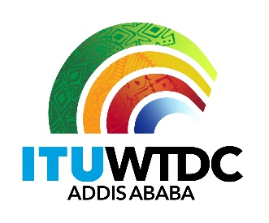 | Telecommunication Development  Advisory Group (TDAG)  29th Meeting, Virtual, 8-12 November 2021 |  | 
 |  | Revision 1 to
 |  | Document TDAG-21/2/13-E
 |  | 8 November 2021
 |  | Original: English
Secretary-General
Draft Agenda of the World Telecommunication
Development Conference (WTDC)

The draft agenda for the forthcoming WTDC is being submitted to TDAG for discussion and endorsement. It will then need to be submitted to Council Member States and later, to all Member States, for their approval.
The text of the agenda is found in annex.

I. Report on the implementation of the Buenos Aires Action Plan
1. Update on global digital transformation and reporting on the implementation of the WTDC-17 Buenos Aires Action Plan (including the Regional Initiatives), contribution to the implementation of the WSIS Plan of Action and the Sustainable Development Goals (SDGs)
2. Report of the Telecommunication Development Advisory Group
3. Report of Study Groups
4. Report on the implementation of outcomes of other ITU Conferences, Assemblies and meetings related to ITU-D work:
a. Plenipotentiary Conference (PP-18)
b. Radiocommunication Assembly (RA-19)/World Radiocommunication Conference (WRC-19)
c. World Telecommunication Standardization Assembly (WTSA-20)
II. ITU-D work plan for 2022-2025
5. Outcomes of Regional Preparatory Meetings for WTDC
6. ITU-D contribution to the ITU Strategic Plan for 2024-2027
7. ITU-D Thematic Priorities
8. ITU-D Action Plan for 2022-2025
9. Addis Ababa Declaration
10. Telecommunication Development Advisory Group
a. Authorization for the Telecommunication Development Advisory Group to act between world telecommunication development conferences (Resolution 24, Rev. Dubai, 2014)
b. Structure and working methods
11. Study Groups
a. Study Questions
b. Structure and working methods
12. Resolutions and recommendations
III. Partner to Connect Digital Coalition (P2C) – non statutory
13. P2C Digital Coalition
14. Any other business
_______________

