 | Telecommunication Development  Advisory Group (TDAG)  29th Meeting, Virtual, 8-12 November 2021 |  | 
 |  | Revision 1 to
 |  | Document TDAG-21/2/8-E
 |  | 27 September 2021
 |  | Original: English
Director, Telecommunication Development Bureau
ITU-D Sector Members, Associates and Academia
Summary:
This document builds on the report presented to the TDAG meeting held from 24 to 28 May 2021 contained in document number TDAG-21/12. It provides an overview of the ITU-D membership evolution in 2021. It also recommends actions aimed at continued strengthening of efforts to recruit and keep more members. ITU-D membership includes Sector Members, Associates and Academia.
Action required:
TDAG is invited to note the document and provide guidance as deemed appropriate.
References:
Resolution 71 (Rev. Buenos Aires, 2017) of WTDC; Resolutions 169 (Rev. Dubai, 2018), 205 (Dubai, 2018) and 209 (Dubai, 2018) of the Plenipotentiary Conference.

- Background
The World Telecommunication Development Conference in 2017 (WTDC-17) revised and adopted Resolution 71 (Rev. Buenos Aires, 2017) to promote active involvement of current Sector Members, Associates and Academia in ITU-D activities, including participation in the work of ITU-D study groups and to attract new members from the public, private and academic sectors.
Resolution 71 (Rev. Buenos Aires, 2017) brought more focus to the role of the private sector in ITU-D, with its instruction to BDT to continue to organize meetings for high-level industry executives e.g. the Industry Advisory Group for Development Issues (IAGDI) and the meeting of Chief Regulatory Officers (CRO).
- ITU-D membership evolution
Chart 1 below illustrates the ITU-D membership evolution (Sector Members, Associates and Academia). The Chart shows absolute figures of new ITU-D Sector Members and Academia by end of December 2020 and those of 2021 (January - September).
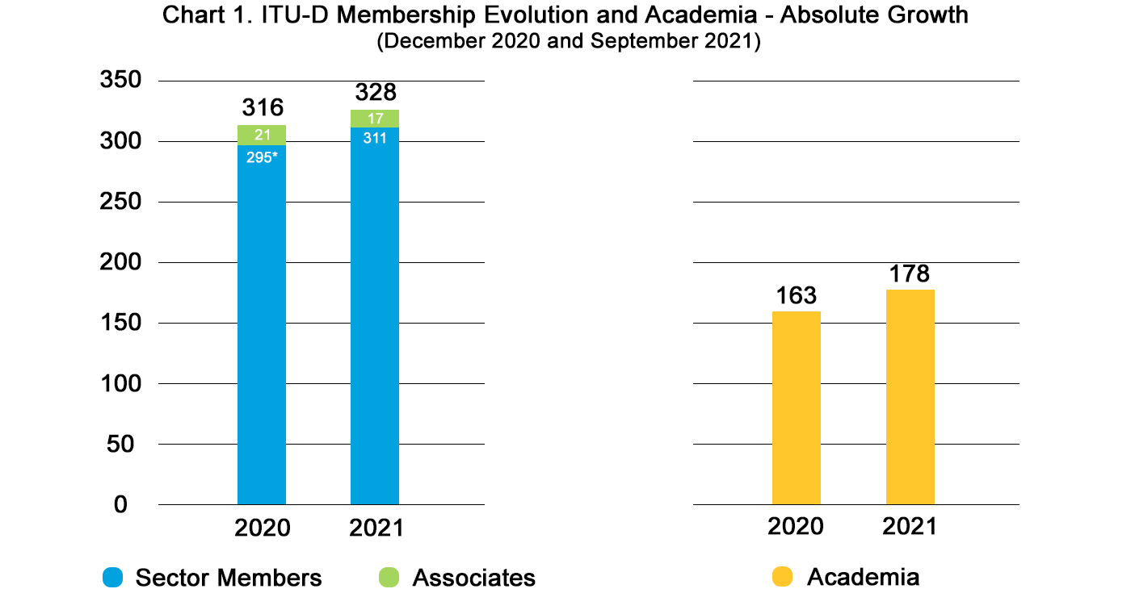
*Three denunciations of longstanding frozen Sector Members received after TDAG-21 were recorded as losses in 2020 according to ITU’s regulations. The original total Sector Member figures for December 2020 s are now officially recorded as 295.
It is worth noting that the number of Associates have decreased mainly due to exclusions resulting from their inability to settle fees. There have been three exclusions and one Associate that upgraded to become a Sector Member.
New Members:
Chart 2 below shows that, as of September of 2021 ITU-D attracted sixteen new Sector Members. Twelve are fully active and four are in the process of finalizing payment. It shows that the number of new entities as of September 2021 is already higher than the total of new members for the full year of 2020 (10 Sector Members and 4 Associates).
Morever, as of September 2021, there are eight additional entities which are expected to join. They are currently pending clearance from their respective administrations as follows:
- Three Sector Members: Alpha Indo Nusa (Indonesia), Science and Advanced Global Technologies Trust (Zimbabwe), Cameroon Telecommunications (Cameroon).
- Five Associates: Acquity Global Services (Nigeria), P2P Network Communications Limited (Trinidad and Tobago), Broadband India Forum (India), TELEGLOBAL Group (Liberia), The Town Owl (United States of America).
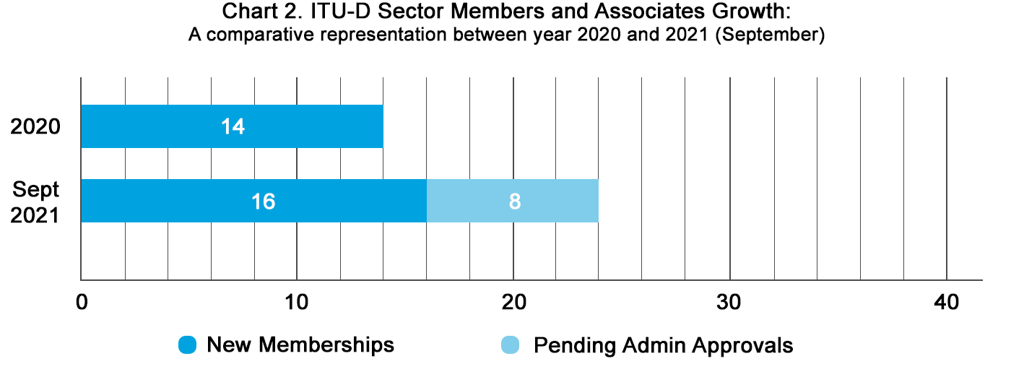
In terms of Academia, Chart 3 shows that in 2021, through efforts coordinated with the General Secretariat, fifteen new Academia have been attracted. Nine are fully active and six are in the process of finalizing payment. Thirteen are currently awaiting administrative approval.
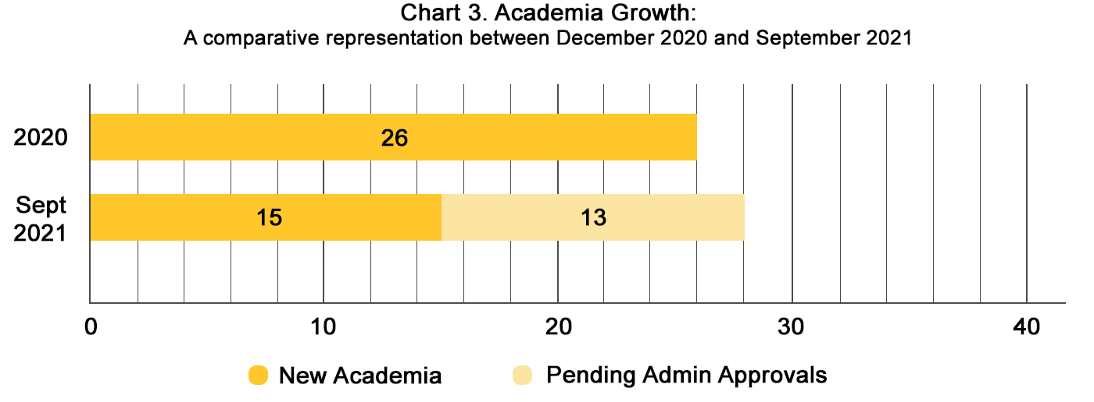
Chart 4 below shows ITU-D Membership and Academia losses compared to 2020. In spite of the increased number of accounts at risk in 2021 due to unsettled fees, the total number of ITU-D Membership and Academia denunciations and exclusions is lower than 2020.
In 2021 ITU-D lost a total of 13 accounts: six denunciations and seven exclusions (due to program closure, review of business strategy, financial difficulties to settle fees or undisclosed reasons undisclosed). A coordinated retention effort involving our field staff resulted in the retention of ten Sector Members’ accounts that were at risk (either by settling fees or reversing the denunciations).
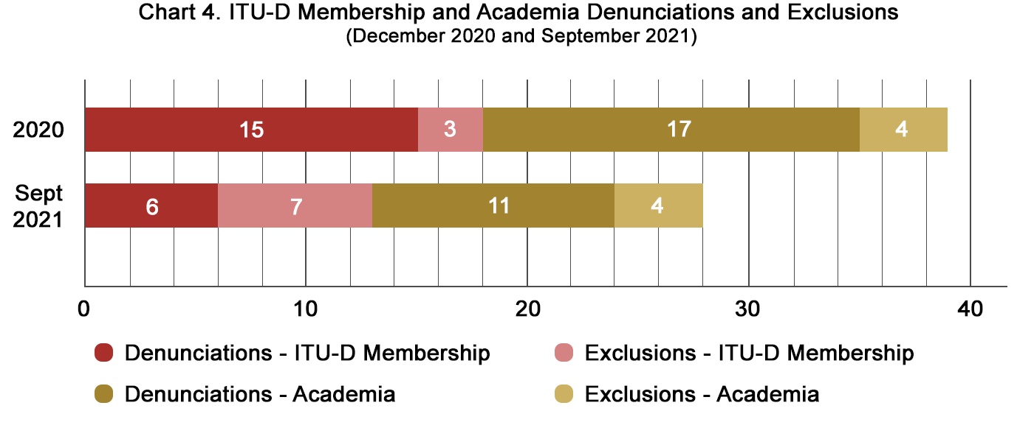
Chart 5 shows the net movements of ITU-D Membership and Academia, with current status as of September 2021. The final figures show that by September 2021 there are 301 Sector Members, 17 Associates and 163 Academia.
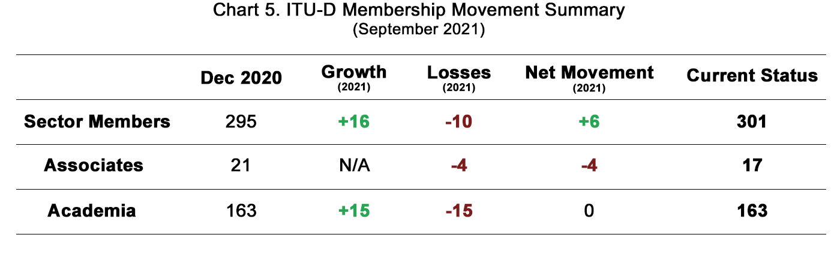
- Engagement, retention, promotion and outreach
In addition to regular membership outreach, engagement and retention actions, the BDT continued to carried out the following:
- The Industry Advisory Group on Development Issues and the Private Sector Chief Regulatory Officers (IAGDI-CRO) meeting was held virtually on June 22, 2021, The Outcome Statement and the Chairman’s Report which can be found here. The upcoming IAGDI-CRO, with an exclusive focus on the Partner2Connect Initiative, will take place on February 2022 at date soon to be defined.
- ITU-D members Testimonials Campaign was launched and will continue to collect C-level industry and private sector members views on the value of ITU-D membership , promoted on ITU events and social media: “Why are we ITU-D Members?” as additional outreach material to new prospects.
- The Know Your Members Series and the Tech Talks Series - launched in 2021 continues to provide a members-only platform for consultations with management and knowledge exchange amongst industry peers and ITU staff. The upcoming Know Your Members session with ITU-D Recognized Operating Agencies (ROA) community will be held on 14 October 2021, The Tech Talks session will be held on 4 November 2021 with the Other Entity membership community. More information can be found here on upcoming and prior meetings.
- Conclusions
BDT is determined to:
- mitigate the impact of COVID-19 by taking measures to attract new Sector Members and retain current ones;
- increase engagement with ITU-D Sector Members in the work of the Sector by demonstrating value. In turn, this has created fertile ground for ITU-D Members to engage in partnerships that unlock financial resources for the financing of high-impact projects and initiatives;
- increase the participation of ITU-D Sector Members in the Sector’s activities and events for impact;
- continuously improve tools and services to facilitate membership engagement and participation.
- Call for Support
Member States are requested and encouraged to engage with their domestic private sector and industry to join ITU-D. Once due diligence is done by Administrations to expeditiously clear the way for applying new Members to pave way for them to complete the joining process. Timely granting of approval by Administrations will encourage applying entities to go through the joining process and not lose interest.
________________

Refer to Resolution 169 (Guadalajara, 2010) of the Plenipotentiary Conference, which enabled the new category of Academia to participate in the work of ITU.
Resolution 71 (Rev. Buenos Aires, 2017), “Strengthening cooperation between Member States, Sector Members, Associates and Academia of the ITU Telecommunication Development Sector and the evolving role of the private sector in the ITU Telecommunication Development Sector.
Axon Partners Group (Spain) , Deloitte Risk Advisory (Italy), New Jersey Fiber Exchange (USA), Security Alliance Limited (UK), Cullen International (Belgium), Amazon.com (USA), Millicom (Luxembourg), Techfugees (UK), Organisation Internationale de la Francophonie (France), Telesat (Canada), Center for Global IT-Federation (Russian Federation) and Hewlett Packard Enterprise (USA), Lulu for Advanced Tech (Sudan), Netflix (USA), Digital Nasional (Malaysia), and Tospay Limited (Kenya).
Academia members participate in the work of all three ITU Sectors, including their advisory groups. They also participate in other global and regional conferences, workshops and activities of the Union, with the exception of plenipotentiary conferences, world radiocommunication conferences, world conferences on international telecommunications and the ITU Council, in conformity with the rules of procedure of the respective Sectors.
Center for Technical and Higher Education (Mexico), Centro Mexico Digital (Mexico), EU Business School (Switzerland), Kadir Has University (Turkey), Shanghai Advanced Research Institute (China), United Arab Emirates University (United Arab Emirates), University of the West of Scotland (United Kingdom), University of Thessaly (Greece), University of Hawaii (USA), State Grid Jiangsu Electric Research Institute (China), State Grid Zheijang Electric Power Co. Ltd Research Institute (China), University of Science and Technology Beijing (China), State Grid Beijing Electric Power Research Institute (China), Konrad Adenauer-Stiftung (Germany), and Universidad Politecnica de Catalunya (Spain).
Loon, (United States of America), Tactikom Africa (Senegal), J.S.C. Silknet (Georgia), Emirates Integrated Telecommunications Company (United Arab Emirates), Bangladesh Communication Satellite Company Limited (Bangladesh), and Altel Communications (Malaysia).
Orange Egypt (Associate), Konkan Railway Corporation, India (Associate), Iranian Net Communication and Electronic Services, Iran (Associate), Office Nationale des Telecommunications, Burundi (Sector Member), Le Consortium du Service Universel, Senegal (Sector Member), Compania Anonima Nacional Telefonos de Venezuela (Sector Member), Agence Tunisienne d’Internet, Tunisia (Sector Member).

