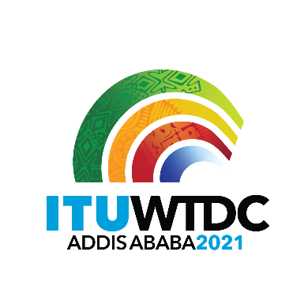 | Telecommunication Development  Advisory Group (TDAG)  28th Meeting, Virtual, 24-28 May 2021 |  | 
 |  | Revision 2 to
 |  | Document TDAG-21/DT/6-E
 |  | 30 May 2021
 |  | English only
Director, Telecommunication Development Bureau
Proposed calendar of meetings for WTDC-21 preparatory process

Dates | Group | Interpretation | Comments
30 June-1 July 2021 | TDAG-WG-RDTP | E only | Virtual
15-16 September 2021 | TDAG-WG-RDTP | E only | Virtual
4 October 2021 | TDAG-WG-SOP | E only | Virtual
11-15 October 2021 | SG1 | Interpreted based on requests at registration | Virtual
18-22 October 2021 | SG2 | Interpreted based on requests at registration | Virtual
8-12 November 2021 | TDAG-21/2 | 6 languages | Number of days to be determined – Geneva?
13-14 December 2021 | IRM-2 | Interpreted based on requests at registration | Geneva?
14-15 March 2022 | IRM-3 | Interpreted based on requests at registration | Geneva?

________________

