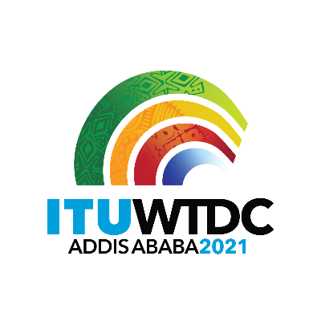 | Telecommunication Development  Advisory Group (TDAG)  28th Meeting, Virtual, 24-28 May 2021 |  | 
 |  | Document TDAG-21/INF/5-E
 |  | 25 May 2021
 |  | English only
Director, Telecommunication Development Bureau
Report on advancement of ICT Development Index

The Secretariat is pleased to report to TDAG that for the 2021 Session of the Council, the Secretary General has prepared a document that provides an overview of the latest developments regarding the attempt to resume the publication of the ICT Development Index. The document is available here.
_________________

