|  |  |  |  |
| --- | --- | --- | --- |
|  | **Telecommunication Development Advisory Group (TDAG)**  **28th Meeting, Virtual, 24-28 May 2021** | |  |
|  | |  | |
|  | | **Document** **TDAG-2****1/7-E** | |
|  | | **13 April 2021** | |
|  | | **Original:** **English** | |
| Director, Telecommunication Development Bureau | | | |
| ITU-D partnership and resource mobilization | | | |
|  | | | |
| **Summary:**  The importance of partnerships and resource mobilization was highlighted by the World Telecommunication Development Conference 2017 (WTDC-17). This document reports on partnerships and resource mobilization activities undertaken in 2020 and in the first quarter of 2021.  **Action required:**  TDAG is invited to note this document and provide guidance as deemed appropriate.  **References:**  ITU Goal 5  Buenos Aires Action Plan, Section 4.5 of the WTDC-17 Final Report  Resolutions 17 (Rev. Buenos Aires, 2017) and 71 (Rev. Buenos Aires, 2017) of WTDC | | | |

1. Background

The World Telecommunication Development Conference 2017 (WTDC-17) highlighted the critical role of partnerships and resource mobilization in supporting the implementation of the Buenos Aires Action Plan, WSIS Action Lines and the Sustainable Development Goals (SDGs).

The WTDC-17 Action Plan indicates that programmes and Regional Initiatives should be, where possible, implemented in partnership with a wide range of stakeholders. Resolution 17 (Rev. Buenos Aires, 2017) instructs BDT to continue to actively conclude partnerships with Member States, ITU-D Sector Members, financial institutions, and international organizations in order to sponsor implementation activities for regional initiatives. The resolution goes on to appeal to international financial organizations/agencies, equipment suppliers and operators/service providers to contribute, fully or partially, to financing these regionally approved initiatives.

1. ITU-D partnership and resource mobilization strategic objective

In accordance with the outcomes of the WTDC-17, the objective is to facilitate, develop and strengthen collaboration with the widest possible range of partners from both developed and developing countries with the goal of enhancing resource mobilization for the implementation of programmes and regional initiatives for sustainable development.

1. Partnerships and results of resource mobilization

Concluding the agreements has been possible thanks to the combined efforts of ITU membership and partners as well as of the BDT staff both in the field and at headquarters.

* 1. Partnership agreements in the first quarter of 2021

In the first quarter of 2021, BDT signed 19 agreements with partners, out of which, 14 have financial contributions amounting to around USD 6.4 million. The list of these agreements can be found in [**Document INF/2**](https://www.itu.int/md/D18-TDAG28-INF-0002/)**.**

The graph below shows the composition of co-financing arrangements between BDT and its partners in the first quarter of 2021.

**Partnership agreements with signed financial contributions (Q1 2021)**

In the first quarter of 2021, BDT’s funding partners were primarily ITU Member States and other Governmental entities followed by UN organizations and private sector entities as follows:

The three funding partners with the largest financial contributions in the first quarter of 2021 were:

* The **Ministry of Industry and Information Technology (MIIT) of the People’s Republic of China**, with a signed financial contribution of about **USD 1.8 million**.
* The **Government of the United Kingdom of Great Britain and Northern Ireland** acting through the Foreign, Commonwealth & Development Office of the United Kingdom, with a signed financial contribution of about **USD 1.4 million**.
* The **King Salman Humanitarian Aid & Relief Centre of Saudi Arabia**, with a signed financial contribution of about **USD 562,500**.

The following graphs show the allocations of financial contributions from the signed agreements per region and per thematic priority.

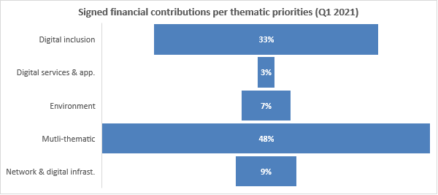

* 1. Partnership Agreements in 2020

In 2020, BDT signed 43 agreements with partners, out of which 28 had financial contributions amounting to around USD 15.2 million. The list of these agreements can be found in [**Document INF/2**](https://www.itu.int/md/D18-TDAG28-INF-0002/).

The graph below shows the composition of co-financing arrangements between BDT and its partners in 2020.

**Partnership agreements with signed financial contributions (in 2020)**

In 2020, BDT’s main funding partners were primarily ITU Member States and other Governmental entities followed by International and Regional Organizations and Associations, Private sector entities, UN organizations, Foundations and Academia.

The three funding partners with the largest financial contributions in 2020 were:

* The **Norwegian Agency for Development Cooperation (NORAD**), with a signed financial contribution of **USD 3.3 million**.
* The **National Cybersecurity Authority (NCA)**, **Saudi Arabia**, with a signed financial contribution of **USD 1.6 million**.
* The **Communications and Information Technology (CITC), Saudi Arabia**, with a signed financial contribution of **USD 1.45 million.**

The following graphs show the of financial contributions from the signed agreements by region and thematic priority.

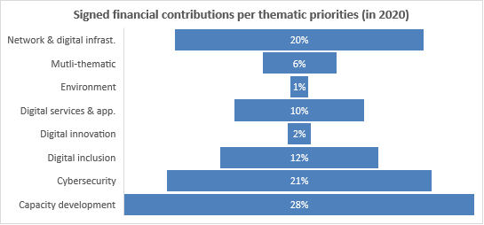

1. Key Actions and Outcomes

BDT has been conducting a series of strategic actions including the development and enhancement of its internal products and external services to enhance partnerships and resource mobilization, such as:

* **Strengthening resource mobilization and partnership building**: A consultancy firm hired to assist the BDT in developing a **new robust and forward-looking resource mobilization strategy and action plan** completed and submitted its work at the end of 2020. BDT further developed a combined Partnerships and Resource Mobilization Strategy aimed at harmonizing the two elements of fundraising i.e., partnerships and resource mobilization. The new strategy is already under implementation.
* **Enhancing staff expertise in resource mobilization**: a virtual training on resource mobilization was organized and successfully delivered through the services of a resource mobilization training consultancy**.** The training, which was based on the BDT’s partnerships and resource mobilization strategy,was deliveredto 91 staff (78 from BDT and 13 from other bureaux). The training provided fundamentals of resource mobilization to staff in the field and at headquarters to equip them with skills to engage, manage, and conclude both financial and non-financial partnership and resource mobilization arrangements with stakeholders.
* **Enhancing Research Tools**: The BDT Resource Mobilization Database and the Funding Partners Prospects Database have been entirely redesigned. The two databases provide information on prospective funding partners (bilateral agencies, development banks, foundations, etc.) including their thematic and geographical priorities.
* **Raising Visibility**:A new common webpage for Partnerships and ITU-D Members was created and launched.The page promotes partnerships among ITU-D members and encourages current members to become partners.The common landing page is available here “[Join ITU-D](https://www.itu.int/en/ITU-D/MembersPartners/Pages/default.aspx)”. The new landing page also provides better visibility for our partners the work we accomplish and with them.

1. Way forward

During the period under review, BDT has made remarkable progress in negotiating and concluding new partnerships and resource mobilization agreements with a diverse group of partners. Ongoing efforts are aimed at consolidating existing partners and attracting new diverse partners that bring more resources to finance large-scale and impactful projects for the successful implementation of WTDC-17 and WTDC-21 programmes and regional initiatives at global, regional and national levels.

_______________