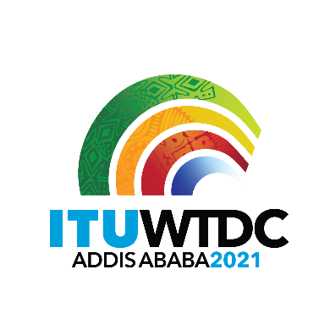 | Telecommunication Development  Advisory Group (TDAG)  28th Meeting, Virtual, 24-28 May 2021 |  | 
 |  | Document TDAG-21/1-E
 |  | 26 March 2021
 |  | Original: English
Director, Telecommunication Development Bureau
Draft agenda

1. Address by the Secretary-General
2. Address by the Director of the Telecommunication Development Bureau
3. Address by other Elected Officials
4. Opening remarks by the Chairman of TDAG
5. Adoption of the agenda and Time Management Plan
6. ITU-D four-year rolling Operational Plan 2022-2025
7. Report on the implementation of the ITU-D Strategic Plan and Operational Plan 2020
8. Reporting on the implementation of the WTDC-17 Buenos Aires Action Plan (including the Regional Initiatives), and contribution to the implementation of the WSIS Plan of Action and the Sustainable Development Goals (SDGs)
9. Preparations for WTDC-21
9.1 Update on the preparations for WTDC-21, including COVID-19 mitigation and contingency measures
9.2 Structure of WTDC-21
9.3 Youth Summit
9.4 Partner2Connect
10. Preparatory process for WTDC-21
10.1 Report on the work of the TDAG-WG-RDTP
10.2 Report on the work of the TDAG-WG-SOP
10.3 Report of the Regional Preparatory Meetings Coordination Meeting (RPM-CM)
10.4 Report of IRM-1 and IRM-2
10.5 Report to WTDC-21 on TDAG activities
11. Report on Study Group activities
12. Collaboration with the other Sectors
13. Membership, Partnership, Private Sector-related matters
14. Report by the Chairman of the Group on Capacity Building Initiatives (GCBI)
15. ITU-D projects
16. Contribution to the work of the Expert Group on the International Telecommunication Regulations (EG-ITR)
17. Measures and Principles for interpretation and translation in ITU
18. Harmonization of ITU websites
18. Calendar of ITU-D events
19. Any other business

_______________

