|  |  |
| --- | --- |
| **Telecommunication Development Advisory Group (TDAG)**  **25th Meeting, Geneva, 2-5 June 2020** | C:\Users\comas\AppData\Local\Temp\Rar$DRa0.735\jpg\ITU official logo_blue_RGB.jpg |
|  |  |
|  | **Document** **TDAG-20/****38-E** |
|  | **17 March 2020** |
|  | **Original:** **English** |
| Director, Telecommunication Development Bureau | |
| APPOINTMENT OF a VICE-CHAIRMAN OF TDAG | |
|  | |
| **Summary:**  Argentina has submitted the nomination of a candidate to the post of vice-chairman of TDAG to replace Mr Hugo Miguel, who has stepped down.  **Action required:**  TDAG is invited to review this document and take a decision concerning the appointment of the new vice-chairman as deemed appropriate.  **References:**  No. 244 of Convention, WTDC Resolution 1 (Rev. Buenos Aires, 2017) and 61 (Rev. Dubai, 2014) | |

The annexes to this document contain the letter from the administration of Argentina, both in Spanish and in English, submitting the nomination of Mr Nicolás Karavaski, as candidate to the position of TDAG Vice-Chairman, and Mr Karavaski’s CV, also in both languages.

**Annex 1**

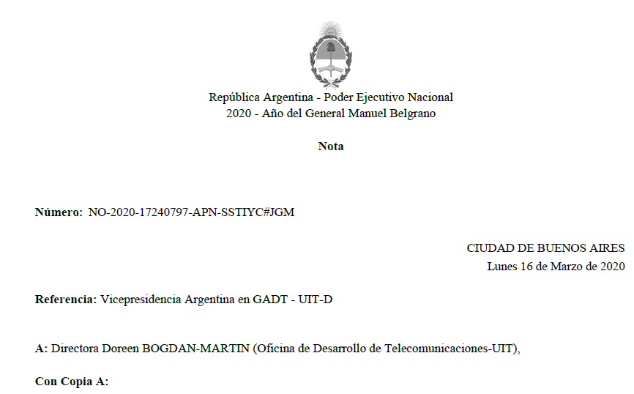

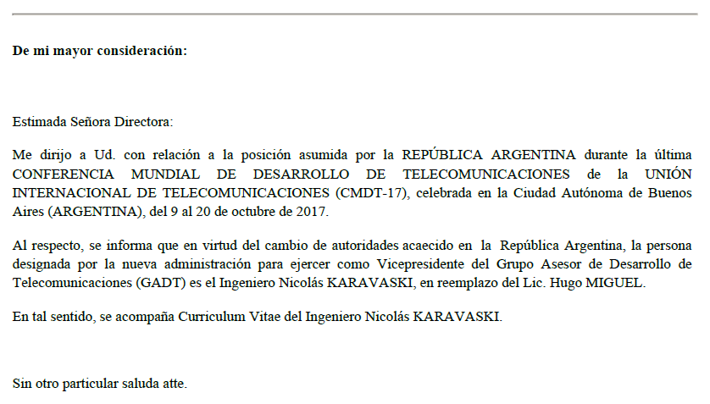

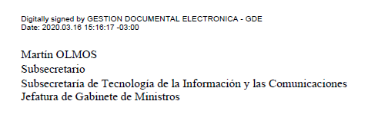

**Annex 2**

NO-2020-17240797-APN-SSTIYC#JGM

Ref: ITU-D / TDAG

(Vice President of Argentina)

Buenos Aires, March 16, 2020

Ms. DOREEN BOGDAN-MARTIN

Madame Director of the

Telecommunication Development Bureau

International Telecommunication Union

Office of the BDT Director

Dear DOREEN BOGDAN-MARTIN,

I am writing to you related to the position assumed by the ARGENTINE REPUBLIC during the last WORLD TELECOMMUNICATION DEVELOPMENT CONFERENCE of the INTERNATIONAL TELECOMMUNICATION UNION (WTDC-17), held in Buenos Aires City (ARGENTINA), from 9 to 20 October, 2017.

In this regard, I would like to inform you that due to changes of authorities that occurred in the Argentine Republic, the person designated by Argentine Administration as Vice President of the Telecommunication Development Advisory Group (TDAG), will be the Engineer Nicolás KARAVASKI, replacing Mr. Hugo MIGUEL.

In this sense, the Curriculum Vitae of Engineer Nicolás KARAVASKI is attached.

Yours faithfully,

Mr. Martín OLMOS –

Undersecretary of Information Technologies and Communications (SPI)

Argentine Republic

**Annex 3**





**Annex 4**



