|  |  |
| --- | --- |
| **Telecommunication Development Advisory Group (TDAG)**  **25th Meeting, Geneva, 2-5 June 2020** | C:\Users\comas\AppData\Local\Temp\Rar$DRa0.735\jpg\ITU official logo_blue_RGB.jpg |
|  |  |
|  | **Document** **TDAG-20/****3-E** |
|  | **5 February 2020** |
|  | **Original:** **English** |
| Director, Telecommunication Development Bureau | |
| ITU-D CONTRIBUTION TO THE IMPLEMENTATION OF THE WSIS OUTCOMES  AND THE 2030 AGENDA FOR SUSTAINABLE DEVELOPMENT | |
|  | |
| **Summary:**  This document provides an update on the contribution of the ITU Telecommunication Development Sector (ITU-D) to the implementation of the outcomes of the World Summit on the Information Society (WSIS) and the 2030 Agenda for Sustainable Development.  **Action required:**  TDAG is invited to note this document and provide guidance as deemed appropriate.  **References:**  Resolution 30 (Rev. Buenos Aires, 2017) of the World Telecommunication Development Conference (WTDC), Resolution 140 (Rev. Dubai, 2018) of the Plenipotentiary Conference, and Resolution 1332 (Rev. 2016) of the ITU Council | |

**Introduction**

1. The [ITU Plenipotentiary Conference 2018](https://www.itu.int/web/pp-18/en/), held from 29 October to 16 November 2018 in Dubai, United Arab Emirates, reconfirmed the mandate of ITU and its contribution to the implementation of the action lines of the World Summit on the Information Society (WSIS) and achievement of the Sustainable Development Goals (SDGs). The  [World Telecommunication Development Conference](https://www.itu.int/en/ITU-D/Conferences/WTDC/WTDC17/Pages/default.aspx) (WTDC-17), held from 9 to 20 October 2017 in Buenos Aires, Argentina, established clear links between ITU-D objectives, outcomes and outputs, and relevant WSIS action lines and SDGs and targets (Annex 1). The mapping of ITU-D study group Questions and WSIS action lines and SDGs provides additional guidance on the contribution of these study groups to WSIS and SDG processes (Annex 2). In this sense, all actions carried out by ITU-D are contributing to the achievement of SDGs and the WSIS implementation. They are reported to the ITU membership through TDAG, regional development forums (RDFs) and the Council Working Group on WSIS (CWG-WSIS) on a regular basis.
2. Flagship activities undertaken by BDT constitute a substantive part of the annual reporting through the *ITU Contribution to the Implementation of the WSIS outcomes*. The 2019 edition of this report is available at <https://www.itu.int/en/itu-wsis/Pages/Contribution.aspx>.

**Specific BDT actions related to WSIS and SDGs**

1. In line with the resolves in Resolution 140 (Rev. Dubai, 2018) of the Plenipotentiary Conference and Resolution 30 (Rev. Buenos Aires,2017) of WTDC, BDT has been contributing to the implementation of the WSIS outcomes and the 2030 Agenda for Sustainable Development as follows:
   1. **Facilitation of WSIS action lines:** On behalf of ITU, BDT has been acting as focal point and facilitator of Action Line C2 (Information and communication infrastructure) and C6 (Enabling environment). BDT has also been implementing a number of activities in the context of WSIS Action Line C5 (Building confidence and security in the use of ICTs), where ITU is the sole facilitator. In 2019, WSIS action lines were updated at the request of the membership.

In coordination with the United Nations Development Programme (UNDP) and the United Nations Educational, Scientific and Cultural Organization (UNESCO), BDT has also been acting as interim focal point for WSIS Action Line C4 (Capacity building). The Bureau has been acting as the official ITU focal point for most of the WSIS action lines, including C1, C3, C4, C7 and C11, where ITU is the co-facilitator, and C9, where ITU is a partner.

* 1. **Partnership on Measuring ICT for Development**: BDT continues to lead the Partnership on Measuring ICT for Development, an international, multistakeholder initiative to improve the availability and quality of ICT data and indicators. The Partnership is actively engaged in monitoring the Sustainable Development Goals. Several SDG targets refer to ICTs and technology, highlighting the need to include specific ICT indicators in the monitoring framework.

The global SDG indicators framework, which helps to monitor progress, identify challenges, and guide policy-makers, contains 231 indicators. However, only seven of those indicators are ICT indicators, covering six targets under Sustainable Development Goals 4, 5, 9, and 17. Five of the seven indicators are collected and disseminated by ITU.

It is important that all areas where ICTs will play a role are measured and monitored. To this end, the Partnership’s Task Group on ICT for SDGs, co-led by ITU and UNDESA (United Nations Department of Economic and Social Affairs), developed a thematic list of 26 ICT indicators[[1]](#footnote-1) that can be used to measure ICT availability and use in sectors relevant to the SDGs that are not covered in the global SDG indicators framework. The 26 ICT indicators relate to 27 SDG targets belonging to 11 Goals. The Partnership has endorsed and submitted the thematic list to the 51st session of the United Nations Statistical Commission planned for March 2020. The Commission is asked to endorse the thematic list of ICT indicators for monitoring progress towards implementation of the 2030 Agenda.

**Measurement:** In line with the WSIS outcomes, BDT continues to facilitate the international debate on measuring ICT for development. In 2019 BDT released the report, *Measuring digital development: Facts and figures 2019*.This first publication in ITU's new *Measuring digital development* series offers a snapshot of the most important ICT indicators, including estimates for 2019. The World Telecommunication/ICT Indicators Symposium (WTIS) is the main global forumfor telecommunication and information society measurements. WTIS-20 will be held in Geneva, Switzerland, from 15 to 17 April 2020.

* 1. **WSIS Forum:** BDT contributed to the preparatory process and organization of the 2019 edition of the WSIS Forum, held from 8 to 12 April, and led a number of thematic streams of the Forum, while fostering partnership building and project generation as presented in the [outcome document](https://www.itu.int/net4/wsis/forum/2019/Home/Outcomes#documents). In 2020, the agenda of the WSIS Forum – to be held from 6 to 9 April in Geneva, Switzerland – will also benefit from a series of sessions led by BDT, including the following:
* WSIS Action Line Facilitation Meetings
* WSIS AL C2: ICT infrastructure
* WSIS AL C4: Capacity building
* WSIS AL C5: Cybersecurity (contributing role, SPM leads)
* WSIS AL C6: Enabling environment
* WSIS AL C7: E-waste (ITU/UNEP)
* WSIS AL C7: E-environment (ITU/WMO)
* WSIS AL C7: E-agriculture (ITU/FAO)
* WSIS AL C7: E-health (ITU/WHO)
* High-Level Dialogue
* Saving lives in disaster using ICTs
* Annual meeting of the Partnership on Measuring ICT for Development
* Special track
* Innovation Track @ WSIS Forum
* Sport Track
* Accessibility Track.

In addition, BDT will organize a number of thematic workshops and sessions focusing on gender equality, child online protection, school connectivity, broadcasting and digital skills, among others. BDT will also contribute to a series of High-Level Interactive Dialogues, WSIS Action Line Facilitation Meetings for WSIS AL C1 (Role of governments), C11 (International cooperation), C7 (e-science, e-learning, e-government) and the WSIS Action Line Facilitators Meeting.

* 1. **WSIS Prizes**: BDT continues to play a significant role in the review committee of the WSIS Prize process and follow-up activities related to partnership building and exchange of best practices. Eighteen WSIS Prizes are awarded annually, with special recognition of the prize winners for their contribution to the WSIS action lines as facilitators. In 2020, over 800 ICT for SDG projects have been reviewed and nominated for the voting phase, thanks to the contribution of BDT.
  2. **ITU-D study groups**: As a follow-up to WTDC-17, ITU-D study group Questions have been mapped onto the WSIS action lines and SDGs, providing additional guidance on how these study groups can contribute to both processes (see Annex 2). ITU-D study groups value rich content shared by stakeholders within the WSIS platform and the opportunities that exist for outreach and exchange that can be undertaken with diverse stakeholders, who participate in the WSIS process.

During ITU-D Study Group 1 and Study Group 2 rapporteur group meetings, which took place from 23 September to 18 October 2019 in Geneva, a document prepared by BDT ([SG1RGQ/258](https://www.itu.int/md/D18-SG01.RGQ-C-0258/en) and [SG2RGQ/167](https://www.itu.int/md/D18-SG02.RGQ-C-0167/en)) further explored benefits and possible next steps for collaboration between these study groups and the WSIS platform. This was a follow-up to an earlier document ([1/207](https://www.itu.int/md/d18-sg01-c-0207) and [2/190](https://www.itu.int/md/d18-sg02-c-0190)) which considered possible linkages between the WSIS Prizes Winner and Champion projects in 2018 and 2019 and ITU-D Study Group 1 and Study Group 2 Questions. The new document highlighted, among other things, the usefulness of the WSIS Stocktaking Database and invited study group members to explore the projects in this database for possible synergies with the ongoing work and planned deliverables.

As a result, a session focusing on the work of ITU-D study groups will be held during WSIS Forum 2020 in order to increase opportunities for collaboration with the WSIS platform. In addition, the chairmen, vice-chairmen, and rapporteurs and vice-rapporteurs of both ITU-D study groups will participate as speakers and active contributors to the different sessions and WSIS action line sessions, promoting outcomes of their study groups.

* 1. **Special initiatives**: BDT continues to support a number of special initiatives to encourage partnerships which have been given high priority pursuant to the WSIS outcomes and the 2030 Agenda for Sustainable Development. These include the Broadband Commission for Sustainable Development and the EQUALS Global Partnership. In 2019, ITU and UNICEF (United Nations Children's Fund) joined forces in a bid to connect every school to the Internet by 2030, launching a special initiative “[GIGA – Connecting Every School to the Internet](https://www.itu.int/en/ITU-D/Initiatives/GIGA)”. This initiative aims to bring the power of meaningful connectivity to fast track young people's access to educational resources and opportunities.
  2. **WSIS and SDGs implementation at the regional level**: In line with Resolution 140 (Rev. Dubai, 2018) of the Plenipotentiary Conference , ITU regional offices continue to undertake actions to strengthen coordination and collaboration at the regional level with the UN regional economic commissions and the UN Regional Sustainable Development Groups, as well as all UN agencies (in particular those acting as facilitator for WSIS action lines) and other relevant regional organizations, especially in the field of telecommunications/ICTs.

ITU regional offices continue to proactively contribute to the meetings of the UN regional coordination mechanisms and UN Regional Sustainable Development Groups, advocating the enabling role of ICTs for SDGs, adapting to the process of UN Development System Repositioning, identifying ways to incorporate ICTs in the UN sustainable development assistance frameworks and the projects delivered by other sister agencies, while developing strategic partnerships with regional counterparts within the UN system and other relevant stakeholders. To continue fostering partnerships for meaningful connectivity for all, and in light of the implementation of the regional initiatives, ITU, UNHCR and the GSMA co-sponsored a session at the first ever Global Refugee Forum, in December 2019, that explored challenges around delivering connectivity for refugees, displaced persons, and the communities that host them.

Building upon the process of monitoring the national sustainable development plans and national voluntary reviews on SDGs carried out by Member States, continuous efforts are made in order to strengthen the role of ICTs at the strategic planning level of countries.

ITU regional offices continue to contribute to the series of *UN Regional Forums for Sustainable Development*, held on an annual basis in six regions. A number of thematic sessions, targeted interventions, and exhibitions were organized in 2019 in order to forge multistakeholder partnerships and advance implementation of ICTs for SDGs projects and initiaitves, while aligning WSIS action lines and SDGs. A series of UN Regional Forums on Sustainable Development are also planned for 2020 as follows:

* [ECA: 6th session of the Africa Regional Forum on Sustainable Development](https://www.uneca.org/arfsd2020)  
  24–27 February 2020, Victoria Falls Town, Zimbabwe.
* [UNECE: 3rd session of the Regional Forum on Sustainable Development for the UNECE region](http://www.unece.org/rfsd2020.html); 19–20 March 2020, Geneva, Switzerland.
* [ESCAP: 7th session of the Asia-Pacific Forum on Sustainable Development](https://www.unescap.org/apfsd/7/)  
  25–27 March 2020, Bangkok, Thailand.
* [ECLAC: 4th session of the Forum of the countries of Latin America and the Caribbean on Sustainable Development;](https://foroalc2030.cepal.org/2019/en) 28-31 March 2020, Havana, Cuba.
* ESCWA: 7th session of the Arab Forum for Sustainable Development 2020  
  7-9 April 2020, Beirut, Lebanon.

Apart from the regular contributions of the ITU regional offices to those meetings, special interventions have been scheduled with the aim to underline the importance of aligning WSIS and SDG processes and their implementation, as requested by UNGA Resolution 70/125.

Working together, under the aegis of the Global Initiative on Decent Jobs for Youth, the International Labour Organization (ILO) and the International Telecommunication Union (ITU), with the support of the African Union (AU), developed a comprehensive approach to youth employment creation in the digital economy, “Boosting decent jobs and enhancing skills for youth in Africa’s digital economy”. An information and awareness-raising session will be held as a side event to the 6th session of the Africa Regional Forum on Sustainable Development 24–27 February 2020, Victoria Falls Town, Zimbabwe.

Building on the partnership with UN-ESCWA, the [Arab High-Level Forum (AHLF) on the World Summit on the Information Society (WSIS) and 2030 Agenda for Sustainable Development](https://www.unescwa.org/events/arab-forum-wsis-sdgs-2019) was organized. The event aimed to shed light on the need for collaboration between all stakeholders to achieve the 2030 Agenda for Sustainable Development and the SDGs in the Arab region.

The ITU Regional Office for the Arab States had organized two sessions as part of AHLF event:

* Session on Smart Cities and New Urban Agenda: The session presented the Smart Sustainable Cities (SSC) as approach to implement the New Urban Agenda and shared ITU works on SSC, IoT and KPIs to measure the progress of cities transition to smart and sustainable model. The session presented the Beirut Smart city project implemented by OGERO as well as the ITU’s regional initiative on IoT, Smart Cities and Big Data.
* Session on Cybersecurity in the Arab Region: The Session shared the ITU’s Global Cybersecurity Agenda (GCA), BDT Cybersecurity Program and promote confidence and security in the use of telecommunications/ information and communication technologies (ICTs), critical information infrastructure protection and discuss key aspects and challenges of cybersecurity in the Arab region. In addition, the session promoted the ITU’s regional initiative on confidence and security in the use of telecommunications/ information and communication technologies (ICTs).

Four ITU regional development forums (RDFs) were organized in 2019 (see dedicated [website](https://www.itu.int/en/ITU-D/Pages/rdf_2019.aspx)).

* ITU Regional Development Forum for the Arab States took place on 19 March 2019 in Beirut, Lebanon, as part of the Arab High Level Forum for WSIS and SDGs organized by UNESCWA.
* ITU Regional Development Forum for the Americas took place on 30 September 2019 in Asunción, Paraguay.
* ITU Regional Development Forum for the Commonwealth of Independent States (CIS) took place from 2 to 3 October 2019 in Bishkek, Kyrgyz Republic.
* ITU Regional Development Forum for Europe took place on 6 May 2019 in Rome, Italy.

These forums provided an open platform for partnership building and for coordinating implementation of the regional initiatives approved by WTDC-17 and aimed at contributing to the implementation of the WSIS action lines and achievement of SDGs. Following recommendations of TDAG-19, agendas of RDFs included issues related to the implementation of WSIS and SDGs. RDFs continue to serve as platforms to engage regional stakeholders, help in developing partnerships and involve regional/international organizations and UN agencies. Another series of RDFs is scheduled for 2020.

**Conclusions**

1. The ITU membership is invited to actively engage in BDT activities contributing to the implementation of the WSIS outcomes and the 2030 Agenda for Sustainable Development, in line with WTDC-17.
2. The ITU membership is invited to actively engage in the preparatory processes related to the WSIS Forums, WSIS Stocktaking and WSIS Prizes.
3. At the national level, the ITU membership is encouraged to mainstream ICTs in the sustainable development plans and UN development assistance frameworks as well as consider supporting ITU efforts in delivering on ICTs for SDGs through the UN’s “Delivering as One” approach, taking into account ITU’s core competencies and mandate.
4. Member States are invited to reinforce their capacities in the collection of statistics and indicators required for SDG measurement.
5. At the regional level, all stakeholders are invited to engage in the preparations of the regional development forums, UN forums on Sustainable Development, specific regional WSIS/SDG events and other events, highlighting the importance of ICTs for SDGs and alignment between WSIS and SDG processes and taking into account the results of WTDC-17.
6. The ITU membership is invited to actively engage in BDT activities with the aim of developing partnerships and contributing to the implementation of the WSIS outcomes and achievement of SDGs, including implementation of regional initiatives approved by WTDC-17; this includes facilitating engagement of stakeholders from other sectors than ICTs/telecommunications.
7. The ITU membership is encouraged to build upon the assistance provided to countries in the field of digital transformation, which fosters sustainable growth of the digital economy, as well as advances in the implementation of WSIS action lines and achievement of SDGs.
8. The ITU membership is invited to submit contributions to the Telecommunication Development Advisory Group and to the relevant ITU-D study groups, where appropriate, and contribute to CWG-WSIS on implementing WSIS outcomes within ITU's mandate, taking into account the 2030 Sustainable Development Agenda.

**ANNEX 1**

**ITU-D contribution to the ITU strategic plan for 2020-2023:   
Objectives, Outcomes, SDGs and WSIS action lines**

| Objectives | D.1 Coordination: Foster international cooperation and agreement on telecommunication/ICT development issues | D.2 Modern and secure telecommunication/ICT Infrastructure: Foster the development of infrastructure and services, including building confidence and security in the use of telecommunications/ICTs | D.3 Enabling environment: Foster an enabling policy and regulatory environment conducive to sustainable telecommunication/ICT development | D.4 Inclusive digital society: Foster the development and use of telecommunications/ICTs and applications to empower people and societies for sustainable development |
| --- | --- | --- | --- | --- |
| Outcomes | **D.1-1**: Enhanced review and increased level of agreement on the ITU-D contribution to the ITU strategic plan, the World Telecommunication Development Conference (WTDC) Declaration, and the WTDC action plan.  Contributes to achievement of SDG Goals 1, 3, 5, 10, 16 and 17  Contributes to facilitation of implementation of WSIS AL C1 and C11  **D.1-2**: Assessment of the implementation of the WTDC action plan and of the WSIS Plan of Action.  Contributes to achievement of SDG Goals 1, 3, 5, 10, 16 and 17  Contributes to facilitation of implementation of WSIS AL C1 and C11  **D.1-3**: Enhanced knowledge-sharing, dialogue and partnership among ITU membership on telecommunication/ICT issues.  Contributes to achievement of SDG Goals 1, 3, 5, 10, 16 and 17  Contributes to facilitation of implementation of WSIS AL C1 and C11  **D.1-4:** Enhanced process and implementation of telecommunication/ICT development projects and regional initiatives.  Contributes to achievement of SDG Goals 1 and 17  Contributes to facilitation of implementation of WSIS AL C1 and C11  **D.1.5**: Facilitation of agreement to cooperate on telecommunication/ICT development programmes between Member States, and between Member States and other stakeholders in the ICT ecosystem, based on requests from ITU Member States involved  Contributes to achievement of SDG Goals 1 and 17  Contributes to facilitation of implementation of WSIS AL C1 and C11 | **D.2-1**: Enhanced capacity of ITU membership to make available resilient telecommunication/ICT infrastructure and services.  Contributes to achievement of SDG Goals 1, 3, 5, 8, 9, 10, 11, 16 and 17  Contributes to facilitation of implementation of WSIS AL C1, C2, C3, C9, and C11  **D.2-2**: Strengthened capacity of Member States to effectively share information, find solutions, and respond to threats to cybersecurity, and to develop and implement national strategies and capabilities, including capacity building, encouraging national, regional and international cooperation towards enhanced engagement among Member States and relevant players.  Contributes to achievement of SDG Goals 4, 9, 11, 16 and 17  Contributes to facilitation of implementation of WSIS AL C5  **D.2-3**: Strengthened capacity of Member States to use telecommunications/ICTs for disaster risk reduction and management, to ensure availability of emergency telecommunications, and support cooperation in this area.  Contributes to achievement of SDG Goals 1, 3, 5, 11 and 13  Contributes to facilitation of implementation of WSIS AL C2 and C7 | **D.3-1**: Strengthened capacity of Member States to enhance their policy, legal and regulatory frameworks conducive to development of telecommunications/ICTs.  Contributes to achievement of SDG Goals 2, 4, 5, 8, 9, 10, 11, 16, and 17  Contributes to facilitation of implementation of WSIS AL C6  **D.3-2:** Strengthened capacity of Member States to produce high-quality, internationally comparable telecommunication/ICT statistics which reflect developments and trends in telecommunications/ICTs, based on agreed standards and methodologies.  Contributes to achievement of SDG Goals 1 - 17  Contributes to facilitation of implementation of WSIS AL C1 - C11  **D.3-3**: Improved human and institutional capacity of the ITU membership to tap into the full potential of telecommunications/ICTs.  Contributes to achievement of SDG Goals 1, 2, 3, 4, 5, 6, 12, 13, 14, 16 and 17  Contributes to facilitation of implementation of WSIS AL C4  **D.3-4:** Strengthened capacity of the ITU membership to integrate telecommunication/ICT innovation in national development agendas and to develop strategies to promote innovation initiatives, including through public, private, and public-private partnerships.  Contributes to achievement of SDG Goals 1, 2, 3, 4, 5, 9, 12, 16 and 17  Contributes to facilitation of implementation of WSIS AL C1, C2, C3, C4, C5, C6, C7, and C11 | **D.4-1**: Improved access to and use of telecommunications/ICTs in least developed countries (LDCs), small island developing states (SIDS) and landlocked developing countries (LLDCs) and countries with economies in transition.  Contributes to achievement of SDG Goals 1, 3, 7, 8, 9, 11, 13 and 17  Contributes to facilitation of implementation of WSIS AL C2 and C6 and C7  **D.4-2**: Improved capacity of the ITU membership to accelerate economic and social development by leveraging and using new technologies and telecommunication/ICT services and applications.  Contributes to achievement of SDG Goals 2, 3, 4, 6, 7 and 11  Contributes to facilitation of implementation of WSIS AL C7  **D.4-3:** Strengthened capacity of the ITU membership to develop strategies, policies and practices for digital inclusion, in particular for the empowerment of women and girls, persons with disabilities and other persons with specific needs.  Contributes to achievement of SDG Goals 4, 5, 8, 10 and 17  Contributes to facilitation of implementation of WSIS AL C1, C2, C3, C4, C5, C6, C7, C8 and C9  **D.4-4:** Enhanced capacity of the ITU membership to develop telecommunication/ICT strategies and solutions on climate-change adaptation and mitigation and the use of green/renewable energy.  Contributes to achievement of SDG Goals 3, 5, 11, 12 and 13  Contributes to facilitation of implementation of WSIS AL C7 |

**ANNEX 2**

**ITU-D study group Questions (2018-2021) and the contribution to the implementation of the WSIS action lines and achieving SDGs**

**Study Group 1: Enabling environment for the development of telecommunications/ICTs**

**Study Group 2: ICT services and applications for the promotion of sustainable development**

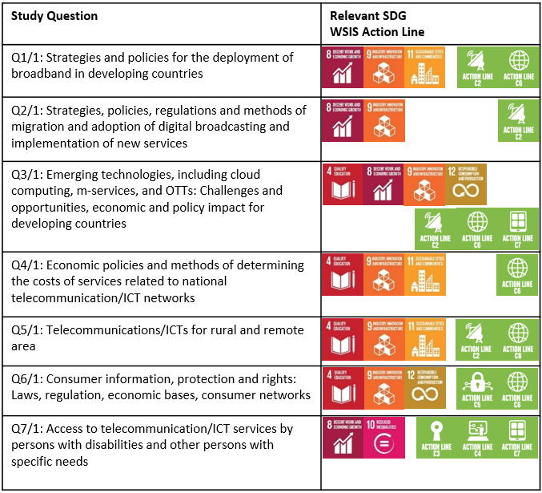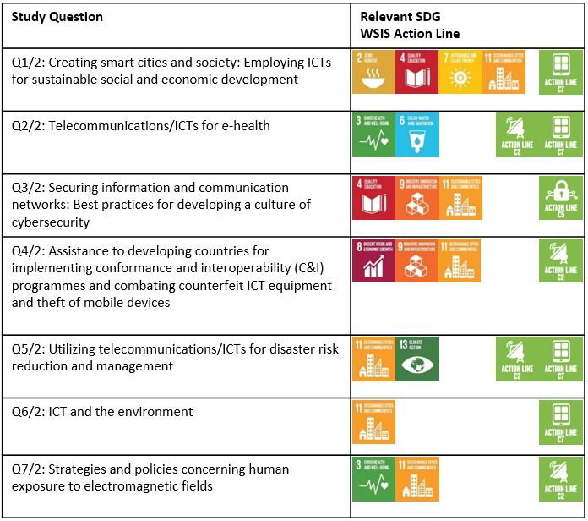

\_\_\_\_\_\_\_\_\_\_\_\_\_\_\_\_

1. See <https://www.itu.int/en/ITU-D/Statistics/Documents/intlcoop/partnership/Thematic_ICT_indicators_for_the_SDGs.pdf> [↑](#footnote-ref-1)