|  |  |
| --- | --- |
| **Telecommunication Development Advisory Group (TDAG)**  **24th Meeting, Geneva, 3-5 April 2019** | C:\Users\comas\AppData\Local\Temp\Rar$DRa0.735\jpg\ITU official logo_blue_RGB.jpg |
|  |  |
|  | **Document** **TDAG-19/INF/2-E** |
|  | **2 April 2019** |
|  | **English only** |
| Director, Telecommunication Development Bureau | |
| Meeting facilities and general information | |
|  | |

**1. Registration**

The opening session of the 24th TDAG meeting will take place at 10:30 hours on Wednesday, 3 April 2019. The opening session will be preceded by an information session for newcomers at 09:30 hours in room Popov. Participant registration will begin at 08:00 hours in the entrance to ITU’s Montbrillant building.

Once you have collected your delegate badge at Montbrillant registration desk, you will be allowed entry and exit at ITU Tower and Montribllant building during the period indicated on your badge. Delegates can enter during weekdays 24 hrs at Montribllant, and from 08:00 to 20:00 hours at ITU Tower. They may also exit through the three doors 24 hrs.

**2. Room allocation**

The allocation of rooms is displayed on the screens. It is planned that all sessions of TDAG will take place in the Popov room.

A number of events linked to TDAG will be taking place in addition to the formal TDAG meetings. All information is available in document [TDAG-19/DT/1](https://www.itu.int/md/D18-TDAG24-190403-TD-0001/).

**3. Printers and computers**

As indicated in the Circular [BDT/TDAG/011](https://www.itu.int/md/D18-BDT-CIR-0011/), of 8 January 2019, the meeting is paperless; however, printers are available in the *cyber café* on the second basement level of the Tower building and near the major meeting rooms.

There are 3 options for printing:

* **Cyber café:** Print from one of the cyber café computers.
* **Local install:** Install a printer on your laptop, once connected to the WiFi.   
  The printer driver will be installed on your laptop. Please see [this document](http://www.itu.int/dms_pub/itu-t/oth/37/02/T37020000010004PDFE.pdf) for details, taken from the ITU Delegate’s corner (<http://www.itu.int/en/delegates-corner>).
* **E-Print:** Send an email, with the document to be printed attached, to the printer (in the form [printername@eprint.itu.int](mailto:printername@eprint.itu.int)). No driver installation is necessary. The printers have a sticker with their names on them. Again, please refer to [this document](http://www.itu.int/dms_pub/itu-t/oth/37/02/T37020000010004PDFE.pdf) for further information.

Also, the ITU Service Desk ([servicedesk@itu.int](mailto:servicedesk@itu.int)) has available a limited number of laptops on a first-come, first-served basis, for those who do not have one. A request form for the loan of a laptop is available from the Service Desk, as well as the registration desk located at the Montbrillant entrance.

**4. Webcast link:**

This meeting will be webcast in all languages of the meeting and can be accessed from [this link](https://www.itu.int/webcast/live2/2018tdag).

**5. Remote participation in the six UN languages**

Remote participation in the six UN languages will be available during the three days of TDAG meeting (9-11 April 2018) for TDAG plenaries.

If you wish to participate remotely in the TDAG meeting, please [register online](https://www.itu.int/net4/ITU-D/CDS/meetings/registration/index.asp) and indicate so on your registration form. The secretariat will get in touch with you upon reception of your request.

**6. Captioning:**

Captioning will be available on the following link: <http://www.streamtext.net/player?event=ITU-D>.

**7. WiFi facilities**

Wireless LAN facilities are available for use by delegates in the ITU main conference room areas.

To connect to ITUwifi:

1. Click the WiFi icon in the notification tray. This will show a list of available WiFi networks.
2. Choose "ITUwifi" and click the Connect button.
3. Enter the security code: "itu@GVA1211".

Detailed information is available on the website <https://www.itu.int/en/general-secretariat/ICT-Services/Pages/default.aspx>

**8. Audio Controls in Room Popov**

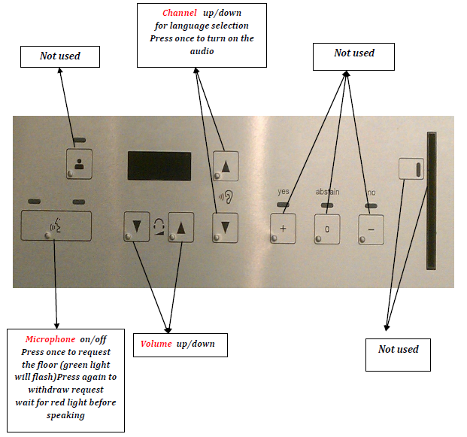

**9. Newcomer information**

A newcomer orientation session is organized on 3 April 2019, at 09:30 hours Geneva local time in meeting room Popov.

Information document ITU-D Delegate Guide ([INF/1](http://www.itu.int/md/D14-TDAG20-INF-0001/)) is intended to help delegates − particularly newcomers − to quickly set up and make best use of their time during the meeting.

**10. Synchronization of TDAG documents**

The documents synchronization application, available for PC and Mac, is available for staff and delegates for TDAG. It allows you to keep a structured local copy of files as they evolve during the meeting. There are links on the [TDAG meeting’s home page](https://www.itu.int/en/ITU-D/Conferences/TDAG/Pages/TDAG24/default.aspx) for both PC and Mac versions.

Follow the on-screen instructions and you will be able to view all TDAG meeting documents for this meeting. You can resynchronize at any time, allowing you to access these documents offline.

**12. Contact information**

* TDAG Secretariat  
  Mr Yushi Torigoe  
  Tel. +41 22 730 5784  
  E-mail: [tdag-secretariat@itu.int](mailto:tdag-secretariat@itu.int)
* TIES Help Desk  
  ITU Office Varembé Building V29  
  Tel. +41 22 730 6666 (6666 from any ITU phone)   
  E-mail: [servicedesk@itu.int](mailto:servicedesk@itu.int)
* Medical Service  
  Office V16  
  Tel. +41 22 730 5397 (5397 from any ITU phone)

\_\_\_\_\_\_\_\_\_\_\_\_\_\_\_