|  |  |  |
| --- | --- | --- |
| **Telecommunication Development Advisory Group (TDAG)**  **23rd Meeting, Geneva, 9-11 April 2018** | P:\SUP\Logos\Post-150th Anniv\ITU-logo-UNblue.jpg | |
|  |  |
|  | **Document** **TDAG-18/****34-E** |
|  | **27 March 2018** |
|  | **English only** |
| Japan | |
| PROPOSAL TO HOLD A PANEL SESSION ON EARLY WARNING SYSTEMS  during THE FIRST ITU-D SG2 MEETING | |
|  | |
| **Summary:**  This document proposes to hold a panel session on Early Warning System (EWS) including safety confirmation system during the first ITU-D Study Group 2 (SG2) meeting in May 2018, in order to share experiences and knowledge for use of EWSs amongst ITU-D members. This panel session would be helpful to gather information and to prepare an annual and final report of Q5/2.  **Action required:**  TDAG is invited to discuss this proposal and agree to hold a workshop or a panel session on EWS.  **References:**  Resolution 2 (Rev. Buenos Aires, 2017), Resolution 35 (Rev. Buenos Aires, 2017) | |

# 1. Introduction

Many disasters have occurred in the world in recent years. Natural or man-made disasters can negatively impact societies, causing disruption of the normal functioning of social and economic life. These negative impacts require an immediate response from authorities and from citizens in order to help those impacted and to re-establish acceptable thresholds of well-being and living conditions. The combination of hazards, vulnerability and inability to reduce the potential negative consequences of risk results in disaster. Because most disasters cannot be predicted, preparedness and disaster risk management are crucial to saving lives and protecting property. It is also important to consider risk management (i.e. damage mitigation, damage preparedness, and early warning/prediction) during non-emergency times. Effective planning and preparedness can save lives.

ITU-D SG2 Question 5 (Q5/2) studied this topic for several years, and published the Report on ICT Experiences and Best Practices in disaster mitigation and relief, which included many disaster response case studies in the world. It was included into the final report of Q5/2 in the last study period, which was translated in all ITU official languages. This can be found in: <https://www.itu.int/pub/D-STG-SG02.05.1-2017>.

This report included best practices on policy, emergency warning, emergency telecommunication, network resilience, restoration and other topics related to all phases of disaster risk reduction. The report covered almost all disaster phases, and the content of each phase was brief because of page limitation. In order to implement these best practices, it is required to study more deeply each of the phases.

At the last WTDC-17 held in Buenos Aires, Argentina, in October 2017, the continuation of Q5/2 and its ToR were agreed, and the revision of Resolution 35 was agreed. The ToR of Q5/2 clearly describes that the first target of the annual report was early warning systems including safety confirmation, the second was emergency drills using ICTs, the latter was a summary of best practices and policies. The disaster preparation phase such as early warning (disaster prediction, disaster warning detection, emergency alert and safety confirmation) and disaster drills are very important for saving lives and preserving property.

This contribution proposes to hold a panel session on Early Warning System (EWS) including safety confirmation system during the first ITU-D SG2 meeting in May 2018, in order to share experiences and knowledge for use of EWSs amongst ITU-D members. This panel session would be helpful in gathering information to prepare the annual and final reports of Q5/2.

# 2. Discussion

## 2.1 Disaster phases

Information and Communications Technologies (ICTs) play a pivotal role in disaster prevention, mitigation and management. Figure 1 shows typical phases of disaster management. Effective disaster management relies upon the timely and effective sharing of information among diverse stakeholders, and ICTs are essential tools to support these communication requirements. ICTs can support all phases of disasters including prediction and early warning (remote sensing via satellites, radar, telemetry and meteorology; satellite M2M sensing technologies; alerts distributed via broadcasting or mobile technology); initial response (radio and television broadcasting, amateur radio, satellite, mobile telephony and Internet); and recovery (temporary base stations; portable emergency systems).

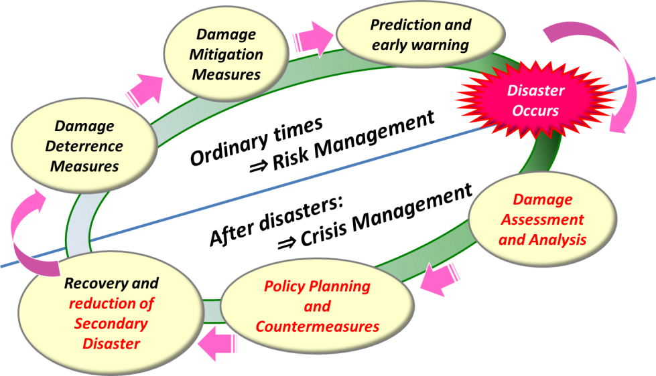

Figure 1. Typical disaster management phases

## 2.2 Prediction and early warning

Due to the importance and demand for ICTs during all phases of disasters, continuity of operations is an important consideration for disaster communications management. Effective disaster management is dependent on the timely and effective delivery of information to those who need it. Types of information needed to support disaster management cover wide-ranging areas such as disaster sensing and alerts, damage assessments, shelter locations, logistical and supply chain coordination, emergency medical support, determining the safety and welfare of family and friends, and search and rescue. In non-disaster phases, prediction and early warning is important, and this can be divided into disaster prediction and detection, emergency alerting and safety confirmation including evacuation guidance.

(1) Disaster prediction and detection

Disaster prediction and detection includes:

* Disaster prediction, including the acquisition and processing of data concerning the probability of future disaster occurrence, location and duration; and
* Disaster detection, including the detailed analysis of the topical likelihood and severity of a disaster event.

These services provide useful if not essential data for maintaining and improving accuracy of weather forecasts, monitoring and predicting climate changes and for information on natural resources.

Some ITU projects were focused on disaster detection in countries like Uganda and Zambia. Since the knowledge should be useful for all ITU-D member countries, exchanging information and sharing the results in Q5/2 discussions would be very helpful.

(2) Emergency alerting

After detecting the first signs of disaster, alerting or warning information should be sent to first responders and citizens as soon as possible. Emergency alerting includes:

* Emergency alerting on broadcasting, including alerting messages and evacuation information sent from TV and radio.
* Emergency alerting on mobile phones in the areas to be affected.
* Emergency alerting on digital signages in the towns to be affected.
* Emergency alerting on social network services.

(3) Safety confirmation and evacuation guidance

When getting emergency alert messages, people will have to prepare for predicted disasters immediately. However, in most cases ordinary people do not know how to prepare and ICTs can provide useful information such as evacuation guidance at that time. First responders, such as local governments or public safety organizations like police and fire departments, should make directions to prevent hazards, hopefully, as soon as notifying emergency alert messages are received. Safety confirmation and evacuation guidance includes:

* Safety confirmation for first responders, including dispatching first responders to hazard areas after confirming their safety and availability.
* Safety confirmation for citizens, including messaging boards to contact or check their family members and/or friends.
* Evacuation guidance, including location of shelters, route information to the nearest shelters and amount of emergency goods and foods.

## 2.3 Discussion at WTDC-17

At the last WTDC-17 held in Buenos Aires, Argentina, in October 2017, the continuation of Q5/2 and its ToR were agreed, the revision of Resolution 35 was agreed. In the ToR of Q5/2, the first target of the annual report is early warning system including safety confirmation, the second was emergency drills utilising ICTs, the latter was a summary of best practices and policies. The disaster preparation phase such as early warning (disaster prediction, disaster warning detection, emergency alert and safety confirmation) and disaster drills are very important for saving lives and preserving property. In addition, having workshops and/or seminars on disaster risk management is also described, both in the ToR of Q5/2 and Resolution 35.

# 3. Proposals

This contribution proposes to hold a panel session on early warning including safety confirmation systems during the first ITU-D SG2 meeting in May 2018, in order to share experiences and knowledge for the use of early warning systems amongst ITU-D members. This panel session would be helpful to gather information and to prepare the annual progress report of Q5/2.

The draft program is also proposed in the Annex of this contribution.

In addition to this, a workshop on emergency drills could be held at the next Q5/2 Rapporteur Group meeting in 2018.

Annex: Draft Program of Panel session on Early Warning

**Scope and background information**

Many disasters occurred in the world in recent years, such as the earthquake in Mexico in 2017 or the one in Taiwan (Province of China) in 2018. Natural or man-made disasters can negatively impact societies, causing disruption of the normal functioning of social and economic life. The combination of hazards, vulnerability and inability to reduce the potential negative consequences of risk results in disaster. Information and Communications Technologies (ICTs) play a pivotal role in disaster prevention, mitigation and management.

This panel session aims to share experiences and knowledge for early warning, including safety confirmation systems amongst ITU-D members. The discussion results of the panel session would be helpful in gathering information to prepare the annual progress report of Q5/2.

The scope of this panel session is mainly focused on early warning as follows, but not limited to:

(1) Disaster prediction and detection

* Disaster prediction, including the acquisition and processing of data concerning the probability of future disaster occurrence, location and duration; and
* Disaster detection, including the detailed analysis of the topical likelihood and severity of a disaster event.

(2) Emergency alerting

* Emergency alerting on broadcasting, including alerting messages and evacuation information sent from TV and radio.
* Emergency alerting on mobile phones in the areas to be affected.
* Emergency alerting on digital signages in the towns to be affected.
* Emergency alerting on social network services.

(3) Safety confirmation and evacuation guidance

* Safety confirmation for first responders, including dispatching first responders to hazard areas after confirming their safety and availability.
* Safety confirmation for citizens, including messaging board for contacting or checking their family members and/or friends.

Evacuation guidance, including location of shelters, route information to the nearest shelters and amount of emergency goods and foods.

**DRAFT PROGRAMME**

**(8 May 2018, Tuesday)**

|  |  |
| --- | --- |
|  | |
| 1600-1610 hours | **Opening Session**   * **Moderator: Hideo IMANAKA (Vice-Rapporteur, Q5/2) (TBC)** * **Opening remarks: Cosmas ZAVAZAVA (BDT) (TBC)** |
|  |  |
| 1610-1720 hours | **Moderator: Joseph BURTON (Co-Rapporteur, Q5/2) (TBC)**  **Panelists**   * UN agency (WMO or UNISDP) * Countries for ITU-project on EWS (e.g., Uganda, Rwanda, Zambia) * Private sector on telecommunications (Satellite operator?) * Research institutes (NICT?)   **Discussion**   * Theme 1: Technical and standardization issues * Theme 2: Policy and economic issues * Theme 3: Best practices and guidelines * Theme 4: Future work in ITU-D Q5/2 |
|  | |
| 1720-1730 hours | **Closing Session**   * **Wrap up: Sanjeev Banzal, (Co-Rapporteur, Q5/2) (TBC)** * **Closing remarks: Ahmed SHARAFAT (Chairman, ITU-T SG2) (TBC)** |

________________