 | Third Inter-Regional Meetings (IRM-3) to prepare for WTDC  Geneva, Switzerland, 10-11 March 2022 |  | 
 |  | Document IRM21-3/70-E
 |  | 7 March 2022
 |  | Original: English
Director, Telecommunication Development Bureau
WTDC Action Plan Base Document
Priority area: - Thematic Priorities, Action Plan, Regional Initiatives and SG Questions
Summary:
This document is contributed as an update to the draft WTDC Action Plan provided by the TDAG-WG-SOP as Temporary Document 6 to TDAG 21/2. TDAG agreed that the Outcomes and Outputs listed in the document, as revised during the TDAG-21/2 and contained in Document DT/13, may serve as the basis for further proposals for revision and refinement by ITU Member States and their delegations in preparation for WTDC. Following the first draft of the new ITU Strategic Plan which will be available in December 2021 for the January 2022 meetings of CWG-SFP, BDT indicated that it could provide an updated draft WTDC Action Plan with necessary adjustments to align with the framework of the Strategic Plan. The updates reflect the discussions of the 2nd meeting of CWG-SFP, based on the Secretariat’s input to annex 1 to Resolution 71 – Draft ITU Strategic Plan for 2024-2027 CWG-SFP 2/2, as well as discussions in TDAG 21/2 on Outputs and Outcomes.
Expected results:
IRM is invited to note this report, for consideration in its deliberations and discussions.
References:
CWG-SFP 2/2, ITU-D TDAG Temporary Document 6, ITU-D TDAG Temporary Document 13

Contents
1 Glossary of terms 3
2 Introduction 7
3 Structure of the WTDC Action Plan 9
3.1 Thematic Priorities 9
3.2 Products and Services 10
3.3 Enablers 12
3.4 Linkages 14
4 Implementation of Thematic Priorities 15
4.1 Implementation of Infrastructure and Services Thematic Priority 15
4.2 Implementation of Applications Thematic Priority 17
4.3 Implementation of Enabling Environment Thematic Priority 18
[4.4 Implementation of Cybersecurity Thematic Priority] 19
4.5 Outcomes and Outputs for Enablers 20
Regional Initiatives 27
Study Group Questions 47
Resolutions and Recommendations 47

1 Glossary of terms

Enabler

The ITU Strategic Plan 2024-2027 defines Enablers as ways of working that allow the Union to deliver on its goals and priorities more effectively and efficiently. They reflect the Union’s values of efficiency, transparency and accountability, openness, universality and neutrality, and being people-centred, service-oriented and results-based, and leverage its key strengths and address its weaknesses so that it can support its Membership.

Goal
A specific end result desired or expected to occur as a consequence, at least in part, of an intervention or activity. In the ITU Strategic Plan 2024-2027, Strategic Goals are defined as the Union’s high-level goals which enable the realization of its mission.

Impact
Impact implies changes in people’s lives. This might include changes in knowledge, skill, behaviour, health or living conditions for children, adults, families or communities. Such changes are positive or negative long-term effects on identifiable population groups produced by a development intervention, directly or indirectly, intended or unintended. These effects can be economic, socio-cultural, institutional, environmental, technological or of other types.

Input
The financial, human, material, technological and information resources used for development interventions.

Outcomes
Outcomes represent changes in the institutional and behavioural capacities for development conditions that occur between the completion of outputs and the achievement of goals. Results that occur at this level are primarily attributable to the government, although this may sometimes differ depending on the national context. In the ITU Strategic Plan 2024-2027, Outcomes are defined as key results the Union aims to achieve under its Thematic Priorities.

Outputs
Outputs are changes in skills or abilities and capacities of individuals or institutions, or the availability of new products and services that result from the completion of activities within a development intervention within the control of the organization. They are achieved with the resources provided and within the time period specified.

The WTDC Action Plan indicates outputs as the specialized “products and services” offered within the mandate of ITU-D as defined by Article 21 of the ITU Constitution, including among others, capacity building and dissemination of ITU expertise and knowledge.

Partnerships
BDT will continue to develop partnerships with a wide range of stakeholders, including other United Nations agencies, and endeavour to mobilize resources from funding agencies, international financial institutions, ITU Member States and ITU-D Sector Members and other relevant partners. In executing projects, available local and regional expertise should be taken into account.

Information on partnership activities will continue to be updated on the BDT website, including summaries of BDT projects and of resources generated and expended. Furthermore, BDT will extend its reach towards potential members and partners from academia by proposing activities such as scientific and academic publications in partnership with Member States, Sector Members, Associates and Academia, and other relevant stakeholders.

Product and Service Offerings

The ITU Strategic Plan 2024-2027 defines Product and Service Offerings as the range of ITU’s products and services that are deployed to support the Union’s work under its Thematic Priorities.

Regional initiatives and other projects
Regional initiatives/priorities [TBD] are intended to address specific telecommunication/ICT priority areas, through partnerships and resource mobilization to implement projects. Under each regional initiative, projects are developed and implemented to meet the region’s needs. The products and services to be developed through regional initiatives, in order to achieve related objectives and outcomes under the ITU-D contribution to the ITU strategic plan, will be identified in relevant project documents.

In fulfilling the Union's dual responsibility as a United Nations specialized agency and executing agency for implementing projects under the United Nations development system or other funding arrangements so as to facilitate and enhance telecommunication/ICT development, ITU-D offers, organizes and coordinates technical cooperation assistance through regional initiatives and projects.

Results
Results are changes in a state or condition that derive from a cause-and-effect relationship. There are three types of such changes – outputs, outcomes and impact – that can be set in motion by a development intervention. The changes can be intended or unintended, positive and/or negative.

Results-based Management (RBM)
RBM is a management strategy by which all actors, contributing directly or indirectly to achieving a set of results, ensure that their processes, products and services contribute to the achievement of desired results (outputs, outcomes and higher-level goals or impact). The actors in turn use information and evidence on actual results to inform decision making on the design, resourcing and delivery of programmes and activities as well as for accountability and reporting.

Alignment with new ITU Strategy: The model followed in this Action Plan aligns the overall RBM structure with the framework envisioned in the ITU Strategic Plan 2024-2027. This RBM model applies an increased client-driven approach to the Thematic Priorities defined by Membership to enhance BDT’s efficiency in focusing products, support and results along these strategic pathways towards the longer-term goals of the Connect 2030 Agenda.

This RBM model for the new Thematic Priorities will serve as the framework for future planning and evaluation, enforcing a common structure between Strategic and Operational Plans. This will include an increased integration of ITU and UN statistics and indicators to enhance the evidence-driven approach to country needs analysis and planning. It will allow BDT to be more agile in adapting technical support and service offering to evolving trends and changing needs of Members.

The exercise to realign BDT’s RBM framework with the new ITU Strategy will also refine the sequencing and integration of its products and services, mapping the most logical order for technical support and conditions for success along the new Thematic Priority ToC pathways for more evidence-driven matching of services with need.

To further guide coherent programmatic focus in the mandate delivery at all levels and through ITU’s regional presence, the BDT framework is designed for full regional-level synchronization of RBM, Thematic Priorities, operational planning, sequenced technical support offerings and portfolio performance assessments. This will also help regions to strategically match BDT technical support according to each of the Regional Initiatives/Priorities (TBC) and specific local trends, while also maintaining alignment with the global vision and mission defined in the ITU Strategic Plan.

Resolutions
A WTDC text containing provisions on the organization, working methods and programmes of ITU-D and Questions/topics to be studied.

Study Group Questions
A description of an area of work to be studied, normally leading to the production of new or revised Recommendations, guidelines, handbooks, or reports.

ITU-D Study Groups are responsible for developing reports, guidelines and Recommendations based on input received from the membership for review by their members. Information is gathered through surveys, contributions and case studies, and is made available for easy access by the membership using content-management and web-publication tools. The Study Groups examine specific task-oriented telecommunication/ICT Questions of priority to the ITU-D membership, to support them in achieving their development goals.

Outputs agreed on in the ITU-D Study Groups, and related reference material, are used as input for the implementation of policies, strategies, projects and special initiatives in Member States. These activities also serve to strengthen the shared knowledge base of the membership. Sharing of topics of common interest is carried out through face-to-face meetings, online e-forums and remote participation, in an atmosphere that encourages open debate and exchange of information as well as input from experts on the topics under study. The products to be developed under Study Group Questions will be defined in the work plan of each study group Question.

Thematic Priorities
In the ITU Strategic Plan 2024-2027, Thematic Priorities are defined as areas of work the Union focuses on, in which outcomes will be achieved to meet strategic goals. The Sectors and General Secretariat will work together under [five or six] Thematic Priorities to deliver outcomes towards achieving the Union’s strategic goals. ITU-D contributes to the achievement of [three or four] of the Union’s Thematic Priorities.

2 Introduction

The WTDC Action Plan is the operational plan of the ITU Telecommunication Development Sector (ITU-D) to monitor and achieve the priorities identified by the ITU-D membership during the 2022 World Telecommunication Development Conference (WTDC). It is results-based and steers the implementation of these priorities and follow the structure of the ITU Strategic Plan for the period 2024-2027.

Based on the Thematic Priorities, Product and Service Offerings and Enablers defined in the ITU Strategic Plan 2024-2027, the WTDC Action Plan aligns and charts the ITU-D work with the ITU Resolutions and Recommendations relevant to the mandate of ITU-D, the BDT Regional Initiatives and the Study Group Questions. The Action Plan also maps its contribution to the World Summit on the Information Society (WSIS) Action Lines and the overarching United Nations Sustainable Development Goals (SDGs).

The WTDC Action Plan describes the scope, products and services of each Thematic Priority and includes key performance indicators on how to support members, and to track progress over the period [2022-2025]. The Plan may be updated or modified by the Telecommunication Development Advisory Group (TDAG) to reflect changes in the telecommunication/ICT environment and/or as a result of the performance evaluation to be conducted each year.

This plan is also the basis for the annual ITU-D rolling operational plan and serves as an implementation framework as it provides a description on how to achieve the priorities and objectives of ITU-D, as identified by its membership at the WTDC. These priorities are based on ITU-D’s core competencies and expertise and are closely linked to and aligned with the priorities and objectives identified by the larger development plans/initiatives of the UN SDGs, the ITU Strategic Plan and the WSIS Action Plan. In particular they all share a common vision of achieving sustainable development by leveraging on the opportunities of digital tools and information and communication technologies. Figure 1 below outlines the key components of the ITU Strategic Framework 2024-2027.

Figure 2.1: ITU Strategic Framework 2024-2027

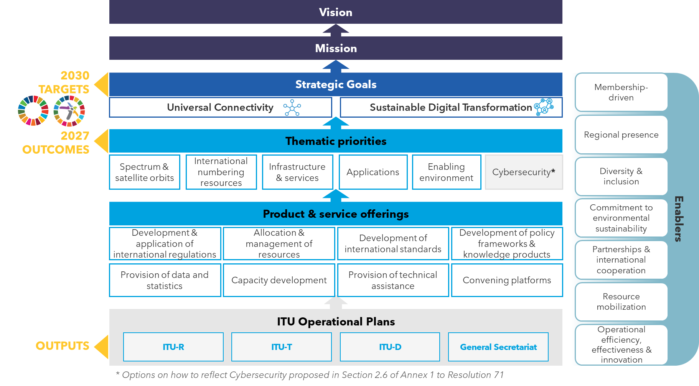
Figure 2.2: Structure and contributions of the Action Plan
ITU Strategic Plan
SDGs and WSIS Action Lines
Achieving

ITU-D contribution
WTDC Action Plan
ITU-D contributes to [3 or 4] Thematic Priorities

Applications
Infrastructure and services

Enabling Environment
[Cybersecurity]

Resolutions
Study Groups
Regional Initiatives

ITU-D Membership

3 Structure of the WTDC Action Plan

The WTDC Action Plan follows an RBM framework based on the thematic priorities identified as key work areas that will support the achievement of the ITU Strategic Plan 2024-2027. Figure 3.1 below highlights the ITU Thematic Priorities which ITU-D will contribute to directly, as well as the Enablers, Products and Services through which ITU-D will deliver. Definitions of the ITU Thematic Priorities, Products and Services relevant to ITU-D are outlined in the sections below.

Figure 3.1: ITU Thematic Priorities, Product and Services where ITU-D will contribute

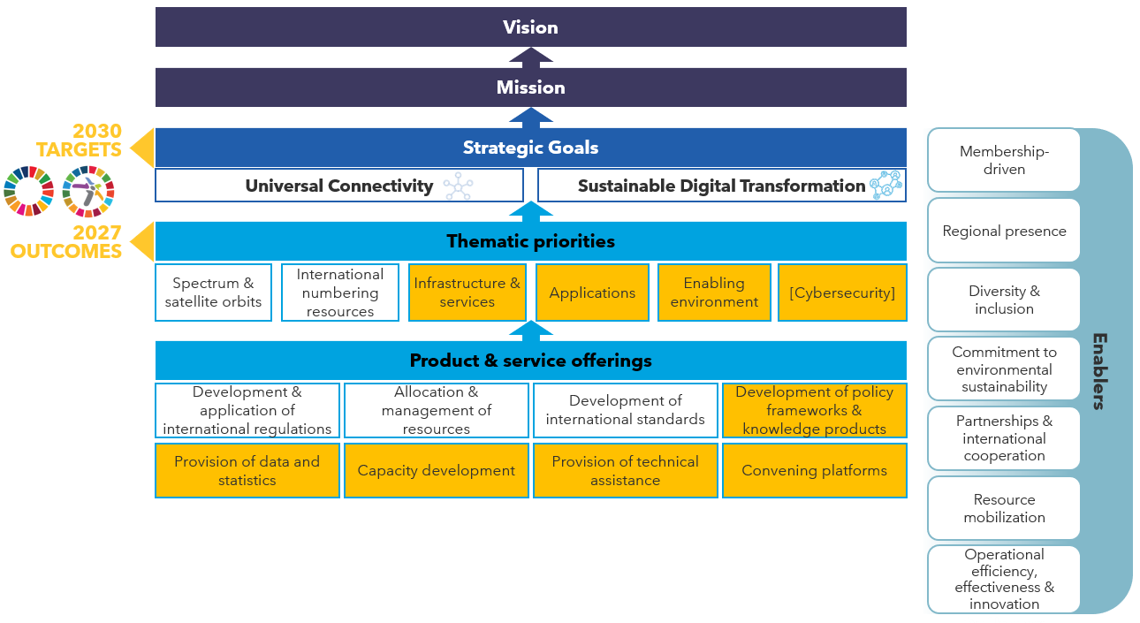

3.1 Thematic Priorities

As per the ITU Strategic Plan 2024-2027, the Sectors and General Secretariat will work together under [five or six] Thematic Priorities to deliver outcomes towards achieving the Union’s strategic goals. ITU-D will directly contribute to [three or four] of the Union’s Thematic Priorities, which are listed below along with the explanations defined in the ITU Strategic Plan 2024-2027.

Infrastructure and Services Thematic Priority
Telecommunications and ICT infrastructure and services are the basis and integral components of the digital economy and society. The work in this Thematic Priority focuses on enabling worldwide connectivity and interoperability, improving performance, quality and affordability, and enhancing the sustainability of telecommunication/ICT infrastructure and services. The work shall also provide for greater compatibility and co-existence of different radio services free from harmful interference.

To achieve this, the Union will work to foster the development of infrastructure and services, including through the development of international standards and new technologies for radiocommunication services and on how telecommunication networks operate and interwork, and by providing assistance to membership on new and emerging solutions.

Applications Thematic Priority
Widespread availability of ICT infrastructure and services has acted as a catalyst for uptake and innovation in applications improving people’s lives and empowering society for sustainable digital transformation, involving areas including, but not limited to, healthcare, education, banking, and the provision of public services to citizens.

ITU contributes to increasing availability, interoperability, scalability and impact of applications, including in underserved areas, by developing digital strategies and standards, and by providing technical assistance to meet the needs and requirements of ITU membership.

Enabling Environment Thematic Priority
An enabling environment consists of an enabling policy and regulatory environment conducive to sustainable telecommunication/ICT development that encourages investment in infrastructure and ICTs and increases adoption of telecommunications/ICTs to reduce the digital divide and towards a more inclusive and equal digital society.

To foster the enabling environment, the Union will work to provide assistance to Member States on technical and organizational aspects in developing an innovative and meaningful environment, by establishing new partnerships and utilizing existing as well as new and emerging digital technologies, connectivity solutions and new business models, with a focus on digital inclusion and environmental sustainability.

[Cybersecurity
The topic of Cybersecurity is still being debated for the ITU Strategic Plan 2024-2027. Two options are being discussed at the level of the ITU Strategic Plan 2024-2027:
- Reflect Cybersecurity as a standalone Thematic Priority; or
- Reflect work under Cybersecurity as integrated / cross-cutting theme applied into the three of the other ITU Thematic Priorities: Infrastructure and services; Applications; and Enabling Environment).]

3.2 Products and Services

To achieve the outcomes under the Thematic Priorities, ITU deploys a range of products and services for its Members, UN agencies and other stakeholders; this range of products and services is presented below. According to the ITU Strategic Plan 2024-2027, each Sector and the General Secretariat will provide more detailed information on how they will deploy these products and services in their respective Operational Plans. The Products and Services specific to ITU-D are outlined below.

Development of policy frameworks and knowledge products
ITU-D Products and Services include:
- development of handbooks, technical reports and papers on telecommunication/ICT matters to assist ITU membership, through its study group process;
- assistance to Member States in enabling digital transformation and building smart digital societies by developing and providing policy frameworks and good practice guidelines;
- good practices from Member States, the private sector, research and academia are collected and shared back with Member States; and
- knowledge exchange products and tools to enable inclusive dialogue and enhanced cooperation to help countries achieve a more inclusive digital society, and supports its membership in understanding and navigating the challenges and opportunities that come with digital transformation.
Provision of data and statistics
ITU-D Products and Services include:
- collection and dissemination of vital data and world-class research to track and make sense of digital transformation globally, as well as support to Member States and other stakeholders at every step of the data life cycle, from setting standards and methods for data collection to promoting the use of data in decision-making;
- responsibility for the international statistical standards for ICT indicators, publishing the standards, the definitions, and the collection methods for over 200 indicators, which represent the ultimate reference for statisticians and economists seeking to measure digital development; and
- active contribution to advancing the statistics agenda within the UN system, as the custodian of several Sustainable Development Goals indicators (4.4.1, 5.b.1, 9.c.1, 17.6.1 and 17.8.1).
Capacity Development
ITU-D Products and Services include:
- development of capacities of telecommunication/ICT professionals and knowledge resources, and works towards boosting digital literacy and skills of citizens, aiming to achieve a digitally competent society where all people use knowledge and skills on digital technologies to improve their livelihoods; and
- promoting, especially by means of partnership, the development, expansion and operation of telecommunication/ICT networks, services and applications, particularly in developing countries, taking into account the activities of other relevant bodies, by reinforcing capacity development.
Provision of technical assistance
ITU-D Products and Services include:
- technical assistance to Member States, in particular to developing countries and LDCs, and their regional organizations, in the field of telecommunications;
- tailor-made projects and solutions for multi-stakeholder needs, with recognized long-standing technical expertise in the telecommunitions/ICT field and comprehensive experience in project development, management, implementation, monitoring and evaluation, with a focus on results-based management, as well as opportunities for public-private partnerships and a trusted platform to address development needs through the use of telecommunications/ICTs; and
- assistance for the implementation of decisions of world and regional conferences, as well as support for spectrum coordination activities amongst ITU Members.
Convening platforms
ITU-D Products and Services include:
- bringing together a wide range of stakeholders as a convening platform in telecommunications/ICTs, to share experiences, knowledge, collaborate and identify means to bring affordable, safe, secure and trusted connectivity and online access and use to people everywhere; and
- encouraging international cooperation and partnerships for the growth of telecommunications/ICTs, especially with regional telecommunications organizations and with global and regional development financing institutions.

Enablers
ITU-D will deliver the Action Plan through the Enablers defined in the ITU Strategic Plan 2024-2027, the definitions of which are included for reference in this section. Enablers are ITU’s ways of working that allow it to deliver on its goals and priorities more effectively and efficiently. They reflect the Union’s values of efficiency, transparency and accountability, openness, universality and neutrality, and being people-centred, service-oriented and results-based, and leverage its key strengths and address its weaknesses so that it can support its membership.
Membership-driven
ITU will continue to work as a membership-driven organization, to effectively support and reflect the needs of its diverse members. ITU recognizes the needs of all countries, in particular those of developing countries, least developed countries, small island developing states, landlocked developing countries, and countries with economies in transition as well as underserved and vulnerable populations, which should be prioritized and given due attention. ITU will also work to deepen its engagement with representatives of the telecommunications/ICTs and of other industry sectors, to demonstrate ITU’s value proposition in the context of the strategic goals.
Regional presence
As an extension of ITU as a whole, the regional presence plays a vital role in the achievement of ITU’s mission, enhancing the Union’s understanding of local contexts and its ability to respond to countries’ needs effectively. The regional presence will consolidate strategic planning at the level of each regional/area office, implementing programmes and initiatives that are consistent with and based on the Union’s strategic goals and thematic priorities. By cascading and applying the global targets and clarifying programme priorities at the regional level, ITU will also seek to enhance its overall global effectiveness and impact. The regional presence will strengthen ITU’s position as a shaper/doer and enhance UN cooperation, to build enhanced regional opportunities and thereby reach more countries and define clearer more impactful priorities for country-level engagements. Efforts will also be made to strengthen capacity at the regional level to ensure the ability of the regional and area offices to implement the programmes and engagements determined based on the Union's strategic goals and thematic priorities.
Diversity and inclusion
ITU remains committed to mainstreaming diversity and inclusion practices across its work, to ensure equality and promote the rights of marginalized groups. In the pursuit of its goals, ITU will work to bridge the digital divide and build an inclusive digital society, by fostering telecommunication/ICT access, affordability and use in all countries and for all peoples, including women and girls, youth, indigenous peoples, older persons and persons with disabilities and specific needs. Internally, ITU continues to cultivate an inclusive culture that promotes diversity among its workforce and members.
Commitment to environmental sustainability
ITU recognizes that telecommunications/ICTs come along with risks, challenges and opportunities for the environment. ITU is committed to helping use digital technologies for monitoring, mitigating and adapting to climate change, facilitating digital solutions for energy efficiency and reduced carbon emissions and protecting human health and the environment from e-waste. ITU will apply an environmental lens across its work to promote sustainable digital transformation, while at the same time continuing to address cilmate change from within and systematically integrate environmental sustainability considerations across its operations in line with the Strategy for Sustainability Management in the UN System 2020-2030.
Partnerships & International cooperation
To increase global collaboration towards its mission, ITU continues to strengthen partnerships among its members and other stakeholders. In doing so, ITU can leverage its diverse membership and multilateral convening power to foster cooperation among governments & regulators, private sector and academic community. ITU also recognizes the importance of cultivating strategic partnerships with UN agencies and other organizations, including standardization bodies, to enhance cooperation across the telecommunication/ICT sector towards the delivery of the WSIS Action Lines and 2030 SDGs.
Resource mobilization
Accelerated resource mobilization efforts and increased financing are critical to achieving the goals of the Union and enhancing ITU support for the membership. ITU, therefore, recognizes the need to identify the most effective ways to mobilize extrabudgetary resources, build its resource mobilization capacity and enhance its current fundraising strategy while leveraging partner inputs to complement these efforts.
Operational efficiency, effectiveness and innovation
Enhancing operational efficiency and effectiveness enables ITU to respond to changes in the telecommunication/ICT landscape and evolving membership needs. ITU, therefore, aims to improve internal processes and accelerate decision-making by addressing operational inefficiencies, duplication and perceived bureaucracy. ITU also recognizes the need to build operational effectiveness, by increasing cross-functional synergies, encouraging internal innovation, providing consistent guidance on the organization's scope and developing a stronger performance and talent management approach. To this end, the organization will be implementing a culture and skills transformation plan based on 4 main tracks: strategic planning, digital transformation, innovation and people management.

3.4 Linkages

The Action Plan is organized along the thematic priorities and provides information on, and linkages between:

- The ITU-D contribution to the Thematic Priorities, including full description, and the corresponding Product and Service Offering, Enablers, key outputs and results
- Graphically shown in Figure 3 below are links from the Thematic Priorities and Supporting Components to:
  - SDGs and targets
  - ITU Strategic Plan and Goals/Targets
  - WSIS Action Lines
  - WTDC Resolutions and Recommendations and PP Resolutions
  - Regional Initiatives
  - Study Group Questions

Figure 3.2: Linkages of Thematic Priorities, Offerings and Enablers relevant to ITU-D with ITU Resolutions, WSIS Action Lines and SDGs

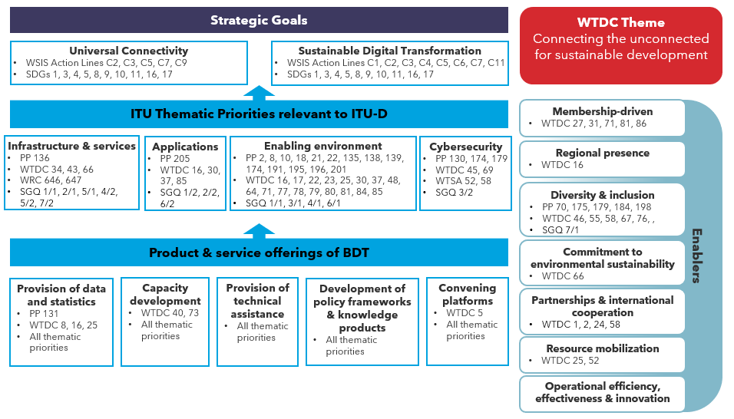

4 Implementation of Thematic Priorities

4.1 Implementation of Infrastructure and Services Thematic Priority
Thematic Priority

Infrastructure & services outcomes
- [Improved broadband connectivity in developing countries, least developed countries (LDCs), small island developing states (SIDS) and landlocked developing countries (LLDCs), countries with economies in transition and countries with specific needs]
- [Improved telecommunication/ICT infrastructure and service, in particular broadband coverage]
- Improved access to digital services by people in urban, rural and remote areas and underserved communities
- Enhanced e commerce for ITU membership to achieve the SDGs
- Strengthened joint Regional Collaboration and cooperation and with UN and Regional Telecommunications Organizations, financial and development institutions for achieving Connect 2030 Agenda for global telecommunication/information and communication technology, including broadband, for sustainable development
- [Improved broadband connectivity in developing countries, least developed countries (LDCs), small island developing states (SIDS) and landlocked developing countries (LLDCs), countries with economies in transition and countries with specific needs, through increased demand creation for broadband adoption and digital skills
OR
Alternative: Improved socio-economic growth in developing countries, least developed countries (LDCs), small island developing states (SIDS), landlocked developing countries (LLDCs), countries with economies in transition and countries with specific needs, through broadband connectivity]
- Strengthened capacity of Member States to use telecommunications/ICTs for disaster risk reduction and management, to ensure availability of emergency telecommunications, and support cooperation in this area

4.2 Implementation of Applications Thematic Priority
Thematic Priority

Applications outcomes
- [Improved capacity of the ITU membership to accelerate digital transformation and sustainable economic and social development by leveraging and using new and emerging telecommunications/ICTs]
- Strengthened capacity of the ITU membership to integrate telecommunication/ICT innovation and digitalization in national development agendas and to develop strategies to promote innovation initiatives, including through public, private and public-private partnerships

4.3 Implementation of Enabling Environment Thematic Priority
Thematic Priority

Enabling Environment outcomes
- [Strengthened capacity of Member States to enhance their telecommunication/ICT policy, legal and regulatory frameworks conducive to sustainable development and growth of the [Digital Economy/digitalisation of the economy]]
- [Strengthened capacity of Member States to produce high quality, internationally comparable Digital Economy statistics which reflect developments and trends in telecommunications/ICT, empowered by new and emerging technologies, based on agreed standards and methodologies]
- [Improved human and institutional capacity of the ITU membership in telecommunications/ICTs to tap into the full potential of Digital economy and society]

[4.4 Implementation of Cybersecurity Thematic Priority]
Thematic Priority

Cybersecurity outcomes
- [Strengthened capacity of Member States to effectively share information, find solutions, and respond to threats to cybersecurity, and to develop and implement national strategies and capabilities, including capacity building, encouraging national, regional and international cooperation in the area of Cybersecurity]
- Enhanced capacity of the ITU membership to make available secure and resilient telecommunication/ICT infrastructure and services
- Strengthened capacity of Member States to effectively share information, find solutions, and respond to threats to cybersecurity, and to develop and implement national strategies and capabilities, including capacity building, encouraging national, regional and international cooperation towards enhanced engagement among Member States and relevant players
- [Strengthened capacity of member states to effectively respond to cybercrime]

4.5 Outcomes and Outputs for Enablers
Enabler

Membership-driven Outcomes

- Strengthen World Telecommunication Development Conference (WTDC) Resolutions implementations
- [Enhanced knowledge-sharing, research and development, [technology transfer], dialogue and partnership among the ITU membership on telecommunication/ICT issues]

Enabler

Regional Presence Outcomes

- Strengthened and empowered Staff and their expertise at all levels, at the Regional presence (Regional and Area Offices)
- Strengthened of the Union’s dual responsibility as a United Nations specialized agency and executing agency for implementing projects
- [Enhanced knowledge-sharing, research and development, [technology transfer], dialogue and partnership among the ITU membership on use of telecommunications/ICT in support of the [transition to the digital economy development and sustainable development/digital transformation of society]
- Strengthened Regional presence for achieving ITU-D objectives, outcomes and outputs, through the involvement and collaboration of Radiocommunication, Telecommunication Standardization sectors and by mainstreaming “One ITU” and Results based management (RBM) approaches
- [Strengthened joint Regional Collaboration and cooperation and with UN and Regional Telecommunications Organizations, financial and development institutions for achieving the 2030 sustainable development goals related to [telecommunications/ICT digital economy] development matters]
Enabler

Diversity and Inclusion Outcomes

- Strengthened capacity of the ITU membership to develop strategies, policies and practices for digital inclusion and equity, in particular for the empowerment of women and girls, persons with disabilities and other persons with specific needs and low-income households

Enabler
Commitment to Environmental Sustainability Outcomes

- Enhanced capacity of the ITU membership to develop telecommunication/ICT strategies and solutions on climate-change adaptation and mitigation and the use of green/renewable energy

Enabler

Partnerships and International Cooperation Outcomes

- [Strengthened UN-wide joint planning, collaboration and cooperation and with financial and development institutions at international and regional levels on achieving the 2030 sustainable development goals related to [telecommunications/ICT and digital economy] development matters]

Enabler
Resource Mobilization Outcomes
- Strengthened Resource mobilization strategy through cooperation with international and regional financial and development institutions

Enabler

Operational Efficiency, Effectiveness and Innovation Outcomes

- Strengthened of the Union’s dual responsibility as a United Nations specialized agency and executing agency for implementing projects
- [Strengthened of the Union’s dual responsibility as a United Nations specialized agency and executing agency for implementing projects
OR
Strengthened project implementation function of the ITU]

Regional Initiatives
Africa

AFR1: Supporting digital transformation to usher a rapid transition to digital economy while accelerating innovation in Africa
Objective: To assist Member States in the Africa region to reap the full benefits of digital transformation by addressing the existing policy and regulatory challenges, and formulating strategies to encourage the development and the use of digital technologies in various sectors of the economy and foster innovation.
Taking into consideration the enormous potential of digital technologies to contribute to the acceleration of the socio-economic development of countries and its vital role to assist in realizing the 2030 sustainable development agenda and the 17 global SDGs, ITU is called upon to support Member States in the Africa region to build, develop and sustain digitally based economies.
Expected results
- Assistance in the development of national digital transformation strategies focusing on enabling policies and regulations to enhance the use of digital technologies in the economy.
- Assistance in developing action plans with digital key performance indicators (KPIs) encompassing the adoption of e-applications geared to sustainable development in various aspects of African economies and e-government services.
- Assistance in conducting research on the current digitization state of industries in Africa, trends and needs, at the regional level.
- Building partnership among ITU Membership to encourage the exchange of best practices and knowledge sharing in the implementation of digital transformation projects.
- Assistance in the adoption and implementation of relevant standards that are targeted at addressing challenges of interoperability stemming from the disruptive and transformative spread of digital innovation.
- Help in designing models and facilitate the finance of digital transformation of economies in Africa, and identification of partnership opportunities to establish sustainable innovation frameworks.
- Support for the designing and implementation of a comprehensive and inclusive human and institutional capacity building long term plan as a fundamental pillar to transform the economy to be digitally oriented and to guarantee its effective functioning that takes into consideration upskilling and reskilling of citizens on aspects related to emerging technologies
- Support the establishment of centres of excellence and incubation entities to help in the nourishing and development of innovative ideas and start-ups in Africa.
- developing Member States' capability to promote accessibility in order to ensure improved specialized skills development to meet the ICT needs of persons with disabilities and thus enhance their use of digital applications.

AFR2: Implementation and expansion of broadband infrastructures, connectivity and emerging technologies
Objective: To promote the deployment of broadband infrastructure to assist Member States in Africa to ensure that no one is left behind to leverage the full benefits of high-speed and high – quality connectivity and the ramifications of emerging technologies.
Expected results
- Assistance in the development of national and regional strategic plans, focusing on enabling policies and regulations addressing high-speed, high-quality broadband networks in the region.
- Provide support and share best practices on national broadband strategies and strengthen capacity development, implement and monitor national broadband plans to use universal service funds effectively and develop financial and operational sustainable business models in order to provide affordable broadband access to unserved and underserved areas.
- Benefiting from development programmes in expanding connectivity to SMEs and businesses to support jobs, business growth and economic development
- Benefiting from development programmes in expanding connectivity to education and health related entities; SMEs and businesses; and homes and communities to enable access to relevant digital content
- Providing support that will enable the sharing of best practices on financing models as well as the identification of partnership opportunities to enhance high-speed, high-quality broadband.
- Assistance in promoting the harmonization of subregional broadband plans so as to ensure equitable access to high-speed, high-quality broadband for all.
- Assistance with human capacity development resources, through training programmes, workshops and such like, to exchange expertise and to provide persons with disabilities with the platform to participate in and benefit from the emergence of new broadband technologies.
- Assistance in extending the regional and continental backbone initiatives to ensure the resilience of submarine cables.
- Improved awareness of policy and regulatory frameworks relating to spectrum-management issues in line with ITU decisions, including radio-frequency planning, trading, re-farming, and sharing along with spectrum licensing frameworks for competition, obligations and pricing.
- Development, implementation and review of policies, legal and regulatory frameworks, including for network infrastructure protection, construction codes, regulations and technical standards for FTTH infrastructure, collaborative construction in civil works, next-generation universal service obligation (USO), infrastructure sharing, and facilitation of right-of-way and site acquisition.
- Undergoing the necessary feasibility studies and setting roadmaps at national and regional levels for deployment of emerging technologies with high speed connectivity such as 5G related technologies; capacity building and ecosystem development to support 5G use.
- Designing and executing awareness raising and measurement campaigns on EMF exposure and safety as well as on benefits of wireless backed technologies by science and medical recommendations.

AFR3: Building trust, safety and security in the use of telecommunications/information and communication technology and protection of personal data
Objective: To assist Member States in developing and implementing policies, strategies, standards and mechanisms as well as human capacity building to enhance the security of information systems and networks, protection of data and people including vulnerable groups such as children and guarantee digital trust. To protect information and communication technology (ICT) and its applications.
Expected results
- Assistance to Member States in improving their cybersecurity readiness status in respect to the ITU Global Cybersecurity Index pillars and the goal of the Connect 2030 Agenda
- support member states in assessing adopting developing and the implementation of a regulatory and legislative framework, at national and regional level, related to cybersecurity
- Development of a global framework for collaboration and awareness at regional and sub-regional levels for nurturing a global culture of cybersecurity and to help consumers better understand and protect against risks.
- Assistance in developing content for educating consumers on their rights and responsibilities related to data protection while performing electronic and physical transactions as well as execution of campaigns to raise the awareness of cyberthreats, cybersecurity measures and quality of service in the use of ICTs.
- Encourage the sharing of best practices and exchange of knowledge between Member States on the mechanisms to combat cybercrimes and cyber threats.
- Support member states in the establishment and the development of national computer emergency/incident response teams (CERT/CIRTs), and strengthening cooperation mechanisms between them, at regional and sub-regional levels.

AFR4: Fostering Emerging Technologies and Innovation Ecosystems
Objective: To foster an enabling digital innovation ecosystem that can navigate technological revolutions and establishment of a sustainable conducive environment for the utilization of emerging technologies and development of SMEEs and start-ups.
Expected results
- Assistance in undertaking a comprehensive assessment of the human and institutional capacity and regulatory environment related to digital innovation, emerging technologies, and SMMEs at national and regional levels.
- Support Member States in developing the necessary legislative and regulatory framework to encourage digital industries and innovation development and the establishment of SMMEs.
- Assistance in the designing and adoption of national strategies and infrastructures such as innovation and Research Labs to usher the utilization of emerging technologies in the different sectors of the economy.
- Support in scaling up digital entrepreneurship and SMMES through global partnerships focused on achieving national development priorities and elaborating financing models to ensure the necessary investments for the continuous development and deployment of emerging technologies.
- Designing a comprehensive human capacity-building framework to upskill and reskill the human factor on emerging technologies and digital innovation related material.
- Raising awareness on the importance of the protection of Intellectual Property (IP) and developing relevant regulatory frameworks.

Figure RI-1: Africa Regional Initiative synergies with ITU Strategic Framework 2024-2027
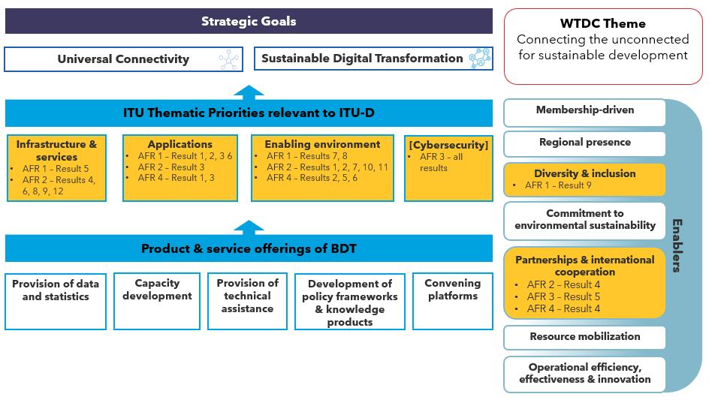

Americas
[No objectives]
AMS1: Deployment of modern, resilient, secure and sustainable telecommunication/ICT infrastructure
Expected results
- Assistance in the design, funding and implementation of national, regional and sub-regional broadband plans and resilient networks, including support to community networks, with special attention to indigenous communities, underserved and unserved areas, critical environment areas and vulnerable populations, taking into account innovative connectivity solutions that can be locally deployed and managed, including access to spectrum and high-speed networks;
- Assistance in the development, funding and implementation of national emergency telecommunication plans and network infrastructure;
- Enhanced and strengthened confidence and security in the use of ICTs, including capacity building and support for the development of national cybersecurity strategies;
- Effective use of sustainable telecommunications/ICTs to mitigate climate change and enhance environmental sustainability;
- Assistance in the design of effective spectrum management plans, enabling affordable access to backbone facilities, development of IXPs, and appropriate use of universal service funds.

AMS2: Enhancement and expansion of digital literacy, digital skills and digital inclusion programs, especially among vulnerable populations
Expected results
- Support for the development of human capacity through national, regional and sub-regional capacity building projects, such as training programs or workshops, to exchange expertise and knowledge, as well as national and international experiences to provide practical skills and tools to bridge digital divides, including the gender digital divide, in order to contribute to the development of sustainable telecommunications/ICTs, enhancing competition, investment and innovation;
- Provision of diligent assistance in the planning, implementation and evaluation of projects and programs on digital literacy, digital skills and digital inclusion.

AMS3: Effective support for the digital transformation and innovation ecosystems through scalable, funded and sustainable connectivity projects
Expected Results
- Assistance in the planning and implementation of foundational infrastructure and special purpose e-services;
- Increased capacity building and multi-stakeholder cooperation to facilitate and enhance innovation in telecommunications/ICTs in support of digital transformation in the region, with special focus on all developing countries in the region, including LDCs, LLDCs, and SIDS, indigenous communities, in particular youth and women in rural, remote, unserved or underserved areas and communities;
- Promotion of the active engagement of civil society, international financial institutions, industry partners, academia and other relevant stakeholders.

AMS-4: Development of enabling policy and regulatory environments to connect the unconnected through accessible and affordable telecommunications/ICTs that support the achievement of SDGs and the progress towards the digital economy
Expected Results
- Support and promotion of sustainable telecommunications/ICTs in all developing countries in the region, including LDCs, LLDCs, and SIDS, and protected areas for emergency communications and to protect, restore and promote a sustainable use of terrestrial ecosystems;
- Support for the development of an enabling policy and regulatory environment and to facilitate investment and innovation to connect the unconnected and achieve the SDGs;
- Support for Member States in the implementation of policy and regulatory strategies to connect the unconnected with a focus on affordability, including support of small operators and community networks;
- Enhanced outreach to all developing countries in the region, including LDCs, LLDCs and SIDS, for greater participation in ITU processes and access to finance and expertise;
- Support for digital financial inclusion and fostering implementation of electronic transactions.

Figure RI-2: Americas Regional Initiative synergies with ITU Strategic Framework 2024-2027

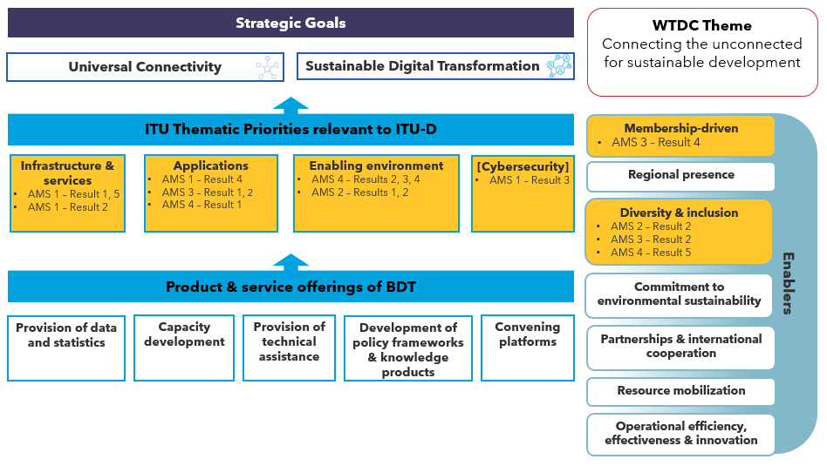

Arab States
[No Expected Results]
ARB1: Promote digital transformation and enable digital inclusion, especially for rapid response to epidemics and emergencies
Objective: Enabling digital transformation and developing digital services using telecommunications/ ICTs and by establishing an advanced infrastructure to support digital transformation and achieve high levels of digital inclusion, especially for rapid response in the face of epidemics and emergencies.

ARB2: Building confidence and security in the use of telecommunications/ICTs in the era of new and emerging digital technologies, including the protection of children online
Objective: To enhance confidence and security in the use of telecommunications/ICTs by supporting the deployment of flexible infrastructure, safe services, protection of children online and combating all forms of cyber threats, including misuse of telecommunications/ICTs.

ARB3: Developing digital infrastructure, promoting universal access, and supporting smart cities and communities
Objective: To facilitate universal access to high-speed connectivity by developing flexible and synergistic infrastructure and creating an enabling environment that ensures coverage everywhere and in a manner that ensures dealing with new and emerging technologies, and taking the necessary measures to ensure the rapid transformation into smart cities and societies.

ARB4: Digital Innovation and Entrepreneurship
Objective: To build capacity and raise awareness about a culture of digital innovation and entrepreneurship, especially for youth, and empower women, in order to harness communications/ICT tools in launching projects and economic activities that focus on providing job opportunities.

ARB: Developing digital and collaborative regulation and harmonization of policy and regulatory frameworks for information and communication technology and the digital economy
Objective: To enhance cooperation between regulators, policymakers in various sectors and other stakeholders in telecommunications/ICTs and to create an enabling environment in the context of digital and collaborative regulation.

Figure RI-3: Arab States Regional Initiative synergies with ITU Strategic Framework 2024-2027

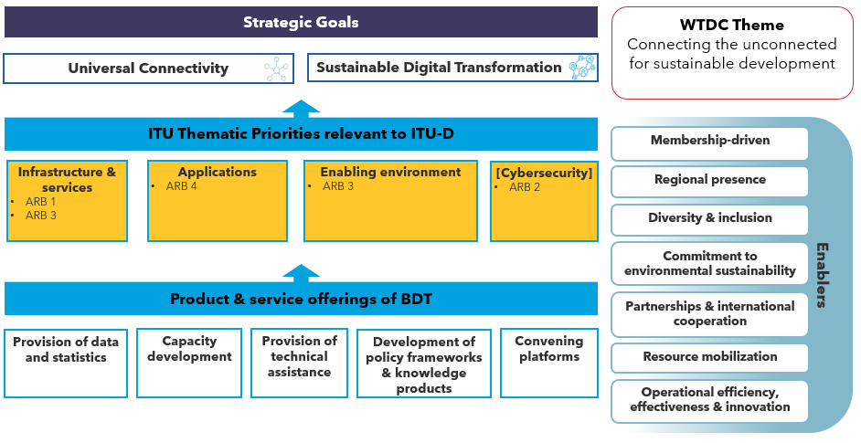

Asia and the Pacific

ASP1: Addressing special needs of least developed countries, small island developing states, including Pacific island countries, and landlocked developing countries
Objective: To provide special assistance to least developed countries (LDCs), small island developing states (SIDS), including Pacific island countries, and landlocked developing countries (LLDCs) in order to meet their priority telecommunication/information and communication technology (ICT) requirements.
Expected results
- Development of policy and regulatory frameworks for broadband infrastructure and ICT applications and cybersecurity, taking into account the special needs of LDCs, SIDS, including Pacific island countries, and LLDCs, and strengthening of human capacity to address future policy and regulatory challenges.
- Promotion of affordable and meaningful broadband universal access in LDCs, SIDS, including Pacific island countries, and LLDCs.
- Assistance to LDCs, SIDS, including Pacific island countries, and LLDCs in adopting telecommunication/ICT applications in disaster management relating to disaster prediction, preparedness, adaptation, monitoring, mitigation, response, rehabilitation and recovery of telecommunication/ICT networks based on their priority needs.
- Assistance to LDCs, SIDS, including Pacific island countries, and LLDCs in their efforts to achieve internationally agreed goals, such as the 2030 Agenda for Sustainable Development, the Sendai Framework for Disaster Risk Reduction, the Istanbul Programme of Action for LDCs, the Samoa Pathway for SIDS and the Vienna Programme of Action for LLDCs.

ASP2: Harnessing information and communication technologies to support the digital economy and inclusive digital societies
Objective: To assist Member States in utilizing information and communication technologies (ICTs) and emerging technologies to reap the benefits of the digital economy by addressing the human and technical capacity challenges, including improving and expanding digital skills to reduce the gender gap, and assisting vulnerable groups to bridge the digital divide.
Expected results
- Planning and elaboration of national strategic frameworks on the digital economy as well as associated toolkits for selected ICT applications and services.
- Establishment and annual updating of a repository of all work done within ITU relating to the digital economy since the World Telecommunication Development Conference (Buenos Aires, 2017).
- Development of policies, strategies and guidelines for efficient and timely implementation of the digital economy including the use of the Internet of Things (IoT), ICT-centric applications and platforms, AI, 5G and big data.
- Acceleration of digital infrastructure readiness by timely deployment of optical fibre, 4G and 5G technologies as well as that of ICT/mobile applications to improve the delivery of value-added services in sectors such as health, education, environment, agriculture, governance, energy, financial services, and e-commerce. In doing so, economic recovery funds and resources of development banks can also be utilized.
- Identification, collation and sharing of knowledge, best practices and case studies on various telecommunication/ICT applications.
- Development of cross-sectoral national/regional programmes on digital literacy and skills for inclusiveness, especially for women, youth, older persons and persons with specific needs.
- Enhancement of international cooperation related to new and emerging technologies pertaining to telecommunications/ICTs to ensure that all countries on the global value chain can benefit from digital transformation.

ASP3: Fostering development of infrastructure to enhance digital connectivity and connecting the unconnected
Objective: To assist Member States in the development of telecommunication/ICT infrastructure in order to facilitate the provision of services and applications taking into consideration the availability, affordability and accessibility of the infrastructure for connecting the unconnected.
Expected results
- Migration/transition of analogue networks to appropriate digital networks, application of affordable wired and wireless technologies (including interoperability of ICT infrastructure) and optimized use of the digital dividend.
- Maximized use of new and emerging technologies for the development of communication networks, including 5G and smart grid infrastructure and services.
- Review and revise, if necessary, existing national broadband objectives and enhance capacity to develop and implement national broadband plans (including support to study the status of national broadband networks and international connectivity) in order to provide broadband access to unserved and underserved areas; promote affordable access, especially for youth, women, indigenous peoples and children; select appropriate technologies; develop and use universal service funds effectively; and develop business models that are financially and operationally sustainable.
- Promotion of Internet exchange points (IXPs) as a long-term solution to advance connectivity and deployment of IPv6-based networks and applications and facilitation of the transition from IPv4 to IPv6.
- Strengthening of the capacity to implement conformance and interoperability (C&I) procedures and facilitating the establishment of common regional/subregional C&I regimes (including the adoption and implementation of mutual recognition arrangements).
- Paying attention to spectrum-management issues, including radio-frequency planning, harmonization of the use of spectrum allocated and identified for International Mobile Telecommunications (IMT), enhancement of spectrum monitoring systems, and facilitating implementation of WRC decisions.
- Building of skills for the development and use of terrestrial and space services.
- Enhancing regional ICT connectivity and strengthening cooperation with international/regional organizations in programmes such as the Asia-Pacific Information Superhighway (AP-IS).

ASP4: Enabling policy and regulatory environments to accelerate digital transformation
Objective: To assist Member States in developing appropriate policy and regulatory frameworks, digital services across various sectors of the economy, fostering innovation, enhancing skills, increasing information sharing and strengthening regulatory cooperation, thereby contributing to a supportive regulatory environment for all stakeholders.
Expected results
- Sharing of information on developments in policy, legal and regulatory frameworks as well as market developments in the information and communication technology (ICT) sector and the digital economies it enables.
- Development, implementation and review of strategies, policies and legal and regulatory frameworks, including for next-generation universal service obligation (USO), consumer protection, transformation of small; and medium-sized enterprises (SMEs) to digital enterprises, and innovation and entrepreneurship.
- Encouraging inclusive dialogues and strengthening cooperation among national and regional regulators, policy-makers and other telecommunication/ICT stakeholders, as well as with other sectors of the economy, on topical policy, legal, regulatory and market issues.
- Strengthening institutional, human and technical capacity on topical policy, legal and regulatory issues, as well as on economic and financial issues and market developments.
- Improved awareness of policy and regulatory frameworks relating to data privacy and cross-border data.
- Development of strategic frameworks to support research and development activities in ICT in developing countries.

ASP5: Contributing to a secure and resilient ICT environment
Objective: To assist Member States to develop and maintain secure, trusted and resilient networks and services, and to address challenges related to climate change and the management of global pandemics and disasters.
Expected results
- Compilation of national/regional cybersecurity strategies, establishment of national/regional cybersecurity capabilities such as computer incident response teams (CIRTs), and sharing of good practices to nurture a culture of cybersecurity.
- Strengthening of institutional cooperation and coordination among key actors and stakeholders at the national, regional and global levels (including through organizing cyberdrills) and enhancing the capacity to address issues related to cybersecurity.
- Development of national emergency telecommunication plans and ICT-based initiatives for providing medical (e-health) and humanitarian assistance in disasters and emergencies.
- Incorporation of disaster-resilient features in telecommunication networks and infrastructure, and development of ICT-based solutions (including the use of wireless and satellite-based technologies) to enhance network resilience.
- Development of standards-based monitoring and early-warning systems linked to national and regional networks, and enhanced use of active and passive terrestrial/space-based sensing systems for disaster prediction, detection and mitigation.
- Formulation of comprehensive strategies and measures to help mitigate and respond to the devastating effects of climate change, including e-waste policy.

Figure RI-4: Asia and Pacific Regional Initiative synergies with ITU Strategic Framework 2024-2027
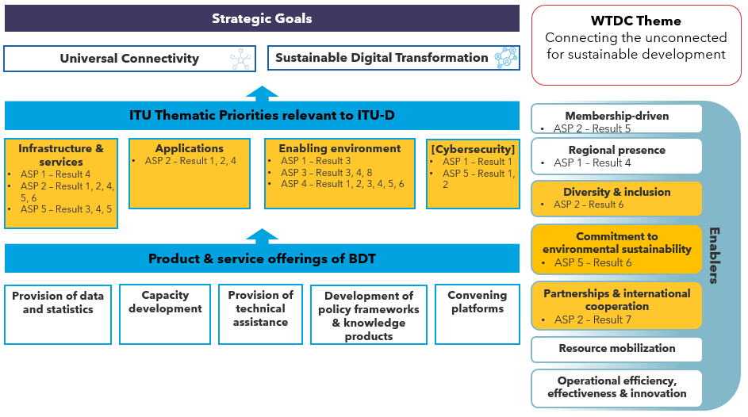

CIS region

CIS1: Infrastructure development to foster innovation and partnerships in the implementation of new technologies – the Internet of Things, including the Industrial Internet, 5G/IMT-2020 and NET-2030 next-generation networks, quantum technologies, artificial intelligence, digital health, digital education, environmental protection, smart cities, digital skills, etc.
Objective: Assist ITU Member States of the region in telecommunication operators’ adoption of innovative technologies (in their introduction as new services), while ensuring the stability and enhanced performance of telecommunication networks, including 5G/IMT-2020 and NET-2030 next-generation networks, within the context of ubiquitous implementation of the concept and technologies of Internet of Things, Industrial Internet, quantum technologies, artificial intelligence, digital health, digital education, environmental protection, smart cities, digital skills, etc.
Expected results
- Development of recommendations on new technologies;
- Creation of telecommunication/ICT infrastructure to foster innovation and partnerships in the implementation of new technologies;
- Raising of the technological level of organizations developing solutions and the general level of well-being of the region’s population;
- Development of recommendations for the measurement of parameters for digital data transmission via telecommunication channels, the Internet and telephony in modern and future communication systems, ensuring that monitoring results are reproducible and traceable;
- Bridging of the digital divide in the countries of the CIS region.

CIS2: Cybersecurity and personal data protection
Objective: Provide assistance to ITU Member States of the region in developing and maintaining secured, reliable and stable digital networks and services and in solving problems related to personal data protection.
Expected results
- Establishment and enhancement of national cybersecurity incident response teams (CIRTs);
- Building of capacity and enhancing communication and incident response capabilities and ensuring of a continued collective effort among the regions’ national computer incident response teams (CIRTs) to combat cyberthreats through global, interregional, regional and national cybersecurity drills;
- Training and retraining of specialists with technical and management profiles through targeted regional and national training programmes;
- Coordination of the gathering and sharing of best practices in the development of national strategies and cybersecurity and measurement of countries’ commitment to cybersecurity.

CIS3: Creating an enabling legal and regulatory environment to accelerate digital transformation
Objective: Provide assistance to ITU Member States of the region in developing related laws and regulations and digital services in various economic sectors, fostering innovation, increasing information sharing and strengthening cooperation in regulation, thereby contributing to the creation of an enabling regulatory environment for all stakeholders.
Expected results
- Creation of an interconnected innovation ecosystem for start-up development and digital transformation in the countries of the region;
- Expert assistance in the creation of digital public services based on open innovation;
- Expert assistance in the creation of regulatory and legal frameworks and coordination mechanisms for the fostering of innovation in the finance and education sectors (Fintech and Edtech);
- Sharing of information on changes in the legal and regulatory framework and market developments in the ICT sector and digital economy;
- Building of institutional, human and technical capacity in relevant issues of sector legislation, regulatory matters, economic and financial issues and market developments.

СIS4: Digital skills and ICT accessibility for the population, in particular for persons with disabilities
Objective: Provide assistance to ITU Member States of the region in formulating recommendations for the development of citizens’ digital skills, paying particular attention to persons with disabilities.
Expected results
- A detailed study of the needs of persons with disabilities in terms of digital-skill training methodology;
- Recommendations on the development and improvement of digital literacy for persons with disabilities;
- Creation of a network of training centres for persons with disabilities, including in remote areas of countries;
- Methodological guidance and training for teachers of training centres for persons with disabilities;
- Recommendations on the development of citizens’ digital skills in art and culture and the reduction of barriers in public access to museum collections;
- Cooperation with museums for the development of special programmes for public access to museum exhibits;
- Professional development courses, forums, training and seminars on matters related to the development of the public’s digital skills in art and culture.

CIS5: Development of smart cities and communities
Objective: Assist ITU Member States of the region in developing legal and regulatory frameworks, creating necessary infrastructure, introducing modern services and applications in different aspects of smart cities and communities (education, healthcare, tourism, transport, energy, security, the environment, etc.) and raising the digital literacy of the population, business and authorities.
Expected results
- Recommendations on the development of a legal and regulatory framework for smart city and community development at all architectural levels, as well as the organizational aspect of smart city and community development;
- Recommendations on the development of necessary infrastructure, including the use of telecommunications and other connective media to support and facilitate sustainable smart city and community development in developing countries;
- Pilot projects for different aspects of smart city and community development (education, healthcare, tourism, transport, energy, security, the environment, etc.);
- Rating and key performance indicator system for the smart city and community domain;
- Further training courses, training sessions and seminars on issues relating to smart city and community development and raising the digital literacy of the population, business and authorities.

Figure RI-5: CIS Regional Initiative synergies with ITU Strategic Framework 2024-2027

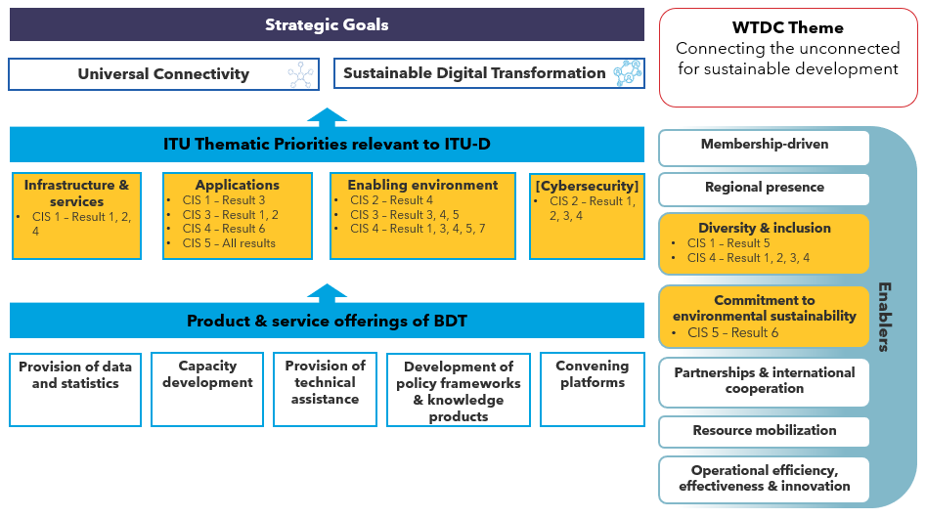

Europe

EUR1: Digital Infrastructure development
Objective: To facilitate attainment of Gigabit connectivity through resilient and synergistic infrastructure development and an enabling environment ensuring ubiquitous coverage.
Expected results: Assistance to the countries in need on the following:
- Development and update of plans and feasibility studies for the deployment of ubiquitous resilient high-speed connectivity with all relevant components including legislation, standards, organizational set-up, capacity building and cooperation mechanisms, as needed.
- Assessment of dynamics, challenges and opportunities in respect of the roll-out thereof and sharing of best practices and case studies on various above-mentioned possibilities via organizing regional workshops, conferences or webinars.
- Sharing of guidelines on collaborative regulation between the telecommunication sector and other synergistic sectors such as energy, railway and transportation.
- Mapping of ubiquitous infrastructure and services, fostering harmonization of approaches across the region and taking into account infrastructure-sharing approaches applied by countries, including development of broadband mapping systems for broadband networks and related facilities and promoting innovative solutions for meaningful connectivity.
- Initiatives on wider deployment of ICT broadband services and contributing to the environmental sustainability.
- Initiatives to raise the state of awareness and education of citizens on new and emerging telecommunications/ICTs and topics such as human exposure to electromagnetic fields (EMF) originating from wireless radio systems.
BDT Thematic Priorities: Network and Infrastructure Development, Policy and Regulation.
SDGs: 9, 17
WSIS Action Lines: C2, C9, C6
Connect 2030 Agenda: Goal 1, Goal 2

EUR2: Digital transformation for resilience
Objective: To facilitate the digitalization processes of services in different sectors (agriculture, health, government, education), including those of public administrations, to ensure greater resilience in responding to critical situations, including pandemic challenges.
Expected results: Assistance to the countries in need in the following areas:
1. Creation of an experience- and knowledge-exchange platform between countries.
2. Development of technical and service infrastructure (data centres, networks, secure gateways, authentication, interoperability, standards and metadata) as well as capacity building within the national administrations and institutions.
3. Fostering the development of, and increase in, types of online transactional services, including applications for administration-to-administration (A2A) and administration to-customer (A2C) services.
4. Building the capacities necessary for accelerating the process of national and regional digitization, through development of national strategies and dedicated programmes.
5. Raising public trust through security enhancements in e-government services, digitization processes and awareness-raising campaigns, including promotion of application-based solutions for e-government by national administrations and other institutions.
6. Identification of areas for improvement and key horizontal factors for the successful implementation of e-government services and digitization, such as secure and accessible digital identification, tools for data analysis, integrating workflow solutions, approach to re-use of data, and fostering their development.
BDT Thematic Priority: Digital Services and Applications
SDGs: 2,3
WSIS Action Lines: C7
Connect 2030 Agenda: N/A

EUR3: Digital inclusion and skills development
Objective: To facilitate equitable access to ICTs and necessary digital skills to all groups of society, including persons with disabilities and persons with specific needs, as well as women and youth, in order to take advantage of telecommunications/ICTs.
Expected results: Assistance to the countries in need in the following areas:
- Leveraging digital accessibility for persons with disabilities and persons with specific needs as a priority to the countries and supporting them through creation and update of strategies and policies, taking into account regional or global standards, capacity building, fostering the innovation, monitoring of the implementation of digital accessibility, and creating new or strengthening existing partnerships such as Accessible Europe – ICT for All.
- Improving gender equality in all groups in the telecommunications/ICTs sector and beyond by providing opportunities for collaboration; maximizing impact and supporting the set up of new projects and the scaling up of ongoing successful projects.
- Meaningful empowerment, engagement and participation of youth in the telecommunications/ICTs sector and beyond, and creating new career schemes and opportunities.
- Assessment of national and regional approaches for digital skills development, elaboration of national and regional strategies or action plans, development of necessary digital skills, knowledge, and literacy programmes, and providing support for educators.
- Building and/or strengthening partnerships with private sector, regional and sub-regional organizations, UN system organizations, academia and other possible stakeholders for the benefit of digital inclusion in the European region and globally.
BDT Thematic Priority: Digital Inclusion, Capacity Development
SDGs: 4, 5, 8, 10, 17
WSIS Action Lines: C3, C4, C7
Connect 2030 Agenda: Goal 2

EUR4: Trust and confidence in the use of digital technologies
Objective: To support the deployment of resilient infrastructure and secure services allowing all citizens, especially children, to use telecommunications/ICTs in their daily lives with confidence.
Expected results: Assistance to the countries in need in the following areas:
1. Providing regional platforms and tools for building human capacities to enhance trust and confidence in the use of telecommunications/ICTs, including establishing common approaches to cybersecurity capacity-building for European countries with cross-sectoral cybersecurity skills curriculum, guidelines promoting skills related to multiple sectors, such as law, psychology, social sciences, economics, security and risk management, diplomacy and interdisciplinary skills.
2. Sharing national and regional best practices and case studies, conducting surveys on enhancing confidence and trust in the use of ICTs, including trainings, and creating other opportunities for sharing knowledge and experience.
3. Elaboration or review of national cybersecurity strategies, including promotion of online safety, ensuring a multi-stakeholders' engagement (government, children and young people, parents, guardians and educators, industry and connectivity providers, research and academia, non-governmental organizations, law enforcement, health, and social services).
4. Setting up or improving the capabilities of national computer security incident response teams (CSIRTs) and the corresponding networks to support these CSIRTs in cooperating with each other.
5. Conducting simulation or educational exercises such as cyberdrills or other events at national and regional level in cooperation with international and regional organizations, and assisting countries in developing tools through synergies and resource optimization.
6. Creation of the safer online environment for children and young people by raising awareness and education about cybersecurity, implementation and promotion of available COP Guidelines and other educational resources, encouraging the governments to identify risks and vulnerabilities to children in cyberspace, promoting the media literacy on cybersecurity.
BDT Thematic Priority: Cybersecurity, Capacity Building
SDGs: 9, 16, 17
WSIS Action Lines: C5
Connect 2030 Agenda: N/A

EUR5: Digital innovation ecosystems
Objective: To foster environments that are conducive to innovation and entrepreneurship through systemic approaches based on digital telecommunications/ICTs, aimed at closing the growing digital innovation divide in the region.
Expected results: Assistance to the countries in need in the following areas:
- National digital innovation strategies and policies such us country profiles and reviews, sectoral innovation assessments to provide an accurate assessment of the digital innovation gaps.
- Capacity building and knowledge-sharing platforms such as Regional Innovation Forums, Open Innovation Competitions, ecosystem development trainings to empower stakeholders.
- Ecosystem building initiatives and projects such as technology sandboxes, programmes supporting tech start-ups and entrepreneurship to create concrete impact.
- Promoting multistakeholder and multisectoral partnerships between and within different ecosystems, for sustainability and scale-up.
- Fostering inclusion by sharing, twinning best practices and connecting different ecosystems with special attention to gender and youth.
BDT Thematic Priority: Digital Innovation Ecosystems
SDGs: 9, 17, 8
WSIS Action Lines: C1
Connect 2030 Agenda: Goal 4

Figure RI-6: Europe Regional Initiative synergies with ITU Strategic Framework 2024-2027

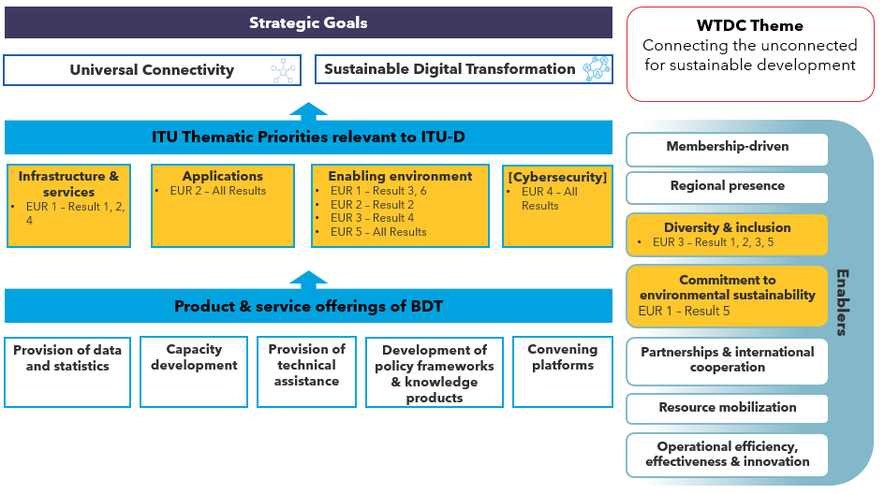

Study Group Questions

Resolutions and Recommendations

CWG-SFP 2/2, page 3
CWG-SFP 2/2, page 10 (64)
United Nations Development Group: Results-Based Management Handbook
CWG-SFP 2/2, page 3
United Nations Development Group: Results-Based Management Handbook
United Nations Development Group: Results-Based Management Handbook
United Nations Development Group: Results-Based Management Handbook
CWG-SFP 2/2, page 3
Buenos Aires Action Plan, page 69
Buenos Aires Action Plan
CWG-SFP 2/2, page 3
Buenos Aires Action Plan, page 64
United Nations Development Group: Results-Based Management Handbook
United Nations Development Group: Results-Based Management Handbook
Adapted from the Secretariat’s response to the PWC Regional Presence Review
WTDC Resolution 1, page 194 (2.6.1)
WTDC Resolution 1, Buenos Aires Action Plan page 195 (2.7.1)
WTDC Resolution 1, Buenos Aires Action Plan page 64-65
CWG-SFP 2/2, page 3
CWG-SFP 2/2, page 5 (16)
WTDC Report, Buenos Aires Action Plan page 59 paragraph 5
CWG-SFP 2/2, page 3
The Thematic Priorities displayed in this diagram align with the ITU Thematic Priorities in the ITU Strategic Plan 2024-2027 to which ITU-D will contribute directly.
CWG-SFP 2/2, page 6 (24)
CWG-SFP 2/2, page 6 (27)
CWG-SFP 2/2, page 6 (28)
CWG-SFP 2/2, page 6 (30)
CWG-SFP 2/2, page 7
CWG-SFP 2/2, page 7 (37)
CWG-SFP 2/2, page 8 (49-52)
CWG-SFP 2/2, page 9 (53-55)
CWG-SFP 2/2, page 9 (56 and 58)
CWG-SFP 2/2, page 9 (59-61)
CWG-SFP 2/2, page 9 (56 and 58)
CWG-SFP 2/2, page 9 (62 and 63)
CWG-SFP 2/2, page 10 (65)
CWG-SFP 2/2, page 10 (66)
CWG-SFP 2/2, page 10 (67)
CWG-SFP 2/2, page 10 (68)
CWG-SFP 2/2, page 11 (69)
CWG-SFP 2/2, page 11 (70)
CWG-SFP 2/2, page 11 (71)
Study Group Question (SGQ) names numbering is subject to change at WTDC.
TDAG 21/2 Working Document: WTDC Action Plan Outcomes and Outputs, Outcome D.7-a
TDAG 21/2 Working Document: WTDC Action Plan Outcomes and Outputs, Outcome D.7-b
TDAG 21/2 Working Document: WTDC Action Plan Outcomes and Outputs, Outcome D.7-c
TDAG 21/2 Working Document: WTDC Action Plan Outcomes and Outputs, Outcome D.7-d
TDAG 21/2 Working Document: WTDC Action Plan Outcomes and Outputs, Outcome D.7-e
TDAG 21/2 Working Document: WTDC Action Plan Outcomes and Outputs, Outcome D.3-a
TDAG 21/2 Working Document: WTDC Action Plan Outcomes and Outputs, Outcome D.2-f
TDAG 21/2 Working Document: WTDC Action Plan Outcomes and Outputs, Outcome D.3-b
TDAG 21/2 Working Document: WTDC Action Plan Outcomes and Outputs, Outcome D.2-d
TDAG 21/2 Working Document: WTDC Action Plan Outcomes and Outputs, Outcome D.2-a
TDAG 21/2 Working Document: WTDC Action Plan Outcomes and Outputs, Outcome D.2-b
TDAG 21/2 Working Document: WTDC Action Plan Outcomes and Outputs, Outcome D.2-c
TDAG 21/2 Working Document: WTDC Action Plan Outcomes and Outputs, Outcome D.2-e
TDAG 21/2 Working Document: WTDC Action Plan Outcomes and Outputs, Outcome D.6-a
TDAG 21/2 Working Document: WTDC Action Plan Outcomes and Outputs, Outcome D.6-b
TDAG 21/2 Working Document: WTDC Action Plan Outcomes and Outputs, Outcome D.6-c
TDAG 21/2 Working Document: WTDC Action Plan Outcomes and Outputs, Outcome D.1-d
TDAG 21/2 Working Document: WTDC Action Plan Outcomes and Outputs, Outcome D.1-c/D.5-c
TDAG 21/2 Working Document: WTDC Action Plan Outcomes and Outputs, Outcome D.4-a
TDAG 21/2 Working Document: WTDC Action Plan Outcomes and Outputs, Outcome D.4-b
TDAG 21/2 Working Document: WTDC Action Plan Outcomes and Outputs, Outcome D.4-c
TDAG 21/2 Working Document: WTDC Action Plan Outcomes and Outputs, Outcome D.4-d
TDAG 21/2 Working Document: WTDC Action Plan Outcomes and Outputs, Outcome D.4-e
TDAG 21/2 Working Document: WTDC Action Plan Outcomes and Outputs, Outcome D.3-c
TDAG 21/2 Working Document: WTDC Action Plan Outcomes and Outputs, Outcome D.3-d
TDAG 21/2 Working Document: WTDC Action Plan Outcomes and Outputs, Outcome D.1-e/D.5-d
TDAG 21/2 Working Document: WTDC Action Plan Outcomes and Outputs, Outcome D.1-a/D.5-a
TDAG 21/2 Working Document: WTDC Action Plan Outcomes and Outputs, Outcome D.1-b
TDAG 21/2 Working Document: WTDC Action Plan Outcomes and Outputs, Outcome D.5-b
Refers to people with specific needs, including children, women, older persons and persons with disabilities.

