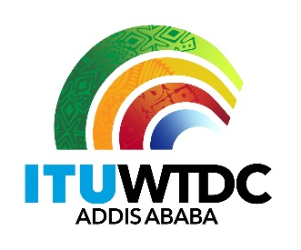 | Second Inter-Regional Meeting (IRM-2) to prepare for the WTDC-21  Virtual, 13-14 December 2021 |  | 
 |  | Revision 3 to
 |  | Document IRM21-2/34-E
 |  | 13 December 2021
 |  | Original: English
Director, Telecommunication Development Bureau
Draft agenda

Agenda item | Documents
- Opening of the meeting
- Approval of the agenda | IRM-2/34(Rev.3)
- WTDC Update | Oral presentation
- Update on RTO preparations | Oral presentations and IRM-2/DT/2, 3, 5, 6
- Contributions from membership
5.1 Resolutions | IRM-2/36, 37, 38, 39, 40, 41, 42, 43, 45, 46(Rev.1), 47, 48, 49, 51, 52, 53, 54, 55(Rev.1)
5.2 Resolution 1 | IRM-2/50(Rev.1)
5.3 Declaration | IRM-2/35, 59
5.4 Thematic Priorities | IRM-2/58
5.5 Regional Initiatives | IRM-2/44, 56, 57
5.6 Strategic Plan | IRM-2/60
- WTDC Action Plan | IRM-2/DT/1
- Any other business
- Closing

_______________

