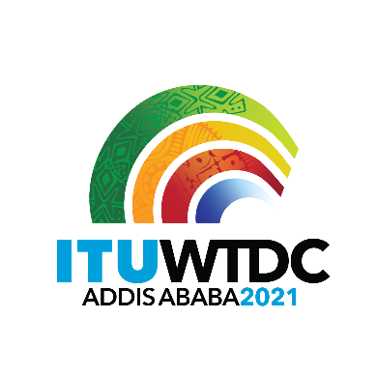 | Second Inter-Regional Meeting (IRM-2) to prepare for the WTDC-21  Virtual, 13-14 December 2021 |  | 
 |  | Revision 1 to
 |  | Document IRM21-2/34-E
 |  | 18 October 2021
 |  | Original: English
Director, Telecommunication Development Bureau
Draft agenda

- Opening of the meeting
- Approval of the agenda
- WTDC Update
- Update on RTO preparations
- Contributions from membership
- Any other business
- Closing

_______________

