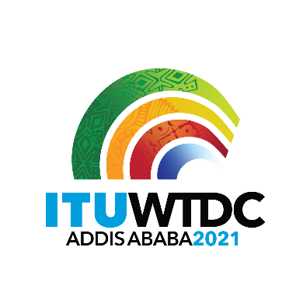 | Second Inter-Regional Meeting (IRM-2) to prepare for the WTDC-21  Virtual, 12-14 May 2021 |  | 
 |  | Document IRM21-2/34-E
 |  | 12 April 2021
 |  | Original: English
Director, Telecommunication Development Bureau
Draft agenda

- Opening of the meeting
- Approval of agenda
- WTDC-21 Update
- Update on RTO preparations
- RPM Outputs
  - RPM-AFR
  - RPM-ARB
  - RPM-CIS
  - RPM-AMS
- Report on the work of TDAG-WG-RDTP
  - Declaration
  - Thematic Priorities (including SG Questions)
  - Streamlining Resolutions
- Report on the work of TDAG-WG-SOP
- AOB

_______________

