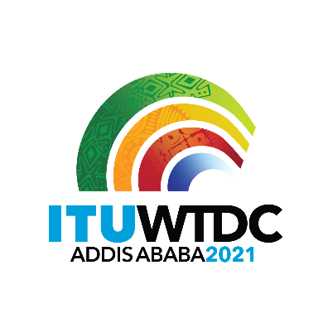 | First Inter-Regional Meeting (IRM-1) to prepare for the WTDC-21  Virtual, 11 March 2021 |  | 
 |  | Document IRM21-1/28-E
 |  | 10 March 2021
 |  | English only
Director, Telecommunication Development Bureau
List of RTO nominations to the posts of IRM vice-chairmen

Vice-chairmen
Dr Ahmad Sharafat | APT - Iran | ahmad.sharafat@gmail.com
Ms Caecilia Nyamutswa | ATU – Zimbabwe | nyamutswa@potraz.gov.zw  Tel: +263 7721 58309
Ms Inga Rimkeviciene | CEPT - Lithuania | inga.rimkeviciene@rrt.lt
Mr Santiago Reyes-Borda | CITEL - Canada | santiago.reyes-borda@canada.ca
Mr Mansour AlQurashi | LAS – Saudi Arabia | mqurashi@citc.gov.sa
Mr Arseny Plossky | RCC – Russian Federation | aplossky@gmail.com

_______________

