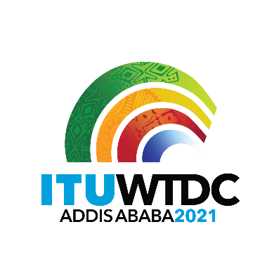 | First Inter-Regional Meeting (IRM-1) to prepare for the WTDC-21  Virtual, 11 March 2021 |  | 
 |  | Document IRM21-1/2-E
 |  | 3 February 2021
 |  | Original: English
European Conference of Postal and Telecommunications Administrations (CEPT)
Proposal for initial points to be raised at the 1st IRM
Agenda item:
N/A
Summary:
During the last meeting of the CEPT Com-ITU Project Team on WTDC-21, several initial points regarding preparation to the WTDC-21 and progress in Europe achieved were proposed to be included into the Agenda of the first Interregional Preparatory Meeting (IRM-1) for WTDC-21.
Expected results:
To include the European proposals into the Agenda of the 1st IRM to foster the discussion on them among the regions.
References:
N/A

Proposal for initial points to be raised at the 1st IRM
- To discuss the Vision for ITU-D. Com-ITU approved the 1st European Common Proposal “Vision for ITU-D”. This document could be presented during the meeting, also with encouragement to other regions to prepare similar Visions.
- Presentation of TDAG-WG-RDTP activity, especially presentation on progress of the ad hoc group on streamlining resolutions proposed in the TDAG WG RDTP, e. g. discussion on Resolution 1. Discussion on common approach towards modifications of this core document would be useful, especially in the view of provisions on preparation of Strategic Plan as agreed by TDAG-WG-SOP.
- Regional Priorities. During RPM-EUR, the regional Priorities for Europe (2022-2025) were elaborated and could be presented to other regions for information.
- Preparatory issues with the Secretariat. Request to the Secretariat to prepare a table with Resolutions which are proposed for modification, suppression, or new Resolutions etc. for WTDC-21, also list of Topic Coordinators per region and other relevant issues that could help the Membership in preparation process could be discussed.
- Distribution of the documents for WTDC-21. Discussion on how Resolutions will be distributed within the WTDC-21 Committees of the Conference, optional for this or the next IRM.

_______________

