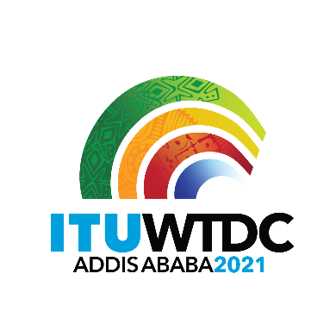 | First Inter-Regional Meeting (IRM-1) to prepare for the WTDC-21  Virtual, 11 March 2021 |  | 
 |  | Revision 4 to
 |  | Document IRM21-1/1-E
 |  | 11 March 2021
 |  | Original: English
Director, Telecommunication Development Bureau
Draft agenda

Agenda items | Documents
1. Approval of agenda | IRM21-1/1  IRM21-1/2 (CEPT)
2. Appointment of chairman and vice-chairmen | IRM21-1/28 (BDT)
3. WTDC-21 Update | IRM21-1/21 (Ethiopia)
4. Update on RTO preparations | IRM21-1/23 (LAS)  IRM21-1/29(Rev.1) (ATU)  IRM21-1/22 (CITEL)  IRM21-1/24(Rev.1) (APT)  IRM21-1/25 (RCC)  IRM21-1/27 (RCC)  IRM21-1/26 (CEPT)  IRM21-1/30 (CEPT)  IRM21-1/31 (CEPT)
5. RPM Outputs
a. RPM-EUR
- Regional Priorities for Europe | IRM21-1/31 (CEPT)
b. RPM-ASP: TBD
c. Calendar of RPMs | link
6. Report on the work of TDAG-WG-RDTP
a. Declaration
b. Thematic Priorities (including SG Questions)
c. Streamlining Resolutions | IRM21-1/3 (RCC)  IRM21-1/4 (RCC)  IRM21-1/5 (RCC)  IRM21-1/6 (RCC)  IRM21-1/7 (RCC)  IRM21-1/8 (RCC)  IRM21-1/9 (RCC)  IRM21-1/10 (RCC)  IRM21-1/11 (RCC)  IRM21-1/12 (RCC)  IRM21-1/13 (RCC)  IRM21-1/14 (RCC)  IRM21-1/15 (RCC)  IRM21-1/16 (RCC)  IRM21-1/17 (RCC)  IRM21-1/18 (RCC)  IRM21-1/19 (RCC)  IRM21-1/20 (RCC)
7. Report on the work of TDAG-WG-SOP
8. AOB

_______________

