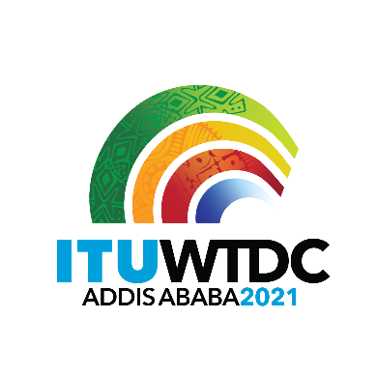 | Regional Preparatory Meeting  for WTDC-21 for Europe (RPM-EUR)  Virtual, 18-19 January 2021 |  | 
 |  | Document RPM-EUR21/17-E
 |  | 6 January 2021
 |  | English only
A.S. Popov Odessa National Academy of Telecommunications (Ukraine)
Development of a multimedia distance-learning course on
improving digital literacy for adults
Agenda item:
Item 8
Summary:
This contribution presents a proposal to develop a multimedia distance-learning course on improving digital literacy for adults, within the framework of the Regional Initative EUR3,“Accessibility, affordability and skills development for all to ensure digital inclusion and sustainable development”, approved by WTDC-17.
Expected results:
RPM-EUR is invited to examine this contribution and to approve the proposal therein.
References:
WTDC Resolution 17 (Rev. Buenos Aires, 2017)

Background
The abilities and skills required by today’s information and communications technologies are often referred to as “digital literacy” caused by digitalization of conditions of living and learning.
The ITU Plenipotentiary Conference (PP) in 2010 defined among the sectoral and intersectoral objectives to build human and institutional capacity, provide data and statistics, promote digital inclusion and provide concentrated assistance to countries in special need. Also PP 2010 defined the improved capacity of members to provide people with specific needs with digital literacy training as outcome to this objective.
At the WTDC 2017 the regional initiative “Accessibility, affordability and skills development for all to ensure digital inclusion and sustainable development” was approved. This regional initiative aims to continue work in order to solve the region's problems in the field of digital literacy and digital skills. The expected results are: developing regional and in-country capacity through relevant web accessibility training to ensure that government websites and related services are available and accessible to all citizens, including persons with disabilities and specific needs; promoting digital literacy, digital skills and e-education, and implementing accessible ICTs in e-education.
Expected results:
Activities:
- Training and testing of at least 2 000 students from various European countries.
- Organization of workshops and presentations of the project execution results at various events of the region, as well as at the meetings of the Development Sector study groups.
Proposal
Project goal is promoting digital literacy and developing regional and in-country capacity through relevant web accessibility training; the assessment of adults preparedness; organization of the testing process for adults; the issuance of certificates that can be taken into account by enterprise managers when employing adults.
The project proposes to:
- develop scenarios, the concept, the structure as well as the textual content of a multimedia distance-learning course on improving digital literacy for adults;
- develop multimedia content (including vocalization and preparation of video content) for the multimedia distance-learning course on improving digital literacy for adults;
- implement software and design of the multimedia distance-learning course on improving digital literacy for adults;
- install and test of software, provide domain registration, maintenance and technical support of the server platform and the course itself;
- provide (ensuring continuous (24/7) high-speed access to the server from the Internet), as well as paying for utilities and maintenance of the required infrastructure;
- issue certificates that can be taken into account by enterprise managers.

_______________

