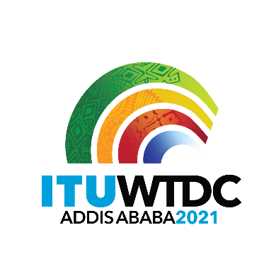 | Regional Preparatory Meeting  for WTDC-21 for Europe (RPM-EUR)  Virtual, 18-19 January 2021 |  | 
 |  | Document RPM-EUR21/1-E
 |  | 10 November 2020
 |  | Original: English
Director, Telecommunication Development Bureau
Draft agenda

1. | Opening ceremony
2. | Election of the Chairman and Vice-Chairman
3. | Adoption of the agenda and time management plan
4. | Digital Trends Europe
5. | Reporting on the implementation of the Buenos Aires Action Plan (including the Regional Initiatives), and contribution to the implementation of the WSIS Plan of Action and the Sustainable Development Goals (SDGs)
6. | Report on the implementation of outcomes of other ITU Conferences, Assemblies and meetings related to ITU-D work: PP-18, WRC-19, RA-19, and WTSA-16
7. | Preparations for WTDC-21
7.1 | Report of the TDAG Working Group on WTDC Preparations (TDAG-WG-Prep)
7.2 | Report of the TDAG Working Group on WTDC Resolutions, Declaration and Thematic Priorities (TDAG-WG-RDTP)
7.3 | TDAG Working Group on Strategic and Operational Plans (TDAG-WG-SOP)
8. | Identification of regional priority areas
9. | Other business

_______________

