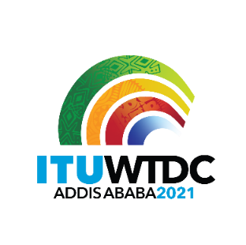 | Regional Preparatory Meeting for WTDC-21 for CIS (RPM-CIS)  Virtual, 21-22 April 2021 |  | 
 |  | Document RPM-CIS21/35-E
 |  | 14 April 2021
 |  | Original: Russian
Regional Commonwealth in the field of Communications (RCC)
CIS Regional Initiative Digital Skills Project
(Digital Skills)
Agenda item:
Item 8
Summary:
In recent years, the world has witnessed a rapid growth in the development of digital technologies. Most states are currently implementing national strategies/programs for the development of digital economies, in this regard, new directions and professions appear, where priority is given to specialists with special digital skills and knowledge.
During the COVID-19 pandemic, many citizens felt the importance of the role of information and communication technologies/ICT in such difficult conditions, when a person, in fact, is in complete isolation. Citizens had to adapt to new conditions, and the market had to promptly offer new digital solutions in various fields - health care, education, communications, etc. In addition to vital services, online services related to access to sources of culture and art became important.
As of the current time, until all the restrictions caused by COVID-19 have been lifted in the countries, there is a great demand for online services in the field of culture and art - remote visits to museum exhibitions and galleries. In particular, virtual reality is capable of teleporting people to places they may never be able to visit. In this regard, VR museum tours are steadily gaining popularity. Modern technology gives you the chance to experience the greatest masterpieces and exceptional relics.
However, given the wide range of opportunities now available, many citizens, especially older people, do not have the digital skills to use them.
Expected outputs:
- Recommendations for the development of digital skills among citizens in the field of culture, art.
- Reducing barriers to public access to museum funds.
Reference:
N/A

RI: Digital Skills
Objective: To provide assistance to ITU Member States in the region in developing recommendations for the development of digital skills among citizens in the field of culture, art, as well as reducing barriers to public access to museum funds.
Expected results:
- Recommendations for the development of digital skills among citizens in the field of culture, art, as well as reducing the barriers to public access to museum funds;
- Cooperation with museums to develop special programs for citizens' access to museum expositions;
- Refresher courses, forums, trainings, seminars on issues related to the development of digital skills among citizens in the field of culture and art.
________________

