|  |  |  |  |
| --- | --- | --- | --- |
|  | **Regional Preparatory Meeting  for WTDC-21 for Asia and the Pacific  (RPM-ASP)  Virtual, 9-10 March 2021** | |  |
|  | |  | |
|  | | **Document** **RPM-ASP21/11-E** | |
|  | | **22 February 2021** | |
|  | | **English only** | |
| Asia-Pacific Institute for Broadcasting Development (AIBD) | | | |
| Over-the-air Radio and Television Broadcasting: Assuring Sustainable Future | | | |
|  | | | |
| **Agenda item:**  Item 8  **Summary:**  The COVID-19 highlighted the value of radio and television broadcasting over the air (OTA). OTA served as the most resilient and reliable disaster management communication mechanism used by national authorities. It also provided education when students locked down at home. As per the mandate of AIBD, it wishes to continue collaboration with ITU to achieve a vibrant and cohesive electronic media environment, especially over-the-air broadcasting in the Asia-Pacific region. AIBD wishes to work with ITU to raise its concern to promote sustainable, both energy and spectrum efficient radio and television broadcasting for each of the populations in their respective countries through policy and resource development.  **Expected results:**  Preserve frequencies or offer an affordable, accessible, sustainable, energy-efficient and frequency efficient mechanism to reach the population in large to communicate disaster communication, development communications, education, and have access to a wide range of views through media plurality. ITU-D could assist the broadcast industry through inter-sectoral activities to achieve the above aim. The AIBD, in collaboration with ITU-D, could advocate, sensitise, and build capacity with its members to reach this goal while communicating with respective governments.  **References:**  N/A | | | |

1. **Introduction**

**What is AIBD?**

The Asia-Pacific Institute for Broadcasting Development (AIBD) was established in August 1977 under the auspices of the United Nations Educational, Scientific and Cultural Organisation (UNESCO). It is a unique regional inter-governmental organisation, servicing countries of the United Nations Economic and Social Commission for Asia and the Pacific (UN-ESCAP) in the field of electronic media development. It is hosted by the Government of Malaysia and the secretariat is located in Kuala Lumpur.[1]

The International Telecommunication Union (ITU), the United Nations Development Programme (UNDP), and the United Nations Educational, Scientific and Cultural Organisation (UNESCO) are the founding organisations of the AIBD and they are non-voting members of the General Conference.

The Institute seeks to fulfil this mandate by mobilising the intellectual and technological resources available within the national broadcasting organisations of its member countries as well as regional and international bodies through a well-established infrastructure and networking mechanism which includes government agencies, non-governmental organizations, institutions of higher learning, private sector and individual professionals.

Full membership of the AIBD is confined to sovereign states, and they are invited to designate the broadcasting authority of the country to be the beneficiary. The AIBD currently has 26 Full Members (countries), represented by 43 organisations, and 50 Affiliate Members (organisations) with a total membership of 93 representing 46 countries and regions and over 50 partners in Asia, Pacific, Europe, Africa, Arab States and North America.

The AIBD is mandated to achieve a vibrant and cohesive electronic media environment in the Asia-Pacific region through policy and resource development.

The ITU is committed to connecting the world, virtually every facet of modern life – in business, culture or entertainment, at work and at home – depends on information and communication technologies.[2] Though WTDC is focused on the ITU Development Sector, let’s review the mission of the ITU Radio communication Sector is to ensure rational, equitable, efficient and economical use of the radio-frequency spectrum by all radiocommunication services, including those using satellite orbits, and to carry out studies and adopt recommendations on radiocommunication matters. This mission lies within the broader framework of the purposes of ITU, as defined in Article 1 of the ITU Constitution and is, in particular, to "maintain and extend international cooperation among all the Member States of the Union for the improvement and rational use of telecommunications of all kinds".[3]

AIBD has been maintaining a close relation with ITU and collaborated over the last four decades, especially related to broadcasting, to train the regional broadcasters through capacity building initiatives.

Access to information and education are human rights. During the unprecedented times of recent pandemic, Broadcasting organisations (especially Public Broadcasting Media organisations) have proved their significance to provide information and education to its audience in precise and accurate manner related to COVID19. Even, UNESCO, WHO and UN studies endorsed the role of the media. Broadcasters can provide such services without any barrier, gatekeeper and is affordable and trustworthy. Over the time, they have proved themselves as a vital catalyst to achieve Sustainable Development Goals (SDG) of UN and by collaborating with its several bodies like ITU, UNESCO, UN-ESCAPE, WHO, etc.[4]

1. **Proposals**

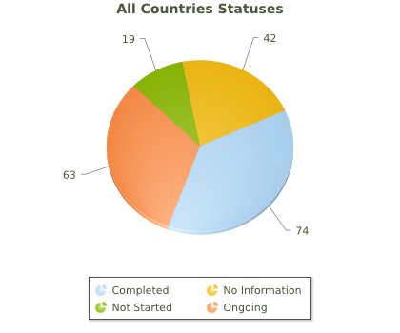

Figure 1: Status of DTT

as of 17 Sep 2020

**Sensitise public service broadcasters and regulators on the value of Over-the-air Radio and Television Broadcasting and to protect and sustain PSM services**

The broadcast industry has been working on the digitalisation of the broadcast value chain for nearly four decades. Most of the operations except the transmission globally happen in the digital domain. However, as of now, not all 193 ITU member countries have migrated their analogue terrestrial television broadcasting services to digital. As of 17th September 2020, according to the ITU-D website reports[5] (figure 1), 74 countries have fully completed analogue to the digital transition of terrestrial television broadcasting and have switched off analogue (ASO) broadcast service.

One of the important factors in the digital transition of terrestrial television transmission is the air interface (radio frequencies). The ITU has recognised four global standards or systems. The first-generation standards are tabulated in Table 1 with relevant ITU standards. Details of those standards are available in the ITU study report “Guidelines for the Transition from Analogue to Digital Broadcasting”, ITU, 2014. The study report can be accessed from the ITU website[6].

Some standards have Satellite, Cable and Online delivery standards besides terrestrial in its family of standards. The second-generation technologies have been developed and recognised for ATSC and DVB-T standards. Countries lately embarking on digital terrestrial television (DTT) can leapfrog to second-generation technologies straightway. Figure 2 shows that the adoption of a digital terrestrial television transmission by technology[7]. Among forty (40) Asia-Pacific countries studied, nine (9) countries have completed analogue switch off. Thirty-one (31) more countries are yet to switch off analogue television broadcasting services. Alarmingly some countries even not started or planned digital terrestrial broadcasting services. Digital Terrestrial Transmission technology is now essential in all the broadcast activities and the broadcast (audio-visual and media) sector is not exempt from the digitalisation process experienced by society in APAC and beyond.

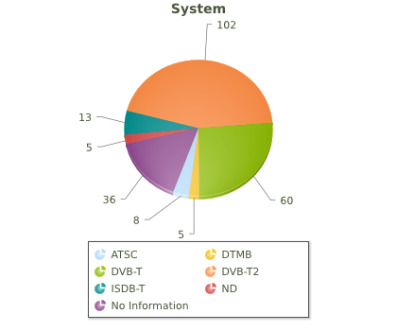

Figure 2: System of DTT

as of 17 Sep 2020

Table 1: First generation of DTT

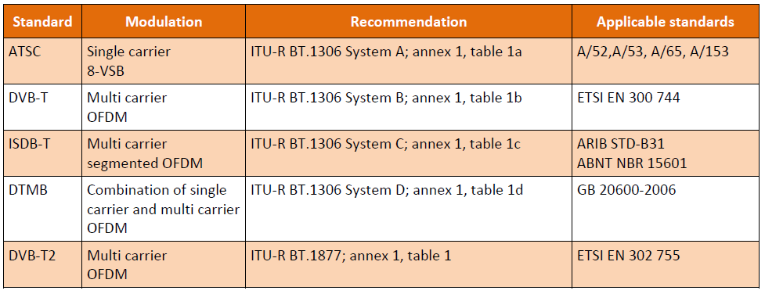

In accordance with international trends, it is important for countries yet to develop an analogue to digital transition new plan for television broadcasting because of the following reasons.

1. The end-to-end value chain of television is digital, and countries already use digital except in terrestrial transmission.
2. The transmission and receiving devices are all digital.
3. People in APAC should also have the same opportunity as the rest of the world to enjoy high-quality media content delivered via digital television broadcast services as free-to-access (FTA).
4. Such analogue to digital transition plans or roadmaps for television broadcasting helped many countries in APAC to complete the transition to digital transmission.

**Need to address Spectrum issues for broadcasting and collaborate with ITU-R for WRC23**

The World Radiocommunication Conference in 2023 will have a significant impact on the future of the broadcast delivery of media services and media production services that are used to produce audio-visual content, news and events. Following the World Radiocommunication Conference (WRC) held in Sharm El-Sheikh in November 2019, the broadcast industry has identified the need in joining forces to prepare for the next WRC as for previous WRC-15 and WRC-19. Proactive broadcast organisations are planning collectively with the participation of public service broadcasters, commercial broadcasters, broadcast network operators and the PMSE (Programme Making and Special Events) community having the objective of defining a roadmap of activities and to identify actions for the various stakeholders. The utilisation of the UHF band 470-960 MHz in region 3, the core band for television broadcasting, is critical for the sustenance of over the air television broadcasting services. Some studies are being done by a dedicated Task Group that is under the leadership of the ITU-R group responsible for broadcasting services. COVID-19 may some impact on some deadlines, possibly needs to be revised. For example, the studies on spectrum use and spectrum needs of existing services (which includes DTT and wireless audio PMSE) are due on 15 May 2021 – and the same deadline applies for the submission of technical parameters and methodologies for the studies on the compatibility services to share the same spectrum. There should be less impact while using the current equipment such as wireless microphones in Programme Making and Special Events.

**Lessons learnt from Broadcasting during the COVID-19 to sustain OTA broadcasting**

Like other industries, the broadcasting and media industry have also been undergoing changes forced by the COVID-19 crisis. When coronavirus health risk escalated to a pandemic, lockdown and social distancing radically transformed the manner in which people carried out their work and daily life. COVID-19 also fast-tracked deployments of remote working tools and mechanisms. The governments introduced various systems to mitigate the coronavirus spread and its ill effects.

Broadcasting has been playing a vital role during the lockdown and subsequent actions as always. Many nations like New Zealand, Turkey and many states in the US declared Broadcasting as an essential service while organisations utilised these services not only to inform, educate, entertain but also to support the public during the crisis. UNESCO in a news reported that “Communication is aid and the right information at the right time saves lives! Media is now more than ever becoming both an essential and emergency service in addition to being critical in response to COVID-19.” On the technical side, the Internet traffic peaked with the start of lockdown as schools closed, teleworking became a normal practice and services become increasingly digital. During COVID-19, the impact of broadcasting on the broadband network was mitigated as the audience accessed television via over-the-air; either terrestrially using digital terrestrial television broadcasting (DTTB) or direct-to-home (DTH) via satellite.

In recent times, television and media consumption patterns have changed notably because of rapid technological advancements. Over-the-top (OTT) services that offer content via broadband uses unmanaged networks. The global pure OTT service providers were urged to reduce their bit rate within the same technical format to ease network congestion (e.g. India, European Union region). Some broadcasting organisations have issued guidelines and recommendations in this regard, especially to public service broadcasters. European Broadcasting Union (EBU), which is a collective group of public broadcasters in the European Union region, has issued recommendations[8] for public service media organisations as measures to mitigate the Internet congestion and to manage the potential impact of streaming media consumption during the COVID-19 pandemic.

Some broadcast organisations and collectives suggested temporarily cap streaming bitrates at appropriate levels for various end-user devices, particularly during the daytime, and that public service media organisations should encourage audiences to consume their offerings over broadcast rather than broadband, and on fixed broadband rather than mobile, where possible. There is no such bottleneck in over-the-air broadcasting services.

As observed in the recent past, collaboration among stakeholders in a country is key to survive and thrive. At a crucial period, such as the COVID-19 pandemic, Public Service Media (PSM) have taken an active and lead role in coordinating national efforts and to engage with other media, network operators and regulatory agencies to collectively analyse and respond to the situation.

Public Service Media (PSM) are also the primary means of communicating with citizens in national emergencies. It can be noted that public service media organisations are playing a key role in managing the crisis – not only by continuing to inform, educate and entertain, but also by actively engaging with relevant organisations and the public to ensure that broadcast and broadband infrastructure is used in the most effective and efficient way.

A collection of broadcasters could respond to potential internet congestion issues that could be caused by higher media consumption and the increased reliance on online collaboration tools during the COVID-19 crisis despite the request was from the European Commission. Obligations of public service media were demonstrated when weighing measures to reduce the impact of their services on the Internet. Subsequently, other media players including pure OTT service providers took actions to reduce bit rates of their streaming services. In India, a service provider reduced the bit rate by 25% while maintaining the quality of service and format integrity as per usage plans with their customers.

**The role of Broadcasting in Education and need to sustain while complementing other learning**

It is required to understand why broadcasting is important for education today. The COVID-19 pandemic has been one of the biggest disruptions to education the world has ever known, affecting over 90% of the world student’s population. UNESCO reports that “Considering this technological divide, most countries around the world are also using television and/or radio-based programmes to implement distance education.”[9]. Africa seems to be the most active in the efforts to leverage either TV or radio (70%), some combining both (34% of countries), while Europe and North America seem to be using less radio than other regions, yet very active in deploying TV-based distance education programmes. The COVID-19 disrupted learning and education for both school children and tertiary students globally. According to the estimates carried out by UNICEF in May 2020, 1.3 billion students[10] were out of school, out of which millions of students lacked Internet access or lived in areas not covered by mobile networks. At its peak, the pandemic had impacted over 165 countries and around 85% of total enrolled learners. By April 2020, close to 1.6 billion children and youth were out of school.[11] More than half of all children and adolescents worldwide are not meeting minimum proficiency standards in reading and mathematics.[12]

While innovative online learning solutions were deployed widely, many countries turned to television to broadcast educational materials, increase access to distance education, and ensure uninterrupted learning. Some examples include TVNZ (New Zealand), FBC (Fiji), DDI (India). Public service media in countries have used and continue to use radio, TV and web-based platforms to instruct students in a wide range of subject areas at the pre-primary, primary and secondary levels.

According to UNICEF, television had the potential to reach the most students (62%) globally[13]. Research by UNICEF showed that in countries studied in Eastern Europe, Central Asia, the Middle East, North Africa, Latin America and the Caribbean, television would reach 80% or more of the school-aged population.[14] UNICEF's COVID-19 education rapid response tracker showed 77% of countries included television in their national response to COVID-19 school closures. It is important to note that a large percentage of 77% of countries included television in their national response to COVID-19 school closures.[15]

Many countries are using educational technologies including online learning, radio, television, texting to support access to remote learning during the COVID-19 pandemic. The COVID 19 crisis has already hit as many as 363 million learners worldwide.

The COVID-19 pandemic has underscored humanity's growing reliance on broadcasting systems. Recognising the impact of television in today's changing world, the United Nations General Assembly proclaimed 21 November as World Television Day to promote the role of TV in issues of peace, security, economic and social development and cultural exchange.

Before the escalation of the COVID-19 pandemic, media and broadcast industries were looking at several areas, including Digital Audio Broadcasting (DAB). A BBC research in the UK has shown that DAB as the most energy-efficient way to deliver radio content in addition that was known to the industry as DAB as the most frequency efficient mechanism.[16] However, with the emergence of COVID-19, broadcasters are looking at how we can mitigate threats to the staff of broadcast stations while discharging the duties of television and radio broadcasting.

**Recommendation**

Considering the role that broadcasting plays, especially the over-the-air, it is required to sustain over the air broadcasting. Broadcasting could facilitate inclusiveness and diversity while accessing quality information and education for all and promote lifelong learning even during disasters.

_______________

1. <https://aibd.org.my/about/>
2. <https://www.itu.int/en/about/Pages/vision.aspx>
3. <https://www.itu.int/en/ITU-R/information/Pages/mission-statement.aspx>
4. <https://sdgs.un.org/goals/goal9>
5. <https://www.itu.int/en/ITU-D/Spectrum-Broadcasting/DSO/Pages/statistics.aspx>
6. <https://www.itu.int/en/ITU-D/Technology/Documents/Publications/PUB_BroadcastingSpectrum/Guidelines_Transition_ADB_2014_E.pdf>
7. <https://www.itu.int/en/ITU-D/Spectrum-Broadcasting/DSO/Pages/statistics.aspx>
8. <https://tech.ebu.ch/publications/r149>
9. <https://en.unesco.org/news/learning-through-radio-and-television-time-covid-19>
10. <https://en.unesco.org/news/13-billion-learners-are-still-affected-school-university-closures-educational-institutions>
11. <https://unric.org/en/sdg-4/>
12. <https://www.un.org/sustainabledevelopment/education/> and <https://www.unicef.org/coronavirus/keeping-worlds-children-learning-through-covid-19>
13. <https://data.unicef.org/resources/remote-learning-reachability-factsheet/>
14. <https://www.un.org/sustainabledevelopment/education/>
15. <https://blogs.unicef.org/evidence-for-action/can-broadcast-media-foster-equitable-learning-amid-the-covid-19-pandemic/>
16. <https://downloads.bbc.co.uk/rd/pubs/whp/whp-pdf-files/WHP393.pdf>.