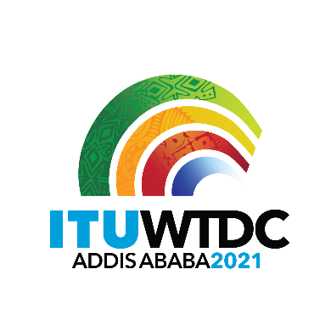 | Regional Preparatory Meeting  for WTDC-21 for Arab States (RPM-ARB)  Virtual, 7-8 April 2021 |  | 
 |  | Document RPM-ARB21/INF/3-E
 |  | 7 April 2021
 |  | English only
Director, Telecommunication Development Bureau
Opening remarks of Ms Doreen Bogdan-Martin, Director,
Telecommunication Development Bureau
Network of Women for WTDC-21 (NoW4WTDC21) Arab Region
RPM-ARB side event

Good afternoon
Distinguished delegates,
Ladies & gentlemen,
I am delighted to welcome you all to this official launch of the Network of Women for WTDC-21 in the Arab region.
We are working to build a support structure for our talented female delegates in the lead up to WTDC-21, and beyond. ….
This is the fourth Network of Women we have launched in the ITU-D Sector, in the lead up to our World Telecommunication Development Conference, with only two more regions to go now before we all come together as one in November.
We have witnessed an incredible level of enthusiasm and excitement from women in each RPM so far, and no less in the Arab region, fuelling momentum towards what I believe will be a landmark development conference.
From the initial launch of the Network of Women at the World Radio Seminar in 2016, these networks have expanded within the World Radio Communication Conference process.
We will soon hear more on lessons learned in the WRC process from Noha Gaafar, one of our well-respected experts from TRA Egypt’s International Policies Department.
Noha had rich experience in the work of ITU-R and was active in the formulation of the NOW4WRC Declaration in 2019.
The Network of Women is designed to:
- facilitate an exchange of experiences,
- help us gain a better understanding of the challenges that female delegates face,
- and identify ways to overcome them.
By removing some of the hurdles that are unique to women, we can level the playing field for women to take on and perform well in senior roles.
Of course the programme includes mentorship opportunities building a community of experienced/supportive women, matched with other upcoming professionals can learn from women with longer career experiences.
Our hope is that this Network will help build and feed the pipeline by supporting female delegates to take on larger responsibilities within their delegations.
We hope to see women take on more leadership roles in the structures that make up ITU-D, such as those of chairs or vice chairs in Committees, study groups among other structures.
This is necessary for a more inclusive WTDC-21 that integrates women’s thoughts and ideas, and also for impactful future work done by the Development sector.
Through the Network, I hope that younger professionals will be able to learn and gain from more experienced women in the field. Many times, such advice and nurturing can go a long way to open up opportunities and boost women’s confidence to pave their own paths.
And in general, the Network will offer opportunities for women to connect with each other and share their experiences, so that we can identify the challenges women face in taking up leadership roles.
I think we all recognize the crucial role that women play in making progress towards our larger goals …to leverage digital for development.
A disproportionate number of the 3.7 billion people left unconnected are women, and if we want to create solutions that meet their needs, we need women at the table to make active contributions right from the conception to the delivery of these solutions.
We have a long way to go to enhance women’s participation and leadership in our work.
But we have made progress since the first WTDC.
Back then, in 1994, the total number of female delegates was only 21%. In our most recent WTDC in 2017, females made up 28% of delegates. Women have increasingly been holding leadership positions such as conference chairs and vice-chairs, but we have a lot more work to achieve gender parity at the committee level.
Diving down to the regional level, we have seen numbers increasing only marginally in Arab States RPMs, with women representing 14% of delegates to the 2013 RPM, held back-to-back with the RDF, in Manama, and 16% at the 2017 RPM also held back-to-back with the RDF, in Khartoum. This year is a milestone, if the number of registrations just before we opened, is anything to go by, 50% of registered delegates for this RPM are women. I am happy to share with you that we have made history, by achieving the highest number of female participants in RPM-ARB!
That is quite an accomplishment!
We have high hopes that we will maintain this level in the years to come, …..and that we will see a similarly great trajectory in Arab women’s participation at other conferences as well generating to see a positive ripple effect in the participation of women in the digital sector at large.
Later this month, we will be celebrating the tenth anniversary of International Girls in ICT Day.
Being the inspiring role models that you are for girls around the world, I invite you to join in the celebrations in your respective countries and in the region at large.
With that, I thank you for joining us today and look forward to seeing your active leadership in taking our work forward.
Thank you.
_______________

