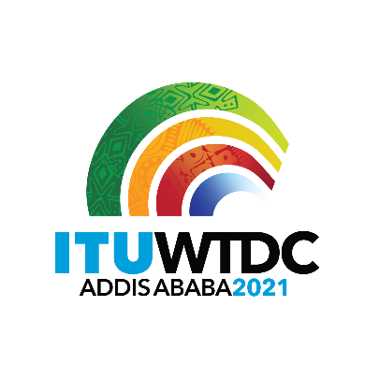 | Regional Preparatory Meeting  for WTDC-21 for the Americas (RPM-AMS)  Virtual, 26-27 April 2021 |  | 
 |  | Document RPM-AMS21/11-E
 |  | 12 April 2021
 |  | Original: English
Canada and United States
Proposed Regional View on Thematic Priorities
Agenda item:
Item 7.2
Summary:
CITEL has been meeting within its Conferences Working Group to consider the ongoing work of the TDAG and RDTP. We have appreciated the discussions over the past months regarding a Fit4Purpose BDT and how to orient our work towards measurable outcomes and more focused and implementable thematic priorities.
This document proposes Americas regional/CITEL views on the thematic priorities based on the draft Proposal for ITU-D Thematic Priorities (WTDC-21) presented by the Chair to the 5th meeting of the TDAG WG-RDTP.
The understanding is that these Thematic Priorities will be contained in the Addis Ababa Action Plan under the section that had programmes in all previous WTDCs.
Expected results:
RPM-AMS is invited to consider this document in developing an Americas / CITEL regional view towards the thematic priorities.
References:
N/A

ITU-D Thematic Priorities
- Connectivity: The focus of this Thematic Priority is on the deployment of modern, available, secure, accessible, and affordable broadband telecommunication/ICT infrastructure with a focus on connecting unserved and underserved populations. This Thematic Priority would seek to foster the development of infrastructure and services, by utilizing a combination of existing, new and emerging connectivity solutions, new business models and forms of connectivity partnerships, and would also include building confidence and security in the use of telecommunications/ICT.
- Innovation: The focus of this Thematic Priority is on the development and use of telecommunications/ICTs and applications and services to close the Digital Divides and empower people and societies for sustainable development. The focus of this priority is to enable innovation in telecommunications/ICTs in support of the digital transformation of society. This is of critical importance as societies adapt to the changes that are needed because of the Covid-19 pandemic.
- Enabling Environment: The focus of this Thematic Priority is on fostering an enabling policy and regulatory environment conducive to sustainable telecommunication/ICT development and infrastructure investment. In so doing, there is need to promote digital inclusion and accessibility, including recognizing the important role that women, youth and persons with disabilities and persons with specific needs can play in making the digital society a reality. This Thematic Priority comprises key enablers that underpin ITU’s work to deliver on the Connectivity and Digital Society priorities.
- Resource Mobilization and International Cooperation: The focus of this Thematic Priority is on mobilizing and attracting resources and fostering international cooperation on telecommunication/ICT development issues. This Thematic Priority is also cross cutting by providing the resources and fostering international cooperation to deliver the relevant global outcomes. The needs of developing countries, LDCs, LLDCs and SIDS should be prioritized and given due attention.
Topics Pertaining to ITU-D Thematic Priorities
The following activity areas/topics pertain to Thematic Priority “Connectivity”:
- Deployment of broadband infrastructure,
- Connecting the unconnected, stimulating demand and closing usage gaps,
- Resilient and Safe Digital Infrastructure (including EMF-related issues, availability, and reliability),
- Cybersecurity,
- Connectivity in the Era of Pandemics and Other Disasters, and
- Telecommunications/ICTs for Disaster mitigation and risk reduction.
The following activity areas/topics pertain to Thematic Priority “Innovation”:
- Digital Services and Applications (use of telecommunications/ICTs in support of health, education, agriculture, digital financial services, etc.),
- Telecommunications/ICT Innovation Ecosystems, and
- Environment (use of telecom/ICT strategies and solutions on climate change adaptation and mitigation, and e-waste).
The following activity areas/topics pertain to Thematic Priority “Enabling Environment”:
- Data and Market Analysis (statistics),
- Policy and Regulation (incentivizing investment, Consumer Protection, etc.),
- Digital Inclusion (gender issues, persons with disabilities and specific needs, financial inclusion, youth, and indigenous people),
- Digital Literacy, and
- Capacity and Skills Development.
The following activity areas/topics pertain to Thematic Priority “Resource Mobilization and International Cooperation”:
- Projects,
- Partnerships,
- Mainstreaming the Needs of Developing countries, LDCS, LLDCs, and SIDS,
- WSIS and SDGs,
- Membership Engagement for Better Impact, and
- ITU-D Study Groups.
________________

