 | 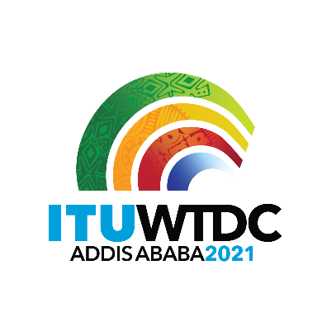 | Regional Preparatory Meeting  for WTDC-21 for Africa (RPM-AFR)  Virtual, 29-30 March 2021 |  | 
 |  |  | Document RPM-AFR21/14-E
 |  |  | 24 March 2021
 |  |  | English only
Ethiopia
WTDC- 21 Host Country Preparation Status
Agenda item:
Item 7
Summary:
This document contains a summary status of the host country preparations for WTDC-21.
Expected results:
RPM-AFR is invited to note this document.
References:
N/A

Organizing Bodies

Steering Committee
A national WTDC-21 Steering Committee has been established composed from different concerned institutions such as the Ministry of Finance, Ministry of Foreign Affairs, Customs Commission, Immigration, nationality and vital events agency and other important institutions. This steering committee is responsible to make key decisions that will facilitate the preparation process, as well as create critical intragovernmental collaborations and facilitate high stakeholder engagement.

Subcommittees
Ten WTDC-21 preparation sub-committees that will work on different issues have been established. These sub committees are responsible for the day-to-day execution of WTDC-21 preparations. and they are,
- Agenda and content development sub-committee
- Sponsorship sub-committee
- Media and communications sub-committee
- Information organization sub-committee
- Hotel and Facilitation sub-committee
- Procurement and logistics sub-committee
- Transportation sub-committee
- Visa, Protocol and Security sub-committee
- Visit and entertainment sub-committee
- Information Technology sub-committee
The Sub-committees regularly meet with ITU counterparts every two weeks to discuss their progresses, challenges faced and important recommendations.

COVID – 19 Working group
Since COVID-19 has continued to be a challenge for hosting WTDC-21 as it was initially planned, Ethiopia has established a COVID-19 working group that is responsible for continuously work on and come up with alternative proposals and contingency strategies for hosting WTDC-21 as safely as possible. The working group has been closely working with ITU counterparts as well.

Major Activities

Host Country Agreement
The Host Country Agreement has been signed on the first “The Road to Addis” series of events on 9 November 2020. The HCA has been signed by H.E. Dr Ahmedin Mohammad representing the government of Ethiopia and Mr Houlin Zhao ITU’s Secretary General.

The Road to Addis
The Road to Addis is building momentum towards WTDC, strengthens partnerships and engagement and helps to shape with key stakeholders the WTDC agenda. The events focus on specific issues relevant to digital development and feature participation of key stakeholders. Seven virtual events were planned and the first three are conducted:
- Road to Addis, kick-off event, 9 November 2020
- Road to Addis, partnerships, 2 February 2021
- Road to Addis, inclusion, 18 March 2021,
- Road to Addis, financing, 28 April 2021 (planned)
- Road to Addis, leadership, 22 June 2021 (planned)
- Road to Addis, innovation, 21 July 2021 (planned)
- Road to Addis, youth, 12 August 2021 (planned)

Chairing Inter Regional Meetings
Ethiopia has chaired the first Inter Regional Meeting on 11 March, and is set to chair the next IRM’s in the coming May and September.
Furthermore, Ethiopia has been participating and involving in WTDC-21 preparatory meetings and working group meetings on different occasions.

Securing Venue
The United Nations Conference center, Addis Ababa, has been selected as the main venue of the conference, since it fulfils most of WTDC’s requirements. Further discussions based on requirements are being conducted.

Travel and Accommodation
We have identified Hotels and guest houses that potentially could provide accommodation for delegates and participants in Addis Ababa. Also, hotels proximity from and to the airport and the venue has been mapped and established.
On the other hand, negotiations with Ethiopian Airline have begun and we are on the verge of signing a Memorandum of understanding to apply discounts for WTDC-21 delegates and participants.

Logo and Host Country Website
The logo of WTDC-21 has been launched on the first “The Road to Addis” event in November along with the signing of the host country agreement.
The WTDC- 21 host country website has been built and being finalized. Contents for the website is being populated with necessary information such as currency exchange rate, weather forecast, hotel’s information, visa and protocol information and etc.
________________

