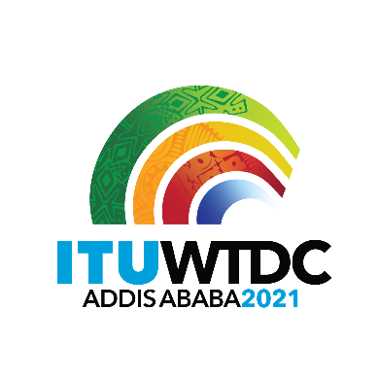 | Regional Preparatory Meeting  for WTDC-21 for Africa (RPM-AFR)  Virtual, 29-30 March 2021 |  | 
 |  | Document RPM-AFR21/1-E
 |  | 29 January 2021
 |  | Original: English
Director, Telecommunication Development Bureau
Draft agenda

1. | Opening ceremony
2. | Election of the Chairman and Vice-Chairman
3. | Adoption of the agenda and time management plan
4. | Digital Trends in Africa
5. | Reporting on the implementation of the WTDC-17 Buenos Aires Action Plan (including the Regional Initiatives), and contribution to the implementation of the WSIS Plan of Action and the Sustainable Development Goals (SDGs)
6. | Report on the implementation of outcomes of other ITU Conferences, Assemblies and meetings related to ITU-D work: PP-18, WRC-19, RA-19, and WTSA-16
7. | Preparations for WTDC-21
7.1 | Update on WTDC-21 preparatory process by the host country Ethiopia
7.2 | Report of the first ATU Regional Preparatory Meeting held on 9 October 2020
7.3 | Report of the TDAG Working Group on WTDC Preparations (TDAG-WG-Prep)
7.4 | Report of the TDAG Working Group on WTDC Resolutions, Declaration and Thematic Priorities (TDAG-WG-RDTP)
7.5 | TDAG Working Group on Strategic and Operational Plans (TDAG-WG-SOP)
8. | Identification of regional priority areas
9. | Launch of Network of Women (NoW) and Generation Connect – Africa Youth Group (GC-AFR)
10. | Other business
_______________

