|  |  |  |
| --- | --- | --- |
| C:\Users\ponder\AppData\Local\Microsoft\Windows\Temporary Internet Files\Content.Word\BDT-25th_anniversary_2017-Logo_411959-3_transparent.png | **World Telecommunication Development Conference 2017 (WTDC-17)**  **Buenos Aires, Argentina, 9-20 October 2017** | C:\Users\ponder\AppData\Local\Microsoft\Windows\Temporary Internet Files\Content.Word\BDT-25th_anniversary_2017-Logo_411959-1_transparent.png |
|  | |  |
| PLENARY MEETING | | **Document WTDC-17/49-E** |
|  | | **27 September 2017** |
|  | | **Original: English** |
| Canada | | |
| EMPOWERING WOMEN THROUGH THE INTERNET | | |
|  | | |
|  | | |
| **Priority area:** - Other proposals  **Summary:**  The Networked Economies program of Canada’s International Development Research Centre (IDRC) aims to support better gender-related outcomes through technology and development in three related areas:  1) Enhancing pro-women policies and rights online;  2) Improving governance and creating economic opportunities that empower women by testing and scaling digital innovations; and  3) Improving access to technology and the skills needed to create and innovate.  This document showcases current projects supporting better gender-related outcomes through technology and development.  **Expected results:**  To achieve SDGs and provide an understanding of how digital innovation can support inclusive economic opportunities and democracy. | | |

CAN/49/1

GENERAL MATTERS

## Empowering Women through the Internet

Digital technologies - the Internet and mobile phones among others - are vital for achieving the Sustainable Development Goals by 2030. The Networked Economies program of Canada’s International Development Research Centre has supported research that has demonstrated that under the right conditions, digital technologies contribute to achieving the SDG targets by fostering economic growth, improving governance, and delivering better outcomes in education and health.

At the same time the positive effects of digital innovation can be too easily counteracted by technologies’ role in amplifying economic nd social inequalities. For instance, women and girls in the developing world often do not have the skills to use, nor equal levels of access to, digital tools. This not only entrenches the significant wage gaps that already exist, but also means that women will struggle to harness 21st century employment opportunities as more jobs move online. A deeper emerging problem is that women who do acquire online skills and access often face severe harassment – as targets for online “trolls” who seek to shame, taunt and marginalize female voices. The digital bias is compounded by the fact that women are underrepresented in fields such as computer science and engineering which shape the design of technologies. ***Ensuring women contribute in these spaces means technological innovations will be designed with their needs in mind, for instance to counter bias or harassment, to provide information on better sanitation, or to support flexible work.***

The goal of the NE program is to understand how digital innovation in developing and middle income countries can support inclusive economic opportunities and democracy. The program aims to deliver on this goal by improving the governance of cyberspace; connecting people in the global South to the online sphere and economic opportunities; and by testing and scaling digital innovations to improve entrepreneurship, education, and democracy.

The program aims to support better gender-related outcomes through technology and development in three related areas:

1) Enhancing pro-women policies and rights online;

2) Improving governance and creating economic opportunities that empower women by testing and scaling digital innovations; and

3) Improving access to technology and the skills needed to create and innovate.

This document outlines current projects that support these efforts, and additional projects are planned to support the achievement of SDG 5 through the Internet.

## Enhance pro-women policies and rights online

## Prospera Digital: Financial Inclusion for Low-Income Women in Mexico

- Mexico

- April 2017 to October 2018

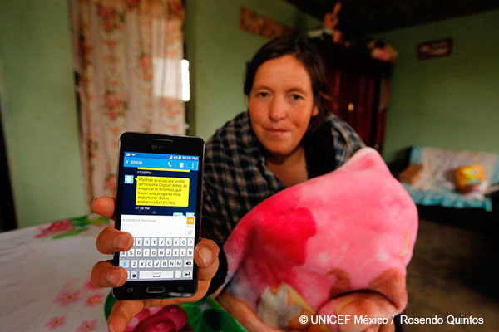

Prospera Digital aims to improve the way that beneficiaries of Mexico’s conditional cash transfer program (Prospera) access and use government financial services through digital technologies. DIRSI conducted preliminary research around existing digital financial inclusion programs and the financial services needs of Prospera beneficiaries. The program is now rolling out a pilot program in 2017 and DIRSI will monitor the results of the interventions. The expectation, based on the preliminary research, is that Prospera Digital will empower low-income women by allowing them more control over family expenditures.

## [Microwork and Virtual Production Networks in Sub-Saharan Africa and Southeast Asia](https://www.oii.ox.ac.uk/research/projects/microwork-and-virtual-production-networks/)

- Sub-Saharan Africa and South East Asia

- March 2014 to March 2017

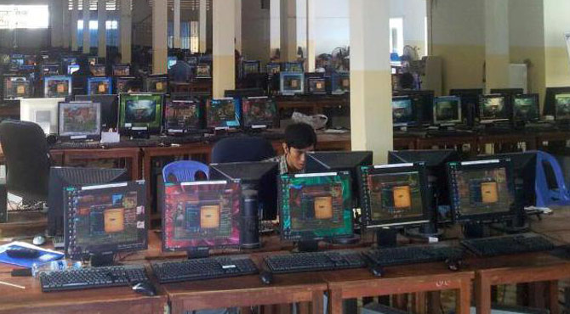

The Oxford Internet Institute and the University of Pretoria are investigating virtual labour markets in Sub-Saharan Africa and South East Asia. The research is analyzing the organization and structure of digital service production, and how this might negatively or positively impact workers in developing and middle income countries. Early findings suggest that many virtual workers are subject to poor labour conditions - especially women. For example, one Philippine transcriber said she had trouble getting paid but was unable to do anything about it because of the policies of the online work platform.

## [Tackling online inequality: Making digital platforms work for inclusive development](http://www.itforchange.net/from-openness-to-inclusion)

- April 2017 to April 2018

With the expansion of digital platforms like Facebook, Amazon, Uber, AirBnB and Twitter, there is a need to understand the socio-economic and gendered dimensions of these new economic drivers - how they are shaping work, learning, communication and engagement, and their impact on inclusion, equity and power in the global South. In a study of online contracting platforms in Latin America, for example, it was found that women globally are underrepresented two to one, and overall tend to bid lower than men. IT for Change in Bangalore is undertaking research to understand existing policy gaps and develop principles for more equitable and inclusive governance of online platforms in the global South.

## [Crowdsourcing Data to Fight Social Misconduct: the Scaling of HarassMap](https://www.idrc.ca/en/project/crowdsourcing-data-fight-social-misconduct-scaling-harassmap)

- Middle East

- February 2016 to February 2018

[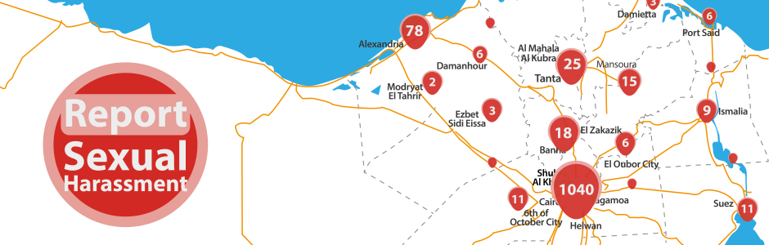](https://www.google.ca/url?sa=i&rct=j&q=&esrc=s&source=images&cd=&cad=rja&uact=8&ved=0ahUKEwjfvoe-iofVAhWp34MKHbELCW8QjRwIBw&url=https://www.ushahidi.com/blog/2015/03/11/harassmaps-research-effectiveness-of-crowdsourced-data&psig=AFQjCNHkJE_LSnxSwPkLqsAoWHWW9ylvYQ&ust=1500063500752067)

HarassMap helps address sexual harassment in Egypt by tracking incidents of harassment, and using data for evidenced-based policy input. The ground breaking work of HarassMap helped generate greater awareness of harassment in Cairo, and resulted in Cairo University becoming the first public university in the Middle East to have an anti-sexual harassment policy. Harassmap is being scaled up to target additional universities in Egypt, and expanded to other countries - and the model is also being replicated elsewhere in Egypt to help tackle corruption.

## Improve governance and create economic opportunities that empower women by testing and scaling digital innovations

## Information Networks and Inclusion in Latin America: Building trust in digital labour in Latin America

- Latin America

- January 2014 to August 2016

Researchers from the Instituto de Estudios Peruanos examined the economic opportunities arising from the proliferation of online labour markets. The research found that digital labour platforms significantly enhance employment opportunities for women and youth in Latin America, but also highlighted issues with geographical discrimination by employers who prefer to hire domestically because of their inability to verify information about the quality of individual job seekers from outside the local context. As a result, researchers collaborated with the largest online labor platform for Spanish-speaking employers and workers – Nubelo - to validate skills and in turn, enhance employment prospects.

## Comparing the Impact of Micro-loans, Mobile Phones, and Business Training on Micro-Enterprises Owned by Women in India

- India

- March 2014 to March 2016

Micro-enterprises are the most common type of business in the global South. In India, recent figures from the National Sample Survey Organization (2012) suggest that there are approximately 1.5 billion micro-enterprises, many owned by women and home-based. Findings from IDRC-supported studies on female micro-entrepreneurs in Mumbai and Chennai suggest a correlation between economic growth and the adoption of mobile phones. When they are able to use mobile communications, many of these women-owned micro-enterprises increase their revenues and hire additional workers. The findings also suggest that successful female micro-entrepreneurs enjoy increased levels of self-efficiency, social respect, and power within their families. Still, little is known about how best to use mobile phones with other common entrepreneurial tools, such as micro-loans and training. This project is assessing the impact of microloans, entrepreneurial training, and mobile phones on the economic growth of micro-enterprises and on the social development of the women who own them. This study aims to determine how efficient the interventions are-either individually or in combination-as a means to increase female micro-entrepreneur participation in developing economies.

## Building an Africa open data network

- Africa

- December 2016 to December 2017

The Open Data for Development Network (OD4D) is seeking to catalyze a more vibrant, viable, and multi-stakeholder ecosystem in Africa through the creation of an Africa Open Data Network (AODN) that will serve as a knowledge hub. Through this project, the Local Development Research Initiative (LDRI) in Kenya will host the AODN hub, in order to amplify the impact of open data in Africa and expand the network’s awareness of and focus on gender-related issues with open data. For one, the most challenging issue to address with open data is the lack of disaggregated data focusing on women. Two, there is a need to understand how women – who represent a minority in the open data community – use, understand and influence open data policies and data-driven innovations. This project will focus on facilitating a better understanding of these issues and support African women leaders in the open data ecosystem.

## Improve access to technology and the skills needed to create and innovate

## Understanding digital access and use in the Global South

- November 2016 to August 2019

Public policies, informed by timely and accurate data, contribute to an affordable and inclusive Internet infrastructure. To ensure that the benefits of broadband are more evenly distributed, such policies must take into account the needs and usage patterns of marginalized populations, particularly women and girls. Unfortunately, such timely and accurate data is not currently available in most developing countries. This project is implemented by Research ICT Africa, a South Africa-based network that conducts research on information and communication technology, policy, and regulation. In collaboration with LirneAsia and Instituto de Estudios Peruanos, Research ICT Africa is collecting nationally-representative data from household and individual surveys in fourteen countries across Africa, Asia, and Latin America. This data will generate evidence on Internet access and use, and the issues that users and non-users face, particularly marginalized communities, including women; promote evidence-informed policy change through strategic research communications; and build the capacity of global South research leaders, enabling them to undertake rigorous policy research.

## Preparing Haitian women and girls for digital jobs

- Haiti

- December 2016 to June 2019

This project aims to create the enabling conditions for young Haitian women to find employment in the digital economy. Building on research that suggests online work can enhance women’s feelings of empowerment, it is designing, piloting, and evaluating locally adapted online courses to enhance the technical skills of young Haitian women; develop platforms for young Haitians to be matched with companies working in the digital economy, particularly those owned by the Haitian diaspora; and perfect the skills of telecommunications engineers in Haiti. Efforts will also be made to use this project to attract further investments in Haiti’s telecommunications infrastructure. As a result of the project, a set of courses, trained teachers, and business strategies will be developed to ensure a greater number of people will be trained and potentially employed in the digital economy.

## Improving Prospects for Digitally Enabled Livelihoods Among Marginalized Communities in Egypt

- Egypt

- December 2016 to June 2019

This project aims to better understand the enabling conditions for Egyptian youth and women in marginalized communities to improve their livelihoods in the digital economy, and address skills and organizational practice deficits in this sector. It focuses on individuals and organizations as change agents enabling women and youth to harness the opportunities of new digital tools. This project will create optimal conditions to enable young Egyptians, mainly women, to take advantage of the entrepreneurial and employment opportunities the digital economy offers.

## Toward a Networked Economy in Myanmar

- February 2015 to December 2018

The project conducted a nation-wide, representative baseline survey on ICT needs and usage in Myanmar in 2015. Over 80 sitting Members of Parliament of the Yangon Regional Hluttaw were also trained in a two-day course on e-government, including representatives from the National League for Democracy (NLD) and the Military and Union Solidarity and Development Party (USDP). The research project collaborated with GSM Association’s *Connected Women* program to explore the gender dimensions of ICT use and ownership in Yangon and Pantanaw. The sampled data collected is true for 97 percent of households (covering 8,138 households), and 96.3 percent of the population aged 15-65, though excluding high security risk areas.

## Digital learning innovations for Syrian refugees and host communities

- Jordan and Lebanon

- July 2016 to December 2018

Since the start of the Syrian civil conflict, Jordan and Lebanon have born much of the burden of educating refugee communities. Estimates suggest that around 714,000 displaced Syrian children, especially girls, in the region are out of school, and nearly half are in Jordan and Lebanon. The International Education Association and Birzeit University are teaming up to improve the quality and accessibility of learning for refugee and host community children with two complementary models: ‘CodeMaker’ kits with Raspberry Pi computers, and experiential learning objects, or ‘xLOBs.’ The Raspberry Pi is a low cost, credit card sized computer, while the xLOBs integrate technology, applied and interactive learning, design and life skills into existing structured educational systems. The project is seeking to provide an effective, low-cost educational model that will build the capacities of teachers, administrators and counselors. It is also aiming to support career guidance to encourage young girls to develop digital skills sets. The project will expand our understanding of the relevance and effectiveness of different digital learning innovations in emergency and non-emergency situations, and in turn, inform educational policy-making at national and sub-national levels.

## Strategy and research development

## Mapping gender and the information society: building the foundations for a research network on gender and inclusion in digital development in the global South

- November 2016 to November 2017

Conducting research on gender and digital technologies remains challenging. Gender-specific barriers in access to, use, and control over information technologies are endemic in many societies and are reinforced by economic and educational institutions that keep women and girls out of science and technology fields. There are a broad variety of approaches to integrating gender in the information and communications field, as well as ongoing challenges in targeting gender-related questions in research projects. Contributing to these challenges is the changing digital landscape itself.

This research scoping project is being carried out by the Association for Progressive Communications, an international network that seeks to empower individuals and organizations through easy and affordable access to a free and open Internet that will enable them to improve their lives. This project aims to build the foundations for a research network on the different dimensions of gender and inclusion in digital development in the global South, with the aim of developing better policy research and building a deeper field of research on these issues. The project will provide an overview of key concerns, trends, and initiatives relating to gender and related issues in digital communication technologies, with a focus on governance, entrepreneurship, and education; identify the gaps in current initiatives, particularly in research; and assess factors leading to success and key challenges faced by research networks, particularly those that focus on gender, sexuality, and inclusion in the broad area of information and communication technologies.

\_\_\_\_\_\_\_\_\_\_\_\_\_\_\_\_\_