|  |  |  |
| --- | --- | --- |
| C:\Users\ponder\AppData\Local\Microsoft\Windows\Temporary Internet Files\Content.Word\BDT-25th_anniversary_2017-Logo_411959-3_transparent.png | **World Telecommunication Development Conference 2017 (WTDC-17)**  **Buenos Aires, Argentina, 9-20 October 2017** | C:\Users\ponder\AppData\Local\Microsoft\Windows\Temporary Internet Files\Content.Word\BDT-25th_anniversary_2017-Logo_411959-1_transparent.png |
|  | |  |
|  | | **Document WTDC17/13-E** |
|  | | **25 July 2017** |
|  | | **Original: English** |
| Chairman, ITU-D Study Group 2 | | |
| Report on ITU-D Study Group 2 Activities for the SIXTH study period between WTDC-14 and WTDC-17 | | |
|  | | |
| **Summary:**  This report summarizes the activities carried out by ITU-D Study Group 2 for the sixth study period between WTDC-14 and WTDC-17.  **Expected results:**  WTDC-17 is invited to note this document.  **References:**  [TDAG16-21/6](https://www.itu.int/md/D14-TDAG21-C-0006), [TDAG15-20/32](https://www.itu.int/md/D14-TDAG20-C-0032/), [2/REP/10](https://www.itu.int/md/D14-SG02-R-0010/) (2014), [2/REP/21](https://www.itu.int/md/D14-SG02-R-0021) (2015), [2/REP/32](https://www.itu.int/md/D14-SG02-R-0032/) (2016), [2/REP/42](https://www.itu.int/md/D14-SG02-R-0042/) (2017) | | |

# Introduction

The report covers the sixth study period of three years for ITU-D Study Group 2, between WTDC- 14 and WTDC-17.

## Mandate and outcomes

Study Group 2 (SG2) was established in accordance with Resolution 2 (Rev. Dubai, 2014) to study Questions and issues relating to the services and applications supported by telecommunications/ICTs, cybersecurity, emergency telecommunications and climate-change adaptation. The Group is responsible for eight substantive topics which can broadly be seen as telecommunications/ICT services and applications, building confidence and security in the use of ICTs, conformance and interoperability testing, the safe disposal of electronic waste, the use of telecommunications/ICTs in mitigating the impact of climate change on developing countries, and for natural disaster preparedness, mitigation and relief, and human exposure to electromagnetic fields. SG2 also considers the implementation of telecommunications/ICTs, taking into account work by ITU-T and ITU-R, and the priorities of developing countries.

In addition, the work conducted by the TDAG Correspondence Group on Rules of Procedure of ITU-D (WTDC Resolution 1) which has been reviewing the existing text in Resolution 1 (Rev. Dubai, 2014) in order to (i) build upon the extensive work in this regard undertaken during WTDC-14; (ii) give practical interpretation of the working methods and (iii) prepare proposals for further consideration by ITU membership, is of importance for the functioning of SG2.

SG2 concluded its work at its fourth and final meeting held in Geneva from 3 to 7 April 2017, approving final reports for all nine Questions for ITU Membership.

## Study Group 2 management

WTDC-14 designated the SG 2 leadership for the sixth cycle (2014-2017): Dr Ahmad Reza Sharafat, (Islamic Republic of Iran) served as Chairman; he was ably assisted by ten Vice-Chairmen:

* Ms Aminata Kaba-Camara (Republic of Guinea)(AFR)(Resigned)
* Mr Christopher Kemei (Republic of Kenya)(AFR)
* Ms Celina Delgado (Nicaragua)(AMS)
* Mr Nasser Al Marzouqi (United Arab Emirates) (ARB)
* Mr Nadir Ahmed Gaylani(Republic of the Sudan)(ARB)
* Ms Ke Wang (People’s Republic of China)(ASP)
* Mr Ananda Raj Khanal (Federal Democratic Republic of Nepal)(ASP)
* Mr Evgeny Bondarenko (Russian Federation)(CIS)
* Mr Henadz Asipovich (Republic of Belarus)(CIS)
* Mr Petko Kantchev (Republic of Bulgaria)(EUR)

## Study Group 2 Questions

Study Group 2 was entrusted by WTDC-14 with the study of the following nine Questions and grouped them into two main groups providing an indication of how possible Working Parties could be formed. After thorough consideration, WTDC-14 decided to leave the considerations of establishing Working Parties up to the two study groups. The Conference did however gather under two distinct thematic groupings eight of the nine study Questions in Study Group 2, which could be considered as guidance for the possible creation of Working Parties going forward.

**Questions related to ICT applications and cybersecurity**

* Question 1/2: Creating the smart society: Social and economic development through ICT applications
* Question 2/2: Information and telecommunications/ICTs for e-health
* Question 3/2: Securing information and communication networks: Best practices for developing a culture of cybersecurity
* Question 4/2: Assistance to developing countries for implementing conformance and interoperability programmes

**Questions related to climate change, environment and emergency telecommunications**

* Question 5/2: Utilization of telecommunications/ICTs for disaster preparedness, mitigation and response
* Question 6/2: ICT and climate change
* Question 7/2: Strategies and policies concerning human exposure to electromagnetic fields
* Question 8/2: Strategies and policies for the proper disposal or reuse of telecommunication/ICT waste material

Outside these topical groups is Question 9/2: Identification of study topics in the ITU‑T and ITU‑R study groups which are of particular interest to developing countries. Question 9/2 is of relevance for both ITU-D SG1 and SG2.

The titles of the Questions together with the names of the Rapporteurs, Vice-Rapporteurs and BDT Focal Points can be found in **Annex 1**. The definitions of the Questions, which include, *inter alia*, the statement of the problem, the description of the expected output, the initial work plan with the required timing for the output, etc., is available on the Study Group 2 website in document [2/2](https://www.itu.int/md/D14-sg02-c-0002)[[1]](#footnote-1).

## Working Party 1/2

During its first meeting in September 2014, SG2 decided that one Working Party be established on an experimental basis for one year with a view to facilitating the work of ITU-D Study Group 2, and especially its Questions related to climate change, environment and emergency telecommunications. At the second SG2 meeting in September 2015, SG2 decided to continue the pilot for the full study period to be in a better position to assess its usefulness for the ITU-D study groups.

The main purpose of the Working Party is to facilitate the work of ITU-D Study Group 2 on the Questions assigned to it by:

* identifying potential work items that may be progressed as joint activities to benefit the deliverables of more than one of the concerned Questions;
* coordinating the progress of those specific topics that are relevant to more than one of the concerned Questions;
* encouraging collaboration between the concerned Questions, with the Programmes and Regional Initiatives, and with relevant entities in the other sectors and externally;
* developing meaningful proposals concerning the Questions in line with the ITU-D Sector strategy;
* developing proposals for the Questions and Study Group for the next study period.

The Study Group selected one of its Vice-Chairmen, Mr Petko Kantchev (Bulgaria), as Chairman of the Working Party.

## Participation and written contributions (2014-2017)

In total for the study period, 461 delegates have participated in at least one Study Group 2 meeting (**Graph 1**). Many, if not most of these delegates regularly attend Study Group and associated Rapporteur Group activities, either in person or remotely, from year to year. In this context, the BDT has hosted and accommodated a total of 1835 delegates to date (**Graph 2**). The highest number of participants came from Africa, followed by Asia and Pacific, then Americas, Europe, Arab States and the Commonwealth of Independent States (CIS)(**Graph 2**).

Study Group 2 considered a total of 604 documents of which 271 were contributions (**Graph 3**). The majority of the contributions have come from Asia and Pacific, Europe followed by Americas, Africa, CIS and Arab States.

As illustrated in **Table 1**, each Question has received a satisfactory number of written contributions, including liaison statements, to complete its deliverables for the study period. The three Questions receiving the highest number are Question 1/2 on 107, followed by Question 3/2 on 92, then Question 5/2 on 86 (**Graph 4**). It is to be noted that incoming liaison statements have been included in the count in **Table 1** and **Graph 4** as this kind of document is highly representative of the relevance and existing interest in a particular Question. **Table 2** shows the number of contributions received per year for ITU-D Study Group 2 and Rapporteur Group meetings. The number of incoming and outgoing liaison statements for the study period is also included in **Table 2**.

In addition, several of the Rapporteur Groups have utilized questionnaires, collected case studies and used the results of other ongoing ITU work to support their analysis. In SG2 this work was to a large extent handled under Working Party 1/2 for Questions 6/2, 7/2, and 8/2.

With regards to the contributions and presentations received from specialized organizations and agencies, industry, academia and universities, Study Group 2 has noted with great satisfaction the interest shown for the work of the relevant Questions and topics under study throughout the study period.

Graph 1

**Number of individual participants (per region) for Study Group 2 and Rapporteur Group meetings   
(September 2014 – April 2017)**

**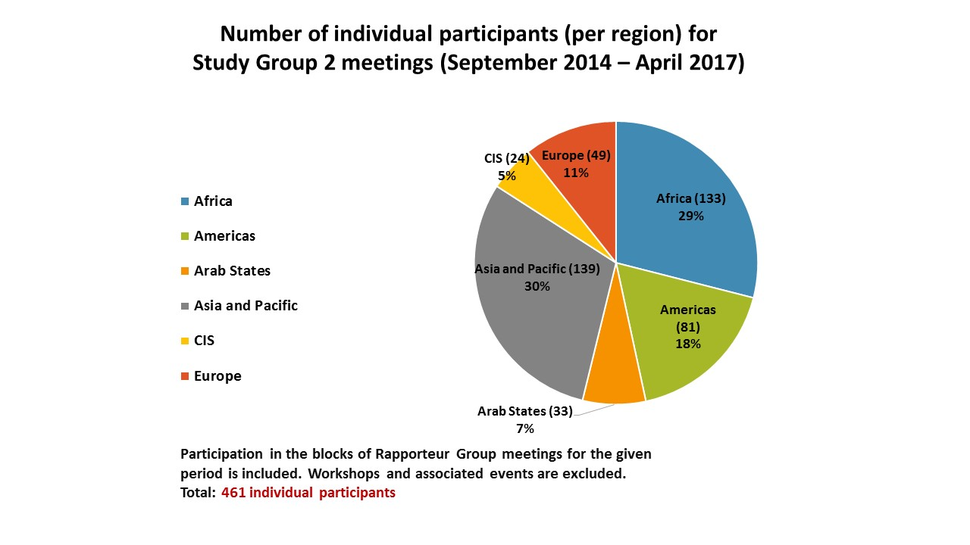**

Graph 2

**Aggregate number of participants (per region) for Study Group 2 and Rapporteur Group meetings   
(September 2014 – April 2017)**

**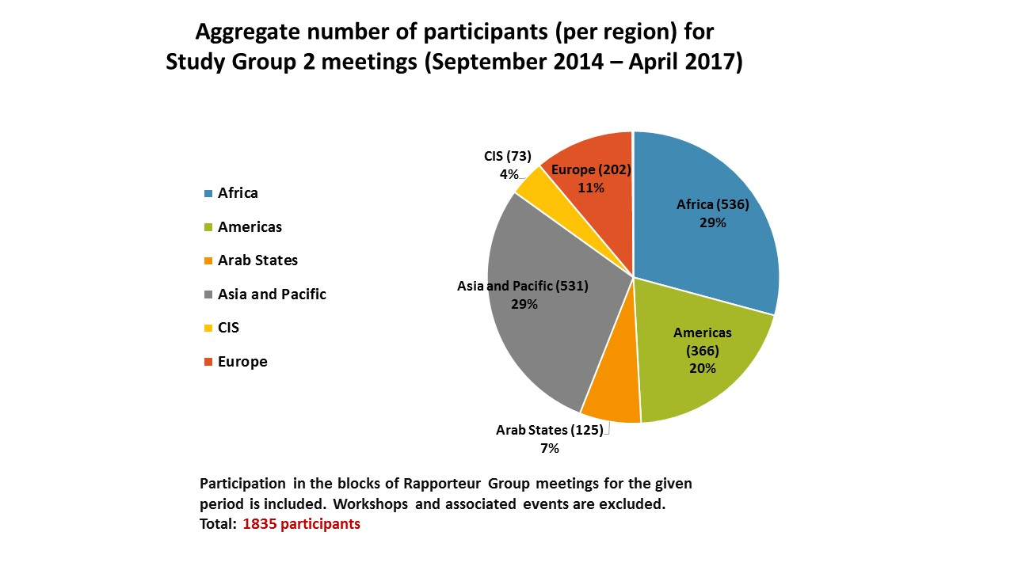**

Graph 3

**Number of contributions received from the membership for consideration during Study Group 2 and Rapporteur Group meetings (per region)**

**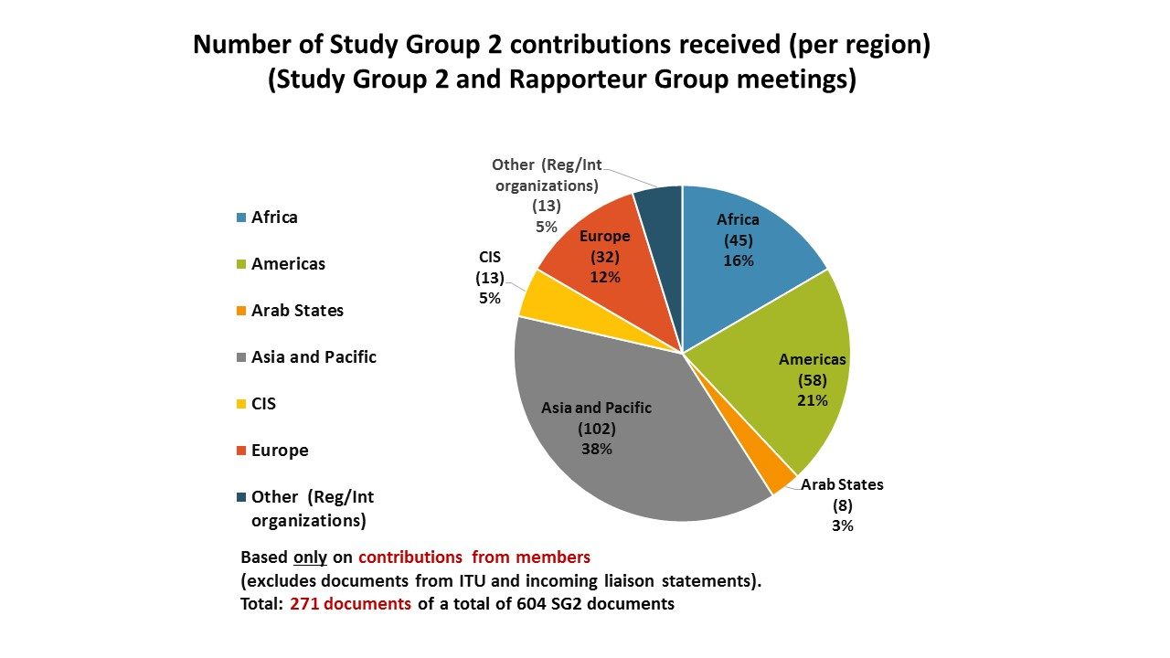**

TABLE 1

**Number of contributions received per Study Group 2 Question (September 2014 – April 2107)**

**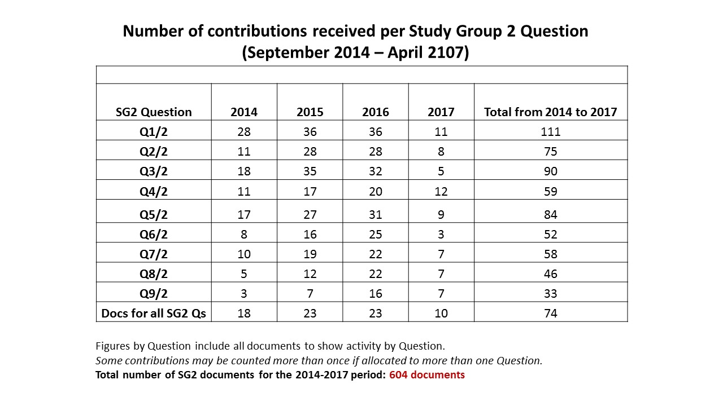**

TABLE 2

**Number of contributions received each year for Study Group 2 (September 2014 – April 2107)**

**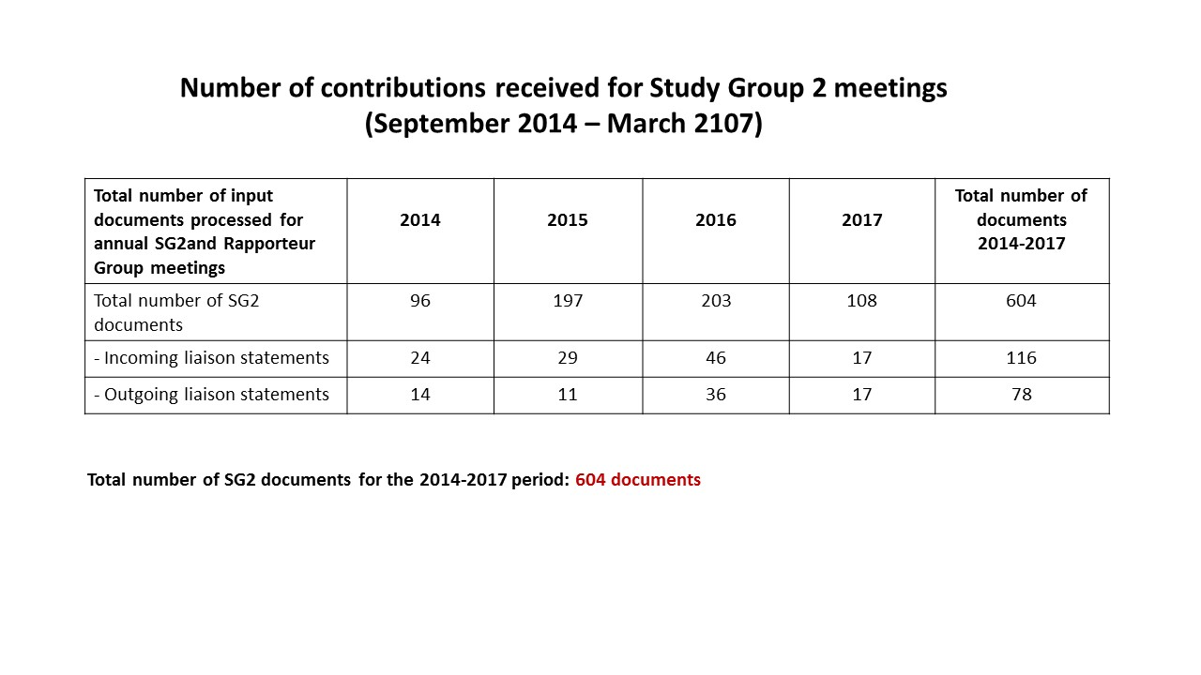**

Graph 4

**Number of contributions received for Study Group 2 and Rapporteur Group meetings per Question   
(with source)(September 2014 – April 2107)**

**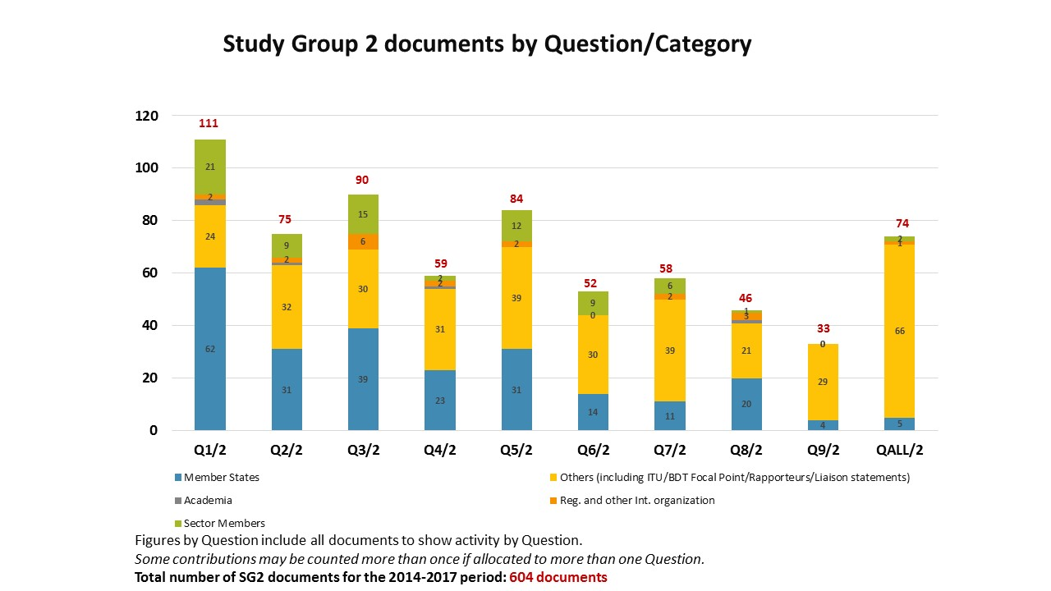**

# Meetings

## 2.1 Management team meetings

The Study Group 2 Chairman and Vice-Chairmen present met in Dubai during the WTDC. In addition to this initial meeting, four Study Group 2 management team meetings with Vice-Chairmen, Rapporteurs, Vice-Rapporteurs and BDT Focal Points were held on the eve of each annual Study Group 2 meeting, in order to prepare for the meeting, approve the time-management plan, review the progress of each Question under study, discuss planned and on-going activities and come up with proposals on further improvements to the functioning of the Study Groups.

## 2.2 Study Group 2 meetings

During the course of the study period, Study Group 2 met four times: three times in the month of September each year (2014, 2015 and 2016) and the fourth and final meeting which was held in April 2017. **Annex 2** presents the dates of the Study Group and the Rapporteur Groups meetings, taking into account that each Rapporteur Group also meets separately, as well as during the annual Study Group meeting. A substantial amount of the work is carried out electronically and by correspondence in between the physical meetings.

* + 1. **The first meeting,** held in Geneva from 22 to 26 September 2014, took the following important decisions:
* Approved the appointment of Rapporteurs and Vice-Rapporteurs for the nine study Questions;
* Agreed to specific and detailed work plans for each of the nine Questions;
* Established Working Party 1/2 to facilitate the work of ITU-D Study Group 2 on the Questions assigned to it.
* Agreed on the dates for the Rapporteur Group meetings in 2015.

The report of this meeting is available online at: <https://www.itu.int/md/D14-SG02-R-0010/>.

* + 1. **The second meeting**, held in Geneva from 7 to 11 September 2015, took the following important decisions:
* Approved the Report of the last meeting;
* Approved the appointment of the following new Vice-Rapporteurs: for Question 2/2 (e-health) Ms Malina Jordanova (Bulgaria), for Question 3/2 (cybersecurity) Mr Christopher Banda (Malawi), and for Q7/2 (EMF) Mr Dirk-Oliver Von der Emden (Switzerland).
* Agreed on the dates for the Rapporteur Group meetings in 2016.

The report of this meeting is available at: <https://www.itu.int/md/D14-SG02-R-0021/>.

* + 1. **The third meeting**, held in Geneva from 26 to 30 September 2016, took the following important decisions:
* Approved the Report of the last meeting;
* Approved the appointment of Mr Ananda Khanal (Nepal) and Mr Juan Pablos Ceballos Ospina as new Co-Rapporteurs for Question 8/2.
* Discussed the future work of ITU-D Study Group 2 and its study Questions during additional meetings and brainstorming sessions that were being scheduled over the course of the week.
* Discussed initial proposals about the future of Study Group 2 Questions.
* Agreed on the dates for the Rapporteur Group meetings in January 2017.

The report of this meeting is available at: <https://www.itu.int/md/D14-SG02-R-0032>.

* + 1. **The fourth meeting and final meeting** was held in Geneva from 3 to 7 April 2017.
* Approved 9 reports containing the outputs called for by WTDC-14 for all SG2 Questions.

The meeting also undertook fruitful discussions on the future on the existing study Questions which will serve to inform Member States as they prepare for WTDC-17. **Annex 3** to this report has a summary of these discussions.

The meeting dates for Study Group 2 during the next study period 2018 –2021 were also considered.

The report of this meeting is available at: <https://www.itu.int/md/D14-SG02-R-0043>.

# Summary of the key results achieved

This section presents an overview of the deliverables of each of the Study Group 2 Questions.

**Questions related to ICT applications and cybersecurity**

* 1. **Question 1/2: Creating the smart society: Social and economic development through ICT applications**

The approved report of the April 2017 Rapporteur Group meeting for Question 1/2 can be found in document [2/REP/22](http://www.itu.int/md/D14-SG02-R-0022/en). The Output Report and guidelines available in document [2/413](https://www.itu.int/md/D14-SG02-C-0413/en), were agreed with a number of changes to be made ([2/481](https://www.itu.int/md/D14-SG02-C-0481/)).

Regarding the future of Question 1/2, the surveys carried out by the ITU-D Study Groups highlighted Members’ satisfaction with the work carried out, and proposed some ways forward. During the Rapporteur Group meeting, the need to focus on specific areas for achieving the SDGs was highlighted. While agreeing with the adoption of the principles of SDGs in conducting Q1/2 in the next study period, it was suggested to also study how ICTs shall contribute to enhance other values such as participation of citizens, collaboration among stakeholders, openness of information, sharing of resources and fair distribution of benefits during the next study period. The Rapporteur Group concluded that this Question should continue with a revised title: **Best practices and guidelines for smart sustainable societies through ICTs**.

* 1. **Question 2/2: Information and telecommunications/ICTs for e-health**

The approved report of the April 2017 Rapporteur Group meeting for Question 2/2 can be found in document [2/REP/23](http://www.itu.int/md/D14-SG02-R-0023/en). The Output Report and guidelines available in document [2/414](https://www.itu.int/md/D14-SG02-C-0414/en), and temporary document [2/TD/16](https://www.itu.int/md/D14-SG02-170403-TD-0016) which includes the modifications requested during the Rapporteur Group meeting, were agreed with a number of changes to be made ([2/482](https://www.itu.int/md/D14-SG02-C-0482)).

Concerning the future of Question 2/2, survey participant emphasize the importance of the topic, the need to continue this Question and to hold workshops. It was suggested to merge Q2/2 and Q7/2 (EMF) as a broader Question on using ICTs for attaining a healthy society, but there was no consensus. The Rapporteur Group agreed that further guidelines on how to implement e-health solutions and projects in cost effective ways were needed. The importance of platforms for e-health that are interoperable, cost effective, and can be scaled was noted as were e-health solutions for developing countries which can be easily adapted and integrated. The Rapporteur Group concluded that this Question should continue with a revised title: **Best practices and guidelines for rapid implementation of eHealth.**

* 1. **Question 3/2: Securing information and communication networks: Best practices for developing a culture of cybersecurity**

The approved report of the April 2017 Rapporteur Group meeting for Question 3/2 can be found in document [2/REP/24](http://www.itu.int/md/D14-SG02-R-0024/en).The Output Report available in document [2/415](https://www.itu.int/md/D14-SG02-C-0415/en), and temporary document [2/TD/17](https://www.itu.int/md/D14-SG02-170403-TD-0017/) which includes the modifications requested during the Rapporteur Group meeting, was agreed with a number of changes to be made ([2/483](https://www.itu.int/md/D14-SG02-C-0483)).

As for the future of Question 3/2, survey participants emphasized the need to continue the study due to the continuing changes in technology and threats. Cybersecurity continues to be very challenging for everyone, and protecting citizens and national ICT-based infrastructure was emphasized. The importance and usefulness of organizing workshops on different aspects of cybersecurity was highlighted, as well as the need for interim annual reports. The Rapporteur Group concluded that this Question should continue with a revised title: **Best practices addressing emerging and evolving threats to cybersecurity.**

* 1. **Question 4/2: Assistance to developing countries for implementing conformance and interoperability programmes**

The approved report of the April 2017 Rapporteur Group meeting for Question 4/2 can be found in document [2/REP/25](http://www.itu.int/md/D14-SG02-R-0025/en). The Output Report available in document [2/416](https://www.itu.int/md/D14-SG02-C-0416/en), was agreed with a number of changes to be made ([2/484](https://www.itu.int/md/D14-SG02-C-0484)).

On the future of Question 4/2, the surveys stress the importance of the topic and especially assistance to countries in implementing C&I regimes, and the meeting participants noted the existing work within the BDT Programme. When discussing the future of Q4/2, there was a proposal to continue the Question but with a revised scope and work methodology. Some Administrations, while acknowledging the importance of C&I, noted that the focus now should be on the implementation of the study results, and hence a study Question may not be required. **There was no consensus**. Should WTDC-17 decide to continue this Question, the title needs to be changed as the current title is not appropriate for a Question to be answered. In this case, it was proposed that a possible title can be: **Strategies, policies and innovative solutions for implementation of conformance and interoperability (C&I) programmes and combatting counterfeit ICT equipment in developing countries***.*

**Questions related to climate change, environment and emergency telecommunications**

* 1. **Question 5/2: Utilization of telecommunications/ICTs for disaster preparedness, mitigation and response**

The approved report of the April 2017 Rapporteur Group meeting for Question 5/2 can be found in document [2/REP/26](http://www.itu.int/md/D14-SG02-R-0026/en). The Question 5/2 final report available in document [2/417](https://www.itu.int/md/D14-SG02-C-0417/en) was approved ([2/485](https://www.itu.int/md/D14-SG02-C-0485)).

The Output Report and guidelines available in document [2/417](https://www.itu.int/md/D14-SG02-C-0417/en), and temporary document [2/TD/17](https://www.itu.int/md/D14-SG02-170403-TD-0017/) which includes the modifications requested during the Rapporteur Group meeting, were agreed with a number of changes to be made.

Regarding the future of Question 5/2, the survey participants noted the importance of emergency communications, particularly for many developing countries and the ITU membership in general. Some respondents suggested to merge Q5/2 and Q6/2 (climate change). The group noted that the Question had been active for nearly 10 years. One suggestion was for the Question to focus on developing guidelines for countries to conduct disaster response drills/exercises. This seemed as a useful way to help countries move from developing plans to their implementation. The need for resiliency and disaster risk reduction was also emphasized, and a modular approach to the study Question’s different aspects was proposed. The Rapporteur Group concluded that this Question should continue with a revised title: **Best practices and implementation guidelines for use of telecommunication/ICT for disaster management**.

* 1. **Question 6/2: ICT and climate change**

The approved report of the April 2017 Rapporteur Group meeting for Question 6/2 can be found in document [2/REP/27](http://www.itu.int/md/D14-SG02-R-0027/en). The Output Report available in document [2/418](https://www.itu.int/md/D14-SG02-C-0418/en), and temporary document [2/TD/18](https://www.itu.int/md/D14-SG02-170403-TD-0018/) which includes the modifications requested during the Rapporteur Group meeting, was agreed with a few changes to be made ([2/486](https://www.itu.int/md/D14-SG02-C-0486)).

While it was noted by the survey participants that this Question has been in existence in some form for several study cycles, climate change still remains a priority for almost all countries. The survey respondents suggested to merge Q6/2, Q5/2 (emergency communications) and Q8/2 (e-waste), while focusing on the implementation of standards developed in ITU-T SG5. It was proposed that the focus in the next study period should be on best practices and guidelines and in line with SDG13. The Rapporteur Group concluded that this Question should continue with a revised title: **Best practices and guidelines for ICT-enabled climate action**. It was further agreed to include specific focus on solutions where Small Island Developing States (SIDS), Least Developed Countries (LDCs) and other vulnerable countries will benefit from the work conducted within the Question under study. The need to engage other relevant experts, ministries of environment or organizations on national level to contribute on this topic was also noted.

* 1. **Question 7/2: Strategies and policies concerning human exposure to electromagnetic fields**

The approved report of the April 2017 Rapporteur Group meeting for Question 7/2 can be found in document [2/REP/28](http://www.itu.int/md/D14-SG02-R-0028/en). The Output Report available in document [2/419](https://www.itu.int/md/D14-SG02-C-0419/en), and temporary document [2/TD/17](https://www.itu.int/md/D14-SG02-170403-TD-0017/) which includes the modifications requested during the Rapporteur Group meeting, which includes the modifications requested during the Rapporteur Group meeting, was agreed with a few changes to be made ([2/487](https://www.itu.int/md/D14-SG02-C-0487)).

On the future of Question 7/2, while unanimous on the importance of the topic, the respondents to the survey were divided as to what the future of the Question should be. Some noted the importance of promoting policies for deployment of wireless technologies that comply with international standards, and others indicated a need to merge Q7/2 and Q2/2 (e-health). The collaboration with WHO was praised, and it was proposed that a revised Question that takes into account the increased cellular penetration, traffic growth, increased use of data services, network coverage and capacity extension would be very desirable. The Rapporteur Group concluded that this Question should continue with a revised title: **Best practices and guidelines for measurement and assessment of human exposure to electromagnetic fields**.

* 1. **Question 8/2: Strategies and policies for the proper disposal or reuse of telecommunication/ICT waste material**

The approved report of the April 2017 Rapporteur Group meeting for Question 8/2 can be found in document [2/REP/29](http://www.itu.int/md/D14-SG02-R-0029/en). The Output Report available in document [2/420](https://www.itu.int/md/D14-SG02-C-0420/en) was agreed with a few changes to be made ([2/488](https://www.itu.int/md/D14-SG02-C-0488/)).

Concerning the future of Question 8/2, the survey participants observed the need to align Q8/2 with ITU-T Study Group 5 work. It also proposed to merge Q8/2, Q6/2 (climate change) and a revised Q7/2 (EMF). It was agreed that while the scope of Q8/2 in the next study period needs to be changed, the Question should continue with a revised title: **Implementation guidelines for management of e-waste and protection of the environment in a cost-effective manner**.

* 1. **Question 9/2: Identification of study topics in the ITU‑T and ITU‑R study groups which are of particular interest to developing countries**

The approved report of the April 2017 Rapporteur Group meeting for Question 9/2 can be found in document [2/REP/30](http://www.itu.int/md/D14-SG02-R-0030/en). The Output Report available in document [2/421](https://www.itu.int/md/D14-SG02-C-0421/en) was agreed with a number of changes to be made ([2/489](https://www.itu.int/md/D14-SG02-C-0489)).

In considering the future of Question 9/2, the survey participants agreed on the importance of the topic and that inter-sectoral collaboration should be strengthened. However, the Question did not receive many contributions from ITU-D membership during the study period, and hence while the final report is highly valued, other mechanisms than a study Question may be more appropriate. While inviting representatives from the other Sectors and the General Secretariat to share updates on their activities on a regular basis seems useful as an alternative, the important role of curator that the Rapporteur for Q9/2 has played was crucial to make sure that relevant, appropriate and important information on the study topics in other Sectors are provided to the ITU-D membership. **Only when the above concerns are properly and effectively addressed, may this Question discontinue**.

* 1. **Working Party 1/2**

The approved report of the April 2017 Working Party 1/2 meeting can be found in document [2/REP/31](http://www.itu.int/md/D14-SG02-R-0031/en).

On the future of the Working Parties within ITU-D Study Groups, the survey responses were considered together with the feedback and food for thought from the Chairman of Working Party 1/2. The respondents to the surveys were divided on the usefulness of working parties in ITU-D. In discussing the future of Working Party 1/2, the participants noted that the mandate and terms of reference of the working party must be clear for all the study Questions belonging to it, and for the Rapporteurs leading these Question in order for the working party to function properly. When these aspects are put in place then Working Party 1/2 can continue. Several meeting participants noted and agreed that in the other ITU sectors, the focus and priority is on the work of the working parties instead of the corresponding Rapporteur Groups. Participants agreed that once the study Questions have been determined, then clear terms of reference and mandate can be established for the Working Party.

# Results of the surveys on the work of ITU-D Study Groups

During the past few months, the ITU-D Study Groups has issued two surveys seeking feedback on different aspects related to the work of the ITU-D Study Groups.

## 4.1 Global survey on the work of ITU-D Study Groups (6th study period, 2014-2017)

The **“Global survey on the work of ITU-D Study Groups (6th study period, 2014-2017)”** was initiated by ITU-D Study Group 2 Question 9/2 and it was sent to the appointed focal points in ITU Member States, Sector Members, Associates, Academia and members of the ITU-D Study Group 1 and 2 Management Teams through a Circular Letter in November 2016 ([BDT/IP/CSTG-14](http://www.itu.int/md/D14-CA-CIR-0014)). This survey aimed primarily to gather feedback on the usefulness of the outputs of ITU-D Study Group 1 and 2 studies, understand the relevance of the topics under study, and seek input for future priority areas. When the survey was closed 40 responses had been received. Representatives from Administrations, Administration-related entities and Ministries made up 57.5 per cent of the respondents. Some results were shared:

* Regarding the **structure** and the **number of ITU-D Study Groups**, the current two were considered appropriate. However, some of the comments received revealed that the Members feel that some **study Questions are allocated to the wrong study group** (e-waste and electromagnetic field exposure should be in SG1). Ambiguity concerning the current mandates of the study groups was mentioned. The **large number of study Questions** was also mentioned by several respondents. Merging Questions would make sense to some respondents in order to strengthen the ITU-D Study Groups. None of the respondents wanted to increase the number of Questions under each study group.
* The need to **avoid duplication** with the work undertaken in the study groups of the other ITU sectors was reiterated. There are topics that are already being studied by ITU-T and ITU-R.

The respondents also rated **their satisfaction with the ITU-D Study Group 1 and Study Group 2 Questions’ deliverables** in terms of their relevance and the outputs that they are producing for the study period. In this regard, respondents indicated that they were “Very satisfied” with Questions 5/1, 7/1, 8/1. Res.9 and Q1/2 (tied with “Satisfied”), Q3/2, and Q5/2, and that they were ‘Satisfied’ with Questions 1/1, 2/1, 3/1, 4/1, 6/1, Q2/2, Q4/2, Q6/2, Q7/2, Q8/2, and Q9/2. For none of the SG1 and SG2 Question, did a majority of the respondents indicate that they felt ‘Neutral’ or ‘Not satisfied’ with the deliverables produced by the Questions.

Full details of the survey results can be found in **Annex 4** to this report and in document[2/448](https://www.itu.int/md/D14-SG02-C-0448/en) + Annexes.

## 4.2 Survey on ITU-D Study Group Questions, procedures, and proposals on future activities

The **“Survey to participants on ITU-D Study Group Questions, procedures, and proposals on future activities”** was initiated by the SG1 Management Team, SG1 Vice-Chair from Côte d’Ivoire, Ms Regina Fleur Assoumou-Bessou and SG1 Chair, Ms Roxanne McElvane Webber, and was aimed to all the participants in ITU-D Study Group and Rapporteur Group meetings. Ms Christine Sund presented the structure of the survey, being this divided into three sections: Section 1 contains contact information; Section 2 provides an analysis and proposals on ITU-D Study Groups 1 and 2 study Questions and Section 3 contains proposals to strengthen the activities of the ITU-D Study Groups during the next study period. A total of 28 responses were received from 22 countries. Regional participation was analysed: Africa (29%), the Americas (19%), Asia and Pacific (19%), CIS (9%) and Europe (24%).

Participants were requested to provide their opinion of the future of each Question in ITU-D Study Groups 1 and 2. There were four possibilities: Continue, Merge, Revise or Suspend. The results revealed that all the Questions should continue. Nevertheless, revising or merging with other Questions were proposed for some of the Questions. One of the most prevalent aspects was the request for merging Questions 1/1 and 2/1 as well as the need to avoid duplication and overlap of the work within the ITU-D Study Groups as well as with groups in the other sectors.

Full details of the survey can be found in document[2/453](https://www.itu.int/md/D14-SG02-C-0453/en) + Annex.

# Conclusion

Study Group 2 has successfully carried out its mandate because of the hard work, dedication, perseverance, flexibility, and expertise of all the parties concerned: the SG 2 Management Team, Vice Chairs, Rapporteurs, Vice-Rapporteurs, Focal Points, Secretariat, active contributors, meeting participants, interpreters and translators. With strong support from the BDT Director and his staff, the Group has fulfilled its mission.

Annex 1:

List of Study Group 2 Chairman, Vice-Chairmen, Rapporteurs,  
Vice-Rapporteurs, and BDT Focal Points

**Sixth study period (2014-2017)**

Study Group 2 Chairman and Vice-Chairmen

| **Role** | **Name** | **Entity represented** | **Region** |
| --- | --- | --- | --- |
| **Chairman** | **Mr Ahmad Reza SHARAFAT** | **Iran (Islamic Republic of)** | **ASP** |
| Vice-Chairman | Ms Aminata KABA-CAMARA | Guinea | AFR |
| Vice-Chairman | Mr Christopher KEMEI | Kenya | AFR |
| Vice-Chairman | Ms Celina DELGADO | Nicaragua | AMS |
| Vice-Chairman | Mr Nasser AL MARZOUQI | UAE | ARB |
| Vice-Chairman | Mr Nadir Ahmed GAYLANI | Sudan | ARB |
| Vice-Chairman | Ms WANG Ke | China (P.R. of) | ASP |
| Vice-Chairman | Mr Ananda Raj KHANAL | Nepal | ASP |
| Vice-Chairman | Mr Evgeny BONDARENKO | Russia | CIS |
| Vice-Chairman | Mr Henadz ASIPOVIC | Belarus | CIS |
| Vice-Chairman | Mr Petko KANTCHEV | Bulgaria | EUR |

|  |  |  |  |
| --- | --- | --- | --- |
| **Question** | **Title of the Question** | | |
| **Q1/2** | **Creating the smart society: Social and economic development through ICT applications** | | |
| **Title** | **Name** | **Represented entity** | **Region** |
| Rapporteur | Dr James Ngari NJERU | Kenya | AFR |
| Vice-Rapporteur | Dr Cheung-Moon CHO | Korea (Rep. of) | ASP |
| Vice-Rapporteur | Mr Richard ANAGO | Burkina Faso | AFR |
| Vice-Rapporteur | Ms Joëlle Géraldine ZOPANI YASSENGOU | Central African Republic | AFR |
| Vice-Rapporteur | Ms Xing XIN | China (P.R. of) | ASP |
| Vice-Rapporteur | Mr Romain CIZA | Democratic Republic of the Congo | AFR |
| Vice-Rapporteur | Mr Jean-David RODNEY | Haiti | AMS |
| Vice-Rapporteur | Mr Seydou DIARRA | Mali | AFR |
| Vice-Rapporteur | Mr Evgeny BONDARENKO | Intervale, Russian Federation | CIS |
| Vice-Rapporteur | Mr Dominic VERGINE | ARM Holdings Plc., United Kingdom | EUR |
| Vice-Rapporteur | Mr Turhan MULUK | Intel Corporation, United States of America | AMS |
| **Focal Points** | | | |
| BDT Focal Point | Mr Hani ESKANDAR | ITU/BDT | Headquarters |
| BDT Focal Point | Mr Takashi MASUMITSU | ITU/BDT | Headquarters |
| BDT Focal Point | Ms Ida JALLOW | ITU/AFR | AFR |
| BDT Focal Point | Mr Karim ABDELGHANI | ITU/ARB | ARB |
| BDT Focal Point | Mr Ashish NARAYAN | ITU/ASP | ASP |
| BDT Focal Point | Mr Farid NAKHLI | ITU/CIS | CIS |
| **Question** | **Title of the Question** | | |
| **Q2/2** | **Information and telecommunications/ICTs for e-health** | | |
| **Title** | **Name** | **Represented entity** | **Region** |
| Rapporteur | Dr Isao NAKAJIMA | Japan | ASP |
| Co-Rapporteur | Dr Done-Sik YOO | Korea (Rep. of) | ASP |
| Vice-Rapporteur | Mr Grégory DOMOND | Haiti | AMS |
| Vice-Rapporteur | Mr Leonid ANDROUCHKO | Dominic Foundation, Switzerland | EUR |
| Vice-Rapporteur | Ms Malina JORDANOVA | Bulgaria | EUR |
| **Focal Points** | | | |
| BDT Focal Point | Mr Hani ESKANDAR | ITU/BDT | Headquarters |
| BDT Focal Point | Mr Takashi MASUMITSU | ITU/BDT | Headquarters |
| BDT Focal Point | Mr Ali Drissa BADIEL | ITU/AFR | AFR |
| BDT Focal Point | Mr Getachew SAHLU | ITU/AFR | AFR |
| BDT Focal Point | Mr Karim ABDELGHANI | ITU/ARB | ARB |
| BDT Focal Point | Mr Ashish NARAYAN | ITU/ASP | ASP |
| **Question** | **Title of the Question** | | |
| **Q3/2** | **Securing information and communication networks: Best practices for developing a culture of cybersecurity** | | |
| **Title** | **Name** | **Represented entity** | **Region** |
| Rapporteur | Ms Rozalin Basheer Faqeer AL-BALUSHI | Oman Telecommunications Regulatory Authority (TRA), Oman | ARB |
| Rapporteur | Mr Eliot LEAR | United States of America | AMS |
| Vice-Rapporteur | Mr Albert KAMGA | Cameroon | AFR |
| Vice-Rapporteur | Mr Jean-David RODNEY | Haiti | AMS |
| Vice-Rapporteur | Ms Miho NAGANUMA | Japan | ASP |
| Vice-Rapporteur | Mr Jaesuk YUN | Korea (Rep. of) | ASP |
| Vice-Rapporteur | Mr Damnam Kanlanfei BAGOLIBE | Togo | AFR |
| Vice-Rapporteur | Ms Jabin S. VAHORA | United States of America | AMS |
| Vice-Rapporteur | Mr Christopher BANDA | Malawi | AFR |
| **Focal Points** | | | |
| BDT Focal Point | Mr Marco OBISO | ITU/BDT | Headquarters |
| BDT Focal Point | Mr Luc DANDURAND | ITU/BDT | Headquarters |
| BDT Focal Point | Ms Rosheen AWOTAR-MAUREE | ITU/BDT | Headquarters |
| BDT Focal Point | Mr Ali Drissa BADIEL | ITU/AFR | AFR |
| BDT Focal Point | Mr Serge Valéry ZONGO | ITU/AFR | AFR |
| BDT Focal Point | Mr Pablo PALACIOS | ITU/AMS | AMS |
| BDT Focal Point | Ms Rouda ALAMIR ALI | ITU/ARB | ARB |
| BDT Focal Point | Mr Sameer SHARMA | ITU/ASP | ASP |
| BDT Focal Point | Mr Farid NAKHLI | ITU/CIS | CIS |

|  |  |  |  |
| --- | --- | --- | --- |
| **Question** | **Title of the Question** | | |
| **Q4/2** | **Assistance to developing countries for implementing conformance and interoperability programmes** | | |
| **Title** | **Name** | **Represented entity** | **Region** |
| Rapporteur | Mr Cheikh Tidjani OUDAA | Mauritania | AFR |
| Rapporteur | Mr Gordon GILLERMAN | United States of America | AMS |
| Vice-Rapporteur | Ms Lisa J. CARNAHAN | United States of America | AMS |
| Vice-Rapporteur | Mr Osmar MACHADO | Brazil | AMS |
| Vice-Rapporteur | Mr Richard ANAGO | Burkina Faso | AFR |
| Vice-Rapporteur | Mr Roland Yaw KUDOZIA | Ghana | AFR |
| Vice-Rapporteur | Mr Faryd NAKHLI (Stepped down) | Belarus | CIS |
| **Focal Points** | | | |
| BDT Focal Point | Mr Vladimir DAIGELE | ITU/BDT | Headquarters |
| BDT Focal Point | Ms Chali TUMELO | ITU/AFR | AFR |
| BDT Focal Point | Mr Bruno RAMOS | ITU/AMS | AMS |
| BDT Focal Point | Mr Slaheddine MAAREF | ITU/ARB | ARB |
| BDT Focal Point | Mr Sameer SHARMA | ITU/ASP | ASP |
| **Question** | **Title of the Question** | | |
| **Q5/2** | **Utilization of telecommunications/ICTs for disaster preparedness, mitigation and response** | | |
| **Title** | **Name** | **Represented entity** | **Region** |
| Rapporteur | Ms Kelly O'KEEFE | United States of America | AMS |
| Vice-Rapporteur | Mr Jean-Marie MAIGNAN | Haiti | AMS |
| Vice-Rapporteur | Mr Hideo IMANAKA | Japan | ASP |
| Vice-Rapporteur | Mr Richard KROCK | Alcatel-Lucent USA Inc., United States of America | AMS |
| **Focal Points** | | | |
| BDT Focal Point | Ms Maritza DELGADO SOLARTE | ITU/BDT | Headquarters |
| BDT Focal Point | Mr Jean-Jacques MASSIMA | ITU/AFR | AFR |
| BDT Focal Point | Mr Rodrigo ROBLES | ITU/AMS | AMS |
| BDT Focal Point | Mr Wisit ATIPAYAKOON | ITU/ASP | ASP |
| **Question** | **Title of the Question** | | |
| **Q6/2** | **ICT and climate change** | | |
| **Title** | **Name** | **Represented entity** | **Region** |
| Rapporteur | Mr Philip KELLEY | France | EUR |
| Vice-Rapporteur | Mr Joseph Bruno YUMA UTCHUDI | Democratic Republic of the Congo | AFR |
| Vice-Rapporteur | Mr Naoki FUKE | Japan | ASP |
| Vice-Rapporteur | Mr Nasser AL MARZOUQI | United Arab Emirates | ARB |
| **Focal Points** | | | |
| BDT Focal Point | Ms Maritza DELGADO SOLARTE | ITU/BDT | Headquarters |
| BDT Focal Point | Ms Anne Rita SSEMBOGA | ITU/AFR | AFR |
| BDT Focal Point | Mr Rodrigo ROBLES | ITU/AMS | AMS |
| BDT Focal Point | Mr Mustafa AL MAHDI | ITU/ARB | ARB |

|  |  |  |  |
| --- | --- | --- | --- |
| **Question** | **Title of the Question** | | |
| **Q7/2** | **Strategies and policies concerning human exposure to electromagnetic fields** | | |
| **Title** | **Name** | **Represented entity** | **Region** |
| Rapporteur | Ms Dan LIU | China (P.R. of) | ASP |
| Vice-Rapporteur | Mr Issoufi K. MAIGA | Mali | AFR |
| Vice-Rapporteur | Mr Dirk-Oliver VON DER EMDEN | Switzerland | EUR |
| **Focal Points** | | | |
| BDT Focal Point | Mr István BOZSOKI | ITU/BDT | Headquarters |
| BDT Focal Point | Mr Jean-Jacques MASSIMA | ITU/AFR | AFR |
| BDT Focal Point | Mr Getachew SAHLU | ITU/AFR | AFR |
| **Question** | **Title of the Question** | | |
| **Q8/2** | **Strategies and policies for the proper disposal or reuse of telecommunication/ICT waste material** | | |
| **Title** | **Name** | **Represented entity** | **Region** |
| Co-Rapporteur | Mr Juan Pablo CEBALLOS OSPINA | Colombia | AMS |
| Co-Rapporteur | Mr Ananda KHANAL | Nepal Telecommunications Authority (NTA), Nepal | ASP |
| Vice-Rapporteur | Mr Géraud-Constant AHOKPOSSI | Benin | AFR |
| Rapporteur | Ms Sandra ALVARADO BARRERO (Resigned) | Colombia | AMS |
| **Focal Points** | | | |
| BDT Focal Point | Mr Orhan OSMANI | ITU/BDT | Headquarters |
| BDT Focal Point | Mr Emmanuel KAMDEM | ITU/AFR | AFR |
| BDT Focal Point | Mr Mustafa AL MAHDI | ITU/ARB | ARB |
| **Question** | **Title of the Question** | | |
| **Q9/2** | **Identification of study topics in the ITU-T and ITU-R study groups which are of particular interest to developing countries** | | |
| **Title** | **Name** | **Represented entity** | **Region** |
| Rapporteur | Mr Nasser AL MARZOUQI | United Arab Emirates | ARB |
| **Focal Points** | | | |
| BDT Focal Point | Ms Eun-Ju KIM | ITU/BDT | Headquarters |
| BDT Focal Point | Ms Christine SUND | ITU/BDT | Headquarters |

**Annex 2:**

**ITU-D Study Group 2: List of Study Group and Rapporteur Group meetings as well as associated workshops (2014-2017)**

| **Study Group/ Rapporteur Group meeting** | **Date and location** |
| --- | --- |
| **Study Group 1 meetings** |  |
| [Fourth meeting of ITU-D Study Group 2](https://www.itu.int/net4/ITU-D/CDS/sg/blkmeetings.asp?lg=1&sp=2014&blk=16862) | 3-7 April 2017, Switzerland [Geneva] |
| [Third meeting of ITU-D Study Group 2](https://www.itu.int/net4/ITU-D/CDS/sg/blkmeetings.asp?lg=1&sp=2014&blk=14386) | 26-30 September 2016, Switzerland [Geneva] |
| [Second meeting of ITU-D Study Group 2](https://www.itu.int/net4/ITU-D/CDS/sg/blkmeetings.asp?lg=1&sp=2014&blk=14030) | 7-11 September 2015, Switzerland [Geneva] |
| [First meeting of ITU-D Study Group 2](https://www.itu.int/net4/ITU-D/CDS/sg/blkmeetings.asp?lg=1&sp=2014&blk=13709) | 22 to 26 September 2014, Switzerland [Geneva] |
| **Rapporteur Group meetings** |  |
| [Rapporteur Group meetings for Study Group 2 Questions 1/2, 2/2, 3/2, 4/2, 5/2, 6/2, 7/2, 8/2, 9/2](https://www.itu.int/net4/ITU-D/CDS/sg/blkmeetings.asp?lg=1&sp=2014&blk=16864) | 18 (pm)-27 January 2017, Switzerland [Geneva] |
| [Rapporteur Group meetings for Study Group 2 Questions 1/2, 2/2, 3/2, 4/2, 5/2, 6/2, 7/2, 8/2, 9/2](https://www.itu.int/net4/ITU-D/CDS/sg/blkmeetings.asp?lg=1&sp=2014&blk=15703) | 18-29 April 2016, Switzerland [Geneva] |
| [Rapporteur Group meetings for Study Group 2 Questions 1/2, 2/2, 3/2, 4/2, 5/2, 6/2, 7/2, 8/2, 9/2](https://www.itu.int/net4/ITU-D/CDS/sg/blkmeetings.asp?lg=1&sp=2014&blk=14211) | 27 April-8 May 2015, Switzerland [Geneva] |
| **Associated topical workshops** |  |
| [ITU cybersecurity workshop: Cybersecurity and risk assessments in practice](http://www.itu.int/net4/ITU-D/CDS/sg/blkmeetings.asp?lg=1&sp=2014&blk=16864) | 26 January 2017, Switzerland [Geneva] |
| [ITU emergency telecommunications and disaster relief workshop](http://www.itu.int/en/ITU-D/Study-Groups/2014-2018/Pages/side-events/2016/emergency-workshop.aspx) | 27 September 2016, Switzerland [Geneva] |
| [ITU cybersecurity workshop: Running national cyberdrills and elaborating national cybersecurity strategies](https://www.itu.int/en/ITU-D/Study-Groups/2014-2018/Pages/side-events/2016/cybersecurity-workshop.aspx) | 18-19 April 2016, Switzerland [Geneva] |
| [ITU cybersecurity workshop: Global Cybersecurity Challenges - Collaborating for effective enhancement of cybersecurity in developing countries](https://www.itu.int/en/ITU-D/Study-Groups/2014-2018/Pages/side-events/2015/cybersecurity-workshop.aspx) | 8 September 2015, Switzerland [Geneva] |

**Annex 3:**

**Proposal for study topics in ITU-D Study Group 2**

**as result of the Ad hoc Group meetings held from 3 to 6 April**

An Ad hoc Group was created to put together some ideas regarding the future of each SG2 Question.

The common views of the participants on the titles of the proposed Questions for the next study period are reflected in the last column of the table below. The table also includes ideas, topics and keywords proposed by some participants as shown in its other columns, but the meeting did not discuss them. It is hoped that this table will assist Administrations in their preparations for the forthcoming WTDC.

The **first meeting** on Monday, 3 April 2017 (17:00-17:50) shared initial thoughts on the approach to be taken to draft proposals for ITU-D Study Group 2 study topics for the next study period.

The **second meeting** on Tuesday, 4 April 2017 (17:45-19:15) expressed no objection to the continuation of Questions 1/2, 2/2, 3/2, 5/2, 7/2, and 8/2. Questions 4/2, 6/2 and 9/2 require further discussion. The meeting agreed to identify SDGs that correspond to each study Question. The meeting also agreed to identify the corresponding outcomes in the ITU-D contribution to the ITU strategic plan for each Question.

The **third meeting** on Wednesday, 5 April 2017 (17:45-19:00) continued developing the content in the table and agreed to wait for input from the Rapporteur Groups for Questions 3/2, 4/2 and 6/2 to complete a draft for consideration in the SG2 plenary. The meeting agreed that in order to replace Question 9/2 an alternative mechanism to share information on the activities of ITU-T/ITU-R/General Secretariat throughout the study period should be implemented.

The **fourth and final meeting** on Thursday, 6 April 2017 (17:45-19:15) added proposed titles for Questions 3/2 and 5/2. A proposed title for Question 6/2 was also developed, however, this is pending further discussion during the forthcoming Rapporteur Group meeting on Friday, 7 April.

|  |  |  |  |  |  |
| --- | --- | --- | --- | --- | --- |
| **Existing ITU-D Study Group 2 Question** | **Proposal from the Rapporteur Group** | **Future topics as per the surveys** | **Proposals** | **Proposed future ITU-D SG2 Question** | |
| **Keywords and topics** | **Titles** |
| QUESTION 1/2  “Creating the smart society: Social and economic development through ICT applications” | Continue Question and revise content.  Artificial intelligence (AI), big data, social engagement, health, agriculture were mentioned as associated topics. | Internet of Things (IoT) | New study topic proposed on IoT ([2/423](https://www.itu.int/md/d14-sg02-c-0423)).  AI, Big data ([2/427](https://www.itu.int/md/d14-sg02-c-0427)).  Participation of citizens, openness of information ([2/457R1](https://www.itu.int/md/d14-sg02-c-0457)). | * implementation guidelines * IoT * Artificial intelligence (AI) * big data * smart society * smart cities and communities * SDGs * cloud computing * data analytics * open data | **Continue** Question but revise title and content.  **“Best practices and guidelines for smart sustainable societies through ICT”** |
| QUESTION 2/2 “Information and telecommunications for e‑health” | Continue Question and revise title to “Speedy implementation of eHealth in developing countries” | Merge Questions 2/2 and 7/2. | Merge Questions 2/2 and 7/2 under Q2/2 entitled “Information and telecommunications for e-health, including human exposure to electromagnetic fields” ([2/451](https://www.itu.int/md/d14-sg02-c-0451)).  New e-Health area using big data and AI ([2/462](https://www.itu.int/md/d14-sg02-c-0462)). | * best practices * e-health * accelerated implementation * standardization * mobile eHealth * medical big data | **Continue** Question but revise title and content.  **“Best practices and guidelines for rapid implementation of eHealth”** |
| QUESTION 3/2 “Securing information and communication networks: Best practices for developing a culture of cybersecurity” | Focus on evolving and emerging (technical) threats and capacity building. | Continue study | Security of creating “smart” cities ([2/451](https://www.itu.int/md/d14-sg02-c-0451)).  Improving GCI Index ([2/458](https://www.itu.int/md/d14-sg02-c-0458)). | * best practices * emergingcyberthreats * smart society * IoT * security challenges * SMS spam * SIM box card * awareness survey * COP * spam/malware * capacity building/workshops * GCI | **Continue** Question but revise title and content.  **“Best practices for addressing emerging and evolving threats to cybersecurity”** |
| QUESTION 4/2 “Assistance to developing countries for implementing conformance and interoperability programmes” | Diverging views. | Further work on C&I can be handled by the Programme (not as study Question) |  | * conformance * interoperability * sustainable industrialization * resilient infrastructure * virtual Lab * virtual testing * policy and regulation | **The topic is very important. Providing assistance to developing countries is critical.**  **Continue the Question**  **[“Strategies, policies and innovative solutions for implementation of conformance and interoperability (C&I) programmes and combatting counterfeit ICT equipment in developing countries”]**  **Discontinue the Question** (Continue work within the BDT and TSB Programmes (not as a study Question)). |
| QUESTION 5/2 “Utilization of telecommunications/ICTs for disaster preparedness, mitigation and response” | Continue the Question but revise title and content. Different topics each year, e.g. early warning, policy and regulatory barriers to implementation, disaster communication drills. | Merge with Q6/2. Develop new method. | Merge Q5/2 with Q6/2 entitled “Use of telecommunication/ICT for climate change, management of natural disasters and emergency situations” ([2/424](https://www.itu.int/md/d14-sg02-c-0424)). | * implementation guidelines * enabling policy environment * early warning systems * emergency communication * exercises and drills * technology trends * safety confirmation | **Continue** the Question but revise title and content. Different topics each year, e.g. early warning, policy and regulatory barriers to implementation, disaster communication drills.  **“Best practices and implementation guidelines for use of telecommunication/ICT for disaster management”** |
| QUESTION 6/2 “ICT and climate change” | Continue the Question without merging with other Questions. Future study to focus on innovations and new country projects. | Merge 6/2 with Q5/2. Already under study in ITU-T SG5. Merge Q6/2 with Q8/2. | Continue by merge Questions 6/2 and 8/2 under Q6/2 entitled “ICT and climate change, including issues related to the proper disposal or reuse of telecommunication/ICT waste material” ([2/451](https://www.itu.int/md/d14-sg02-c-0451)).  Discontinue by merging Questions 5/2 and 6/2 under Q5/2 ([2/424](https://www.itu.int/md/d14-sg02-c-0424)). | * climate change * technology trends * climate action * adaptation * mitigation * policies * SDG 13 * involve stakeholders external to telecommunication/ ICT | **Continue** the Question but revise title and content.  **“Best practices and guidelines for ICT- enabled climate action”** |
| QUESTION 7/2 “Strategies and policies concerning human exposure to electromagnetic fields” | Continue the Question and revise content. Focus on measurement and assessment, etc. | Merge with Q2/2.  Merge with Q6/1 (end user protection).  Merge with Q8/2 (e-waste).  Measurements needed. | Discontinue the Question by merging of Questions 2/2 and 7/2 under Q2/2 ([2/451](https://www.itu.int/md/d14-sg02-c-0451)).  Merge Question 7/2 with 8/2 entitled “Strategies and policies for the human protection against electromagnetic fields for the disposal or adequate recycling of waste resulting from the use of telecommunications / ICT ([2/424](https://www.itu.int/md/d14-sg02-c-0424)).  Provide implementation guidelines ([2/410](https://www.itu.int/md/d14-sg02-c-0410)) and ([2/434](https://www.itu.int/md/d14-sg02-c-0434)). | * guidelines * measurement and assessment * human exposure to electromagnetic fields * technology trends | **Continue** the Question but revise title and content.  **“Best practices and guidelines for measurement and assessment of human exposure to electromagnetic fields”** |
| QUESTION 8/2 “Strategies and policies for the proper disposal or reuse of telecommunication/ICT waste material” | Continue Question. | Emerging issue. Merge Q8/2 with Q6/2. Merge Q8/2 with Q7/2. | Discontinue by merging Question 8/2 into Question 6/2 ([2/451](https://www.itu.int/md/d14-sg02-c-0451)).  Merge Question 7/2 and Question 8/2 ([2/424](https://www.itu.int/md/d14-sg02-c-0424)).  Strategies for implementation ([2/432](https://www.itu.int/md/d14-sg02-c-0432)). | * guidelines * e-waste * recycling * protection of environment * cost efficient procedures | **Continue** the Question but revise title and content. **“Implementation guidelines for management of e-waste and protection of the environment in a cost-effective manner”** |
| QUESTION 9/2 “Identification of study topics in the ITU‑T and ITU‑R study groups which are of particular interest to developing countries” | ? | Important topics. Relevant to both SG1 and SG2. Intersectoral in nature. | Discontinue and include scope of the intersectoral coordinating group with Telecommunication Development Advisory Group (TDAG) on issues of mutual interest ([2/451](https://www.itu.int/md/d14-sg02-c-0451)). | * ITU-R * ITU-T * General Secretariat | **Discontinue** the Question but implement an alternative mechanism to share information with developing countries on the activities of ITU-R/ITU-T/General Secretariat throughout the study period.  Invite ITU-R/ITU-T/General Secretariat to present updates to SG1 and SG2 plenaries.  Intersectoral collaboration should furthermore be strengthened. |

**Annex 4:**

**Analysis of feedback received through the global survey on**

**the work of ITU-D study groups**

The global survey on the work of ITU-D study groups was made up of three substantive parts, **Part 1** sought input on the participation in ITU-D study groups, **Part 2** considered the structure of ITU-D study groups and **Part 3** asked Members to provide comments on the outputs and deliverables of ITU-D study groups. Forty responses were received for the survey from representatives in Ministries, Regulators, private sector members, regional and international organizations as well as academic institutions. Representatives from Administrations, Administration-related entities and Ministries made up 57.5 per cent of the respondents. The majority of the responses came from representatives based in Europe (38%), followed by Arab States (23%), Africa (12%), Americas (12%), Asia Pacific (12%), and CIS (3%).

**PART 1: Participation in the activities organized by the ITU-D study groups**

Concerning **participation in the activities organized by the ITU-D study groups**, 70 per cent of the respondents indicated that their entity, or someone in their Administration, participates regularly in the activities of the ITU-D study groups. Thirty per cent indicated that there is no regular participation by their entity in the work of the ITU-D study groups due to resource constraints (human and financial) and the fact that the entity is already engaged in many other activities and thus priority may need to be given to other work items. Some of the respondents noted that they are involved in the work of the other ITU Sectors and their priority lies primarily with them. Additional information about the ongoing work of ITU-D study groups and how to effectively participate and contribute to the work without necessarily having to stay the full duration of the meetings, would also be appreciated.

* **Encourage participation of private sector representatives**

Administrations participating in the survey were also asked whether they **invite and encourage private sector representatives** from their country to participate in the ITU-D study groups. Two thirds (70%) of the respondents noted that they are from Administrations and out of these, 6 out of 7 highlighted that they encourage private sector participation in ITU-D study groups.

Proposals were provided by the responding entities concerning measures that could be taken to further encourage the participation of the private sector in the work of the ITU-D study groups. It was suggested that more visibility be provided for the specific topics under study in the Questions in order to solicit contributions to their work. Regional and national seminars and forums on themes related to the Questions of ITU-D study groups would positively raise awareness on the work being undertaken. Targeted use of social media could be one vehicle to increase awareness and increased communication from ITU on the outcomes and importance of study groups could be another.

Some respondents noted more generally that the private sector in the countries are not well aware of the role of ITU and how they can contribute to and benefit from the work of ITU. The forming of a national task force with private sector stakeholders in each country was encouraged. Specific meetings dedicated to the private sector may be useful for raising awareness of the work of ITU more generally and the ITU-D study groups in particular.

Thoughts were shared on the necessary role of the ITU Regional and Area Offices in disseminating the work of the ITU-D study groups and also ensuring that the regional projects and initiatives be better aligned with private sector initiatives, and, for example, provide a broader variety of capacity building for both public and private sector entities and individuals. In order to encourage future participation of the private sector in the work, their needs, requirements and priorities for different activities within planning and preparatory phases should be identified. Flexible working methods could be useful to encourage broader participation. Providing free and open access to all documents and reports could encourage new actors to learn more about ITU-D.

* **Encourage participation of Medium-sized Enterprises (SMEs)**

When Administration were asked if they **invite and encourage Small and Medium-sized Enterprises (SMEs) to participate in the work of the ITU-D study groups**, just over 50 per cent of the Administrations who participated in the survey noted that they do encourage SMEs to join in the activities. The respondents did however note that reaching out to SMEs and encouraging them to participate in the activities of international organizations like ITU is not evident. The cost of participation is an obvious barrier hindering those who may be interested in participating from doing so. Encouraging SMEs to make use of alternative ways of participation in ITU-D study groups, such as remote participation could be an interesting option. Alternative funding mechanisms and a new discounted ITU membership category for SMEs were proposed. Selecting study topics that are of particular interest to SMEs could encourage more SMEs to join the work of ITU-D study groups.

* **Encourage participation of Academia**

Eighty two per cent of the Administrations participating in the survey indicated that they **invite and encourage Academia to participate in ITU-D study groups**. Highlighting to universities and academic institutions the benefits of being involved in the work of the ITU-D study groups, especially in terms of how they can participate with studies and research that are conducted in their educational institutions, could further increase their participation. While encouraging students and researchers to participate remotely in the meetings of ITU-D study groups would be a cost effective means for them to engage and participate, fellowships for participants from Academia would also be welcomed.

* **Cooperation between the ITU Sectors and General Secretariat on topics of common interest**

The last survey question related to participation in ITU-D study groups asked the respondents to express their **views on the cooperation between the ITU Sectors as well as the General Secretariat on topics of common interest**. The views of the respondents varied on this question. While some considered the cooperation to be excellent, others felt that work could be done to strengthen the cooperation.

A respondent from a developing country noted that the work of the Sectors contribute to ITU’s work to bridge the digital divide and towards the realization of the SDGs. The function has been executed well and can be enhanced through the cooperation of personalities and mutual respect for the mandate of the individual Sectors. Others noted that the good cooperation allows Members to compile best practices and gather specific experiences related to the common topics between the three Sectors and the General Secretariat. It was highlighted that liaison statements constitute a very useful tool to achieve efficient work and cooperation between Sectors. The good cooperation between ITU-D and ITU-R, and BDT and BR, was mentioned.

The aim is for the three ITU Sectors to complement each other. Thus, the work that is conducted in one Sector should be used and implemented by other Sectors for the benefits of the Membership, in particular for developing countries. Duplication of work between the Sectors was given as an example of areas to be improved. It was noted that continued efforts are needed to coordinate the work amongst the Sectors and the General Secretariat to reduce duplication and irrational use of ITU resources. Capacity building, as an example, should only be coordinated through ITU-D, with the participation by the other Sectors on delivering the technical issues. In order to improve this, explanatory work on the mandates and objectives of each Sector through the Secretariat, Advisory Groups, task forces and coordinating groups on issues of mutual interest were suggested. It was also noted that Member States in adopting Plenipotentiary Resolution 191 (Busan, 2014) on “Strategy for the coordination of efforts among the three Sectors of the Union” caused some confusion as there is a discrepancy between the aims behind the Resolution and how it is being implemented. Cooperation should be improved in order to achieve more efficient results and optimize resources. One initiative that could be led by ITU-D to enhance the existing cooperation mechanisms is to establish a joint program with ITU-R and ITU-T with aim to implement and promote their standards. This would be an important step to increase the overall efficiency in ITU.

**PART 2: Structure of ITU-D study groups**

When asked about the **structure of ITU-D study groups**, 92.5 per cent indicated that they are aware of the current structure of the ITU-D study groups and their Questions. About 7.5 per cent of the respondents answered that they are not aware of the current structure. Seventy per cent of the respondents noted that they are “Satisfied” or “Very satisfied” with the current structure. Eight per cent mentioned that there are improvements that could be made to the structure and 19 per cent remained neutral on the structure.

Comments received on the structure reveal that the Members feel that some **study Questions are allocated to the wrong study group** (e-waste and electromagnetic field exposure should be in SG1). Ambiguity concerning the current mandates of the study groups was mentioned. The **large number of study Questions** was also mentioned by many respondents. Merging them would make sense to some respondents in order to strengthen the ITU-D study groups. None of the respondents wanted to increase the number of Questions under each study group. Merging Questions to five Questions under each study group was one proposal. Concerning the merging of study Questions some proposals were also provided, for example Q2/1 (broadband access technologies) could be combined with Q5/1 (rural access), Q1/1 (broadband) and Q2/1 (broadband access technologies), Q6/2 (climate change) and Q8/2 (e-waste), all Questions related to applications (e-health, education, etc.) in one Question, in order to optimize ITU resources and possibly increase efficiency of ITU-D study group meetings and the time used for the meetings. It was proposed to focus the topics under study and avoid broad topics (e.g., Q1/1). Q9/2 should be considered for both ITU-D SG1 and SG2. No future study Question should include the mention of a specific technology, like IMT.

The need to **avoid duplication** with the work undertaken in the study groups of the other ITU sectors was reiterated. There are topics that are already being studied by ITU-T.

On the **number of ITU-D study groups**, the current two were considered appropriate.

The usefulness of the work conducted in the ITU-D study groups was mentioned, however, the **output reports should focus on specific challenges** faced by developing countries as this is their real added value. More **focused studies** and outputs delivered to the Membership at least every two years instead of every four years was suggested. The reports should be allowed to exceed 50 pages (translated text). **Recommendations** should become a more relevant tool in the ITU-D Sector.

To make the meetings more effective a **limit of 40 contributions per meeting** should be set.

* **Topics not covered by current topics under study in the ITU-D study groups**

In discussing the **current topics under study in the ITU-D study groups**, half of the respondents were of the opinion that there are topics/studies that they consider important and that are not covered within the current ITU-D study Questions. Examples provided of such topics were the following:

* Infrastructure sharing
* Regulation of mobile financial services
* How to encourage more active participation of Small Islands and Developing States in the work of ITU-D study groups
* Green technologies
* How to organize numbering and number portability
* Local content and font standard
* Impact of social media
* Regulation of Internet of Things (IoT)
* Internet of Things (IoT)
* Machine-to-Machine (M2M)
* Digital sound broadcasting
* Non-terrestrial digital television
* The study of sustainable and smart cities
* Regulatory models for the Digital Economy (IoT, OTT). Q1/2 (smart society) could be revised to incorporate this.
* Renewable/alternative forms of energy in ICTs. Q6/2 (climate change) could incorporate this.
* Explore how ICTs influence education
* Data centers
* Promoting investment in the ICT sector
* Developing affordable digital infrastructures needed for the digitization of micro, small and medium-sized enterprises (MSMEs) operations
* Other topics related to the Digital Economy
* Disaster counter measurements and bridging the digital divide
* Convergence of technologies and hybrid solutions to ensure true geographic ubiquitous coverage and resilience
* Sharing regulatory and licensing experiences
* ICT in education/Use of ICTs in the education sector
* How to utilize ICTs to implement SDGs
* IP interconnection/NGN

In discussing the study Questions, one Administration noted that Administrations in developed countries are not involved in the work of the ITU-D study groups partially as they may not feel affected by several of the Questions as they have already overcome those problems. The same goes for Sector Members. Maybe, another respondent noted, the issue with ITU-D study Questions is their repetition for a number of consecutive study cycles. Every four year a fresh new set of Questions on emerging issues in the telecommunications/ICT/broadband sectors should be adopted instead of continuing existing ones.

One survey respondent further noted that when considering the continuation of a study Question, and the adoption of a new one, two perspectives should be considered: 1) Does the Question address the current and emerging policy, legal, regulatory and operational issues of the telecommunications/ICT/broadband ecosystem? 2) Does the Question facilitate the achievement of SDGs through telecommunications/ICT/broadband interventions?

* **Use of Working Parties within the ITU-D study groups**

In considering the structure of ITU-D study groups, the Membership was also asked to express their **views on the use of Working Parties within the ITU-D study groups**. Less than half of the respondents (19 out of 40) chose to answer this question. Of the 19 respondents some noted that Working Parties can be a useful tool for ITU-D study groups, and necessary in some cases, if implemented fully, while others felt that Working Parties are not useful for ITU-D study groups.

Amongst those who were positive to Working Parties, the usefulness of Working Parties to allow for collaboration and information sharing across Questions was mentioned. Working Parties are effective and can help to accelerate and facilitate the work of ITU-D study groups. The Working Parties can assist in ensuring greater coordination of the joint work and exchange of information among the Questions that could be useful and enriching for all.

The fact that the work in the Working Parties (in other ITU Sectors) is conducted in English only was raised as a concern. The merging of the Questions according to common interests would avoid the need to create Working Parties, whose meetings and work could entail additional burdens. On the other hand, joint groups between the Sectors should be encouraged for sharing information and to increase participation in the work. It was further mentioned by other respondents that Working Parties are useless and a waste of time, and even counter-productive. With Working Parties less time is allocated to the actual Questions. Working Parties are not the solution to maximizing the amount of time dedicated to each Question. Furthermore, another respondent emphasized, the use of Working Parties is unnecessary within the ITU-D study groups. Hence, the views amongst the survey respondents was very divided on the usefulness of Working Parties in ITU-D study groups.

Interestingly, in the follow up question, the survey asked the respondents to provide a “Yes” or a “No” to whether they **support having Working Parties within the structure of the ITU-D Study Groups**. Thirty one of the 40 respondents replied to this question, with the majority, 81 per cent indicating their support and 19 per cent expressing opposing views.

However, with the learning experience of testing the use of a single Working Party for four ITU-D Study Group 2 Questions (Q5/2 (emergency telecoms/ICTs), Q6/2 (climate change), Q7/2 (EMF), and Q8/2 (e-waste)), less than two thirds of the respondents (63 %) indicated that they **support the continuation of the current Working Party under ITU-D Study Group 2**.

Advantages of using Working Parties in the ITU-D study groups were indicated to include the following (It is important to note that there is no agreement on what the advantages are. What some see as advantages may seem less so to others.):

* Allow for deeper study into the work of each Question.
* Allow for specialized/deeper analysis within Questions.
* Coordinate the work within the study groups through Working Parties.
* Combining all the Questions that are linked under a Working Party, will facilitate the participation of experts in the studies.
* The creation of Working Parties will facilitate hosting the meetings.
* The outputs will be structured and the Working Parties will structure the studies as well in order to avoid duplication.
* Creating Working Parties will develop a strong and efficient work and will avoid wasting time.
* Working Parties will allow the methods and procedures of the Sectors to be aligned and provide ability to structure research effectively.
* Working Parties will reduce the time of discussing documents submitted at once to several Questions.
* Working Parties open up a possibility of parallel or partially parallel work during the meetings which can become an effective solution for high-quality work when a large number of input documents are received for consideration.
* Working Parties provide improved depth of study and will speed up the process during the study period.
* Meetings for the study Questions under a Working Party are held consecutively.
* Gather and optimize resources in treating the related issues in the framework of the Working Party.
* Allows for more co-creation spaces and work networks related to the topics addressed, giving a more comprehensive knowledge about the study Questions concerned.
* Each Working Party can focus on a specific topic, related to certain goal or program taking into consideration objectives in the strategic plan.
* Working Parties are an intermediate level between the Questions and the study groups. Therefore, Working Parties within the ITU-D Study Groups allow experts to discuss technical issues that cannot be addressed to the Study Groups or during the meetings due to time constraints and the large numbers of participants that attend Study Group meetings.
* Working Parties encourage complementary work and exchanges for more relevant results.
* Working Parties make the work more manageable.

Additional comments on the use of Working Parties included the following:

* On mandate, management and reporting:
* If Working Parties are established, it would be necessary to clearly specify the mandates to avoid duplicates with the terms of reference of the Rapporteur Groups.
* In order to make Working Parties more efficient, it is necessary to ensure that qualified persons are appointed in the positions of Chair and Vice-Chair of the Working Party. Working Parties may be open to the participation of experts from the private sector. It would be appropriate to provide a more flexible mechanism to modify the mandates of the Working Parties in line with their progress.
* The reports of the Working Parties have to be submitted to their main study group.
* On the number of Working Parties and Questions under a WP:
* It is advisable to create two Working Parties per ITU-D study group.
* Within the existing framework it is difficult to modernize outputs of study groups without grouping Questions by topics/areas. In this case each working party can focus on 4 to 5 Questions being grouped by a relevant subject and aligned with the goals.
* The Working Parties should group the study Questions in clear/logical manner.
* On the contribution of Working Parties to the deliverables of the study group:
* Each Working Party could organize joint activities, like seminars, Recommendations, and joint output documents to enrich the discussions and outcomes.
* More virtual meetings should be implemented among the Working Parties and other groups.
* Working Parties are not useful.
* The Working Party pilot has not been able to ensure coordination between the Questions.
* It will remain difficult to coordinate actions between the management of Rapporteur Groups, Working Parties and Study Groups.
* **Frequency and number of ITU-D Study Group and Rapporteur Group meetings**

The survey respondents were also asked to provide their **views on the frequency and number of ITU-D Study Group and Rapporteur Group meetings during the year**. The majority of the 27 respondents who answered this question was of the view that the frequency and number of meetings each year were acceptable, reasonable and satisfactory. The current frequency and number of meetings correctly reflect the balance between the Members’ needs and the funds of ITU. Thus the study groups would continue to meet once a year, with the Rapporteur Group and Working Parties meeting twice a year.

While some thought the number of meetings and days should not increase due to the higher costs this would entail, others suggested extended the annual ITU-D Study Group 1 and 2 meetings from 2 to 3 weeks (7 instead of 5 days per study group). The need to allocate enough time for the meetings of each study group was mentioned. Emphasis on the need to reduce the number of Questions in order to focus the studies was reiterated. The need to increase the number of meetings was also mentioned.

Increasing the use of **virtual meetings/e-meetings** and **mailing lists/reflectors** in between face-to-face meetings was highlighted by many of the respondents. Thirty three per cent of the respondents thought that the holding of regular electronic Rapporteur Group meetings in between the physical meetings be useful to advance the work of the Groups on the topics under study. Thirty three per cent of the respondents were of the view that electronic meetings could be organized on an ad hoc basis depending on the need of the Group.

In light of this, it was explained that it is difficult for developing countries and LDCs to keep up with the current frequency of the meetings due to the number of experts they have and due to financial constraints. Consideration should be given to reducing the number of meetings and encouraging the preparation of such meetings through electronic exchange. However, such electronic meetings or exchanges should be limited to the preparation of meetings and not to decision making. This could involve virtual meetings by the Rapporteur Groups as well as virtual meetings by SG1 and SG2 management teams. Thus the importance of performing work in-between meetings to follow up in agreed action items remotely in order to ensure greater participation, in particular by those who were not able to participate in the face-to-face meetings was emphasized. Information about the electronic meetings should be shared with a broader audience. A question was asked whether or not interpretation services in the languages of the Union be available and ensured during electronic meetings. As matters related to translation and interpretation have given cost implications, this matter would need to be discussed further.

The use of real time TEMP documents should be encouraged during the meetings so as to encourage live participation during the face-to-face meetings.

For the future, the **location of the meetings** should take into account the travel difficulties experienced by representatives from developing countries. Increasing the frequency of **regional meetings** may also accelerate the results on the different Questions.

**PART 3:**

* **Work of Question 9/2**

As this survey was initiated by ITU-D Study Group 2 Question 9/2 (Identification of study topics in the ITU-T and ITU-R study groups which are of particular interest to developing countries), the survey respondents were asked specific questions related to the **work of Question 9/2**.

The respondents noted that the work of Question 9/2 provides developing countries with reports and updates concerning the recent activities and events that are conducted by ITU-T and ITU-R. Fifty two per cent of the respondents indicated that they benefitted from and found the information and presentations provided by ITU-T and ITU-R study groups during the Question 9/2 meetings throughout the study period useful. As many of the Administrations and Sector Members may not have direct access to ITU-T and ITU-R activities or their participation in these activities is low, providing the major highlights and relevant outcomes from ITU-R and ITU-T through ITU-D study groups is useful.

It was suggested that as the matter is very important it should not be treated as a study Question, but instead as a coordination activity. It was further noted that ALL topics are relevant for the countries. One respondent highlighted the need for Member States to have their own direct participation in the ITU-R and ITU-T Sectors and that ITU-D Sector should encourage such participation instead of having a study Question for this.

If Question 9/2 was to continue in the next study period, in order to **make its outcomes even more relevant to the Membership**, the Question should also include the work of the ITU General Secretariat in its work and bring the Question beyond ITU-D Study Group 2.

* **Satisfaction with the ITU-D Study Group 1 and Study Group 2 Questions’ deliverables**

The respondents rated **their satisfaction with the ITU-D Study Group 1 and Study Group 2 Questions’ deliverables** in terms of their relevance and the outputs that they are producing for the study period.

* The respondents indicated that they were “Very satisfied” with Questions 5/1, 7/1, 8/1. Res.9 and Q1/2 (tied with “Satisfied”). Q3/2, Q5/2
* The respondents indicated that they were ‘Satisfied’ with Questions 1/1, 2/1, 3/1, 4/1, 6/1, Q2/2, Q4/2, Q6/2, Q7/2, Q8/2, Q9/2.
* For none of the SG1 and SG2 Question, did a majority of the respondents indicate that they felt ‘Neutral’ or ‘Not satisfied’ with the deliverables produced by the Questions.

It is worth nothing this this survey was conducted before the final Output Reports and deliverables were submitted to the last SG1 and SG2 plenaries for approval. Thus the draft deliverables for each of the Questions were considered by the survey respondents in their respective assessments.

Overall concerning the respondents’ **satisfaction with the outcomes and deliverables of the ITU-D Study Groups for the 2014-2017 study period**, 69 per cent of the respondents indicated that they were either “Very satisfied” or “Satisfied” with the outcomes and deliverables. About 25.7 per cent indicated that they remained “Neutral” while 5.7 per cent said that they were “Not satisfied”.

Respondents indicated that they value the work of the ITU-D study groups in the platform they provide for the exchange of experiences and discovery of best practices. They are positive about the crucial role of the ITU-D study groups in order for the Union to carry out its mission of sharing and exchanging knowledge for the benefit of its Members. However, the large number of subjects studied (due in part to the continuation of the same Questions from cycle to cycle) and the lack of concentration of the reports on specific challenges faced by developing countries are not conducive to the production of reports that bring a real added value. Furthermore, as indicated by another respondent, it is essential to promote the outcomes of the ITU-D study groups. Another respondent highlighted the need for the ITU-D study groups to focus and deliver more Recommendations. Uniformity in the outcome documents was also requested.

Overall, 98 per cent of the respondents highlighted that in one way or other they definitely **benefit from the studies and research developed by ITU-D study groups**. Ninety one per cent of the respondents mentioned that they use the outcomes of the ITU-D study groups in reviewing, revising and /or re-drafting policies, regulations and legislations.

When asked about **how often they use the reports, guidelines and best practices** developed by ITU-D study groups, half of the respondents (49 per cent) said that they “use them regularly throughout the study period”, 16 per cent “immediately when they are released”, 13 per cent “at the end of the study period”, and 19 per cent mentioned that they “rarely” use the deliverables.

Comments were made that **ITU-D reports can used everywhere, also in other sectors of ITU**. The working methods do however in certain ways seem outdated and do not improve the work within ITU-D. It was also mentioned that ITU-D should further distribute the outcomes of ITU-D study groups to the Sector Members and Administrations. To some, the studies produced are not deep enough and thus limited in their use.

In order to **improve the outcomes of ITU-D study groups**, the respondents asked that the ITU-D study groups to release more of their deliverables throughout the study period and make better use of online platforms in between meetings to collaboratively develop contributions and guidelines that can be used in the deliverables. Encouraging the membership to submit their contributions in a different format to allow for better use of the main aspects of the contributions and lessons learned for the Question outcomes and change the format of the deliverables that are produced by the ITU-D Study Groups could also help to improve the outcomes of ITU-D study groups.

The survey respondents further asked for **greater involvement of the ITU-R and ITU-T Members in the work of ITU-D study groups** and the Members of other Sectors’ study groups in the preparation process of output documents in order to follow the decisions and documents of ITU-T and ITU-R.

On the use of the official languages of the Union in the work of ITU-D study groups, the **usefulness of ensuring services in all official languages** of the Union was highlighted. However, while all delegates coming to ITU-D study group meetings may not speak English, this should not be a reason to slow down the progress of the work.

Furthermore, the **Questions under study should be less generic** and, address specific challenges faced by some Members, on which sharing and exchanging knowledge would be beneficial.

**More contributions to the work was encouraged**. Still, not enough countries make contributions. As far as developing countries are concerned, their participation and contribution is a crucial issue, as it is the best way to expose their context and their eventual difficulties or needs. However, both participation and contributions remain too limited, in comparison to those of developed countries, even if efforts have been made.

**Rapporteur management roles as well as meeting locations should be rotated between different Member States** to promote their commitment to the objectives of ITU.

* **General comments on the survey:**
* The survey is too long.
* Invite the continuation of this type of survey as it is important to improve the work carried by the ITU-D study groups.
* ITU-D study groups are ground field for members to understand the work of ITU, up to date policy from members by sharing information. Relevant forum, meeting and working group to support the work of ITU-D study group as the other two Bureau.
* It is advisable to make this Questionnaire regular and discuss responses not only within ITU-D study groups but within TDAG as well.
* The newer set of study Questions for next study period should not be repetition of the existing questions unless they are absolutely essential. A new paradigm should be applied while formulating new Questions.
* The survey is very interesting.

\_\_\_\_\_\_\_\_\_\_\_\_\_\_\_

1. <http://www.itu.int/md/D14-SG02-C-0002> [↑](#footnote-ref-1)