|  |  |  |
| --- | --- | --- |
| C:\Users\ponder\AppData\Local\Microsoft\Windows\Temporary Internet Files\Content.Word\BDT-25th_anniversary_2017-Logo_411959-3_transparent.png | **World Telecommunication Development Conference 2017 (WTDC-17)**  **Buenos Aires, Argentina, 9-20 October 2017** | C:\Users\ponder\AppData\Local\Microsoft\Windows\Temporary Internet Files\Content.Word\BDT-25th_anniversary_2017-Logo_411959-1_transparent.png |
|  | |  |
|  | | **Document WTDC17/12-E** |
|  | | **13 September 2017** |
|  | | **Original: English** |
| Chairman, ITU-D Study Group 1 | | |
| ITU-D Study Group 1 Activities for the SIXTH study period between WTDC-14 and WTDC-17 | | |
|  | | |
| **Summary:**  ITU-D Study Group 1 (SG1) was established to examine, through Questions adopted by the ITU Membership at the World Telecommunications Development Conference (Dubai, 2014) (WTDC-14), issues relating to the enabling environment for telecommunications/ICT development. This report summarizes the activities carried out for the sixth study period, September 2014 – March 2017.  **Expected results:**  WTDC-17 is invited to note this document.  **References:**  [TDAG16-21/5](https://www.itu.int/md/D14-TDAG21-C-0005/), [TDAG15-20/32](https://www.itu.int/md/D14-TDAG20-C-0032/), [1/REP/10](https://www.itu.int/md/D14-SG01-R-0010/) (2014), [1/REP/20](https://www.itu.int/md/D14-SG01-R-0020) (2015), [1/REP/30](https://www.itu.int/md/D14-SG01-R-0030) (2016), [1/REP/40](https://www.itu.int/md/D14-SG01-R-0040) (2017) | | |

# Overview and highlights

During 2014-2017, ITU-D Study Group 1 (SG1) examined several issues through its 8 questions and Resolution 9: broadband policy, technology, and implementation strategy, cloud computing, tariff/cost models, transitions from analogue to digital terrestrial television broadcasting and use of the digital dividend, rural communications, consumer protection, access to telecommunication/ICTs by persons with disabilities and specific needs, and spectrum management.

Highlights from the sixth study period between WTDC-14 and WTDC-17 include:

* Just under 600 delegates participated in the SG1 meetings. The highest number were from Africa, followed by Asia and Pacific, then the Americas, Europe, the Arab States, and the Commonwealth of Independent States (CIS). Annual SG1 meetings averaged a little more than 160 participants from more than 57 nations.
* All Questions received a substantial number of inputs; with 698 documents and nearly 500 contributions, none received fewer than 60 contributions. Asia and Pacific submitted the highest number, followed by Africa, then Americas, Europe, CIS, and the Arab States.
* Three expert group meetings and four workshops were organized. These events covered spectrum management and DTV (Budapest, Hungary), consumer information and protection (Chongqing, China and Cotonou, Benin) and with ITU-T, international mobile roaming (Geneva, Switzerland).
* Participants also enjoyed live technology demonstrations/presentations from companies from the United Kingdom, the People’s Republic of China, Germany, the United States, and the BDT.
* SG1 benefitted from significant contributions from the BDT in the form of meeting statistics, tools for electronic collaboration, substantive contributions from Focal Points, and organizing workshops and expert groups.
* In a work cycle nearly cut in half, and with a majority of new leaders, an increase in written contributions, participants, and communications from the other sectors, this team was able to produce the deliverables called for by WTDC-14 reflected in the Final Output Reports, to hold four different workshops to enrich the membership and the work, to further contribute to the ITU-D case study library, survey participants on their views, and together with all participants, make recommendations for continuous improvements for the sector.
* These accomplishments result from an unmatched *esprit de corps*; understandable rules of procedure that are respected by all, and most significantly, dedication and commitment of the SG1 participants and management team, and the steadfast support, collaboration, and guidance from the BDT Director and his entire team, the Chairman of TDAG, the SG1 Vice-Chairs and the Chairman of SG2.

## Mandate and outcomes

Study Group 1 (SG1) was established in accordance with Resolution 2 (Rev. Dubai, 2014) to examine, through Questions adopted by the ITU Membership at the World Telecommunications Development Conference (Dubai, 2014) (WTDC-14), issues relating to the enabling environment for telecommunications/ICT development.

The formal titles of the Study Group Questions and Resolution 9 are:

* **Question 1/1**: Policy, regulatory and technical aspects of the migration from existing networks to broadband networks in developing countries, including next-generation networks, m-services, OTT services and the implementation of IPv6
* **Question 2/1**: Broadband access technologies, including IMT, for developing countries
* **Question 3/1**: Access to cloud computing: challenges and opportunities for developing countries
* **Question 4/1**: Economic policies and methods of determining the costs of services related to national telecommunication/ICT networks, including next-generation networks
* **Question 5/1**: Telecommunications/ICTs for rural and remote areas
* **Question 6/1**: Consumer information, protection and rights: Laws, regulation, economic bases, consumer networks
* **Question 7/1**: Access to telecommunication/ICT services by persons with disabilities and with specific needs
* **Question 8/1**: Examination of strategies and methods of migration from analogue to digital terrestrial broadcasting and implementation of new services
* **Resolution 9** (Rev. Dubai, 2014) on the “Participation of countries, particularly developing countries, in spectrum management,” a joint group with ITU-R Study Group 1

These topics were adopted by WTDC-14 with the intention that all deliverables would be completed in 4 years. In keeping with the 2014 ITU Plenipotentiary conference decision to reduce the ITU-D sixth study period to three years so that the ITU calendar could be normalized for all Membership, SG1 maintained a rigorous schedule to produce the WTDC-17 deliverables.

At the first meeting in **September 2014**, the management teams for all Questions and Resolution 9 prepared and presented [**detailed work plans**](https://www.itu.int/md/meetingdoc.asp?lang=en&parent=D14-SG01.RGQ-C&question=WP) describing how the expected outputs called for by WTDC-14 for each question would be achieved. The plans specified milestones, activities, due dates, and responsible parties. Responding to the compressed study cycle, by **September 2015**, the management teams for all Questions and Resolution 9 prepared and presented **preliminary draft outlines** for all WTDC expected output reports, and extraordinarily, three of the study questions exceeded this objective, Q1/1 (broadband migration), Q4/1 (tariffs/cost models) and Q8/1 (DTV) by also presenting their **first draft output reports** for review. By **September 2016**, all Questions and Resolution 9 had **draft final output reports** for consideration; the principal focus was to include **guidelines** for Membership. SG1 concluded its work at its fourth and final meeting held in Geneva from 27 to **31 March 2017,** **agreeing on final reports** for all nine questions, and producing close to 80 guidelines for ITU Membership.

SG1 thus produced their results in the first quarter of 2017, two years after meeting to act on the new deadlines, and 3 years subsequent to WTDC-14.[[1]](#footnote-1) Both Study Groups 1 and 2 successfully navigated these accelerated deadlines.

In sum, with a work cycle nearly cut in half, and with a majority of new leaders,[[2]](#footnote-2) an increase in written contributions, participants, and communications from the other sectors, this team was able to produce the deliverables called for by WTDC-14 reflected in the Final Output Reports, to hold four (4) different workshops to enrich the membership and the work – three outside of Geneva – to further contribute to the ITU-D case study library, to survey participants on their views, and together with all participants through regular brainstorming sessions, make recommendations for continuous improvements for the sector and its future work.[[3]](#footnote-3)

## Study Group 1 management

WTDC-14 designated the SG1 leadership for the sixth cycle (2014-2017): Mrs Roxanne McElvane Webber, (United States) served as Chairman, and was ably assisted by eleven Vice-Chairmen representing the six regions of the world:

* Mrs Regina Fleur Assoumou Bessou (Côte d’Ivoire)(AFR)
* Mr Peter Ngwan Mbengie (Cameroon) (AFR)
* Mrs Claymir Carozza Rodriguez (Venezuela) (AMS)
* Mr Victor Martinez (Paraguay) (AMS)
* Mr Wesam Al-Ramadeen (Jordan) (ARB)[[4]](#footnote-4)
* Mr Ahmed Abdel Aziz Gad (Egypt) (ARB)
* Mr Yasuhiko Kawasumi (Japan) (ASP)
* Mr Nguyen Quy Quyen (Viet Nam) (ASP)
* Mr Vadym Kaptur (Ukraine) (CIS)
* Mr Almaz Tilenbaev (Kyrgyz Republic) (CIS)
* Ms Blanca Gonzalez (Spain) (EUR)

**1.2.1 Study Group 1 Vice Chairs: Duties and focus[[5]](#footnote-5)**

The SG1 Vice-Chairs actively followed the work assigned by WTDC-14, consistently providing sound and valuable advice to the Chair on all issues related to the Study Group including personnel matters, working methods, and all substantive outcomes called for by WTDC-14. In the latter regard, the Vice-Chairs particpated in an organized peer review exercise to help prepare the final outputs for all nine final reports from the Questions and Resolution 9 according to their declared principal areas of interest:

* Mrs Regina Bessou (tariffs, rural communications, and accessibility);
* Mr Peter Mbengie (cloud computing and Resolution 9 spectrum issues);
* Mrs Claymir Rodriguez (migration to broadband, broadband technology, rural comunications and DTV transition);
* Mr Victor Martinez (migration to broadband, broadband technology, rural communications and Resolution 9 spectrum issues);
* Mr Ahmed Gad (migration to broadband, broadband technology and Resolution 9 spectrum issues);
* Mr Yasuhiko Kawasumi (broadband technology and rural communications);
* Mr Nguyen Quyen (consumer issues, DTV transition and rural communications);
* Mr Vadim Kaptur (migration to broadband, cloud computing and tariffs);
* Mr Almaz Tilenbaev (rural communications and accessibility);
* Ms Blanca Gonzalez (ITU Council issues, DTV transition, and languages and interpretation issues).

Some Vice-Chairs also corresponded with ITU regional offices and with Administrations in their regions to encourage relevant contributions to the work. Others prepared and contributed to the survey distributed to the SG1 participants on study group questions and working methods, and helped translate, evaluate and summarize the results during informal SG1 managment team working groups. Vice Chairs also managed a process to review contributios proposing to revise existing questions submitted by various Administrations to the final meeting of the 2014-2017 period.[[6]](#footnote-6)

Finally, in addition to serving as a Vice-Chair from the CIS Region, Mr Vadim Kaptur served as Co- Rapporteur for Question 1/1 on strategies for migrating to broadband networks, services and applications, which received the highest number of contributions during 2014-2017.

The Chair notes that all engagements with the SG1 management team during 2014-2017 period exhibited collegiality, cooperation, and a high degree of professionalism reflecting each member’s sincere dedication to the mission and objectives of the study group and its participants.

The team of Rapporteurs, Co-Rapporteurs, Vice-Rapporteurs, and BDT Focal Points responsible for the SG1 Questions and Resolution 9 can be found in **Annex 1**. The full text the Questions adopted including, a statement of the Question’s context, a description of the expected output, and an initial work plan with the required timing for the output, etc., is available on the Study Group 1 website in document [1/2](http://www.itu.int/md/D14-SG01-C-0002)[[7]](#footnote-7).

## Participation and written contributions (2014-2017)

A total of 599 delegates participated in at least one Study Group 1 meeting (**Graph 1**). The highest number came from Africa, followed by Asia and Pacific, then the Americas, Europe, Arab States and the Commonwealth of Independent States (CIS). Annual SG1 meetings average a little more than 160 participants from more than 57 countries.

Graph 1

Number of individual participants (per region) for Study Group 1 meetings  
(September 2014 – March 2017)

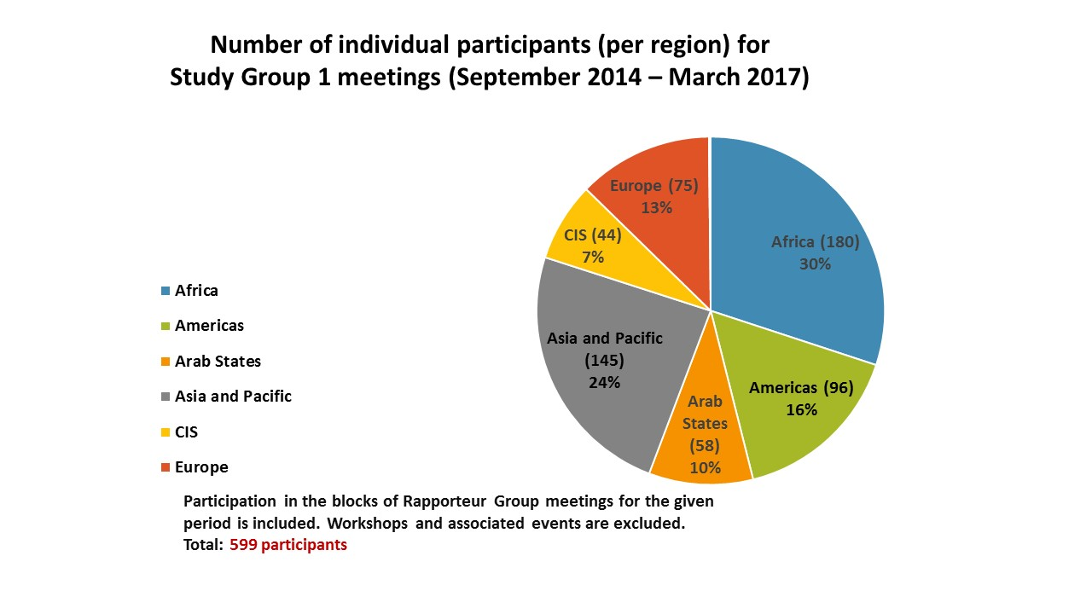

Graph 2

Aggregate number of participants (per region) for Study Group 1   
and Rapporteur Group meetings[[8]](#footnote-8)  
(September 2014 – March 2017)

**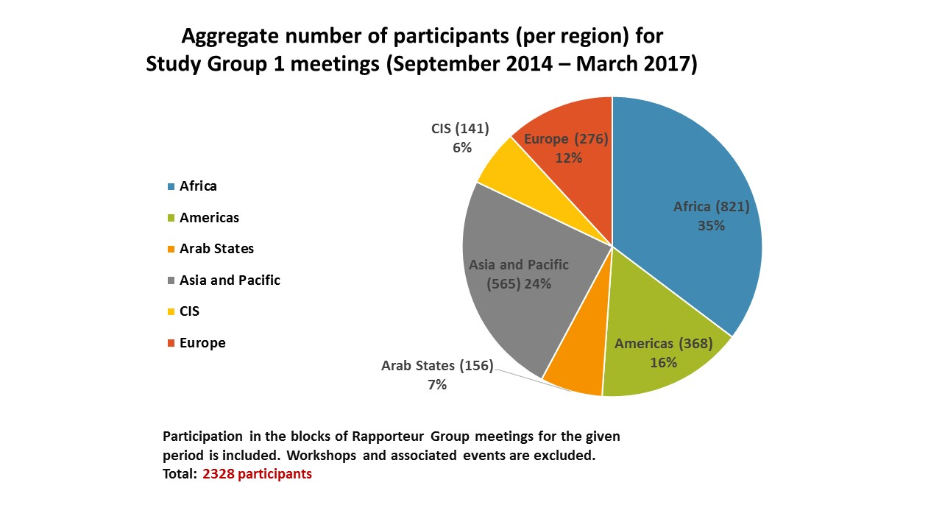**

Study Group 1 received a total of 698 documents of which 476 were contributions (**Graph 3**). The majority of the contributions came from Asia and Pacific, followed by Africa, then Americas, Europe, CIS and Arab States.

Graph 3

Number of contributions received (per region) for Study Group 1   
and Rapporteur Group meetings  
(September 2014 – March 2017)

**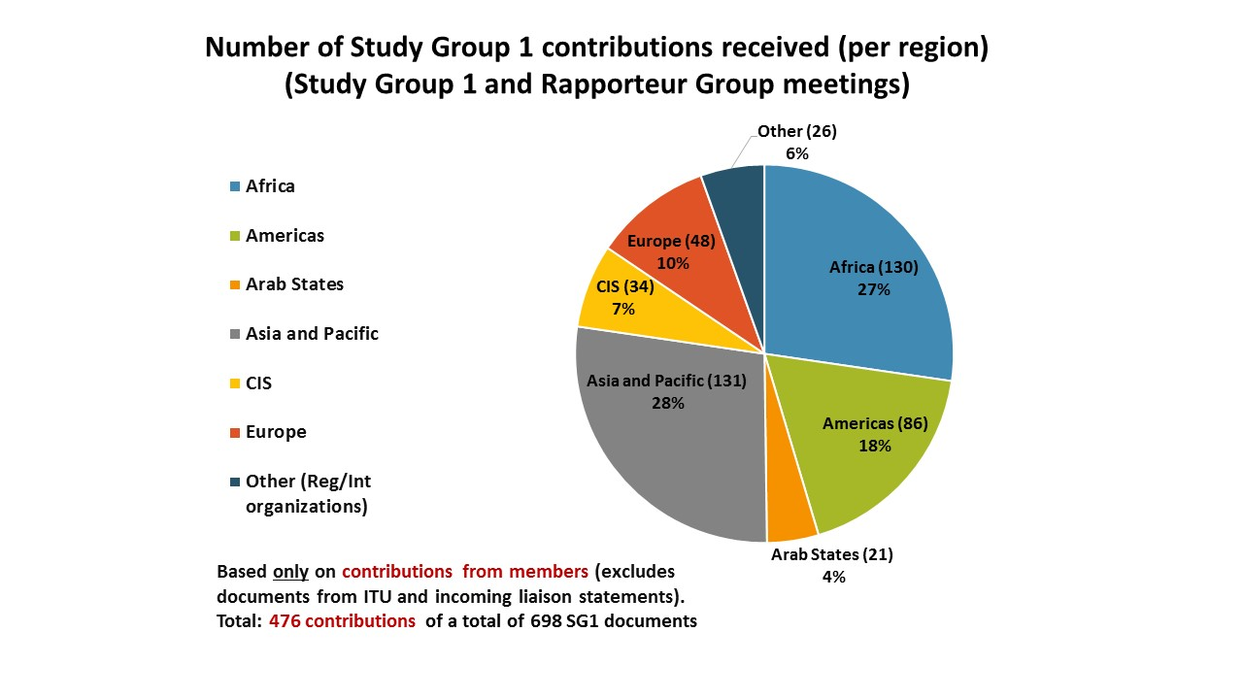**

As illustrated in **Table 1** each Question received a substantial number of written contributions, including liaison statements, to complete its deliverables for the study period. The three Questions receiving the highest number are: Question 1/1 (migration to broadband) with 143, Question 7/1 (ICTs for persons with disabilities and specific needs) with 108 and Question 5/1 (rural communications) with 99 (**Graph 4**). Contributions that were addressed to all Questions and liaison statements received by SG1 are included in the total reflected in **Table 1**, as this is highly representative of the relevance and interest in a particular Question. **Table 2** shows the number of contributions received per year for ITU-D Study Group 1 and Rapporteur Group meetings. The number of incoming and outgoing liaison statements for the study period are also included in **Table 2**.

Graph 4

Number of contributions received for Study Group 1 and Rapporteur Group meetings per Question (with source) (September 2014 – March 2017)

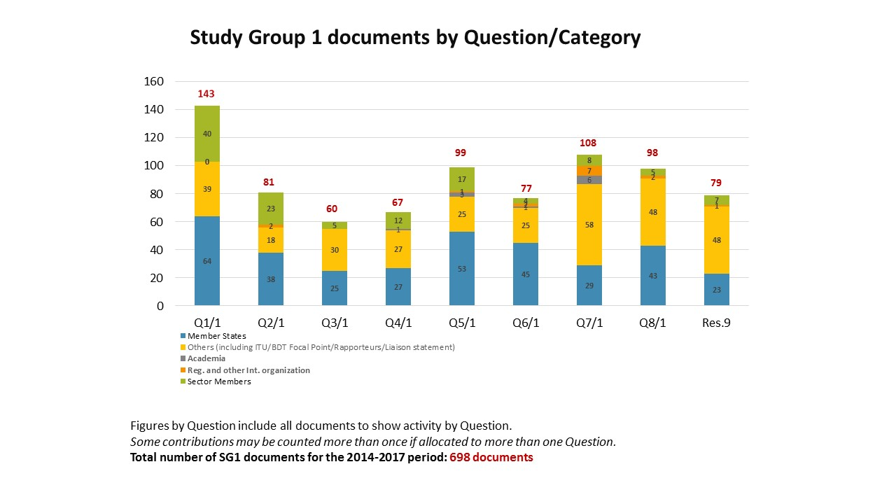

Table 1

Number of contributions received per Study Group 1 Question  
(September 2014 – March 2017)

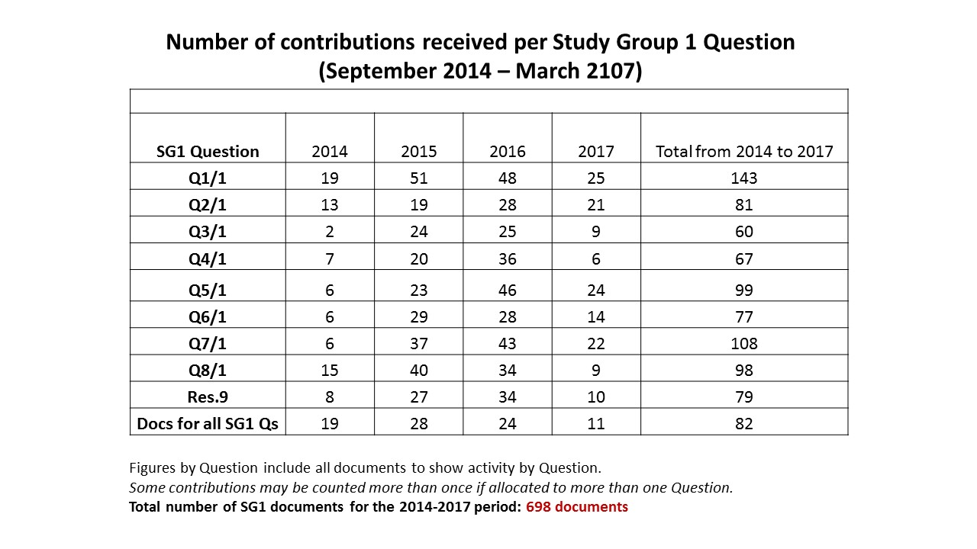

Table 2

Number of contributions received for Study Group 1 and Rapporteur Group meetings each year  
(September 2014 – March 2017)

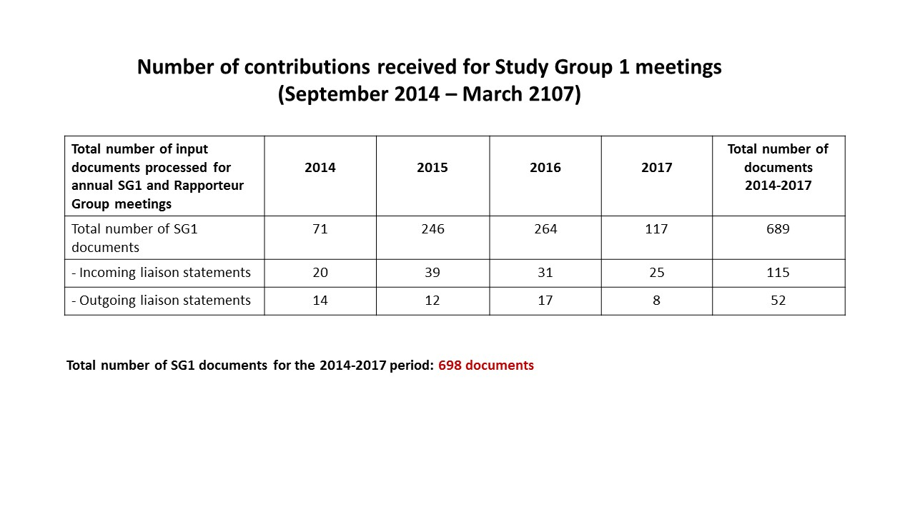

The Rapporteur Groups for Questions 5/1 (rural communications) and 6/1 (consumer protection) prepared and circulated questionnaires to gather specific information on telecommunications/ICTs for rural and remote areas and telephone numbering misuse and misappropriation respectively for use in their reports. Other groups included information provided by the BDT Focal Points from the BDT annual regulatory survey, and reviewed the results of other ongoing ITU work in their analysis. Using data obtained by the BDT through the annual survey, case studies, regional initiatives, projects, and other ongoing activities can provide comprehensive and current information to the Study Groups while helping to avoid duplication.

Drawing from their expertise and work in the Telecommunication Development Sector, and in keeping with past practice in the previous study period (2010-2014), at least one of the BDT Focal Points assigned to work with the nine SG1 questions made substantive, written contributions to each of the Questions at every meeting. Crucial statistical information, objective and anecdotal examples from the regions, materials presented at regional seminars, and illustrative charts and graphs supplied by the focal points enhance and appear in the SG 1 final reports. In addition, Study Group participants received consistent and critical support from the BDT Secretariat throughout the period.

# Tools for results

## Study Group 1 work plan

The Chair made two contributions to help guide SG1 activities: a Work Plan for SG1 activities through 2017 ([1/232](http://www.itu.int/md/d14-sg01-c-0232)) as required by Resolution 1, and through the BDT Secretariat, a compendium of all the draft outlines prepared by the Rapporteur Groups for the expected outputs called for by WTDC-14. The [Work Plan](https://www.itu.int/md/d14-sg01-c-0232) (**Annex 3**) presented along a timeline dates, important milestones and other actions towards completion of the WTDC expected outputs. The [Compendium](http://www.itu.int/md/D14-SG01-C-0231) ([1/231 (Rev.1)](http://www.itu.int/md/D14-SG01-C-0231)) was intended to inform those preparing the Final Output Reports about the approach taken to individual topics being covered by all the Questions so that possible synergies, opportunities for collaboration, and any potential duplication could be easily identified. Both inputs were updated throughout the study period.

## BDT collaborative tools

In line with the expectation expressed by WTDC-14, the BDT Secretariat introduced various collaborative tools to facilitate electronic participation in the Study Group work.A SharePoint site was launched to provide a virtual meeting place for participants. The site incorporates a calendar of Study Group activities, announcements, and a document exchange feature to facilitate work in between meetings. A sub-site with similar facilities was created exclusively for the Study Group Management Teams.

In addition to the e-Forum, which was available during the previous study period, mailing lists were created to allow study group participants interested in specific topics under study to exchange e-mails. The tools are available on a dedicated [web page](http://www.itu.int/en/ITU-D/Study-Groups/2014-2018/Pages/collaborative-tools.aspx). Finally, for each annual SG1 meeting, the BDT made available statistics summarizing participation by region, contributions by Question, and standard webcast service with interactive, multilingual, remote participation. The full archives of the meetings are also available.

The BDT also developed the [Innovation Portal](http://innovation.itu.int/), the main access point for the innovation platform and its products and services, and an idea management solution [cocreate.itu.int](http://cocreate.itu.int/) to facilitate innovation dialogues beyond physical meetings both within the BDT and with the membership.

# Meetings

## Management team meetings

Following the appointment of the Chairman and Vice-Chairmen at WTDC-14 in Dubai, four management team[[9]](#footnote-9) meetings were held on the eve of each annual Study Group 1 meeting. These meetings were important for all leaders to attend as they permit the Chairman, Vice-Chairmen, Rapporteurs, Vice-Rapporteurs, BDT Focal Points and Secretariat to review the progress of each Question under study, identify any substantive, personnel or administrative issues that need attention, discuss planned and on-going activities, propose ways to manage the work product, and discuss ideas to enhance the Study Group output and procedures.

## Study Group 1 meetings

During the course of the study period, Study Group 1 met four times: three times in the month of September each year (2014, 2015, 2016); the fourth and final meeting was held in March 2017. Notably, the 2014 Plenipotentiary conference decided to hold only one major ITU Conference each year, WTDC-14 was moved from 2018 to 2017.

Notwithstanding this abbreviated schedule, because of the dedication and tenacity of many leaders of Questions, Resolution 9, and BDT Focal Points, the generosity of several Administrations and the support of the BDT Director and Staff, SG1 participants were also able to benefit from three expert group meetings and four workshops during the period*: Global Dialog on International Mobile Roaming* (Geneva, 2015); *Workshop on Spectrum Management and DTV* (Budapest, Hungary, February 2016); *Workshop on Consumer Protection in a digital collaborative economy* (Chongqing, China, November 2016); *Regional Forum on Consumer Information, Protection, and Rights for Africa* (Cotonou, Benin, March 2017).[[10]](#footnote-10)

* + 1. **The first meeting** was held in Geneva from 15 to 19 September 2014. The meeting reviewed and discussed the 69 contributions received and made the following decisions:
* Appointed Rapporteurs and Vice-Rapporteurs for the nine study Questions;
* Agreed to detailed work plans for all Questions and Resolution 9 prepared by the associated management teams.

The report of this meeting is available at: https://www.itu.int/md/D14-SG01-R-0010/.

* + 1. **The second meeting** was held in Geneva from 14 to 18 September 2015. The meeting reviewed the 154 contributions received and made the following decisions:
* Appointed Mr Vadim Kaptur (ONAT, Ukraine) and Mr Yahya Nasser Mohammed Al Hajri (TRA, Oman) as Co-Rapporteurs for Question 1/1. Appointed Mr Christopher Banda (Malawi) as Vice-Rapporteur for Question 5/1, and Ms Amela Odobašić (Bosnia-Herzegovina) as Co-Rapporteur for Q7/1 (accessibility).
* Agreed on preliminary draft outlines for all WTDC expected outputs for all Questions and Resolution 9;
* Extraordinarily, received preliminary draft output reports for three of the study questions, Q1/1 (migration to broadband), Q4/1 (tariffs/cost models) and Q8/1 (DTV);

With ITU-T, SG1 held a successful event titled “Let’s Roam the World, the ITU Global Dialog on International Mobile Roaming” referenced earlier.

The report of this meeting is available at: <https://www.itu.int/md/D14-SG01-R-0020/>.

* + 1. **The third meeting** was held in Geneva from 19 to 23 September 2016. The meeting reviewed the 147 contributions received and made the following decisions:
* Appointed Ms Tharalika Livera (Telecommunications Regulatory Commission, Sri Lanka), as Vice-Rapporteur for Question 2/1 and Question 5/1; Ms Zhang Li (People’s Republic of China) as Vice-Rapporteur for Question 5/1 to replace Ms Chunxia Bai (People’s Republic of China), Mr Arseny Plossky (Russian Federation), as Vice-Rapporteur for Question 8/1, and Ms LiChing Sung (United States of America) as Vice-Chair for Resolution 9 to replace Mr Scott Kotler (Lockheed Martin Corporation, United States of America);
* Agreed to include **guidelines** in all revised drafts of final outputs for all Questions and Resolution 9;

The report of this meeting is available at: <https://www.itu.int/md/D14-SG01-R-0030/>.

* + 1. **The fourth meeting and final meeting** was held in Geneva from 27 to 31 March 2017. The meeting reviewed the 66 contributions and made the following decisions:
* Agreed on 9 reports containing the outputs called for by WTDC-14 for all SG1 Questions and Resolution 9.

The meeting also undertook constructive discussion on the future of the existing study Questions and future SG1 work, considering several contributions proposing to revise existing and add new questions for the 2018-2021 period. The outcome of these discussions is included in Section [ ] of this report summarizing the views of study group participants. The meeting also reviewed the SG1 meeting dates for the next study period (2018 –2021).

The report of this meeting is available at: <https://www.itu.int/md/D14-SG01-R-0040/>.

**Annex 2** presents a table showing the dates the Study Group and Rapporteur Groups met during the period. A substantial amount of the work is carried out electronically and by correspondence in between the physical meetings in order to finalize the WTDC deliverables.

# Summary of the key results achieved

## Question 1/1 – Policy, regulatory and technical aspects of the migration from existing networks to broadband networks in developing countries, including next-generation networks, m-services, OTT services and the implementation of IPv6

The approved report of the Final Rapporteur Group meeting in March 2017 for Question 1/1 can be found in [1/REP/31](https://www.itu.int/md/D14-SG01-R-0031/en).

The Final Output Report is available here: [1/476](https://www.itu.int/md/D14-SG01-C-0476/).

Regarding the future of the Question, the results of the two surveys carried out by the ITU-D Study Groups indicate that respondents would like this Question to continue, however, the focus was considered too broad. Two proposals for revision were presented to SG1 at the final meetings ([1/432](https://www.itu.int/md/D14-SG01-C-0432/en), [1/454](http://web.itu.int/md/D14-SG01-C-454/en)) and considered. The Q1/1 Co-Rapporteur asked for a group of volunteers to work on these proposals and develop a common proposal before the meeting of Telecommunication Development Advisory Group (TDAG) in May 2017. *No agreed way forward was reached by the Rapporteur Group.*

* 1. **Question 2/1 – Broadband access technologies, including IMT, for developing countries**

The approved report of the March 2017 Rapporteur Group meeting for Question 2/1 can be found in [1/REP/32](https://www.itu.int/md/D14-SG01-R-0032/en).

The Final Output Report and guidelines is available here: [1/477](https://www.itu.int/md/D14-SG01-C-0477/).

Discussion on the future of this Question included a proposal focused on expanding the current mandate to policies for allocation and access technologies, and a proposal ([1/463](https://www.itu.int/md/D14-SG01-C-0463/)) to reflect the importance of IMT-2020 (5G) and relevant work. A summary table on the present situation of the all Questions dealing with broadband issues was also presented. *No agreed way forward was reached by the Rapporteur Group.*

* 1. **Question 3/1 – Access to cloud computing: challenges and opportunities for developing countries**

The approved report of the March 2017 Rapporteur Group meeting for Question 3/1 can be found in [1/REP/33](https://www.itu.int/md/D14-SG01-R-0033/en).

The Final Output Report and guidelines is available here: [1/478](https://www.itu.int/md/D14-SG01-C-0478).

According to the results of the surveys, the topics studied under this question were considered relevant for the future and respondents encouraged further work during the next study period. The Rapporteur for the question recommended that the scope should be revised, suggesting that the focus could be: 1) specific applications within cloud computing, including digital and environmental aspects; 2) cloud computing within states: indicators and country's readiness for cloud implementation; 3) economic issues of integrating cloud technologies into existing business models. *The Rapporteur Group proposed to continue the study Question.*

* 1. **Question 4/1 – Economic policies and methods of determining the costs of services related to national telecommunication/ICT networks, including next-generation networks**

The approved report of the March 2017 Rapporteur Group meeting for Question 4/1 can be found in [1/REP/34](https://www.itu.int/md/D14-SG01-R-0034/en).

The Final Output Report and guidelines is available here: [1/479](https://www.itu.int/md/D14-SG01-C-0479).

Regarding the future of the Question, participants expressed the view that while the scope would need to change, Q4/1 should continue its work. Comments included the view that the task is no longer to compare bottom-up and top-down models but to move on to reflect reality at the regulatory level, e.g., how to help regulators apply principles in a new tariffing environment focusing more on contracts and packages. Emphasis should be put on new costing and tariff methods, others noted. Beyond that, the group noted that it is important to address this issue in the context of emergent new services and concepts such as OTTs and Internet of Things (IoT). A proposed title for the new study period: ***“Policies, economics and tariff methods for applications and services on communication networks****.”* Other specific issues proposed were to include spectrum pricing, tax and other fiscal incentives and their impact on telecommunications/ICTs, as well as the needs of people with specific needs. *The Rapporteur Group proposed to continue the study Question.*

* 1. **Question 5/1 – Telecommunications/ICTs for rural and remote areas**

The approved report of the March 2017 Rapporteur Group meeting for Question 5/1 can be found in [1/REP/35](https://www.itu.int/md/D14-SG01-R-0035/en).

The Final Output Report and guidelines is available here: [1/480](https://www.itu.int/md/D14-SG01-C-0480).

Regarding the future of Question 5/1, the participant survey highlighted the importance of continuing to study issues related to ICTs for rural and remote areas as the majority of people in developing countries still live in these areas and thus there is a need to ensure access, innovation and capacity building. Drawing on earlier discussion, a contribution ([1/423](https://www.itu.int/md/D14-SG01-c-0423)) presented some views on the future of Q5/1. A continued interest in and need for further studies into topics related to telecommunications/ICTs for rural and remote areas was indicated. *The Rapporteur Group proposed to continue the study Question.*

* 1. **Question 6/1 – Consumer information, protection and rights: Laws, regulation, economic bases, consumer networks**

The approved report of the March 2017 Rapporteur Group meeting for Question 6/1 can be found in [1/REP/36](https://www.itu.int/md/D14-SG01-R-0036/en).

The Final Output Report and guidelines is available here: [1/481](https://www.itu.int/md/D14-SG01-C-0481).

Regarding the future of Question 6/1, the participant survey points out the cross-cutting nature of consumer protection and also draws attention to the need to revise Q6/1 to take into account changing consumer needs. During the final Rapporteur Group meeting, participants agreed on the need to continue to explore the Question with the understanding that the description of the Question and its title requires refinement to reflect a changing ecosystem. A proposal for the title was: ***“Consumer protection, challenges and opportunities in the digital economy/era”****.* Other ideas for future study: more emphasis should be put on collaboration, capacity building mechanisms, and more coordination among regulatory organizations, operators and consumer groups. The next study period could address how such collaboration mechanisms in the new ecosystem could be improved. Tools for consumers could be addressed to enable them to be better informed about market offers and supply and thus make more informed choices. *The Rapporteur Group proposed to continue the study Question.*

* 1. **Question 7/1 – Access to telecommunication/ICT services by persons with disabilities and with specific needs**

The approved report of the March 2017 Rapporteur Group meeting for Question 7/1 can be found in [1/REP/37](https://www.itu.int/md/D14-SG01-R-0037/en).

The Final Output Report is available here: [1/482](https://www.itu.int/md/D14-SG01-C-0482).

Regarding the future of Question 7/1, the participant survey underscores the role of the ITU-D Study Groups as a global platform that enables Members to work on ICT accessibility for persons with disabilities (PwD). Commenters suggested that in the next study period the question could work to help Members implement the guidelines that have been developed during this cycle. Additionally, the meeting agreed that, based on a contribution received ([1/469](https://www.itu.int/md/D14-SG01-C-0469/en)), Q7/1 should also focus on accessible telecommunications/ ICT access for the aging population. A proposal for the title was: ***“ICT accessibility for persons with disabilities, including age related disabilities and with specific needs”****. The Rapporteur Group proposed to continue the study Question.*

* 1. **Question 8/1 – Examination of strategies and methods of migration from analogue to digital terrestrial broadcasting and implementation of new services**

The approved report of the March 2017 Rapporteur Group meeting for Question 8/1 can be found in [1/REP/38](https://www.itu.int/md/D14-SG01-R-0038/en).

The Final Output Report is here: [1/483](https://www.itu.int/md/D14-SG01-C-0483), and guidelines are available here: in [1/485](https://www.itu.int/md/D14-SG01-c-0485).

Regarding the future of Question 8/1, respondents to the participant survey noted that many transition deadlines for analogue to digital terrestrial television had passed, and many countries are still in the experimental phase with new digital sound/radio services. New topics proposed during the final Rapporteur Group meeting included broadening the scope of Q8/1 to include the evolution of the digital transition in broadcasting and digital radio/sound broadcasting, and how to use the released frequencies for new services and applications; to include economic aspects of the deployment of new broadcasting services and applications, and to study the impact of other television distribution platforms. Collecting countries’ experiences on interference mitigation between broadcasting and new service and the implementation of new services and applications (Community and regional TV on DTV and new Broadcasting services: 3D, 4K, 8K, etc.) were also deemed important. Including relevant issues related to people with disabilities was also supported. *The Rapporteur Group proposed to continue the study Question.*

* 1. **Resolution 9 –Participation of countries, particularly developing countries, in spectrum management**

The approved report of the March 2017 meeting of the ITU-D/ITU-R Joint Group for WTDC Resolution 9 can be found in [1/REP/39](https://www.itu.int/md/D14-SG01-R-0039/en).

The Final Output Report is available here: [1/484](https://www.itu.int/md/D14-SG01-C-0484).

The discussion on the future of the Resolution 9 addressed both the preferred method of work and the topics to study for the next study period.

* Study topics supported: spectrum fees, software for fees calculations, harmonization of licenses and the role of spectrum management in achieving the 2030 SDGs, effective utilization of spectrum and IoT applications, and short-range devices;
* Working methods: Mechanisms to strengthen the collaboration between the ITU-D and ITU-R sectors. One suggestion was to hold regular meetings jointly with the ITU-R SG1 meetings to allow for more interaction between experts and attendees of the two sectors. Another issue is how to re-envision the Resolution 9 outputs of e.g., the type of report and guidelines, holding a series of workshops, and the topics to be discussed.

*The joint group proposed to continue the study during the next study period.*

Following the final ITU-D SG1 meeting on 31 March 2017, which agreed to the Final Output Report prepared by the ITU-D/ITU-R Joint Group for Resolution 9 pursuant to its agreed work plan and outline, a liaison statement from the Radiocommunication Advisory Group (RAG) was sent to TDAG in May 2017. Among other things, the liaison stated RAG’s views concerning possible improvements on cooperation and coordination on WTDC Resolution 9 (Rev. Dubai, 2014) and expressed concern that all the modifications requested by ITU-R had not been included in the Final Output Report. After discussions during the meeting, TDAG replied via liaison statement ([TDAG/17-22/72](https://www.itu.int/md/D14-TDAG22-C-0072)) noting among other things its appreciation for several RAG suggestions. For the sake of having an agreed report by both sectors, TDAG recommended that ITU-R SG1 be given the opportunity to consider the report at its June 2017 meeting, with the objective of reaching consensus before WTDC-17.

ITU-D SG1 subsequently received the ITU-R SG1 agreed Resolution 9 report, which had been substantially revised. The report was considered by the ITU-D SG1 management team, in which SG1 Vice-Chairs from all the regions agreed to send the report, with some amendments, on to WTDC-17 as the report for Resolution 9. A member of the management team maintained the view that a discussion of TV white spaces in the report contained a few technical inaccuracies that if not corrected would be harmful to providers of the associated emerging technologies and services. The report is therefore submitted with the objection.

# Surveys on the ITU-D Study Groups: Questions, working methods,[[11]](#footnote-11) and future activities

In keeping with Section 11.4.3 of Resolution 1 (Rev. Dubai 2014), the ITU-D Study Groups issued two surveys to obtain feedback both from ITU Members and from individual study group participants on the work conducted by the Groups, its future work, and on participant’s specific experiences. In addition, along with brainstorming sessions held throughout the period, participants at the final SG1 meeting for 2014-2017 considered several contributions proposing to revise the existing questions. The outcomes from that meeting are included in Section 5.2 below.

## 5.1 Global survey to ITU Membership (6th study period, 2014-2017)

The **“Global survey on the work of ITU-D Study Groups (6th study period, 2014-2017)”** was initiated by ITU-D Study Group 2 Question 9/2 and in November 2016 was sent to the appointed focal points in ITU Member States, Sector Members, Associates, Academia and members of the ITU-D Study Group 1 and 2 Management Teams through a Circular Letter ([BDT/IP/CSTG-14](http://www.itu.int/md/D14-CA-CIR-0014)). This survey aimed primarily to gather feedback on the usefulness of the outputs of ITU-D Study Group 1 and 2 studies, understand the relevance of the topics under study, and seek input for future priority areas. 40 responses were received. Representatives from Administrations, Administration-related entities and Ministries made up 57.5 per cent of the respondents. Some results include:

* Regarding the **structure** and the **number of ITU-D Study Groups**, the current two were considered appropriate. However, some Members believe that some **study Questions were allocated to the wrong study group.**[[12]](#footnote-12) Ambiguity of the **mandates of the study groups** was noted and the **large number of study Questions** was also mentioned by several respondents. Some respondents favored merging Questions. None of the respondents wanted to increase the number of Questions under either study group.
* The need to **avoid duplication** was noted.
* The respondents also rated **their satisfaction with the ITU-D Study Group 1 and Study Group 2 Questions’ deliverables**.[[13]](#footnote-13) Indicating that they were “Very satisfied” with Questions 5/1, 7/1, 8/1, Q3/2 and Q5/2, and ‘Satisfied’ with Questions 1/1, 2/1, 3/1, 4/1, 6/1, Q2/2, Q4/2, Q6/2, Q7/2, Q8/2, and Q9/2. Res.9 and Q1/2 had the same number of responses for “Very satisfied” and “Satisfied”. In no cases did a majority of the respondents indicate that they felt ‘Neutral’ or ‘Not satisfied’ with the deliverables being produced by the Questions at that time.

Full details of the survey can be found in document[1/447 + Annexes.](https://www.itu.int/md/D14-SG01-C-0447/)

## 5.2 Survey to ITU-D Study Group Participants

Initiated by ITU-D Study Group 1, and led by Vice Chair Mrs Regina Fleur Assoumou Bessou with the assistance of the BDT Secretariat, the purpose of the “**Survey on ITU-D Study Group Questions, procedures, and proposals on future activities**” was to seek the views of all Study Group 1 and 2 participants on the groups’ activities and outputs for the 2014 – 2017 study period, and on future activities for the next study period. The aim of the survey was to gather information from actual participants so their experience and views could benefit and inform those who may seek to formulate proposals on these issues at Regional Preparatory Meetings (RPMs) and at WTDC-17. The survey results were also intended to complement the feedback obtained from Member States through the survey initiated by ITU-D Study Group 2 Question 9/2 referenced above.

A total of 28 responses were received from 22 countries. Regional participation: Africa (29%), the Americas (19%), Asia and Pacific (19%), CIS (9%) and Europe (24%). Respondents indicated a preference for all the Questions to continue. Several respondents proposed revising or merging some of the Questions, particularly to merge Questions 1/1 (Policy, regulatory and technical aspects of migration to broadband networks) and 2/1 (broadband access technologies). The need to avoid duplication and overlap was also emphasized.

Full details of the survey can be found at: [1/458](https://www.itu.int/md/D14-SG01-C-0458/en) + Annex.

SG1 participants also provided specific feedback on contributions submitted by two Administrations proposing to revise the existing Questions. An Ad-Hoc Working Group of the Plenary Chaired by SG1 Vice-Chair Ms Blanca Gonzalez (Spain) with assistance from SG1 Vice-Chair Mrs Regina Fleur Assoumou Bessou (Cote D’Ivoire) reached the following conclusions:

* Question 1/1 (broadband migration), Question 2/1 (broadband technology) and Question 5/1 (rural communications): There was no opposition to a proposal to merge Questions 1/1 and 2/1 in the 2018-2021 study period, but several participants opposed a proposal to include Question 5/1 in that merger.
* Question 3/1 (cloud computing): participants recommended that the question continue the 2018-2021 study period and to include big data in the scope.
* Question 7/1 (accessibility): participants recommended that the question continue in the 2018-2021 period and to include accessibility for the elderly in its scope.
* Participants recommended that Questions 4/1 (tariffs/cost), 5/1 (rural communications), 6/1 (consumer information and protection), 8/1 (DTV transition) and Resolution 9 (spectrum management) continue in the 2018-2021 study period.

# Innovation exercises 2014-2017: Views of Study Group 1 participants

Continuing the ‘culture of innovation’ encouraged by the BDT Director and staff initiated during 2010-2014, at each of the three annual SG1 meetings, discussions were held on ways to innovate for continuous improvement. A summary of suggestions follows for further consideration:

**Ways to increase time**

* Add additional meetings or workshops in the regions for several days where issues can be discussed at length.
* Hold regional meetings; increase the role of regional offices.
* Make greater use of technology (e.g., video conference); add virtual meetings to the annual schedule to increase the number and frequency of outputs.
* Use correspondence groups.
* Post draft output reports on SharePoint in advance of meeting so SG participants can begin comment.
* Resolution 1 could be modified to direct Rapporteur to determine the order of documents presented so that those directly relevant to the WTDC output could be presented before others.
* Avoid multiple presentations of the same document.
* Present all documents on days one and two; use the balance of the time to discuss and analyze, hold drafting groups.
* Add additional days or a third week and overlap SG1 and 2.
* Hold parallel meetings within and between groups, include captioning.
* 5 questions per study group maximum.

**Contributions**

* On the Resolution 1 template for contributions, add a place indicating where the contribution should be placed in the expected output.
* Resolution 1 can be modified to encourage the Rapporteur to define contributions needed to complete the expected output.
* At the final meeting of the study period, limit (most) contributions to text or track changes for the final output report.
* BDT trains Rapporteurs and their teams to use appropriate tech tools, e.g., SharePoint, etc. to advance additional communications with the team for the final output and so that drafting could proceed between and in advance of physical meetings; use with all groups.

**Other**

* Use regions, regional offices, and study groups to obtain feedback on the workability or success of implementing existing guidelines.
* Create and implement a monitoring and feedback system so that the SG can determine whether the work throughout the cycle and the final output was useful.
* Consider outputs other than reports.
* Explore innovative ways to increase financial resources for translation, interpretation, fellowships, workshops, and other SG activities.
* Gather feedback from Rapporteurs through short, informal reports describing their individual experiences over the study period. Rapporteurs could present these reports to support their teams and flag any issues during the cycle.
* To arrange seating at certain meetings according to topic/issues or Rapporteur Group to easily identify others with similar interests and stimulate further discussion.

# Recommendations from the Chair, SG1

For Chair/Vice-Chairs:

* Consider how to highlight and feature the information that members share through their contributions, and how the outputs of the study groups could be presented and shared with Membership and others.
* Assign a member to track progress on regional initiatives and transmit relevant information to the appropriate questions.
* Provide contributions, peer review, and other assistance to questions.
* Help promote activities and results.
* Assign a member to track and follow up on liaison statements.
* Attend all management team meetings.

For Rapporteurs and Vice-Rapporteurs :

* Provide written contributions to the Question.
* Review related Final Output Reports from the 2014-2017 period; use as a starting point or contribution to the 2018-2021 period, as appropriate.
* Include workshops and informal roundtables in the Question’s work plan and consider providing results from these activities as one way to deliver more frequent outputs.
* Assign members of the team to:
* include a description of the current status of developing countries relative to the question under study;
* compile guidelines and lessons learned suggested by contributors to the question;
* develop a plan or strategy for peer review of the expected output(s); and
* coordinate with other questions and study groups as needed.
* Consider new ways to approach the issues, particularly those that have been studied for several cycles. Other than producing a report at the end of a 4-year period, consider other outputs that could be of value to Membership and alternatives for how results could be achieved;
* Identify ways to use the results;
* Attend all management team meetings

# Conclusion

In this year of the ITU-D 25th anniversary, SG1 has successfully carried out its mandate because of the hard work, dedication, perseverance, flexibility, and expertise of all the parties concerned: the entire SG1 Management Team, Focal Points, BDT Secretariat, active contributors, all participants, interpreters, translators and IT support staff. With strong and consistent support from the BDT Director and his staff, the Chairman of TDAG, and cooperation of the Chairman of Study Group 2, SG1 has fulfilled its mission.

Annex 1  
List of Study Group 1 Chairman, Vice-Chairmen, Rapporteurs,  
Vice-Rapporteurs, and BDT Focal Points

**Sixth study period (2014-2017)**

Study Group 1 Chairman and Vice-Chairmen

| **Role** | **Name** | **Country** | **Region** |
| --- | --- | --- | --- |
| **Chairman** | **Ms Roxanne MCELVANE WEBBER** | **United States** | **AMS** |
| Vice-Chairman | Ms Regina Fleur ASSOUMOU-BESSOU | Côte d'Ivoire | AFR |
| Vice-Chairman | Mr Peter Ngwan MBENGIE | Cameroon | AFR |
| Vice-Chairman | Mr Víctor MARTÍNEZ | Paraguay | AMS |
| Vice-Chairman | Ms Claymir CAROZZA RODRÍGUEZ | Venezuela | AMS |
| Vice-Chairman | Mr Wesam AL-RAMADEEN | Jordan | ARB |
| Vice-Chairman | Mr Ahmed Abdel Aziz GAD | Egypt | ARB |
| Vice-Chairman | Mr Nguyen Quy QUYEN | Viet Nam | ASP |
| Vice-Chairman | Mr Yasuhiko KAWASUMI | Japan | ASP |
| Vice-Chairman | Mr Vadym KAPTUR | Ukraine | CIS |
| Vice-Chairman | Mr Almaz TILENBAEV | Kyrgyz Republic | CIS |
| Vice-Chairman | Ms Blanca GONZÁLEZ | Spain | EUR |

**Study Group 1 Rapporteurs, Vice-Rapporteurs, and BDT Focal Points**

|  |  |  |  |
| --- | --- | --- | --- |
| **Question** | **Title of the Question** | | |
| **Q1/1** | **Policy, regulatory and technical aspects of the migration from existing networks to broadband networks in developing countries, including next-generation networks, m-services, OTT services and the implementation of IPv6** | | |
| **Title** | **Name** | **Represented entity** | **Region** |
| Co-Rapporteur | Mr Yahya Nasser Mohammed AL HAJRI | Oman Telecommunications Regulatory Authority (TRA), Oman | ARB |
| Co-Rapporteur | Mr Vadym KAPTUR | A.S. Popov Odessa National Academy of Telecommunications (ONAT), Ukraine | CIS |
| Vice-Rapporteur | Dr William Kyoungyong JEE | Korea (Rep. of) | ASP |
| Vice-Rapporteur | Mr Rachid OUTEMZABET | Algeria | ARB |
| Vice-Rapporteur | Mr Serge Edgard KOUDJO | Benin | AFR |
| Vice-Rapporteur | Mr Abdoulaye OUEDRAOGO | Burkina Faso | AFR |
| Vice-Rapporteur | Mr Albert KAMGA | Cameroon | AFR |
| Vice-Rapporteur | Mr Gilbert BALEKETTE | Central African Republic | AFR |
| Vice-Rapporteur | Mr Chunfei ZHANG | China (P.R. of) | ASP |
| Vice-Rapporteur | Mr Luc MISSIDIMBAZI | Congo (Rep. of) | AFR |
| Vice-Rapporteur | Mr Patrick H.B. ZEBOUA | Côte d'Ivoire | AFR |
| Vice-Rapporteur | Mr Joseph Bruno YUMA UTCHUDI | Democratic Republic of the Congo | AFR |
| Vice-Rapporteur | Mr Mamadou Pathé BARRY | Guinea | AFR |
| Vice-Rapporteur | Mr Satya N. GUPTA | ITU-APT Foundation, India | ASP |
| Vice-Rapporteur | Ms Jane COFFIN | United States of America | AMS |
| Vice-Rapporteur | Mr Turhan MULUK | Intel Corporation, United States of America | AMS |
| **Focal Points** | | | |
| BDT Focal Point | Mr Vladimir Daigele | ITU/BDT | Headquarters |
| BDT Focal Point | Nancy Sundberg | ITU/BDT | Headquarters |
| BDT Focal Point | Mr Marcelino TAYOB | ITU/AFR | AFR |
| BDT Focal Point | Ms Chali TUMELO | ITU/AFR | AFR |
| BDT Focal Point | Mr Sylvester CADETTE | ITU/AMS | AMS |
| BDT Focal Point | Mr Sameer SHARMA | ITU/ASP | ASP |
| BDT Focal Point | Mr Farid NAKHLI | ITU/CIS | CIS |
| **Question** | **Title of the Question** | | |
| **Q2/1** | **Broadband access technologies, including IMT, for developing countries** | | |
| **Title** | **Name** | **Represented entity** | **Region** |
| Rapporteur | Mr Luc MISSIDIMBAZI | Congo (Rep. of) | AFR |
| Vice-Rapporteur | Mr Yuki UMEZAWA | Japan | ASP |
| Vice-Rapporteur | Mr Philip KELLEY | Alcatel-Lucent International, France ; Nokia France, France | EUR |
| Vice-Rapporteur | Ms Laboni PATNAIK | United States of America | AMS |
| Vice-Rapporteur | Mr Turhan MULUK | Intel Corporation, United States of America | AMS |
| Vice-Rapporteur | Ms Tharalika LIVERA | Sri Lanka | ASP |
| Vice-Rapporteur | Mr Farid NAKHLI (Resigned) | Belarus | CIS |
| **Focal Points** | | | |
| BDT Focal Point | Mr Désiré KARYABWITE | ITU/BDT | Headquarters |
| BDT Focal Point | Mr Ali Drissa BADIEL | ITU/AFR | AFR |
| BDT Focal Point | Ms Chali TUMELO | ITU/AFR | AFR |
| BDT Focal Point | Mr Sameer SHARMA | ITU/ASP | ASP |
| BDT Focal Point | Mr Farid NAKHLI | ITU/CIS | CIS |
| **Question** | **Title of the Question** | | |
| **Q3/1** | **Access to cloud computing: challenges and opportunities for developing countries** | | |
| **Title** | **Name** | **Represented entity** | **Region** |
| Rapporteur | Mr Nasser KETTANI | Microsoft Corporation, United States of America | AMS |
| Vice-Rapporteur | Mr Abdoulaye OUEDRAOGO | Burkina Faso | AFR |
| Vice-Rapporteur | Mr Jules ESSOH KAMBO | Cameroon | AFR |
| Vice-Rapporteur | Mr Henri-Dodo Numbi ILUNGA | Democratic Republic of the Congo | AFR |
| **Focal Points** | | | |
| BDT Focal Point | Ms Youlia LOZANOVA | ITU/BDT | Headquarters |
| BDT Focal Point | Ms Ida JALLOW | ITU/AFR | AFR |
| BDT Focal Point | Mr Emmanuel KAMDEM | ITU/AFR | AFR |
| BDT Focal Point | Mr Slaheddine MAAREF | ITU/ARB | ARB |

|  |  |  |  |
| --- | --- | --- | --- |
| **Question** | **Title of the Question** | | |
| **Q4/1** | **Economic policies and methods of determining the costs of services related to national telecommunication/ICT networks, including next-generation networks** | | |
| **Title** | **Name** | **Represented entity** | **Region** |
| Rapporteur | Mr Amah Vinyo CAPO | Togo | AFR |
| Vice-Rapporteur | Mr Luc BOKO | Benin | AFR |
| Vice-Rapporteur | Mr Gilbert BALEKETTE | Central African Republic | AFR |
| Vice-Rapporteur | Mr Denis R. VILLALOBOS ARAYA | Instituto Costarricense de Electricidad (ICE), Costa Rica | AMS |
| Vice-Rapporteur | Mr Alexandre IPOU | Côte d'Ivoire | AFR |
| Vice-Rapporteur | Mr Romain CIZA | Democratic Republic of the Congo | AFR |
| Vice-Rapporteur | Mr Mamadou Pathé BARRY | Guinea | AFR |
| Vice-Rapporteur | Dr James Ngari NJERU | Kenya | AFR |
| Vice-Rapporteur | Mr Mohamed Abdullah Suliman AL-KHARUSI | Oman Telecommunications Regulatory Authority (TRA), Oman | ARB |
| Vice-Rapporteur | Mr Saad ALSHAMMARI | Saudi Arabia | ARB |
| Vice-Rapporteur | Mr Seyni Malan FATY | Senegal | AFR |
| **Focal Points** | | | |
| BDT Focal Point | Ms Carmen PRADO-WAGNER | ITU/BDT | Headquarters |
| BDT Focal Point | Mr Jean-Jacques MASSIMA | ITU/AFR | AFR |
| BDT Focal Point | Ms Anne Rita SSEMBOGA | ITU/AFR | AFR |
| **Question** | **Title of the Question** | | |
| **Q5/1** | **Telecommunications/ICTs for rural and remote areas** | | |
| **Title** | **Name** | **Represented entity** | **Region** |
| Rapporteur | Mr Shuichi NISHIMOTO | Japan | ASP |
| Vice-Rapporteur | Ms Zhang LI | China (P.R. of) | ASP |
| Vice-Rapporteur | Mr Joseph Bruno YUMA UTCHUDI | Democratic Republic of the Congo | AFR |
| Vice-Rapporteur | Ms Tharalika LIVERA | Sri Lanka | ASP |
| Vice-Rapporteur | Mr Edva ALTEMAR | Haiti | AMS |
| Vice-Rapporteur | Mr Ibrahim A. KONE | Mali | AFR |
| Vice-Rapporteur | Mr Yuriy Sergeevich AVANESOV | Russian Federation | CIS |
| Vice-Rapporteur | Mr Christopher BANDA | Malawi | AFR |
| Vice-Rapporteur | Ms Chunxia BAI  (Resigned) | China (P.R. of) | ASP |
| **Focal Points** | | | |
| BDT Focal Point | Mr Désiré KARYABWITE | ITU/BDT | Headquarters |
| BDT Focal Point | Mr Marcelino TAYOB | ITU/AFR | AFR |
| BDT Focal Point | Mr Wisit ATIPAYAKOON | ITU/ASP | ASP |
| **Question** | **Title of the Question** | | |
| **Q6/1** | **Consumer information, protection and rights: Laws, regulation, economic bases, consumer networks** | | |
| **Title** | **Name** | **Represented entity** | **Region** |
| Co-Rapporteur | Mr Romain Abilé HOUÉHOU | African ICT Consumers Network / Réseau des Consommateurs Africains des TIC (RéCATIC), Benin | AFR |
| Co-Rapporteur | Dr Jinqiao CHEN | China (P.R. of) | ASP |
| Vice-Rapporteur | Ms Cristiana Camarate Leäo QUINALIA | Brazil | AMS |
| Vice-Rapporteur | Ms Suzy OWONA NOAH | Cameroon | AFR |
| Vice-Rapporteur | Mr Stanislas KANVOLI KAKOU BIDJE | Côte d'Ivoire | AFR |
| Vice-Rapporteur | Mr Romain CIZA | Democratic Republic of the Congo | AFR |
| Vice-Rapporteur | Mr Edva ALTEMAR | Haiti | AMS |
| Vice-Rapporteur | Mr Ahmadou TRAORÉ | Mali | AFR |
| Vice-Rapporteur | Mr Majid Khalid AL BALUSHI | Oman Telecommunications Regulatory Authority (TRA), Oman | ARB |
| Vice-Rapporteur | Mr Yawo Sitsofé Mawuéna GAMO | Togo | AFR |
| Vice-Rapporteur | Mr Carl Adams KOPATI GBADI | Agence de régulation des télécommunications, Central African Republic) | AFR |
| **Focal Points** | | | |
| BDT Focal Point | Ms Sofie MADDENS | ITU/BDT | Headquarters |
| BDT Focal Point | Ms Anne Rita SSEMBOGA | ITU/AFR | AFR |
| BDT Focal Point | Mr Farid NAKHLI | ITU/CIS | CIS |
| **Question** | **Title of the Question** | |  |
| **Q7/1** | **Access to telecommunication/ICT services by persons with disabilities and with specific needs** | |  |
| **Title** | **Name** | **Represented entity** | **Region** |
| Co-Rapporteur | Ms Amela ODOBASIC | Bosnia and Herzegovina | EUR |
| Co-Rapporteur | Mr Abdoulaye DEMBELE | Mali | AFR |
| Co-Rapporteur | Dr Miran CHOI | Korea (Rep. of) | ASP |
| Vice-Rapporteur | Ms Joëlle Géraldine ZOPANI YASSENGOU | Central African Republic | AFR |
| Vice-Rapporteur | Ms Lyliane KALUBI | Democratic Republic of the Congo | AFR |
| Vice-Rapporteur | Dr Mitsuji MATSUMOTO | Japan | ASP |
| Vice-Rapporteur | Mr Godfrey MUHATIA MUTSOTSO | Kenya | AFR |
| **Focal Points** | | | |
| BDT Focal Point | Ms Roxana WIDMER-ILIESCU | ITU/BDT | Headquarters |
| BDT Focal Point | Ms Ida JALLOW | ITU/AFR | AFR |
| BDT Focal Point | Mr Karim ABDELGHANI | ITU/ARB | ARB |
| BDT Focal Point | Ms Aurora RUBIO | ITU/ASP | ASP |
| BDT Focal Point | Mr Farid NAKHLI | ITU/CIS | CIS |
| **Question** | **Title of the Question** | | |
| **Q8/1** | **Examination of strategies and methods of migration from analogue to digital terrestrial broadcasting and implementation of new services** | | |
| **Title** | **Name** | **Represented entity** | **Region** |
| Rapporteur | Mr Roberto HIRAYAMA | Brazil | AMS |
| Vice-Rapporteur | Mr Fabrice DJOUMESSI DONTSA | Cameroon | AFR |
| Vice-Rapporteur | Mr Mamadou Pathé BARRY | Guinea | AFR |
| Vice-Rapporteur | Mr Jean-Marie MAIGNAN | Haiti | AMS |
| Vice-Rapporteur | Mr Peter Martin IKUMILU | Kenya | AFR |
| Vice-Rapporteur | Ms Jinane KARAM | Telecommunications Regulatory Authority (TRA) of Lebanon, Lebanon | ARB |
| Vice-Rapporteur | Mr Arseny PLOSSKY | Russian Federation | CIS |
| **Focal Points** | | | |
| BDT Focal Point | Mr István BOZSOKI | ITU/BDT | Headquarters |
| BDT Focal Point | Mr Jean-Jacques MASSIMA | ITU/AFR | AFR |
| BDT Focal Point | Ms Rouda ALAMIR ALI | ITU/ARB | ARB |
| BDT Focal Point | Mr Wisit ATIPAYAKOON | ITU/ASP | ASP |
| BDT Focal Point | Mr Farid NAKHLI | ITU/CIS | CIS |
| **Question** | **Title of the Question** | |  |
| **Resolution 9** | **Participation of countries, particularly developing countries, in spectrum management** | |  |
| **Title** | **Name** | **Represented entity** | **Region** |
| ITU-D Co-Chairman | Dr Fadel DIGHAM | Egypt | ARB |
| ITU-R Co-Chairman | Mr Sergey PASTUKH | ITU-R SG1, Russian Federation | CIS |
| Co-Chairman | Ms LiChing SUNG | United States of America | AMS |
| Vice-Chairman | Mr Richard KIMASI | Democratic Republic of the Congo | AFR |
| Vice-Chairman | Dr Amer HASSAN | United States of America | AMS |
| Vice-Chairman | Mr Scott KOTLER  (Resigned) | United States of America | AMS |
| **Focal Points** | | | |
| BDT Focal Point | Mr István BOZSOKI | ITU/BDT | Headquarters |
| BR Focal Point | Mr Philippe AUBINEAU | ITU/BR | Headquarters |
| BDT Focal Point | Mr Jean-Jacques MASSIMA | ITU/AFR | AFR |
| BDT Focal Point | Mr Aamir RIAZ | ITU/ASP | ASP |
| BDT Focal Point | Mr Farid NAKHLI | ITU/CIS | CIS |

Annex 2  
ITU-D Study Group 1: Study Group, Rapporteur Group, and Expert Group meetings and associated workshops  
(2014-2017)

| **Study Group/ Rapporteur Group meeting** | **Date and location** |
| --- | --- |
| **Study Group 1 meetings** |  |
| [Fourth meeting of ITU-D Study Group 1](https://www.itu.int/net4/ITU-D/CDS/sg/blkmeetings.asp?lg=1&sp=2014&blk=16861) | 27-31 March 2017, Switzerland [Geneva] |
| [Third meeting of ITU-D Study Group 1](https://www.itu.int/net4/ITU-D/CDS/sg/blkmeetings.asp?lg=1&sp=2014&blk=14384) | 19-23 September 2016, Switzerland [Geneva] |
| [Second meeting of ITU-D Study Group 1](https://www.itu.int/net4/ITU-D/CDS/sg/blkmeetings.asp?lg=1&sp=2014&blk=14029) | 14-18 September 2015, Switzerland [Geneva] |
| [First meeting of ITU-D Study Group 1](https://www.itu.int/net4/ITU-D/CDS/sg/blkmeetings.asp?lg=1&sp=2014&blk=13708) | 15 to 19 September 2014, Switzerland [Geneva] |
| **Rapporteur Group meetings** |  |
| [Rapporteur Group meetings for Study Group 1 Questions 1/1, 2/1, 3/1, 4/1, 5/1, 6/1, 7/1, 8/1, Res. 9](https://www.itu.int/net4/ITU-D/CDS/sg/blkmeetings.asp?lg=1&sp=2014&blk=16863) | 9-18 (am) January 2017, Switzerland [Geneva] |
| [Rapporteur Group meetings for Study Group 1 Questions 1/1, 2/1, 3/1, 4/1, 5/1, 6/1, 7/1, 8/1, Res. 9](https://www.itu.int/net4/ITU-D/CDS/sg/blkmeetings.asp?lg=1&sp=2014&blk=15702) | 4-15 April 2016, Switzerland [Geneva] |
| [Rapporteur Group meetings for Study Group 1 Questions 1/1, 2/1, 3/1, 4/1, 5/1, 6/1, 7/1, 8/1, Res. 9](https://www.itu.int/net4/ITU-D/CDS/sg/blkmeetings.asp?lg=1&sp=2014&blk=14210) | 13-24 April 2015, Switzerland [Geneva] |
| **Expert Group meetings** |  |
| [Expert Group meeting for Question 6/1](http://www.itu.int/net4/ITU-D/CDS/sg/blkmeetings.asp?lg=1&sp=2014&blk=17141) | 9 November 2016, Chongqing [People’s Republic of China] |
| [Expert Group meeting for Question 8/1](https://www.itu.int/net4/ITU-D/CDS/sg/blkmeetings.asp?lg=1&sp=2014&blk=15729) | 15-16 February 2016, Budapest [Hungary] |
| [Expert Group meeting for Resolution 9](https://www.itu.int/net4/ITU-D/CDS/sg/blkmeetings.asp?lg=1&sp=2014&blk=15729) | 18-19 February 2016, Budapest [Hungary] |
| **Associated topical workshops** |  |
| [ITU Regional Forum on Consumer Information, Protection and Rights for Africa](http://www.itu.int/en/ITU-D/Regulatory-Market/Pages/Events2016/Benin/Home.aspx) | 14-16 March 2017, Cotonou [Benin] |
| [ITU workshop on consumer protection in a digital collaborative economy](http://www.itu.int/net4/ITU-D/CDS/sg/blkmeetings.asp?lg=1&sp=2014&blk=17141) | 10-11 November 2016, Chongqing [People’s Republic of China] |
| [Workshop on spectrum management and digital terrestrial television broadcasting](http://www.itu.int/en/ITU-D/Study-Groups/2014-2018/Pages/meetings/hungary-feb16-schedule.aspx) | 17 February 2016, Budapest [Hungary] |
| * [ITU Global Dialogue on International Mobile Roaming](http://www.itu.int/roaming-dialogue15) | 18 September 2015, Switzerland [Geneva] |

Annex 3  
ITU-D Study Group 1 Work Plan

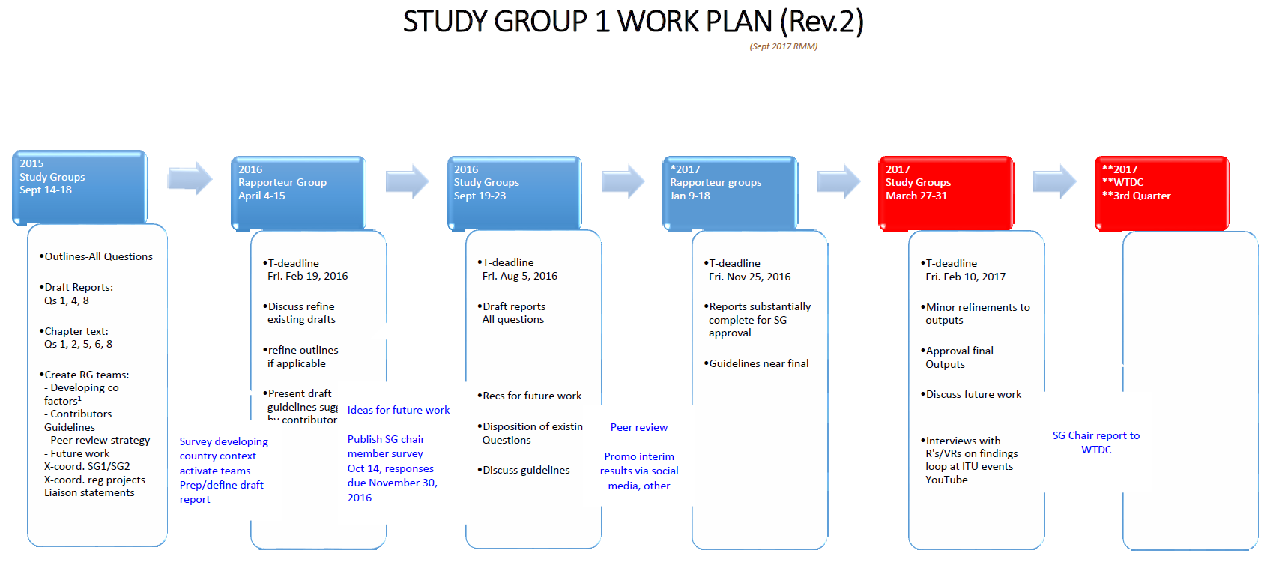

\_\_\_\_\_\_\_\_\_\_\_\_\_\_\_

1. The SG1 Rapporteur Group meetings in April 2015 were the first for the groups after the PP decision, released in November 2014, to reduce the study period. This effectively gave SG1 a little less than 2 years to complete the deliverables for all the Questions and Resolution 9. [↑](#footnote-ref-1)
2. Half of the 16 individuals selected to lead the Questions and Resolution 9 (excluding Vice-Rapporteurs), were completely new to the ITU-D sector, and 12 were new to the management team. Of the 12 Vice-Chairs selected to represent the six regions, 7 were new both to the position and the Sector. [↑](#footnote-ref-2)
3. See Sections 5, 6 and 7 of this report. [↑](#footnote-ref-3)
4. Mr Wesam Al-Ramadeen actively served in this capacity from 2014 to 2015. [↑](#footnote-ref-4)
5. Mrs Regina Assoumou Bessou, Mr Yasuhiko Kawasumi, Mr Nguyen Quy Quyen and Ms Blanca Gonzalez also served as SG1 Vice Chairs during the fifth study period, 2010-2014. [↑](#footnote-ref-5)
6. Outcomes on these revisions are summarized in Section 5.2 of this report. [↑](#footnote-ref-6)
7. <http://www.itu.int/md/D14-SG01-C-0002>. [↑](#footnote-ref-7)
8. Many delegates also regularly attended Study Group and associated Rapporteur Group activities, either in person or remotely, from year to year. In this context, which includes participants who have attended more than once, the BDT hosted and accommodated a total of 2328 delegates in the 2014-2017 period. [↑](#footnote-ref-8)
9. The SG1 management team is made up of the SG1 Chair and Vice Chairs, all Rapporteurs and Vice Rapporteurs, and the Resolution 9 Chair and Vice Chairs. [↑](#footnote-ref-9)
10. Responsible parties include (but are not limited to): Mr Fadel Digham, Mr Sergey Pashtukh, Dr. Amer Hassan, Mr Richard Kimasi, Mr Roberto Hirayama, Dr. Jinqiao Chen, Mr Romain Houehou, Mr Amah Capo, Mr Istvan Bozsoki, Mr Philippe Aubineau, Ms Sofie Maddens, and Ms Carmen Prado-Wagner. [↑](#footnote-ref-10)
11. We note also, the work conducted by the TDAG Correspondence Group on Rules of Procedure of ITU-D (WTDC Resolution 1) which reviewed the existing text in Resolution 1 (Rev. Dubai, 2014) during the 2014-2017 period to: (i) build upon the extensive work undertaken during WTDC-14 to revise the procedures of the Sector; (ii) give practical interpretation to the working methods; and (iii) prepare proposals for further consideration by ITU membership. [↑](#footnote-ref-11)
12. Some comments indicated that e-waste and electromagnetic field exposure should be in SG1. [↑](#footnote-ref-12)
13. It is important to note that the final outputs for all the Questions and Resolution 9 were delivered 27 – 31 March 2017 or 3-7 April 2017 at the final Study Group meetings, so responses in the survey related to Question’s outputs were considering draft reports that had not yet been finalized. [↑](#footnote-ref-13)