|  |  |  |
| --- | --- | --- |
| C:\Users\ponder\AppData\Local\Microsoft\Windows\Temporary Internet Files\Content.Word\BDT-25th_anniversary_2017-Logo_411959-3_transparent.png | **World Telecommunication Development Conference 2017 (WTDC-17)**  **Buenos Aires, Argentina, 9-20 October 2017** | C:\Users\ponder\AppData\Local\Microsoft\Windows\Temporary Internet Files\Content.Word\BDT-25th_anniversary_2017-Logo_411959-1_transparent.png |
|  | |  |
|  | | **Document WTDC-17/5-E** |
|  | | **12 June 2017** |
|  | | **Original: English** |
| Chairman, Telecommunication Development Advisory Group (TDAG) | | |
| Report on the Telecommunication Development Advisory Group (TDAG) Activities to WTDC-17 | | |
|  | | |
| **Summary:**  This report contains a summary of the work carried out by the Telecommunication Development Advisory Group (TDAG) during the period 2014-2017.  **Action required:**  WTDC-17 is invited to note this document.  **References:**  [TDAG14-19/26](https://www.itu.int/md/D14-TDAG19-C-0026/en), [TDAG15-20/32](https://www.itu.int/md/D14-TDAG20-C-0032/en), [TDAG16-21/43](https://www.itu.int/md/D14-TDAG21-C-0043/en), [TDAG17-22/76](https://www.itu.int/md/D14-TDAG22-C-0076/en) | | |

[1. Introduction 3](#_Toc482300234)

[1.1 Terms of Reference of TDAG 3](#_Toc482300235)

[1.2 Telecommunication Development Advisory Group Bureau 3](#_Toc482300236)

[2. TDAG Meetings 3](#_Toc482300237)

[2.1 19th TDAG Meeting 3](#_Toc482300238)

[2.2 20th TDAG Meeting 8](#_Toc482300239)

[2.3 21st TDAG Meeting 12](#_Toc482300240)

[2.4 22nd TDAG Meeting 12](#_Toc482300240)

[3. TDAG Correspondence Group Meetings 17](#_Toc482300241)

[3.1 TDAG Correspondence Group on rules of procedure of ITU-D (WTDC Resolution 1) 23](#_Toc482300242)

[3.2 TDAG Correspondence Group on Strategic Plan, Operational Plan and Declaration 24](#_Toc482300243)

[3.3 TDAG Correspondence Group on Streamlining WTDC Resolutions 25](#_Toc482300244)

[4. Matters assigned to TDAG by WTDC Resolution 24 (Rev. Dubai, 2014) 26](#_Toc482300245)

[4.1 Background 26](#_Toc482300246)

[4.2 Upkeep of up-to-date, efficient and flexible working guidelines 27](#_Toc482300247)

[4.3 Evaluation of the working methods and functioning of the ITU-D study groups, and approval of changes to improve efficiency and maximize programme delivery 28](#_Toc482300248)

[4.4 Provision of advice to the Director of BDT on relevant financial and other matters 28](#_Toc482300249)

# Introduction

This report contains a summary of the work carried out by the Telecommunication Development Advisory Group (TDAG) during the period 2014-2017.

## Terms of Reference of TDAG

The terms of reference of TDAG can be found at: [www.itu.int/ITU-D/tdag/](http://www.itu.int/ITU-D/tdag/).

## Telecommunication Development Advisory Group Bureau

In application of Resolution 61 (Rev. Dubai, 2014), WTDC-14 adopted the composition of the TDAG Bureau and appointed the TDAG chairman and vicechairmen, as follows:

|  |  |  |  |
| --- | --- | --- | --- |
| **Chairman/**  **Vice-Chairmen** | **Name** | **Country** | **BDT Region** |
| Chairman | Prof. Dr Vladimir Minkin | Russian Federation | CIS |
| Vice-Chairman | Ms Roxanne McElvane Webber | USA | Chairman SG1 |
| Vice-Chairman | Mr Ahmad Reza Sharafat | Iran (Islamic Rep. of) | Chairman SG2 |
| Vice-Chairman | Mr Elie Djerambete | Chad | AFR |
| Vice-Chairman | Mr Ahmadou Traoré | Mali | AFR |
| Vice-Chairman | Ms Clarisa Estol | Argentina | AMS |
| Vice-Chairman | Mr Héctor Edmundo Valdés Moreno | Mexico | AMS |
| Vice-Chairman | Mr Al-Ansari Al-Mashagbah | Jordan | ARB |
| Vice-Chairman | Mr Mohamed Saeed Ali Al Muathen Al Mazrooei | United Arab Emirates | ARB |
| Vice-Chairman | Mr Kishore Babu | India | ASP |
| Vice-Chairman | Mr Bohyun Seo | Korea (Rep. of) | ASP |
| Vice-Chairman | Mr Rufat Taghizadeh | Azerbaijan | CIS |
| Vice-Chairman | Ms Nurzat Boljobekova | Kyrgyzstan | CIS |
| Vice-Chairman | Mr Dominique Würges | France | EUR |
| Vice-Chairman | Mr Fabio Bigi | Italy | EUR |

# TDAG Meetings

TDAG held three meetings during the period covered by this report under the chairmanship of Professor Vladimir Minkin (Russian Federation). The complete summary of conclusions of these meetings can be found at: [www.itu.int/ITU-D/tdag/](http://www.itu.int/ITU-D/tdag/).

## 19th TDAG Meeting

1. The 19th meeting of the Telecommunication Development Advisory Group (TDAG) was held at ITU headquarters in Geneva, from 29 September to 1 October 2014, under the chairmanship of Professor Dr Vladimir Minkin.

The full meeting report, in the six official languages of ITU, is available at: <https://www.itu.int/md/D14-TDAG19-C-0026/en>

1. Participants

The following chart provides the breakdown of participants by category:

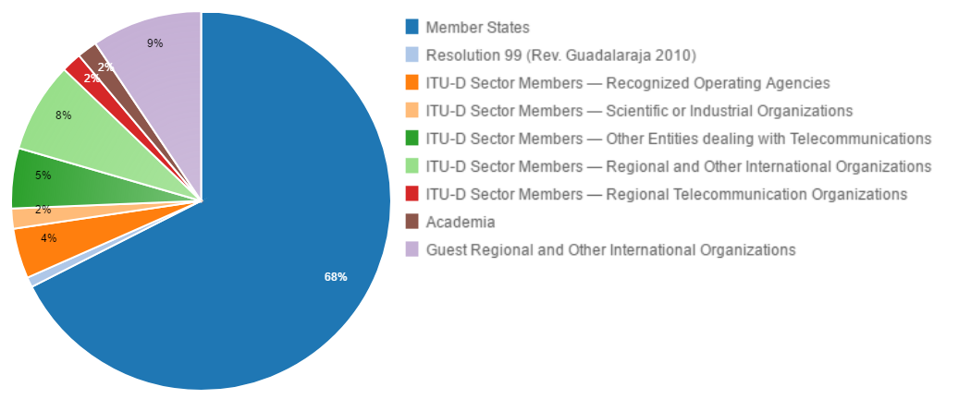

The following chart provides the breakdown of participants by region:

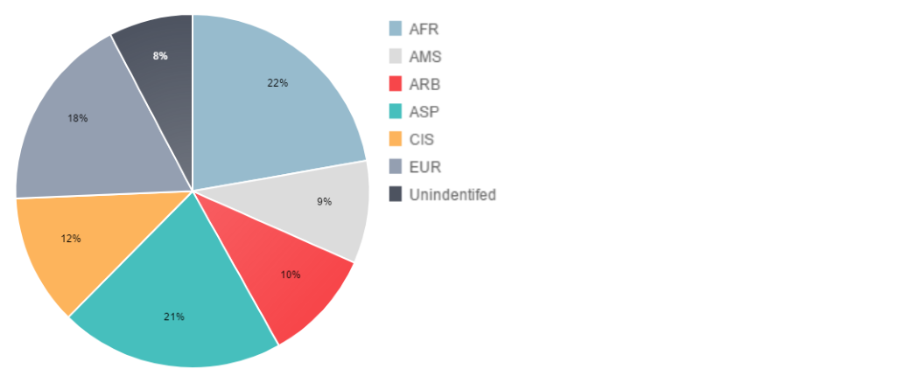

1. Documents

The following chart provides the number of documents broken down by category of documents:

1. 19th TDAG Meeting Outcomes

The following table provides the summary of the outcomes of the 19th TDAG meeting by subject:

| ***Subject*** | ***TDAG Conclusions / Outcomes*** |
| --- | --- |
| World Telecommunication Development Conference (WTDC 14) | The summary report on the conclusions of WTDC-14 was noted. |
| TDAG's new scope of work - Resolution 24 (Rev. Dubai, 2014) | TDAG took note of the document and emphasized that its content would provide useful guidance for its work going forward. |
| Strategic considerations for the implementation of the Dubai Action Plan | TDAG noted with appreciation document 4 that presents WTDC-14 revised Resolution 24; TDAG created a correspondence group to review Resolution 1; TDAG elaborated the outcome indicators and key performance indicators. |
| Inter-sectoral activities | It was highlighted that the purpose of the inter-sectoral group was to provide a better understanding of what is done in the other two Sectors so that developing countries can easily access this information. TDAG agreed to send its representatives to participate in the inter-sectoral group. |
| Review of the implementation of the ITU-D Operational Plan | TDAG took note of the 2013 performance report and the Quarterly Performance Report: January-June 2014 and gave its support for BDT activities. In the framework of the enhancement of the effectiveness of the implementation of regionally approved initiatives at the national, regional, interregional and global levels, TDAG advised to strive to organize annual Regional Development Forum (RDF) meetings whenever possible taking into consideration the importance of such meetings in the implementation of the regional initiatives. |
| ITU-D Study Groups related matters | The Scope of work of ITU-D Study Group 1 and Study Group 2 for the 2014-2018 study period were considered. TDAG thanked the members for the exceptionally large number of contributions received for the first meetings and noted that this shows that there is an interest in the work of the Development Sector. TDAG thanked the chairmen of study groups, vice-chairmen and rapporteurs for excellent work. |
| ITU-D contribution to the implementation of the WSIS Plan of Action | The role of BDT in the WSIS process was highlighted, particularly in the implementation of WSIS outcomes and the preparatory work for the WSIS+10 High-Level Event. TDAG expresswed its appreciation, particularly regarding the leading role of BDT as facilitator of WSIS Action Lines C2, C5 and C6 and other WSIS Action Lines where ITU is co-facilitator, with BDT as its focal point. |
| ITU-D contribution to the implementation of the WSIS Plan of Action | The role of BDT in the WSIS process was highlighted, particularly in the implementation of WSIS outcomes and the preparatory work for the WSIS+10 High-Level Event. TDAG expresswed its appreciation, particularly regarding the leading role of BDT as facilitator of WSIS Action Lines C2, C5 and C6 and other WSIS Action Lines where ITU is co-facilitator, with BDT as its focal point. |
| ITU-D 4-year rolling Operational Plan 2015-18 | The revised operational plan is proposed to reflect the following changes which were adopted by WTDC-14 as the ITU-D contribution to the ITU Strategic Plan of the Union 2016-2019.TDAG requested the correspondence group to consider the 2016-2019 operational plan for ITU-D and for the General Secretariat in the area relevant to ITU-D and prepare advice for the Director before Council 2015. |
| TDAG and study groups working methods | TDAG noted that electronic working methods have been effective in saving costs, reducing the carbon footprint and broadening participation. TDAG also expressed its gratitude for the mobile application on ITU-D events and hopes its use will be extended to other Sectors. TDAG invited the Director to examine the possibility of extending the ITU-D events mobile application to the ITU as a whole. |
| Report of the Group on Capacity Building Initiatives (GCBI) | TDAG thanked the Chairman of the Group on Capacity Building Initiatives for the excellent work that his group is doing. TDAG requested that the work of the group be made more visible on BDT’s website. |
| Membership and partnership-related issues | TDAG noted with appreciation the reports and the work carried out by BDT to attract new Sector Members and to enhance partnership in ITU-D work, as well as the excellent contribution from Japan’s “proposal for acceleration of resource mobilization for projects”. TDAG also recommended to the BDT Director, when determining the key performance indicators to take into account the outcomes of attracting and involving new members in the work of the Sector. |

## 20th TDAG Meeting

1. The 20th meeting of the Telecommunication Development Advisory Group (TDAG) was held at ITU headquarters in Geneva, from 28 to 30 April 2015, under the chairmanship of Professor Dr Vladimir Minkin.

At its 19th meeting (29 September-1 October 2014), TDAG established a Correspondence Group on the Strategic Plan, Operational Plan and Declaration; a Correspondence Group on WTDC Resolution 1 (Rev. Dubai, 2014), “Rules of procedure of the ITU Telecommunication Development Sector”, and an Inter-Sectoral Team on issues of mutual interest. These correspondence groups and the Inter-Sectoral Team held their first physical meetings in Geneva on 27 April 2015 and reported their preliminary progress to TDAG.

The full meeting report, in the six official languages of ITU, is available at: <https://www.itu.int/md/D14-TDAG20-C-0032/en>

1. Participants

The following chart provides the breakdown of participants by category:

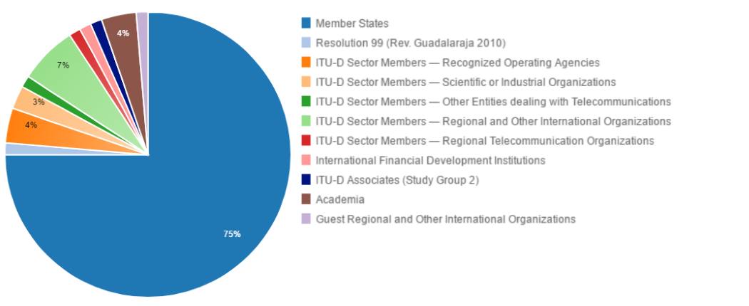

The following chart provides the breakdown of participants by region:

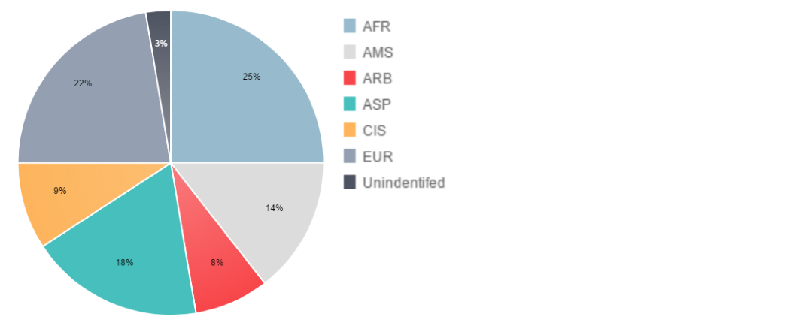

1. Documents

The following chart provides the number of documents broken down by category of documents:

1. 20th TDAG Meeting Outcomes

The following table provides the summary of the outcomes of the 20th TDAG meeting by subject:

| ***Subject*** | ***TDAG Conclusions / Outcomes*** |
| --- | --- |
| Outcomes of PP-14 related to ITU-D | TDAG took note of the main outcomes of the 19th Plenipotentiary Conference that relate to ITU-D. TDAG was informed that BDT has already developed an action plan to address, and follow up on, all these outcomes, which include decisions, resolutions and recommendations. |
| Review of the implementation of the ITU-D Strategic Plan and Operational Plan 2014, including WTDC-14 Resolutions/PP-14 Resolutions related to ITU-D and regional initiatives | TDAG took note of the key outcomes of WTDC-14 of which the Dubai Declaration, the ITU-D Contribution to the 2016-2019 ITU Strategic Plan and the new scope of work for the Study Groups. TDAG also noted the Performance Report 2014, which provides the status of implementation of the objectives and outputs defined in the ITU-D strategic and operational plans. Finally, TDAG took note of the document on regional initiatives and expressed its appreciation to the secretariat for the reports. |
| ITU-D Study Group-related matters | TDAG thanked both study group chairmen and rapporteurs for their enormous work and their collaboration and cooperation with the other ITU study groups. |
| ITU-D contribution to the implementation of the WSIS Plan of Action | TDAG took note of the contribution from secretariat and proposed that the road maps under ITU-D responsibilities should be updated taking into account the outcomes of the WSIS+10 High-Level Event, the Sustainable Development Goals Summit and High-Level Meeting (HLM) implementation of WSIS outcomes at the 70th session of the United Nations General Assembly in 2015. |
| Rules of procedure of ITU-D (WTDC Resolution 1 - Working methods), including TDAG Correspondence Group | TDAG commended the group for the progress made so far and encouraged it to continue developing proposals to further improve WTDC Resolution 1. |
| ITU-D four-year rolling Operational Plan 2016-19, including TDAG Correspondence Group | TDAG endorsed the operational plan and expressed appreciation for its quality. The Correspondence Group has started to prepare the ITU-D strategic plan for 2020-2023. In this regard, TDAG noted the draft ITU-D contribution to the draft Strategic Plan of ITU for the period 2020-2023 submitted to it by the Chairman of its Correspondence Group on the Strategic Plan, Operational Plan and Declaration, based on the group’s meeting held on 27 April 2015.  TDAG agreed that the Correspondence Group should continue its work in both areas on the basis of the draft 2020-2023 ITU-D Strategic Plan and the draft WTDC-17 Declaration. |
| Collaboration with other Sectors, including progress report on Inter-Sectoral Team | TDAG emphasized the importance of IXPs and invited Argentina to take note of the comments and information shared during the meeting, to prepare a concrete proposal where the IXPs matter should be addressed within ITU-D study groups’ activity, and consider proposing to add the item to an existing Question or creating a new ITU-D Question specifically related to IXPs. As for ITU-T/TSB and ITU-D/BDT collaboration and cooperation, TDAG concluded that a first step is to determine a number of issues of mutual interest, and Document 8 was seen as a good starting point. Concerning ITU-D web pages, TDAG considered the contribution that outlines proposals to improve the ITU-D website, focusing, in particular, on the issue of translation of web pages. The contribution highlights specific links to pages that have translation issues.  TDAG advised that the above proposals be considered by the BDT Director. TDAG also noted that these proposals may have an impact on BDT’s budget and advised that the Director take these proposals into account when implementing the ITU-D Operational Plan. |
| Report of the Group on Capacity Building Initiatives | TDAG took note of the report, thanked the Chairman of GCBI, and requested that the work of the group be made more visible on the ITU-D website. |
| Report on other ITU-D activities | TDAG emphasized the importance of the 15th Edition of the Global Symposium for Regulators (GSR-15). TDAG considered the work on ICT indicators and statistics as highly important for good policy-making. TDAG recognized the need to enhance the level of WTIS participants to ministers and decision-makers. TDAG agreed that the question of emergencies is of relevance to all countries, whether developing or developed, making the interest in this issue universal. TDAG advised that Regional Development Forums (RDFs) should take place in the first quarter of the year so that the results are available to TDAG meetings. TDAG further supported the holding of RDFs on an annual basis. |
| Membership, partnership and innovation-related matters | TDAG noted the actions carried out at global and regional levels to encourage partnerships, including public-private partnerships. TDAG also reviewed the proposed strategies and actions to facilitate the innovation agenda in both ITU-D and its membership. |
| Progress report on the preparation of the 2016-2017 budget | TDAG expressed appreciation to the secretariat regarding the budget being balanced, but most importantly that measures had been taken not to withdraw funds from the Reserve Account. |
| Calendar of ITU-D events | TDAG thanked the secretariat for the calendar of ITU-D events as a very useful document and noted that after the Council, there will be some changes to this document. |

## 21st TDAG Meeting

1. The 21st meeting of the Telecommunication Development Advisory Group (TDAG) was held at ITU headquarters in Geneva, from 16 to 18 March 2016, under the chairmanship of Professor Dr Vladimir Minkin.

TDAG’s Correspondence Group on the Strategic Plan, Operational Plan and Declaration, Correspondence Group on WTDC Resolution 1 (Rev. Dubai, 2014), “Rules of procedure of the ITU Telecommunication Development Sector”, and the Inter-Sector Coordination Team on Issues of Mutual Interest met in Geneva on 15 March 2016 and reported their progress to TDAG.

The full meeting report, in the six official languages of ITU, is available at: <https://www.itu.int/md/D14-TDAG21-C-0043/en>

1. Participants

The following chart provides the breakdown of participants by category:

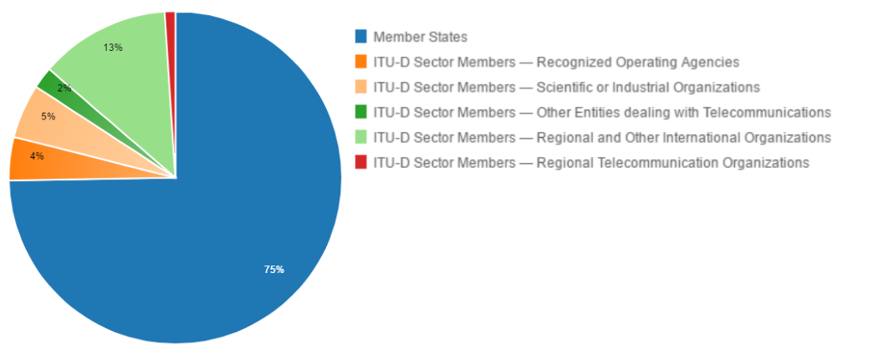

The following chart provides the breakdown of participants by region:

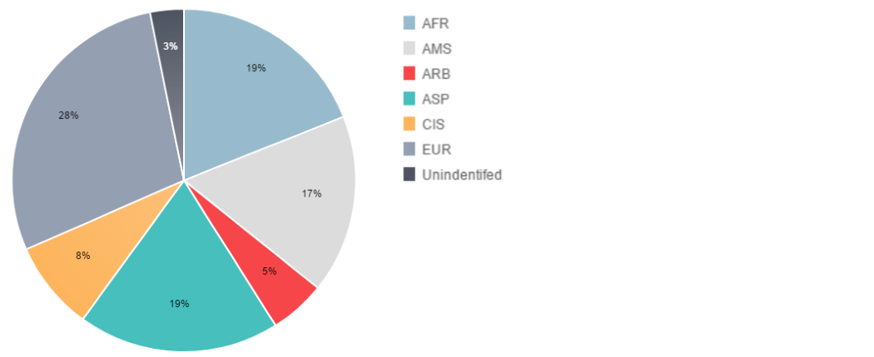

1. Documents

The following chart provides the number of documents broken down by category of documents:

1. 21th TDAG Meeting Outcomes

The following table provides the summary of the outcomes of the 21th TDAG meeting by subject:

| ***Subject*** | ***TDAG Conclusions / Outcomes*** |
| --- | --- |
| Outcomes of RA-15 and WRC-15 related to ITU-D | TDAG took note of this document and invited ITU-D study groups to consider the outcomes of RA-15, WRC-15 and CPM19-1 in their future work. |
| Review of the implementation of the ITU-D Strategic Plan and Operational Plan 2015, including regional initiatives | TDAG provided positive feedback on the 2015 Performance Report and the Regional Initiatives, congratulated BDT for the high level of presentations and welcomed the efficient collaboration between the Regional Offices and the three ITU Sectors. TDAG noted that the draft satisfaction survey on the regional presence covers not only BDT, but the whole ITU.TDAG also noted that the draft survey will be sent to Council-16. Concerning case studies and information sharing of ITU projects and regional initiatives, TDAG noted that ITU has accumulated a lot of valuable experience and information in the implementation of ITU projects and regional initiatives which could be an important repository for developing countries. TDAG called upon ITU-BDT to improve its website to make this information accessible. |
| ITU-D Study Group-related matters | TDAG provided positive feedback to the chairmen of ITU-D Study Groups 1 and 2 regarding the current status of the groups’ work.  TDAG called upon ITU-D and in particular the ITU-D study group chairmen to coordinate work between ITU-D and ITU-T study groups.  TDAG noted the relationship between Questions in Study Group 2 and those of Study Group 1, as well as with Questions in ITU-T and ITU-R study groups and provided positive feedback that measures have been initiated by way of information exchange and liaison statements to start and maintain cooperation. |
| ITU-D contribution to the implementation of the WSIS Plan of Action, including the United Nations General Assembly Overall Review and the Sustainable Development Goals | TDAG noted the contribution of ITU-D to the implementation of the WSIS outcomes, including actions undertaken by BDT in the context of the United Nations General Assembly Overall Review of the Implementation of the WSIS Outcomes. TDAG welcomed the substantive contribution of ITU-D to the implementation of the WSIS Plan of Action. |
| Working methods, including a progress report by the TDAG Correspondence Group on Rules of Procedure of ITU-D | TDAG thanked the Chairman of the Correspondence Group for her outstanding work. TDAG advised that the group consider the items brought up in the discussion. As regards to the use of electronic resources for improving efficiency of work of study groups and their rapporteur groups, TDAG invited the BDT Director to seek the possibility of using SharePoint for the Development Sector, taking into account the contribution from the Russian Federation and the potential difficulties referred to above. Finally TDAG invited BDT to explore the proposals in relation to he simplification of the access to ITU-D documents, taking into account the best practices of the Radiocommunication Bureau (BR), to the extent feasible. |
| ITU-D four-year rolling Operational Plan 2017-2020, including a report by the TDAG Correspondence Group on Strategic Plan, Operational Plan and Declaration | TDAG took note of the four-year rolling Operational Plan for ITU-D. TDAG also expressed its appreciation for the work of BDT in resource mobilization and encouraged BDT to continue this work in particular in fostering collaboration and partnerships with Sector Members, Associates and Academia. Finally, TDAG agreed that the discussion on this issue at the Correspondence Group meeting should be included in the report. |
| Preparations for WTDC-17 | With regards to the Progress Report of the TDAG Correspondence Group on Strategic Plan, Operational Plan and Declaration, TDAG requested that all CG-SPOPD output documents (40(Rev.1), 10, 30, and 31(Rev.1)), along with the summaries of the Correspondence Group’s discussions, should be posted on the CG-SPOPD website to populate it. Concerning the Preliminary Draft ITU-D Contribution to the ITU Strategic Plan for 2020-2023, TDAG endorsed the revised ITU-D contribution to the ITU Strategic Plan for the period 2020-2023 while noting the guidance of CG-SPOPD as defined at its 15 March 2016 meeting, including that ITU-D is aligning its work to contribute to the achievement of the SDGs and to the facilitation of implementation of the referenced WSIS Action Lines. TDAG requested that the Correspondence Group on the Strategic Plan, Operational Plan and Declaration should continue its work in line with the conclusions above. Finally, concerning the Preliminary Draft WTDC-17 Declaration, TDAG noted the progress made in the preparation of the Preliminary Draft Declaration and requested that the Correspondence Group on the Strategic Plan, Operational Plan and Declaration should continue its work in line with the conclusions above. Conclusions on the preparation of WTDC-17, RDFs and RPMs: TDAG took note of the status of the preparations for WTDC-17 and its associated Regional Preparatory Meetings and Regional Development Forums. TDAG welcomed the fact that that the places of the conference/meetings are already known at such an early stage, and noted that participation in, and contributions to, Regional Preparatory Meetings are an opportunity for members to contribute to WTDC preparations. TDAG considered Document 39 presented by Argentina, supported the comments and proposals made in that document, and advised that the BDT Director make use of these proposals in his work in the run-up to the conference. TDAG also noted that in 2017, ITU-D will celebrate its 25th anniversary marking its creation as a Sector. |
| Collaboration with the other Sectors, including a progress report by the Inter-Sector Coordination Team on Issues of Mutual Interest | TDAG approved the updated Terms of Reference of the Inter-Sector Coordination Team on Issues of Mutual Interest, and agreed to send the updated list of issues of mutual interest and the Terms of Reference, together with the report in Document 12 to the other two Sector advisory groups. |
| Report on the Group on Capacity Building Initiatives (GCBI) (Document 13) and Report on capacity building activities | TDAG provided positive feedback on the Report of the Chairman of GCBI, the report on capacity building activities and the report on future improvement of the ITU Centres of Excellence (CoE) strategy.  TDAG expressed its wish that the level of transparency on the work of the steering committees of CoE in the various regions be increased. Participants, for example, suggested that a mechanism be defined for Steering Committees across regions to share experiences amongst themselves. |
| Report on other ITU-D activities | TDAG thanked BDT for the excellent work in organizing this unique annual forum for regulators and invited membership to actively participate in the forthcoming Global Symposium for Regulators (GSRs). TDAG expressed appreciation for the information provided on the 13th WTIS and thanked the Government of Japan and BDT for organizing the event.  TDAG considered the work on ICT indicators and statistics as highly important for good policy-making. In preparation for WTIS-16, TDAG advised the development of ICT indicators for the measurement of the UN 2030 Agenda for Sustainable Development. TDAG advised that BDT provide more information on the results of activities being undertaken on the use of human and financial resources in emergency telecommunications and highlighted the importance of capacity building in this area. |
| Membership, Partnership and Innovation-related matters | TDAG expressed its appreciation for BDT’s work in encouraging the involvement and participation of the private sector in ITU-D initiatives, projects and activities at regional as well as at global levels. TDAG highlighted the importance of telecommunications/ICTs for global development and underlined the role of the private sector in leading this effort, making collaboration with BDT even more important. TDAG commended the work of BDT and underlined that further engagement with the private sector could only benefit both parties. TDAG commended strategies and actions on innovation for the membership proposed by BDT. TDAG took note with satisfaction of Document 23 and advised that BDT continue its work on innovation jointly with the private sector and Member States. |
| Calendar of ITU-D events | TDAG noted with appreciation the calendar of events. |

## 22nd TDAG Meeting

1. The 22st meeting of the Telecommunication Development Advisory Group (TDAG) was held at ITU headquarters in Geneva, from 9 to 12 May 2017, under the chairmanship of Professor Dr Vladimir Minkin.

The TDAG Correspondence Group on the Strategic Plan, Operational Plan and Declaration, the Correspondence Group on WTDC Resolution 1 (Rev. Dubai, 2014), “Rules of procedure of the ITU Telecommunication Development Sector”, the Correspondence Group on Streamlining WTDC Resolutions and the Inter-Sector Coordination Team on Issues of Mutual Interest met in Geneva on 9 and 10 May 2017 and reported their outcomes to TDAG.

The full meeting report, in the six official languages of ITU, is available at: <https://www.itu.int/md/D14-TDAG22-C-0073/en>

1. Participants

The following chart provides the breakdown of participants by category:

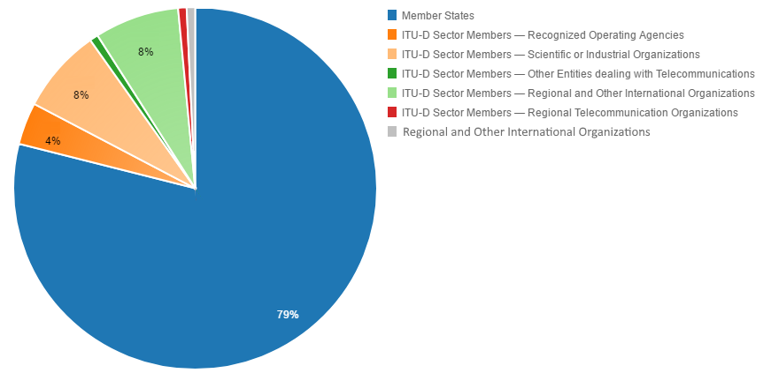

The following chart provides the breakdown of participants by region:

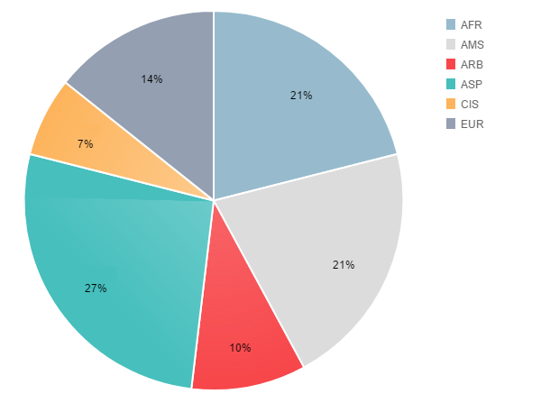

1. Documents

The following chart provides the number of documents broken down by category of documents:

1. 22nd TDAG Meeting Outcomes

| ***Subject*** | ***TDAG conclusions / outcomes*** |
| --- | --- |
| 5. Outcomes of WTSA-16 related to the work of ITU-D | TDAG raised the issue of the financial implications for ITU as a whole of any decisions taken by the Conferences/Assemblies of one of the Sectors. TDAG advised the Director of BDT to raise the issue of the implications at ITU Council, including but not limited to, the financial implications of WTSA-16 on the work of ITU-D and ITU-D Study Groups in particular.  TDAG reiterated that each ITU sector should work within the limits of their terms of reference. TDAG further advised the Director of BDT to engage in preliminary consultation with the other ITU Sectors to avoid overlap in the implementation of activities.  TDAG invited the Members to take these aspects into account when preparing their proposals and contributions to WTDC-17. |
| 6. Report on the implementation of the ITU-D Strategic Plan and Operational Plan 2016 | TDAG welcomed the reports and thanked the Secretariat for compiling this information. It advised that in the future report on projects, detailed project information broken down by each region should also be featured as much as possible. TDAG encouraged the Secretariat to continue efforts on resource mobilization with other partners and develop project proposals to this effect. |
| 7. Reports on ITU-D Study Group activities | TDAG welcomed the results achieved by the ITU-D Study Groups and expressed appreciation to the Chairman of Study Group 1, Ms Roxanne McElvane Webber and the Chairman of Study Group 2, Dr Ahmad Reza Sharafat, Vice-Chairmen, Rapporteurs, Vice-Rapporteurs, Co-Rapporteurs, and the Secretariat for the remarkable work undertaken. TDAG asked the Chairmen to take note of the comments made by TDAG members in finalizing their report to WTDC-17. TDAG supported the constructive initiatives undertaken by the Study Groups, noted the successful holding of seminars and workshops and providing surveys and encouraged to continue such activities in the coming study period. TDAG requested that the deadline of surveys be extended until September 2017.  TDAG considered the liaison statement from RAG on Resolution 9 (Rev. Dubai, 2014) and prepared the liaison statement to RAG (TDAG/17-22/72). |
| 8. ITU-D contribution to the implementation of the WSIS Plan of Action, including UNGA Overall Review and SDGs | TDAG welcomed the report and advised that it be used by Members in preparation for WTDC-17 on the Strategic Plan, the Action Plan and the Declaration as well as relevant Resolutions. |
| 9. ITU-D four-year rolling Operational Plan 2018-2021 | TDAG noted the documents and drew attention of the Secretariat on the necessity to provide information on the financial implications of the WTSA Resolutions pertaining to the work of ITU-D. |
| 10. Preparations for WTDC-17 (Secretariat and Member contributions) |  |
| 10 a. Update on the preparations for WTDC | TDAG welcomed document [*16*](https://www.itu.int/md/D14-TDAG22-C-0016/)and presentation document [*69*](https://www.itu.int/md/D14-TDAG22-C-0069/)and thanked the government of Argentina for hosting the forthcoming WTDC in Buenos Aires from 9-20 October 2017. With regards to document [*16*](https://www.itu.int/md/D14-TDAG22-C-0016/), the meeting supported the proposal of maintaining policy statements while limiting their duration to 3minutes. One delegation pointed out that the opportunity of policy statements should be extended to all Heads of delegation. TDAG advised the BDT Director to consider this proposal. |
| 10 b. Report of RPM-CM | TDAG welcomed the report and emphasized the importance of organizing RPMs in preparation for WTDC. TDAG advised that RPMs be organized as close as possible to WTDC and the reports of the RPMs should be reported to the last TDAG meeting before WTDC. |
| 10 c. Structure of WTDC-17 | TDAG welcomed the document and advised the Director of BDT and to WTDC-17 that:  1) The number of drafting/ad hoc group meetings should be kept to the minimum.  2) Such meetings should not be held in parallel, to the extent possible, in particular drafting groups should not be organized parallel to the parent Committee.  3) The cut-off time for ad hoc meetings should be limited to 2300h local time and no meetings should be held on Sundays.  4) All timetables and notifications regarding all meetings, including ad hoc groups, occurring the next day should be announced on the screens and published not later than 2100h. |
| 10 d. ITU-D Contribution to the Draft ITU Strategic Plan | Documents were considered during the meeting of the TDAG Correspondence Group on Strategic Plan, Operational Plan and Declaration (CG-SPOPD) which took place on 9 May 2017.  TDAG welcomed the results achieved by the CG-SPOPD and expressed appreciation to the Chairman, Dr Fabio Bigi for the work undertaken. TDAG requested the BDT Director to submit to WTDC-17 the versions of the preliminary draft ITU-D contribution to the ITU Strategic Plan for 2020-2023 (RPM-XXX/7), the preliminary draft ITU-D Action Plan for 2018-2021 (RPM-XXX/8) and the preliminary draft WTDC-17 Declaration (RPM-XXX/9) that were submitted to each RPM. Members will be invited to make their proposals to WTDC-17 based on these documents.  The TDAG drew attention to documents TDAG17-22/7, TDAG17-22/8 and TDAG17-22/9, which contain the compilation of outcomes by RPMs and contributions to TDAG17 and invited members to use these documents in their preparation for WTDC-17.  Considering that the regional groups will continue to work on preparation for WTDC-17, the Secretariat was requested to publish a list of meetings for all the regional groups. The regional groups were encouraged to identify a focal point for each document and share their contact details so that the regional organizations could attempt to coordinate amongst themselves in an effort to reach agreement in advance of WTDC-17. Regional organizations were also requested to immediately inform the secretariat of any changes on place and dates of their meeting so they are published on the BDT website. |
| 10 e. Draft ITU-D Action Plan (including ITU-D Study Group Questions) | TDAG agreed that the existing mechanism of the two Expert Groups on Indicators was suited to discuss issues related to indicators and statistics, which also allowed for multistakeholder participation, in particular from National Statistical Offices. TDAG requested the Secretariat to continue providing support to the Expert Groups in improvement of the methodology taking into account the fast changing environment within telecommunication/ICT sector and to report on the work of the Expert Groups at every TDAG meeting. |
| 10 f. Draft WTDC-17 Declaration |  |
| 10 g. Working methods and Rules of Procedure of ITU-D (WTDC Resolution 1) | Documents were discussed during the meeting of the TDAG Correspondence Group on Rules of Procedure of ITU-D (CG-Res1) which took place on 10 May 2017.  TDAG welcomed the results achieved by the CG-Res.1 and expressed appreciation to the Chairman, Ms Roxanne McElvane Webber for the work undertaken. TDAG advised members to use the compilation document TDAG17-22/10 in the preparation for WTDC. |
| 10 h. Streamlining WTDC Resolutions | Documents were considered by the meeting of TDAG Correspondence Group on Streamlining WTDC Resolutions (CG-SR) which took place on 10 May 2017.  TDAG welcomed the results achieved by the CG-SR and expressed appreciation to the Chairman, Dr Ahmad Reza Sharafat for the work undertaken. TDAG noted that the representatives of three regions expressed their wish to work on common proposals for streamlining Resolutions 17 and 32 and Resolutions 37 and 50.  TDAG endorsed the guidelines for streamlining WTDC resolutions in annex 1 to TDAG17-22/11 and recommended to use the material in the preparation for WTDC.  For the review of the documents that had been allocated by TDAG to the CG-SR on study Questions, TDAG supported the report of CG-SR and appreciated the proposal to reduce the number of study Questions and efforts to avoid duplications. |
| 11. Collaboration with the other Sectors, including a progress report by the Inter-Sector Coordination Team on Issues of Mutual Interest | Documents were considered by the meeting of Inter-Sector Coordination Team on Issues of Mutual Interest (ISCT) which took place on 10 May 2017.  TDAG noted the report with appreciation and thanked the Chairmen, Dr Fabio Bigi for the work undertaken. It was proposed that gender aspects be considered for inclusion in the areas of mutual interest, while noting that gender is a cross-cutting issue.  TDAG expressed its appreciation for the mapping tables provided in the appendices which are useful when preparing proposals on ITU-D study Questions. It was also proposed to add reference to ITU-R SG1 Question 1/239 on EMF in appendix 2. |
| 12: Report of TDAG to WTDC-17 | TDAG noted the draft report of TDAG activities for 2014-2017 to WTDC-17 and decided to request members to provide any comments to this draft by 1 June 2017. Chairman promised to finalize the report by 15 June 2017. |
| 13. Report on the GCBI | TDAG welcomed the report and expressed its appreciation for the work of the GCBI and the Chairman Mr Santiago Reyes-Borda and encouraged the group to continue its efforts in advising the BDT Director on matters related to strengthening capacities. |
| 14. Report on other ITU-D activities |  |
| 14 a. Report on GSR | TDAG welcomed the document and thanked the Government of the Bahamas for hosting the forthcoming Global Symposium for Regulators (GSR) 2017. |
| 14 b. Report on CBS | TDAG welcomed the report and, in particular, appreciated the presence of young people in the Symposium and welcomed efforts to ensure their participation in the next Capacity Building Symposium. |
| 14 c. Report on WTIS | TDAG welcomed the document and thanked the Governments of Botswana for hosting WTIS-16 and Tunisia for the offer to host WTIS-17. TDAG emphasized the importance of ITU statistics which are used by many other stakeholders. It was proposed to continue reviewing the working mechanisms with a view to move the releasing the results of the ICT Development Index (IDI) earlier in the year. |
| 15. Membership, Partnership and Innovation-related matters | TDAG welcomed the documents and advised the BDT Director to take into account the comments raised and provide additional information on each region for WTDC. A snapshot specifically of the 2014-2017 cycle would also be appreciated.  TDAG asked the Secretariat to take into account the comments received, especially in terms of a detailed analysis on the engagement with academia in the regions. TDAG asked the Director to consider ways to attract SMEs and micro enterprises. With regards to a definition of SMEs, interested parties can work on this and submit contributions to WTDC, the content of which could be included in relevant resolutions.  TDAG expressed appreciation to the TDAG Vice-Chairman, Mr Dominique Würges for the work undertaken on the private sector issues during two cycles. |
| 16. ITU-D 25th Anniversary celebrations | TDAG welcomed the presentation and advised to clarify the issue of participation by high-level officials. TDAG also advised ensuring high visibility on the achievements of ITU-D over the past 25 years through various mechanisms focusing on success stories and meaningful outcomes, in particular in the interest of developing countries as well as on the leading role of ITU-D in the implementation of WSIS outcomes, the Sustainable Development Goals and the Connect 2020 Agenda. Membership was encouraged to contribute to the preparation of the ITU-D 25th anniversary celebration. |
| 17. Calendar of ITU-D events | TDAG welcomed the document and endorsed the calendar of events. TDAG encouraged to continue coordination of events with other Sectors and other internal and regional organizations. |
| 18. Any other business | TDAG welcomed the information documents. |

# TDAG Correspondence Group Meetings

During the period 2014-2017, TDAG established three Correspondence Groups:

* TDAG Correspondence Group on rules of procedure of ITU-D (WTDC Resolution 1);
* TDAG Correspondence Group on Strategic Plan, Operational Plan and Declaration;
* TDAG Correspondence Group on Streamlining WTDC Resolutions.

TDAG also dealt with the work and outcomes of the Inter-Sector Coordination Team on Issues of Mutual Interest.

The Groups worked through electronic means and physical meetings.

## TDAG Correspondence Group on rules of procedure of ITU-D (WTDC Resolution 1)

The TDAG Correspondence Group on rules of procedure of ITU-D (CG-Res.1) held three meetings, on 27 April 2015, 15 March 2016 and 10 May 2017.

The terms of reference of the group are the following:

Building upon the extensive work undertaken during WTDC-14:

* To review the existing text in Resolution 1 (Rev. Dubai, 2014) with a view to give practical interpretation of the working methods and prepare proposals for further improving the text of the resolution, between the two WTDCs, through the Telecommunication Development Advisory Group (TDAG).
* To study the matters dealt with in Resolution 1 and recommend areas of improvement by presenting progress on its work to the annual TDAG meetings in 2015 and 2016.
* To examine in particular matters left outstanding by WTDC-14, e.g.
* Continue evaluating the working methods;
* Editorial alignments; Process and use of information documents;
* Approval process for Study Group deliverables;
* Duties of Co-Rapporteurs and Vice Rapporteurs; and
* Relevant results of the 2014 Plenipotentiary Conference, if any.
* To take into account useful information and relevant practices of the other Sectors where appropriate.

CG-Res.1 has met to agree on changes required to the text in Resolution 1 and to identify items requiring further work. Some further modifications have been done by correspondence. The document has also been submitted as a contribution to all six Regional Preparatory Meetings (RPMs).

(see section 2.4 d 10 g for the conclusion of TDAG17)

## TDAG Correspondence Group on Strategic Plan, Operational Plan and Declaration

The TDAG Correspondence Group on Strategic Plan, Operational Plan and Declaration (CG-SPOPD) held three meetings, on 27 April 2015, 15 March 2016 and 9 May 2017.

The terms of reference are the following:

* To review the Strategic Plan approved by the 2014 Plenipotentiary Conference and to prepare proposals for the draft new ITU-D contribution to the ITU Strategic Plan for the next period (2020-2023).
* To review the Dubai Action Plan and its links with the Operational Plan.
* To review the four-year rolling Operational Plan, identify areas of improvement, and develop recommendations for the draft Operational Plan beforeit is considered by Council.
* To propose elements for the future draft Declaration.

CG-SPOPD prepared the draft versions of the preliminary draft ITU-D contribution to the ITU Strategic Plan for 2020-2023, the preliminary draft ITU-D Action Plan for 2018-2021 and the preliminary draft WTDC-17 Declaration.

These were reviewed by the CG-SPOPD during its April 2015 and March 2016 meetings and then submitted to TDAG-16.

After online consultation by the ITU-D membership, these three documents were then submitted to all six Regional Preparatory Meetings for consideration. Outcomes of RPMs were compiled at the RPM Coordination Meeting on 8 May 2017. In addition, outcomes of RPMs and contributions to TDAG17 were compiled at the CG-SPOPD meeting on 9 May 2017.

(see section 2.4 d 10 d, 10 e, 10 f for the conclusion of TDAG17)

## TDAG Correspondence Group on Streamlining WTDC Resolutions

The TDAG Correspondence Group on Streamlining WTDC Resolutions (CG-SR) held five meetings, on 17 March 2016, 28 September 2016, 25 January 2017, 3 April 2017 and 10 May 2017.

The terms of reference are the following:

* To review existing World Telecommunication Development Conference (WTDC) Resolutions and Recommendations with a view to streamlining them, taking into account the Resolutions in Plenipotentiary Conference and other Sectors as appropriate.
* To give due regard to the outcomes of the Regional Preparatory Meetings for the World Telecommunication Development Conference 2017 (WTDC-17), as far as the Resolutions and Recommendations are concerned.
* To report to the 2017 meeting of TDAG.

CG-SR has decided on the following guiding principles in the work on streamlining Resolutions:

* Coherence and Consistency;
* Overlap and duplication;
* Necessity;
* Action-orientation and accountability.

CG-SR has also set guidelines for drafting new WTDC Resolutions.

CG-SR has received a total of 12 proposals to streamline WTDC resolutions through RPMs in the CIS, Africa, Arab States, Americas and Asia-Pacific regions. CG-SR compiled the following regionally-agreed proposals for streamlining resolutions:

1. The merger of Resolutions 1 and 31
2. The merger of Resolutions 17 and 32
3. The merger of Resolutions 37 and 50
4. The abrogation of Resolution 31
5. The abrogation of Resolution 32
6. The abrogation of Resolution 50.

Proposals from individual Member States were also put forward to either RPMs or the dedicated meetings of CG-SR regarding:

1. The merger of Resolutions 46 and 68
2. The merger of Resolutions 50 and 54
3. The abrogation of Resolution 68
4. The abrogation of Resolution 54
5. The abrogation of Resolution 33
6. The abrogation of Resolution 67.

(see section 2.4 d 10 h for the conclusion of TDAG17)

# Matters assigned to TDAG by WTDC Resolution 24 (Rev. Dubai, 2014)

## Background

According to provision No. 215JA of Article 17 of the Convention of the International Telecommunication Union, the Telecommunication Development Advisory Group (TDAG) shall submit a report to the 2017 World Telecommunication Development Conference (WTDC-17) on the specific matters assigned to it by WTDC-10, in accordance with provision No. 213A of Article 16 of the Convention.

WTDC-14 revised Resolution 24 (Rev. Dubai, 2014) Which assigned to TDAG the following specific matters, between two consecutive WTDCs, acting through reports from the Director of theTelecommunication Development Bureau (BDT) and study group chairmen, as appropriate:

i) continue to maintain efficient and flexible working guidelines, and update them as necessary, including to provide opportunities for crossregional sharing of experiences on the implementation of regional actions, initiatives and projects;

ii) review, on an ongoing basis, the relationship between the ITU-D objectives outlined in the strategic plan for the Union and the budgetary appropriations available for activities, particularly programmes and regional initiatives, with a view to recommending any measures necessary to ensure the efficient and effective delivery of the principal products and services (outputs) of the Sector;

iii) review, on an ongoing basis and in accordance with No. 223A of the Convention, the implementation of the rolling four-year operational plan for ITU-D and provide guidance to BDT on the elaboration of the draft ITU-D operational plan to be approved by the following ITU Council session;

iv) evaluate, and update as necessary, working methods and guidelines to ensure the most efficient and flexible implementation of the key elements of the WTDC Action Plan;

v) evaluate periodically the working methods and functioning of the ITU-D study groups, to identify options for maximizing programme delivery and to approve appropriate changes thereto following an assessment of their work programme, including strengthening of the synergy between Questions, programmes and regional initiatives;

vi) conduct the assessment pursuant to v) above, taking into account the following actions in relation to the current work programme of the study groups, if needed:

* redefinition of the terms of reference of Questions in order to provide focus and eliminate overlap;
* deletion or merging of Questions as appropriate; and
* evaluation of criteria to measure the effectiveness of Questions, both in qualitative and quantitative terms, including a periodical review based on the ITU-D strategic plan with a view to further exploring performance measures in order to more effectively implement actions referred to in v) above;

vii) restructure ITU-D study groups, if required, and, as a result of a restructuring or creation of ITU-D study groups, appoint chairmen and vice-chairmen to act until the next WTDC in response to the needs and concerns of the Member States, within the agreed budgetary limits;

viii) issue advice on study group schedules that meet development priorities;

ix) advise the Director of BDT on relevant financial and other matters;

x) approve the programme of work arising from the review of existing and new Questions and determine the priority, urgency, estimated financial implications and time-scale for the completion of their study;

xi) in order to promote flexibility in responding rapidly to high-priority matters, if required, create, terminate or maintain other groups, appoint their chairmen and vice-chairmen, and establish their terms of reference with a defined duration, in accordance with Nos 209A and 209B of the Convention and taking into account the leading role of the study groups in carrying out the studies on such matters; such other groups shall not adopt Questions or Recommendations;

xii) consult the Director of BDT on the development and implementation of an action plan on electronic working methods and, going forward, procedures and rules for electronic meetings, including legal aspects, taking into account the needs and the means of developing countries and in particular the least developed countries;The actions taken by TDAG between WTDC-10 and WTDC-14 in this regard are presented below.

## Upkeep of up-to-date, efficient and flexible working guidelines

Electronic working methods, including remote participation, have been embedded in the work of the TDAG during the period under consideration.

TDAG created several correspondence groups and coordination team to work electronically (see section 3).

TDAG noted with appreciation the innovative steps taken by the BDT to provide electronic working facilities for the use of the membership, in particular regarding remote participation, the document management system (DMS) for the creation and publication of documents and the Customer Relationship Management (CRM) project that is progressively entering in pilot stage.

TDAG Correspondence Group on Rules of Procedure of ITU-D (CG-Res.1) reviewed the existing text in Resolution 1 (Rev. Dubai, 2014) to give practical interpretation of the working methods and prepare proposals for further consideration at WTDC-17 (see section 3.1).

The cost of providing interpretation and translation services was also noted. In the other Sectors, the focus groups use one working language only, English. This may exclude some participants from the work of the focus groups. On the other hand, it was noted that existing mechanisms in ITU-D with rapporteur groups and study groups may already be sufficient and provide the necessary flexibility in conducting the work.

To further the work of CG-Res.1, the Chairman highlighted some steps that could be considered: given that amending resolutions should be done on the basis of written contributions, it was asked that for the new revision of the Resolution 1 text, the mention of focus groups could be removed, unless a written justification agreeable to all can be adopted. Whenever new concepts are introduced in the text, they need to be justified and validated.

## Evaluation of the working methods and functioning of the ITU-D study groups, and approval of changes to improve efficiency and maximize programme delivery

Throughout the study period the Chairmen of the two ITU-D Study Groups reported systematically to TDAG on the progress made by their respective Study Group and any challenges encountered that may have prevented the Groups from finalizing their work. Items discussed during the Management Team meetings, including the Joint Management Team meeting of the two Study Groups, have been included in these reports and brought to the attention of TDAG.

TDAG during its 2016 meeting provided positive feedback to the chairmen of ITU-D Study Groups 1 and 2 regarding the current status of the groups’ work.

TDAG called upon ITU-D and in particular the ITU-D study group chairmen to coordinate work between ITU-D and ITU-T study groups. A number of participants as well as the TDAG Chairman suggested that greater use of personal contacts could contribute to closer coordination between the two Sectors. They proposed that rapporteurs of the ITU-D Questions should carefully study the information provided by ITU-T on the mapping of Questions and identify any overlapping topics between the two Sectors to be able to send feedback to ITU-T.

TDAG pointed out the importance of collaboration between the study groups in the different Sectors. TDAG encouraged study group chairmen to enhance collaboration and a correct understanding of the work undertaken in the Sectors, the aim being to ensure complementarity.

TDAG noted the relationship between Questions in Study Group 2 and those of Study Group 1, as well as with Questions in ITU-T and ITU-R study groups and provided positive feedback that measures have been initiated by way of information exchange and liaison statements to start and maintain cooperation.

Being able to send feedback to ITU-T and ITU-R is of prime importance and TDAG encouraged rapporteurs of the ITU-D study groups to carefully examine input provided by the other Sectors and to provide ITU-D’s position, including through liaison statements.

## Provision of advice to the Director of BDT on relevant financial and other matters

In considering the implementation of the Dubai Action Plan (DuAP) (Performance Reports), TDAG expressed its support and appreciation for the results-based approach focusing on outcomes and achieved results. TDAG acknowledges the improvement in the monitoring and reporting related to the implementation of the strategic and operational plans through the preparation of the operational plans, performance reports and quarterly reports.

In relation to project implementation, TDAG expressed its support and appreciation for the significant progresses made in the monitoring and reporting of ITU projects through he development of the [ITU Projects Portfolio](https://www.itu.int/en/ITU-D/Projects/Pages/Portfolio.aspx) and the [ITU Projects in Figures](https://www.itu.int/en/ITU-D/Projects/Pages/figures.aspx) webpages.

Throughout its various meetings, TDAG stressed the important role of the private sector in the work of ITU-D and highlighted the progresses achieved to further foster collaboration with the private sector. It recommended that the BDT Director continue thinking about innovative ways of attracting new members as well as retaining the existing ones. TDAG further noted that the resources and expertise of the private sector can greatly contribute to all BDT activities and therefore the private sector should have access to more information and opportunities regarding these.

TDAG noted with appreciations the actions carried out at global and regional levels to encourage partnerships, including public-private partnerships. Resource mobilization efforts to identify potential partners to implement ITU-D projects and initiatives include: the databases on funding partners and on partnership agreements, the websites dedicated to partnership and sponsorship opportunities, the work of the Intersectoral Resource Mobilization Group as well as a study on innovative partnership and resource mobilization.

In the framework of the electronic working methods available for ITU-D events, BDT reported on the acheviements made in relation to the implementation of Resolution 167 (Guadalajara, 2010) on Strengthening ITU capabilities for electronic meetings and means to advance the work of the Union, namely, multilingual remote participation, ITU-D events mobile app, contribution submission, document synchronization and mailing lists. The report focuses on the newer tools made available for TDAG, namely multilingual remote participation which has been available since TDAG 2012 and the ITU-D events mobile app which is being made available for the first time at this year’s TDAG.

TDAG also expressed its support and appreciation for the BDT achievements on the new electronic means, such as online portals and remote participation, that contributed to enhance the communication channels not only with the private sector but with all members.

TDAG noted that electronic working methods have been effective in saving costs, reducing the carbon footprint and broadening participation. TDAG is grateful for the advancements made in remote participation and encourages ITU to continue improving this service, especially through the use of new technologies. TDAG also expressed its gratitude for the mobile application on ITU-D events andrecommended its use will be extended to other Sectors.

# Cooperation and Collaboration

**Inter-Sector Coordination Team on Issues of Mutual Interest (ISCT)**

The ISCT held four meetings since its creation at WTDC-14: 28 September 2014, 27 April 2015, 15 March 2016, and 10 May 2017.

In March 2016, the Team met and approved its terms of reference as revised by all three Sector advisory groups – Radiocommunication Advisory Group (RAG), Telecommunication Standardization Advisory Group (TSAG) and Telecommunication Development Advisory Group (TDAG). The Team appointed Mr Fabio Bigi (Italy) as its Chairman, developed a list of proposed areas of mutual interest based on input from the three advisory groups and nominated TSAG representatives. The Team also welcomed a new electronic calendar covering the years 2016, 2017, 2018 and 2019 developed by BDT to facilitate collaboration and coordination of various meetings and events of the ITU Sectors.

On 10 May 2017, the Team met and reviewed progress made since its March 2016 meeting.

The Team reviewed all documents on its agenda, approved “Matching of ITU-D Study Group 1 and 2 Questions of interest to ITU-T study groups” and “Matching of ITU-R WPs of interest to ITU-T study groups” ([TDAG17-22/21](https://www.itu.int/md/D14-TDAG22-C-0021/) Attachments 1 and 2 respectively), and also updated the following list of areas of mutual interest to include candidate topics on working methods for ITU inter-Sector coordination:

1. Participation

1.1 Remote participation.

1.2 E-meetings, e-correspondence groups.

1.3 Increasing involvement of developing countries.

1.4 Participation issues, including vice-chairmen tasks.

1.5 Non-member participation.

2. Document handling

2.1 Electronic document handling.

2.2 Deadline for submission of secretariat contributions for action.

2.3 Electronic access to documents, including the application of the access policy of the documents decided by Council.

3. Registration

3.1 Harmonization of registration.

3.2 Registration for participation in meetings, including for remote participants.

4. Improvement of the ITU webpages in official ITU languages taking into account best practices.

4.1 Language issues

5. Meeting planning.

5.1 Preparation to conferences and meetings.

5.2 Further enhancement and optimization of seminars/symposia/workshops/capacity building.

5.3 Collaboration and cooperation on events.

6. Streamlined establishment procedures of inter-Sector Rapporteur group (IRG).

6.1 Liaison statement handling of Inter-Sector Rapporteur Groups

7. Identification of technical issues with common interests.

8. Exchange of information on related study activities

8.1 Improvement of interaction between working parties and study groups of different Sectors.

9. Working methods (Resolution 1) of the three Sectors and application of best practices.

10. Sector membership.

The Team noted the liaison statement from RAG to TDAG on cooperation and coordination between ITU-R and ITU-D on WTDC Resolution 9 (Rev. Dubai, 2014) and the measures and course of action proposed.

\_\_\_\_\_\_\_\_\_\_\_\_\_\_\_