 | Telecommunication Development  Advisory Group (TDAG)  22nd Meeting, Geneva, 9-12 May 2017 | 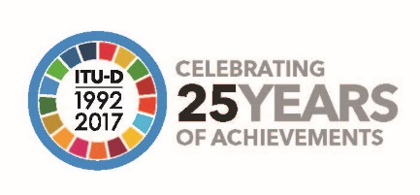
 |  | Document TDAG17-22/1-E
 |  | 20 February 2017
 |  | Original: English
DRAFT AGENDA
- Address by the Secretary-General
- Address by the Director of the Telecommunication Development Bureau
- Opening remarks by the Chairman of TDAG
- Adoption of the agenda and consideration of the Time Management Plan
- Outcomes of WTSA-16 related to the work of ITU-D
- Report on the implementation of the ITU-D Strategic Plan and Operational Plan 2016
- Reports on ITU-D Study Group activities
- ITU-D contribution to the implementation of the WSIS Plan of Action, including the United Nations General Assembly Overall Review and the Sustainable Development Goals
- ITU-D four-year rolling Operational Plan 2018-2021
- Preparations for WTDC-17
  - Update on the preparations for WTDC-17
  - Report of the Regional Preparatory Meetings Coordination Meeting
  - Structure of WTDC-17
  - ITU-D Contribution to the Draft ITU Strategic Plan, including a report by the TDAG Correspondence Group on the Strategic Plan, Operational Plan and Declaration
  - Draft ITU-D Action Plan, including a report by the TDAG Correspondence Group on the Strategic Plan, Operational Plan and Declaration
  - Draft WTDC-17 Declaration, including a report by the TDAG Correspondence Group on the Strategic Plan, Operational Plan and Declaration
  - Working methods and Rules of Procedure of ITU-D (WTDC Resolution 1), including a report by the TDAG Correspondence on Rules of Procedure of ITU-D
  - Streamlining WTDC Resolutions, including a report by the TDAG Correspondence Group on Streamlining WTDC Resolutions
- Collaboration with the other Sectors, including a progress report by the Inter-Sector Coordination Team on Issues of Mutual Interest
- Report of TDAG to WTDC-17 on matters assigned to it by Resolution 24 (Rev. Dubai, 2014)
- Report on the Group on Capacity Building Initiatives (GCBI)
- Report on other ITU-D activities
  - Global Symposium for Regulators (GSR) 2016 and 2017
  - Global ICT Capacity Building Symposium 2016 (CBS-2016)
  - World Telecommunication/ICT Indicators Symposium (WTIS) 2016 and 2017
- Membership, Partnership and Innovation-related matters
- ITU-D 25th Anniversary celebrations
- Calendar of ITU-D events
- Any other business
Brahima Sanou
Director
___________________

