Regional Preparatory Meeting  for WTDC-17 for the Americas (RPM-AMS) | 
Asunción, Paraguay, 22-24 February 2017
 | Document RPM-AMS17/6-E
 | 15 December 2016
 | Original: English
Director, Telecommunication Development Bureau
ICT Trends and Developments in the Americas
Summary:
This document provides an overview of trends and developments in ICT infrastructure, access and use in the Americas, which includes 35 countries and is home to a population of almost one billion people. The document highlights how the ICT sector has continued its remarkable transformation and its impact on society and economic and social growth since the last World Telecommunication Development Conference in 2014 (WTDC-14). It also tracks the evolution of regulation.
Expected results:
Serve as an authoritative reference for shaping the future of ICT development in the Americas.
References:
Data and analysis from the ITU ICT Facts and Figures 2016 (ITU, 2016b), Measuring the Information Society Report 2016 (ITU, 2016a) and Trends in Telecommunication Reform 2015 (ITU, 2015).

Contents
ICT Trends and Developments in the Americas 3
1. Overview of global ICT policies and regulatory trends 3
New players and business models 3
Taking connectivity to the next level: smart devices and network growth 5
Focus on consumers 7
2. Regulatory trends 8
Tracking the evolution of regulation 8
Trends as a result of the evolution of regulation 11
Regulatory trends in the Americas 14
Innovation, business disruption and fifth-generation regulation 19
Quantifying the impact of regulation on ICT uptake 20
3. Overview of ICT developments 22
Mobile market developments 22
Fixed-broadband and international Internet bandwidth 25
Internet access, use, and gender gap 27
4. The ICT Development Index (IDI) 32
IDI 2016 regional analysis 33
The IDI 2016 in the Americas region 37
The Americas: most dynamic countries in the IDI 38
5. Monitoring the price and affordability of ICTs in the Americas region 43
Mobile-cellular prices in the Americas region 43
Fixed-broadband prices in the Americas region 45
Mobile-broadband prices in the Americas region 47
6. Conclusions 49
7. References 51

ICT Trends and Developments in the Americas

Overview of global ICT policies and regulatory trends
Since the last World Telecommunications Development Conference (WTDC), the ICT sector has continued its remarkable transformation, and its impact on society and economic and social development has become even more obvious. The growing adoption of broadband-enabled mobile devices has made access to the digital world more ubiquitous and pervasive. A truly networked society will lead to even more changes, with new behaviors, opportunities, and challenges. Broadband and ICTs have a unique potential to support countries to meet the achievement of the 17 Sustainable Development Goals that will rely heavily on the digital ecosystem since there is an ever-expanding variety of services and applications to serve our social, business and entertainment needs. However, fulfilling this potential needs continued investments in the necessary networks and services to expand access to broadband for all.
As the ICT sector is recognized as a critical backbone of socio-economic development, it is facing changes, from the transition in technologies, to the emergence of new players, the displacement of revenues, and changes in business models. Technological growth has also expanded the capability of ICT use across sectors, and this is being recognized and harnessed by businesses, policy makers and regulators in relation to health, education, agriculture, governance, finance, disaster management or even smart cities. It is important that the interaction of the ICT sector for stimulating growth in the digital economy alongside other sectors be understood and, wherever possible, managed by policy and regulatory frameworks that take this reality into consideration.

New players and business models
The prospect of constant connectivity and complex interconnection of devices is shaping business models. Despite tremendous growth in connectivity, 3.9 billion people – 53 percent of the world’s population – will still be offline at the end of 2016. This presents a challenge as well as an opportunity as new players are entering the market, including to bring the remaining unconnected online.
Providers of telecommunications services are moving fast, investing in future systems, and exploring new commercial opportunities with other industry sectors as they try to find their place in a new ecosystem that demands flexibility to meet changing demands. Increasingly, new classes of companies (not just those previously thought of as “technology” companies) are developing new capabilities and developing innovative products and services that rely on new connectivity and data services. This is also reshaping the regulatory landscape.
The ICT industry has moved from distinct infrastructure platforms and connected devices to an interconnected ecosystem of computing, the cloud, which changes the traditional rules of the game. The cloud is enabling new innovations across society and the economy, at all levels, for everyone. Everything becomes a computing device, a connected device – be it a car, a fridge, or a pair of glasses. This new dimension of connectivity opens the way to almost unlimited possibilities. Apps and m-services are empowering citizens to innovate and engage in all aspects of life irrespective of time, distance and location. However, at the same time there are questions relating to the protection of personal data and trust in general.
In this digital environment, huge amounts of data are created every minute. The explosive growth of data combined with the demand for data – the new oil of the economy as some have called it – is reshaping the ICT industry opening up a wealth of new opportunities to innovate, do things better, faster, more widely or in a completely new way. For consumers, a new set of interactions is ruling user experiences and creating new efficiencies. New opportunities are arising for governments, business players, and consumers alike, with new challenges for ICT regulators given the additional challenges for infrastructure development. New skills, new thinking, and a different set of policy tools are part of the strategy needed to leverage the digital transformation and enable innovation and investment. This needs to be balanced with the need to maintain trust in such opportunities.
Over recent years, technological advances have democratized ICTs moving from a time where mainframes and PCs were the exclusive use of a group of qualified professionals to a society where many more people can use multiple screens and devices; where cars and objects can be connected and communicate; where cities are increasingly becoming smart; and where cognitive computing and artificial intelligence will soon be turned into full-fledged reality (see Figure 1.1). Technology has moved from being uncommon and difficult to use to being pervasive, intuitive, and more user-friendly. Digitization has accelerated technological developments over the last two decades.
Figure 1.1: History of the future
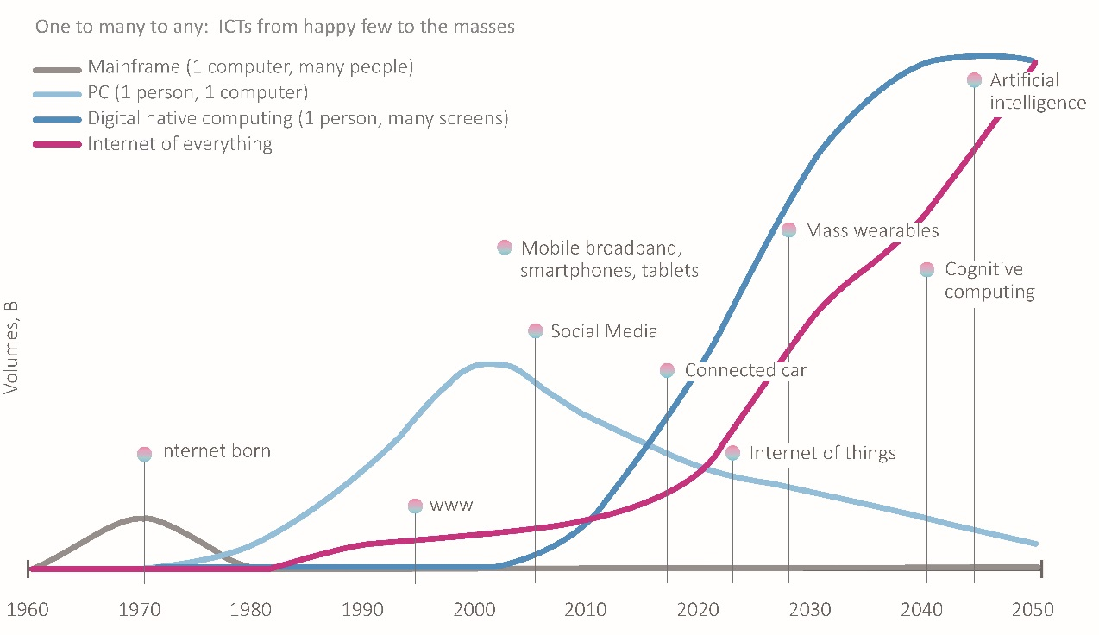
Source: ITU.
The Internet, including through the cloud, has intimately invaded all spheres of people’s lives, changing economic, social and cultural patterns, and has become a fundamental enabler of progress across the economy. What will be next? Some of the exciting future innovations such as wearables and artificial intelligence are nascent, and have yet to prove their full potential. Other, even more revolutionary innovations are probably not even on today’s radars yet.
Shaping the history of the digital future needs an understanding of past and present phenomena, as past innovations become the normal standards and are sometimes reinvented in a new way to fulfil people’s continuing need to communicate, create and innovate.

Taking connectivity to the next level: smart devices and network growth
Information and communication technologies are advancing in three key areas: new platforms for the delivery of broadband and connectivity services are enabling new services and the possibility of being always connected; new network architectures and complementary technologies are increasing the capabilities of platforms and Internet-based services; and new applications of these advances are transforming consumer demand, available services, and private-sector business models.
Recent advances in technology are transforming delivery platforms, the way that they use spectrum and the services they can provide. Traditional players and some new classes of operators are moving quickly to develop new types of services, especially internet based services.
Satellite communications form part of the Internet connectivity ecosystem, and are used to support commercial and consumer data services, such as through VSATs, residential and commercial broadband services, and M2M/IoT connections. Satellite communications are used particularly in remote and rural areas and to complement terrestrial networks by increasing resiliency, ubiquity, and capacity. The satellite sector is also seeing new operator and manufacturing entrants, and competitive pressures from other access technologies such as high-altitude drones or balloons aiming to provide Internet services to remote and rural areas.
While initial trials are underway, there is still a long way to go before 5G becomes a reality. The World Radiocommunication Conference 2015 (WRC-15) defined the technical specifications for the adoption of global standards on 5G with the International Mobile Telecommunications 2020 (IMT-2020) system. Some see 5G as having the potential to completely change the way we interact with connected devices and how everything, in turn, is linked to IoTs, while others view these technologies as the consolidation of the existing generations of mobile telephony and the next iteration of cellular networks services based on much greater coverage and always-on reliability.
Whatever changes 5G will bring along, mobile broadband will continue to play a complementary role alongside fixed broadband in some markets, but may increasingly dominate over fixed broadband in other markets. However, it is clear that fixed technologies will still continue to play a vital role in providing backhaul networks. The integration of fixed and wireless networks is further exemplified with the increasing offload of mobile data traffic onto fixed networks, with Cisco estimating that, globally, 51 percent of total mobile data traffic was offloaded onto the fixed network through Wi-Fi or femtocell in 2015. In total, 3.9 exabytes of mobile data traffic were offloaded onto the fixed network each month. Satellite communications also offer ‘universal’ broadband services rapidly to large numbers of people instantaneously, and can be deployed rapidly without large investments in terrestrial infrastructure.
In terms of value, it is forecasted that the total value of the global fixed broadband market will grow at 3 per cent CAGR to reach USD 276 billion by 2019. Mobile operators are continuing to focus on generating a return on investment from their 3G and 4G networks by developing new services and pricing packages to make more efficient use of their networks. 4G is growing rapidly in many countries, with an industry association expecting 4G network infrastructure to account for much of the USD1.7 trillion which mobile operators will have invested from 2015-2020. 2015 is likely to prove a ‘cusp year’, as growth in 3G starts to slow, while growth in 4G subscriptions accelerates further. Some 480 LTE networks had been commercially launched in 157 countries around the world by the end of 2015.
The ICT industry is also developing new ways of building networks to accommodate increased demands for data – some that centralize resources in order to attain economies of scale, others that distribute resources to the edges of networks so as to respond more flexibly to changing needs. These innovations are also emerging in part because of the increasing role that software is assuming relative to hardware in network technologies. Nearly all the major players are now investing heavily to capitalize on recent rapid developments in broadband technology, with 4G mobile, VDSL vectoring, DOCSIS 3.0 and FTTx technologies all offering significantly higher speeds. Technologies such as Network Functions Virtualization (NFV), Software-Defined Networking (SDN) and heterogeneous networks (HetNets) are already being deployed by operators and will continue to enable the move towards the hyper-connected society, alongside imminent developments in 5G.
It is not just the humans who are getting connected, things are also becoming smart. Sensors are deployed in a number of places to quantify (measure) almost anything from human, animals to machine activities. The Internet of Things (IoT), which connects many things to the Internet, and Machine to Machine (M2M) communications through cellular mobile networks are predicted to become the fastest-growing parts of the industry in terms of traffic. Many analysts agree that the Internet of Things (IoT) is now coming of age, and foresee strong growth in the IoT, which will also put additional pressure on infrastructure development and spectrum resources.
The global wearables market is estimated to have grown by 172 percent in 2015. Fitbit, Apple and Co. shipped a total of 78.1 million devices in the past year, up from 28.8 million in 2014. One billion wireless IoT devices were to be shipped in 2015, up 60 per cent from 2014 figures, and resulting in an installed base of 2.8 billion connected devices by the end of 2015. 25 billion networked devices are predicted to be connected by 2020, driven largely by consumer connected things (including businesses, hospitals, local authorities and other entities) and followed by manufacturing, utilities and transportation, transforming the concept of the Internet and the connected society irreversibly. In terms of revenues, the market for IoT is expected to grow to USD 1.7 trillion by 2019 to become the largest device market worldwide.
Looking at devices, the tablet market has been in decline since the beginning of 2015. Total shipments for 2015 were 206.8 million, down -10.1 percent from 230.1 million in 2014. Likewise, global shipments of PCs and laptop totaled 276.2 million units in 2015, a year-on-year decline of -10.4 percent. The prospects for 2016 are brighter though, with detachable tablet expected to boost volumes to a modest 1-2 percent growth. Turning to smartphones, in 2015, smartphone sales reached 1.4 billion units, an increase of 14.4 percent from 2014. The volume has exceeded the sales of the PC, television, tablets and game console sectors combined in terms of both units and revenues. The growing adoption of smartphones means that, for many consumers in developing markets, their first-hand experience of the Internet will likely be via a smartphone. Added to that, with the growth of low-cost smartphones mobile and smartphone sales are expected to grow in the next five years, in particular in developing countries, where many consumers still remain unconnected.
In mature markets, vendors rely mainly on replacement of handsets rather than sales to first-time users. As mobile devices proliferate, analysts predict a shift in focus towards serving the needs of users in diverse contexts and environments, rather than the features and functionality of devices in isolation. And going forward, phones and wearable devices will form part of an expanding computing environment (including consumer electronics and connected screens). It is therefore not surprising that global smartphone traffic is expected to increase tenfold by 2019 to reach 18.24 exabytes per month up from 1.74, with video representing a significant part of the traffic.
Mobility, always-on access, and broadband-enabled devices have irreversibly changed consumers’ social and economic behaviours. The proliferation of apps developed to respond to consumers’ increasing needs to interact, communicate and share information online, are turning consumers into digital social consumers, digital communicators and prime agents of change in the digital transformation that is sweeping the sector. In January 2016, the number of global social media active accounts reached over 2.307 billion, with active mobile social accounts representing 85 per cent. With active social media users spending an average of nearly 3 hours and 13 minutes per day on social media, the economic impact of the time spent on social media, even though indicative, is not to be neglected, with users providing a wealth of valuable data. The impact of social networks and multi-platform apps (providing access to a multitude of services from one platform) are raising expectations from many businesses and market players seeing new commercial opportunities in these platforms (including big data analytics and advertising). The blurring lines between the physical and digital world is clearly opening a window of new economic opportunities, but also raising a host of new social questions.

Focus on consumers
The digital economy has clearly raised many new exciting opportunities, but also challenges that require increased attention from a regulatory perspective. Consumers are presented with new opportunities brought about by the greater choice of devices, online services and applications. Identifying pro-active policy and regulatory measures in addition to co-regulatory and self-regulatory solutions and initiatives geared towards educating and empowering consumers is essential to provide the framework to enable investment and innovation while at the same time protect the rights of all users in an open, transparent and inclusive digital world. Regulators participating in the 2014 ITU Global Symposium for Regulators (GSR-14) identified and endorsed a set of regulatory best practice guidelines to protect consumer interests, while also ensuring a level-playing field for traditional and new market players by fostering a light touch regulatory approach. Regulators recognized that the rights of all stakeholders must be balanced to ensure that both consumers and businesses benefit from digital opportunities.

Regulatory trends
Communication networks and services have become more efficient with the use of digital technologies and have enabled the emergence of smart cities, smart nations and smart societies. This has benefitted people, businesses and government.
ICT policies and regulations have a crucial role to play to create an enabling environment to bridge the digital divide. The disruption of the ICT sector is putting ICT regulators and policy makers under pressure to continuously review, adapt and anticipate changes to ensure that their national ICT regulatory framework remains relevant.
In building smart connected societies and seeking to achieve the Sustainable Development Goals, policy makers and regulators together with all stakeholders face similar concerns requiring common solutions. There is a need to work together to create an enabling regulatory environment across the sectors and remove the barriers that hinder progress. Adopting more flexible and inclusive policy and regulatory frameworks and holding inclusive dialogues with relevant stakeholders to fully embrace the potential of the digital economy remains more critical than ever.
Regulators and policy makers also need to strengthen their enforcement powers to respond to the challenges of the dynamic digital environment. Sector reform is an ongoing process promoting social and economic development in the ICT sector and beyond through best-practice regulation.
Furthermore, the development of the global digital connected society requires trust and security, based on sound regulation of the use of personal data. Cultural and conceptual differences between countries on the issues of privacy and data have not allowed to shape a global regulatory framework. A way forward can be the global acceptance of a broad human rights-based concept of data protection that states must apply to everyone affected by their actions, irrespective of nationality or legal status or the place where they live. The global digital connected society can only develop in and between states that accept this fundamental principle.

Tracking the evolution of regulation
The dawn of the global digital economy has opened the way to a ladder of regulation or five generations of ICT regulation. In response to market and technology developments, policy-makers and regulators face ever louder calls to ensure access to digital infrastructures, so that consumers and societies can be empowered and ICTs can be fully leveraged to achieve SDGs. Broadband networks and internet services are increasingly viewed as a commodity – while access to them has even become a right in some countries – their availability and performance impact every aspect of the development of the economy and society today.
The interaction of the ICT sector for stimulating growth in the digital economy alongside other sectors needs to be understood and, wherever possible, managed by policy and regulatory frameworks of a new kind. To shape these, however, it is essential to have a clear understanding of the complex relationships between regulatory policies and ICT growth. It is also important to quantify recent trends and learn from successful past experiences.
To do so, ITU has developed the ICT Regulatory Tracker, an evidence-based tool to help decision-makers and regulators to make sense of the rapid evolution of the ICT sector regulation. More than a look back, the Tracker, a powerful analytical tool, helps pinpoint the strengths and weaknesses of regulatory interventions to provide a learning curve for achieving a vibrant and innovative ICT sector (see Box 1.1).
Box 1.1: Making sense of regulatory trends: the ITU Regulatory Tracker
ITU has built a new tool to monitor and measure the changes taking place in the telecommunication/ICT regulatory environment. Using quantitative methods and data gathered through the annual ITU World Telecommunications/ICT Regulatory Survey, the Tracker makes both benchmarking and the identification of trends in legal and regulatory frameworks in the ICT sector possible. The countries included in the Tracker are split into score thresholds that relate to generations of regulation to help analyse the evolution of ICT regulation worldwide and its future perspectives.
The Tracker covers up to 156 countries out of the 193 ITU Member States or the period from 2003 through 2013, showcasing progress within the same country, amongst countries and regions as well as worldwide. The full set (50 indicators) is available for the period 2007-2013, and will be updated annually. It is built on self-reported data gathered yearly via ITU’s World Telecommunication Regulatory Survey and on compiled desktop research.
The Tracker was established by assessing the various dimensions of the regulatory environment: the regulatory authority itself; which segments and services that are regulated; the scope and direction of the regulations; and the enabling of a competitive environment. A variety of traditional and new regulatory matters is included, in four clusters: the regulatory authority, regulatory mandates, the regulatory regime and competition framework in the ICT sector (see Table 1.1 below).
Table 1.1: ICT Regulatory Tracker summary structure (full set), 2007-2013
Cluster | Name | Nb indicators | Max score | Min number of indicators for countries to be ranked
1 | Regulatory authority | 10 | 20 | 3
2 | Regulatory mandates | 11 | 22 | 3
3 | Regulatory regime | 15 | 30 | 4
4 | Competition framework | 14 | 28 | 4
Totals | ICT Regulatory Tracker | 50 | 100 | 14
Note: For the full set of indicators, see the technical notes in Trends in Telecommunication Reform 2015, Chapter 1

The assessment made by the Tracker is of both qualitative and quantitative order. All indicators have been scored between 0 and 2. The reference for the scoring is what is considered the best possible scenario-based on the internationally recognized regulatory best practices adopted by the global community of regulators at the annual ITU Global Symposium for Regulators.
Monopoly, private or publically-owned and managed utilities, were overseen by first generation regulations with the intent to encourage improvements in efficiency and service – in effect regulations simulated competition. With part privatization and licensing of competing infrastructure the second generation of regulations focused on ensuring the incumbent made its infrastructure available in a nondiscriminatory manner, often under pressure to look after the interests of Government shareholdings. With full privatization and a move towards service rather than infrastructure competition the independent third generation of regulations focused on net neutrality requiring protection of sustainable competition in services and with the growth in content delivery, an increased need for consumer protection arose (see Figure 1.2).

Figure 1.2: Generations of regulation
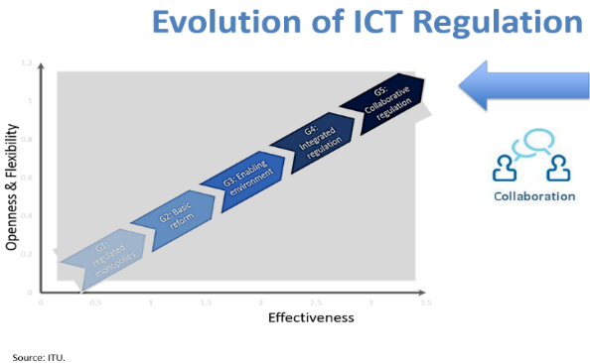  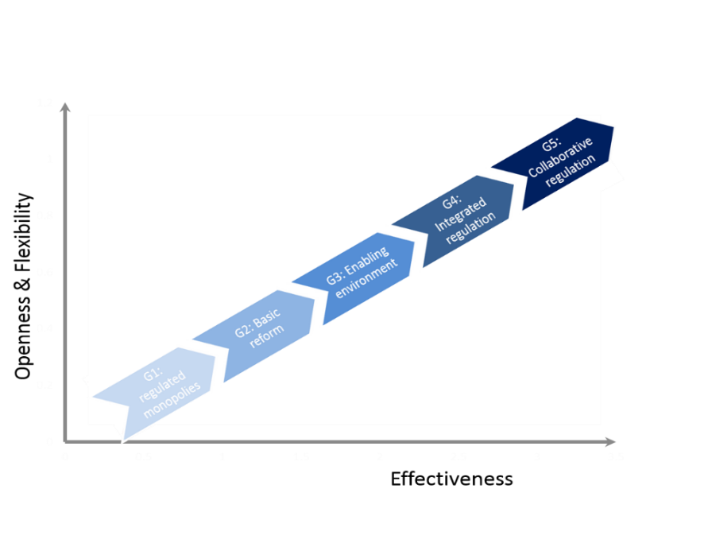 | G1: Regulated public monopolies without an independent regulator  G2: Basic reform, including the creation of separate regulatory bodies, partial liberalization and privatization across the layers  G3: Regulation for enabling investment, innovation and access, with focus on stimulating competition  G4: Integrated regulation, with an evolving role of the regulator as a partner for development and social inclusion  G5: Collaborative regulation, with the need to define the foundation, platforms and mechanisms for working with other sector regulators to help achieve the Sustainable Development Goals
Source: ITU.
Greater complexity and a cross-sectoral view, expanding beyond ICTs, are some of the main features of fourth-generation regulation, leading to fifth generation collaborative regulation. Market and technology developments have stimulated a move to fourth generation regulators to tackle a different challenge – a challenge of regulatory purpose. Fourth-generation regulation characterized by agility and flexibility has been rapidly gaining momentum over the past decade. One out of four surveyed countries now enjoys a fourth-generation regulatory environment that allows for leveraging on the ICT sector to achieve economic growth and social development across the economy (see Figure 1.3). Not all of those countries have yet fully realized digital opportunities; however, they have opened a way to meaningful change and can expect tangible improvement of their ICT sectors as well as the entire economy over the short- to medium-term.
Figure 1.3: Evolution in ICT Regulation, 2007-2015
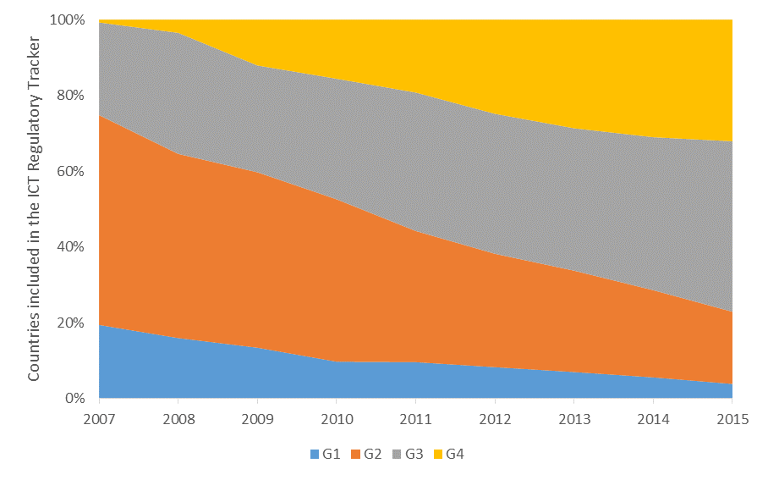 | Legend:  (ICT Tracker score points)  1st generation >=0 <40  2nd generation >=40 <70  3rd generation >=70 <85  4th generation >=85 <=100
Source: ITU.
Overall, the regulatory environment is steadily enhanced in the great majority of countries worldwide, as countries have been gradually transitioning to higher generations of regulation. The number of countries in the first- and second-generation categories of regulation has been cut by half in less than a decade, going from two-thirds to less than one-third of countries. This positive outlook reflects the dynamic pace of technological and business innovation faced by telecom/ICT regulators, a reality that challenges them to adapt to the new digital world order.
We stand at the edge of fifth-generation regulation which builds on complementarity and synergies. Fifth-generation regulation is about cross-sectoral collaboration along with innovative regulatory approaches such as co-regulation and self-regulation, leading to new forms of collaborative regulation.

Trends as a result of the evolution of regulation
But what does the evolution of regulation mean, in real terms?
Looking closely at trends in regulatory evolution across different regions, it is evident that there are different tiers and speeds of regulatory development. Beginning from a largely unfavorable regulatory setting in 2008, which was dominated by second-generation regulation, Arab States has achieved a great leap forward. Asia-Pacific countries and Africa have followed a similar pattern over the same period, swiftly moving to higher generations of regulation. One out of five Arab States belongs today to the fourth generation of ICT regulation. CIS countries have evolved at a slower pace and in 2015 counts, roughly as many countries with first and second-generation regulation as with third and fourth (see Figure 1.5).
Europe has been the cradle of the fourth generation of regulation and not surprisingly, not only the transition has started earlier, but is has also been achieved much faster that in the other regions, with Europe counting two thirds of countries in the fourth-generation of regulation versus only 10 per cent of countries with either first or second generation. The overall level of regulatory maturity in the Americas was already higher than the other developing regions back in 2008 and the region remains the second most advanced worldwide in 2015, with two-thirds of countries with over third- and fourth-generation regulation (see Figure 1.5). Overall, the pace of regulatory change has been sustained and compared to other sectors of the economy, change has been happening more swiftly, raising expectations to ICT regulators and opening way to ever more impressive technologies and business models.
Talking about evolution, not all areas of ICT regulation have been evolving at the same pace. Quantitative mapping of key areas of regulation allows for tracking trends across the board (see Figure 1.6). Competition in end-user broadband markets, undoubtedly one of the most powerful boosters of connectivity and use of digital services, has been steadily expanding over the past decade, ruling over 128 markets in 2015. Infrastructure sharing has been gaining momentum, in particular in the aftermath of the global financial crisis of 2008, enabling the leveraging of established facilities to drive service innovation and diversify revenues. Licensing of operators and service providers has gone a long way since the advent of fixed and mobile broadband. The liberalization of licensing regimes has facilitated a crowded ICT market place today – from service-specific individual licences to multi-service and class licences to general authorizations.

Figure 1.5: Every region is different: improving regulatory patterns, 2008-2015
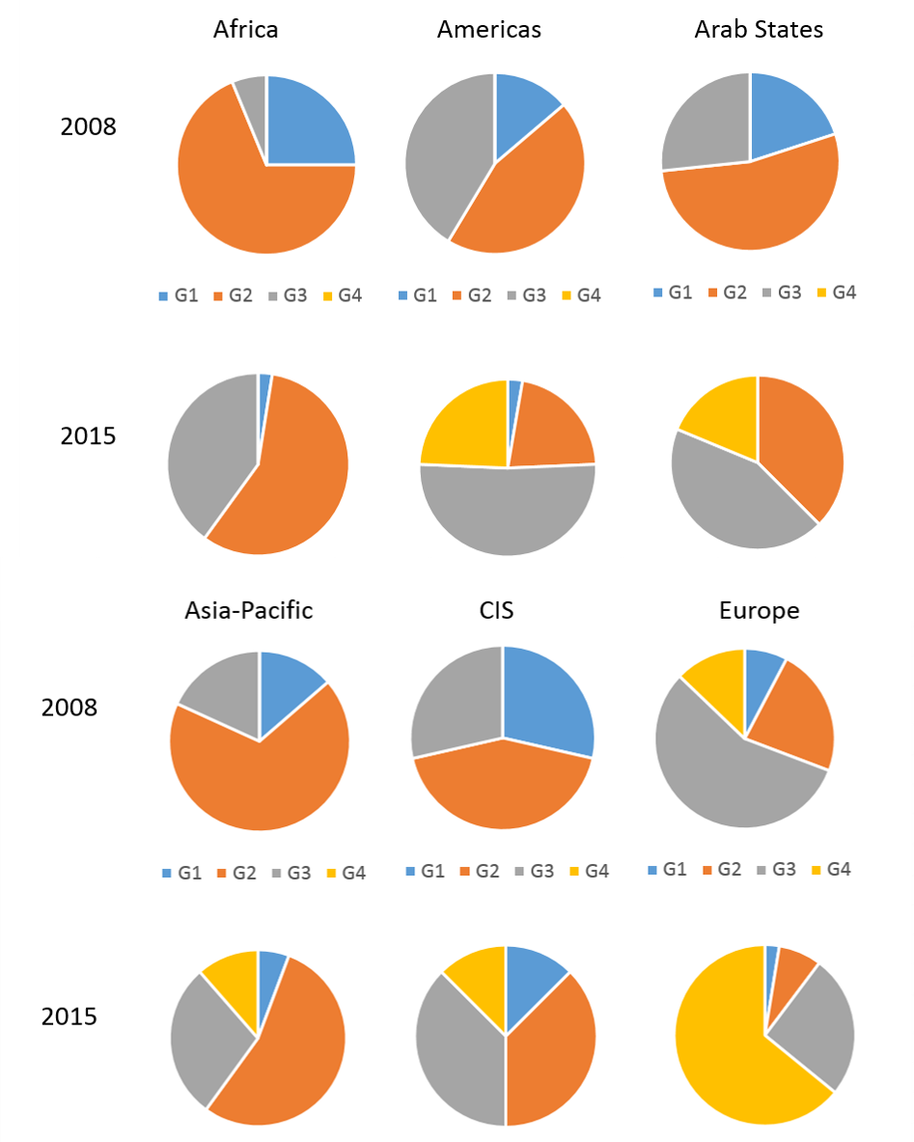
Source: ITU.
Some of the first converged digital services that used to be the privilege of the few users with broadband connection a decade ago have been widely democratized. Voice-over-IP (VoIP) has grown into one of the most popular free services. Regulation, or more accurately, the removal of regulatory barriers, has been an important facilitator. Other regulatory practices have experienced slower adoption and remain limited to relatively fewer jurisdictions. With spectrum trading or net neutrality, however, such practices can have a significant impact on the development of national markets. Last but not least, new policy instruments have also come of age, since new issues may need to be addressed in new ways. National broadband plans and related policies which mainly came to prominence after the 2008 global financial crisis as a means of channeling stimulus funding, have now widespread in 143 countries and are being used to reconnect economic sectors to improve efficiencies and create new business opportunities.

Figure 1.6: Screening regulatory practices: which regulations have shaped the ICT sector? 2005-2015
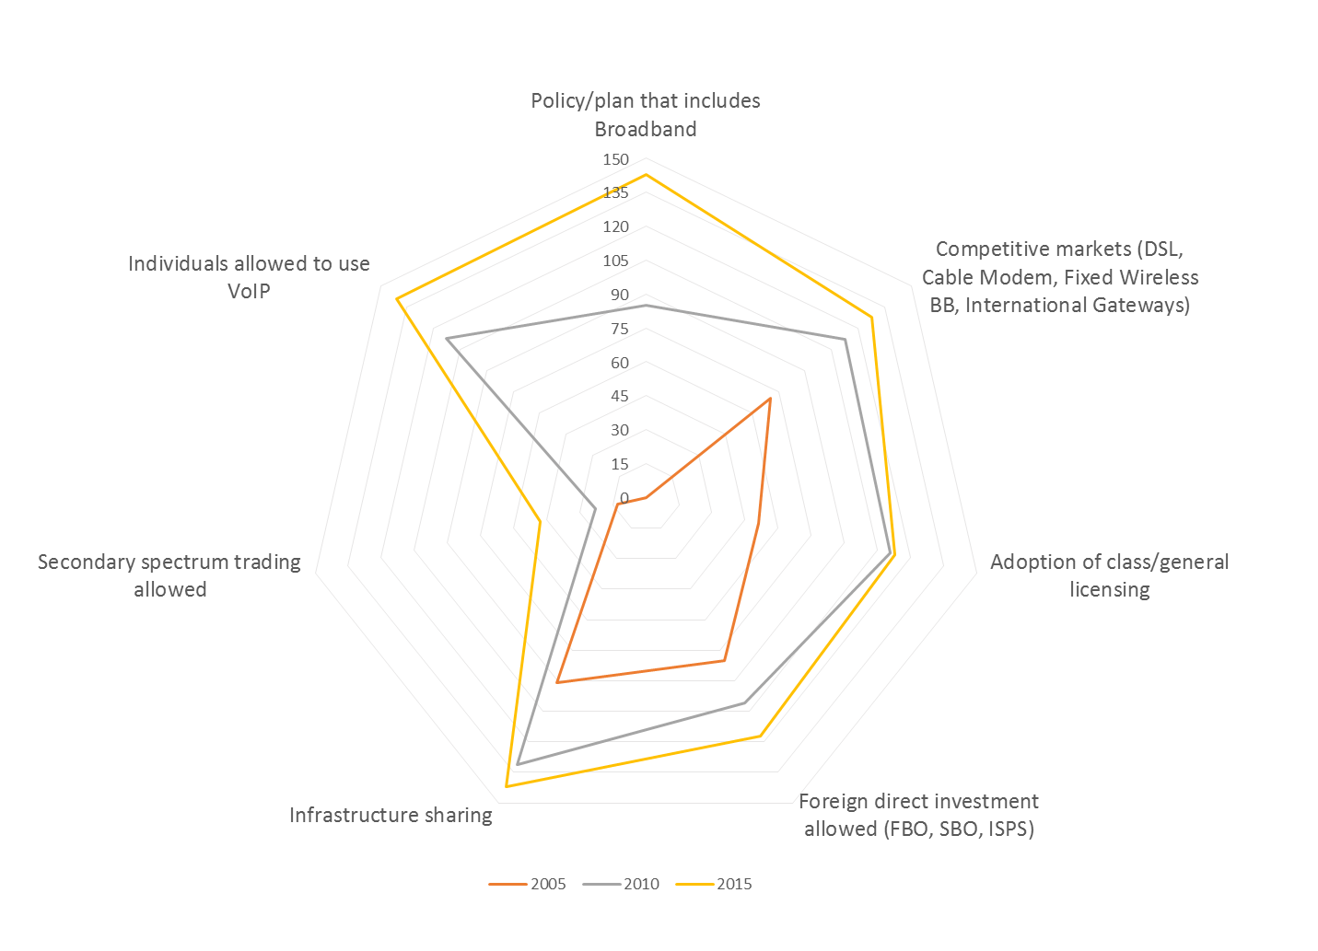
Source: ITU.
Box 1.2: Winning formulas for fixed and mobile broadband markets
It is widely recognized that the quality of regulation is a key success factor to the development of vibrant digital economies. Based on evidence produced with the ICT Regulatory Tracker, the choice of regulatory intervention(s) appears to have an equally strong impact on stirring up market growth.
More precisely, the combination of a handful of regulatory measures is closely associated with a catalytic effect on market take-up. With respect to mobile-broadband penetration, countries with a broadband plan, competition in both the mobile sector and international gateways, infrastructure sharing, mobile number portability and band migration, systematically outperform countries lacking some or all of those regulatory settings.
As of the end of 2013, countries having applied this “winning formula” to their mobile broadband markets had an average national penetration rate of close to 60 per cent compared to a world average of 27 per cent, or more than twice lower. In the short-term, these measures seem to have had a booster effect associated with the trebling of mobile-broadband penetrations (since 2011), an effect which tends to slow down slightly over the medium-term and, potentially, the long-term. In a similar way, fixed broadband markets seem to have their “winning formula”, too.
The top-five measures on record are a Broadband Plan, open competition in wireline broadband technologies, an advanced licensing framework (featuring either unified licenses or a general authorization regime) combined with an infrastructure sharing policy and provisions for fixed number portability.
Countries which have realized the potential of those regulatory pillars are associated with consistent performance above the curve, achieving, on average, fixed broadband penetrations 13 to 16 per cent higher than the global average.
Within reasonable limitations, this quantitative evidence suggests that best-practice regulation does matter and both the design and the effective enforcement of regulatory frameworks are essential for broadband markets to thrive. The ICT Regulatory Tracker can serve as a sound benchmarking tool for a range of regulatory cases.
Source: ITU.

Regulatory trends in the Americas
In the Americas region, 33 countries out of the 35 (or 94 per cent) have established a Telecommunication/ICT regulatory Authority (see Chart 1.7). The great majority of them or over 80 per cent have today the power to enforce pro-competitive regulatory decisions, compared to two thirds of them 10 years ago. This very positive trend witnesses the ever more important role of regulators in the digital era, which are expected to juggle competing interests, ensure a level playing field, promote transparency and create an environment that nurtures the technological and service innovation.

Figure 1.7: Countries with a separate regulator, by region, 2015
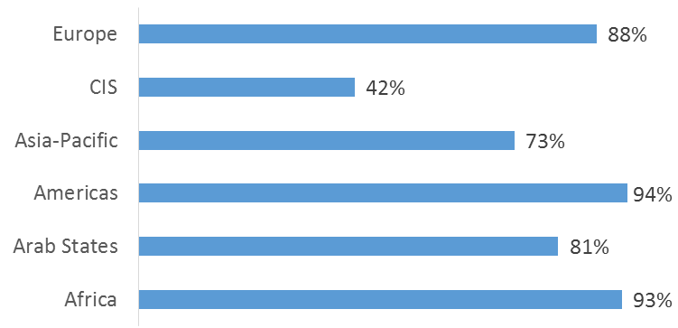
Source: ITU.
From the outset, the mainstay of regulators in the Americas, like in other parts of the world, has been regulating access to telecommunication networks (including interconnection, licensing, quality of service monitoring, etc.) and prices of services. More recently, they have been called upon to pursue public policy objectives, such as universal ICT access or service. Two thirds of regulators in the Americas have also been empowered to deal with spectrum issues, such as allocation and assignment. More recently and increasingly, they have been tasked with overseeing adjacent areas such as cybersecurity and consumer protection.
Figure 1.8: Evolving mandate of the regulator in the Americas, 2010-2015

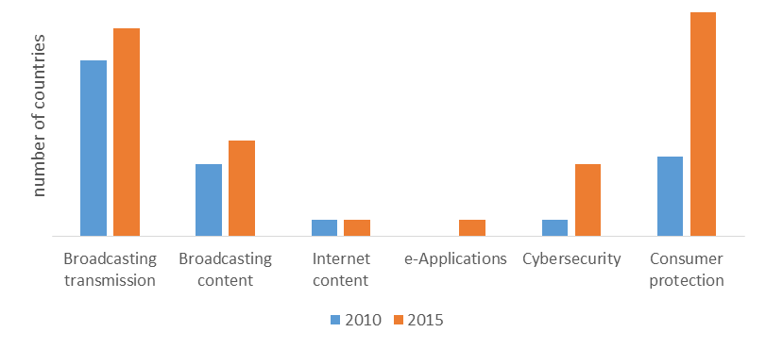
Source: ITU.
At the global level, there has been an outstanding trend towards expanding and diversifying the mandate of the regulator. This is very much linked to the technological transformation that has taken place in the sector with the move towards IP-based networks, and the opportunities as well as the complexity it brings about. Rather than dumb pipes, broadband networks are today considered to deliver the lifeblood for the digital economy and society as a whole in the form of services, applications and content. Issues of electronic content, security and data protection as well as, ultimately, full-fledged consumer protection, have become key challenges for the healthy development of both networks and services, and require regulatory attention. The mandate of regulators in the Americas has thus also evolved over the past 5 years or so (see chart 1.8).
Like their fellow regulators in the other regions, regulators in the Americas share the belief that enhanced competition will allow for more abundant investment and boost the ICT development in the region. Competition in ICT services is the norm in the region, although one fifth of countries in the Americas still maintain monopolies in local and long distance fixed-line services as well as in the DSL market (see chart 1.9 below). One key challenge for many regulators in the Americas is to further develop their regulatory frameworks to ensure more incentives are available for investors in both new networks and new services.
Figure 1.9: Competitiveness of selected ICT market segments, Americas, 2015
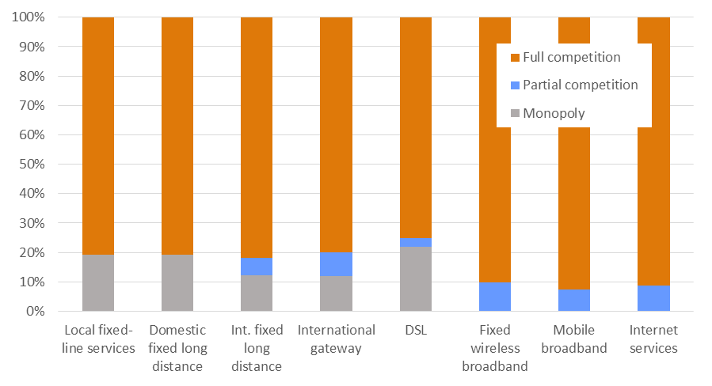
Source: ITU Telecommunications/ICT Regulatory Database.
Efforts that have been made over the past 10 years to liberalize international gateways in a majority of countries in the region have proved successful and only around 10 percent of national gateways remain under a monopoly controlled by the fixed line incumbent (see Figures 1.9). As a result, broadband growth across the region has been strong, also allowing developing countries to develop new services and employment opportunities. Moreover, foreign investors’ interest in the majority of countries in the region has remained high thanks to the enabling environment for new entrants.
Internet services in particular, like in other regions, have been very competitive. There are virtually no monopolies today in fixed wireless broadband, mobile broadband and ISP services in the Americas region. Traditionally, there has been a preference for deploying full competition rather than partial – which has significantly contributed to the fast growth of both new services and the number of subscribers.
The adoption of simplified licensing regime encompasses further regulatory and institutional measures undertaken by governments to reform the sector. Some countries have eased their market entry processes by simplifying their licensing regime. Belize and Costa Rica have adopted a unified licensing regime while Jamaica and Venezuela have introduced multi-service licences. Antigua and Barbuda, Bahamas and Colombia have been applying a converged licensing framework with general authorization regime. Service-specific individual licences remain though the norm in most countries in the Americas. Building up a sound licensing framework has been essential to support the development of convergent services and the expansion of markets and competition, with the objective of promoting the provision of new and innovative services, the reduction of prices and an increase of efficiency in the provision of services, as well as increasing the variety of offerings for subscribers.
Figure 1.10: Submarine cables connecting the Americas, 2015
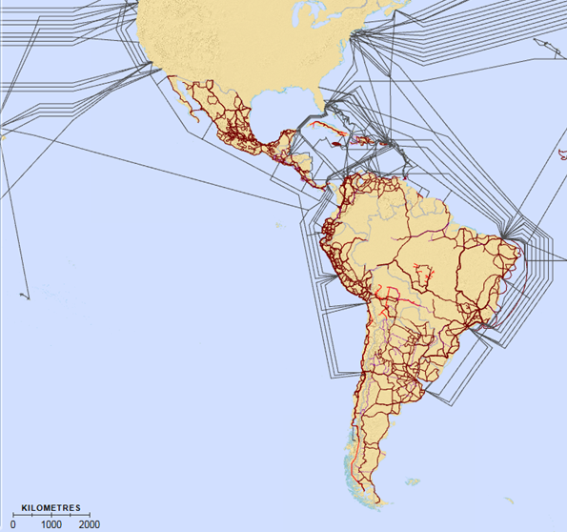
Source: ITU and Telegeography, http://www.itu.int/itu-d/tnd-map-public/ (work in progress).
Over the last five years, additional international submarine cables were deployed throughout the region, increasing the options for international high speed connectivity between the various costs of the Americas region and the rest of the world (see Figure 1.10), thereby further reducing the costs of international bandwidth through the availability of competitive offers. The challenge now is to ensure these cable landing stations are further connected to domestic broadband backbone networks.
The cost of network deployment at the national level, and in particular next generation networks, remains a challenge across Latin America and the Caribbean. To bring these down and to capitalize on the investments made, around one third of countries in the region have mandated passive infrastructure sharing and half of all countries permit mobile virtual network operators (MVNOs) in their markets, respectively in line with world average level of regulation in these areas (see Figure 1.11). Collocation or site sharing are mandated, however, in only one fifth of countries, this number being considerably lower than the world average.
Figure 1.11: Infrastructure sharing, Americas and the world, 2015
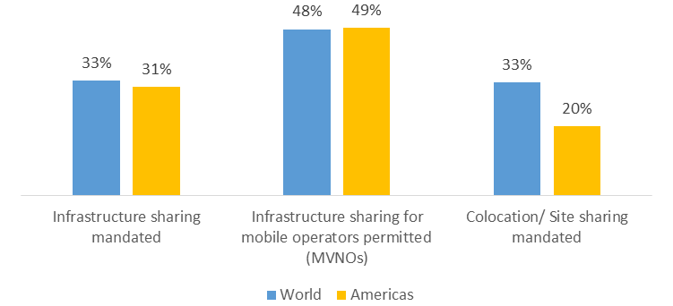
Source: ITU Telecommunications/ICT Regulatory Database.
To respond to the growing demand for spectrum, almost one third of ICT regulators in the Americas have introduced secondary spectrum trading. Further 15 percent of countries have adopted some form of market based mechanisms by allowing in-band migration. Operators were assigned spectrum for mobile broadband services in the majority of the countries in the region. Spectrum for WiMax services was assigned in a third of the countries and the service has been commercially available in most of them. Spectrum for LTE services was assigned and made available in eight countries, including Brazil, Canada and Peru.
Acknowledging the key role broadband plays in today’s digital economy, 23 countries in the region or 66 percent have adopted or are planning to adopt a national policy, strategy or plan to promote broadband (see Figure 1.12). Nationwide broadband infrastructure built-out ranks high as a goal within these plans, along with demand stimulation, through the adoption of online services and applications and the provision of public services using broadband. In addition, at least seven countries in the Americas include broadband as part of their universal service definition. With 21 countries in the region having an operational Universal Service Fund (USF), the Americas is the region with the highest USF ratio at over 60 percent. However, only two of these funds, in Peru and the United States, are either partly or wholly used to finance the national broadband band plan. In addition to direct government funding, public-private partnerships have been identified as of the main means of financing these plans.
For citizens in Latin America and the Caribbean to benefit from accessing the digital society, more needs to be done to develop and extend national broadband backbones and extend broadband access at the local level (likely through wireless) to connect the unconnected and reduce connectivity costs. Further sector reforms are indeed needed to increase penetration levels, in particular in terms of broadband and Internet uptake.
Figure 1.12: Broadband plans, by region, 2015
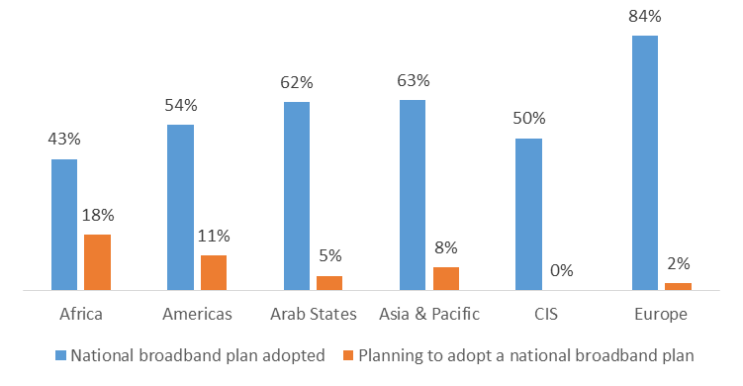
Source: ITU World Telecommunication/ICT Regulatory Database.
Overall, the gradual sector reform across the Americas region and the evolution of ICT regulation have had a positive impact on market developments. Looking back to 2008, more than two thirds of countries were either in the first or the second generation of ICT regulation (see Figure 1.13, left chart), only having a limited impact on the penetration of key ICT services. In 2015, however, over two thirds of countries in the region have joined the bandwagon of the third or even fourth generation of regulation. A small minority of countries are still under the first generation while many have successfully transited to second or third generation over the past seven years. The impact on the ICT access have been remarkable. As a result of the evolution of ICT regulation, the symbolic mark of 25 percent in penetration of major ICT services has been passed in a number of countries. Virtually in all countries in the Americas, everyone had daily access to mobile cellular services in 2015. In addition, in over 80 percent of countries at least a quarter of the population also had access to mobile broadband services and has been using the Internet (see Figure 1.13, right chart).
Figure 1.13: The evoluiton of ICT regulation as a lever of growth in access to ICTs in the Americas, 2008 and 2015
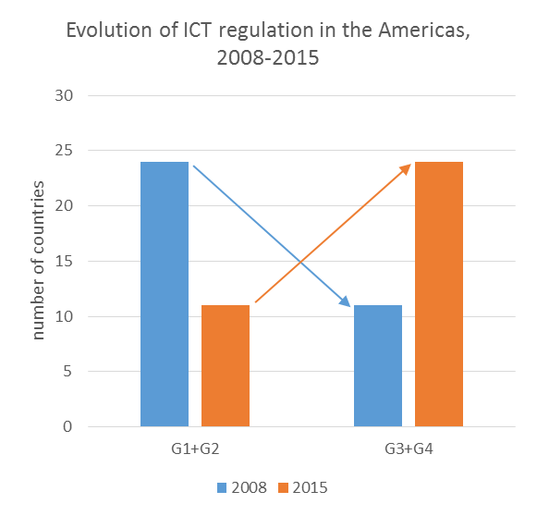 | 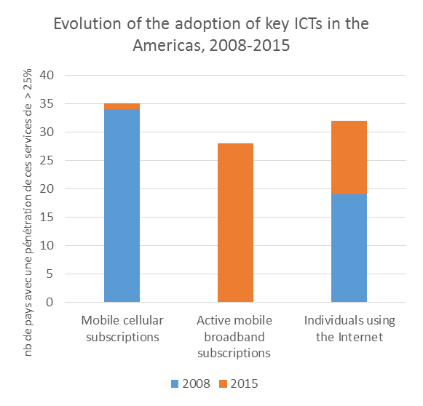
Source: ITU.

Innovation, business disruption and fifth-generation regulation
Like in the ICT sector, policy and regulatory frameworks have evolved independently in many economic sectors over the past decade. As mentioned above, recognition has grown that there is an increasing interdependence between sectors. Technologic innovation and new business models are enabling effective global, regional and local development. The benefits range from enhanced knowledge management to effective sharing and collaboration between all sectors and at all levels of government as well as with businesses and users. Policy makers and regulators from all sectors are now partners in the development process. This makes transparent, practical cooperation and communication across sectors as well as between stakeholders essential.
Collaboration within the ICT sector and across sectors has led to the growth of the digital collaborative economy, allowing an even greater level of experimentation, innovation and growth than ever before. A strong digital economy is vital for innovation, growth, jobs and competitiveness.
The success of smart connected digital societies and their economy will rest on trust as well as on regulation. The success or failure of collaborative businesses revolves around user trust, and appropriate regulation is a key element in those new models.
This new environment has put policy and regulatory frameworks under pressure, calling for more and more effective collaboration among sector regulators. Fifth-generation regulation means having the necessary tools for creating an enabling environment for effective collaboration across the sectors so as to include and empower citizens though ICTs. It also means adopting a holistic view so that ICTs can be leveraged across the sectors. The goal of using ICTs across the sectors as a tool for economic and social development requires coherent and strategic policy planning. Policy makers and regulators should work together to ensure people have access to new technologies, have the digital skills to use them and can trust ICTs (see Figure 1.15).
Figure 1.15: Fifth generation of collaborative regulation
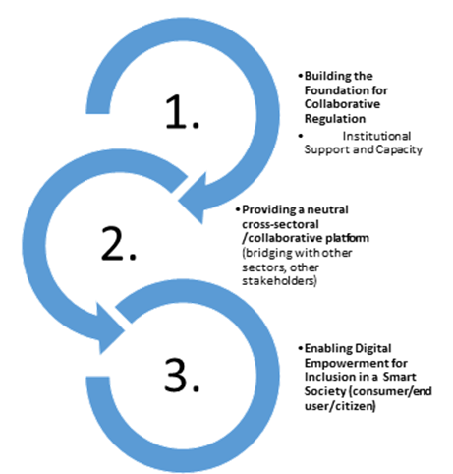
Source: ITU.

This was also recognized by regulators at the 2016 Global Symposium for Regulators (GSR-16), where regulators identified and endorsed a forward-looking set of regulatory best practice guidelines. Regulators from all regions recognized that a sound national framework for collaborative regulation goes a long way towards creating working synergies and effectively enabling new services.
Box 1.3: Building bridges between ICT and financial regulators
In terms of digital financial inclusion, regulators at the 2016 Global Dialogue on Digital Financial Inclusion agreed that a collaborative policy framework could start with the harmonization of the Telecommunications/ICT Act with the relevant financial legislation and regulatory policies. In the same way, collaboration could be extended to critical cross-cutting areas such as consumer protection, cybersecurity, privacy and data protection. Ongoing dialogue and regulatory cooperation is needed regarding competition between financial and telecom service providers as well as over-the-top players. Periodic open consultations and meetings with stakeholders, public and private, have to be involved in both policy-making and monitoring of policy implementation.
A harmonization of legal and regulatory requirements for digital financial services at the regional or sub-regional level, regulators noted, can have a multiplier effect on innovation and investment in national markets, and thus needs to be brought to the agenda of Regulatory Associations and Regional Economic Communities in view of facilitating the spread and benefits of digital financial inclusion in developing regions.
Source: ITU, Guiding measures of the Global Dialogue on Digital Financial Inclusion, http://www.itu.int/en/ITU-D/Conferences/GSR/Pages/GSR2016/GDDFI.aspx

Quantifying the impact of regulation on ICT uptake
There is by now a large body of qualitative research investigating the causality and relationship between regulation and ICT adoption. Quantitative evidence, however, is considerably less extensive. In order to fill in the gaps in this important area and provide grounds for informed policy-making, ITU has developed two econometric models based on the ICT Regulatory Tracker, for fixed broadband and for mobile cellular, which suggest that a sound regulatory environment is significantly associated with a positive impact on ICT adoption (see ITU Trends in Telecommunication Reform 2015).
This recent ITU research suggests that a 10 per cent increase in the ICT Regulatory Tracker score (corresponding to an incremental enhancement of regulatory frameworks) is associated with an increase of 7.7 per cent in fixed-broadband penetration over the period 2008-2013. To illustrate that, a country that has adopted some form of a broadband development strategy (a national broadband plan or digital agenda etc., that includes pro-active regulatory measures such as infrastructure sharing), countries which allow the use of VoIP services and promote a competitive environment for broadband technologies would have penetration levels 7.7 per cent higher on average than a country without these measures in place, other conditions being equal.
The model further suggests that a 1 per cent increase in the population living in urban areas is associated with a 7.8 per cent increase in fixed-broadband penetration, other things being equal. This high coefficient could be representative of the various characteristics urbanization is controlling for: infrastructure, commerce, investment in the Internet-intensive tertiary sector, etc.
Gross national income per capita also plays a valid role in explaining the levels of fixed-broadband penetration. A country that witnesses a 10 per cent increase in income per capita, for example from USD 10 000 to USD 11 000 is expected to have additional 9.4 fixed broadband users per every 100 people, other things being equal. This could be explained by different interpretations of the role Gross National Income (GNI) per capita plays in this model: as a proxy for economic development, a higher income could represent a more developed economy, with intense use of ICTs in all areas; as a proxy for the individual purchasing power, higher incomes could stand for an increase in willingness to pay for the fixed-broadband subscriptions.
Best-practice regulation also has a beneficial impact on mobile-cellular penetration. The positive effect of regulation on mobile penetration is corroborated by the results of the economic regression model for mobile cellular. A 10 per cent increase in a country’s score in the Tracker is associated with an increase of 2.3 per cent in mobile-cellular penetration. For example, a country that has introduced mobile number portability, permitted infrastructure sharing for mobile operators, allowed foreign investment in operators that own spectrum, legally promoted a competitive environment and required interconnection prices to be made public would have penetration levels 2.3 per cent higher than a country without these measures in place, all other things being equal.
The impact of regulation on the mobile sector over the studied period is lower than for fixed broadband, since mobile-cellular services have been in place for longer and the effect of regulation has tended to peak few years after adoption, while fading out in the longer term. The mobile sector has also been subject to more incentive regulations rather than obligations imposed, as in the case of fixed networks. These are well-known facts remedied by regular reviews and upgrades of existing policy and regulatory settings, as well as by the adoption of new measures and policy initiatives to address the changing nature of the digital ecosystem.
Urbanization is one of the key determinants of mobile-cellular adoption; a 1 per cent increase in urbanization is associated with an increase equivalent to 4.7 per cent in mobile-cellular penetration, all other factors being equal. Evidences point to the role of network externalities in the use of mobile phones, for instance, the high amount of mobile-cellular users motivate those who have not adhered to the service to do so. It is worth noting, nevertheless, that the impact of urbanization on the take up of mobile-cellular services is lower than on fixed-broadband penetration levels, mobile-cellular being less infrastructure-intensive and thus deployed at a lower cost beyond urban areas.
With regards to national wealth, the results of the regression model were highly predictable and confirm general assumptions. GNI per capita has a positive impact on mobile-cellular adoption: a 10 percent increase in income, for example from USD 10 000 to USD 11 000, is expected to generate 6.5 subscriptions per every 100 people, other things being equal. GNI per capita could be representative of the individual’s purchasing power and his budget constraints, for both the individual that has the necessity of subscribing to mobile-cellular services for the first time and the individual that seeks more than one subscription.
Ensuring that consumers benefit from the wealth of opportunities brought by the digital economy in an informed, responsive and safe manner is a challenge that policy-makers and regulators from around the world are increasingly facing. Undoubtedly, this can only be achieved through effective and smart regulation targeted at empowering consumers, redefining responsibilities and creating the conditions for a data driven economy to flourish.

Overview of ICT developments
Over the last ten years, the Americas region, which includes 35 countries and is home to a total population of almost one billion people, has seen growth in ICT infrastructure, access, and use (Chart 2.1). The percentage of individuals using the Internet has increased steadily from only 36 per cent in 2005 to an estimated 65 per cent at the end of 2016. This trend closely mirrors the steady increase in households that have Internet access at home which went from only 33 per cent in 2005 to an estimated 64 per cent by end of 2016. The mobile market continues to grow despite being relatively saturated. Mobile-cellular subscriptions more than doubled since 2005 and by end 2016, the numbers reached 111 subscriptions per 100 inhabitants. At the same time, active mobile-broadband subscriptions grew more rapidly than fixed-broadband subscriptions. Between 2011 and 2016, active mobile-broadband subscriptions per 100 inhabitants increased by 300 per cent while fixed-broadband subscriptions increased by 35 per cent. This suggests that the spread of Internet access was driven largely by mobile technologies. About 92 per cent and 73 per cent of the population are now within the reach of a 3G and LTE mobile-broadband signal, respectively.
The Americas region contains a diverse set of low, middle and high income countries. According to the World Bank, the average (nominal) GNI p.c. of countries in the region is about USD 11 000. Thirteen of the 35 countries in the Americas have a nominal GNI p.c. equal to or greater than USD 11 000 while one country has a GNI p.c. below USD 1 000. The United States, Brazil, Canada and Mexico are the largest telecommunications markets in the region, given the combination of their income levels and population size. Together, they account for 90 per cent of the region’s total economic output.
Chart 2.1: The Americas region ICT developments, 2006-2016*
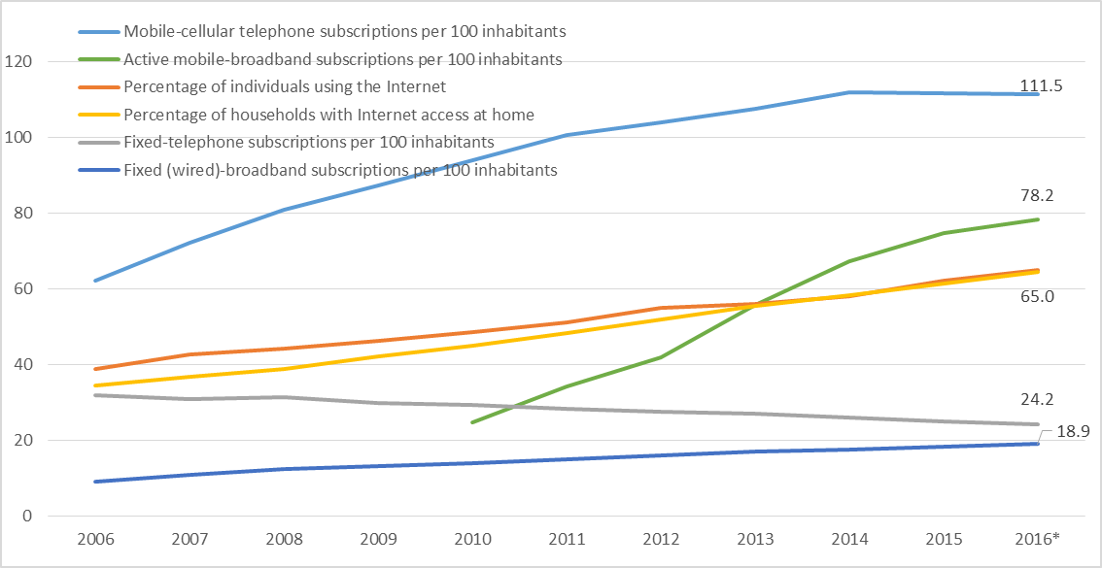
Source: ITU.
Note: * Estimate

Mobile market developments
As a whole, the Americas region has relatively higher penetration levels for mobile-cellular (in terms of subscriptions per 100 inhabitants) compared to the global average. The majority of the countries in the region have reached penetration levels above the world average (Chart 2.2). However, there remain several countries where mobile-cellular subscription rates are falling behind the rest of the region. The subscription rates in many of these countries are not growing fast enough to catch up and in some cases, have even contracted in recent years. The exceptions, Cuba and Haiti, experienced a 2 000 per cent and 400 per cent jump in mobile-cellular subscription rates since 2006, respectively. Despite high growth rates, both countries will need several years more of sustained expansion before catching up to the rest of the Americas.
Chart 2.2: Mobile-cellular subscriptions in the Americas, 2015 (top) and by region, 2016* (bottom)
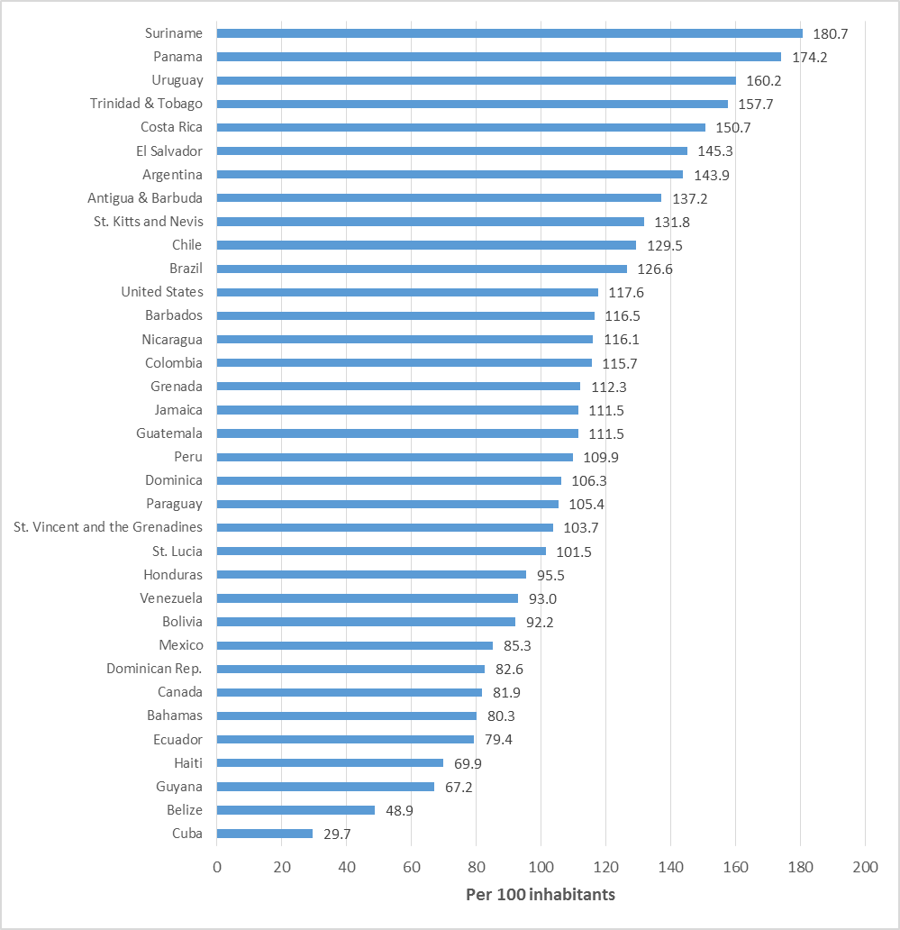
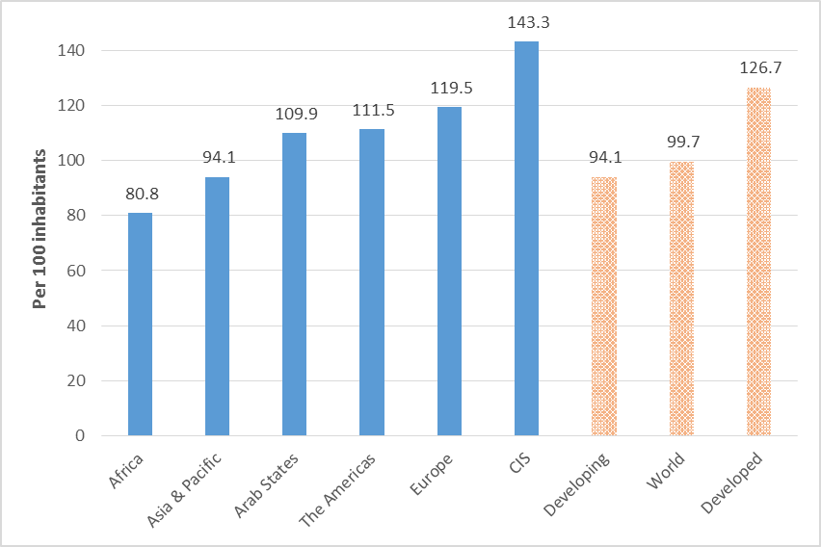
Source: ITU.
Note: * Estimate.
Among the various regions, the Americas has the highest mobile-broadband subscription rates which can be attributed partly to the presence of the United States with its large population and high income. By end 2016, ITU estimates that mobile-broadband subscriptions per 100 inhabitants for the whole of the Americas will reach more than 78 per cent. Within the region, twelve countries have mobile-broadband penetration rates higher than the world average of 49 per cent (see Chart 2.3). Between 2010 and 2015, Costa Rica and Brazil saw the most rapid increases in mobile-broadband subscriptions, overtaking Canada and Venezuela, countries with the second and third highest mobile-broadband penetration levels in the region in 2010. The experience of Suriname and St. Kitts and Nevis are also noteworthy, having gone from no mobile-broadband service in 2010 to higher than 70 per cent penetration levels by 2015. If current growth trends continue, Costa Rica, Brazil, Uruguay, Suriname and St. Kitts and Nevis could be expected to reach 100 per cent mobile-broadband uptake in less than 5 years. At present, the mobile-broadband market in the Americas region is far from saturated and still holds a lot of potential for expansion.
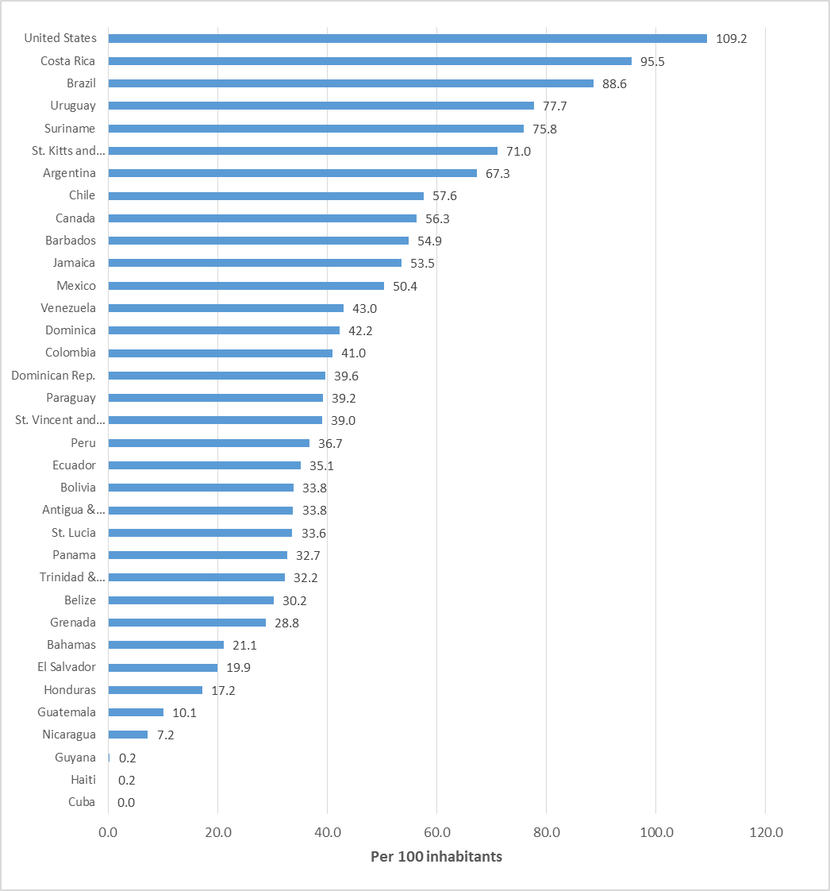
Chart 2.3: Active mobile-broadband subscriptions per 100 inhabitants by country in the Americas, 2015 (top) and by region, 2016* (bottom)
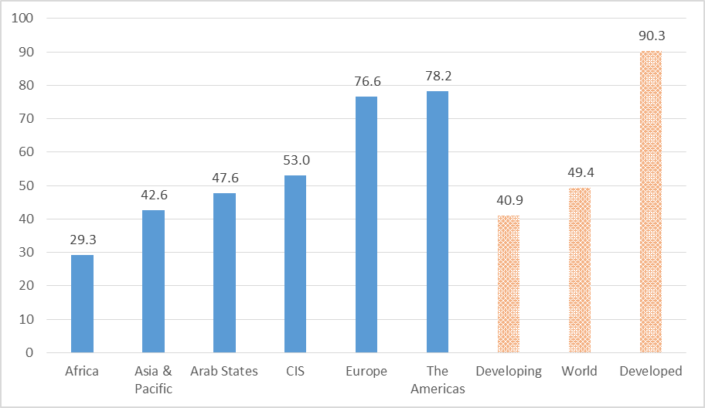
Source: ITU.
Note: * Estimate.
Investments in mobile infrastructure, which are already in place in many countries in the Americas region, will enable these countries to further expand their mobile-cellular and mobile-broadband uptake. In 2015, 96 per cent of the population in the Americas are covered by second-generation (2G) mobile networks. At the same time, mobile-broadband coverage has expanded rapidly and 79 per cent of the population are already within the reach of a 3G mobile signal. Among the 27 countries in the Americas who reported figures for their 3G coverage in 2015, more than half already achieved a 3G coverage rate of at least 90 per cent. Similarly, among the 22 countries who reported figures for LTE/4G coverage, ten have achieved LTE/4G coverage rates higher than the global average of 57.8 per cent. Given that only the U.S.A., Canada and the Bahamas have reached LTE/4G coverages rates of more than 90 per cent, there is still a lot of room to expand 3G and LTE/4G network infrastructure in the rest of the region.
Chart 2.4: Population covered by 2G, 3G, and LTE in the Americas region, 2015
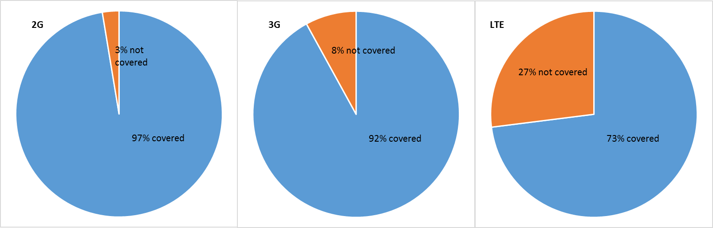Source: ITU.

Fixed-broadband and international Internet bandwidth
Among the various regions, the Americas has the second highest fixed-broadband subscription rates. ITU estimates a fixed-broadband penetration level of almost 19 per cent for the Americas as a whole in 2016, a figure far above the global average of 12 per cent. Within the region, 15 countries have achieved a level of fixed-broadband penetration greater than the global average. Between 2010 and 2015, the average improvement in fixed-broadband subscriptions per 100 inhabitants among countries in the Americas was 4.2 percentage points, with one country experiencing a decline during the same period. Uruguay and the Bahamas saw the largest absolute improvements in the last five years while Dominica and St. Kitts and Nevis saw the largest absolute improvements from 2014 to 2015.
Chart 2.5: Fixed-broadband subscriptions in the Americas, 2015 (top) and by region, 2016* (bottom)
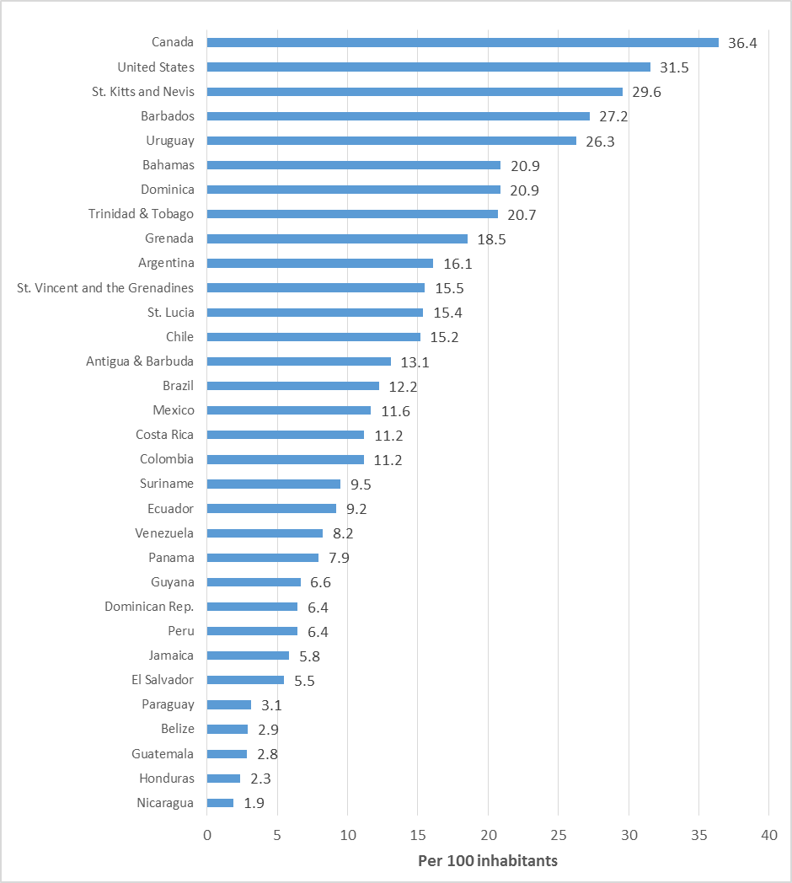

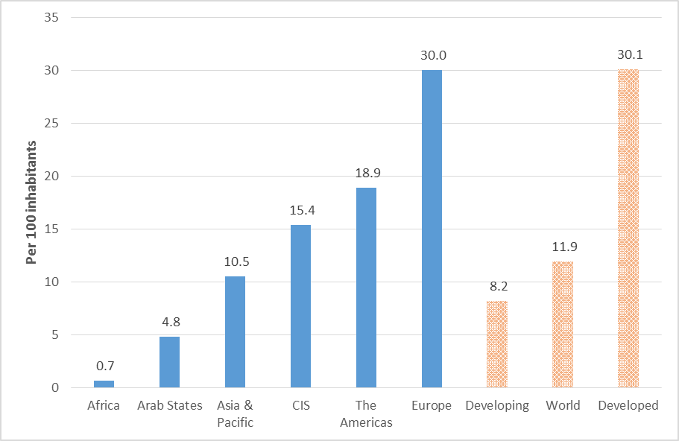
Source: ITU.
Note: * Estimate.
The availability of international Internet bandwidth continues to be an important area for policy and investment, especially given the rising amount of data-intensive applications and increasing numbers of Internet users desiring better international connectivity. The Americas region experienced a three-fold increase in the total amount of international Internet bandwidth between 2010 and 2015. The region now has a total of 42 570 Gbit/s of used international Internet bandwidth representing 4.4 per cent of the world’s total. In 2015, the amount of international Internet bandwidth per inhabitant in the Americas region was 46 kbits/s, a figure that is significantly higher than all the other regions except Europe (see Chart 2.6). However, there is still room for market expansion given that the amount of international Internet bandwidth per inhabitant varies greatly within the countries of the region. For example, most of the Caribbean countries have amounts of international Internet bandwidth per inhabitant greater than 100 000 bit/s – figures that are higher than the median reported by European countries. In contrast, the amount of international Internet bandwidth per inhabitant in majority of the countries in the Americas is below the regional average of 50 141 bit/s.
Chart 2.6: International Internet Bandwidth by regions, 2015

Source: ITU.

Internet access, use, and gender gap
The proportion of households with Internet access at home in the Americas region as a whole is 64.4 per cent, a figure significantly higher than the world average of 52.3 per cent (see Chart 2.7). In 14 out of 35 countries in the Americas, more than half of the households are connected to the Internet. Canada, the United States and St. Kitts and Nevis tops the list with more than 70 per cent of households with Internet access. Relative to other regions, the expansion in the proportion of connected households in the Americas was modest. However, Panama and the Caribbean countries of St. Kitts and Nevis, Bahamas, Dominica, and Antigua & Barbuda were able to add more than 50 percentage points to their respective proportion of Internet connected households. Panama’s recent experience is noteworthy. Between 2014 and 2015, its proportion of households with Internet access at home increased by more than 11 percentage points. This meant that within a year, Panama had an additional 107 748 households connected to the Internet. Consequently, more than half of the households in Panama are now reported to have Internet access at home.
Chart 2.7: Households with Internet access in the Americas, 2015 (top) and by region, 2016* (bottom)
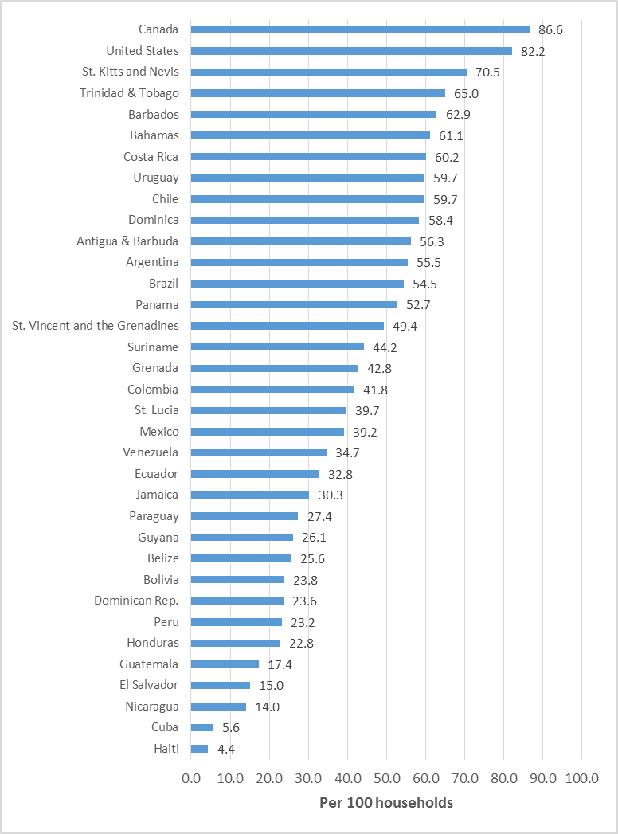
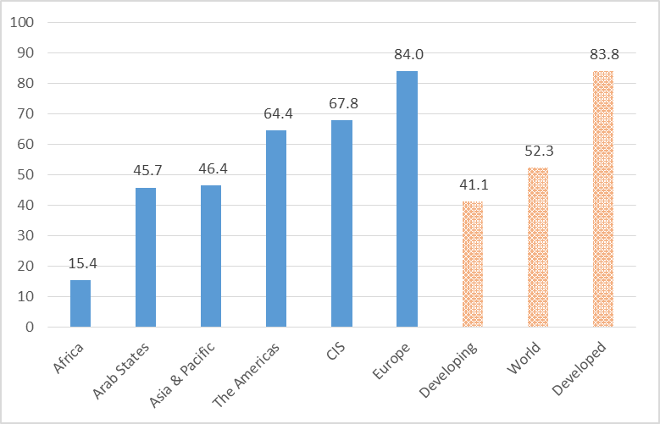
Source: ITU.
Note: * Estimate.
The ITU estimates that in 2016, about six out of ten individuals in the Americas region are using the Internet. This places the region well above the global average of 47 per cent of individuals reported as Internet users.
More than 60 per cent of countries in the Americas have already reached individual Internet penetration rates higher than the global average (see Chart 2.8). However, there is still a lot of opportunities for expanding the number of Internet users in most of the countries in the Americas. On average, countries in the region have added 16 percentage points to their Internet penetration rates during the period 2010 to 2015. Countries such as Bahamas, Grenada, and Mexico have grown significantly faster during the same period, adding more than 25 percentage points to their Internet penetration rates. More recently, Mexico, Bolivia and Dominica are seeing significant growth in Internet users, adding more than 10 percentage points to their Internet penetration rate between 2014 and 2015. If these trends continue, the Americas region will soon be at par with CIS and Europe in terms of the proportion of individuals reported as Internet users.
Chart 2.8: Percentage of individuals using the Internet in the Americas, 2015 (top) and by region, 2016* (bottom)
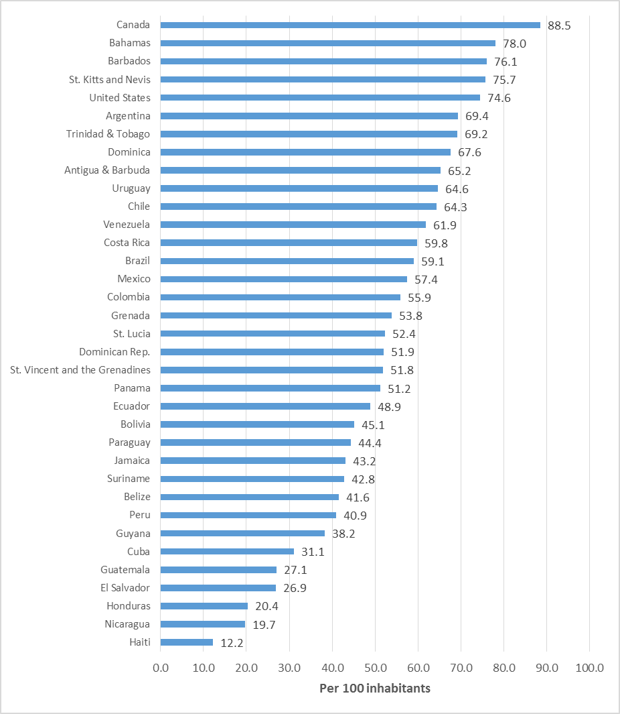

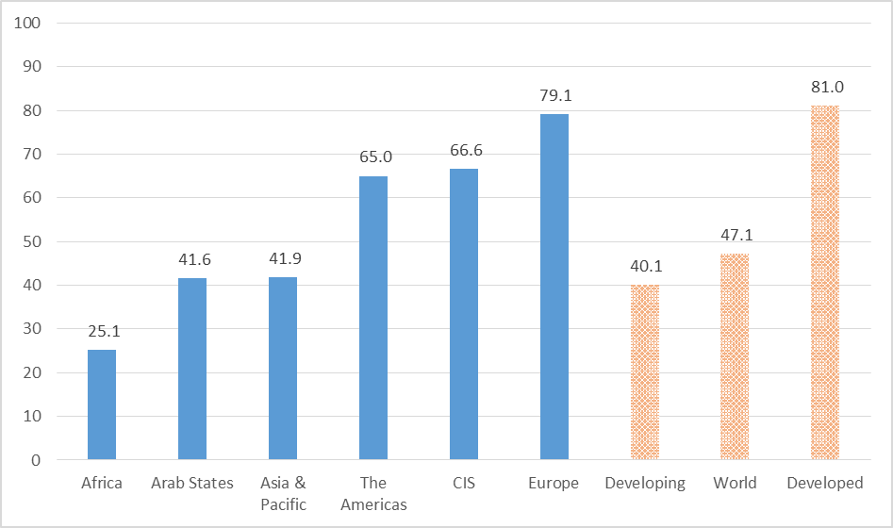
Source: ITU.
Note: * Estimate.
ITU data show that at the end of 2016, proportionally more men than women use the Internet in all regions of the world. The Americas region has the smallest gender gap in Internet use among all regions (Chart 2.9). However, between 2013 and 2016, the Americas was one of the regions that saw a widening of its Internet user gender gap, along with the Arab states and Africa (Chart 2.10). The gender gap represents the difference between the Internet user penetration rates for males and females relative to the Internet user penetration rates for males, expressed as a percentage. The Americas experienced two percentage points increase in its gender gap in the last three years.
Chart 2.9: Proportion of individuals using the Internet by region, by gender, 2016*

Source: ITU.
Note: * Estimate
Chart 2.10: Internet user gender gap (%), 2013 and 2016*
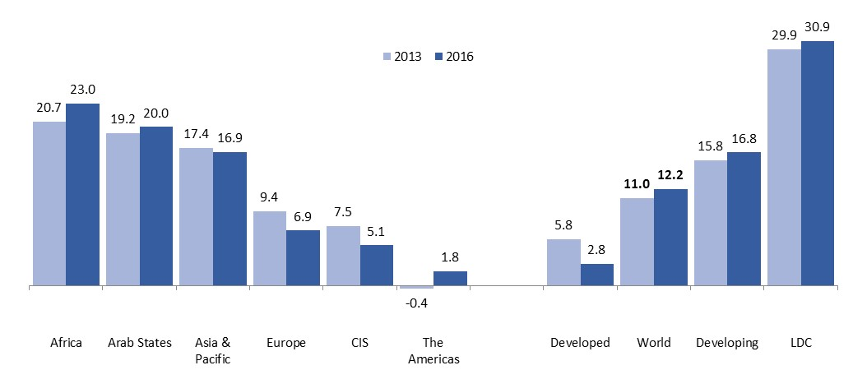
Source: ITU.
Note: * Estimate. The gender gap represents the difference between the Internet user penetration rates for males and females relative to the Internet user penetration rate for males, expressed as a percentage.
The following two sections feature a regional analysis of the ITU ICT Development Index (IDI) and an overview of the price and affordability of ICT services.

The ICT Development Index (IDI)
The ICT Development Index (IDI) is a composite index that combines 11 indicators into one benchmark measure that can be used to monitor and compare developments in information and communication technology (ICT) between countries and over time (Figure 3.1). The IDI was developed by ITU in 2008 in response to ITU Member States’ request to establish an overall ICT index, was first presented in the 2009 edition of the Report (ITU, 2009), and has been published annually since then. In the following analysis, the IDI 2016, which is calculated using data at end 2015, and assesses progress by comparing these data with those for IDI 2015 (calculated using data at end 2014).
The main objectives of the IDI are to measure:
- the level and evolution over time of ICT developments within countries and the experience of those countries relative to others;
- progress in ICT development in both developed and developing countries;
- the digital divide, i.e. differences between countries in terms of their levels of ICT development; and
- the development potential of ICTs and the extent to which countries can make use of them to enhance growth and development in the context of available capabilities and skills.
The Index is designed to be global and reflect changes taking place in countries at different levels of ICT development. By looking at the regional level, it is possible to highlight trends and identify reasons why some countries are doing better than others, or lagging behind.
This section will present the results of the regional IDI analysis, and be followed by the analysis of the Americas region. This section will also outline the countries in the Americas that have improved their position in the overall IDI rankings most dramatically since 2015.
Figure 3.1: ICT Development Index: indicators, reference values and weights
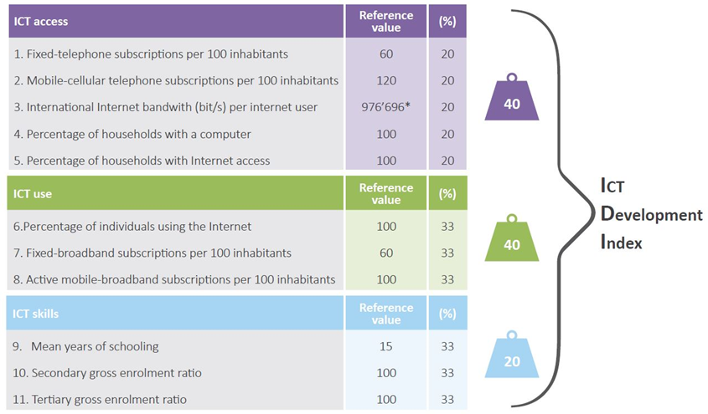
Source: ITU

IDI 2016 regional analysis
ITU Member States are divided into six regions – Africa, the Americas, Arab States, Asia and the Pacific, Commonwealth of Independent States (CIS) and Europe. The distribution of countries between regions differs in a number of respects from the regional distributions used in other UN data series, most notably where the Europe and Africa regions are concerned, and this should be borne in mind when undertaking comparative analysis with other data sets.
The IDI 2016 data published in this volume are derived from 175 economies, of which 39 are in the Africa region, 34 in the Americas, 18 in the Arab States region, 34 in Asia and the Pacific, 10 in the CIS region and 40 in the Europe region. Of the 21 ITU Member States for which data are not available, five are in the Africa region, one in the Americas, four in the Arab States region, six in Asia and the Pacific (including five from the UN Oceania region), two in the CIS region, and three, all small states, in Europe.
Table 3.1 sets out the results of IDI 2016 for each of the six ITU regions, and compares them with the results for IDI 2015. Chart 3.1 shows the distribution of average, minimum and maximum IDI values in these regions, compared with the global average.
Table 3.1: IDI by region, 2016 and 2015
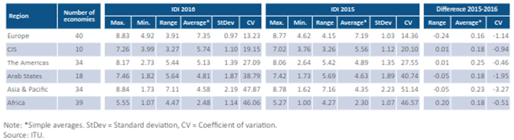
Chart 3.1: IDI by region compared with global average, 2016
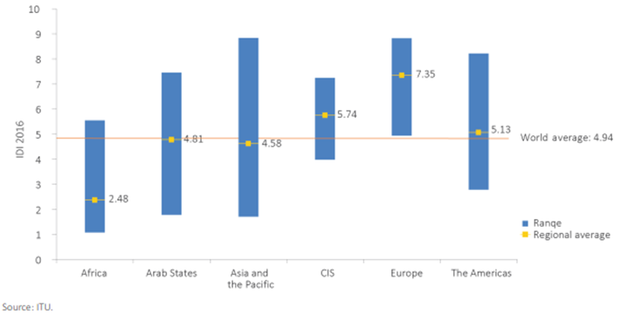
As in previous years, the Europe region records the highest regional average IDI value, at 7.35, and includes only one country, Albania, just below the global average of 4.94. The regional average value for the CIS region, at 5.74, is significantly higher than the global average (although it should be noted that two lower-income countries in this region are not included in the Index). The average for the Americas slightly exceeds the global average, at 5.13, while the average IDI values for the Arab States and Asia-Pacific regions, at 4.81 and 4.58, respectively, fall somewhat below. As in previous years, the Africa region records by far the lowest average IDI value, at 2.48, little more than half that of the next lowest region.
There is much greater variation in some regions than in others. The CIS region has the smallest range between its highest and lowest IDI values, 3.27 points, reflecting its relative economic homogeneity. Europe also has a relatively narrow IDI range, of 3.91 points, a figure which drops to 3.14 if the region's two lowest-ranking countries (Albania and Bosnia and Herzegovina) are excluded.
The IDI distribution in the Africa region is more variable, but at much lower levels which are consistent with the region’s economic development. Here again, the distribution is affected by outliers, in this case three relatively high-performing countries (Mauritius, Seychelles and South Africa); without these, Africa’s average IDI would drop from 2.48 to 2.26 and the IDI range would shrink from 4.47 points to 3.53.
The range of IDI values is greater in the Americas, the Arab States and, particularly, Asia and the Pacific, reflecting the economic heterogeneity of these regions. The Americas region includes high-income countries in North America as well as developing countries to the south. The Arab States region includes oil-rich countries belonging to the Gulf Cooperation Council but also several least developed countries (LDCs). The Asia-Pacific region includes a number of top performers in the Index, such as the Republic of Korea, Singapore and Hong Kong (China), alongside least connected countries (LCCs) in South Asia.
There were broadly consistent improvements in the average level of the IDI across all regions in the year between IDI 2015 and IDI 2016, the greatest improvements taking place in the Americas and Asia-Pacific regions. The range between the highest and lowest IDI values changed only marginally in most regions in the year between IDI 2015 and IDI 2016, the largest variations being observed in the Europe and Africa regions. In Europe, the 0.24-point reduction in the range resulted from a higher rate of improvement by the lowest-ranking country, Albania, in comparison with countries at the top end of the distribution which are approaching the Index’s maximum value. In Africa, the 0.20-point increase in the range resulted from faster improvements by the country with the highest ranking, Mauritius, in comparison with those at the bottom of the distribution.
Table 3.2 illustrates the five highest- and-lowest ranking countries in each region in IDI 2016, in order to provide further insight into differences in levels of ICT development.
The similarities and differences between regions can be explored in more detail by comparing spider charts of the average scores achieved in the different regions on each of the 11 indicators making up the Index. These are presented in Chart 3.2, along with a world chart to enable comparison between regional and global average values. In considering these charts, it should be remembered that they do not reflect the range of values within regions, which, as noted above, is much wider in some regions than in others.
Table 3.2: Highest- and lowest-ranking countries by region, IDI 2016
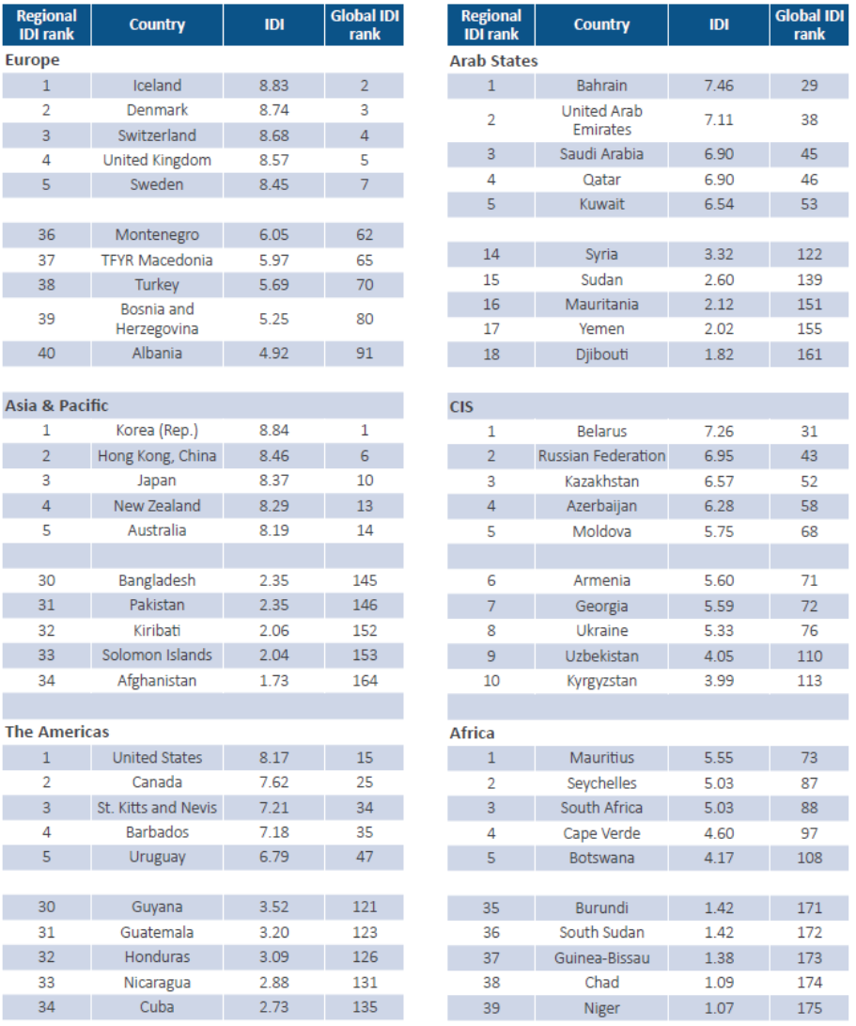
Source: ITU
As these spider charts indicate, there has been little difference in average IDI performance across regions over the year between IDI 2015 and IDI 2016 on the majority of indicators in the Index. The biggest change in most regions has been in the proportion of active mobile-broadband subscriptions, followed by the proportion of Internet users and of households with Internet access. Increases in households with a computer were more significant in regions displaying a higher average overall performance (Europe, CIS and the Americas) than in those with a lower average overall performance (Africa, Asia and the Pacific and the Arab States region), reflecting the relative importance of growth in mobile-cellular subscriptions in the latter regions’ lower-income countries. Most regions showed fairly modest increases in fixed-broadband subscriptions and a decline in fixed-telephone subscriptions.
Chart 3.2: Average IDI values for each indicator, world and regions, 2015-2016
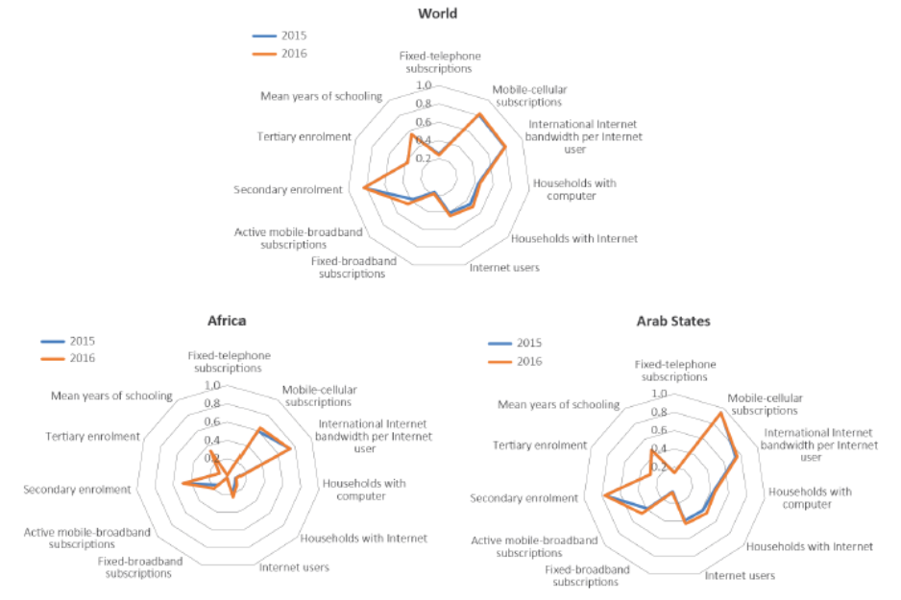
Source: ITU
The smoothest distribution of results across the range of indicators – with relatively high performance across the board – is observed in the Europe region. The distribution of indicator results becomes less smooth as overall IDI performance declines, the most significant contributors to this phenomenon being differences between regions in the proportions of fixed-telephone and fixed-broadband subscriptions. The spider charts for the CIS and Americas regions reveal stronger performance overall than those for the Arab States and Asia-Pacific regions, but are broadly similar in their overall shape, reflecting this distribution of indicator values.
The spider chart for the Africa region is much less smooth than those for other regions. This reflects particularly low indicator values in Africa for fixed-telephone and fixed-broadband subscriptions and for household Internet and computer access, as well as for enrolment in tertiary education. The strongest results in the Africa region relate to mobile-cellular subscriptions and international Internet bandwidth. These variations between indicators have been influenced by the prevalence of mobile over fixed terrestrial infrastructure in Africa, the relatively high cost of fixed-broadband connections on the continent, and the increasing number of submarine cables offering international connectivity.

The IDI 2016 in the Americas region

IDI values and rankings for the Americas region are set out in Chart 3.3 and Table 3.3, where they are compared with the global average and with averages for developed and developing countries.
The Americas region, like the Asia-Pacific region, is highly diverse, including two high-income developed countries in North America, large middle-income developing countries in South America, and smaller developing countries and small island states in Central America and the Caribbean. At the top of the rankings are the region’s two large developed countries, the United States and Canada, which rank within the top 25 countries worldwide. Like developed countries in Europe and the Asia-Pacific region, the improvement in their IDI level over the year was below the global average. Two of the region’s small island countries – St. Kitts and Nevis and Barbados – are also in the high quartile of the rankings, while only one country in the region, Cuba, ranks in the lowest (LCC) quartile. The region’s only LDC, Haiti, does not provide data for the IDI.
Chart 3.3: IDI values, the Americas region, 2016
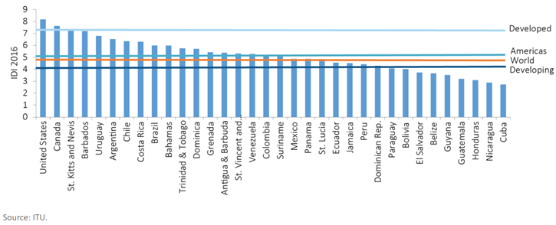
Table 3.3: IDI rankings, the Americas region, 2016 and 2015
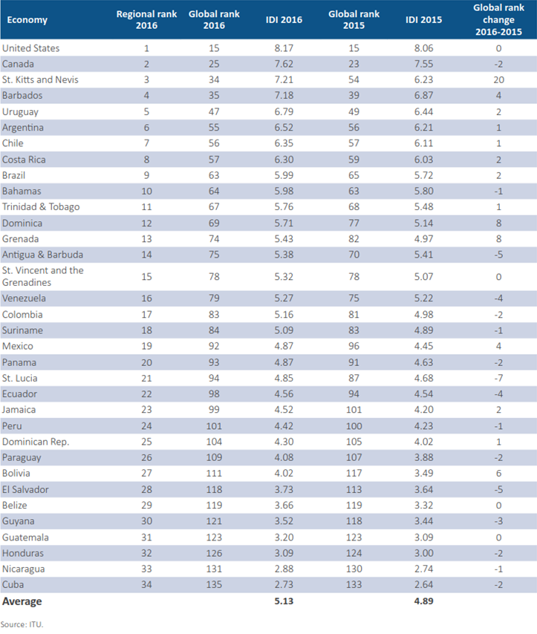

The Americas: most dynamic countries in the IDI
Higher rates of improvement were achieved by a number of South American developing countries and Caribbean countries. In South America, significant gains were made by both relatively high performers – Uruguay (up 0.35 points), Argentina (up 0.31 points), and Costa Rica and Brazil (up 0.27 points) – and relatively low performers – Mexico (up 0.42 points) and Bolivia (up 0.53 points). However, some other countries made only marginal gains on the previous year.

The greatest gain in the region was made by the Caribbean island state of St. Kitts and Nevis, which rose 20 places in the global rankings on the strength of an increase of 0.98 points in its IDI value. This improvement on the IDI appears to have resulted from infrastructure improvements and marketing initiatives by communications operators (see Box 3.9). Substantial improvements in IDI value were also recorded by five other Caribbean countries – Dominica (up 0.57 points), Grenada (up 0.46 points), Belize (up 0.33 points), Barbados (up 0.31 points) and the Dominican Republic (up 0.28 points).

Box 3.9: ICT and IDI developments in St. Kitts and Nevis and other Eastern Caribbean countries
The most dynamic country in IDI 2016 was St. Kitts and Nevis, which moved up 20 places to 34th in the rankings in this year’s Index. Very substantial gains were also made by two of its neighbours in the Eastern Caribbean, Dominica and Grenada. The countries have seen improvements in most of the indicators making up the IDI, although with different emphases.

St. Kitts and Nevis experience a very significant and rapid increase in active mobile-broadband subscriptions, building on a strong performance in mobile-cellular subscriptions. The mobile-broadband penetration rate increased from just 18.6 per 100 inhabitants in 2014 to 71.0 in 2015. A similar trend can be observed in Grenada, where mobile-broadband penetration rose from only 2.6 per 100 inhabitants in 2014 to 28.8 in 2015. Dominica saw an increase in active mobile-broadband subscriptions from 29.3 to 42.2 per 100 inhabitants in the course of the past year, as well as substantial improvements in fixed-broadband penetration, the proportion of Internet users, and households with access to the Internet.

A number of factors appear to have contributed to this trend. In St. Kitts and Nevis, the cost of prepaid mobile broadband decreased from USD 51.9 in 2014 to USD 13.7 in 2015. A number of promotions and zero-rating options also became available, which may have had an impact. Digicel offered occasional promotions of free credit in 2014. At the end of 2014 and throughout 2015, Digicel offered free Wikipedia, free social media (Facebook, Twitter, Instagram, and later on WhatsApp), and triple credit promotions several times a month.

The two main operators in the region, Digicel and Cabel & Wireless Communications (C&W), have undertaken large infrastructure investments that support this improvement in local IDI values. C&W launched project Marlin in 2014 to invest USD 250 million to improve and upgrade its network across the region. According to C&W, this has enabled significant improvements in network resilience and speed, and its network is carrying 104 per cent more traffic on mobile and 42 per cent more traffic on fixed networks in 2016 in comparison with previous years. Digicel has also invested heavily in the region in the three years ending on 31 March 2015 (Digicel, 2015).

Table 3.4 sets out the most dynamic countries in the Americas region in terms of IDI rankings and values. In both cases, the most dynamic countries are three island states in the Eastern Caribbean – St. Kitts and Nevis, Dominica and Grenada – which share a common communications regulatory authority. The most dynamic country on the American mainland, also in both cases, is Bolivia.
Table 3.4: Most dynamic countries by IDI ranking and IDI value, the Americas region, 2015-2016
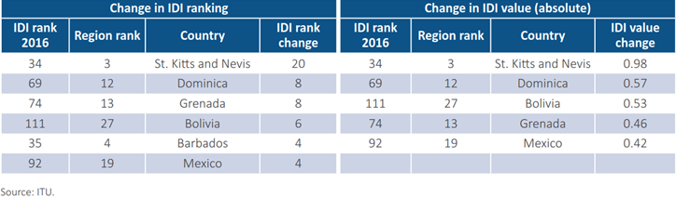
The Americas region shared the general trend in the IDI whereby the greatest improvements occurred in the indicator for mobile-broadband penetration. Gains on this indicator were driven by large increases in a number of Caribbean countries (St. Kitts and Nevis, Grenada, Belize and Jamaica) and four countries on the South American mainland (Bolivia, Uruguay, Argentina and Brazil). As in other regions, there were also significant improvements in average performance on the proportion of Internet users and the proportion of households with Internet. Ecuador registered a sizeable reduction in the indicator for mobile-cellular penetration, apparently because of a new telecommunication law passed in 2015 which imposed a charge on each active line above a given threshold and so prompted mobile operators to purge their subscriber base of inactive SIM cards . Chart 3.4 contains spider charts showing the performance of these countries.
Chart 3.4: IDI values, selected countries, the Americas region, 2015-2016
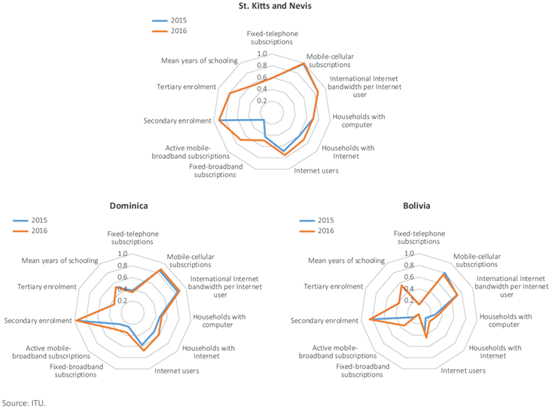

The spider charts highlight a number of similarities and differences between dynamic countries within the region. The chart for St. Kitts and Nevis has the more rounded shape associated with higher-income higher-ranked countries in the IDI, with a relatively high value for fixed-telephone subscriptions, and stronger performance in the use sub-index than lower-income lower-ranked countries. The charts for Dominica and Bolivia are more representative of those associated with middle-ranking developing countries, with low (in the case of Bolivia, very low) levels of fixed telephony and fixed broadband, relatively strong values for international Internet bandwidth per Internet user, and moderate values for other access indicators.
The principal gains made by all of these more dynamic countries in the Americas between IDI 2015 and IDI 2016 were in mobile-broadband subscriptions, Internet users and households with Internet. This is consistent with findings in other dynamic developing countries. However, the two island states in the Eastern Caribbean, whose geography is more conducive to fixed-network deployment than that of a large country with difficult terrain such as Bolivia, also registered significant gains in fixed-broadband subscriptions.
By far the largest gain for any indicator in any country in this region within IDI 2016, however, was observed on mobile-broadband penetration in St. Kitts and Nevis, which rose from 18.63 per cent to 71.02 per cent over the year. Strong performance on this indicator was also a feature of the improvement in IDI values and rankings achieved by Dominica and Grenada. Some of the factors which contributed to this are described in Box 3.9. Box 3.10 below describes the ICT and IDI environment in Bolivia.

Box 3.10: ICT and IDI developments in Bolivia
Bolivia moved up six places in the IDI ranking, thanks to an increase of 0.53 points in its IDI value, more than twice the world average IDI improvement. This Andean country significantly improved its performance in terms of the percentage of households with a computer and households with Internet, which rose to an estimated 33.1 per cent and 23.8 per cent, respectively, by end 2015.

The increase in household ICT access was spurred by growth in mobile-broadband subscriptions, which almost tripled from 12.2 subscriptions per 100 inhabitants in 2014 to 33.8 at end 2015. This large increase in active mobile-broadband subscriptions resulted from the migration of 2G mobile data customers to 3G networks. The growth of household Internet access and mobile-broadband uptake also contributed to an increase in the proportion of Internet users from 34.6 per cent in 2014 to an estimated 45.1 per cent by end 2015. Higher Internet uptake was reflected in an increase in data consumed: mobile Internet data traffic doubled between 2014 and 2015 (ATT, 2015), and the traffic exchanged in the national Internet exchange point also grew significantly.

Although more people are coming online in Bolivia, there remains a large urban-rural divide. Most Internet users and households with Internet access are located in urban areas, while less than 10 per cent of the population in rural areas use the Internet (Chart Box 3.1). In addition, 3G coverage remains limited to 27 per cent of the population, suggesting that most rural areas do not have access to mobile-broadband networks.

Chart Box 3.1: Households with Internet, 2006-2015
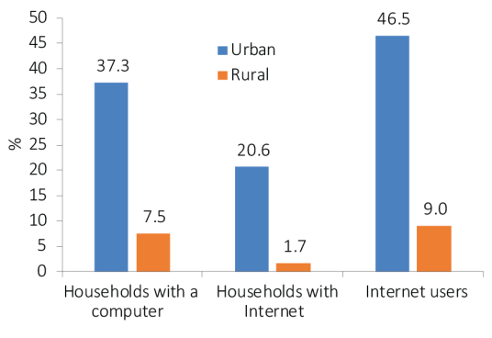
Source: ITU
The extension of broadband networks to rural areas and the promotion of Internet uptake among rural communities is therefore one of the most important challenges that ICT policy-makers face in Bolivia. This has been a focus of policy attention, and several initiatives of the Programa Nacional de Telecomunicaciones de Inclusión Social have tried to bridge the gap, for example by providing Internet access to rural schools or deploying mobile-broadband-capable base stations in rural areas.

Monitoring the price and affordability of ICTs in the Americas region
Many people continue to be excluded from the global information society, and the relatively high cost of ICT services remains one of the key barriers to ICT uptake. Survey-based data that ITU collects from national statistical offices confirm that, next to the availability of access and the relevance of services, affordability is one of the key factors that continue to determine whether or not people will use ICTs. A number of recent studies on ICT developments also confirmed these findings. Monitoring prices is therefore a critical step towards better policies to make ICT services more affordable.
The need to provide affordable access to ICTs has been clearly recognized by policy-makers at the national and international level. The World Bank’s 2015 World Development Report states that collecting Internet price data and benchmarking is the first step towards better regulation for lower prices.
Furthermore, making ICT services more affordable and increasing the number of ICT users will play a key role in the context of the 2030 Agenda for Sustainable Development. This new global development agenda, which was adopted by the United Nations in September 2015, recognizes the immense potential of ICTs to “accelerate human progress” and specifically refers to the need to “significantly increase access to information and communications technology and strive to provide universal and affordable access to the Internet...” (UNGA, 2015a).
To identify trends and track the affordability of ICT services, ITU collects and publishes price data for fixed-telephone, mobile-cellular and fixed- and mobile- broadband services.
The following section, which is based on prices collected at the end of 2015, will look at the development of mobile-cellular prices in the Americas region and show some regional differences in the affordability of mobile- cellular prices, based on the mobile-cellular price basket. This will be followed by an analysis of prices in the fixed- and mobile broadband market, and some pricing trends in the dynamic mobile-broadband services segment.

Mobile-cellular prices in the Americas region
To monitor mobile-cellular prices, ITU uses the mobile-cellular sub-basket, which refers to the price of a standard basket of 30 outgoing calls per month (on-net/off-net to a fixed line and for peak and off-peak times, in predetermined ratios), plus 100 SMS messages. It is calculated as a percentage of a country’s average monthly GNI per capita, and also presented in USD and PPP$. The mobile-cellular sub-basket is based on prepaid prices, although postpaid prices are used for countries where prepaid subscriptions make up less than 2 per cent of all mobile-cellular subscriptions.

A regional analysis of mobile-cellular prices reveals some differences across and within regions (see Chart 4.1). Mobile-cellular prices range from USD 4 to USD 36 in the Americas region, and the average is the highest of all regions at USD 18.
In PPP terms the range is wider, and the average remains the highest of all regions at PPP$ 27. The high average price in the Americas is explained, on the one hand, by the relatively high pay-per-use prices in countries such as Argentina, Belize, Guatemala and Nicaragua, where prepaid packages of bundled services with long validity periods are not available. On the other hand, in high-income countries such as Canada and the United States, good value-for-money offers are typically all-inclusive family plans (voice, SMS and data), whereas individual prepaid packages have a higher price. In the global comparison, Costa Rica is the only country in the Americas that stands out for the affordability of mobile-cellular prices (PPP$ 5.5). Indeed, the service in Costa Rica costs almost half as much as in Venezuela and Paraguay, the second and third countries with the lowest mobile-cellular prices in PPP terms in the Americas, respectively.
Chart 4.1: Mobile-cellular prices as a percentage of GNI p.c. (top chart), in USD (middle chart), and PPP$ (bottom chart) by region, 2015
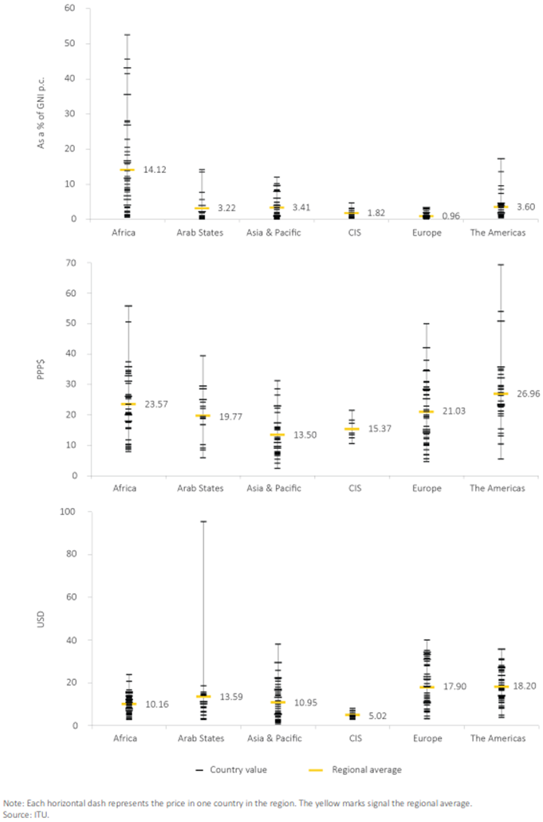
Variations are narrower when considering the GNI p.c. of each country, and most countries in the region have prices that represent less than 5 per cent of GNI p.c. This suggests that, although there is room for further reductions of mobile-cellular prices in most countries in the Americas, the service is already relatively affordable in most countries of the region. Costa Rica stands out as being among the countries with the most affordable mobile-cellular prices worldwide (Table 4.1). The countries where mobile-cellular prices correspond to more than 5 per cent of GNI p.c. remain unchanged in the Americas since 2014, namely Honduras, Belize, Guatemala, Haiti and Nicaragua. In addition to some specific initiatives to reduce prices in these countries, such as the dynamic discounts offered by the operator Tigo in Guatemala, some additional and sustained private-led initiatives or regulatory and policy interventions would be required to achieve lower mobile-cellular prices in these countries, particularly in Belize and Haiti, the countries with the lowest mobile-cellular penetration in the region, together with Cuba.
Table 4.1: Top five countries with the cheapest mobile-cellular services in each region, PPP$, 2015
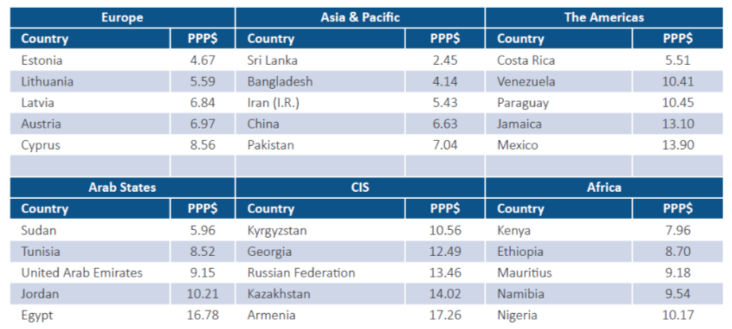
Note: George exited the CIS on 18 August 2009 but is included in the ITU/BDT administrative region for CIS countries. Source: ITU

Fixed-broadband prices in the Americas region

To monitor fixed-broadband prices, ITU uses the fixed-broadband sub-basket, which refers to the price of a monthly subscription to an entry-level fixed-broadband plan. It is calculated as a percentage of a country’s average monthly GNI per capita, and also presented in USD and PPP$. For comparability reasons, the fixed-broadband sub-basket is based on a monthly data usage of (a minimum of) 1 Gigabyte (GB). For plans that limit the monthly amount of data transferred by including data volume caps below 1 GB, the cost for the additional bytes is added to the sub-basket. The minimum speed of a broadband connection is 256 kbit/s.
A regional comparison of fixed-broadband prices, speeds and data caps highlights important differences between, as well as within, regions. Africa remains the region with the greatest divergence in absolute and relative price for Internet access, while the CIS region has relatively low, and similar, prices. Africa, but also Asia and the Pacific and the Americas, have some outliers, where prices remain prohibitively expensive, which influence these regions’ averages (Chart 4.2).
Chart 4.2: Fixed-broadband prices by region, 2015, in USD (left) and in PPP$ (right)
Note: Each horizontal dash represents the price in one country in the region. The yellow marks indicate the regional average. * In Africa, the price of a fixed-broadband subscriptions was above USD300 (at USD489 and at USD500) in two countries. ** In Africa, the price of a fixed-broadband subscription was above PPP$300 (at PPP$862) in one country.
Source: ITU
In the Americas, the cost of a fixed-broadband connection has dropped to about USD 30 (PPP$ 37) and at end 2015 the region is close to meeting the 5 per cent of GNI p.c. benchmark in terms of affordability of the service. Fixed broadband is most affordable in the United States and Brazil, where it corresponds to as little as 0.4 and 0.9 per cent of GNI p.c. In about two thirds of the countries in the Americas fixed-broadband services cost less than 5 per cent of GNI p.c., but most other countries, including Jamaica and lower middle-income economies such as Bolivia, El Salvador and Guatemala, have made the service relatively affordable. The exceptions are Nicaragua, Honduras, and Cuba, where the service is still the most expensive and remains relatively unaffordable (Chart 4.3).
Chart 4.3: Fixed-broadband prices as a percentage of GNI p.c., speeds and caps, the Americas 2015
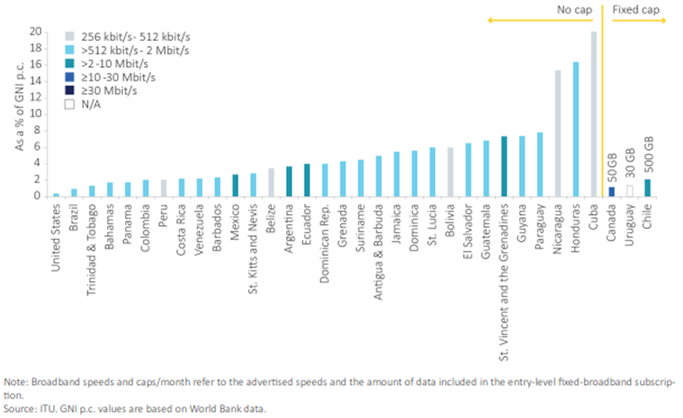
In the majority of countries in the Americas, entry-level fixed-broadband connections are offered at speeds between 512 kbit/s and 2 Mbit/s. Lower speeds are offered only in Bolivia, Belize, Cuba, Nicaragua and Peru. A handful of countries, including Argentina, Chile, Ecuador and Mexico, offer connections with speeds of between 2 and 10 Mbit/s. Canada’s entry-level plan offers 15 Mbit/s.
The Americas is the region with the largest number of unlimited data plans. Only Canada, Chile and Uruguay cap the amount of data that subscribers can download, and even then the caps are very high, at 50, 30 and 500 GB, respectively.

Mobile-broadband prices in the Americas region
To monitor mobile-broadband prices, ITU collects data for (a) prepaid handset-based mobile-broadband plans with a data allowance of 500 MB per month, and (b) postpaid computer-based mobile-broadband plans with a data allowance of 1 GB per month. The plan selected in each country for each service is not necessarily the one with the cap closest to 500 MB or 1 GB, but the one from the dominant operator that is cheapest while including a minimum of 500 MB/1 GB. The validity period considered for the plans is 30 days or four weeks.
The aggregate analysis of prices in terms of GNI p.c. shows that, on average, mobile broadband became more affordable in all regions in 2015 (Table 4.2). All regional averages saw double-digit drops in 2015, and the strongest improvement was recorded in the CIS, where computer-based prices as a percentage of GNI p.c. dropped by more than 50 per cent.
Table 4.2: Average mobile-broadband prices and ranges by region, as a percentage of GNI p.c., 2015
Note: * Simple averages based on 155 countries for which 2014 and 2015 price data for all mobile-broadband services were available.
Source: ITU

Europe continues to be the region with the most affordable mobile-broadband services, and also the one with the smallest differences across countries in terms of GNI p.c. The CIS and the Americas have similar ranges for handset-based mobile broadband, but the average for the CIS is lower and decreasing faster. When considering postpaid computer-based services, the Americas has an average price in terms of GNI p.c. that is well above that of the CIS. Moreover, the Americas saw the smallest reduction in the average price of all regions.
Prices across countries in the Asia-Pacific region display a wide range, especially for postpaid computer-based plans, thus reflecting the different stages of development of the mobile-broadband markets in the region. Furthermore, the relatively high average for postpaid computer-based prices in terms of GNI p.c. suggests that providing affordable Internet access with large data allowances remains an issue in several countries in the region.
The Arab States region has the widest range of handset-based mobile-broadband prices in terms of GNI p.c. of all regions. This is explained by the contrast between a few Arab LDCs where the service remains largely unaffordable and the high-income GCC countries where prices represent less than 1 per cent of GNI p.c. The range is similar for postpaid computer-based services, although they are more expensive than handset-based mobile-broadband in most Arab States.
Africa is the only region in which the average price of handset-based mobile-broadband plans represents more than 5 per cent of GNI p.c. This underlines that the service remains unaffordable for several segments of the population in many African countries, although there has been a large reduction in prices in terms of GNI p.c. in 2015. Postpaid computer-based services have much higher prices in Africa, with an average price corresponding to more than 20 per cent of GNI p.c. in the region. This average is four times that of any other region and, coupled with the high fixed-broadband prices in Africa, highlights that computer-based broadband access remains largely unaffordable in the region.
A closer look at prepaid handset-based mobile-broadband prices as a percentage of GNI p.c. provides additional insights into the differences in affordability within each region. Prepaid handset-based mobile-broadband plans priced at less than 5 per cent of GNI p.c. are offered in a majority of countries in the Americas region. These now include the Dominican Republic, where the price reduction between 2014 and 2015 drove prices down below that threshold (Chart 4.4).
Chart 4.4: Prepaid handset-based mobile-broadband prices (500 MB per month) as a percentage of GNI p.c. and data volume (cap) included, in the Americas region, 2015 and 2014
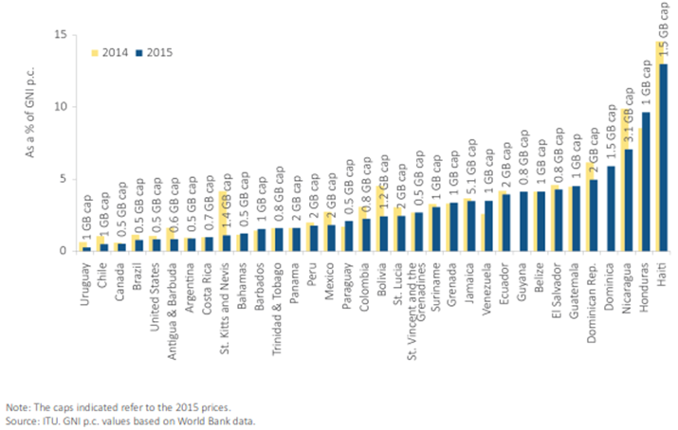

Conclusions
ICT access and use in the Americas region have seen a sustained and solid increase over the last years. In many areas of ICT development such as: mobile-cellular subscriptions, mobile-broadband subscriptions, fixed-broadband uptake, availability of international Internet bandwidth, household Internet access and individual Internet penetration rates, the Americas region as a whole is already performing above the global average. The region has also achieved the most gender equitable outcomes in ICT development, especially with respect to Internet use.
Despite what looks to be a relatively saturated market, mobile remains the most dynamic sector, with continued expansion in mobile-cellular uptake and mobile-broadband services. Mobile technologies also continue to drive the spread of Internet access in the region, especially given the significant expansion in mobile-broadband infrastructure and access.
ICT development in the Americas remains correlated with national income levels per capita. With some exceptions, the countries in the Americas which perform well in terms of ICT access and use also tend to be economies with relatively higher per capita incomes (e.g. United States, Canada, St. Kitts and Nevis). Mexico, Bolivia and several Caribbean countries are exhibiting the most dynamic improvements in ICT development. These improvements were largely driven by growth in mobile-broadband uptake.
Some of the key challenges that lie ahead is to increase fixed-broadband penetration rates and coverage in the region as a whole, to maintain equitable access to ICTs, and ultimately bring more people online to benefit from and participate in the information society. Countries can also further leverage on the existing mobile-cellular networks and sustain the development of mobile markets by expanding mobile-broadband growth.
Given the cross-sectoral nature of ICT networks and online services, transparent, practical cooperation and communication between regulators and policy-makers as well as with other stakeholders essential to ensuring that regulation is responsive to government policy decisions and the realities of the markets around the world. Such collaboration can contribute to achieving fifth generation regulation and constitutes a fundamental building block for smart societies in a connected world.
Cross-border harmonization of relevant regulatory policies as well as enhanced collaboration among national government agencies, regional and global organizations is essential for creating a global digital ecosystem while putting in place effective safeguards against fraud and abusive practices. Regulators have a role to play in building consumer trust and protecting security of services by appropriately addressing data protection, privacy issues and cybersecurity matters.
Incorporating mechanisms to engage citizens, including disadvantaged and vulnerable groups, is also a key element of collaborative regulation. This requires policies to enhance digital skills and using ICTs to promote empowerment.

References
East Horizon EECA Cluster (2014) ICT Environment, Innovation Policies & International Cooperation. Available at: http://eeca-ict.eu/images/uploads/pdf/EECA_counires_reports_NEW/ICT-Env_Inno-policies_and_Inter-coop_report_KYRGYZSTAN.pdf
ITU (2009) Measuring the Information Society Report 2009. Available at: https://www.itu.int/en/ITU-D/Statistics/Pages/publications/mis2009.aspx
ITU (2014a), Resolution 200 on the Connect 2020 Agenda for global telecommunication/information and communication technology development, Final Acts of the Plenipotentiary Conference 2014, Busan 2014. Available at: https://www.itu.int/dms_pub/itu-s/opb/conf/S-CONF-ACTF-2014-PDF-E.pdf
ITU (2014b) Measuring the Information Society 2014. Available at: https://www.itu.int/en/ITU-D/Statistics/Pages/publications/mis2014.aspx
ITU (2016a), Measuring the Information Society 2016. Available at: http://www.itu.int/en/ITU-D/Statistics/Pages/publications/mis2015.aspx
ITU (2015), Trends in Telecommunication Reform 2015: Getting ready for the digital economy. Available at: https://www.itu.int/pub/D-PREF-TTR.16-2015
ITU (2016b) ICT Facts and Figures 2016. Available at: https://www.itu.int/en/ITU-D/Statistics/Pages/facts/default.aspx
ITU GSR 2016 Discussion Paper, Building Blocks for Smart Societies in a Connected World: A Regulatory Perspective on Fifth Generation Collaborative Regulation. Available at: https://www.itu.int/en/ITU-D/Conferences/GSR/Pages/GSR2016/Papers.aspx
ITU GSR 2016 Discussion Paper, Emerging technologies and the global regulatory agenda. Available at: http://www.itu.int/en/ITU-D/Conferences/GSR/Pages/GSR2016/Papers.aspx
​ITU GSR 2016 Discussion Paper, Maintaining trust in a digital connected society. Available at: http://www.itu.int/en/ITU-D/Conferences/GSR/Pages/GSR2016/Papers.aspx
ITU GSR 2016 Discussion Paper, The race for scale: market power, regulation and the App economy. Available at: http://www.itu.int/en/ITU-D/Conferences/GSR/Pages/GSR2016/Papers.aspx
UNESCAP (2014), An In‑Depth Study of Broadband Infrastructure in North and Central Asia. Available at: http://www.unescap.org/resources/depth-study-broadband-infrastructure-north-and-central-asia d

This document was prepared for the ITU Regional Preparatory Meeting (RPM) for the Americas, 22 to 24 February 2017, Asunción, Paraguay. It is based on data and analysis from the ITU ICT Facts and Figures 2016 (ITU, 2016b), the Measuring the Information Society 2016 report (ITU, 2016a) and Trends in Telecommunication Reform 2015 (ITU, 2015).
Officially known as Transforming our world: the 2030 Agenda for Sustainable Development, the Sustainable Development Goals are contained in paragraph 54 United Nations Resolution A/RES/70/1 of 25 September 2015.
ITU GSR 2016 Discussion Paper, Emerging technologies and the global regulatory agenda, http://www.itu.int/en/ITU-D/Conferences/GSR/Pages/GSR2016/Papers.aspx
ITU GSR 2016 Discussion Paper, Emerging technologies and the global regulatory agenda, http://www.itu.int/en/ITU-D/Conferences/GSR/Pages/GSR2016/Papers.aspx
ITU GSR 2016 Discussion Paper, Emerging technologies and the global regulatory agenda, http://www.itu.int/en/ITU-D/Conferences/GSR/Pages/GSR2016/Papers.aspx
GSMA Intelligence, Understanding 5G: perspectives on future technological advancements in mobile, December 2014, https://gsmaintelligence.com/research/?file=141208-5g.pdf&download
Cisco Visual Networking Index (VNI) 2016.
www.broadbandcommission.org/documents/reports/bb-annualreport2014.Pdf
Ovum, “Global Fixed Voice and Broadband Outlook: 2014-2019”, available from http://ovum.com/knowledge-center/
GSMA Intelligence, “Understanding 5G: Perspectives on future technological advancements in mobile” (December, 2014).
Global mobile Suppliers Association 2016, http://gsacom.com/press-release/gsa-confirms-4416-lte-user-devices-researches-new-bands/
Statista, 2016, https://www.statista.com/chart/4423/wearable-device-shipments-2015/
Gartner, 2016, www.gartner.com/newsroom/id/2905717
John Greenough, The ‘Internet of Things’ will be the world’s most massive device market and save companies billions of dollars, Business Insider (Feb. 18, 2015), http://www.businessinsider.com/the-internet-of-things-market-growth-and-trends-2015-2#ixzz3WBO0CLrW.
IDC World Quarterly Tablet Tracker
IDC World Quarterly PC Tracker
http://www.gartner.com/newsroom/id/3215217
www.broadbandcommission.org/documents/reports/bb-annualreport2014.Pdf
“Gartner Identifies the Top 10 Strategic Technology Trends for 2015”, available from Gartner at: www.gartner.com/newsroom/id/2867917
Cisco Virtual Networking Index, February 2015.
We Are Social, http://wearesocial.com/uk/special-reports/digital-in-2016.
Id.
www.itu.int/bestpractices
www.itu.int/bestpractices
ITU, Trends in Telecommunication Reform 2015, Chapter 1.
Id.
Vicente, M.R. and A.J. López (2006), A Multivariate Framework for the Analysis of the Digital Divide: Evidence for the European Union15.
More information about the methodology can be found in Chapter 2 and Annex 1 of ITU’s Measuring the Information Society Report 2016.
The countries included in each regional grouping of the ITU’s Telecommunication Development Bureau are listed at http://www.itu.int/en/ITU-D/Statistics/Pages/definitions/regions.aspx. Palestine is not an ITU Member State; the status of Palestine in ITU is the subject of Resolution 99 (Rev. Busan, 2014) of the ITU Plenipotentiary Conference.
Mance, H., ‘CWC plans to fire up telecoms networks with $250m investment’, 2014, in Financial Times. Available at: http://www.ft.com/cms/s/0/61fe7820-e0e6-11e3-a934-00144feabdc0.html#axzz4DhgytUZm.
See Article 34 of the Ley Orgánica de Telecomunicaciones approved in February 2015, available at: http://www.telecomunicaciones.gob.ec/wp-content/uploads/downloads/2016/05/Ley-Org%C3%A1nica-de-Telecomunicaciones.pdf.
Punto de Intercambio de Tráfico Bolivia, http://www.pit.bo/index.php/en/trafico.
For more information on the initiatives undertaken under Bolivia’s Programa Nacional de Telecomunicaciones de Inclusión Social, see: https://www.oopp.gob.bo/vmtel/index.php/informacion_institucional/content,1160.html
See, for example, Facebook (2015) and ISOC (2015). Both reports highlight access/infrastructure, content and affordability as key barriers to ICT access and use.
Prepaid handset-based mobile broadband is selected for the analysis because it is the mobile-broadband service which holds the greatest potential for development. Indeed, handset-based subscriptions are much more widespread than computer-based subscriptions, and most handset-based subscriptions in the world are prepaid. This suggests that the affordability of prepaid handset-based mobile-broadband services will be a key enabling factor if the “mobile miracle” (i.e. the mass uptake of regular mobile-cellular services) is to be replicated in the broadband arena. ______________________

