Telecommunication  Development Sector |  | 
Regional Preparatory Meeting for the Americas Region
for WTDC-10
Santa Marta, Colombia, 9 - 11 September 2009
 |  | Document RPM-AMS09/21-E
 |  | 7 September 2009
 |  | Original: Spanish
SOURCE: | Colombia
TITLE: | Colombia's national ICT plan
Priority area
Telecommunication/ICT policy and regulatory issues, including ICT economics (market analysis, cost modelling and tariffs) and statistics (indicators, measuring the information society), as well as human capacity building for each of these areas.
Description of the proposal
Colombia's national ICT plan
This plan is a short, medium and long-term planning strategy, led by the Ministry of Information Technologies and Communications, whose core objective is to ensure that all Colombians are connected and informed by 2019, thereby achieving social inclusion and competivity.
The plan is built around four sectoral axes: education, health, justice, and competivity; and four cross-cutting axes: online government, community, research and development and innovation, and regulatory framework and incentives. Persons/entities responsible, objectives, goals, indicators and budget are identified for each axis.
The plan was drawn up with the assistance of ministries and other public bodies, private companies, academia and over 35 million Colombian citizens who made proposals.
The plan is in its second year of implementation.
The health sector
The health axis of the plan includes infrastructure indicators (hospital connectivity) and some service indicators (e.g. remote diagnosis).
Colombia has made significant strides in terms of e-health infrastructure. Nevertheless, we need to move quickly towards the formulation of a "national e-health plan " which will: harmonize initiatives; make more widespread use of technologies (mobile, digital terrestrial television, broadband Internet); incorporate more services both for hospital administration and for remote treatment of patients, especially those living in areas furthest from urban centres; provide for health campaigns, digitized patient records, distribution of medicines, etc.
This national e-health plan will have the following content:
Infrastructure
This chapter relates to the formulation of a proposal for 2010-2019 on the basis of success factors identified from the experiences of other countries, adapted to Colombia's specific situation. It will contain a set of public policy guidelines for the adoption of e-health technologies, delineating phases of development and taking into account advances in the country's regions.
The infrastructure proposal will of course be framed within the principle of neutrality enshrined in law.
It will address, inter alia, the following issues:
a. Interoperability standards and protocols, their advantages, disadvantages and recommendations for adoption.
b. Definition of a strategy for adopting a model for electronic patient records, based on successful international experiences in this area.
c. Technological tools for administration and increased efficiency of the health-service providing institutions (IPS), delineation in development phases and proposed adoption.
Content, services and processes
This chapter consists in a set of guidelines, goals and indicators for 2009 for the generation of e-health content, services and processes which will serve, among other objectives, to:
• Improve treatment rates
• Relieve congestion in centres providing health services
• Implement more focused promotion and prevention plans
• Facilitate statistical reporting
• Create a single electronic patient records system
• Strengthen the health sector by developing health tourism, as one of Colombia's world-class sectors
• Reduce medical errors
• Improve efficiency in the health sector
• Facilitate online training of IPS staff.
These improvement goals can be achieved by learning the lessons of national and international experience and ensuring technological sustainability, information security and availability, and protection of patients' privacy and professional secrecy.
Regulatory framework and incentives
The objective of this chapter is to provide recommendations for regulations focusing on four areas: protection of information, stakeholder and service-provider responsibility, regulation of equipment, and formulation of business models for financing and defraying the cost of e-health services. These recommendations must be designed bearing in mind the inherent technical aspects and their implementation objective, namely to improve the quality of life of all citizens. As in the previous chapters, the recommendations are to be formulated with due regard to national legal precedent and lessons learned from relevant regional initiatives.
Financing, measurement and evaluation
This chapter will establish a methodology for incorporating the national e-health plan in current strategies for digital inclusion in Colombia. Specifically, policies will be put forward to enable the regions, within an overall structured national framework, to build their own e-health action plans through strategies such as, for example, the Ministry of Information Technologies and Communications' digital territories, or other such strategies, so as to be able to structure and channel more effectively the investment made by both the Ministry of Communications and the Ministry of Social Welfare in education, online government and health throughout the country.
In addition, this chapter will present policy guidelines for the allocation of public resources for infrastructure, content, services and processes. This resource allocation could be aligned on a strategy for the presentation, selection and financing of projects.
The section on measuring and evaluation will include a strategy for measuring results, including the definition of an array of basic, management and impact indicators for each of the ICT components (content, infrastructure, awareness-raising and training) in the area of e-health.
The definition of these indicators will have to be aligned on the methodology used by the Ministry of Social Welfare and the management information system in the national ICT plan.
Recommendations
Specific recommendations will be drawn up for the plan's various stakeholders, with a view to fulfilling the stated goals:
a. National government
b. Territorial entities
c. Digital territories
d. Health sector (IPS, health-service promoters (EPS), administrators of the subsidized system (ARS), other)
e. ICT industry
f. Universities
g. Research centres and groups
h. Unions
i. Service users
j. Other
Proposal
Many Latin American countries are in the process of drawing up this type of plan (some, like Mexico, have completed them).
At the Conference on the information society in Latin America and the Caribbean, held in 2008 in San Salvador, the eLAC2007 and eLAC2010 agendas were drawn up. One of the three chapters thereof is precisely ICTs and health, or e-health, which will be reported on at the ministerial summit in Lima in 2010.
The commitments set out in the chapter of eLAC2010 on e-health are as follows:
a. Promote the proper integration of information and communications technologies into the health sector, fostering the adoption of public policies that provide for people-centered content production and consumption attitudes and practices that focus on service continuity.
b. Establish electronic health services, including Internet-based services, in 70 per cent of public health centres and 80 per cent of public hospitals or double the current number.
c. Train 80 per cent of public health professionals in the use of ICTs or double the current number.
d. Promote the inclusion in the training of health professionals, particularly decision-makers, of issues relating to the planning and operation of ICT-based health services.
e. Ensure that 70 per cent of health centres and hospitals work with process-planning and management software or applications, ensuring their interoperability, or double the current number.
f. Promote improvements in regional health networks through the adoption of standards that will permit digital systems’ interoperability, software exchange, interactive applications, the interconnection of applications, and the interconnection of virtual health-related libraries and portals.
In the light of the foregoing, WE PROPOSE:
a. That the ITU meeting consider granting technical and methodological support to countries in developing their national e-health plans and in achieving the objectives of eLAC2010, possibly along the lines of the following framework:

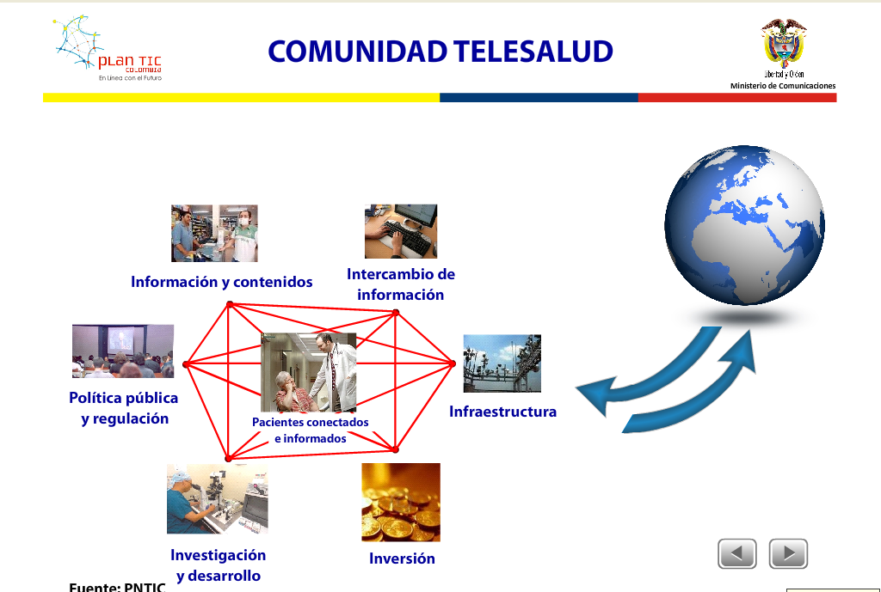
COMMUNITY E-HEALTH
Information and content
Information
exchange
Public policy and regulation
R&D
Infrastructure
Investment
Investment
Connected and
informed patients

b. Promote and support the establishment of regional networks to share e-health services, along the lines of the following framework:

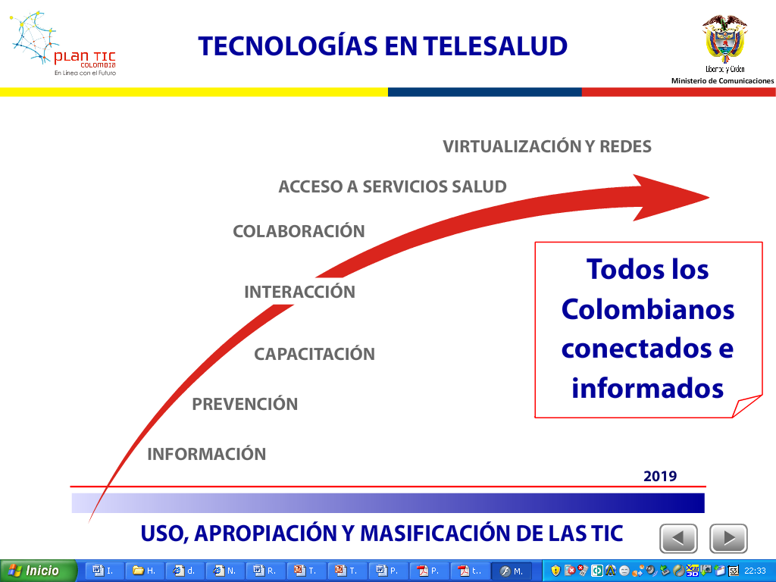
VIRTUAL WORKING AND NETWORKS
ACCESS TO HEALTH SERVICES
COLLABORATION
INTERACTION
TRAINING
PREVENTION
INFORMATION
All
Colombians
connected
and informed
E-HEALTH TECHNOLOGIES
SPREADING THE USE OF ICT
___________

