Facilitator’s Report

ITU World Café @ Council 2012 “Engendering Change”

Hosted by
Dr Hamadoun Touré
Secretary-General of ITU

and

Doreen Bogdan
Chief of Strategic Planning and Membership Department
Chair of the ITU Gender Task Force

12:30-15:30, Tuesday, 10 July 2012, Geneva
2nd floor, ITU Montbrillant Building

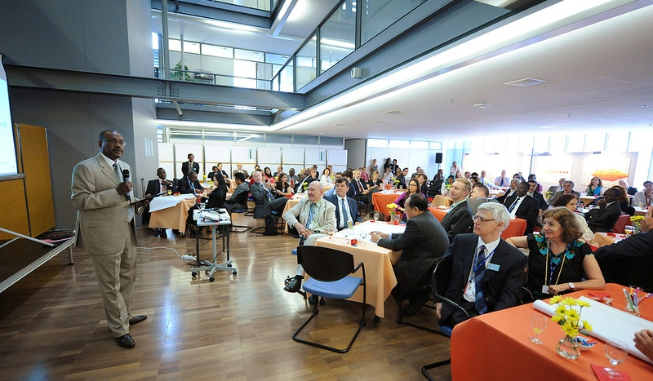
Summary
A vibrant World Café session, held at ITU Headquarters in Geneva, lent further volume to ITU's "gender mainstreaming" agenda. The event assembled over 100 representatives of ITU’s membership and staff in a collaborative conversation to uncover new ideas able to advance the organization’s commitment to enshrine gender in all ITU policy and strategic decisions.
Organized by the ITU Gender Task Force, the World Café was held as an informal working session of the ITU Council 2012 meeting, hosting an inclusive conversation enabling dialogue between government ministers, ICT industry executives, and a cross-section of ITU's staff spanning interns to top-level managers and elected officials.
Participants called on ITU to foster a gender-conscious organizational culture and to build its membership's capacity to follow suit.
Photo collection:
http://www.flickr.com/photos/itupictures/sets/72157630540069408/with/7554733034/
Video:
http://www.youtube.com/watch?v=gcNgUCAgz2U
Contents
1 Participants 3
2 Purpose and goals 3
3 ITU Gender Task Force 3
4 Opening remarks – Dr Hamadoun Touré, Secretary-General 3
5 Overall figures 4
6 Visual Summary of the Outcome 4
7 Methodology 4
8 The Collaborative Conversations 5
9 Results of Conversation 1 7
9.1 Summary of the trends in Conversation 1 7
9.2 Word Cloud for Conversation 1 7
10 Results of Conversation 2 8
10.1 Summary of the trends in Conversation 2 8
10.2 Word Cloud for Conversation 2 8
11 Midway Town Hall 9
12 Results of Conversationx 3 11
12.1 Summary of the trends in Conversation 3 11
12.2 Word Cloud for Conversation 3 11
13 Final Town Hall 12
14 Closing remarks: Ms Doreen Bogdan, Chief SPM 13
14.1 Next steps 13
15 Participants’ feedback 14
15.1 Overall figures 14
15.2 Overall impressions 14
15.3 Word Cloud - How did you like the World Café? 14
15.4 Word Cloud - Would you recommend using it again? 15
16 Organizers 16
Annex 1 - Full transcript of participants’ input in Conversation 1 17
Annex 2 - Full transcript of participants’ input in Conversation 2 20
Annex 3 - Full transcript of participants’ input in Conversation 3 24
Annex 4a - Full transcript – How did you like the World Café? 27
Annex 4b - Full transcript - Would you recommend using it again? 31
Annex 4c - Full transcript - Suggestions for improvements 34

Participants
The ITU World Café “Engendering Change” welcomed over 100 participants, ITU Council Members and ITU Staff, who formed a gender-balanced attendance of global thinkers, intent on moving the ITU Gender Mainstreaming agenda forward.

Purpose and goals
The World Café “Engendering Change” was an informal working session of Council 2012 during which ITU Council Members and ITU Staff shared views on how to promote gender mainstreaming in the Union’s activities.
The goals of the event were to:
- Empower individuals to contribute to gender mainstreaming
- Ensure active involvement of all participants
- Facilitate exchanges and networking
- Raise awareness on the need for gender equality
- Support the ITU Gender Task Force in the formulation of the new ITU Gender Policy

ITU Gender Task Force
The mandate of the new ITU Gender Task Force is to:
- Coordinate ITU’s action in the area of gender mainstreaming (PP Resolution 70)
- Propose ways to include gender perspective in ITU policies and programmes
- Coordinate with UN-Women on Implementation of System Wide Action Plan on Gender Mainstreaming (SWAP)
- Report progress to ITU governing bodies
- Raise awareness on the importance of gender mainstreaming
By organizing the World Café “Engendering Change”, the Task Force was able to harness the input and suggestions of ITU Council Members and ITU Staff.

Opening remarks – Dr Hamadoun Touré, Secretary-General
Dr Hamadoun I. Touré, Secretary-General of ITU welcomed all ITU Member States and ITU Staff participating in the World Café on Engendering Change. Dr Touré presented and summarized the ITU work on gender that has been already implemented in the organization’s activities. He highlighted events organized by ITU:
Girls in ICT Day – An ITU event celebrated Girls in ICT on 26 April 2012 in accordance with ITU Members decision to hold such events on the 4th Thursday of every April, Plenipotentiary Resolution 70 (Guadalajara, 2010).
Tech needs Girls – this ITU campaign seeks to achieve greater empowerment, equality, education and employment for girls through greater access to education and opportunities in the world of information and communication technologies (ICTs).
Girls in ICT - ITU has launched a new web portal focused on helping girls and women access training, job opportunities and career information in the fast-growing information and communication (ICT) sector: http://girlsinict.org/
World Telecommunication and Information Society Day - was celebrated on 17th of May 2012 - with the theme of “Women and girls in ICT”. The event included designating laureates of the WTISD Award: Cristina Fernández de Kirchner, President of Argentina, Sun Yafang, Chairman of Huawei, and Geena Davis - founder of the non-profit Geena Davis Institute on Gender in Media.
Dr Touré noted that ITU is determined to harness the full potential of ICT for the benefit of women and girls by eliminating gender disparities and by empowering women and girls to achieve their goals and meet their aspirations. The growing demand for ICT skills presents a unique window of opportunity to properly position girls and women in the industry and provide them with the tools necessary to succeed. In this context ITU has set up the ITU Gender Task Force which aims to move gender agenda forwards.
Dr Touré also recognized the importance of the reference to the ICTs in the RIO+20 outcome document agreed by UN Member States in Brazil. The critical role of information and communication technologies (ICT) in accelerating the implementation of sustainable development commitments is covered under Article 44 of the RIO+20 declaration’s text.
The Secretary-General pointed out that gender balance is based on “e”– key words which are: education, equality, employment and empowerment of women and that ITU is moving ahead with gender mainstreaming.
He encouraged participants to talk about gender equality in the World Café, ITU’s innovative collaborative tool and to engender change by making the world more fair, and especially more equal.

Overall figures
- Over 100 participants
- Three conversation rounds
- Total event duration: 2 hrs 30 min
- Over 300 ideas and suggestions

Visual Summary of the Outcome
A visual record summarizes the outcome of the World Café “Engendering Change”.

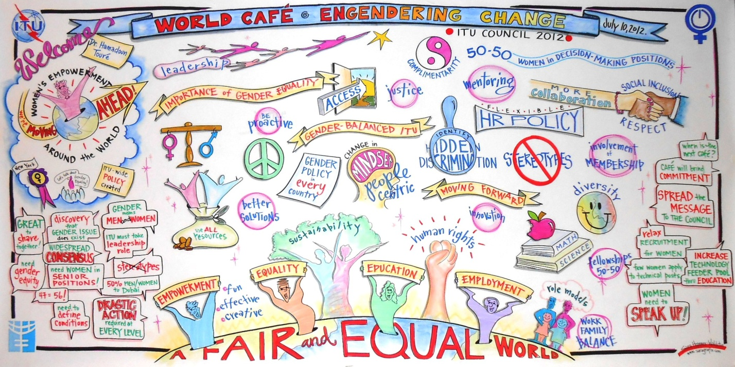

Methodology
The World Café is a collaborative conversation methodology in which participants are invited to explore questions together in an informal conversation setting. Amongst the key design principles of The World Café are the creation of hospitable space, exploring questions that matter, encouraging everyone’s contribution, connecting diverse perspectives, and sharing collective discoveries.
At the issue of a World Café, results are shared and analyzed for further follow-up actions and implementation.

The Collaborative Conversations
The event was moderated by Ms Saba Imru, Telecommunication Standardization Bureau, who presented the goals of the World Café Engendering Change, amongst which to empower participants to take part in improving gender equality.
She highlighted that conversation is a core process, exchanging ideas is already engendering change and an action in itself. She gave examples of previous ITU World Cafés, explained the concept and how it works in practice.
The participants of the World Café Engendering Change started by defining what they consider to be the qualities of a great conversation including trust, frankness, compassion and more listening than speaking.
They then proceeded to holding three rounds of collaborative conversations to explore three meaningful, strategic questions.

Theme | Goal
Conversation 1, Question 1  Why is achieving gender equality important? | Clarify what’s at stake
Conversation 2, Question 2  What will a gender-balanced ITU look like? | Envision the future
Conversation 3, Question 3  What is our unique individual contribution to moving this forward? | Determine steps forward

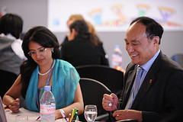 | The participants were assembled around tables in small groups for the three rounds of conversation (30 min. each) At the end of each round, the main ideas of each table were collected on post-it notes and participants changed tables for the next round, to meet new people and to carry ideas into the new group.
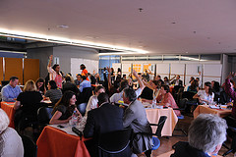 | Two town hall discussions were held to connect the various ideas that emerged, identify common trends, and determine the new initiatives and commitments.
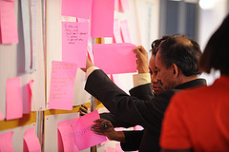 | In a World Café each individual contributes with ideas to the creation of the content.  The multiple exchanges amongst participants stimulated new thoughts and connections. The ideas emerging from each conversation were collected and clustered by topic area. The conclusions of each conversation were more than simply a catalogue of individual ideas but rather a combination of common and diverse views.  The co-created event produced very interesting content; it provided concrete results and invited engagement.

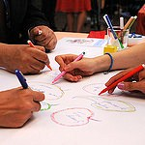 | 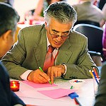
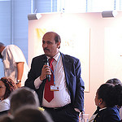 | 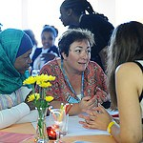

Results of Conversation 1

9.1 Summary of the trends in Conversation 1
During the first conversation participants explored the importance of achieving gender equality and the impact of this achievement
In response to Question 1 "Why is achieving gender equality important?" several perspectives emerged.
Social responsibility: participants acknowledged that gender balance has not yet been achieved; they focused on the need for social justice, equality, human rights, and ethics. They highlighted the opportunity to create a better future for the next generations.
Equal opportunities: participants underlined the need for equal access to education and career. Allowing equal opportunities for women will create a more diverse and balanced society.
Effectiveness and efficiency: participants noted that diversity allows for the inclusion of different perspectives and generates better solutions.
Economic development: participants noted that gender balance has a positive impact on profitability and economic development, it guarantees progress and sustainability.
Empowerment: participants highlighted the importance of empowering women so that they can reach their full potential and have an impact on their family and on society.
Changing mentality: participants called for a culture change through awareness, education, and the breaking down of stereotypes.
The full transcript of all the main ideas from Conversation 1 can be found in Annex 1.

9.2 Word Cloud for Conversation 1

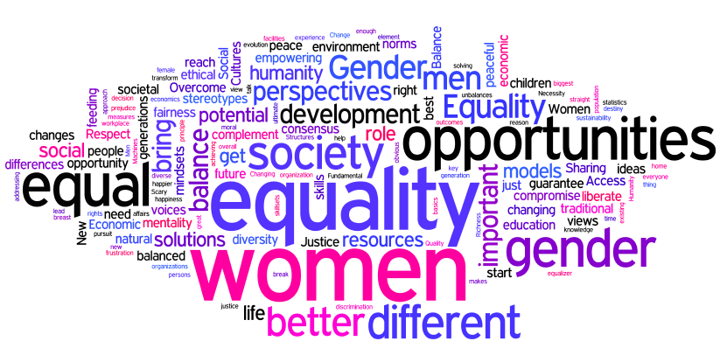

Results of Conversation 2

10.1 Summary of the trends in Conversation 2
During the second conversation, participants envisioned a future scenario in which gender balance had been achieved.
In response to Question 2 “What will a gender-balanced ITU look like?” the conversations produced a clear portrait of the future of the organization:
Women decision makers: a strong push emerged for gender balance at all levels of the organization, including professional, senior and elected official positions.
HR and recruitment policies: participants anticipated more proactive recruitment and selection policies to hire more women. Mentoring and training as tools to develop women in ICT careers.
Role of ITU Members: the conversations highlighted the role of ITU members in achieving gender equality through gender balanced delegations, more women as participants and chairing in ITU activities, 50% of fellowships to women, and funding for educational programmes.
Quota system: most comments were in favour of a 50% quota system in various areas (Elected Officials, RRB, Chairs, staff at all levels).
Better organization: participants noted that gender balance will improve the ITU in many ways including being more collaborative, having a broader perspective in decision making, being more creative and more people-focused. Moreover, ITU would improve its image as being a contemporary, modern, dynamic, and attractive organization.
Work life balance: Flexibility emerged as a key factor in a gender-balanced ITU. Flexibility will be reflected in career management; working arrangements and a management style supportive of work-life balance.
The full transcript of all the main ideas from Conversation 2 can be found in Annex 2.

10.2 Word Cloud for Conversation 2
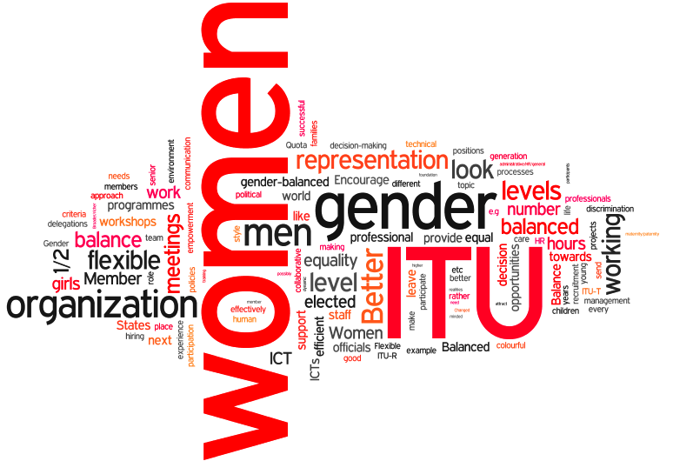

Midway Town Hall
After the second conversation round, a town hall session enabled participants to share experiences and insights with the whole group.
There was an overall agreement that gender equality is important and a shared understanding of the positive impact this will have on the organization and on society at large. The main concern was on how to implement such a change.
Participants commented on what they had discovered in the first two conversation rounds:
- We found a most liberal way to hear each other’s views, share experiences, be totally interactive on an equal basis and reach consensus.
- There is a surprisingly wide level of consensus on the importance of promoting gender equality. It’s not an issue, we all agree on this.
- Some of us in this room didn’t even think that there was a gender issue, now we are all aware that a gender issue does exist and are probably willing to think about it.
- The debate needs to move from gender equality to gender equity. That is where you positively discriminate, where a certain gender has been discriminated against.
- Apparently there are 47 man 56 women present; I conclude that in our ITU world 47 is 56.
- We see no women in elected positions in ITU. More women are needed in senior professional positions.
- Gender equality is something absolutely normal. When discussing it one can see that it needs certain conditions to be realized. The question then is how to realize it, what has to be put in place, how much will it take, what is needed to change things, to put the right framework.
- Courageous, important decisions have to be taken at the highest level by governments and by ITU management.
- Improving recruitment policies is an example of what can be done concretely.
- There is a broad consensus but the real discussion starts when we need to find solutions on what to do. A concrete action would be to achieve 50% of fellowships given to women for ITU Telecom World next October.
- ITU has a tremendous opportunity to show leadership not just internally, but outside in industry, making it possible for people to take advantage of the opportunities that ICT offers.
- We all have stereotypes that are very disadvantageous to the progress of women, so we have to begin to consciously think of these stereotypes which are barriers and see how we can remove them.
- There has been an important focus on girls but we should not disadvantage boys and create an imbalance again.

Rapporteurs summarized the trends emerging from of Conversation 1:
- It is a moral principle. All are equal so it is a question of human rights and a matter of creating a better future for future generations.
- Without equality there is no empowerment and by empowering women we empower families and societies. There must be a political will to involve women in state affairs.
- From an economy perspective, gender equality maximizes resources and profitability and is a key element for development.
- Gender statistics show the disparities.
- Breaking stereotypes is a challenge.
- Solutions are to be sought in different directions: in education, positive action, positive discrimination, fostering consensus and being more flexible in HR policies to get to gender equality. Much work has to be put into implementation of equal opportunities.

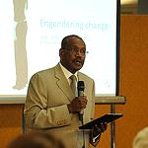 | 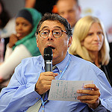
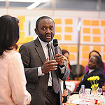 | 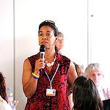
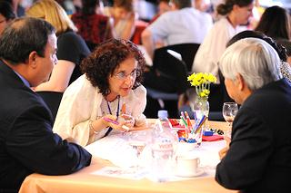 | 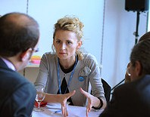

Results of Conversation 3

12.1 Summary of the trends in Conversation 3
In the third conversation, participants determined a number of concrete actions to be taken within the organization and externally.
In response to Question 3 “What is our unique individual contribution to moving this forward?” several ideas were identified for implementation:
Internal policies: proposed actions include the establishment of a gender policy, systematic reference to gender mainstreaming and gender sensitive language; improvement of recruitment procedures with concrete measures such as including a gender focal point in panels; fostering a more family-friendly work environment.
External policies: ITU Members are encouraged to nominate women for official ITU positions (Council and Study Group chairs, Elected Officials etc.); to include gender equality in their national policies, to promote women to leadership roles; and to support the granting of fellowships to women.
Advocacy and change of mentality: advocating for gender equality and encouraging a change of mindset are proposed by participants as key factors to engender change. Refusing discrimination, breaking stereotypes, promoting the gender agenda, sharing experiences and getting involved are concrete measures that can be taken by all on a daily basis.
Education and training: proposed actions focus on facilitating access to ICT education; mentoring for women and education on gender mainstreaming.
Personal commitment: participants expressed their individual commitment towards furthering the gender agenda through various means such as being proactive, being a role model, contributing to the cause and drafting a gender policy in their country.
The full transcript of all the main ideas from Conversation 3 can be found in Annex 3.

12.2 Word Cloud for Conversation 3

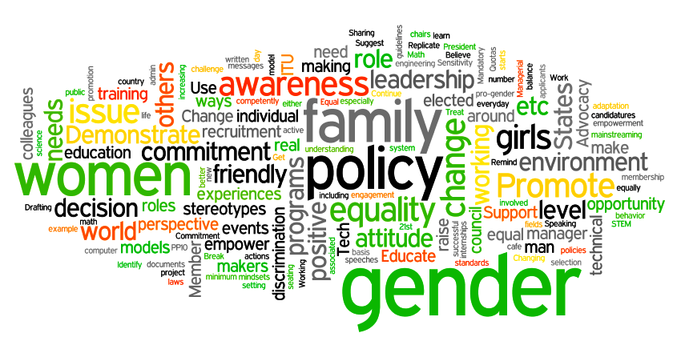

Final Town Hall
During the final town hall, participants expressed their final comments about the World Café on Engendering Change.
- ITU Council members recognized ITU’s leadership role, the personal involvement, commitment of all ITU elected officials, management and staff towards achieving gender equality and women empowerment.
- The active involvement of the Membership was stressed, in particular through greater gender balance in the participation to ITU meetings and activities as well as in national policies to empower women.
- When is the next World Café? We should hold more World Cafés, the new ITU collaborative way to collect actionable ideas. It is a great opportunity to exchange views, collect suggestions, formulate innovative solutions and get personal commitment from the people who are around the table.
- The outcome of this first experiment of World Café should be conveyed to Council and to all the Member States, particularly as some of the proposals are for Member States to implement.
- The ITU recruitment panel should include a gender focal point to institutionalize gender equality in the organization. Moreover, there should be a form of relaxation in recruitment for women, similar to what is in place for developing countries.
- We need more girls studying maths and engineering, obtaining technical degrees so that we get more women in leadership positions in these fields. All governments should take measures to encourage girls to go into the technology fields.
- The lists of applicants for technical positions show that there are in fact fewer women candidates.
- There are studies that show that women tend not to speak up. This is an opportunity to encourage them to speak up more in their families, in their work, in their countries. Managers should also encourage their women colleagues to speak up.
- It has been a very good experience to talk to our delegates and our colleagues in this World Café setting.

Rapporteurs summarized the trends emerging from of Conversations 2 and 3:
- Gender equality will foster more creative and an efficient organization.
- ITU Members should be involved and support the gender agenda by sending more women as delegates to ITU activities and by granting more fellowships to women.
- HR management and recruitment policies should be adapted with outreach to women, quotas to achieve 50% women representation and work-life balance.
- In the third and last conversation participants produced many concrete, actionable ideas on their unique contribution to move the gender agenda forward. Examples are: the commitment to drafting a national gender policy, undertaking the mentoring of women and identifying hidden discrimination.

Closing remarks: Ms Doreen Bogdan, Chief SPM

Closing remarks
Ms Doreen Bogdan – Chief of the Strategic Planning and Membership Department and Chair of the ITU Gender Task Force echoed the participants’ view that the meeting was a unique opportunity to engage in a discussion between ITU Council delegates and ITU staff. Thanks everyone.

14.1 Next steps
Ms Bogdan presented the next steps after the World Café Engendering Change:
- The presentation to Council 2012, on the following day, of Document 49 on Resolution 70 - Gender mainstreaming.
- A brief presentation to Council 2012, also on the following day, to report on the outcomes of the World Café together with the Graphic Record of the event, to be followed by a full report.
- ITU Gender Task Force, created to ensure the workflow and actions related to the Resolution 70, will support and coordinate the implementation of gender mainstreaming activities.
- The Gender Task Force will initiate work towards the establishment, by next year, of the ITU Gender Policy taking into account the output from the World Café Engendering Change.

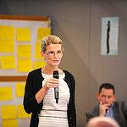 | 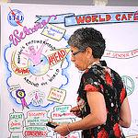
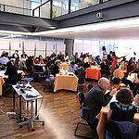 | 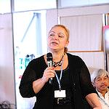

Participants’ feedback

15.1 Overall figures
73 forms were filled in, out of over 100 participants.
- Feedback forms received: 73
- Level of satisfaction 5: 39
- Level of satisfaction 4: 27
- Level of satisfaction 3: 7
- Recommend using World Café again: 70 (95% of respondents)

15.2 Overall impressions
A great majority of participants enjoyed the experience of the World Café and were enthusiastic about this innovative approach, considering it an extremely useful tool to exchange ideas in a collaborative atmosphere. The participatory concept of the World Café was highlighted as was the interactive, dynamic and open nature of the process.
The interaction between ITU Council Members and ITU Staff was appreciated as an excellent opportunity to meet new people and hold fruitful conversations on an important topic.
Attendees expressed the desire that the outcomes of the World Café be put into action.
The full transcript of the feedback forms can be found in Annexes 4a, 4b and 4c.

15.3 Word Cloud - How did you like the World Café?

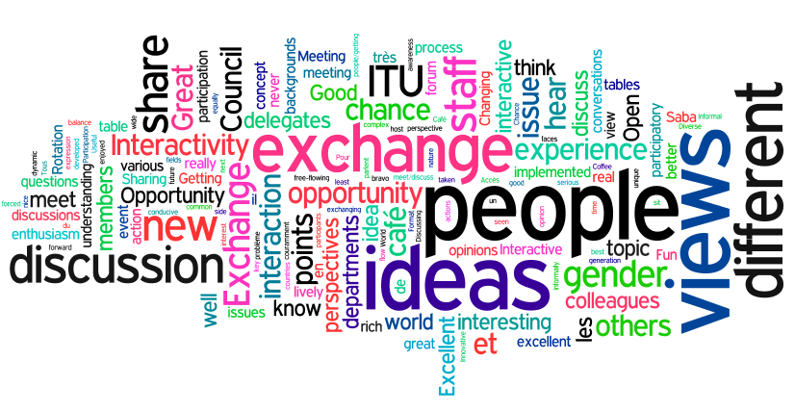

15.4 Word Cloud - Would you recommend using it again?
95% of respondents (70 out 73 respondents) recommended the continued use of the World Café, ITU’s innovative collaborative tool. Participants suggested different contexts in which to use this tool such as Council, WCIT, WTSA, PP, RC and for various purposes including brainstorming, problem solving, team building and also as a follow-up session to the present event on gender mainstreaming.

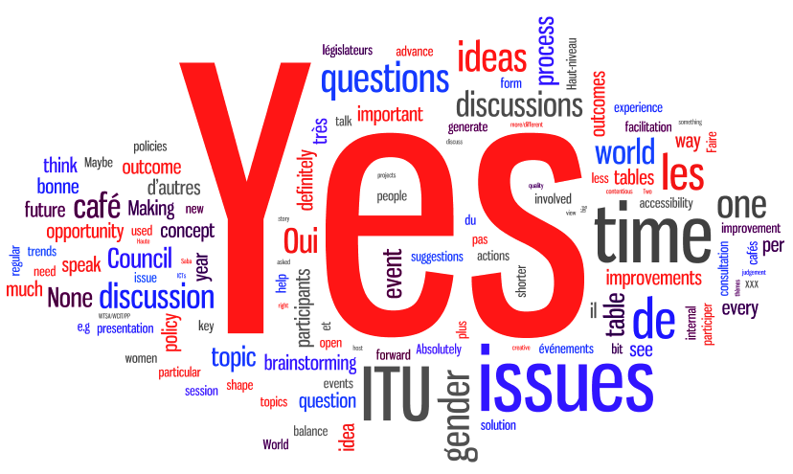

Organizers

The organization of the ITU Council 2012 World Café “Engendering Change” was in itself a successful cross-departmental collaborative effort, demonstrating the lively, dynamic team-spirit present in the Union.

Hosts | Dr Hamadoun Touré, Secretary-General of ITU  Ms Doreen Bogdan, Chief Strategic Planning and Membership Department (SPM); Chair of the ITU Gender Task Force
Participants | ITU Council Members and ITU Staff
Facilitator | Saba Imru, Telecommunication Standardization Bureau
Rapporteurs | Eric Dalhen, Anna Polomska, Béatrice Pluchon  Pradeep Rasad, Florence Tunzi
Visuals | Jesús Vicente
Graphic Recorder | Sara Heppner-Waldston (external consultant)
ITU Gender Task Force and representatives | Michele Coat, Marianne Dimier, Enrica Ferraro  Nicolas Jammes, Ewandro Magalhaes, Thierry Perewostchikow  Alessandra Pileri, Beatrice Pluchon, Pradeep Prasad  Kadiatou Sall-Beye, Susan Schorr, Florence Tunzi, Julia Watt  Marianne Wilson
Organizing Team | Emer Windsor, Isabel Ribalda  Wendy Hinds-Anagbogu, Diaba Guye, Maria Furcy
Administration | Jude Mariani, Mardjaneh Khabiri-Herscu
Logistics | Patrick Cailler, Jack Le Van, Cedric Mateu, Marc Zanou
Communications | Sarah Parkes, Matthew Dalais
Protocol | Patricia Benoit-Guyot
Council | Elaine Baron
Videography and Photography | Maximilian Jacobsen-Gonzales  Rowan Farrell  Elisabeth Kiatsurayanon
Audio | Jean Claude Ajavon, Shahid Merchant

Annex 1
Full transcript of participants’ input in Conversation 1
Question 1
Why is achieving gender equality important?
Social responsibility
It’s obvious! Why exclude more than half of the population?
Gender equality facilitates peace
Society will be more peaceful
Conflict resolution
Half of humanity
For balance and wisdom
All are equal
For fairness and humanity
It’s fair
Because it is an ethical principle
Better future for future generation
For development of society
Social inclusion
Foundation of society
Quality of life - equal rights, equal opportunities, equal treatment
Equality is important: The pursuit of happiness – women just get what they want and they will be happy
Humanity and kindness - sensibility
Respect
Eliminate social prejudice
Cultures and mindsets changing
Responsibility
It’s natural
To bring peace
Necessity of modern life
It’s an ethical moral question
Individual or persons not just defined by men or women
Overcome traditional norms
Richness of diversity
Justice
The reason why achieving gender equality is important because it has not been achieved
It's more fun
More colorful world
Human right, fairness, justice
Justice
Equal opportunities
Fundamental human right = equal opportunity
Equality of opportunities, self-actualization, the power to reach your potential
Access to the opportunity
Complementarity
Balance of views
Because both men and women should have access to resources and opportunities
Equality is a natural thing- inequality is man-made – so, why NOT equal??
To guarantee equal opportunities
Change societal mentality towards status of women
Balance of views, compromise the differences
To transform certain societal and cultural unbalances
Intervention of women to attenuate men’s aggressively
To break stereotypes for both men and women
With gender equality, the overall result for society will be better
A gender balanced society is a happier, prosperous and peaceful society
Men and women are different but complement each other
To provide better chances to all the humanity
Rights/opportunities
Participation
Respect for equal opportunities and for the person
Sharing
Want environment that allows everyone to bring all their talents and passions to the community
Equality is important: so people can be their best, true selves
Gender balance instead of gender equality
Access
Equality means equal opportunities
Scary gender equality statistics for high level management
Math is the ultimate equalizer
Effectiveness & efficiency
Exposure to different points of view
Improves decision making
Foster consensus
Structures systems equality
More voices at the table, different viewpoints, different perspectives, better solutions from a diverse group
Partnerships
Positive discrimination
But mere presence is not enough - women’s voices need to be valued
More solution-focused approached. Focus on end results
More diversity bring better solutions
Establish strong role models for nest generations
Living equality: positive role models for next generations
Maximizing resources
What are the measures that will be taken to practically achieve gender balance and equality: recruit young women, promote existing female staff
Do we really have to start from the beginning every time we talk about this?
To liberate men - so they get a richer life experience, their own work-life balance, can create a vicious circle as children get a more balanced rounded upbringing
Different perspectives and skillsets which together lead to great things
Economic Development
Enhancing economic development
Economic empowerment & independence
Gender equality – smart economics
It's profitable
To guarantee sustainability
With gender equality, social and economic development will be better
Progress and evolution
Innovation
From the biggest pool of different ideas & resources via the richest discussion to the best outcomes – the most stable consensus
Technological changes have allowed women to progress: Machines, ICT, birth control, baby feeding, breast feeding facilities, etc.
Gender equality is a key element for development
We have to start from the fundamental and the basics: - changes in surroundings and environment, home- society – workplace; compromise the differences
Empowerment
We all need to live to our full potential
Without equality, people cannot attain their potential
Political will to encourage women to participate in state affairs
New role models, new leadership ideas
Women to liberate themselves from the fear of…
Sharing knowledge for problem solving/sharing
Empowering women = empowering families; engendering women = empowering society
Women have to be less passive to be in charge of their destiny
Gender equality is important because women can avoid frustration
Correct the past principles
Changing mentality
It will help reduce stereotypes
It’s better for the children
To bring different perspectives, skills and backgrounds to organizations
Overcome traditional norms
Cultures and mindsets changing
Integrate different perspectives in addressing problems and finding solutions
Education
Women’s education: social interaction skills
Men’s education: straight ways to reach objectives
New opportunities for innovation - scientific, technical with a holistic approach
Diversity for gender makes a well-rounded organization because men and women complement each other
Very difficult issue with its friends: SOLUTIONS

Annex 2
Full transcript of participants’ input in Conversation 2
Question 2
What will a gender-balanced ITU look like?
Women decision makers
 | Balance between gender at all levels in ITU
 | More women elected as ITU officials
 | Equalize number of men and women at all levels in ITU
 | Women at ITU top levels
 | More women in professional grades
 | To have women in elected official ranks (e.g. SG position)
 | Encourage women representation at the professional level, not just administrative/HR/general levels
 | Balance decision making which is not biased based on gender
 | Successful "ICT-women" as ambassadors for ITU/ICT
 | Balanced at the higher decision making level
 | Women = more social oriented projects without ignoring the other important issues
 | The equal gender representation in the management
 | Both male and female elected officials
 | To see more women in senior positions (P levels) not only as G
 | Gender balanced teams are a good combination
 | More positions of responsibility for women
 | The gender empowerment it is not a matter of number in working place but rather equality in representation and decision-making process
 | Leadership role in ICT advocacy as a tool for creating opportunities in all sectors
HR and recruitment policies
 | Internal ITU - Proactive recruitment policies. Better outreach to women
 | If gender balanced would be more efficient, especially if developing programmes for sponsoring women in ICT studies
 | Elimination of barriers in the progression of women in the corporate world
 | Hire more girls (engineers) straight from university
 | Attract proactivity, more women to apply for posts at ITU
 | Positive discrimination?
 | Relaxation in recruitment criteria (for women)
 | Do we need to make each and every grade and division/dept. gender balanced?
 | New selection criteria for ITU projects/programmes, e.g. impact on women
 | Young women professional; recruit from universities
 | Mentoring and role models for young girls
 | ICT Academy - training for both girls and boys
 | Mentor program for senior professionals to pass on wisdom and experience to young women
Role of ITU Members
 | Member States/Sector Members to encourage women to participate in ITU meetings
 | 50% of fellowships to women
 | More women heads of delegations
 | Removal of political obstacles and political influence
 | More women chairing ITU-R and ITU-T study groups and working parties
 | More women participating in the technical work of the ITU-R and ITU-T
 | Setting -up of committees, equal representation
 | More women in Council meetings
 | Encourage Member States to send more women to ITU programmes: 1st 3 years
 | Oblige Member States over the next 3 years; provide incentives and make them develop more women participants at ITU workshops and meetings
 | Set up a foundation with funds towards financing education of deserving girls in ICTs
 | More women representation in ITU international and regional conferences
 | Encourage women participation in the ITU's activities towards the countries who participate to meetings
 | Increase fellowships to give experience to the gender that doesn't have it
 | ITU to support ICS/science/engineering programmes in schools/universities
 | Incentivize Member States to send women to workshops: mandate only gender-balanced workshops
 | Promote importance of women & ICTs on home page of website (advocate ICTs provide opportunities)
 | Balanced approach to projects, focused
 | Better gender balanced in delegations attending ITU meetings
 | Gender equality in staff and delegates
Quota system
 | Aim to achieve 50% women and 50% men
 | Balance of men and women at all levels of organization:
 | - 1/2 elected officials
 | - 1/2 members of the RRB
 | - 1/2 chairmen/chairwomen
 | - 1/2 staff at every level
 | - 1/2 applicants & nominees
 | Establish a quota at delegation level and at ITU level for women representation
 | Quota - by 2020, x% of P staff to be women
 | Deliberate measures to promote equality - Quotas
 | Better gender balance for G, P and above
 | Competence should be prioritized, as giving quotas to gender and offering special categories perpetuates discrimination rather than fight it!
 | Equal number & participation
 | Statistics - unbalanced number in ITU
 | Same rights to everybody - women and men - in ITU
Better organization
 | No gender stereotypes
 | Women have same capacities with men only with different ways/style to solve problems
 | Better strategic planning at HR level - that takes into consideration the needs of women and men
 | A more successful organization
 | ITU will set up an example for the next generation
 | Equitable versus equality
 | Capacity building to provide equal opportunity
 | Better managed ITU
 | Changed mentality of both men and women
 | Pink and colourful
 | Gender-balanced ITU = Multitasks, consensus, colourful and smile
 | Less technical
 | Tech - empowerment - ITU (circle)
 | Fun
 | Would a gender-balanced ITU function better?
 | Abolish male-like military/hierarchical organization structure & communication style. Replace with more informal communication and flat organization
 | A place where gender is no longer a topic of discussion
 | ITU will look more: modern, dynamic, human, practical, efficient
 | Attention to detail
 | ITU would possibly look the same with gender balance
 | More collaborative organization
 | Managers would embrace life realities - respect employees' needs, holistic approach. A happy team member will work more effectively, more productively
 | Broader/richer perspective
 | ITU will attract the best expertise & professionals
 | Merit-based organization
 | Effective
 | More open minded organization - new ideas
 | Behind a successful ITU there is gender balance
ITU would look like an organization that gives opportunities to women:
- for the next generation
- for our membership
- for the ICT sector
 | More people-centric
 | Creative
 | More collaborative decision-making but maybe slower responses
 | More understanding
 | More people focused = +participation
 | ITU would look more contemporary if gender balanced
 | A gender-balanced ITU would be a good example to the outside world
ITU will be more:
- competitive
- efficient
- fair
 | Future World Café topic: Save Men!
 | Some men should leave behind their chauvinism
 | Very different
 | Different priorities
 | ITU would look like the WSIS team!
 | Multitasking
Work Life Balance
 | Better support for families - through hiring processes, support for spouses who have relocated, etc.
 | More flexible hours, more flexible career path, more teleworking, more job sharing
 | Flexible working hours
 | More flexible hiring processes - to cope with maternity/paternity leave, part-time working
 | Solution to spouse employment
 | Be more green - Teleworking adopted on a wide-spread basis
 | Provide flexible time/working environment for women and men with children
 | Flexible working hours
 | More flexible working hours, environment for couples with children
 | People looked after better, work-life balance improved
 | Would reflect the conformity of human kind
 | More collaboration & flexibility (paternity leave encouraged, crèches, flexi-time)
 | It will look like - Changing management style towards more flexible and gentle
 | Flexibility
 | Child care and after-school care, etc., to help those with families balance their commitments and work more effectively
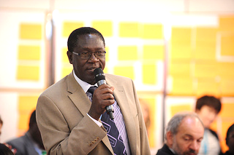 |  | 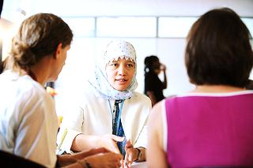
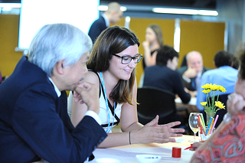 |  | 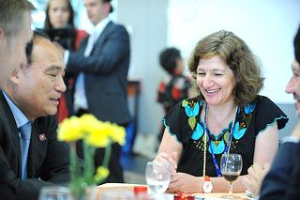

Annex 3
Full transcript of participants’ input in Conversation 3
Question 3
What is our unique individual contribution to moving this forward?
Internal policies
Demonstrate the commitment in the policy and written guidelines for gender equality
Refer to Resolution 70, PP10
Include gender perspective in documents, speeches to raise awareness
Remind everyone of gender equity principles and work on a gender policy at ITU
An end to Mrs. Chairman: President or chairperson
Equal participation in decision making and events like this one
Convey to ITU council the results of the first experiment of the world cafe in brief
Further minimum recruitment standards, including gender
Establish criteria together with associated action plan to implement gender balance
Appoint gender focal point in ITU recruitment panel
Look at gender policies: Hiring? Quotas?
Identify hidden discrimination in HR/staffing rules and find ways to overcome them
Spouse employment (ICSC)
Reflect 21st century at ITU: more admin + development, not just technical
Demonstrate a family friendly working environment
Cultivate a more family-friendly, “understanding” leadership
External policies
Members States should nominate women for elected officials, chairs of council, study groups, etc.
Mandatory gender balanced candidatures (1 from each gender) for elected functions
Member States and ITU create fellowships for women
Council members to identify female university students for internships either in Geneva or remotely at ITU
All nations to celebrate ICT for girls day
Change legislations/laws
Gender equality to be included in policy making
Support increasing leadership roles for women in governments
Tech needs girls: awareness; leadership; membership engagement; collaboration; issue + solution oriented
Advocacy and change of mentality
Promote a change in cultural aspects - national level and family level
Working on (trying to) change mentality around us (world, family, environment)
Positive attitudes to women applicants in the selection process
Men and women = in family roles and housework
Continue looking at the issue
Changing mindsets
Exchange ideas and experiences
Promote positive role models in ITU
Change of mindset - raise the issue (policy makers)
Speak up
Suggest policy
Suppress local barriers to job market for spouses
Raise awareness/capacity building to foster gender equality for Member States
We need role models: women in high management/decision makers
Advocacy for project/policy with gender perspectives
Sharing our own positive experiences
Break down our own prejudice on a daily basis
Stand up, challenge the system, break stereotypes
Sensitizing others at every opportunity (especially as a dept./region director)
Encourage women around us with self confidence
Promote changes in attitudes
Refuse any form of discrimination in everyday life
ITU setting an example: public messages, campaigns
Speaking up on things that are important
Breaking stereotypes
Get involved
Promote flexibility and adaptation
Use any opportunity to advance the issue
Replicate World Cafés at other ITU events for awareness, commitment (individual)
Understand: what is gender equality? Treat yourself equally, empower others
Education and training
Find ways to empower more girls studying math and sciences
Educate a girl, contribute to girls’ empowerment programs
We need real actions- real decision: improve/equal education for both men and women; improve facilities (health etc. equal for both man and women)
Mentor others, women who are new to working in ITU
Prepare promotion of women by mentoring/training programs
Support STEM (Science, Tech, Engineering, Math) programs
Help increase the number of women in technical fields (engineering, computer science, etc.)
Educate managers to better know their employees
Use of education to fill the access gap
Mentoring
Sensitivity - change starts from within - accommodation of individual needs of both genders – behaviour - hiring
Believe in the gender perspective
Know, learn more about gender mainstreaming
Target recruitment skill-based
Managerial exchange of experience on pro-gender activities with other ITU colleagues
Personal commitment
Work professionally, competently, show your skills and dynamism
Contribution as a professional, a mother, a wife
Commitment to the cause
Being competitive
Be successful and a positive role model
Being yourself
Each of us needs to make a change of attitude at family, community & workplace level
Be proactive make myself known for my manager
Highlight achievements by colleagues and subordinates
Be more active
Drafting gender policy in my country

Annex 4a
Full transcript – How did you like the World Café?
1. How did you like the World Café?
5 | VERY satisfied | 53% (39/73)
4 |  | 37% (27/73)
3 | Neutral | 10% (7/73)
2 |  | 0% (0/73)
1 | NOT satisfied | 0% (0/73)
Comment:
- Very interesting and useful program
- Hope it will not be only for talks/brainstorming but also for action/decisions to be made
- We could combine this technique with other knowledge management techniques for better results
- It was a very lively discussion
- The real value will only be seen in the actions that are implemented
- It was an excellent experience
- I liked it very well. It is a new approach for me
- It has been a wonderful experience!
- Very promising event: To be taken out into the real world (coffee breaks with same topic)
- A fantastic participating way to obtain ideas on a topic of interest to all
- To be held in the future (next Council)
- Innovative (at least for me)
- I really enjoyed it!
- Meeting between men and women with a clear discussion
- Good idea to include Council representation
- Useful exchange of views
- Fun and productive
- It enables to discuss freely with both gender and as a result better understanding of the key ideas that are being discussed
- I hope "action points" are developed
- No translation for other languages
- To many general comments
- It is very nice to share thoughts, so each of us can think how we can improve the situation form his side
- The host was excellent
- It was a great experience to sit down and informally exchange views on the issue
- Excellent program, I am looking forward to the report
- Very valuable experience
- Great idea, which was very well implemented and unique opportunity to speak to Council Members
- The interaction was rich!
- Great and very innovative event from ITU!
- More delegates would have been more effective!
- Excellent free-flowing forum
- Very interesting and efficient concept
- It forced me to think of the issue. I had never given it much thought until now
- Congratulations!
- First time participant. Very impressed by the process
- Excellent idea/concept
- Nice gathering
- Très fantastique et géniale

What did you like the best?
- The exchange on a complex subject
- The very purpose of "World Café": exchanging with others
- The interaction with people in their understanding of gender issues
- The World Café concept itself
- Exchange of different views
- I found out more about my colleagues than about the delegates (which I seemed to know better)
- Exchange of ideas, awareness of people's prejudices
- The lively discussions
- Accès facile et informel avec les délégués et membres élus, très sympa!
- L’ambiance et le travail en groupe très enrichissant. Partage d’expériences.
- We can hear lots of different views more openly and more interactively
- We have more chance to express our views
- Good interaction, enthusiasm, people from various fields and countries enriches the discussion
- Mixing of staff with council members
- Sharing of ideas
- Exchange of opinion
- Getting to know colleagues and share points of view
- Coffee!
- The enthusiasm of the participants
- Participation by all and openness
- Getting to know ITU employees from other departments
- Interactivity
- To exchange points of view with different people with different cultures
- Opportunity to share the views on this important issue
- Format, brainstorming, meeting people
- Hearing the opinions of a varied group of people and having the opportunity to really think about this issue
- Opportunity of meet/discuss with colleagues
- The possibility to exchange ideas by changing tables for each question
- The questions were very interesting
- Pour améliorer « café du monde », il faudra beaucoup plus prendre en compte les questions de langue. Tous les francophones ne parlent pas couramment l’anglais. Donc il se pose souvent un problème de compréhension.
- Rotation
- To hear others' perspectives; gender, geography, age, culture
- The participatory nature of the café
- Friendly atmosphere prevailing the World Café
- Interactivity, sharing
- Meeting people I had never met before
- Sharing equally
- Discussions and exchange of ideas and opinions
- Changing table to exchange ideas with different people
- The discussion - so that we can throw our ideas and have interaction from others - from Council members and also from ITU staff
- Interaction between delegates and ITU staff
- The chance to meet new people and hear their perspective
- Rotation - hence inclusion
- Dynamism, gender balance
- Table conversations
- Chance to discuss issues with fresh vision and new faces
- Changing tables and meeting new people, getting more perspectives
- The participation of the Members in the discussion
- Atmosphere very conducive
- Really well represented and participation very good
- Exchange of views. Possibility to discuss as small groups
- Great discussion, interesting people
- Very dynamic and participatory. Great leadership by Saba! Very dense, rich and fun
- Open, interactive
- The informal environment and the table changes, giving us the chance to meet new people with different views
- The opportunity to meet and talk with ITU staff and share views across cultures/countries
- Learning from others points of views
- Exchange views/discussion with Member States Delegates
- Open and honest conversations with a wide range of people from different backgrounds
- The opportunity to share ideas with people working in different departments and having different backgrounds
- Free flow of ideas
- Diversity of the ideas
- Openness in expression
- The chance to share views, hear new ideas and find common ground
- Interactivity, idea generation
- Interactivity
- Very interactive
- The moderator was great, bravo Saba!
- Animation & exchange
- Discussing with people from diverse backgrounds/perspectives - mix of delegates & staff
- "Good energy" to create policy
- Fun interactive process for a "serious" topic
- Interacting with ITU staff from various departments
- Interactive, open, action
- Open discussion
- Interactive discussions
- Diverse perspectives
- Thematic forum
- Opportunity to exchange views
- Le quota genre

Annex 4b
Full transcript - Would you recommend using it again?
Would you recommend using this process again?
Yes = 70/73 (95%)
(n.a.) = 3/73 (7%)
No = 0/73 (0%)
If yes, in what context?
- Yes
- Yes
- Yes, because there is more interaction in World Cafés
- Yes
- Yes, outside ITU buildings
- Yes, brainstorming has always been a way to generate ideas!
- Yes, it is a very good process for introduction of any idea
- Oui, définitivement très bonne idée. Excellent organization, très bonne facilitation. Serait bien 2X ou 3X par an
- Oui, aux plénipotentiaires, CR, et d’autres événements de Haute importance
- Yes
- Yes: Cyber securities; and how to solve problem-gender balance (find the solution)
- Yes, WTSA-12, Workshops
- Yes, at Bureau's level - regular (1 per year)
- Yes, it's an easy way of making conscience of certain issues
- Yes
- Multi stakeholder discussions
- Raising a healthy family with balanced responsibility
- Yes, as a follow up to see the outcomes
- Yes
- Yes, during WTSA/WCIT/PP
- Yes, to discuss other important issues
- Yes, accessibility
- Yes, as a Council delegate, I'd welcome the opportunity to participate again
- Yes, but at a more mobile event
- Yes, within departments
- Absolutely. For any topic!
- Oui, le présent contexte n’est pas mal aussi que dans d’autres événements de l’UIT (les Plénipotentiaires, …)
- Yes, in real-life ICT related issues
- Duplicate for regional offices
- Yes, for future Council meetings
- Yes. The same working on the results of this World Café and the implementations focussed and finalized
- Using the World Café in other cases of social problems
- Yes, any topic which needs creative ideas
- Yes, of course!
- Yes. Repeat the experience at future Council session and other conferences in ITU
- Definitely yes, it can be used to brainstorm any important issue
- Divergent phases of problem presentation & early solution
- Yes
- Yes, surely. In context of sharing of useful practices or applied outcomes in a year or so
- Yes, pretty much anything benefits form this process
- Yes! At preparatory sessions for WCIT & WRC; maybe to get ideas for the operational plans for the Bureaus & Secretariat!
- Yes, in my work area in my country
- Yes, multiple possibilities for brainstorming & consolidating
- I think gender issues and "rights" need further discussion
- Yes
- Absolutely. I am hooked! Saba, we will be after you to host a World Café every week!
- The process allows one to freely contribute raised issues without fear of judgement
- Yes, in other upcoming trends as a form of consultation
- Yes, I think the process was excellent and the facilitation was superb.
- Yes
- Yes, sure.
- Yes!
- Yes, definitely. Main issues, campaigns and policy changes
- Yes, in creation of new policies, guidelines, etc.
- Yes, to move this gender issues forward and to gather consensus on other contentious issues
- Yes!
- Yes, the concept should be repeated in all areas of ITU's critical issues
- Yes, at all ITU events
- Yes! To shape future ITU strategies on all subjects
- Yes definitely
- Yes, many topics possible
- Yes, definitely! In each topic that requests improvement (ITU events, sectors brainstorming for development)
- Yes, policy developments. Brings forth a plethora of ideas from "all walks of life"
- Yes, team building exercises
- Yes, around key issues, e.g. accessibility
- Yes, once a year
- Yes, hot issues in international affairs
- Yes, open consultation on Internet/WCIT public policy issues
- Oui
- Oui, l’initiative est très bonne et il faudrait organiser d’autres rencontres de Haut-niveau

Annex 4c
Full transcript - Suggestions for improvements
A great number of participants suggested to have more time for the conversations, while a few would have liked them to be shorter. Others suggested more diverse participation and more frequent use of the World Cafés.
An important concern was expressed regarding language, since non-English speaking participants were not able to fully engage in the event.

What are your suggestions for improvements
- Do it more often
- Follow-up on ideas
- Maybe give questions to participants in advance
- More round tables, which means more time
- The implementation of the action in gender issue because we speak too much but no actions
- Apply the concept to more concrete topics
- More time devoted to the discussions
- Targeted recruitment-skill based
- Spouse employment (ISCS)
- More time
- Maybe there should be another rule: that every person at the table has to say something
- Moins de thèmes de discussion plus de temps pour les discussions
- Faire participer les législateurs, les décideurs.
- Would like to see the outcome and some improvements in the gender balance in ITU
- Invite more/different backgrounds
- More information/hints to participants (before the event) about what to talk about
- None
- A little more help and direction on Question 3
- We could improve the key questions asked - that require more discussions
- Be open and speak the truth
- Making it a bit shorter
- More time to respond to each question
- To associate other UN organizations
- To think about HR regulations and some particular improvements for the ITU to achieve gender quality ACTIONS!
- To have opportunity to prepare in advance, e.g. to distribute a short presentation on the event beforehand
- Engage more males
- None!
- More switching of tables on the same topic, less time with the same group
- Less facilitator talk time, less theory
- Have hosts share in Plenary one idea per table and only if a new one
- Communicate right there, not later
- More intervention of management in the discussions
- Pour améliorer « café du monde », il faudra beaucoup plus prendre en compte les questions de langue. Tous les francophones ne parlent pas couramment l’anglais. Donc il se pose souvent un problème de compréhension.
- Allowing or trying to make more to join for fresh views
- All participants at the café need to be fully involved by contributing individually to the final outcome (suggestions, personal experience, arguments)
- A way to obtain feedback on individual commitments would be apt
- Summarize the ideas put forward
- Questions were too general. Two questions are enough. At the third one, people were willing to leave
- More time
- To have the similar session in every ITU big meeting/events
- Keep it shorter
- More chairs in the room
- Five people per table
- Making more use of ICTs during the meeting
- Not an improvement but promote the idea among ITU membership
- Encourage women to speak up in Town Hall!
- Start with a more positive question. All the women at my table were dismayed that we were starting up a question about why gender diversity is important
- Create more opportunity for other groups to be involved in the discussion
- Better coffee!
- Focus one discussion on internal ITU "structure" and one on internal member states issues
- More frequent World Cafés and more tables. More questions?
- Making the questions available before the event
- Well done. I only encourage you to do this at other ITU conferences/events
- Some background reading to do before illustrating main view and trends
- More sum up of the outcomes of the questions/trends
- More time for discussion and more moderators
- None
- More time could generate much more
- None - it was great!
- It was a bit rushed, have a dedicated afternoon or even a day
- Hold World Cafés on more occasions
- It should be used as a decision-making tool & to help people/management to shape policies
- Do it more regularly
- No particular suggestion. Perhaps to lengthen the time to have more time to debate
- To continue this concept & include more Council Members
- More time (waiting to see outcome)
- Should bring a success story (examples)
- Taking actions through projects
- Keeping the World Café a regular activity
- Faire participer les législateurs de Haut-niveau

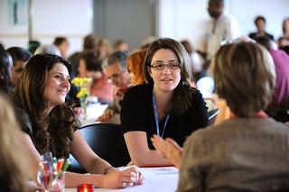 | 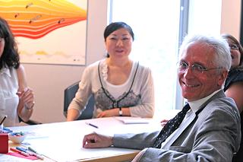
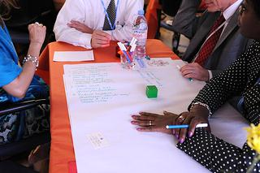 | 



