English only

information technology facilities for delegates
at Council 2007
ITU Document Management System (ITU DMS) Services
This document is aimed at helping users of the ITU website to take full advantage of the services offered by the ITU Document Management System (ITU DMS), concerning Conference documents.
These services are described through the following paragraphs:
1 Gaining access to the electronic version of the Conference documents
2 Keeping track of recent document additions
3 Downloading multiple documents at once
4 Laptop synchronization with the ITU website
5 Getting short file names for Conference documents
6 Direct booking of the Conference sessions in the user agenda

1 Gaining access to the electronic version of the Conference documents
The electronic versions of the Conference documents are available on the ITU website, at the following location:
http://www.itu.int/council/C2007/index.html
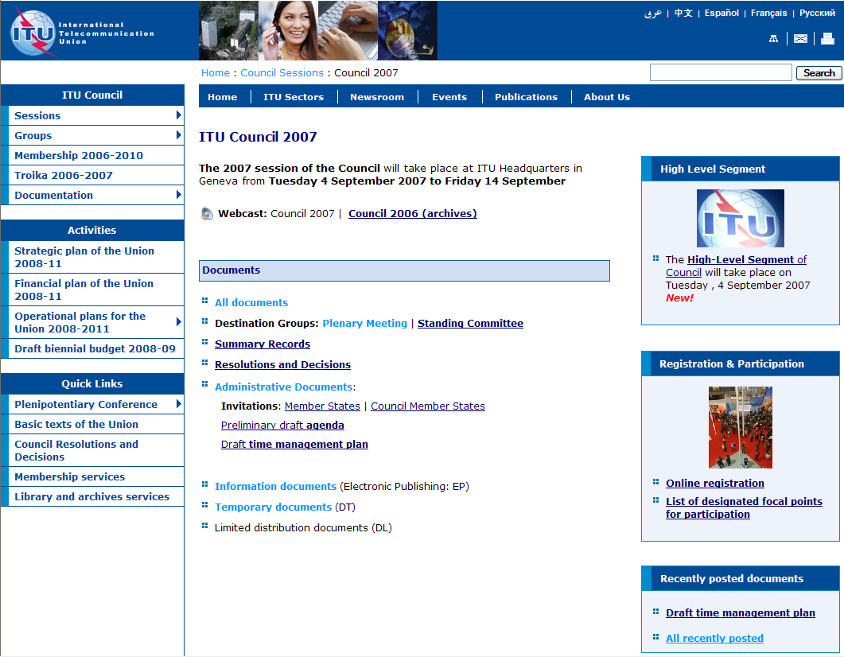

Documents are listed in reverse order along with their: reception date, source, title and destination:
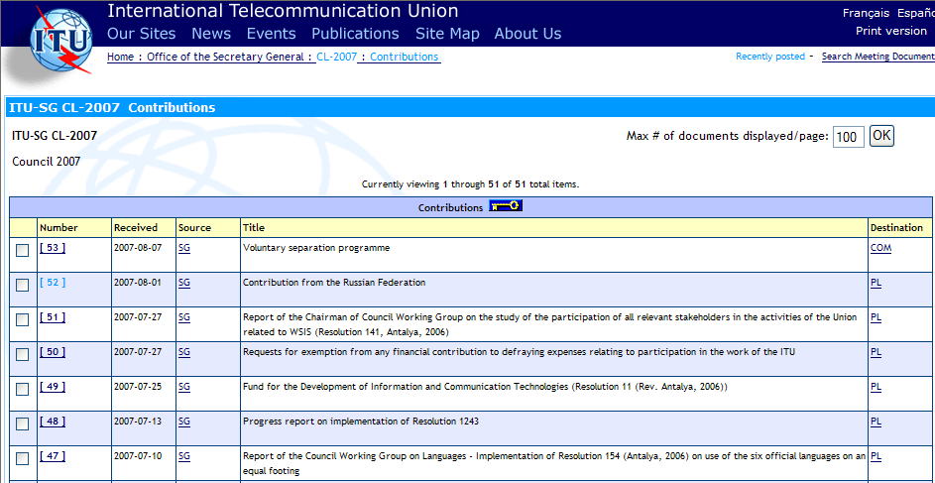
http://www.itu.int/md/S07-CL-C/en
Details about each document are available, comprising eventual revisions, addenda, corrigenda, and the different language versions available. Each version can be downloaded by clicking on the corresponding link: http://www.itu.int/md/S07-CL-C-0042/en
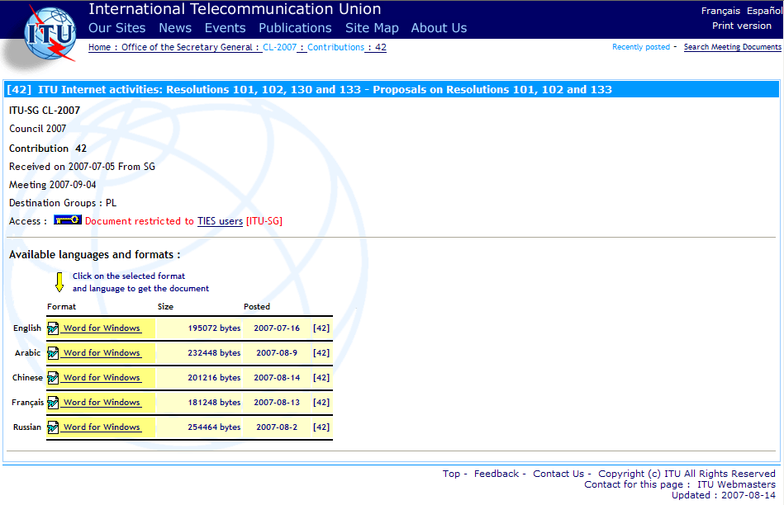

2 Keeping track of recent document additions
A list of recent document additions is available along with the posting date and time, allowing keeping track of new documents availability: http://www.itu.int/md/S07-CL/new/en

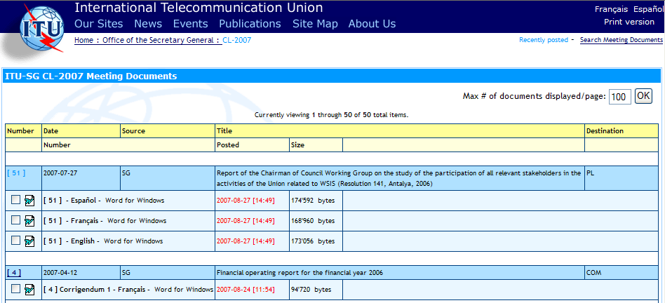

3 Downloading multiple documents at once
In each document list it is possible to select multiple documents using the checkboxes on the left side or the “Check All” button at the bottom. Then the selected documents can be packed into a “zip file” to be downloaded at once, using the “Zip and Download” button.
The zip file is automatically created from:
• the selected documents;
• any existing addenda and corrigenda; and
• associated html pages (similar to the ITU web pages)
in the chosen languages and formats. http://www.itu.int/md/S07-CL-INF/en
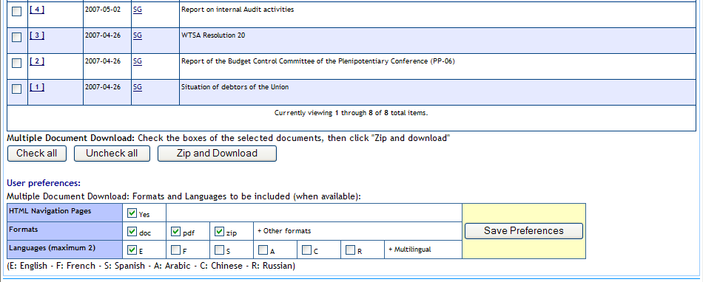
The user has the option to select the formats and languages to be downloaded. It is also possible to get a copy of the html navigation pages (lists of documents). Then the user preferences can be saved (for the whole conference duration).

4 Laptop synchronization with the ITU website
Services are offered to maintain on a laptop a copy of the ITU website related to Conference documents. The strategy for maintaining on a laptop such a website is the following:
• Get the initial set of documents and web pages.
• Update regularly this collection using the multiple document download with the “Recently Posted” option. Select only the documents that have been added since your last synchronization, and make sure the “HTML Navigation Pages” box is checked.

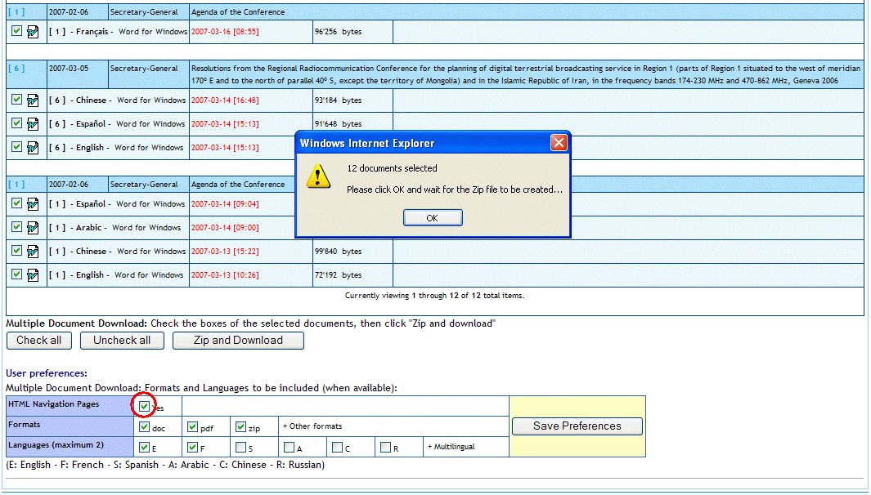
http://www.itu.int/md/S07-CL/new/en

You will get along with the selected documents, up-to-date html web pages (with local links) allowing easy navigation among the documents on the laptop.
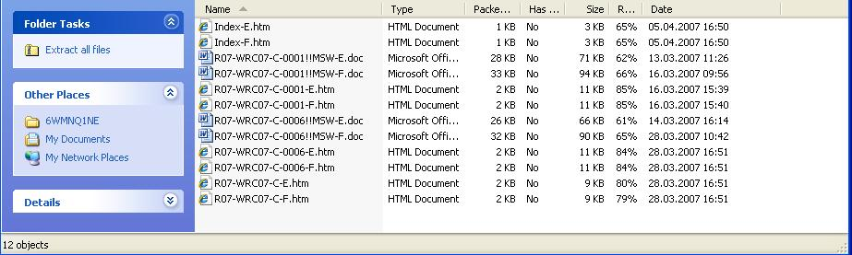

5 Getting short file names for Conference documents
A naming scheme has been developed for ITU Meeting and Conference documents allowing name uniqueness. This naming scheme (long file names) is applied by default to downloaded documents.
For users who prefer to keep a collection of documents with short file names, a utility is available to shorten the names of the downloaded documents in one operation.
This unsupported utility (to be installed on the laptop PC) is available at the following URL:
http://www.itu.int/md/rename_meeting_documents.zip.
Important remark: Short file names are not compatible with the local html pages provided to maintain a local copy of the ITU website.

6 Other services: Direct booking of the Conference sessions in the user agenda
From the agenda of Council session, users can directly book in their agenda the sessions they are interesting by clicking the corresponding icon.
http://www.itu.int/events/ExtWebDailyagenda.asp?sector=ITU-SG

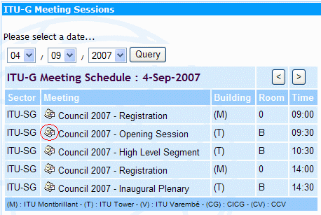

Laptop connectivity

Access to the Internet and Council documents at the ITU Council will be available using the LAN technologies listed below:
- Wired: Ethernet RJ45 10/100 Mbps
  - in Rooms H, K, L, M and cybercafés of ITU
- Wireless IEEE 802.11a/b/g
  - in all conference areas of ITU
The ITU has recently upgraded its IEEE 802.11a/b/g wireless LAN facilities in the Tower conference area to improve performance, reliability, availability and serviceability. The approximate percentage of bandwidth available in each case is as follows:
- Wireless IEEE 802.11a: 58%
- Wireless IEEE 802.11g: 34%
- Wireless IEEE 802.11b: 9% (low due to limitation of the technology)
To make the most efficient use of network resources, we strongly recommend the following:
- Check to see if your laptop has 802.11a capability. If it does not, purchase an 802.11a/b/g card and have it configured before you arrive.
- Ensure that your user account has administrative privileges. Should you require help onsite, the service desk staff will only be able to help you if you have administrative rights on your laptop.
- You are kindly requested to test your WiFi connection well before the Opening Session. The Service Desk at the ground floor of the Varembe building will be there to help you if you require assistance.
- Refrain from using peer-to-peer connections.
Please note that the installation and use of non-ITU wireless access points without prior authorization from the ITU/IS Department is prohibited.

Useful reminders for laptops

Wireless LAN configuration parameters
Please follow the installation instructions delivered with the card. You may need to log in with administrator privileges depending on your PC’s operating system and the card purchased.
The following parameters should be set in order to connect to the ITU wireless network:
• Set the case-sensitive SSID as “ITUdelg”.
• Set WEP encryption to “Off”.
• Set Operation mode to “Infrastructure” (not Ad-Hoc or peer-to-peer). The Ad-Hoc mode creates a lot of confusion not only for you but also for other participants.
• Choose 802.11a band whenever possible as it will give you the most bandwidth. Most cards are able to search for the radio channel automatically. If your card does not support this function, try channels 36, 40, 44, 48, 52, 56, 60, 64 for 802.11a and channels 1, 6 or 11 for 802.11b/g. You may have to change to another channel if you move to another part of the building.
Network Connection settings
Enable DHCP so that your laptop will obtain the IP address and other network parameters automatically
Security
Please be aware that delegate network communication can be intercepted, end-to-end encryption is recommended for confidentiality.
If you are concerned about computer security, please use personal firewall software.
Firewall software configurations may prevent access to local resources (e.g. printers).
All wireless users must have a good anti-virus program that has up-to-date virus database. Viruses can easily spread in the wireless network. You will also need a few spyware detection programs such as Ad-Aware.
Outgoing e-mail
Set up smtp.itu.ch as your outgoing (SMTP) server.
Web-proxy
Ensure that your Internet browser’s proxy setting is either removed or set to www-proxy.itu.int:3128.
Socks
Disable any SOCKS configurations.

Notes on using wireless connections:
1) Wireless network connections are good for web browsing but fair for FTP downloads or for telnet applications.
2) Before taking out your wireless card (or any other PC card from its slot), you should first properly stop it, or risk re-installation of the operating system.
3) Wireless cards can drain considerable power from your laptop – so recharge your laptop frequently.

Buying wireless cards

Before buying a card, it is advisable to check that it is in the compatibility list at http://www.wi-fi.com and that the frequency range is valid. ITU recommends the use of 128-bit encryption cards from known vendors to minimize problems and to facilitate troubleshooting.
When buying a new card, be sure to mention that you need “Wi-Fi compatible 802.11a/b/g wireless card with 128-bit encryption” (although encryption is not used at the moment in ITU, it may become mandatory in future and most cards come with it anyway).
Please note that all IEEE 802.11a or 802.11b/g standard compliant cards are not necessarily Wi-Fi compliant, whereas Wi-Fi compliant cards are IEEE 802.11a or 802.11b/g or both compliant. Look for the card with one of the following certificates:
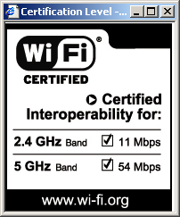

Please check that your card’s model number is mentioned at http://www.wi-fi.com before you buy the card.

Check frequency range
Please note that wireless cards manufactured for some specific countries like France and Spain may not work in ITU because of frequency limitations imposed in these countries.
For 802.11a at the 5 GHz band (5.15 – 5.35 GHz), the following channels are allowed in Switzerland:
Channels: 36, 40, 44, 48, 52, 56, 60, 64
For 802.11b/g at the 2.4 GHz band (2.4-2.4835 GHz), the following channels are allowed in Switzerland:
Channels: 1 to 13
To avoid interference and to maximize throughput, we use only three channels 1, 6 and 11 in our 802.11b/g equipment.
What this means for practical purposes is that if you buy cards destined for USA, Canada, Japan (TELEK) or the European region (ETSI), your card will work in ITU but if you buy older cards that are destined only for France or Spain, it may not work here. An example: for older cards meant only for France the model number may be followed by something like –FR.
So, before buying a card, it is wise to check that it is in the compatibility list at http://www.wi-fi.com and also that your frequency range is valid as described above.

