INTERNATIONAL TELECOMMUNICATION UNION |  |  | Cloud Computing  ‘joint coordination activity’
TELECOMMUNICATION STANDARDIZATION SECTOR  STUDY PERIOD 2013-2016 |  |  | Doc 148
English only
Original: English
TD
(Ref: SG2 - LS 66 -E)
Source: | ITU-T Study Group 2
Title: | LS/i/r on response for Collaboration on Cloud Computing Management (Reply to SG13-LS 64 – E) [from ITU-T SG2]
LIAISON STATEMENT
For action to: |  | SG13
For comment to: |  | -
For information to: |  | JCA-Cloud
Approval: |  | ITU-T SG2 meeting (Geneva, 6 June 2014)
Deadline: |  | 31 July 2014
Contact: |  | Mr. Zhao Ping  China Telecom  P.R.China | Tel: +86 20 38639086  Fax: +86 20 38639277  Email: zhaop@gsta.com or rogers.zhao@gmail.com

 | INTERNATIONAL TELECOMMUNICATION UNION |  |  |  |  |  | COM 2 – LS 66 – E
TELECOMMUNICATION
STANDARDIZATION SECTOR
STUDY PERIOD 2013-2016
English only
Original: English
Question(s): |  | 5/2, 7/2 |  | Geneva, 28 May - 6 June 2014
Ref.: TD 0397 Rev.3
Source: |  | ITU-T Study Group 2
Title: |  | LS/r on response for Collaboration on Cloud Computing Management (Reply to SG13-LS 64 – E)
LIAISON STATEMENT
For action to: |  |  | ITU-T SG13 (WP2/13)
For comment to: |  |  | -
For information to: |  |  | JCA-Cloud
Approval: |  |  | ITU-T SG2 meeting (Geneva, 6 June 2014)
Deadline: |  |  | 31 July 2014
Contact: |  |  | Mr. Zhao Ping  China Telecom  P.R.China |  | Tel: +86 20 38639086  Fax: +86 20 38639277  Email: zhaop@gsta.com or rogers.zhao@gmail.com
 |  |  | Mr. Zhili Wang  BUPT,  P.R.China |  | Tel: +86 10 6228 3119 ext. 8726  Fax: +86 106228 3412  E-mail: zlwang@bupt.edu.cn
 |  |  | Ms. Yanchuan Wang  China Telecommunications Corporation  P.R.China |  | Tel: +86 10 58501695  Fax: +86 10 58501854  Email: wangych@chinatelecom.com.cn
Working party 2/2 would like to thank SG13 for sending us the liaison on Collaboration on Cloud Computing Management (COM 13 – LS 64 – E).
After exchanging the understandings about Cloud Computing Management between SG2 experts and Q19/13 rapporteur, Working party 2/2 agreed to propose the following,
1) To get close cooperation upon Cloud Computing Management between SG2 and SG13, it is necessary to set up the common principles and a demarcation between SG2 and SG13 for future work which may be an output of the joint Rapporteurs group.
2) To avoid misunderstanding and confusion, a common terminology about Cloud Computing Management should be referred by both sides.
3) To push forward the study work of Cloud Computing Management, a common basic physical architecture of Cloud Computing Management is needed critically for both sides, which is the fundamental architecture that should be used by both sides.
From the technical viewpoint, WP2/2 thinks that M.occm and M.rcsm will try to focus the Cloud-integrated Telecom BSS/OSS part. A preliminary proposed management architecture is illustrated as the following diagram:
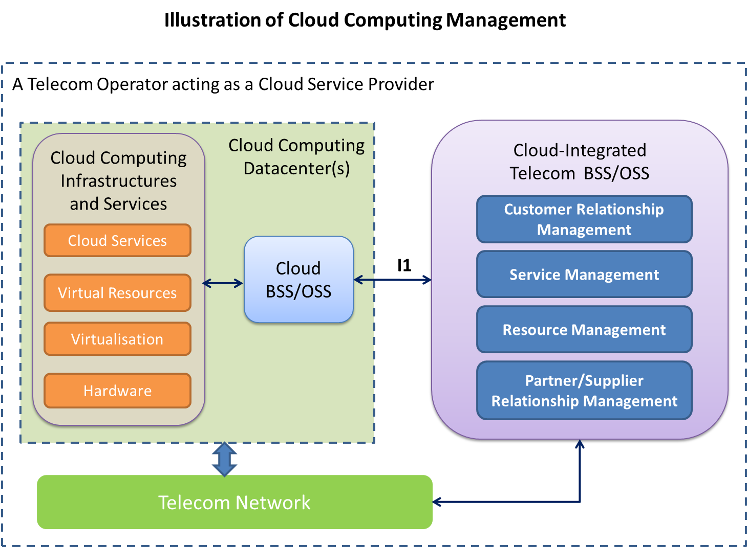
Note: This diagram only focuses on management of cloud computing within ITU-T, and the customer’s self-service management is outside the scope of this diagram.
- The whole box indicates a telecom operator acting as a cloud service provider.
- In the traditional Telecom management, whether the data centre(s) belong to the Telecom operator will make I1 a different kind of interface in SG2, either an X or Q interface.
The above diagram illustrates the Cloud Computing Management architecture of telecom operators which have cloud computing infrastructures and services. The left side of this diagram is cloud computing data centre(s) which has cloud computing infrastructures and services. It also has Cloud BSS/OSS which can provide management functions for the data centre. The right side of this diagram is Cloud-Integrated Telecom BSS/OSS, which can provide integrated management functions for both cloud computing and telecom services. The I1 interface in the diagram is the interface between Cloud-Integrated Telecom BSS/OSS and Cloud BSS/OSS. Through this interface Telecom BSS/OSS and Cloud BSS/OSS can exchange management information to support Cloud-Integrated management functions.
4) It is necessary to define the management interface between Cloud BSS/OSS and Cloud-integrated Telecom BSS/OSS. That means to study how cloud management functions can fit telecom management requirements. The interface between Cloud BSS/OSS and Cloud-integrated Telecom BSS/OSS may involve not only the operation and monitoring of the (virtual) resources, but also the aspects of customer relationship, billing events, SLA, regulation requirements, etc. The current version of M.mivrcc could be an input to the standardization of this interface.
In order to understand the necessity of such interfaces, some possible scenarios are mentioned in the discussion:
- When a telecom operator need to activate cloud services packaged in a product for a customer. The Telecom OSS needs to interact with cloud OSS. The capacity and performance requirements for cloud service need to be transferred to Cloud OSS, and the status of cloud services need to be reported to the Telecom OSS.
- When a telecom operator need to generate an overall bill for a customer, and this customer order more than one service (some of them are cloud services), the usage and billing information need to be transferred from Cloud BSS to Telecom BSS.
Also, it’s agreed that it’s necessary to set up a Joint Rapporteurs Group on Cloud Computing Management. Ms. Wang Yanchuan, from China Telecom, is appointed as the rapporteur representing SG2.
WP2/2 proposes to have future joint Rapporteurs group meetings in September 2014 and January 2015 timeframe in China on Cloud Computing Management including M.occm, M.rcsm and M.mivrcc.
Terms of Reference of the Joint Rapporteurs Group on Cloud Computing Management is drafted as the attachment.
_______________

Attachment to COM2-LS066

Draft Terms of Reference of the
joint Rapporteurs group on Cloud Computing Management

- Purpose
This document provides the Terms of Reference for the joint Rapporteurs group on Cloud Computing Management between relevant Questions of SG 2 and SG13.
Name and composition
This group will be known as the ITU-T Q5/2, Q7/2 and Q19/13 joint Rapporteurs group on Cloud Computing Management (JRG-CCM).
- Parent Bodies
The parent bodies of the joint Rapporteurs group on Cloud Computing Management are ITU-T WP2/2 and ITU-T WP2/13. The joint Rapporteurs group will report to its parent bodies.
- Scope and Goals
The scope and goal of the project is the development of Cloud Computing Management draft Recommendations based on the common understanding from both SG2 and SG13 perspectives. This work will be based on the three following documents:
- Draft new Recommendation ITU-T Y.3500, Cloud Computing Definitions, from ITU-T Q17/13;
- Draft new Recommendation ITU-T Y.3502, Cloud Computing Reference Architecture, from ITU-T Q.18/13;
- Recommendation ITU-T Y.3520, Cloud computing framework for end to end resource management, from ITU-T Q.19/13.
- Deliverables
The joint Rapporteurs group will deliver draft Recommendations to the applicable parent bodies for initiation of the relevant approval process. The joint Rapporteurs group can advise the parent bodies as to which Recommendation series seems most appropriate (e.g. M-series, Y-series), or suggest dual numbering of the draft Recommendation. The approval process will be handed as usual, by the Study Group normally responsible for the relevant document series. Where dual numbering is agreed, each affected Study Group will handle their respective approval process as usual.
- Participation
Those qualified to participate in either parent body may participate in the joint Rapporteurs group. Individual experts’ participation follows the rules of WTSA-12 Resolution 1, clause 2.3.1.
A list of participants will be maintained for reference purposes and reported to the parent groups as an attachment to the report of each meeting.
- Meetings
JRG-CCM may meet physically or electronically.

During meetings of parent bodies
As appropriate, joint Rapporteurs group meeting venues and dates should be arranged to coincide with meetings of the parent bodies when the meetings are held under the auspices of SG2 or SG13. The work of the joint Rapporteurs group during an associated parent body meeting will be scheduled by the Rapporteurs as part of the overall meeting schedule of that parent body. Separate sessions for participating Questions to run their regular business (other than that one of JRG) will be arranged on the overall meeting schedule.

Interim meetings
Interim meetings of the joint Rapporteurs group, i.e. when not collocated with a parent body, should be timed and located so as to minimize travel difficulties for participants.
Remote virtual meetings may be held as needed.
The procedures for arranging interim joint Rapporteurs group meetings are the same as for scheduling normal Rapporteurs meetings (see Rec. ITU-T A.1, section 2.3.3). If either parent Study Group authorizes an interim meeting of their relevant Questions within the joint Rapporteurs group, the members of the corresponding Questions of the other Study Group should be invited to join the meeting.
- Management
The Joint Rapporteurs group will have one Rapporteur appointed by SG2 and one Rapporteur appointed by SG13. Rapporteurs for the joint Rapporteurs group need not be serving as Question Rapporteurs, but should be active in their respective Questions.
- Documents and Contributions
The procedures for submitting documents are the same as for submissions to normal Study Group, Working Party, or Rapporteur meetings as applicable (see Rec. ITU-T A.1, section 2.3.3).
- Liaison with other groups
The Joint Rapporteurs group can receive and send liaison statements as normal for a Question/Rapporteur meeting. The source of outgoing liaisons is JRG-CCM (i.e., Qs 5/2,7/2 and 19/13).
- Work Plan
- The joint Rapporteurs group, upon formation, will decide what should be the list of initial documents that the work will be deriving from.
- The first task of the joint Rapporteurs group is to develop a common understanding of the cloud computing management environment, and the way this fits into the overall standardization efforts.
- A next step will be agreement on a common set of overall requirements.
- To avoid misunderstanding and confusion, a common terminology about Cloud Computing Management should be referred by both sides. (e.g., cloud datacenter, cloud Operations Support Systems and Business Support Systems - OSS/BSS.)
- To mutually develop a draft Recommendation on cloud computing management architecture taking into account the Y.3502 cloud computing reference architecture.
- Documentation repository
JRG will have its dedicated informal FTP area or SharePoint site to convene its work.

Lifetime

The JRG will continue until the end of the current ITU-T Study Period (2013-2016). The scope and the purpose of JRG should be revisited at the first meeting of a parent body in the next study period (2017 - 2020) for the purpose of its extension in which case the approval by each study group is needed.

______________________

