ITU-T/ ATIS Workshop

“Next Generation Technology and Standardization”

BIO
BIO |  | Las Vegas, 19-20 March 2006
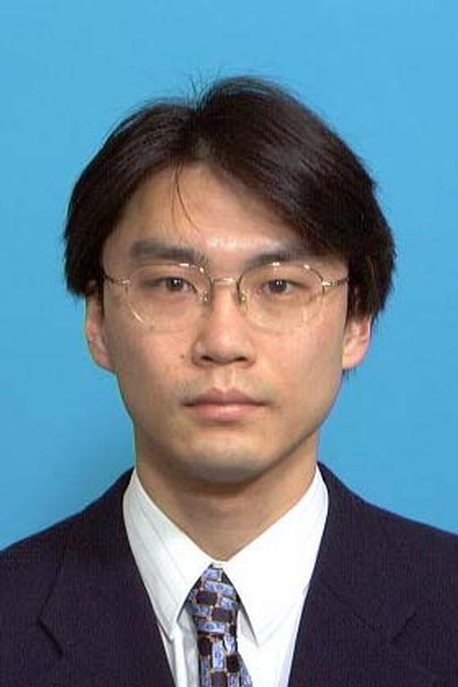 | Takumi Ohba  NTT
Session: | 5. Interconnection, Interworking and Evolution
Title of Presentation: | NGN NNI signalling profile

Senior Research Engineer, NGN System Architecture Project, NTT Service Integration Laboratories.

He received the M.S. degree in physics from the University of Tokyo, Tokyo in 1993. He joined NTT the same year and has been studying ATM signaling and VoIP signalling. Since April 2004, he has been promoting globalization of the next-generation network. He is a member of the Institute of Electronics, Information and Communication Engineers (IEICE).

