ITU-T/ ATIS Workshop

“Next Generation Technology and Standardization”

BIO
BIO |  |  | Las Vegas, 19-20 March 2006
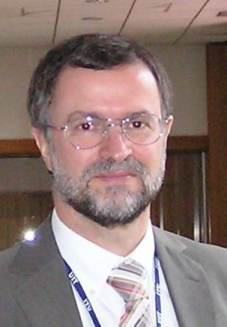 |  | Keith Mainwaring, Cisco Systems.
Session: |  | 4: Signaling and control
Title of Presentation: |  | Resource and Admission Control and IMS

Keith began his career in telecommunications in 1978 at the Rutherford Appleton Laboratory of the UK Science and Engineering Research Council where he was involved in building and operating SERCNet which later evolved into the UK Joint Academic Network (JANET).

From 1984 to 1990 he worked for Logica on a number of projects grounded on OSI protocols, in particular the X.400 message handling system, and on ISDN standardisation.

From 1990 to 2000 he was engaged in ISDN, ATM and IP network development at Telia (formerly Swedish Telecom) in Stockholm, Sweden.

He now has the position of Technical Leader in Cisco Systems with specialisation in the areas of Voice over IP, interworking with the PSTN and QoS control architectures.

Keith has been active in standardisation activities for over two decades. He has been editor of several ITU-T Recommendations, ETSI and British Standards; Rapporteur in ITU-T Study Group 11 and in ITU-D SG1; and co-chair of the QoS working group in the ITU-T NGN Focus Group.

He has a Higher Technical Certificate in Electrical and Electronic Engineering from Oxford Polytechnic and a Masters Degree in Communications Policy Studies from City University, London. Keith has published a number of technical courses and numerous papers.

